APPLICATION FOR FULL PLANNING PERMISSION CASE OFFICER REPORT

APPLICATION REFERENCE: | PL/2026/04842
APPLICATION TYPE: | Full planning permission
SITE ADDRESS: | Meadow View, Agricultural Building to the North of Drakes Corner, Ford, Salisbury, SP4 6DH
DEVELOPMENT DESCRIPTION: | External and internal alterations to an existing agricultural barn
RECOMMENDATION: | Approve with Conditions

SITE DESCRIPTION/CONTEXT

The application site relates to an existing agricultural barn located within an agricultural field outside of any settlement boundaries. The site is within the Special Landscape Area. Mill House and attached mill to the east are Grade II listed. The site is located within the River Avon catchment SAC & SPA, is within the 13.8km buffer of New Forest SPA and is within Flood Zone 3 and susceptible to groundwater flooding.

PROPOSAL

The application seeks planning permission for external and internal alterations to an existing agricultural barn located within an established agricultural holding at Ford. The proposed works comprise alterations to the existing building, including the replacement of a number of existing openings with roller shutter doors, the installation of additional roller shutter doors on the south-east and north-east elevations, and alterations to the southern roof slope to increase the height of part of the building. Internal alterations are also proposed to improve the functionality and accessibility of the building.

The submitted Planning Statement explains that the building is currently used in connection with agricultural and forestry activities, including the storage of agricultural machinery, animal feed and firewood associated with the applicant's forestry business. The proposed alterations are intended to improve operational efficiency, enhance security, protect stored materials from the elements and facilitate the continued use of the building for these rural business purposes. The existing vehicular access arrangements would remain unchanged.

Existing elevations

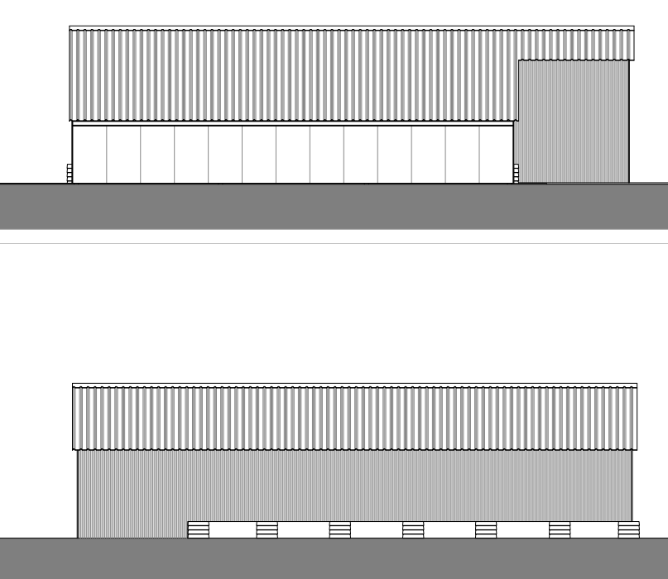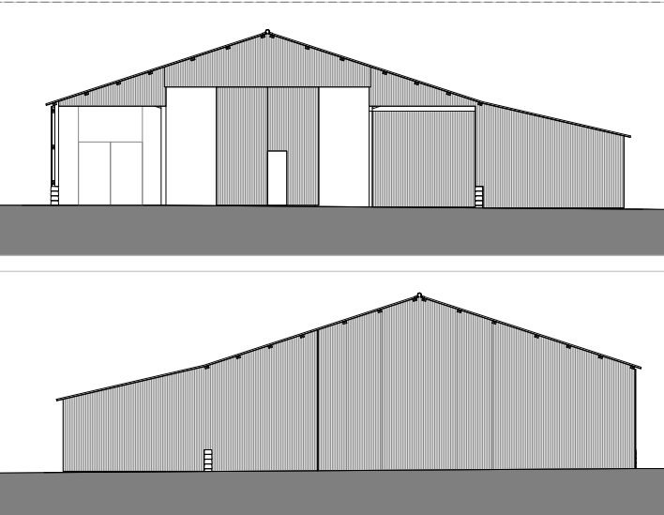

Proposed elevations

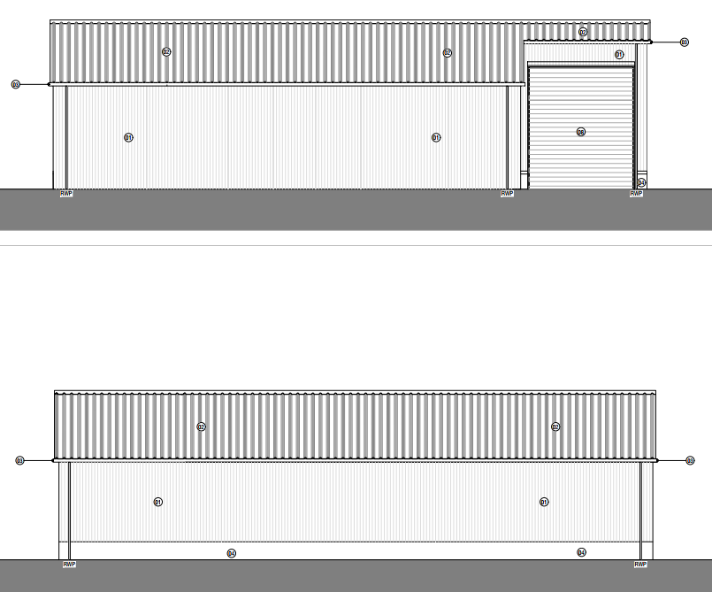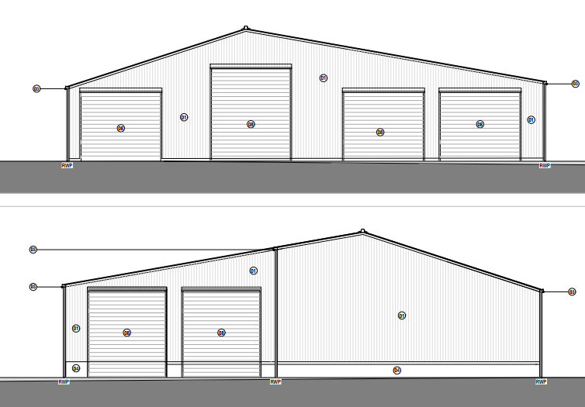

Existing and proposed ground floor plan

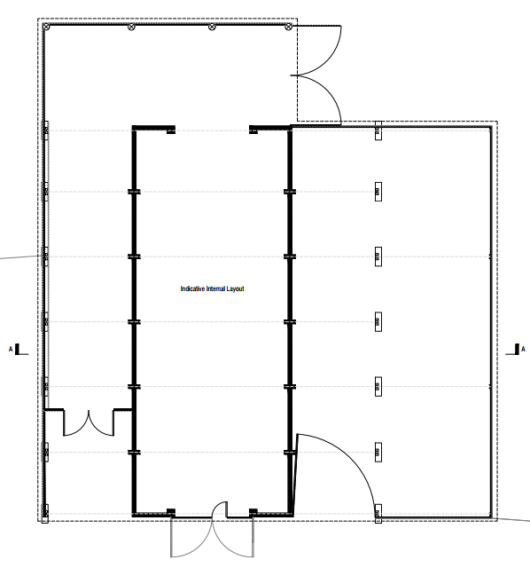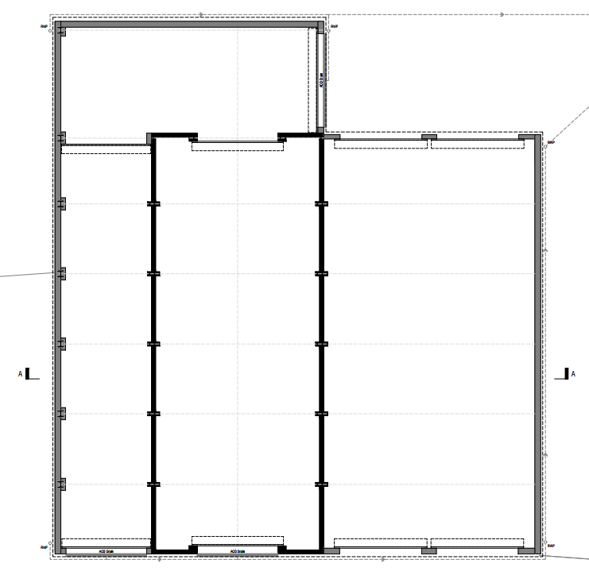

PLANNING HISTORY

Proposal / Summary
PL/2025/06052 - MEADOW VIEW, FORD, SALISBURY, SP4 6DL - Lawful development: Existing use Decision - Refuse Date: 9/9/2025 – Commencement of works and confirmation of a meaningful start in relation to planning application PL/2022/03712. Installation of drainage and soakaway system.
PL/2022/03712 - Agricultural Building to the North of Drakes Corner, Ford, Salisbury - Full planning permission Decision - Approve with Conditions Date: 22/6/2022 – External and internal alterations to an existing agricultural barn
S/2002/0662 - MEADOW VIEW BARN, FORD, SALISBURY, SP4 6DL - Full planning permission Decision - Approve with Conditions Date: 3/9/2002 – CONVERSION OF EXISTING BARN INTO OFFICE SPACE

RELEVANT LEGISLATION, POLICIES AND GUIDANCE

Statutory Legislation:

National Planning Policy:
National Planning Policy Framework (NPPF)
Planning Practice Guidance (PPG)

Development Plan:

The development plan for Wiltshire comprises the Wiltshire Core Strategy (WCS) (adopted January 2015) and any made neighbourhood plans, which remains the principal statutory planning document guiding development across the county. In line with Section 38(6) of the Planning and Compulsory Purchase Act 2004, planning decisions must be made in accordance with the development plan unless material considerations indicate otherwise.

Though the development plan is considered as a whole, those parts deemed to be particularly relevant to this application are listed below:

The adopted Wiltshire Core Strategy (WCS), with particular regard to:

Core Policy 24 New Forest National Park
Core Policy 34 Additional Employment Land and Buildings
Core Policy 48 Supporting Rural Life
Core Policy 50 Biodiversity
Core Policy 51 Landscaping
Core Policy 57 Ensuring high quality design and place shaping
Core Policy 67: Flood Risk
Core Policy 69 Protection of the River Avon SAC

Saved policy C6 – Special Landscape Area (Salisbury District Local Plan)

Draft Wiltshire Local Plan
At Full Council on 19 May 2026, the elected members of Wiltshire Council agreed to withdraw the emerging Wiltshire Local Plan. The said Plan has no material weight for the purposes of the application.

In accordance with Regulation 19 of the Town and Country Planning (Local Planning) (England) Regulations 2026, on 30th June 2026 Wiltshire Council published a notice of intention to prepare a new local plan for Wiltshire. The next stage is a Scoping Consultation which commences on 2nd September 2026. This plan is at a very early stage and currently carries no weight for decision making.

Neighbourhood Plan:

Laverstock Neighbourhood Plan

Supplementary Planning Documents and other Guidance:

Wiltshire Design Guide (adopted April 2024)
National Design Guide
Creating Places Design Guide

CONSULTATION RESPONSES

Parish Council – no comment

Highways – no objection

Ecology- no objection subject to conditions

REPRESENTATIONS

None received

ASSESSMENT
Section 38(6) of the Planning and Compulsory Purchase Act 2004 states:

"If regard is to be had to the development plan for the purposes of any determination to be made under the planning Acts, the determination must be made in accordance with the plan unless material considerations indicate otherwise."

In accordance with this statutory requirement, this application has been assessed against the relevant policies of the Development Plan, including the Wiltshire Core Strategy (2015) and, where applicable, any made Neighbourhood Plans. Consideration has also been given to the policies of the NPPF (NPPF) as a material consideration in the assessment.

The assessment below considers each of the main issues in turn with reference to the relevant policy context, the evidence submitted, consultee responses, and all other material considerations, before a conclusion is reached.

Principle

Core Policy 34 supports development in the rural area where it supports sustainable farming and food production, facilitates rural diversification and assists existing rural businesses, provided the development is appropriately scaled and does not result in unacceptable impacts.
The application relates to an existing agricultural barn situated within an established agricultural holding. The building is currently used in connection with agricultural and forestry activities, and the proposed works are intended to improve the functionality, accessibility and longevity of the structure rather than facilitate a new use. The submitted information explains that the alterations are required to accommodate agricultural and forestry equipment, provide improved storage arrangements and support the ongoing operation of the associated rural enterprise.

It is also material that planning permission was granted under application PL/2022/03712 for substantially the same works. Whilst that permission has now lapsed, officers note that there have been no material changes in planning policy, site circumstances or the nature of the proposal which would justify reaching a different conclusion. The principle of the development is therefore considered acceptable, subject to the detailed matters considered below.

Since the determination of the previous application, the National Planning Policy Framework has been revised – August 2026. However, officers are satisfied that the updated relevant provisions relating to sustainable development, rural economic growth, design and amenity do not materially alter the planning balance in this case. The proposal remains compliant with the relevant policies of the development plan and the NPPF and there have been no material changes in site circumstances which would justify reaching a different conclusion.

Design, Character and Landscape Impacts

Core Policy 57 of the Wiltshire Core Strategy requires development to achieve a high standard of design that responds positively to local character, context and distinctiveness.

Policies DP1-DP4 of the NPPF seek to ensure that development is well-designed, visually attractive, sustainable and responsive to its surroundings. Development should contribute positively to local character, create high quality places and support healthy and inclusive communities.

The Wiltshire Design Guide provides further guidance on achieving high quality, context-led design and should be taken into account where relevant.

Core Policies 51 and 57 of the Wiltshire Core Strategy seek to ensure that development responds positively to local character and conserves landscape quality. Saved Policy C6 similarly seeks to protect the character and appearance of the Special Landscape Area. Policies DP1-DP4 of the NPPF require development to be well-designed and sympathetic to its surroundings.

The application site occupies a rural location and contains an existing agricultural barn which is already a well-established feature within the landscape. The proposal would retain the agricultural function and overall form of the building, with alterations principally comprising the installation of roller shutter doors, replacement cladding and a modest alteration to part of the roof profile.

The proposal would result in a more well-maintained appearance whilst retaining the agricultural character of the building, the use of agricultural materials, including profiled metal sheeting and roller shutter doors, is typical of contemporary agricultural buildings. The works would not alter the fundamental agricultural character of the structure nor introduce built form that would appear significantly out of keeping within its rural context.

Officers note that the building is currently in a relatively poor state of repair. The proposed refurbishment works would improve the appearance and longevity of the building and ensure its continued use as part of the wider agricultural holding.

The alterations would result in only a modest increase in building volume associated with the amended roof slope. Given the scale of the existing building, the agricultural context and the limited visibility of the site within the wider landscape, the proposal would not result in any materially harmful impact upon the character of the countryside, the Special Landscape Area or the wider landscape setting.

The proposal therefore accords with Core Policies 51 and 57 of the Wiltshire Core Strategy, Saved Policy C6 and Policies DP1-DP4 of the NPPF.

Amenity

Core Policy 57 (vii) requires development to avoid unacceptable impacts upon neighbouring amenity. Policy P3 of the NPPF similarly requires development to avoid unacceptable effects on the living conditions of neighbouring occupiers.

The proposal relates to alterations to the fabric of an existing agricultural building and would not introduce a new use of the site. The building would continue to serve agricultural and forestry purposes as existing.

The nearest residential properties include Meadow View, Whitegates, The Hollies and Drakes Corner. Having regard to the separation distances involved, the existing lawful use of the site and the nature of the proposed alterations, it is not considered that the proposal would result in unacceptable impacts arising from overlooking, loss of light, overbearing effects or visual dominance.

Whilst the alterations would improve the functionality of the building, the proposal does not seek permission for any intensified or materially different use. As such, officers are satisfied that the development would not result in unacceptable levels of noise, disturbance or activity beyond that already associated with the lawful agricultural and forestry use of the site.

The proposal is therefore considered to comply with Core Policy 57 of the Wiltshire Core Strategy and Policy P3 of the NPPF.

Highways Impacts and Parking

Policies TR3-TR8 of the NPPF seek to ensure that development is supported by safe, suitable and sustainable transport arrangements. Development should provide appropriate access, promote sustainable travel choices where possible and avoid unacceptable impacts on highway safety and the operation of the transport network.

Core Policies 60-64 of the Wiltshire Core Strategy require development to provide safe access, promote sustainable transport, minimise transport impacts and provide appropriate parking arrangements.

The application seeks consent for external and internal alterations to an existing agricultural barn. The submitted Planning Statement confirms that the building will continue to be used for agricultural and forestry purposes and that the proposals do not involve any change of use of the site. The works are intended to improve the functionality, accessibility and operational efficiency of the existing building.

The Council's Highway Officer has reviewed the proposal and raises no objection. It is noted that the development does not involve any alterations to the existing access arrangements, parking provision or internal site layout. Furthermore, given that the building would remain in agricultural and forestry use, the proposal is not anticipated to result in any material increase in vehicle movements or traffic generation beyond that already associated with the lawful use of the site.

Officers note that planning permission was previously granted for substantially the same development under application PL/2022/03712 and there have been no material changes in site circumstances which would alter the previous highway assessment. Having regard to the nature of the proposal and the absence of any changes to site access or operation, the development is not considered likely to have an adverse impact upon highway safety or the operation of the local highway network.

The proposal is therefore considered to comply with Core Policy 61 of the Wiltshire Core Strategy and the relevant provision of the NPPF.

Ecology and Biodiversity

Core Policy 50 of the Wiltshire Core Strategy requires development to protect and, where appropriate, enhance biodiversity and geodiversity interests.

Policy N2 of the NPPF seeks to conserve and enhance biodiversity, support nature recovery, protect habitats and species, and strengthen ecological networks.

The application is supported by a Preliminary Roost Assessment prepared by BatCraft. The survey included an internal and external inspection of the existing agricultural barn and found no evidence of bats. The building was assessed as having negligible potential to support roosting bats owing to its poor condition, including significant light ingress, water ingress and an unstable internal environment. As such, the report concludes that no further bat surveys are required.

The Council's Ecologist has reviewed the submitted ecological information and raises no objection to the proposal subject to conditions. The Ecologist agrees with the conclusions of the Preliminary Roost Assessment and notes that the building has negligible potential to support roosting bats.

The application site falls within the catchment of the River Avon SAC and the 13.8km Zone of Influence for the New Forest international designated sites, comprising the New Forest SPA, SAC and Ramsar site. The proposal must therefore be considered under the Conservation of Habitats and Species Regulations 2017 (as amended) in respect of potential impacts arising from nutrient loading and recreational pressure. However, the development would not result in any net increase in residential units or overnight accommodation and, consequently, there is no mechanism by which it could create additional wastewater discharges or increased recreational pressure on these designated sites. The proposal is therefore not likely to have a significant effect on the integrity of the River Avon SAC, New Forest SPA, New Forest SAC or New Forest Ramsar site, either alone or in combination with other plans or projects.

The Ecologist further advises that the site lies outside the 20m buffer of the River Avon SAC and that, having regard to the nature of the development, significant impacts upon protected species or designated sites are not anticipated. Biodiversity Net Gain requirements are not applicable in this case as the proposal falls below the de minimis threshold.

Subject to conditions securing biodiversity enhancement measures and controlling external lighting, the proposal is considered to comply with Core Policy 50 of the Wiltshire Core Strategy and the relevant provisions of the National Planning Policy Framework.

Flood Risk

Core Policy 67 of the Wiltshire Core Strategy seeks to ensure that development is appropriately located and designed to avoid increasing flood risk on-site or elsewhere. Sustainable drainage measures should be incorporated where appropriate.

Policies F4-F8 of the NPPF require flood risk to be taken into account in planning decisions and seek to ensure that development is safe for its lifetime, does not increase flood risk elsewhere and incorporates appropriate drainage measures.

The application relates to alterations to an existing agricultural building and does not involve the construction of a new building or a significant increase in the extent of built development on the site. The submitted Planning Statement confirms that the proposals are primarily intended to improve the functionality and operational efficiency of the existing barn and would retain its agricultural and forestry use.

The application site lies within Flood Zone 1, which is identified by the Environment Agency as having the lowest probability of flooding and also partly within flood zone 3 as shown with the pink wash on the map extract below.


The proposal would not introduce any vulnerable uses and is not considered likely to increase flood risk either within the site or elsewhere. Furthermore, the development would not result in a significant increase in impermeable surfacing, drainage is shown on the site plan, this relates back to the recent application for a certificate of lawfulness to prove the commencement of development for the previous approval. The drainage shown is for the runoff from the new gutters on the building and not to alleviate flood risk measures; this is therefore a building regulations matter.

Officers note that substantially the same development was previously granted planning permission under application PL/2022/03712 and there have been no material changes in circumstances which would alter the previous assessment in relation to flood risk.

Having regard to the nature and scale of the proposal, officers are satisfied that the development can be accommodated without increasing flood risk on or off site and that the proposal complies with Core Policy 67 of the Wiltshire Core Strategy and Policies F4-F8 of the NPPF.

PLANNING BALANCE AND CONCLUSION

The application seeks consent for external and internal alterations to an existing agricultural barn within an established agricultural holding. The proposed works would support the ongoing operation of the site by improving the functionality, accessibility and usability of the building whilst retaining its agricultural and forestry role.

Officers acknowledge that the proposal would result in changes to the appearance of the building. However, the works would remain consistent with the character of agricultural development within the countryside and would not result in unacceptable harm to the landscape, rural character or visual amenities of the area. Furthermore, the proposal would not give rise to unacceptable impacts in respect of neighbouring amenity, highway safety, ecology or flood risk.

Significant weight is afforded to the fact that planning permission was previously granted for substantially the same development under application PL/2022/03712 and that there have been no material changes in planning policy, site circumstances or the nature of the proposal which would justify reaching a different conclusion. Whilst the National Planning Policy Framework has been revised since that decision was issued; and that permission has now expired without being implemented, officers are satisfied that the updated policy framework does not materially alter the assessment of the proposal.

Taking all material considerations into account, the proposal is considered to represent an appropriate form of rural development which supports an existing rural enterprise without causing unacceptable harm. The application is therefore considered to comply with the relevant Core Policies the Wiltshire Core Strategy, Saved Policy C6 of the Salisbury District Local Plan and the relevant provisions of the National Planning Policy Framework.

RECOMMENDATION: That Planning Permission be GRANTED, subject to conditions

1. The development hereby permitted shall be begun before the expiration of three years from the date of this permission.

REASON: To comply with the provisions of Section 91 of the Town and Country Planning Act 1990 as amended by the Planning and Compulsory Purchase Act 2004.

2 The development hereby permitted shall be carried out in accordance with the following approved plans:

Application form received 03/08/2026
Location plan Drg no 932-03-A received 21/08/2026
Proposed side elevations Drg no 10-201 A received 03/08/2026
Proposed ground floor plan Drg no 10-100 A received 03/08/2026
Proposed front & rear elevations, section AA and soakaway detail Drg no 10-200 A received 03/08/2026
Proposed roof plan Drg no 10-101 A received 03/08/2026
Ecological Survey Report. July 2026. BatCraft received 01/09/2026

REASON: For the avoidance of doubt and in the interests of proper planning.

3 The alterations to the existing agricultural barn hereby permitted shall accord with the materials shown on the approved plans proposed front & rear elevations, section AA and soakaway detail Drg no 10-200 A and proposed side elevations Drg no 10-201 A. The colour and finish for any new wall and roof materials and the roller doors shall be submitted to and agreed in writing by the Local Planning Authority before they are installed on the building and shall be implemented in accordance with the approved details.

REASON: The application contained insufficient information to enable this matter to be considered prior to granting planning permission and the matter is required to be agreed with the Local Planning Authority before the materials are installed in order that the development is undertaken in an acceptable manner, to secure a harmonious form of development and in the interests of landscape amenity.

4. All external lighting provided on site shall be in accordance with the appropriate Environmental Zone standards set out by the Institute of Lighting Engineers in their publication GN01:2021, ‘Guidance for the Reduction of Obtrusive Light’ (ILP, 2021), and Guidance note GN08/23 “Bats and artificial lighting at night”, issued by the Bat Conservation Trust and Institution of Lighting Professionals.

REASON: To protect bat foraging and commuting habitat. In the interests of visual and landscape amenity.

5. No part of the development hereby permitted shall be first brought into use until full details of the number, design and locations of the intended ecological enhancement features, including bat boxes and bird boxes, have been submitted to and approved in writing by the Local Planning Authority. The ecological enhancement features shall be implemented in accordance with the approved details prior to the development hereby permitted being first brought into use and maintained and retained as such for the lifetime of the development

REASON: : The application contained insufficient information to enable this matter to be considered prior to granting planning permission and the matter is required to be agreed with the Local Planning Authority before the development is brought into use in order that the development is undertaken in an acceptable manner and in the interests of biodiversity

Informatives

1. BNG not required

The effect of paragraph 13 of Schedule 7A to the Town and Country Planning Act 1990 is that planning permission granted for development of land in England is deemed to have been granted subject to the condition (biodiversity gain condition) that development may not begin unless:

(a) a Biodiversity Gain Plan has been submitted to the planning authority, and
(b) the planning authority has approved the plan.

The planning authority, for the purposes of determining whether to approve a Biodiversity Gain Plan, if one is required in respect of this permission would be Wiltshire Council.

There are statutory exemptions and transitional arrangements which mean that the biodiversity gain condition does not always apply. For further information on exempt developments please refer to:
https://www.gov.uk/guidance/biodiversity-net-gain-exempt-developments
Based on the information available this permission is considered to be one which will not require the approval of a biodiversity gain plan before development is begun because one or more of the statutory exemptions or transitional arrangements is considered to apply.

2. The applicant should note that this permission is for the alteration of the fabric of an existing agricultural barn building in accordance with the permission granted, the approved drawings and as set out in the Planning Statement. Any significant demolition or rebuilding of the existing structure on the site [other than that specified on the approved plans] or changes of use for industrial purposes related to forestry will mean that the permission hereby granted may no longer be in effect and any further development would then be unauthorised and need further planning permissions.

3. Any alterations to the approved plans, brought about by compliance with Building Regulations or any other reason must first be agreed in writing with the Local Planning Authority before commencement of work.

4. The applicant should note that under the terms of the Wildlife and Countryside Act (1981) and the Conservation of Habitats and Species Regulations 2017 (as amended) it is an offence to disturb or harm any protected species including for example, breeding birds and reptiles. The protection offered to some species such as bats, extends beyond the individual animals to the places they use for shelter or resting. Please note that this consent does not override the statutory protection afforded to any such species. In the event that your proposals could potentially affect a protected species you should seek the advice of a suitably qualified and experienced ecologist and consider the need for a licence from Natural England prior to commencing works. Please see Natural England’s website for further information on protected species

