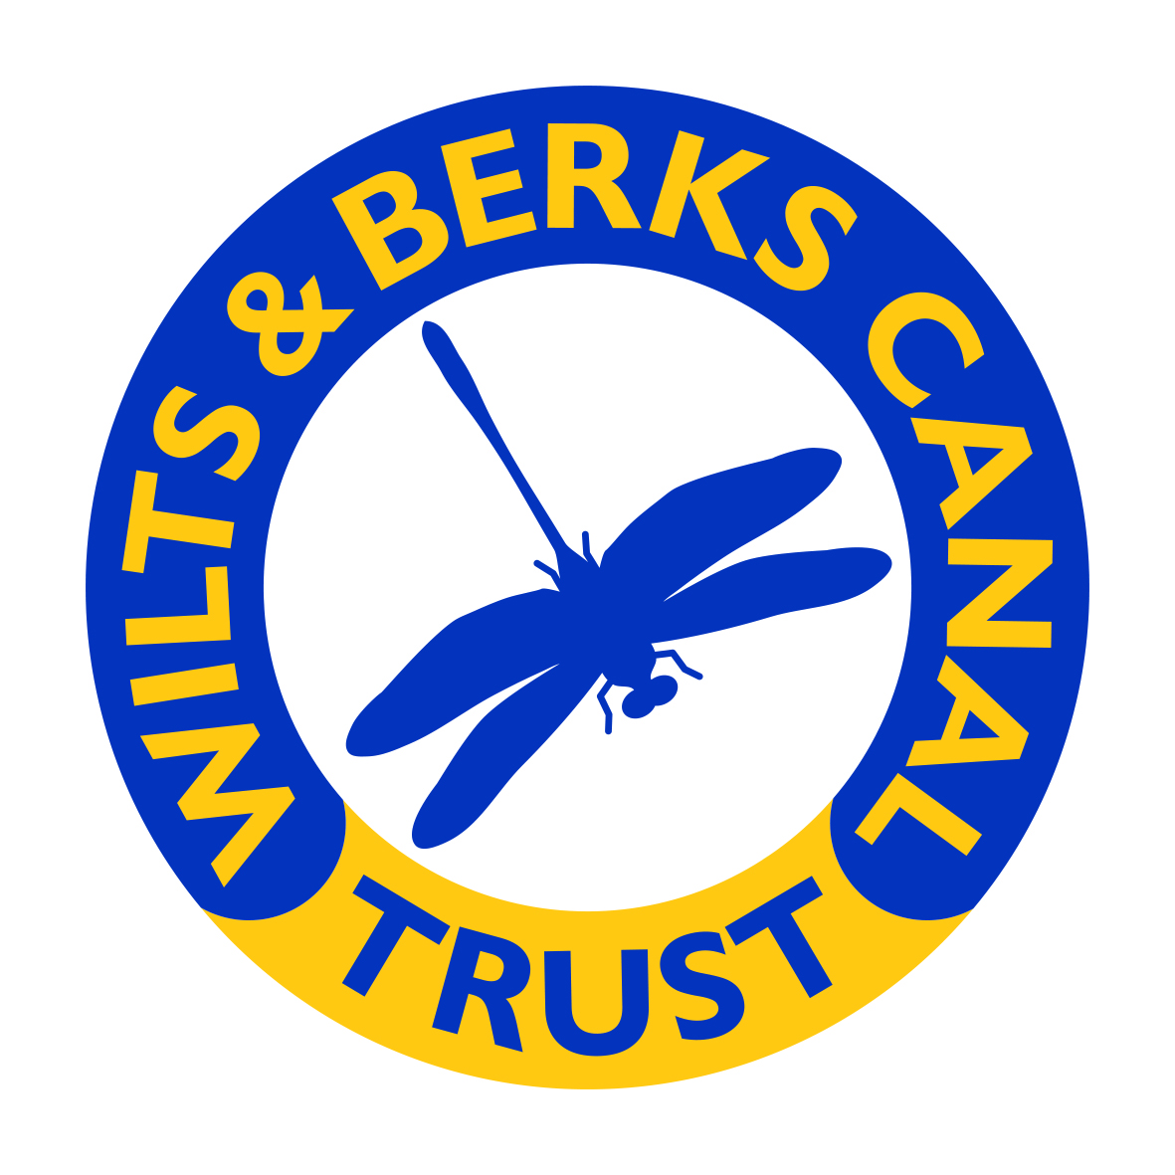

Suggested Framework for Local Plan Policies Supporting the Restoration of the Wilts & Berks Canal

Prepared to Support Engagement with Wiltshire Council on the New Wiltshire Local Plan

Wilts & Berks Canal Trust

Draft Policy Framework

September 2026

1. Introduction

1.1 Purpose of this Document
This document sets out a suggested planning policy framework to support the restoration of the Wilts & Berks Canal through the preparation of a new Wiltshire Local Plan.
The document is intended to:
- Provide a structured basis for engagement with Wiltshire Council Planning Department;
- Identify planning policy mechanisms capable of safeguarding and delivering canal restoration;
- Establish a framework for integrating canal restoration into strategic growth, infrastructure planning, placemaking, active travel, environmental enhancement, and heritage conservation;
- Establish a policy basis for future development to contribute, where justified, toward restoration of the canal and associated infrastructure;
- Support delivery of the Wilts & Berks Canal Trust’s long-term restoration vision.
- Support Wiltshire Council's own strategic objectives.
The policies suggested within this framework are intended to complement national planning policy, including the National Planning Policy Framework (NPPF), Active Travel England guidance, biodiversity net gain requirements, climate resilience objectives, and wider infrastructure delivery planning.

2. Strategic Context

2.1 Opportunity Presented by the New Wiltshire Local Plan
The preparation of a new Wiltshire Local Plan provides a significant opportunity to strengthen planning protections and delivery mechanisms relating to the Wilts & Berks Canal.
Wiltshire Council is now preparing a new Local Plan under the new plan-making system that came into effect in March 2026. The September 2026 scoping consultation is an early opportunity to help shape the Plan's key challenges and priorities, spatial strategy, locally specific policies, evidence requirements, content and future engagement.
This creates an important opportunity to:
- Safeguard the line of the canal from inappropriate development;
- Integrate canal restoration into strategic growth planning;
- Establish policy support for developer contributions;
- Enhance active travel infrastructure using canal towpaths;
- Deliver environmental, heritage, tourism, leisure, and health benefits;
- Coordinate restoration with wider transport and green infrastructure strategies.
The Trust considers that restoration of the canal should be recognised as strategic green and blue infrastructure delivering multiple public benefits across Wiltshire and reflected, where appropriate, in the spatial strategy, Policies Map, evidence base and Infrastructure Delivery Plan.

3. 2050 Vision and Strategic Objectives

3.1 2050 Vision
The Wilts & Berks Canal will be restored as a strategic blue and green infrastructure corridor delivering heritage conservation, active travel, biodiversity enhancement, sustainable transport, recreation, tourism, climate resilience, placemaking, and economic regeneration benefits across Wiltshire.

3.2 Strategic Objectives
It is suggested that the new Local Plan should:
- Safeguard the route of the canal and the land, levels, engineering clearances, drainage, utilities and associated infrastructure needed to keep future restoration physically deliverable.
- Support phased restoration and rewatering.
- Establish a proportionate policy basis for development to contribute toward restoration where justified.
- Integrate canal restoration with strategic growth.
- Promote canal towpaths as strategic active travel corridors.
- Enhance biodiversity and ecological connectivity.
- Protect and enhance canal heritage assets.
- Support sustainable tourism and recreation.
- Support Active Travel.
- Coordinate infrastructure funding and delivery through the Infrastructure Delivery Plan and relevant wider investment programmes.
- Support partnership working between Wiltshire Council, developers, infrastructure providers, and the Wilts & Berks Canal Trust.

4. Suggested Structure within the Local Plan
The Trust suggests that the new Wiltshire Local Plan includes:

4.1 Strategic Policies
Strategic policies should:
- Recognise the canal as strategic infrastructure;
- Safeguard the canal corridor;
- Support restoration and rewatering;
- Provide a policy basis for proportionate development contributions where justified;
- Integrate canal restoration into placemaking and infrastructure delivery.

4.2 Development Management Policies
Development management policies should:
- Guide design and layout of development adjacent to the canal;
- Secure towpath access and active travel connectivity;
- Require biodiversity enhancement;
- Protect heritage assets and landscape character;
- Secure developer contributions.

4.3 Site Allocation Policies
Major allocations adjoining or affecting the canal should include site-specific policy requirements to:
- Safeguard restoration routes and their physical deliverability;
- Secure delivery of canal infrastructure where necessary and proportionate;
- Provide towpaths and public access;
- Secure proportionate contributions or direct delivery of restoration works where justified;
- Integrate waterside placemaking.

4.4 Infrastructure Delivery Planning
The Local Plan Infrastructure Delivery Plan should:
- Identify canal restoration as strategic infrastructure and identify priority projects;
- Include delivery priorities;
- Set out the relationship between Section 106, Community Infrastructure Levy (CIL) and other funding and delivery mechanisms;
- Support phased restoration delivery and alignment with relevant Council infrastructure, capital and investment programmes.

Appendices
The following two appendices provide suggested Planning Policies which have been identified as being helpful in Canal Restoration projects for consideration by the Council.
Appendix A provides possible general policies, such as protection of the line of the canal. Appendix B identifies site-specific areas where planning policies could be developed to help deliver projects within the Trust's 2050 Vision.

Appendix A - Suggested General Strategic Planning Policies

Strategic Policy WB1: Safeguarding the Canal Corridor

Policy
The alignment of the former and proposed Wilts & Berks Canal, as identified on the Policies Map (“the Canal Corridor”), shall be safeguarded from development that would prejudice:
- restoration;
- rewatering;
- navigation;
- towpath provision;
- engineering works;
- associated infrastructure;
- ecological enhancement;
- active travel connectivity.
The safeguarded Canal Corridor should ultimately be defined on the Policies Map using the best available mapped restoration alignment and the land required for associated infrastructure. Pending more detailed mapping, land extending 100 metres either side of the historic canal alignment may be used as an initial safeguarding and assessment corridor, unless an alternative alignment or engineering solution has been approved.
Development proposals within, adjoining, crossing or otherwise affecting the Canal Corridor must:
- Protect the route from severance, encroachment, or sterilisation.
- Safeguard land required for restoration works and associated infrastructure.
- Safeguard land required for reservoirs, water storage, feeder systems, pumping and other water-resource infrastructure where identified.
- Safeguard the land, levels, bridge and structural clearances, drainage, utilities and access arrangements required to keep future restoration physically deliverable.
- Provide appropriate land transfers where necessary.
- Protect associated structures, towpaths, bridges, locks, wharves, and heritage assets.
- Maintain opportunities for future active travel connections.
Planning permission will be refused where development would:
- prevent restoration;
- significantly hinder restoration;
- result in irreversible loss of critical canal infrastructure land;
- obstruct future towpath continuity;
- prejudice future water management infrastructure or otherwise render future restoration physically impracticable.

Supporting Text
The route of the Wilts & Berks Canal represents strategic infrastructure with significant long-term public benefits. Safeguarding policies are necessary to ensure that future development does not compromise restoration opportunities.
Protection of the canal corridor should extend beyond the historic canal channel itself to include engineering tolerances, towpaths, landscaping, biodiversity corridors, water management infrastructure and associated public access. Safeguarding should also ensure that development does not fix land levels, bridge or structural clearances, drainage, utilities or access arrangements in a way that would make future restoration impracticable.
The Call for Sites mapping represents the Trust's current best estimate of the permanent land requirement and, where detailed design is not yet available, generally uses an indicative 30 metre corridor. This is distinct from the wider 100 metre either-side interim safeguarding and assessment corridor above, which is not intended to define the eventual land take but to ensure that development proposals are considered against restoration requirements while route and design work are refined. Where a future diversion or alternative alignment has not yet been defined, the historic canal alignment should remain the mapped reference point until more detailed evidence is available.
Water-resource requirements will also be refined through further technical studies. Where reservoir, storage or other associated infrastructure requirements are sufficiently evidenced, the relevant land should be safeguarded and reflected in future updates to the evidence base and mapping.

Strategic Policy WB2: Canal Restoration and Infrastructure Contributions

Policy
Development proposals affecting the Canal Corridor, or located within an indicative 2 kilometre assessment area, should be assessed for potential canal-related contributions where a demonstrable relationship exists and the relevant statutory tests are met. Relevant circumstances may include cases where:
- the development creates additional demand for identified canal-related infrastructure;
- the development has a demonstrable functional or accessibility relationship with that infrastructure;
- the development directly affects the Canal Corridor, restoration route or associated infrastructure;
- the development forms part of a wider allocation or opportunity area where canal infrastructure is identified as necessary to support sustainable development.
Contributions may be secured through:
- Section 106 planning obligations;
- Community Infrastructure Levy (CIL);
- direct delivery of infrastructure works;
- land transfers;
- partnership funding arrangements.
Where a contribution is justified, it shall be proportionate to:
- the scale and nature of development;
- infrastructure impacts;
- the identified infrastructure need and relationship to the development;
- viability considerations.
Subject to the statutory tests and a demonstrated relationship with the development, developer contributions may support:
- canal excavation and engineering works;
- rewatering infrastructure;
- pumping stations and water management systems;
- bridges, locks, culverts, and towpaths;
- active travel infrastructure;
- biodiversity enhancement;
- visitor facilities and interpretation;
- heritage restoration;
- public realm improvements;
- strategic green and blue infrastructure.
Applicants submitting viability objections must provide transparent open-book viability assessments.

Supporting Text
The canal represents strategic infrastructure delivering transport, recreation, environmental, heritage, health, and placemaking benefits. Where identified canal infrastructure is required to address development-generated demand or impacts and the statutory tests are met, development may contribute toward restoration and associated infrastructure.
A consistent policy framework will provide certainty for developers while enabling coordinated delivery. The 2 kilometre area is intended as an evidence-led screening and assessment tool rather than a fixed contribution boundary. This distance is supported by UK green-infrastructure practice: Natural England's Accessible Greenspace Standard identifies a 20 hectare wider-neighbourhood natural greenspace within 2 kilometres of home; Leeds City Council identifies the 2 kilometre standard as valuable for new housing developments, growth areas and masterplanning; and East Dunbartonshire uses a 2 kilometre area for certain strategic green-network/open-space contributions, with the Forth & Clyde Canal forming part of its strategic green network. These examples support 2 kilometres as a reasonable starting point for assessment, rather than establishing an automatic canal contribution zone. Development outside 2 kilometres may still be relevant where a clear and demonstrable relationship with identified canal infrastructure exists.

Strategic Policy WB3: Integration of Development with the Canal

Policy
Development adjoining or affecting the Canal Corridor shall positively integrate with the canal environment.
Development proposals must:
- Provide active frontages facing the canal.
- Avoid blank elevations and rear servicing onto canal corridors.
- Deliver public access to towpaths where appropriate.
- Safeguard future towpath widening opportunities.
- Incorporate biodiversity enhancement.
- Provide high quality landscaping.
- Ensure natural surveillance and user safety.
- Support inclusive access.
- Integrate sustainable drainage measures where technically and environmentally appropriate, without prejudicing restoration, water quality or the operation of the canal.
- Respect the historic and landscape character of the canal corridor.
Major development proposals should:
- incorporate the canal as a key placemaking feature;
- provide or fund on-site restoration works where necessary, directly related and proportionate;
- demonstrate integration with strategic active travel networks.

Supporting Text
Canal-side development provides opportunities for high-quality placemaking and sustainable movement corridors. Positive integration with the canal can improve design quality, biodiversity, accessibility, public health outcomes, and local distinctiveness.

Strategic Policy WB4: Canal Towpaths as Active Travel Infrastructure

Policy
Canal towpaths and canal corridors shall be recognised as strategic active travel infrastructure and part of Wiltshire’s wider green and blue infrastructure network.
Development proposals shall:
- Safeguard and enhance towpath continuity and accessibility.
- Support walking, wheeling, cycling, and access to public transport.
- Improve links between canal corridors and:
  - residential areas;
  - town centres;
  - schools and colleges;
  - employment areas;
  - rail stations and bus services;
  - parks and public open spaces.
- Avoid obstruction, severance, narrowing, or loss of accessibility.
- Contribute toward coherent strategic active travel networks.
Development proposals generating significant travel demand shall:
- assess opportunities to connect to canal towpaths;
- provide direct and safe access points;
- contribute toward towpath improvements where justified by the development's impacts and the statutory tests.

Supporting Text
Canal towpaths provide important traffic-free routes supporting sustainable transport, healthier lifestyles, reduced car dependency, and improved connectivity.
Towpath infrastructure can play an important role in achieving modal shift and climate objectives while supporting recreation and tourism.

Strategic Policy WB5: Canal Corridors as Green and Blue Infrastructure

Policy
Canal corridors shall be protected and enhanced as multifunctional green and blue infrastructure assets.
Development proposals affecting canal corridors must:
- Enhance biodiversity and ecological connectivity.
- Deliver measurable biodiversity net gain.
- Retain and strengthen landscape character.
- Improve public access to waterside environments.
- Support climate resilience and flood management.
- Protect water quality.
- Safeguard and, where appropriate, integrate water-storage and water-management infrastructure required to support restoration.
- Avoid adverse impacts on protected species and habitats.
Enhancement measures may include:
- habitat creation;
- wetland restoration;
- ecological buffers;
- native planting;
- naturalised canal edges;
- rain gardens and swales;
- sustainable drainage integration;
- tree planting.

Supporting Text
Canal restoration can deliver substantial ecological and climate resilience benefits through habitat creation, ecological connectivity, flood attenuation, and urban cooling.

Water Management and Water Resources
Canal restoration will require an adequate and resilient water supply. Water-resource infrastructure may include reservoirs, water-storage areas, feeder systems, pumping and associated works. Requirements will be refined through further technical studies and land should be safeguarded where those requirements are sufficiently evidenced.
Where technically and environmentally appropriate, and subject to water quality, hydraulic capacity, flood-risk and relevant approvals, discharge from SuDS detention features should in the first instance be directed to the canal where this would support canal water resources. Such arrangements should not prejudice canal restoration, water quality or ecological function.

Strategic Policy WB6: Historic Canal Environment

Policy
The historic significance of the Wilts & Berks Canal and associated heritage assets shall be conserved and enhanced.
Development proposals affecting canal heritage assets or their setting must:
- Preserve or enhance significance.
- Retain historic canal alignments and structures where feasible.
- Use materials and detailing appropriate to the historic environment.
- Respect historic landscape character.
- Avoid visually intrusive development.
- Support restoration of historic canal features.
Where harm to heritage significance is identified, applicants must demonstrate clear and convincing justification consistent with national planning policy.

Supporting Text
The canal corridor contains important heritage assets contributing significantly to local identity, landscape character, and tourism value.

6. Development Management Policies

Development Management Policy WB7: Towpath Design and Accessibility

Policy
Development affecting canal towpaths shall deliver safe, inclusive, and accessible routes suitable for users of all ages and abilities.
Proposals shall:
- Provide step-free access wherever practicable.
- Comply with relevant accessibility guidance and active travel standards.
- Deliver durable and appropriate surfacing.
- Maintain sufficient width for shared use.
- Provide appropriate lighting where justified.
- Deliver clear wayfinding and signage.
- Minimise conflict between different users.
- Ensure safe access during construction.
Development proposals shall demonstrate how inclusive access and user safety have been addressed.
This should include proposals that demonstrate that the towpath will be constructed to such an active travel standard as to enable cycling and wheeling.

Development Management Policy WB8: Waterside Development Contributions

Policy
Development adjacent to canal corridors, or otherwise having a demonstrable relationship with canal infrastructure, may be required to contribute toward towpath and canal infrastructure improvements where:
- development would increase towpath usage;
- development would generate additional demand for waterside access or towpath infrastructure;
- development has a demonstrable relationship with identified canal infrastructure improvements.
Contributions may include:
- towpath widening for cycling;
- surfacing improvements;
- bridges and ramps;
- biodiversity enhancement;
- lighting and wayfinding;
- public realm works;
- maintenance arrangements.
Any contribution shall be necessary, directly related to the development and fairly and reasonably related in scale and kind, and proportionate to the development's identified impacts and infrastructure needs.

Development Management Policy WB9: Safety and User Experience

Policy
Canal-related development and towpath schemes shall promote safe and welcoming environments.
Proposals shall:
- Improve visibility and natural surveillance.
- Avoid isolated or enclosed routes.
- Balance vegetation management with ecological objectives.
- Address potential user conflicts.
- Incorporate inclusive design principles.
- Support safe access for all users.

Appendix B

Projects where site-specific policies are requested to enable delivery of the Trust's 2050 Vision

The following projects are identified by the Trust as priorities within its 2050 Vision and should be considered through the Local Plan and Infrastructure Delivery Plan. Within Wiltshire these are the Melksham Link, Pewsham Waterside and the Royal Wootton Bassett to Swindon connection.

Melksham Link

WBCT 2050 Vision:
- To deliver the 2012 planning application in 5 x 5 yr business cycles starting in 2025
- 5 km of wide beam navigable waterway linking the K&A to the town of Melksham
- New fully accessible, 3 km stretch of towpath linking Melksham to the K&A towpath
- Injection of £10.1 into the economy per year with £74m in the next 10 years ( end ‘24 figures)
- Supporting the regeneration of the town as proposed in the Neighbourhood Plan.
- Significant biodiversity gains with wetlands, buffer strips and tree planting

Also included are:

- 4 New locks
- 2 New road bridges
- Construction of a 90KW hydro-electric scheme
- Blue-green corridor for Semington and Berryfield
In addition it is requested that the Local Plan support:
- The provision for a marina and slipway at Outmarsh Farm;
- The provision of refuge moorings and winding hole at Berryfields;
- The creation of new towpath links between the A350 bridge and Melksham Forest Activity Centre;
- Integration with the National Cycle Network;
- Associated biodiversity and public access improvements.

Pewsham Waterside

WBCT 2050 Vision:
To complete the work at Pewsham based on the planning application authorised in 2013 - carpenter's workshop, dry dock, 3 locks, 2 pounds, saw pit, lime kiln and lock keeper's cottage (N/13/00330/FUL)

To extend the navigable canal section from 1.8km to 3.5km by extending

- down to the lane at Reybridge adding a further 0.5km to the South
- extending 1km north of the Pewsham site up to the A4

Further expanding the Naish Hill site to create woodland meadow with accessible pathways linked to the towpath.

Expanding Pewsham as the primary site for the Trust, including its HQ, access road and utilities

In conjunction with Chippenham local council and other partners, develop significant community benefit from the site including a visitor centre, play area, road access and car park.

To extend further the cyclable towpath north of the A4 up to Studley Hill, linking into the national cycle way route N403 at both ends
In addition it is requested that the Local Plan support:
- Widening of the existing towpath for strategic active travel use;
- Securing adequate water supplies.
- The construction of visitor facilities and interpretation centre
- The improvement of public access;
- The provision of adequate parking and servicing arrangements;
- The provision and safeguarding of a deliverable canal crossing beneath the A4, including the land, levels, structural clearances and associated access needed for future delivery.
- The integration of sustainable drainage infrastructure with the canal where technically and environmentally appropriate and without prejudicing restoration or water quality.

Royal Wootton Bassett to Swindon Connection

WBCT 2050 Vision:
- To link the canal at RWB all the way into Wharf Green in Swindon via the new canal in Wichelstowe establishing a 10km stretch of navigable waterway
- Working with National Highways to complete the critical M4 underpass, delivering the project commenced in 2022

In addition it is requested that the Local Plan support:
- The delivery of the Templars Firs Project;
- Replacement of Chaddington Lane Bridge;
- Bridge replacement works on the B4005;
- Enabling works associated with construction of a canal route beneath the M4;

North Wilts Canal

The restoration of the North Wilts Canal is not contained within the 2050 Vision. However, it is necessary to protect the route in order to enable future restoration. The route as originally defined has either been built over or planning consent has been given so as to prevent the use of the original route around Cricklade.
Consequently, it is requested that the Local Plan support:
- The use of appropriate funding, including developer contributions where the statutory tests are met, to support a consultant's report identifying a satisfactory alternative route.
- The safeguarding of the North Wilts Canal route between Swindon and Cricklade;
- Connections with the Thames and Cotswold Canals.

Charitable Incorporated Organisations

The Trust would welcome Council support for appropriate delivery vehicles, including one or more Charitable Incorporated Organisations (CIOs), where these would assist implementation of canal restoration projects.

A Charitable Incorporated Organisation is a legal structure designed specifically for charities in England and Wales. It operates for charitable purposes and public benefit, while allowing the organisation to own property, employ staff and enter into contracts in its own name. For a canal restoration charity, it can provide a structure for managing projects and raising funds under Charity Commission regulation.

As a charitable structure, any surplus is retained and applied to the organisation's charitable purposes rather than distributed as profit. This can provide reassurance to funders that grant funding is directed to the purposes for which it was awarded.

