APPLICATION FOR FULL PLANNING PERMISSION CASE OFFICER REPORT

APPLICATION REFERENCE: | PL/2026/04826
APPLICATION TYPE: | Full planning permission
SITE ADDRESS: | St John The Baptist Church, Church Lane, Bishopstone, Salisbury, SP5 4AS
DEVELOPMENT DESCRIPTION: | Resurface and widen existing gravel path with a resin bound product.
RECOMMENDATION: | Approve with Conditions

SITE DESCRIPTION/CONTEXT

The application site relates to St John the Baptist Church, a Grade 1 listed building located on the east side of Church Lane in Bishopstone which lies outside of defined settlement boundaries as defined by Wiltshire Core Strategy (WCS) policies CP1, CP2, and CP33. There are other nearby listed buildings to the east, south and west as shown with black hatching on the map extract below.

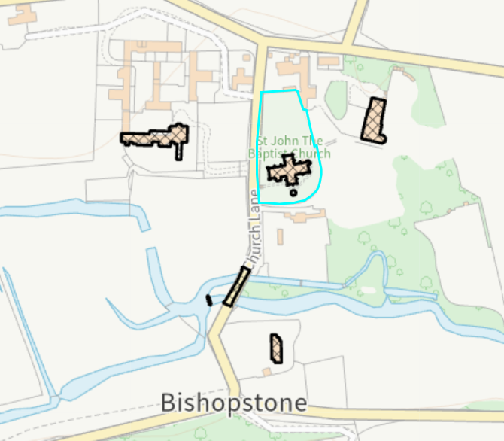

The site is not located within a conservation area but does lie within the Cranborne Chase and West Wiltshire Downs National Landscape. It is situated within the Hampshire River Avon Catchment and within the 13.8 kilometre recreational buffer of the New Forest Special Protection Area (SPA). However, these designations are not relevant to the assessment of this full planning application due to the nature of the proposed development concerned.

There are three public rights of way close to the application site, but none run through the site itself, these are marked with purple lines on the map extract below.

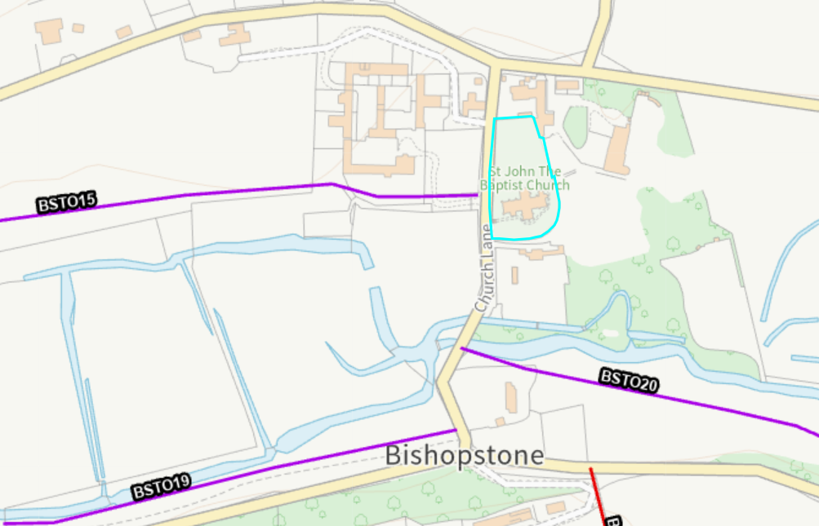

PROPOSAL

The application seeks planning permission to resurface and reinstate an existing footpath within the churchyard of St John the Baptist Church. The path is proposed be restored to its original width of approx. 1 metre due to its narrowing by encroaching vegetation, a wheelchair turning area is to be provided adjacent to the church entrance. The path would be resurfaced in a resin-bound gravel material.

Existing plan

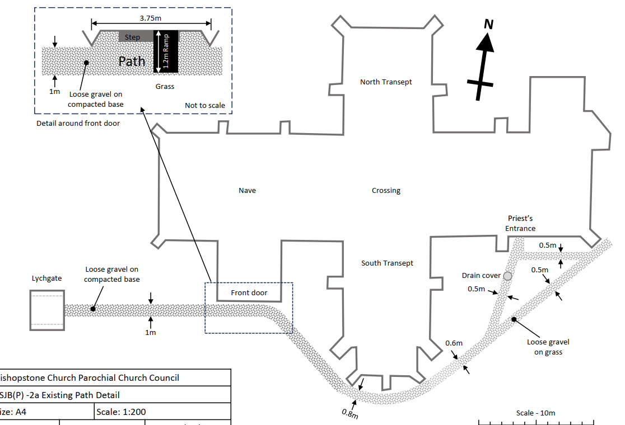

Proposed plan
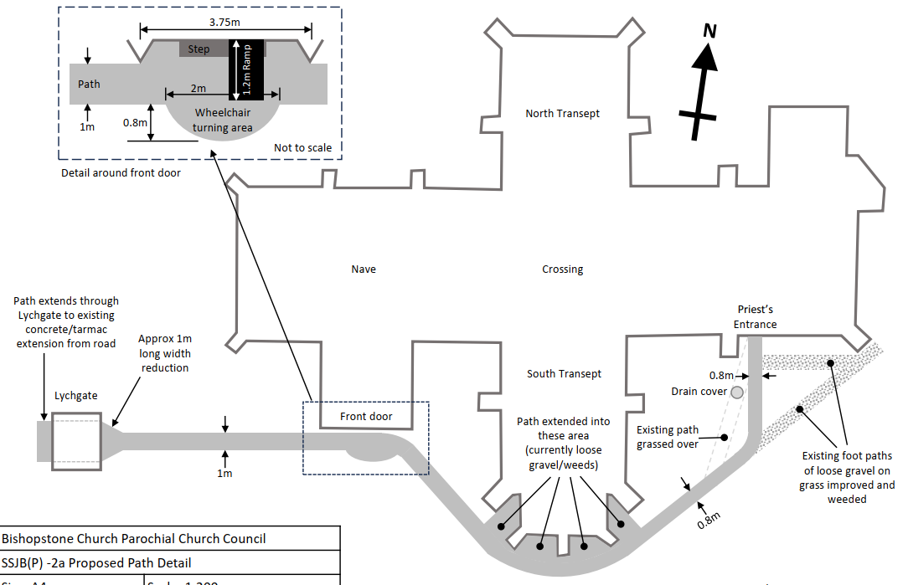

PLANNING HISTORY

Proposal / Summary
PL/2023/00432 - Full planning permission Decision - Approve with Conditions Date: 14/3/2023 – Installation of hand rails beside steps of entrance to church (Not attached to the Grade 1 listed building)
PL/2026/02830 - Full planning permission Decision - Approve with Conditions Date: 16/7/2026 – Replacement wooden shed which houses a camping toilet in the churchyard.

RELEVANT LEGISLATION, POLICIES AND GUIDANCE

S66 of the Planning (Listed Building and Conservation Areas) Act 1990

The National Planning Policy Framework (NPPF)
The Planning Practice Guidance
National Design Guide

The development plan for Wiltshire comprises the Wiltshire Core Strategy (WCS) (adopted January 2015) and any made neighbourhood plans, which remains the principal statutory planning document guiding development across the county. In line with Section 38(6) of the Planning and Compulsory Purchase Act 2004, planning decisions must be made in accordance with the development plan unless material considerations indicate otherwise.

Though the development plan is considered as a whole, those parts deemed to be particularly relevant to this application are listed below:

Wiltshire Core Strategy:

- Core Policy 1: Settlement Strategy
- Core Policy 2: Delivery Strategy
- Core Policy 33: Spatial Strategy for the Wilton Community Area
- Core Policy 50: Biodiversity and Geodiversity
- Core Policy 51: Landscape
- Core Policy 57: Ensuring High Quality Design and Place Shaping
- Core Policy 58: Conservation
- Core Policy 61: Transport and New Development
- Core Policy 64: Demand Management
- Core Policy 69: River Avon SAC

Wiltshire Design Guide: Appendix D – Design Guidance for Householder extensions
Creating Places Design Guide

Draft Wiltshire Local Plan
At Full Council on 19 May 2026, the elected members of Wiltshire Council agreed to withdraw the emerging Wiltshire Local Plan. The said Plan has no material weight for the purposes of the application.

In accordance with Regulation 19 of the Town and Country Planning (Local Planning) (England) Regulations 2026, on 30th June 2026 Wiltshire Council published a notice of intention to prepare a new local plan for Wiltshire. The next stage is a Scoping Consultation which commences on 2nd September 2026. This plan is at a very early stage and currently carries no weight for decision making.

CONSULTATION RESPONSES

Parish Council – None received

Archaeology - Although the proposed new path passes through a cemetery, the negligible level of groundwork required to lay the new surface means that it would be very unlikely for construction work to disturb any human remains. I would therefore not wish to burden this application with the costs of an unnecessary archaeological condition and therefore do not wish to raise any issues in this instance.

Highways - It is considered the proposal is not detrimental to highway safety and I raise no highway objection providing the following condition is imposed:
The proposed development shall not be first brought into use until means/works have been implemented to avoid surface water from entering the highway.
REASON: To ensure that the highway is not inundated with surface water.

Conservation - I have no objection in principle to the relaying of the path, however, I note they are proposing a bound gravel surface which can have a flat shiney and rather suburban appearance, whereas, I believe a bonded gravel path would have a more textured finish. When the NT was considering paths at Stourhead they opted for a bonded approach rather than bound. I believe the bonded may also be more water permeable.
I suspect this is an issue that the DAC (in granting a faculty) may comment upon. It might be worth checking with the PCC before reaching your decision if they have considered other options? If not, we might want to condition the choice of surfacing material?

Second set of comments following the submission of further information from the applicant.

Apparently bonded resin is not porous as I mistakenly thought. I would defer to the DAC on the choice of surfacing material. I would suggest conditioning the final choice of surfacing once the PCC have their faculty.

Historic England - Proposals
The proposals are to resurface and widen an existing gravel path on the south side of St John the Baptist Church with a resin bound product to improve access to the church. The current gravelled path extends approximately 50 metres from the Lych Gate to the Priest’s Entrance into the Chancel. The proposed resin-bound path would follow the same route as the existing path except at the Priest’s Entrance where the route would be amended to avoid a drain sump cover.

The proposed path would be widened, removing overgrown grass, to a 1m width up to the South Transept and 0.8m width between the South Transept and Priest’s Entrance. A wheelchair turning area would be incorporated at the front door and the new path would extend into the areas between the buttresses of the South Transept.

Significance
St John the Baptist Church is listed Grade I and is therefore considered to be of exceptional historic and architectural interest. The church predominantly dates from the 14th century but incorporates 13th and 15th century fabric and was restored by notable 19th century architects with work by Pugin in 1836 and T.H. Wyatt in 1858. As noted in the submitted Heritage Statement, it is described as an important and large village church in the listing description.

Impact
While we support the proposal to provide a more accessible surface to the path, which currently has an uneven gravel surface, the proposed resin-bound gravel is not considered appropriate in the setting of the Grade I listed church. The resin bound gravel has a less natural, smooth appearance compared to unbound gravel that is not in keeping with the character of the church or its setting. It would therefore result in some harm to the setting of the church.

Position
We support the proposal to improve the accessibility and appearance of the path but for the reason outlined above we recommend that the proposed surface material is amended. An unbound surface such as self-binding gravel is preferred in heritage terms as it provides a more natural finish. It also provides a compact, stable, and accessible surface.

However, we understand that a bonded surface provides greater longevity and lower maintenance and if this is required we would support the use of a tar spray and chip surface. A tar spray and chip surface has a more traditional texture and rustic appearance than resin-bound gravel, is easier to repair that resin-bound or resin-bonded gravel as it does not require specialist contractors. It is also preferable from a sustainability perspective as it does not contain plastic/resin.

Recommendation
Historic England advises that your Council should seek an amendment to the proposed path surface material, for the reasons explained above, in order to remove potential harm to the setting of the Grade I listed church.

Should the proposals remain unchanged, it will be for your Council to assess whether the harm to the significance of St John the Baptist Church would be outweighed by public benefits secured by the development. In doing so, it should give substantial weight to the conservation of this designated heritage asset.

No further comments were received from Historic England following re-consultation after the receipt of further information from the applicant regards the choice of proposed surface material for the path.

REPRESENTATIONS

None received

ASSESSMENT

Section 38(6) of the Planning and Compulsory Purchase Act 2004 states:

"If regard is to be had to the development plan for the purposes of any determination to be made under the planning Acts, the determination must be made in accordance with the plan unless material considerations indicate otherwise."

In accordance with this statutory requirement, this application has been assessed against the relevant policies of the Development Plan, including the adopted Wiltshire Core Strategy (2015) and, where applicable, any made Neighbourhood Plans.

Design and Impact upon the upon the character and context of the area, National Landscape and setting of adjacent listed buildings.

Section 66 of the Planning (Listed Buildings and Conservation Areas) Act 1990 requires special regard to be given to the desirability of preserving listed buildings, their settings and any features of special architectural or historic interest which they possess. Core Policies 51, 57 and 58 of the Wiltshire Core Strategy and Policies DP1-DP4, N2, N4 and HE4-HE10 of the NPPF similarly seek to ensure that development responds positively to local character, conserves heritage assets and their settings and protects landscape character.

The application seeks to resurface an existing footpath within the churchyard of the Gade I listed church. The works do not introduce a new route but instead reinstate and improve an existing path which has long formed part of the setting and function of the church. The alignment of the path would remain substantially unchanged, with only minor alterations proposed near the Priest's Door to provide a wheel chair turning area. The proposal would also restore the path to its historic width where it has become narrowed through vegetation encroachment.

Given the limited scale of the proposal, its location within the existing churchyard and the fact that the works are confined to an established path alignment, the development would have no material impact upon the wider landscape character or special qualities of the National Landscape.

In heritage terms, Historic England and the Council's Conservation Officer acknowledge the benefits of resurfacing the path but express a preference for alternative surfacing materials on the basis that resin-bound gravel may appear less traditional within the setting of the Grade I listed church. Historic England considers that the proposal would result in some harm to the setting of the listed building, whilst accepting that this harm must be weighed against any public benefits arising from the scheme. The Conservation Officer raises no objection in principle and subsequently advises that they would defer to the Diocesan Advisory Committee regarding the final choice of surfacing material.

Officers have carefully considered these comments alongside the additional information submitted by the applicant. The applicant has provided a detailed assessment of alternative surfacing options and explains that resin-bound gravel was selected following extensive research due to its durability, permeability, limited maintenance requirements and ability to provide a firm, level and inclusive surface for wheelchair users and those with mobility impairments. The evidence submitted demonstrates that the proposal would significantly improve accessibility to the church and support the wider objectives of increasing community access to this important heritage asset.

Whilst officers acknowledge that the proposed surfacing may appear different from a traditional loose gravel path, the visual changes would be limited. The path would continue to follow the existing alignment, would be of a colour comparable to the existing gravel surface and would remain a relatively modest feature within the wider churchyard setting. Having regard to the nature, scale and appearance of the proposals, any harm to the significance or setting of the Grade I listed church would be at the very lower end of the less-than-substantial harm scale.

In accordance with national policy, this limited harm must be weighed against the public benefits of the proposal. Officers attach significant weight to the enhanced accessibility of the church, particularly for wheelchair users and those with limited mobility, together with the long-term maintenance, durability and usability benefits associated with the replacement path. These public benefits would support wider community access to and enjoyment of an important heritage asset and are considered to outweigh the limited heritage harm identified.

Officers have considered whether it would be appropriate to impose a condition requiring the final surfacing material to be agreed through a separate process. However, the application has been submitted and assessed on the basis of a specific surfacing material, and it is necessary for the Local Planning Authority to determine the acceptability of that material as part of the application before it. The Local Planning Authority is therefore satisfied that the proposed resin-bound gravel surface is acceptable in planning terms, and it would neither be reasonable nor necessary to defer that planning judgement to a third party.

Accordingly, the proposal would preserve the significance of the Grade I listed church and would result in less than substantial harm to its setting which is outweighed by the identified public benefits. The development is therefore considered to comply with Sections 66 of the Planning (Listed Buildings and Conservation Areas) Act 1990, Core Policies 51, 57 and 58 of the Wiltshire Core Strategy and the relevant provisions of the NPPF.

Amenity

Core Policy 57 (Point vii) of the Wiltshire Core Strategy requires development to respect the amenity of existing occupants and ensure appropriate amenity levels for future residents.

Policy P3 of the NPPF requires development to be appropriate for its location, taking account of its likely effects on health, living conditions and the environment. In particular, Policy P3(2)(b) requires development to avoid giving rise to unacceptable impacts on the living conditions of neighbouring residents and occupiers. In assessing amenity impacts, regard should be had to matters including daylight and sunlight, outlook, privacy, overbearing impacts and other effects on residential amenity.

These policies guide the assessment of amenity impacts. Each of the below matters has been assessed having regard to the specific site context and layout of the proposal.

Given the nature of the proposals to resurface and reinstate an existing path around the Church, there are no neighbour amenity concerns raised.

Highways Impacts

Policies TR3-TR8 of the NPPF seek to ensure that development is supported by safe, suitable and sustainable transport arrangements. Development should provide appropriate access, promote sustainable travel choices where possible and avoid unacceptable impacts on highway safety and the operation of the transport network.

Core Policies 60-64 of the Wiltshire Core Strategy require development to provide safe access, promote sustainable transport, minimise transport impacts and provide appropriate parking arrangements.

The proposal relates to the resurfacing and reinstatement of an existing pedestrian path and would not alter the existing vehicular access arrangements serving the site. The development would improve pedestrian accessibility within the churchyard and raises no highway safety concerns. The proposal is therefore acceptable from a highways perspective subject to a condition relating to the means of avoiding surface water entering the highway.

Ecology Impact

Core Policy 50 of the Wiltshire Core Strategy seeks to protect and enhance biodiversity and geodiversity, including through ensuring that development avoids harm to protected species and habitats.

The development relates to resurfacing works within an existing path corridor and would not result in the loss of habitat or impact upon protected species. Having regard to the nature and scale of the proposal, the development is not considered likely to adversely affect biodiversity interests and complies with Core Policy 50 of the Wiltshire Core Strategy.

The application site falls within the catchment of the River Avon SAC and the 13.8km Zone of Influence for the New Forest international designated sites, comprising the New Forest SPA, SAC and Ramsar site. The proposal must therefore be considered under the Conservation of Habitats and Species Regulations 2017 (as amended) in respect of potential impacts arising from nutrient loading and recreational pressure. However, the development would not result in any net increase in residential units or overnight accommodation and, consequently, there is no mechanism by which it could create additional wastewater discharges or increased recreational pressure on these designated sites. The proposal is therefore not likely to have a significant effect on the integrity of the River Avon SAC, New Forest SPA, New Forest SAC or New Forest Ramsar site, either alone or in combination with other plans or projects.

Biodiversity Net Gain (BNG) became mandatory from 12 February 2024 under Schedule 7A of the Town and Country Planning Act 1990. The proposal relates to the replacement of an existing shed within the same location and footprint area and falls within the exemptions from the mandatory BNG requirement. Consequently, no Biodiversity Gain Plan is required.

PLANNING BALANCE AND CONCLUSION

The proposal would reinstate and resurface an existing path within the churchyard of the Grade I listed church, delivering significant accessibility and inclusivity benefits for visitors, including those with mobility impairments. Whilst the proposal would result in a limited degree of harm to the setting and significance of the heritage asset, officers are satisfied that such harm would not be significant and would be outweighed by the public benefits of the scheme.

Having regard to the advice received from consultees, the additional supporting information submitted by the applicant and the requirements of the development plan and the NPPF, the proposal is considered acceptable and approval is therefore recommended.

RECOMMENDATION: That Planning Permission be GRANTED, subject to conditions

1. The development hereby permitted shall be begun before the expiration of three years from the date of this permission.

REASON: To comply with the provisions of Section 91 of the Town and Country Planning Act 1990 as amended by the Planning and Compulsory Purchase Act 2004.

2. The development hereby permitted shall be carried out in accordance with the following approved plans:

Application form received 03/08/2026
Location plan Ref: SJB(P)1 received 03/08/2026
Site plan Ref: Ref: SJB(P) 2 received 03/08/2026
Proposed Path Detail Ref: SSJB(P) -2a Drwg No. BC002 received 18/08/2026

REASON: For the avoidance of doubt and in the interests of proper planning.

3. The proposed development shall not be first brought into use until means/works have been implemented to avoid surface water from entering the highway.
REASON: To ensure that the highway is not inundated with surface water.

4. Materials to be used in the development hereby permitted shall be as stated on the application form.

REASON: In the interests of visual amenity and the character and appearance of the area and setting of the listed building.

INFORMATIVES

1. BNG not required

The effect of paragraph 13 of Schedule 7A to the Town and Country Planning Act 1990 is that planning permission granted for development of land in England is deemed to have been granted subject to the condition (biodiversity gain condition) that development may not begin unless:

(a) a Biodiversity Gain Plan has been submitted to the planning authority, and
(b) the planning authority has approved the plan.

The planning authority, for the purposes of determining whether to approve a Biodiversity Gain Plan, if one is required in respect of this permission would be Wiltshire Council.

There are statutory exemptions and transitional arrangements which mean that the biodiversity gain condition does not always apply. For further information on exempt developments please refer to:
https://www.gov.uk/guidance/biodiversity-net-gain-exempt-developments
Based on the information available this permission is considered to be one which will not require the approval of a biodiversity gain plan before development is begun because one or more of the statutory exemptions or transitional arrangements is considered to apply.

2. The applicant should note that any alterations to the approved plans and/or proposed surface material for the works to reinstate and resurface the path may require further consent and must first be agreed in writing with the Local Planning Authority before commencement of work.

