APPLICATION FOR FULL-PLANNING PERMISSION
CASE OFFICER REPORT

APPLICATION REFERENCE: | PL/2026/02932
APPLICATION TYPE: | Full planning permission
SITE ADDRESS: | Garden land of 144 St Ediths Marsh, Bromham, Chippenham, SN15 2DG
DEVELOPMENT DESCRIPTION: | Construction of a new 4 bedroom dwelling, garage, access, parking and landscaping
RECOMMENDATION: | Approve with Conditions

SITE DESCRIPTION/CONTEXT

The application site is located in a hamlet along St Ediths Marsh, typified by existing dwellings

clustered together and a short distance from Bromham, which is classified as a ‘Large Village’.

The location falls within the Devizes Community Area.

The existing plot of land within which No. 144 is located is of a very generous size. The land is generally level and is bound by hedgerow, fencing and a boundary stone wall. Access into the site is located along a single track lane / access track that serves a number of properties, this exits onto the A342 to the north.

The access from the main road is a private unadopted road, to which parts of it are in a poor state of repair, although the rest is laid to tarmac.

The site is subject to the following constraints:

- The site lies within an area of ground water flood risk where ground water is modelled to be between 0.025 and 0.5m of the surface.
- Public rights of way BROM23 runs to the rear of the application site.
- Bath and Bradford-on-Avon Bats Special Area for Conservation (SAC).

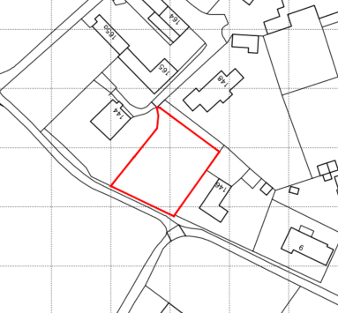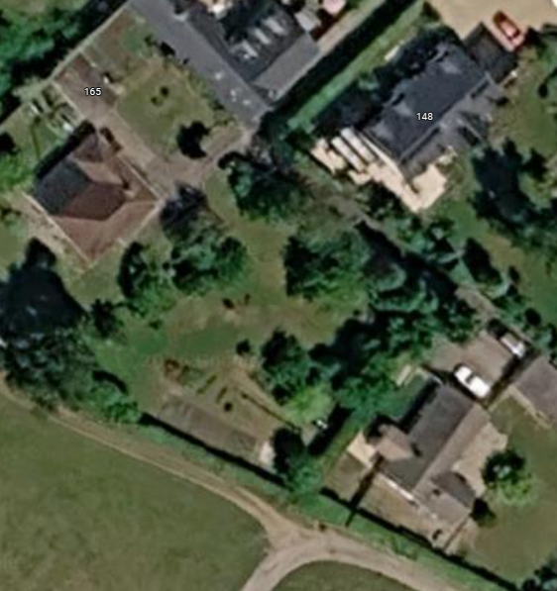

Site Location Plan and Aerial image of the site

PROPOSAL

The proposal is to construct a detached two storey 4 bedroom dwelling comprising of a main dwelling and a detached garage with a first-floor office room above. The dwelling would be finished with red multi-stock facing bricks, vertical timber cladding and dark grey standing seam metal cladding; under a charcoal smooth concrete tiled roof.

The building takes on a modern and contemporary design approach as shown in the elevation plans below. The blue outline shows the outline of the extant planning permission from applications PL/2022/04974 and PL/2024/07964 – which expire on 28 March 2027.

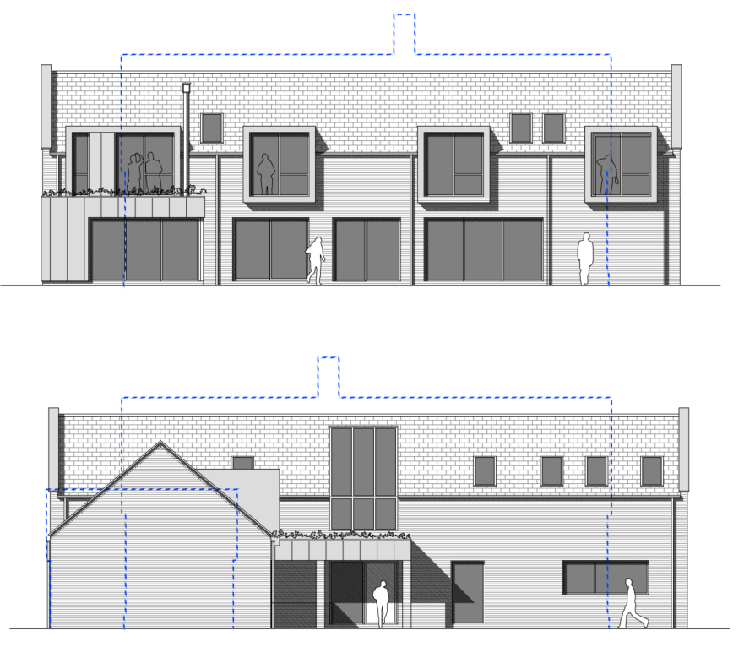

Proposed Front and Rear Elevations

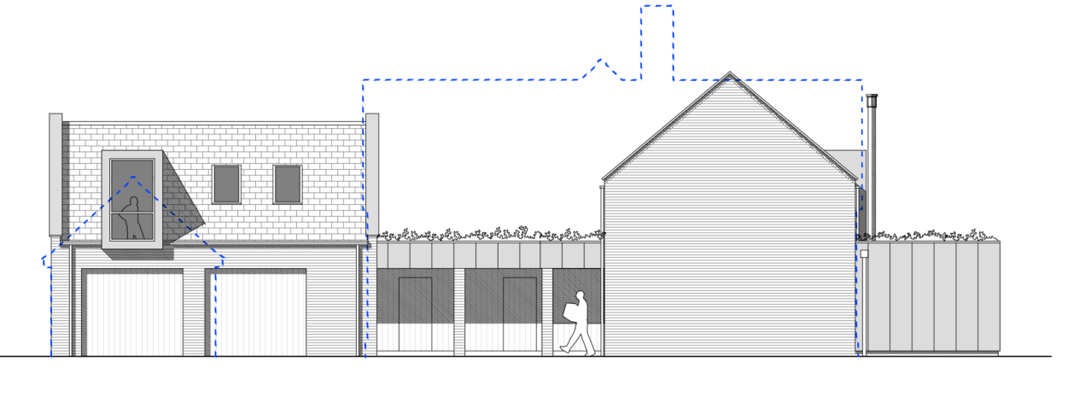

Proposed South East Side Elevation (as you arrive into site)

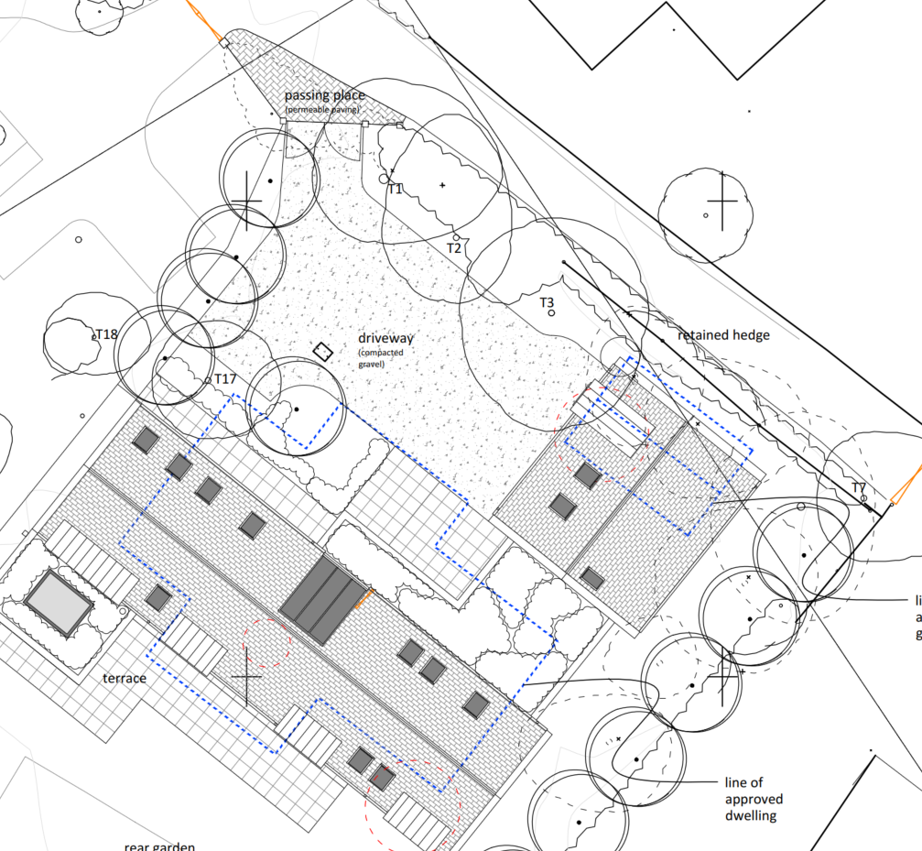

Proposed Site Plan

In support of the application the following documents have been submitted:

- Construction Management Plan

- (updated) drainage Strategy Plan

- Proposed Ecology Enhancement Plan

- Preliminary Ecology Assessment

- Tree Survey and Arboricultural Impact Assessment

- Design and Access Statement

For the avoidance of doubt, this application was originally submitted as a self-build dwelling and was recommended for approval subject to the completion of a legal agreement securing the development as self-build. This was necessary both because the self-build nature of the proposal was a material consideration weighing in favour of the development and to ensure that the biodiversity net gain (BNG) exemption relied upon could not subsequently be circumvented. Under the BNG regulations applicable at that time, self-build development benefited from an exemption from the mandatory 10% BNG requirement.

During the preparation of the legal agreement, it became apparent that the site plan intended to be appended to the agreement did not accurately reflect the application site and that amendments to the red line boundary were required. As a consequence, the application was re-started and re-consulted on 10 September 2026 to enable the corrected site boundary to be considered. At around the same time, changes to the biodiversity net gain (BNG) exemptions had come into effect on 6 August 2026. These changes introduced an exemption for developments on sites of 0.2 hectares or less, provided they do not impact priority habitat. The application site measures approximately 0.13 hectares and the Council's Ecologist has confirmed that no priority habitat is present. Accordingly, the proposed development benefits from this exemption irrespective of whether it is delivered as self-build development.

Following the re-start of the application, the applicants amended the application form and supporting Planning Statement to remove references to self-build development. Consequently, the proposal is now being considered as an open market dwelling, with the self-build status no longer forming part of the development proposal.

PLANNING HISTORY

Proposal / Summary
K/10522 - Full planning permission Decision - Refused Date: 4/6/1987 – ERECTION OF A SINGLE DWELLING AND GARAGE
K/13700/O - Outline Planning Decision - Refused Date: 11/4/1989 – ERECTION OF ONE BUNGALOW.
PL/2022/04974 - Outline planning permission: Some matters reserved Decision - Approve with Conditions Date: 17/8/2022 – Proposed dwelling and detached garage (Outline application relating to access only)
PL/2024/07964 - Approval of reserved matters Decision - Approve with Conditions Date: 28/3/2025 – Proposed dwelling and detached garage (Reserved matters application pursuant of Outline Consent PL/2022/04974 for approval of detailed design of consented dwelling and garage, including the site layout and boundary treatment)

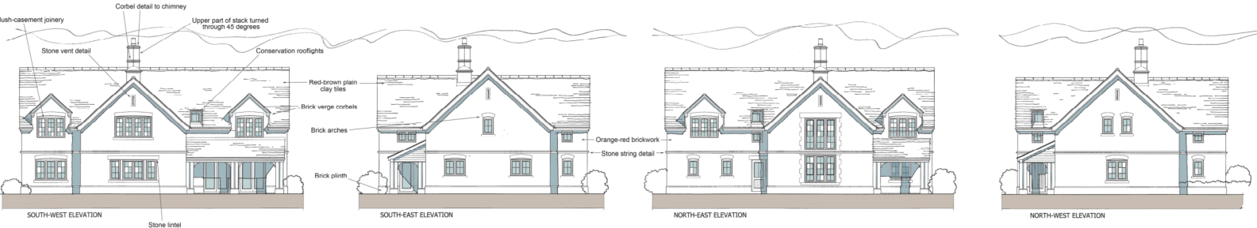

Approved and extant elevations of PL/2024/07964

It should be noted that the outline permission included two specific conditions relating to a construction method statement and archaeological investigation. The archaeological investigation was carried out and submitted as part of the reserved matters application PL/2024/07964. Wiltshire Council’s Archaeology Officer commented:

“This site has been subject to an archaeological trial trench evaluation that recorded no archaeological features or deposits. As a result of this assessment there are no further archaeological issues that I would wish to raise in regard to this application.”

Therefore, no archaeology information has been submitted in support of this application.

Since the outline permission was granted (which established the principle of development for the site) the NPPF has changed with the notable change being that all sources of flood risk (including groundwater) had to be taken into account. All of the above issues will be addressed in the following sections of this report.

RELEVANT LEGISLATION, POLICIES AND GUIDANCE

Statutory Legislation:

The Town and Country Planning Act 1990
National Planning Policy:

- National Planning Policy Framework 2026 - (NPPF)
- Planning Practice Guidance (PPG)
Development Plan:

The development plan for Wiltshire comprises the Wiltshire Core Strategy (WCS) (adopted January 2015) and any made neighbourhood plans, which remains the principal statutory planning document guiding development across the county. In line with Section 38(6) of the Planning and Compulsory Purchase Act 2004, planning decisions must be made in accordance with the development plan unless material considerations indicate otherwise.

Though the development plan is considered as a whole, those parts deemed to be particularly relevant to this application are listed below:

The adopted Wiltshire Core Strategy (WCS), with particular regard to:

- Core Policy 1 Settlement Strategy;
- Core Policy 2 Delivery Strategy;
- Core Policy 12 Spatial Strategy Devizes Community Area;
- Core Policy 45 Meeting Wiltshire’s Housing Needs;
- Core Policy 50 Biodiversity and Geodiversity;
- Core Policy 51 Landscape;
- Core Policy 57 Ensuring High Quality Design and Place Shaping;
- Core Policy 61 Transport & Development;
- Core Policy 64 Demand Management;
- Core Policy 67 Flood Risk.

New Wiltshire Local Plan

At Full Council on 19 May 2026, the elected members of Wiltshire Council agreed to withdraw the emerging Wiltshire Local Plan. The said Plan has no material weight for the purposes of the application.

In accordance with Regulation 19 of the Town and Country Planning (Local Planning) (England) Regulations 2026, on 30th June 2026 Wiltshire Council published a notice of intention to prepare a new local plan for Wiltshire. The next stage is a Scoping Consultation which commences on 2nd September 2026. This plan is at a very early stage and currently carries no weight for decision making.

Neighbourhood Plan:

Bromham became a designated area in 2018 but has not progressed to referendum stage.

Wiltshire Council Briefing Note: No 26-07 – dated 5 June 2026
Wiltshire Council’s updated five-year housing land supply position is a 2.8 years supply.
Supplementary Planning Documents and other Guidance:

- Wiltshire Design Guide (adopted April 2024)
- Wiltshire Local Transport Plan 2011-2026, adopted 2015 - including the Car Parking Strategy and Cycling Strategy, adopted 2015
- Wiltshire Council Strategic Flood Risk Assessments 2019 and 2024
- Wiltshire Housing Land Supply Statement (June 2026) – base date April 2025

ISSUES

The main issues that need to be addressed in this case include:

- Whether the proposal constitutes EIA development
- Whether the development is acceptable in principle (CP 1 and 2)
- Whether the scheme constitutes high quality design (CP 57)
- Whether the scheme would have an acceptable impact upon the reasonable living conditions of the adjoining occupants (CP 57)
- Whether the proposal would have a negative effect upon highway safety, including if there is sufficient parking for the proposed development (CP 61 and 64)
- Whether the site can be adequately drained without increasing flood risk elsewhere (CP 67)
- Whether the proposal would have an unacceptable impact on biodiversity and ecology (CP 50)

CONSULTATION RESPONSES

Bromham Parish Council: No objection subject to robust drainage proposals as the area is already significantly affected by flooding.

Wiltshire Council Public Rights of Way Officer: No objection to the original proposal. No comments received in response to the re-consultation of the amended application.

Wiltshire Council Drainage Officer: No objection

Wiltshire Council Tree Officer: No objection

Wiltshire Council Highways Officer: No objection subject to conditions to the original proposal. No comments received in response to the re-consultation of the amended application.

Wiltshire Council Archaeology Officer: No objection

Wiltshire Council Ecology Officer: No objection subject to conditions. In the original consultation response, the Ecology Officer confirmed that the proposal would not adversely affect the Bath and Bradford-on-Avon Bats SAC, raised no objection in respect of protected species or habitats, and recommended ecological enhancement measures be secured by condition.

The amended proposal was re-consulted upon; however, no formal response had been received at the time of writing this report. Notwithstanding this, the Ecology Officer had prior confirmed by email (4 September 2026) that, following the biodiversity net gain (BNG) exemption changes which came into effect on 6 August 2026, the development would benefit from the exemption for sites smaller than 0.2 hectares where no priority habitat would be affected. The Ecology Officer further confirmed that, in those circumstances, there would be no need to secure self-build status for the purposes of BNG.

REPRESENTATIONS
In accordance with the requirements of the Town and Country Planning (Development Management Procedure) (England) Order 2015 (as amended), the application was publicised by way of:

- 4 Neighbour notification letters sent to adjoining and nearby properties;
- Press Advert dated 4 June 2026 with expiry date of 25 June 2026 and;
- A site notice displayed near the site

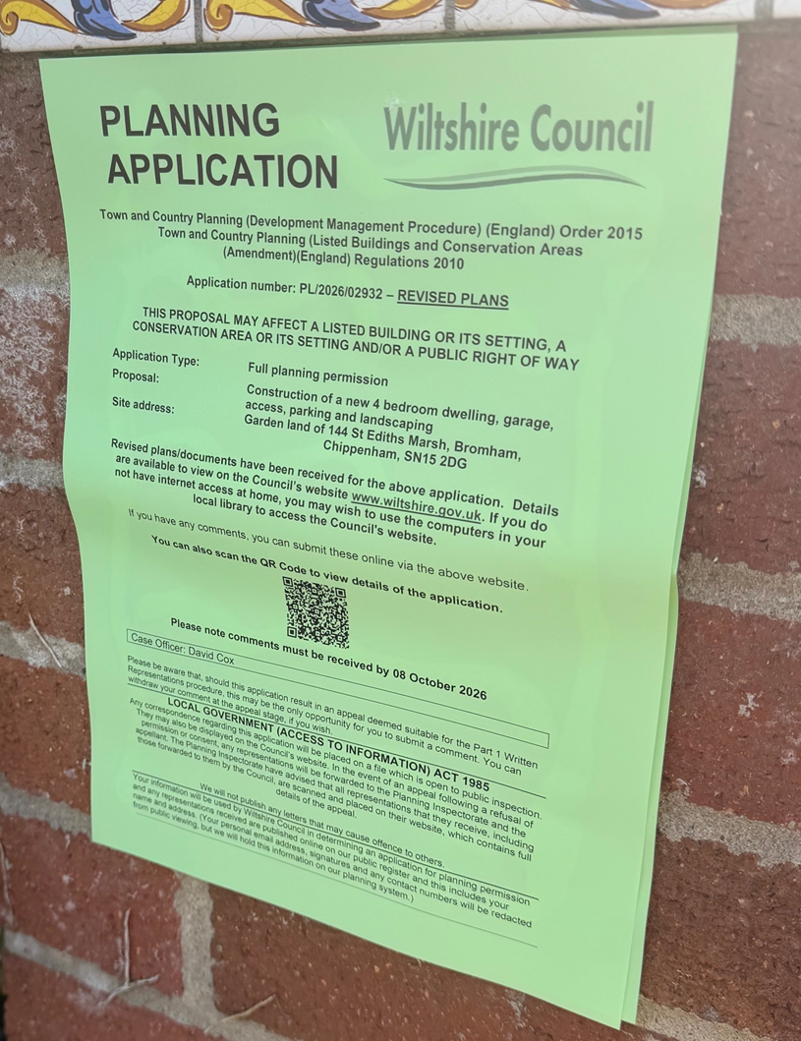

These methods were used to inform interested parties and provide a period of 21 days for comments to be submitted.

No comments were received.

ASSESSMENT
Section 38(6) of the Planning and Compulsory Purchase Act 2004 states:

"If regard is to be had to the development plan for the purposes of any determination to be made under the planning Acts, the determination must be made in accordance with the plan unless material considerations indicate otherwise."

In accordance with this statutory requirement, this application has been assessed against the relevant policies of the Development Plan, including the Wiltshire Core Strategy (2015) and, where applicable, any made Neighbourhood Plans. Consideration has also been given to the policies of the National Planning Policy Framework (NPPF) as a material consideration in the assessment.

Environmental Impact Assessment (EIA) Screening
In accordance with the Town and Country Planning (Environmental Impact Assessment) Regulations 2017 (as amended), the local planning authority has considered whether the proposed development constitutes EIA development.

No formal EIA screening opinion has been requested or issued. However, having regard to the nature, scale and location of the proposal, which is for a single dwelling and associated works, the Local Planning Authority is satisfied that the development does not constitute Schedule 1 or Schedule 2 EIA development for the purposes of the Town and Country Planning (Environmental Impact Assessment) Regulations 2017.

Principle of Development
Policy Context
Core Policies 1 and 2 of the Wiltshire Core Strategy establish the overarching spatial strategy for Wiltshire and provide the primary Development Plan framework for determining whether development is appropriately located. Together, these policies seek to direct growth towards the most sustainable locations whilst protecting the intrinsic character and beauty of the countryside. The strategy prioritises development within Principal Settlements, Market Towns, Local Service Centres and larger villages, whilst development in the countryside will only be supported where it accords with specific development plan policies or where material considerations indicate otherwise.

The NPPF also contains national policies relating to the location of development. Policies S3-S5 distinguish between development within settlements and development in the countryside, support sustainable patterns of growth, and require decisions to have regard to the role and function of settlements, accessibility to services and facilities, and other site-specific considerations.

The principle of development should be assessed having regard to the Development Plan as a whole, the NPPF and all other material considerations. The weight afforded to individual policies will depend upon the nature, scale and location of the development proposed.
Policy HO7 of the NPPF recognises the importance of delivering homes which contribute towards meeting the evidenced accommodation needs of the community and states that substantial weight should be given to the benefits of providing such homes.

Planning History:
The extant outline permission and reserved matters approval are highly material considerations and establish a realistic fallback position comprising a dwelling and detached garage on the site. Whilst the current application must be assessed on its own merits against current planning policy and other material considerations, significant weight is afforded to the fallback position as development remains capable of lawful commencement until 28 March 2027.

The delegated report for the outline application PL/2022/04974 stated:

“The site is located within what is construed as countryside outside of the limits of development, although it is located within the built form of St Edith’s Marsh, a hamlet of a cluster of dwellings within the Devizes community area nearby to the village of Bromham. The proposed scheme is for the provision of a singular dwelling. The proposal does not meet the requirements of any of the exceptions policies as laid out in the development plan.

The site is not within what is construed as a sustainable location with most journeys requiring to be made by private motor vehicle. The spatial strategy of the development plan does not support this type of development within this location. However, the Council is unable to demonstrate a 5-year housing land supply for the area and the policies pertaining to developing housing are therefore considered out of date and paragraph 11 of the NPPF kicks in. This does not mean that the policies of the development plan are silent, but just that they carry less weight in the planning balance.

The Council’s most recently published Housing Land Supply Statement identifies a 4.72 year
deliverable housing land supply.

The NPPF is thus clear that permission should be granted unless the adverse impacts of the
development significantly and demonstrably outweigh the benefits of the development. This
advice is a material consideration to be weighed alongside the policies of the development plan.

It is considered that the scheme would infill a gap within the cluster of dwellings within this location, and its overall character and appearance in this instance can be designed under the reserved matters stage to sit well within this location respecting the existing built form. The proposal neither elongates the village or imposes development within a sensitive landscape and does not consolidate an existing sporadic loose knit area of development. The scheme is
considered to be a sympathetic addition within this location without causing visual harm on the character of the area.

The erection of one additional residential unit would make a minor contribution to local housing, with associated economic benefits during the construction phase and potentially through CIL contributions and thereafter in supporting the occupation of the dwellings. The additional dwelling would make a more efficient use of the land and contained within the overall envelope of St Edith’s Marsh.

Weighing the particular circumstances of this site and the factors above it is concluded on balance that the circumstances are sufficient to warrant approval of the development as there are no adverse impacts that significantly and demonstrably outweigh the benefits in this case.”
Assessment
The application site lies outside the defined settlement boundary of Bromham (the closest large village) and is not allocated for residential development within the Development Plan, nor does it comply with any of the exception policies listed at paragraph 4.25 of said plan. The proposal therefore conflicts with the spatial strategy set out in Core Policies 1 and 2 of the Wiltshire Core Strategy.

Policy S5 of the NPPF is therefore relevant.

The first question is whether the proposal falls within one of the categories of development identified by Policy S5(1) as potentially acceptable outside settlements.

It is considered that the proposal falls within qualifying category at Policy S5(1) (e).

e. Limited infilling within groups of houses;

The fundamental question is whether the proposal genuinely satisfies the requirements of the relevant Policy S5 category and is therefore capable of being supported in principle outside a defined settlement.

The application site forms an undeveloped gap within an established group of existing dwellings. Whilst the site lies outside any defined settlement boundary and is therefore regarded as open countryside for the purposes of the Development Plan, it is not isolated in character and is physically contained within a cluster of residential properties. The proposed dwelling would occupy a parcel of land that is closely related to the existing pattern of development and would not extend the group of houses into the surrounding countryside.

The proposal is therefore considered to constitute limited infilling within a group of houses for the purposes of Policy S5(1)(e) of the NPPF. As such, the development falls within one of the forms of development identified by Policy S5 as potentially acceptable outside settlements.

Accordingly, whilst the proposal conflicts with the Development Plan, Policy S5 indicates that development of this nature may be acceptable in principle outside settlements.

Having regard to the above, the proposal is considered to comply with the requirements of Policy S5(1) e of the NPPF and is therefore acceptable in principle.

Conclusion
The proposal conflicts with the Development Plan when read as a whole. However, the proposal falls within Policy S5(1) e. of the NPPF and is therefore capable of being supported in principle outside a defined settlement.

The proposal must nevertheless be assessed against all other relevant Development Plan policies, national policy and material considerations.

Whether the benefits of the proposal are substantially outweighed by any adverse effects, having regard to the requirements of Policy S5, is considered within the planning balance section of this report.

5 Year Housing Land Supply

The Council's latest Housing Land Supply Statement (June 2026) provides the most up-to-date position regarding the availability of deliverable housing land within Wiltshire and is a material consideration in the determination of planning applications.

The NPPF requires local planning authorities to identify and maintain a supply of specific deliverable housing sites. Housing need, housing requirements, and the supply of deliverable sites are addressed through Policies HO1 to HO6 (for plan-making) and HO7 to HO13 (for decision taking) and Annex D of the NPPF. Annex D sets out the methodology for calculating housing need, assessing land supply, the application of housing land supply buffers using the latest Housing Delivery Test results, and establishing a five-year supply of deliverable housing sites.

The Council's current housing land supply position demonstrates a supply of 2.8 years of deliverable housing land against the relevant housing requirement. This position is a material consideration when assessing proposals for residential development. Where a shortfall exists, this indicates that the Council is unable to demonstrate a full five-year supply of deliverable housing sites and this is capable of attracting significant weight in favour of proposals which would contribute towards meeting identified housing needs. Conversely, where a five-year supply can be demonstrated, this is also a material consideration to be afforded appropriate weight in the overall planning balance. In this regard, it is noted that the extant planning permission for development of the site was granted at a time when the Council could demonstrate a housing land supply of approximately 4.72 years. The Council's current housing land supply position is 2.8 years and this is a material consideration which increases the weight to be afforded to the delivery of additional housing.

In determining this application, regard has been had to the Council's current housing land supply position, the relevant housing policies of the development plan, the housing objectives of the NPPF, and all other material considerations. The extent to which the Council's housing land supply position affects the weight to be afforded to housing delivery and other material considerations has been considered as part of the planning balance set out below.

The contribution that this proposal would make towards meeting housing needs, together with any other benefits and harms arising from the development, is assessed within the overall planning balance and conclusion sections of this report.

Design and Impact on the Character and Appearance of the Area
Policy Context
Core Policy 57 of the Wiltshire Core Strategy requires development to achieve a high standard of design that responds positively to local character, context and distinctiveness.

Policies DP1-DP4 of the NPPF seek to ensure that development is well-designed, visually attractive, sustainable and responsive to its surroundings. Development should contribute positively to local character, create high quality places and support healthy and inclusive communities.

The Wiltshire Design Guide provides further guidance on achieving high quality, context-led design and should be taken into account where relevant.

Assessment
The current application adopts a markedly different architectural approach to the extant permission. The approved scheme proposed a substantial two-storey dwelling of a more traditional appearance, with part of the first floor accommodated within the roof space, incorporating dormer windows and prominent projecting gable features on both the front and rear elevations.

In contrast, the revised proposal adopts a contemporary design approach, utilising a palette of three complementary materials. The front elevation is intentionally simple in its composition, incorporating a limited number of openings and avoiding excessive architectural detailing. A prominent porch canopy provides visual interest and creates a strong connection between the dwelling and the detached garage. To the rear, large first-floor bay windows introduce a more contemporary element and enhance the building's relationship with the garden and surrounding landscape. The dwelling would also be positioned slightly further back within the site and adopts a simpler, more linear form overall, resulting in a clear and coherent architectural focus upon arrival at the property.

The submitted elevation plans include a blue outline illustrating the relationship between the approved and proposed schemes. Whilst the proposed dwelling would result in a modest increase in footprint, this is offset by a reduction in overall ridge height. Furthermore, the repositioning of the dwelling further into the plot creates greater separation and a stronger sense of openness between the main dwelling and the detached two-storey garage.

Although the design represents a significant departure from the approved scheme, officers raise no objection to the proposed appearance. The dwelling remains proportionate to the size of the plot and would continue to sit comfortably within its generous setting.

It is acknowledged that the contemporary design would contrast with the more traditional character of surrounding development and would be visible from the public right of way to the rear of the site. However, the dwelling would not be a prominent feature within the wider street scene, given the site's secluded position at the end of a long and winding cul-de-sac. The reduced ridge height would further assist in limiting the visual prominence of the building and help maintain the site's discreet presence within the locality.

Views of the dwelling from the public right of way would be relatively immediate; however, the site benefits from established hedgerows and mature vegetation which provide a strong landscape framework. Whilst the dwelling would inevitably be visible, the spacious nature of surrounding plots and the well-established boundary treatments characteristic of the area mean that the proposal would not result in any material harm to the character or appearance of the locality. On balance, it is considered that the development would integrate satisfactorily within its setting and would preserve the overall qualities of the surrounding townscape and landscape character.

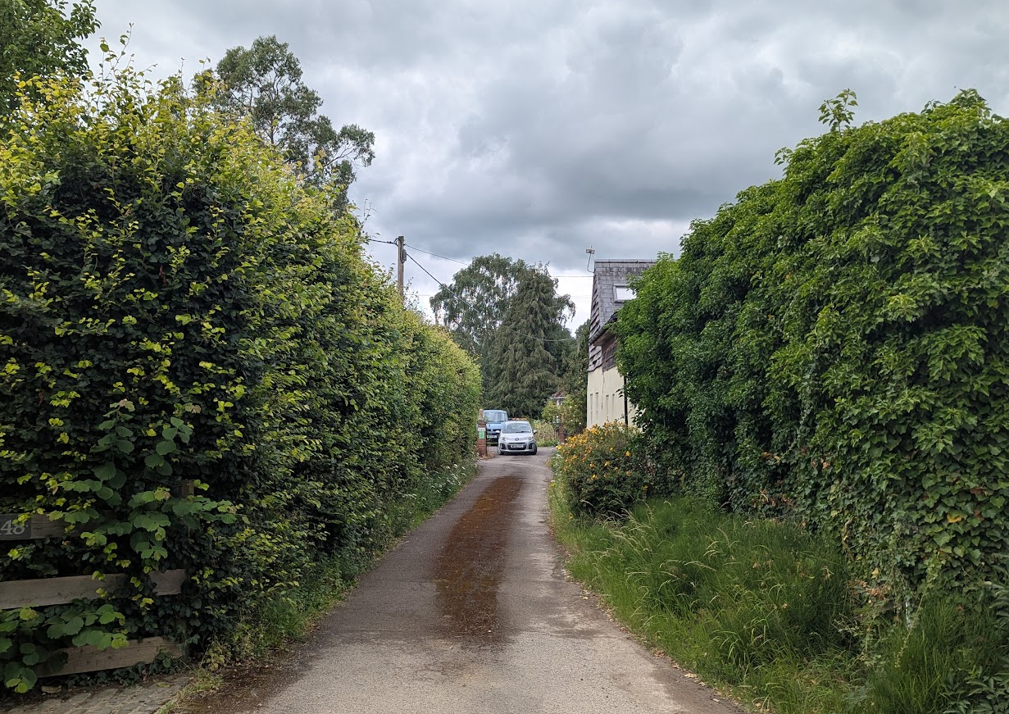

View from the entrance of No 148 looking straight to No 144’s driveway (application site slightly to the left)

Conclusion
On balance, the proposal represents a clear departure from the design approach established under the extant permission; however, the contemporary appearance, reduced ridge height and revised siting are considered to be acceptable in planning terms. The dwelling would remain proportionate to the generous plot, would not appear unduly prominent within the wider street scene, and would have a limited impact on views from the adjoining public right of way due to the site's established landscape setting. As such, the proposal is considered to integrate satisfactorily within its surroundings and would not result in harm to the character or appearance of the area. Consequently, the design and visual impacts of the development are considered acceptable.

Amenity
Policy Context
Core Policy 57 (Point vii) of the Wiltshire Core Strategy requires development to respect the amenity of existing occupants and ensure appropriate amenity levels for future residents.

Policy P3 of the NPPF requires development to be appropriate for its location, taking account of its likely effects on health, living conditions and the environment. In particular, Policy P3(2)(b) requires development to avoid giving rise to unacceptable impacts on the living conditions of neighbouring residents and occupiers. In assessing amenity impacts, regard should be had to matters including daylight and sunlight, outlook, privacy, overbearing impacts and other effects on residential amenity.

These policies guide the assessment of amenity impacts. Each of the below matters has been assessed having regard to the specific site context and layout of the proposal.

The proposal has three immediate neighbours No’s 144, 148 and 146 (to which no objections have been received).

The proposal would also provide a satisfactory standard of accommodation for future occupiers. The dwelling would benefit from adequate internal floorspace, good levels of outlook and natural light, a large private garden, dedicated parking provision and a detached ancillary garage building. Officers are therefore satisfied that the development would provide an appropriate living environment for future residents.

Overlooking
It is important to note that the extant permission included three large first-floor windows facing towards No. 148, positioned approximately 16 metres from the shared boundary. In addition, two side elevation windows faced No. 144 at a distance of only around 5 metres. By comparison, the current proposal increases the separation to No. 148 to approximately 19 metres and removes any bedroom windows facing in that direction. The revised internal layout and contemporary architectural approach ensure that all principal bedroom windows are orientated towards the open countryside to the rear of the site. Consequently, no side elevation windows would directly face either No. 144 or No. 146, representing a significant improvement over the extant permission.

The only potential source of overlooking relates to the detached two-storey garage building, which incorporates office accommodation at first-floor level, that would be served by two rooflights and a dormer window facing towards No. 144. These openings would be located approximately 16.3 metres from the boundary and around 27 metres from the neighbouring dwelling itself. Whilst labelled as an office, the first-floor accommodation is capable of functioning as habitable accommodation. The assessment has therefore considered the windows on the basis of their likely relationship with neighbouring properties irrespective of the room's label. Having regard primarily to the approximately 27-metre separation from the neighbouring dwelling and the orientation and nature of the openings, an acceptable level of privacy would be maintained for the occupiers of No. 144. The boundary fence and proposed landscaping would provide additional screening but are not essential to that conclusion.

The garage would also contain a single rooflight on its rear roof slope facing towards No. 146. Although the submitted cross-sections do not specifically identify this window, its position close to the ridge line indicates that it would be unlikely to afford direct views into the neighbouring property. Furthermore, it would serve a staircase rather than a habitable room and therefore would not provide a realistic opportunity for harmful overlooking to occur.

Overbearing/Overshadowing impacts
The proposed development would give rise to a level of bulk, massing and overshadowing broadly comparable to that established under the extant permission, albeit with some differences arising from the revised design approach. It is acknowledged that the enlarged footprint brings parts of the development closer to both No. 144 and No. 146 than previously approved.

In respect of No. 146, the overall impact is considered to be broadly similar to that of the extant scheme. While the footprint has increased, this is offset by the reduction in ridge height and the substantial separation created between the main dwelling and the detached garage. The development would remain approximately 5 metres from the shared boundary, which is also screened by an established conifer hedge of around 2 metres in height. As such, it is considered that the occupiers of No. 146 would continue to receive adequate levels of direct sunlight during the late afternoon and evening through the gap between the proposed buildings, while sunlight received during the morning and mid-afternoon would remain unaffected.

The effects on No. 144 are likely to be more noticeable. The proposal would result in an increased degree of overshadowing during the morning period, although the effect would diminish as the sun moves across the site during the course of the day. Having regard to the orientation of the buildings, separation distances and the fallback position represented by the extant permission, the additional overshadowing is not considered sufficient to justify refusal of planning permission.

Careful consideration has also been given to the potential for the development to appear overbearing when viewed from No. 144. The two-storey side elevation would be positioned approximately 1.4 metres from the shared boundary, compared with around 4 metres under the extant permission. The building would have an approximate ridge height of 7.75 metres, eaves height of 4.8 metres and a side elevation measuring roughly 6.9 metres in length. Whilst officers acknowledge that the development would have some adverse visual presence when viewed from No. 144, the degree of impact is not considered so significant as to warrant refusal of the application on amenity grounds.
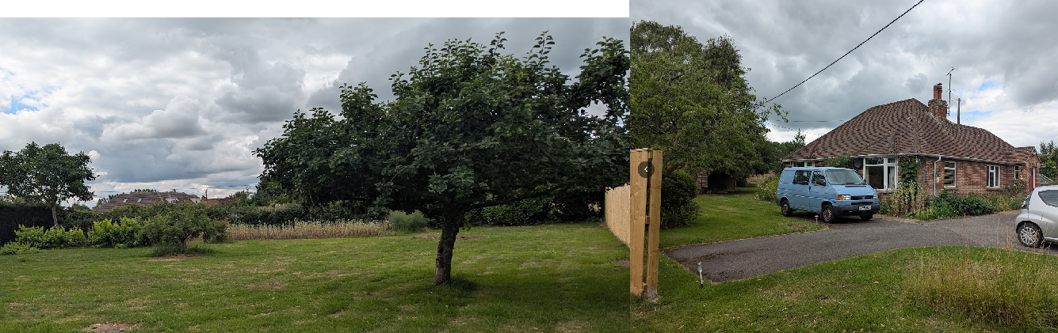

Application site (left) and No 144 (right)

Conclusion
Having regard to the above assessment, it is considered that the proposal would not give rise to any unacceptable impacts on the residential amenity of neighbouring occupiers. The revised design represents an improvement over the extant permission in terms of overlooking, with side-facing windows removed and principal habitable room windows directed away from neighbouring properties. While some increased overshadowing and a degree of additional visual prominence would be experienced by No. 144, these impacts are not considered to be so significant as to warrant refusal, particularly when viewed against the fallback position of the extant consent. Overall, the proposal is considered to provide an acceptable standard of amenity for both existing and future occupiers and is therefore compliant with Core Policy 57 of the Wiltshire Core Strategy and the relevant provisions of the NPPF.

Highways Impacts and Parking
Policy Context
Policies TR3-TR8 of the NPPF seek to ensure that development is supported by safe, suitable and sustainable transport arrangements. Development should provide appropriate access, promote sustainable travel choices where possible and avoid unacceptable impacts on highway safety and the operation of the transport network.

Core Policies 60-64 of the Wiltshire Core Strategy require development to provide safe access, promote sustainable transport, minimise transport impacts and provide appropriate parking arrangements.

Where relevant, regard should also be had to the Wiltshire Local Transport Plan, the Council's parking standards and any applicable Local Cycling and Walking Infrastructure Plans (LCWIPs).

Assessment
The proposal would utilise the existing access arrangement serving the site, as established under the extant permission. The access is via a private unadopted lane, parts of which are in a poor state of repair; however, the additional traffic associated with a single dwelling would be limited and the Highway Authority raises no objection. The submitted plans provide sufficient off-street parking and turning space for a four-bedroom dwelling, and the recommended conditions would secure parking provision, an EV charging point and compliance with the Construction Management Plan. On this basis, the development would not give rise to an unacceptable impact on highway safety or result in a severe residual cumulative impact on the road network.

Public right of way BROM23 runs to the rear of the application site. The proposal would not obstruct or divert the route. Views of the dwelling from the route would be possible, but for the reasons set out in the design assessment, those views would not result in material harm to the character or enjoyment of the route.

Ecology and Biodiversity
Policy Context
Core Policy 50 of the Wiltshire Core Strategy requires development to protect and, where appropriate, enhance biodiversity and geodiversity interests.

Policy N2 of the NPPF seeks to conserve and enhance biodiversity, support nature recovery, protect habitats and species, and strengthen ecological networks.

Where relevant, proposals should assess impacts upon protected species, habitats, ecological networks and green and blue infrastructure and demonstrate that any adverse impacts can be appropriately avoided, mitigated or compensated for.

Biodiversity Net Gain (BNG) is mandatory for most development and proposals should demonstrate compliance with the statutory requirements unless an exemption applies.

Assessment
The Council’s Ecology Officer has provided full detailed comments:

Bath and Bradford-on-Avon Bats Special Area for Conservation (SAC)
The site is located within a Lesser Horseshoe core roost buffer associated with the Bath and
Bradford-on-Avon SAC. The current proposal therefore has potential to result in significant
adverse impact on the special features of the Bath and Bradford-on-Avon SAC.

A test of likely significance has been carried out by the relevant Competent Authority (Wiltshire
Council) as required by Regulation 63 of the Conservation of Habitats and Species Regulations 2017 (as amended). This concluded that given the scale and nature of the currently proposed development which (i) involves no overall loss of a roost of a qualifying species, (ii) does not propose removal of any core bat habitat, and iii) does not propose any additional external lighting, there is no mechanism for adverse impact on the Conservation Objectives of the SAC, and the proposal can be screened out of Appropriate Assessment.

Protected species and habitats
The site comprises species-poor amenity grassland, maintained as short, with individual trees
and boundary hedgerow. The boundary trees and hedgerow will remain unimpacted, but the
works will result in the loss of grassland and some fruit trees.

The ecology report confirms that no potential bat roosting features will be lost, and that the site is of low value to bats in general. The site does not offer significant opportunities for reptiles or amphibians.

In line with NPPF and with CP50, applications that do not fall into the category where Biodiversity, Net Gain is required must still ensure that no net loss of functional habitat for the benefit of wildlife in the local area will occur as a result of the proposed development. In addition, gains for biodiversity, relevant to local habitats and wildlife populations, should form part of the proposed development. As such, ecological enhancements should be secured. An ecological enhancement plan has been submitted which includes the locations and specifications of new native trees, two sparrow terraces, two insect boxes, a hedgehog nest box and three bat boxes. These enhancements are welcomed and should be secured via a compliance condition.

Biodiversity Net Gain
Biodiversity Net Gain (BNG) became mandatory under Schedule 7A of the Town and Country Planning Act 1990 (as inserted by Schedule 14 of the Environment Act 2021).

The requirement to deliver a minimum 10% biodiversity net gain does not apply to this development. Amendments to the BNG exemptions which came into effect on 6 August 2026 introduced an exemption for developments on sites of 0.2 hectares or less, provided they do not impact priority habitat.

The application site measures approximately 0.13 hectares and the Council's Ecologist has confirmed that the site does not contain priority habitat. Accordingly, the proposal benefits from the small sites exemption and is not subject to the statutory biodiversity gain condition or the requirement to demonstrate a 10% biodiversity net gain.

Conclusion

Having considered the advice of the Council's Ecologist, the Local Planning Authority, acting as Competent Authority under the Conservation of Habitats and Species Regulations 2017 (as amended), concludes that the proposal would not be likely to have a significant effect on the Bath and Bradford-on-Avon Bats SAC either alone or in combination with other plans or projects. Appropriate Assessment is therefore not required.

The ecological enhancements shown on the submitted Ecology Enhancement Plan should be secured by condition, together with a condition requiring details of any external lighting to be submitted to and approved in writing by the Local Planning Authority prior to installation.

The proposal benefits from the statutory Biodiversity Net Gain exemption for developments on sites of 0.2 hectares or less which do not impact priority habitat. The application site measures approximately 0.13 hectares and the Council's Ecologist has confirmed that no priority habitat is present. Accordingly, the proposal is not subject to the statutory biodiversity gain condition or the requirement to demonstrate a minimum 10% biodiversity net gain.

Subject to the recommended conditions, the proposal is therefore considered to accord with Core Policy 50 of the Wiltshire Core Strategy and Policy N2 of the NPPF.

Flood Risk and Drainage
Policy Context
Core Policy 67 of the Wiltshire Core Strategy seeks to ensure that development is appropriately located and designed to avoid increasing flood risk on-site or elsewhere. Sustainable drainage measures should be incorporated where appropriate.

Policies F4-F8 of the NPPF require flood risk to be taken into account in planning decisions and seek to ensure that development is safe for its lifetime, does not increase flood risk elsewhere and incorporates appropriate drainage measures.

Assessment
The site lies within an area identified within the Council's Strategic Flood Risk Assessment as being susceptible to groundwater flooding, with groundwater modelled to be between 0.025m and 0.5m below ground level. As such, careful consideration has been given to the proposed drainage strategy and the potential implications of seasonal groundwater fluctuations.

During the course of the application the Local Lead Flood Authority (LLFA) initially raised concerns regarding the adequacy of the submitted drainage information, particularly in relation to groundwater levels and the long-term performance of the proposed infiltration drainage system. Further information and technical justification were subsequently provided by the applicant's drainage consultant, including BRE365 infiltration testing and drainage calculations. The LLFA has confirmed that the infiltration testing was undertaken in accordance with BRE365 methodology and that a safety factor of 3 has been applied within the design calculations. Whilst the LLFA acknowledged that some uncertainty remains regarding aspects of the submitted calculations, it accepted that the level of investigation undertaken is broadly proportionate for a single dwelling development.

The LLFA also advised that, from a technical perspective, confirmation of maximum seasonal groundwater levels would ordinarily provide greater confidence regarding the long-term effectiveness of an infiltration-based drainage system. Wiltshire Council's soakaway guidance similarly recommends that soakaways maintain at least a 1 metre separation from maximum groundwater levels. However, the LLFA recognised the practical difficulties of obtaining definitive groundwater data outside the winter monitoring season and concluded that requiring further evidence in this particular case would be disproportionate.

A significant material consideration is the existence of extant outline permission PL/2022/04974 and reserved matters approval PL/2024/07964, both of which remain capable of implementation until 28 March 2027. Those permissions establish a realistic fallback position and were granted without drainage conditions requiring further drainage details or investigation. The LLFA expressly acknowledged that this fallback position materially alters the planning balance and advised that it would be difficult to sustain an objection to the current proposal solely on drainage grounds where a materially similar development could lawfully proceed under the existing permissions. Accordingly, the LLFA has withdrawn its holding objection.

Officers acknowledge that there remains some residual uncertainty regarding seasonal groundwater levels and the long-term performance of the proposed soakaway. Nevertheless, the applicant has undertaken BRE365 infiltration testing, provided a drainage strategy proportionate to a single dwelling development, and the Council's specialist drainage officer raises no objection. Moreover, the fallback position associated with the extant permissions attracts significant weight in the assessment. On balance, it is not considered that the remaining uncertainty regarding groundwater levels justifies withholding planning permission in this instance.

Conclusion
The submitted testing and calculations provide a reasonable basis for concluding that an infiltration-based drainage solution is capable of implementation for this single dwelling, although some uncertainty remains concerning maximum seasonal groundwater levels and performance during particularly wet periods. Having regard to the proportionate technical evidence, the absence of an objection from the LLFA, the recommended implementation condition and the extant fallback, the residual uncertainty would not justify withholding permission.

PLANNING BALANCE AND CONCLUSION

Policy Context
In reaching a decision, all identified harms and benefits must be weighed in the overall planning balance, having regard to Section 38(6) of the Planning and Compulsory Purchase Act 2004, the provisions of the Development Plan and the NPPF.

The NPPF establishes national decision-making policies for achieving sustainable development. In this case, Policy S5 provides the relevant policy test for development outside settlements, read alongside Policy HO7 and the other applicable national decision-making policies. Applications should be determined in accordance with the development plan unless material considerations indicate otherwise.

The weight to be afforded to any identified benefits must be considered alongside all other material considerations, including whether the proposal accords with the Development Plan and whether any other policies of the NPPF indicate that development should be refused or that substantial weight should be attributed to identified harms.

The proposal conflicts with the Development Plan when read as a whole. Accordingly, the statutory duty under Section 38(6) of the Planning and Compulsory Purchase Act 2004 requires that planning permission be refused unless material considerations indicate otherwise.

The application site lies outside a defined settlement and Policy S5 of the NPPF is therefore relevant.

As set out within the Principle of Development section of this report, the proposal is considered to comply with the requirements of Policy S5(1) (e) and is therefore capable of being supported in principle outside a settlement.

Policy S5 is engaged due to an identified unmet housing need. Policy HO7 of the NPPF states that substantial weight should be given to the benefits of providing homes which will contribute towards meeting the evidenced accommodation needs of the community, as identified through needs assessments prepared for the area of the local planning authority and other relevant evidence. However, the existence of housing need does not remove the requirement to assess the proposal against all other relevant policies of the Development Plan and the NPPF.

Policy S5 states that where a proposal falls within one of the categories identified by Policy S5(1), planning permission should be granted unless the benefits of doing so would be substantially outweighed by the adverse effects when assessed against the national decision-making policies of the NPPF.

In applying Policy S5, regard has been had to:

• whether any national decision-making policy indicates that planning permission should be refused in the circumstances of the case;
• whether national policy requires substantial or particular weight to be attributed to identified harms; and
• whether the adverse effects identified substantially outweigh the benefits arising from the proposal.

The Balance

The principle of development has been assessed elsewhere within this report having regard to the Development Plan, the National Planning Policy Framework and all other material considerations.

For clarity, the principal harms and benefits identified through that assessment are summarised below and weighed against one another in the overall planning balance.

The assessment above has considered the principal planning issues arising from the development, including:

- the principle of development and the proposal's compliance with Policy S5(1)(e) of the NPPF as limited infilling within a group of houses;
- the impact of the development on the character and appearance of the area, neighbouring residential amenity, highway safety, biodiversity and ecology, and flood risk and drainage; and
- the fallback position represented by the extant planning permissions, the Council's current housing land supply position and all other material considerations.

Whilst some planning harms have been identified, these are limited in extent and are set out and weighed below as part of the overall planning balance. Any technical matters arising can be appropriately addressed through planning conditions.

The proposal benefits from an extant planning permission granted when the Council's housing land supply position stood at approximately 4.72 years. The Council's current housing land supply position is 2.8 years and this is a material consideration which increases the weight to be afforded to the delivery of additional housing.

Benefits of the Proposal
Provision of Market Housing
The proposal would deliver one additional market dwelling in the context of the Council’s 2.8-year housing land supply. The quantitative contribution of a single dwelling would be modest; however, Policy HO7 requires substantial weight to be given to the benefits of homes contributing towards evidenced accommodation needs. Taking account of both the limited scale of the contribution and the current housing shortfall, the benefit is afforded moderate weight in the overall balance.
- Benefit: Provision of 1 new dwelling.
- Weight: Moderate weight.

Socio-Economic Benefits
The proposal will generate economic benefits during both the construction and operational phases. This includes direct employment in the construction sector, supply chain benefits, and increased local spending by future residents.
- Benefit: Economic uplift through construction jobs and post-occupation local expenditure.
- Weight: Limited weight due to only being a single dwelling

Identified Harms

Where harms are identified, they must be considered in terms of their nature, extent and policy conflict, and weighed against the benefits of the development having regard to the requirements of Policy S5.

Conflict with Spatial Strategy
The proposal conflicts with Core Policies 1 and 2 because the site lies outside a defined settlement boundary and does not fall within a Development Plan exception. Those policies continue to pursue the sustainable distribution of development and are not considered materially inconsistent with the broad objectives of the NPPF. However, Policy S5(1)(e) now expressly supports limited infilling within groups of houses outside settlements. The site-specific conflict with Core Policies 1 and 2 is therefore afforded significant, but not determinative, weight and must be balanced against the proposal’s compliance with Policy S5 and the other material considerations identified below. This is the case here.
- Harm: Departure from the development plan.
- Weight: Significant weight.

Impact on Neighbouring Amenity
The proposed development would result in some adverse effects on the occupiers of No. 144 when compared to the extant permission. In particular, the revised siting and increased footprint of the dwelling would bring elements of the built form closer to the shared boundary, resulting in a greater sense of enclosure and increased overshadowing during the morning period. Whilst these impacts are acknowledged, they would be limited in extent and would not result in an unacceptable living environment for neighbouring occupiers. The proposal also represents an improvement over the extant permission in relation to overlooking, with the removal of side-facing habitable room windows and the reorientation of principal bedroom windows away from adjoining properties. Overall, the identified amenity impacts fall short of a degree of harm that could reasonably justify refusal of planning permission.

• Harm: Increased overshadowing and a greater sense of enclosure to the occupiers of No. 144 when compared to the extant permission
• Weight: Limited weight.

Residual uncertainty regarding seasonal groundwater levels and long-term infiltration performance.
The site lies within an area identified as being susceptible to groundwater flooding and definitive evidence of maximum seasonal groundwater levels has not been provided. As such, there remains a risk that groundwater conditions could affect the long-term effectiveness of the proposed soakaway during particularly wet periods. However, BRE365 infiltration testing has been undertaken and the LLFA accepted that the level of investigation is broadly proportionate for a single dwelling development.

• Harm: Residual uncertainty regarding seasonal groundwater levels and the long-term performance of the proposed infiltration drainage system.
• Weight: Limited weight.

Neutral Impacts
In assessing the overall planning balance, it is also important to identify those aspects of the development that are considered to be policy-compliant and acceptable, but which do not result in either a net benefit or harm. The following elements are afforded neutral weight in the planning balance, as they represent the baseline expectation for sustainable development in accordance with the development plan and national policy:

- Highways Impact
- Ecology
- Design
- Standard of Living Accommodation of Proposed Occupants

Fall Back Planning Permission
The extant outline permission PL/2022/04974 and reserved matters approval PL/2024/07964 establish a realistic fallback position. Development remains capable of lawful commencement until 28 March 2027, subject to compliance with the relevant conditions. Significant weight is therefore afforded to this fallback position in assessing the comparative impacts of the current proposal.

Conclusion
The proposal conflicts with Core Policies 1 and 2 because it would introduce residential development outside a defined settlement boundary. However, the proposal constitutes limited infilling within a group of houses under Policy S5(1)(e) of the NPPF. To the extent that Core Policies 1 and 2 resist this nationally supported category of development, they are materially inconsistent with Policy S5 and the conflict is therefore afforded very limited weight in accordance with Annex A of the NPPF. Moderate weight is afforded to the delivery of one dwelling in the context of the current housing shortfall, and significant weight is afforded to the realistic fallback permission. The limited amenity harm and residual drainage uncertainty do not substantially outweigh those considerations. Material considerations therefore indicate that permission should be granted.

Accordingly, planning permission should be granted.

RECOMMENDATION:
That Planning Permission be GRANTED, subject to conditions

