HOUSEHOLDER PLANNING PERMISSION
OFFICER REPORT

APPLICATION REFERENCE: | PL/2026/04860
APPLICATION TYPE: | Householder
SITE ADDRESS: | Acacia House, 72 Martins Road, Keevil, Trowbridge.
DEVELOPMENT DESCRIPTION: | Proposed Two Storey Rear Extension & Enlargement of Existing Garage
RECOMMENDATION: | Approve with Conditions.

PROPOSAL
The proposal seeks planning permission for the demolition of a conservatory and for the construction of a two-storey rear extension and for the enlargement of an existing non attached garage building, which would provide ancillary accommodation at first floor level. The scheme is similar, but smaller, to the recent approval that was granted in permission reference PL/2024/07488, for a two-storey proposal, which although consented has not been implemented.

SITE DESCRIPTION/CONTEXT
The site is an area of developed residential land located away from the main central village area of Keevil, towards the air field, and is bounded to the north by neighbouring property at No.72a, and undeveloped countryside to its south. To the northeast there is further residential development, and the site is outside of the Keevil Conservation Area. The site is also located outside of any designated ecological areas.

RELEVANT PLANNING HISTORY
Proposal / Summary
W/75/00914/HIS – extension to form new garage with bedroom and bathroom over and new entrance drive – Approved with conditions.
W/76/00981/HIS – new front entrance porch and internal alterations – Approved with conditions.
W/84/00364/FUL – double garage – Approved with conditions.
W/89/00597/FUL – renewal of double garage – Approved with conditions.
W/89/01925/FUL – change of use of MOD land to garden and erection of double garage - Approved with conditions.
W/99/00474/FUL – ground floor front extension – Approved with conditions.
PL/2024/07488 - Proposed Two Storey Extensions and Alterations – Approved with conditions.(Unimplemented)

RELEVANT POLICIES AND GUIDANCE

Wiltshire Core Strategy:

- Core Policy 57 Ensuring High Quality Design and Place Shaping
- Core Policy 50: Biodiversity and Geodiversity
- Core Policy 51: Landscape
- Core Policy 58: Ensuring the Conservation of the Historic Environment
- Core Policy 61: Transport and New Development
- Core Policy 64: Demand Management
- Core Policy 67: Flood Risk

Wiltshire Design Guide: Appendix D – Design Guidance for Householder extensions

The National Planning Policy Framework (NPPF Revised on 17.08.2026)

The Planning Practice Guidance

National Design Guide

Emerging Wiltshire Local Plan:
At Full Council on 19 May 2026, the elected members of Wiltshire Council agreed to withdraw the emerging Wiltshire Local Plan. The said Plan has no material weight for the purposes of the application.

In accordance with Regulation 19 of the Town and Country Planning (Local Planning) (England) Regulations 2026, on 30th June 2026 Wiltshire Council published a notice of intention to prepare a new local plan for Wiltshire. The next stage is a Scoping Consultation which commences on 2nd September 2026. This plan is at a very early stage and currently carries no weight for decision making.

CONSULTATION RESPONSES
Keevil Parish Council: No objections and commented in support of the application:

‘In referring to the approved 2024 extension plans, Members noted the overall footprint was actually reduced and, with village and wider planning policy in mind, the proposals were considered proportionate for the site and in keeping with the surroundings. The uplift in garage space (with office-over) was felt to be favourable from a parking perspective’.

Highways: No objections and supports the application.

REPRESENTATIONS
No comments were received.

PRINCIPLE OF THE PROPOSAL.
The principle of the proposed scheme is acceptable for the reasons as discussed below.

ASSESSMENT
Section 38(6) of the Planning and Compulsory Purchase Act 2004 states:

"If regard is to be had to the development plan for the purposes of any determination to be made under the planning Acts, the determination must be made in accordance with the plan unless material considerations indicate otherwise."

In accordance with this statutory requirement, this application has been assessed against the relevant policies of the Development Plan, including the adopted Wiltshire Core Strategy (2015).

Design and Impact upon the upon the character and context of the area

Core Policy 57 - Ensuring High Quality Design and Place Shaping of the Wiltshire Core Strategy seeks to ensure that all new development is of high design quality, reflecting local context, character, and distinctiveness.

The proposals can be viewed within the plan snippets taken from the submitted plans and officer photographs:
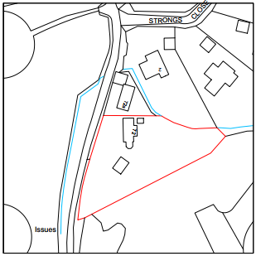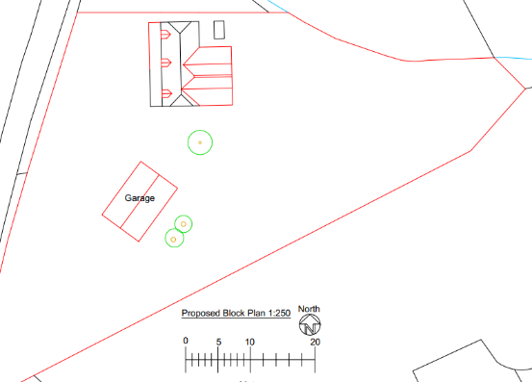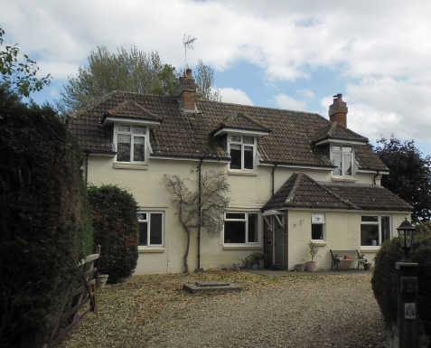
Location Plan Proposed Site Plan Site photograph.

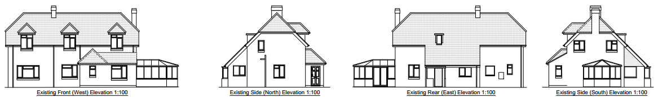
Elevations as existing.

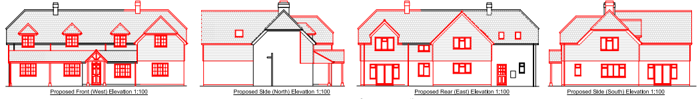
Previously proposed scheme as granted in PL/2024/07488.

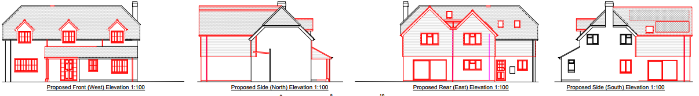
Proposed elevations as currently proposed.

Core Policy 41 of the WCS states: “New development, refurbishment and extensions will be encouraged to incorporate design measures to reduce energy demand. Development will be well insulated and designed ...” This includes maximising the opportunity to retrofit and improved building specs for insulation

The property is aged and the proposed scheme aims to introduce upgrade works of a lesser scale and reduced proportions than that as previously approved within the 2024 permission. Essentially, the building would retain its original form, with the loss the conservatory serving to bring the building back to its original form. The extended works would take place to the rear of the host building with two extended gables which would not come out any further than those as previously approved.

The use of materials would consist of a matching render finish, matching roof tiles and use of natural horizontal timber cladding as shown in the above plan snippets, all of which are acceptable.

In regard to the proposed enlargement of the existing garage, the scheme would take the form as shown below:

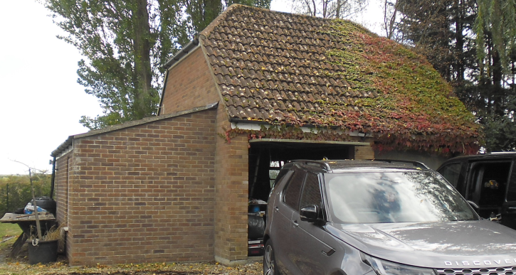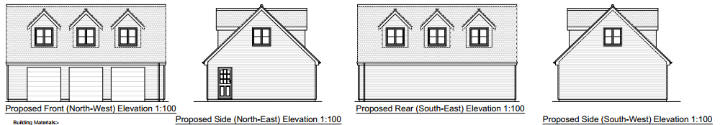
Existing Garage Proposed elevations of garage.

Materials would consist of matching brickwork and roof tiles, with timber cladding, and the proposed dormer windows would mimic those as located on the host dwelling. The enlarged garage would have a new first floor area which would serve as ancillary residential area to the host building. The proposals are appraised as being acceptable.

Therefore, in summary, having regard to the above, the proposal complies with the design principles set out in Core Policy 57 of the Wiltshire Core Strategy and Appendix D of the Wiltshire Design Guide.

Amenity
Point vii of Core Policy 57 - Ensuring high-quality Design and Place Shaping of the Wiltshire Core Strategy seeks to ensure that developments do not adversely affect neighbouring properties.
At the national level.

The proposed extension would be two storey in height and would look out onto and face the rear garden area, where there are no neighbouring properties. There are no new proposed side windows or other openings within the northern side elevation, thereby offering neutral impact on the neighbouring property at No.72 and beyond. As there are no neighbours to the south, there would not be any impact on amenity from this elevation.

The separation distance of the proposed rear east extension from the neighbouring boundary of the property is just over 5 metres, and the setback siting of the host dwelling and its rear extension, from the rear elevation of No. 72a, would not result in harmful impact with regard to being overbearing or overshadowing. There may be some very slight overshadowing to the rear garden of no. 72a closest to the boundary during the mid to latter part of the day as the sun moves east to west, but this would be mitigated by the presence of an intervening outbuilding and high-level vegetation boundary treatment. Consequently, it is appraised that there would not be material harm to the amenity of the occupiers of no. 72a.

In terms of potential overlooking from the dormer windows within the garage building, the front northwest elevation would look onto the site’s garden area and lane opposite, with the rear southeast aspect also looking onto the site’s large private garden area. The separation distance with No.72a is an established 28 metres with the intervening presence of the principal building offering no clear sightline between the two buildings.

The proposal therefore accords with Core Policy 57 point vii. in respect of safeguarding residential amenity and Appendix D of the Wiltshire Design Guide.

Highway Matters.
Core Policy 57 (xiv) of the Wiltshire Core Strategy seeks to ensure that development must meet the requirements of Core Policy 61. This policy requires proposals to be capable of being served by safe access to the highway network. Core Policy 64 seeks to ensure compliance with parking standards set out in the Local Transport Plan.

NPPF Policy TR6 confirms that development should be refused where it would result in a severe adverse impact on the transport network or an unacceptable impact on highway safety after consideration of any mitigation measures.

The proposed development would continue to use the established site access which would not be altered and would not have any adverse impact on highway safety. Adequate parking and turning provision is provided within the site and such access arrangements are acceptable. The council’s highways officer has been consulted who has not raised any objections.

The proposal is therefore considered to comply with Core Policies 57 (xiv), 61 and 64 of the Wiltshire Core Strategy, the NPPF, and the Wiltshire Local Transport Plan.

Ecology Impact CP50 requires no net loss of biodiversity on site. The site is located outside of any ecological zone, thereby offering no such harmful impact, likewise, the application is exempt from the requirement to deliver Biodiversity Net Gain under Schedule 7A, Section 4(2)(a) of the Town and Country Planning Act 1990, as inserted by the Environment Act 2021, because the proposal is a householder extension.

CONCLUSION
The proposed development is acceptable in terms of its design, scale, and relationship with the surrounding area. It would not result in any unacceptable harm to the character of the locality, the amenities of neighbouring occupiers, or the interests of highway safety, or ecology.

The proposal is therefore considered to comply with the relevant policies of the Wiltshire Core Strategy, the Wiltshire Local Plan, and the National Planning Policy Framework. As such, the application is recommended for approval, subject to the conditions set out below.

RECOMMENDATION: Planning Permission be GRANTED subject to conditions.

