APPLICATION FOR HOUSEHOLDER PLANNING PERMISSION
DELEGATED REPORT

APPLICATION REFERENCE: | PL/2026/05664
APPLICATION TYPE: | Householder Planning Permission
SITE ADDRESS: | Frog Lane Barn, 86 Sand Street, Longbridge Deverill, Warminster, BA12 7DS
DEVELOPMENT DESCRIPTION: | Revamp Your Tank Scheme - replacement of septic tanks with treatment plants
RECOMMENDATION: | That Planning Permission be GRANTED

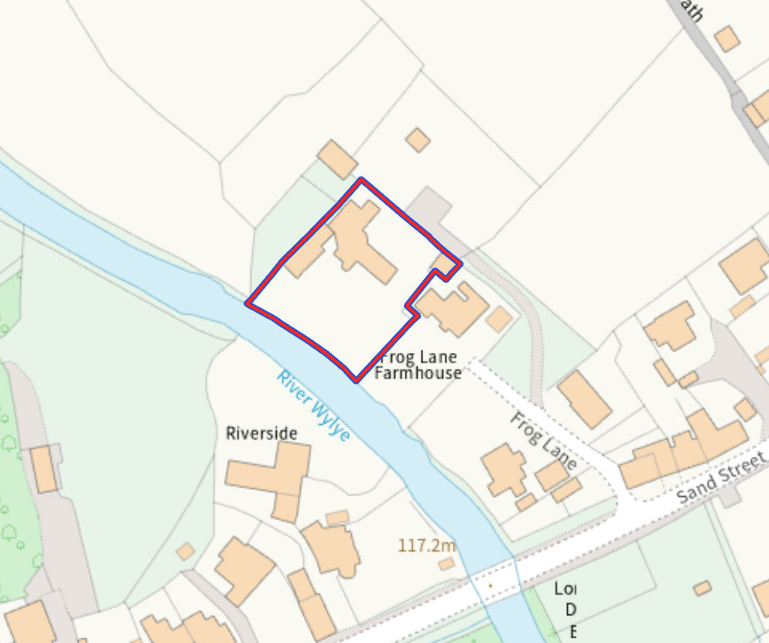
PROPOSAL

The application seeks planning permission for the replacement of an existing non-mains sewerage system serving Frog Lane Barn with a new small sewage treatment plant (STP). The works include the installation of the treatment unit, associated pipework, electrical cabling, inspection chambers and ancillary engineering operations, together with a new discharge arrangement to the River Wylye. The proposed system is designed to achieve a phosphorus treatment efficiency of at least 5mg/l without chemical dosing and forms part of Wiltshire Council's Revamp Your Tank programme aimed at reducing nutrient pollution within the River Avon catchment.

SITE DESCRIPTION / CONTEXT

The application site relates to a detached residential property known as Frog Lane Barn, located within the built-up area of Longbridge Deverill. Longbridge Deverill is identified within the Wiltshire Core Strategy as a Small Village and does not benefit from a defined settlement boundary. The site lies within the Cranborne Chase and West Wiltshire Downs National Landscape and falls within Source Protection Zones 1 and 3. The southern boundary directly adjoins the River Wylye, with Flood Zones 2 and 3 and areas of surface water flood risk extending into part of the site. The Council's Strategic Flood Risk Assessment also identifies areas of elevated groundwater flood risk. The site lies within the Upper Wylye Headwaters sub-catchment of the Hampshire River Avon catchment and within the 6.4km buffer of the Salisbury Plain SPA.

PLANNING HISTORY

Reference No. | Proposal / Summary | Decision
W/79/00992/HIS | Car Port | Approved
W/98/01531/FUL | Kitchen Extension | Approved
PL/2023/09478 | Erection of a new single storey extension, new window openings and external alterations | Approved

RELEVANT LEGISLATION, POLICIES AND GUIDANCE

Wiltshire Core Strategy:

Core Policy 1 Settlement Strategy;
Core Policy 2 Delivery Strategy;
Core Policy 31 Spatial Strategy: Warminster Community Area;
Core Policy 50 Biodiversity and Geodiversity;
Core Policy 51 Landscape;
Core Policy 57 Ensuring High-Quality Design and Place Shaping;
Core Policy 60 Sustainable Transport;
Core Policy 61 Transport and Development;
Core Policy 64 Demand Management;
Core Policy 67 Flood Risk;

The National Planning Policy Framework (NPPF) and The Planning Practice Guidance (PPG)

Wiltshire Design Guide - Appendix D – Design Guidance for Householder extensions

The Wiltshire Local Transport Plan 2011 – 2026: Car Parking Strategy (March 2015).

The Wiltshire Local Transport Plan 4 (LTP4) (March 2025)

New Wiltshire Local Plan

At Full Council on 19 May 2026, the elected members of Wiltshire Council agreed to withdraw the emerging Wiltshire Local Plan. The said Plan has no material weight for the purposes of the application.

In accordance with Regulation 19 of the Town and Country Planning (Local Planning) (England) Regulations 2026, on 30th June 2026 Wiltshire Council published a notice of intention to prepare a new local plan for Wiltshire. The next stage is a Scoping Consultation which commences on 2nd September 2026. This plan is at a very early stage and currently carries no weight for decision making.

CONSULTATION RESPONSES

Drainage (Wiltshire Council) – No Objection

Environment Agency – No Objection

REPRESENTATIONS

No comments received.

ASSESSMENT

Section 38(6) of the Planning and Compulsory Purchase Act 2004 states:

"If regard is to be had to the development plan for the purposes of any determination to be made under the planning Acts, the determination must be made in accordance with the plan unless material considerations indicate otherwise."

In accordance with this statutory requirement, this application has been assessed against the relevant policies of the Development Plan, including the adopted Wiltshire Core Strategy (2015) and, where applicable, any made Neighbourhood Plans.

The proposal comprises the replacement of existing private foul drainage infrastructure serving an established dwelling and does not facilitate any increase in residential accommodation, occupancy levels or operational activity at the site. The submitted information identifies that the existing septic tank is in poor condition and does not comply with current General Binding Rules due to its proximity to a watercourse, with evidence that the existing discharge arrangements are not functioning correctly. The proposal forms part of the Council's wider nutrient mitigation programme within the River Avon catchment and seeks to replace outdated infrastructure with a more efficient treatment system. Subject to detailed consideration of drainage, flood risk and ecological impacts, the principle of replacing existing private foul drainage equipment within the residential curtilage is considered acceptable and accords with the objectives of the Wiltshire Core Strategy and the wider environmental aims of the Revamp Your Tank initiative.

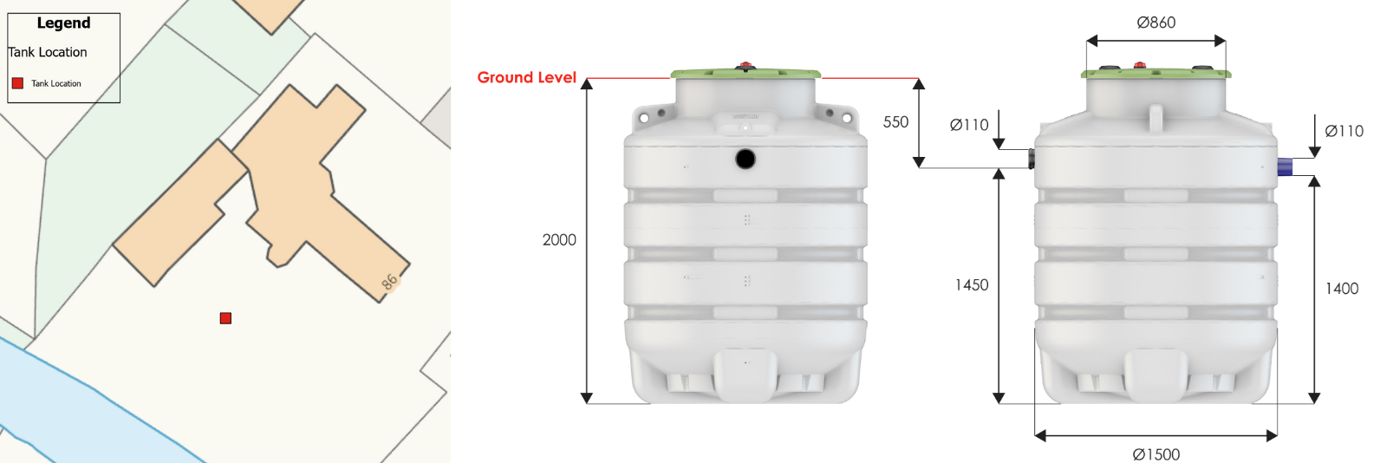
Site Plan and Proposed Tank Elevations

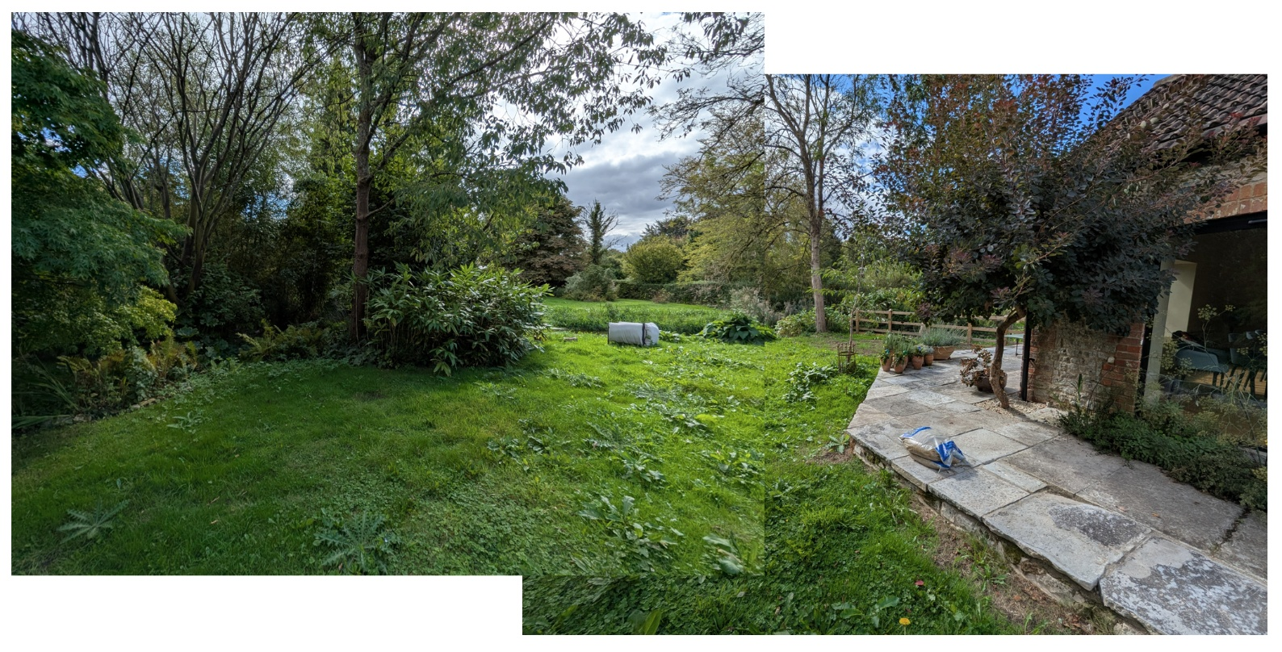
Site Visit Composite Image

Ecology

Core Policy 50 of the Wiltshire Core Strategy seeks to protect and enhance biodiversity interests and ensure development avoids unacceptable harm to ecological assets. National policy is set out within Policies N2 and N6 of the National Planning Policy Framework. These policies require development proposals to minimise impacts upon biodiversity, protect important habitats and species, and secure opportunities for biodiversity enhancement where appropriate. Where significant harm to biodiversity cannot be avoided, adequately mitigated or compensated for, development should be refused. Biodiversity Net Gain (BNG) was established as a mandatory aspect of planning evaluation through Schedule 7A of the Town and Country Planning Act 1990 (as amended by the Environment Act 2021 Schedule 14). Householder development is exempt from the statutory Biodiversity Net Gain requirements introduced through Schedule 7A of the Town and Country Planning Act 1990 (as amended). Nevertheless, proposals should seek to avoid ecological harm and incorporate biodiversity enhancements where appropriate.

The application relates to the replacement of an existing private foul drainage system serving an established dwelling. The proposal would not facilitate additional residential development, increase occupancy levels or result in the loss of habitats of recognised ecological importance. The works are largely confined to previously developed residential curtilage and comprise predominantly underground engineering operations associated with the installation of replacement drainage infrastructure.

Whilst no consultation response has been sought from the Council's Ecology Team, the application is accompanied by a Water Vole Survey undertaken by a Wiltshire Council ecologist. The survey assessed a section of the River Wylye adjacent to the site and concluded that no evidence of water vole presence was recorded within the survey area. The report states that the proposed replacement of septic tanks within this location is unlikely to result in adverse impacts upon water voles and that no mitigation measures or species licensing are required.

The site lies within the Hampshire River Avon catchment, specifically the Upper Wylye Headwaters sub-catchment, where nutrient pollution is a recognised environmental concern. The proposal seeks to replace an existing drainage arrangement with a modern sewage treatment plant capable of achieving improved phosphorus removal performance. As the development replaces existing infrastructure rather than introducing new wastewater flows, and as the proposed treatment process would provide enhanced wastewater treatment compared to the existing situation, the proposal is considered to result in a neutral to beneficial outcome from an ecological perspective.

The site additionally falls within Source Protection Zones 1 and 3. Core Policy 68 requires development proposals within such areas to demonstrate that groundwater resources and groundwater quality will be protected throughout both the construction and operational phases of development. To ensure the long-term environmental performance of the approved system, conditions are recommended requiring the sewage treatment plant to be installed, maintained and operated without chemical dosing and requiring any future replacement system to achieve an equivalent phosphorus treatment efficiency of at least 5mg/l Total Phosphorus removal.

Subject to the recommended conditions and informatives, it is considered that the proposal would not result in unacceptable ecological impacts and would accord with the aims of Core Policies 50 and 68 of the Wiltshire Core Strategy.

Flooding and Drainage

Core Policy 67 of the Wiltshire Core Strategy seeks to ensure that development is directed away from areas at greatest risk of flooding and is designed to minimise vulnerability to flooding whilst avoiding any increase in flood risk elsewhere. National planning policy relating to flood risk and drainage is contained within Policies F4 to F8 of the National Planning Policy Framework. Collectively, these policies establish a risk-based approach to the location and assessment of development proposals. The Framework requires flood risk to be properly assessed where necessary, seeks to direct development towards areas at the lowest risk of flooding through the application of the sequential approach where applicable, and ensures that development remains safe for its lifetime without increasing flood risk elsewhere. The policies also support the incorporation of sustainable drainage measures where appropriate in order to manage surface water runoff and reduce the potential for flooding.

Householder proposals and small extensions below 250 square metres are exempt from both the sequential test and exception test under Policy F5(2)(c), although flood risk considerations remain material where site specific constraints have been identified.

The submitted information confirms that the existing septic tank is in poor condition, does not comply with current regulations and is not functioning correctly. The proposal would replace the existing system with a modern sewage treatment plant specifically designed to continue operating during flood events. The submitted details indicate that critical components would be positioned above anticipated flood levels where necessary, sealed covers would prevent surface water ingress, non-return valves would be incorporated within the system and the treatment unit would be concreted into position to prevent flotation during periods of inundation.

The land sits within an area designated as a Source Protection Zone by the Environment Agency, including SPZ1 which represents the area most vulnerable to pollution around a groundwater abstraction point. Government guidance advises that sewage discharges within SPZ1 may require environmental permitting from the Environment Agency. This is controlled through separate environmental legislation and is not a matter that can be duplicated through the planning process. Appropriate informatives are therefore recommended to make the applicant aware of these requirements.

The submitted drainage information demonstrates that the proposal would replace an existing non-compliant drainage arrangement with a modern treatment system incorporating enhanced phosphorus removal. Subject to the recommended planning conditions relating to ongoing operation without chemical dosing and maintenance of treatment efficiency, it is considered that the proposal would result in a neutral to positive drainage outcome and would not conflict with the aims of Core Policy 67.

Design and Impact upon the character and context of the area

Core Policy 57 of the Wiltshire Core Strategy seeks to secure high-quality design which responds positively to local character and distinctiveness. At the national level, Policy DP3 of the National Planning Policy Framework requires development proposals to respond positively to their context and integrate with and enhance their surroundings. Development should also reflect, where relevant, the principles of liveability, climate resilience, nature, movement, built form, public space and local identity. Assessment of design quality therefore requires consideration of the scale, appearance, massing, materials, layout and relationship of the proposal with both the host site and the wider character of the surrounding area.

Core Policy 51 seeks to protect, conserve and where possible enhance landscape character. Where applicable, Policy N4 of the National Planning Policy Framework requires development within Protected Landscapes to be limited in scale and extent and sensitively located and designed so as to avoid harm to their special qualities. The assessment therefore considers the extent to which the proposal would preserve the character and appearance of the local landscape and, where relevant, the purposes of any landscape designation.

Core Policies 51 and 57 seek to ensure that development responds positively to local character whilst conserving landscape quality. In this instance, the proposal relates exclusively to the installation of underground drainage infrastructure and associated treatment equipment within the residential curtilage of an existing dwelling. Whilst temporary excavation works would be required during construction, the completed development would be largely concealed beneath ground level and existing surface treatments would be reinstated following completion of the works. As such, no material alteration to the established appearance, character or layout of the site would occur.

The site is located within the Cranborne Chase and West Wiltshire Downs National Landscape, where great weight should be afforded to conserving and enhancing landscape character. Given the limited scale of the works, their domestic nature, and the fact that the development would be substantially below ground level, it is considered that the proposal would preserve the character and appearance of both the application site and the wider National Landscape. No adverse visual impacts are identified and the proposal therefore complies with the design principles set out in the NPPF Policy DP3, Core Policy 57 of the Wiltshire Core Strategy, and Appendix D of the Wiltshire Design Guide.

Amenity

Core Policy 57 criterion vii seeks to ensure development does not have an unacceptable impact upon the amenities of neighbouring occupiers. Nationally, Policy P3 requires development proposals to provide healthy living conditions for occupiers and users and to avoid unacceptable impacts arising from loss of light, outlook, privacy, noise, disturbance or other forms of pollution. Policy DP3 additionally requires development to create liveable and attractive places for existing and future users. Accordingly, the assessment below considers the effect of the proposal upon neighbouring occupiers and whether acceptable living conditions would be maintained.

The proposed development would replace existing drainage infrastructure serving the dwelling and would not introduce any new built form, operational activity or external equipment that would materially affect neighbouring occupiers. The treatment plant would be installed below ground level within the residential curtilage and would not give rise to unacceptable impacts in terms of outlook, privacy, overbearing effects, loss of light, noise or disturbance. The proposal is therefore considered to safeguard the amenities and living conditions of neighbouring occupiers and accords with Core Policy 57 point vii in respect of safeguarding residential amenity and Appendix D of the Wiltshire Design Guide.

Transport and Highways

Core Policies 60, 61 and 64 of the Wiltshire Core Strategy seek to promote sustainable transport, secure safe access arrangements and ensure adequate parking provision. Nationally, Policies TR3 and TR4 of the National Planning Policy Framework require development to be located in sustainable locations where appropriate, provide safe access arrangements, prioritise walking, wheeling and cycling, and provide suitable parking provision having regard to the nature and location of the development. Policy TR6 confirms that development should be refused where it would result in a severe adverse impact on the transport network or an unacceptable impact on highway safety after consideration of any mitigation measures.

The proposal does not alter the use of the site, generate additional vehicle movements, modify access arrangements or affect parking provision. The development relates solely to the replacement of existing foul drainage infrastructure associated with an existing dwelling. Consequently, no highway safety or transportation concerns arise and the proposal is considered to accord with Core Policies 60, 61 and 64 of the Wiltshire Core Strategy.

CONCLUSION

The proposal seeks the replacement of an existing failing and non-compliant private foul drainage system with a modern sewage treatment plant serving an established dwelling. Having regard to the scale and nature of the development, it is considered that the proposal would have no harmful impact upon the character and appearance of the site, the Cranborne Chase and West Wiltshire Downs National Landscape, neighbouring residential amenity, highway safety, or flood risk. Furthermore, the replacement system would provide an improved method of wastewater treatment with associated ecological and water quality benefits when compared with the existing arrangement. Subject to the recommended planning conditions and informatives, the development is considered to accord with Core Policies 50, 51, 57, 60, 61, 64, 67 and 68 of the Wiltshire Core Strategy and is therefore recommended for approval.

RECOMMENDATION: That Planning Permission be GRANTED subject to conditions

