APPLICATION FOR HOUSEHOLDER PLANNING PERMISSION
DELEGATED REPORT

APPLICATION REFERENCE: | PL/2026/03401
APPLICATION TYPE: | Householder Planning Permission
SITE ADDRESS: | 127 Lacock Gardens, Hilperton, Trowbridge, BA14 7TG
DEVELOPMENT DESCRIPTION: | Proposed single-storey, pitched roof, rear extension (part- retrospective)
RECOMMENDATION: | That Planning Permission be GRANTED

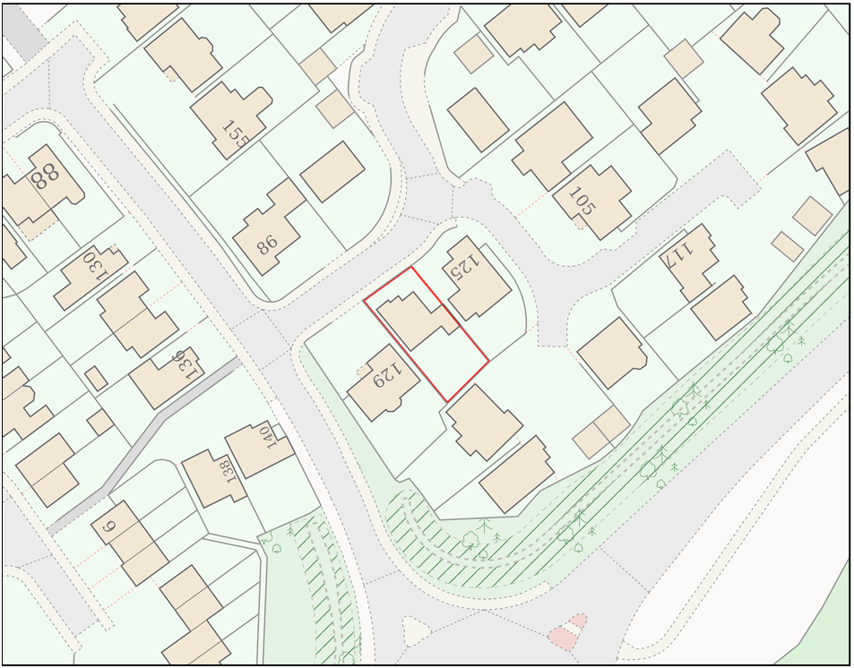
PROPOSAL

The application seeks planning permission for the erection of a single-storey rear extension to the existing dwelling. The extension would project approximately 2 metres beyond the rear elevation, measure 3.9 metres in width, and incorporate a mono-pitched roof rising from approximately 2.4 metres at the eaves to 3.5 metres where it adjoins the host dwelling. External materials are proposed to comprise red/grey interlocking concrete roof tiles and lightly stained horizontal larch timber cladding, together with associated lead flashing and detailing. The extension would provide additional internal living accommodation ancillary to the existing residential use of the property.

SITE DESCRIPTION / CONTEXT

The application site comprises a detached dwelling located within a modern residential estate characterised predominantly by two-storey dwellings constructed in red brick with white uPVC fenestration and tiled pitched roofs. Properties within the locality generally benefit from modest front gardens and low-level hedgerow boundary treatments, creating a medium-density suburban character. The site occupies an edge-of-settlement location, with open agricultural land situated to the south beyond the residential development. The property lies within the Trowbridge Settlement Boundary and is located within the Trowbridge and Westbury Bat Mitigation Strategy Grey Zone and within identified Bechstein Bat Core Roost Buffers. The site is also located within Flood Zone 1, with the Council's Strategic Flood Risk Assessment indicating a negligible risk from both surface water and groundwater flooding.

PLANNING HISTORY

Reference No. | Proposal / Summary | Decision
W/88/01650/OUT | Residential development together with local centre, highway improvements and public open space | Approved
W/99/00472/REM | 59 detached houses | Approved

RELEVANT LEGISLATION, POLICIES AND GUIDANCE

Wiltshire Core Strategy:

Core Policy 1 Settlement Strategy;
Core Policy 2 Delivery Strategy;
Core Policy 29 Spatial Strategy: Trowbridge Community Area;
Core Policy 50 Biodiversity and Geodiversity;
Core Policy 51 Landscape;
Core Policy 57 Ensuring High-Quality Design and Place Shaping;
Core Policy 60 Sustainable Transport;
Core Policy 61 Transport and Development;
Core Policy 64 Demand Management;
Core Policy 67 Flood Risk;

Hilperton Neighbourhood Development Plan 2017-2026

The National Planning Policy Framework (NPPF) and The Planning Practice Guidance (PPG)

Wiltshire Design Guide - Appendix D – Design Guidance for Householder extensions

The Wiltshire Local Transport Plan 2011 – 2026: Car Parking Strategy (March 2015).

The Wiltshire Local Transport Plan 4 (LTP4) (March 2025)

New Wiltshire Local Plan

At Full Council on 19 May 2026, the elected members of Wiltshire Council agreed to withdraw the emerging Wiltshire Local Plan. The said Plan has no material weight for the purposes of the application.

In accordance with Regulation 19 of the Town and Country Planning (Local Planning) (England) Regulations 2026, on 30th June 2026 Wiltshire Council published a notice of intention to prepare a new local plan for Wiltshire. The next stage is a Scoping Consultation which commences on 2nd September 2026. This plan is at a very early stage and currently carries no weight for decision making.

CONSULTATION RESPONSES

Hilperton Parish Council – No Objection

REPRESENTATIONS

No comments received.

ASSESSMENT

Section 38(6) of the Planning and Compulsory Purchase Act 2004 states:

"If regard is to be had to the development plan for the purposes of any determination to be made under the planning Acts, the determination must be made in accordance with the plan unless material considerations indicate otherwise."

In accordance with this statutory requirement, this application has been assessed against the relevant policies of the Development Plan, including the adopted Wiltshire Core Strategy (2015) and, where applicable, any made Neighbourhood Plans.

The application proposes a modest householder extension to an existing dwelling located within the Trowbridge Settlement Boundary, where the principle of residential development is established and accepted. The proposed works represent a domestic alteration ancillary to the continued residential use of the property and, having regard to their limited scale and location within the residential curtilage, are considered acceptable in principle.

Design and Impact upon the character and context of the area

Core Policy 57 of the Wiltshire Core Strategy seeks to secure high-quality design which responds positively to local character and distinctiveness. At the national level, Policy DP3 of the National Planning Policy Framework requires development proposals to respond positively to their context and integrate with and enhance their surroundings. Development should also reflect, where relevant, the principles of liveability, climate resilience, nature, movement, built form, public space and local identity. Assessment of design quality therefore requires consideration of the scale, appearance, massing, materials, layout and relationship of the proposal with both the host site and the wider character of the surrounding area.

The proposed extension is modest in scale, projecting approximately 2 metres from the existing rear elevation and measuring 3.9 metres in width. It is designed as a simple mono-pitched form with the roof connecting into the existing dwelling at a maximum height of approximately 3.5 metres and reducing to 2.4 metres at the eaves. The extension occupies the footprint of an existing rear projection and therefore does not materially increase the overall rearward extent of built development beyond that already established. The proposed materials are considered appropriate to the host dwelling and surrounding area, with the use of interlocking concrete roof tiles reflecting the existing roofscape. Whilst timber cladding is proposed to sections of the external elevations, this material would be confined to the rear garden environment where it would not be visible from the public realm and would sit comfortably within a setting already characterised by timber fencing and domestic garden features. Overall, the extension is considered appropriately designed, proportionate to the host dwelling, subservient in appearance, and would preserve the character and appearance of both the property and the wider street scene.

Having regard to the above, the proposal complies with the design principles set out in the NPPF Policy DP3, Core Policy 57 of the Wiltshire Core Strategy, and Appendix D of the Wiltshire Design Guide.

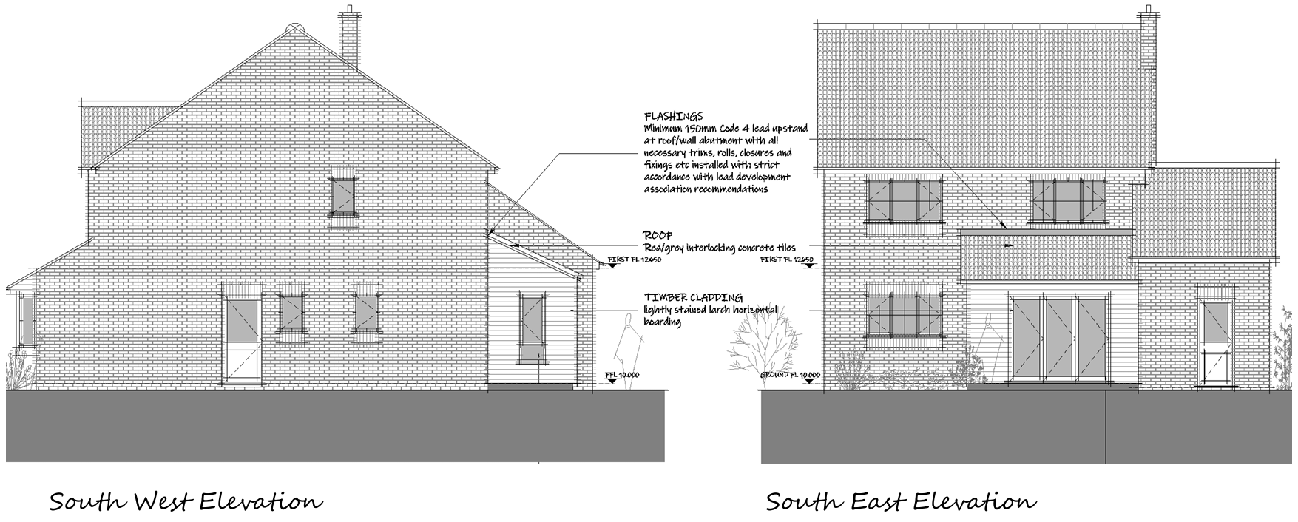
Proposed Elevations

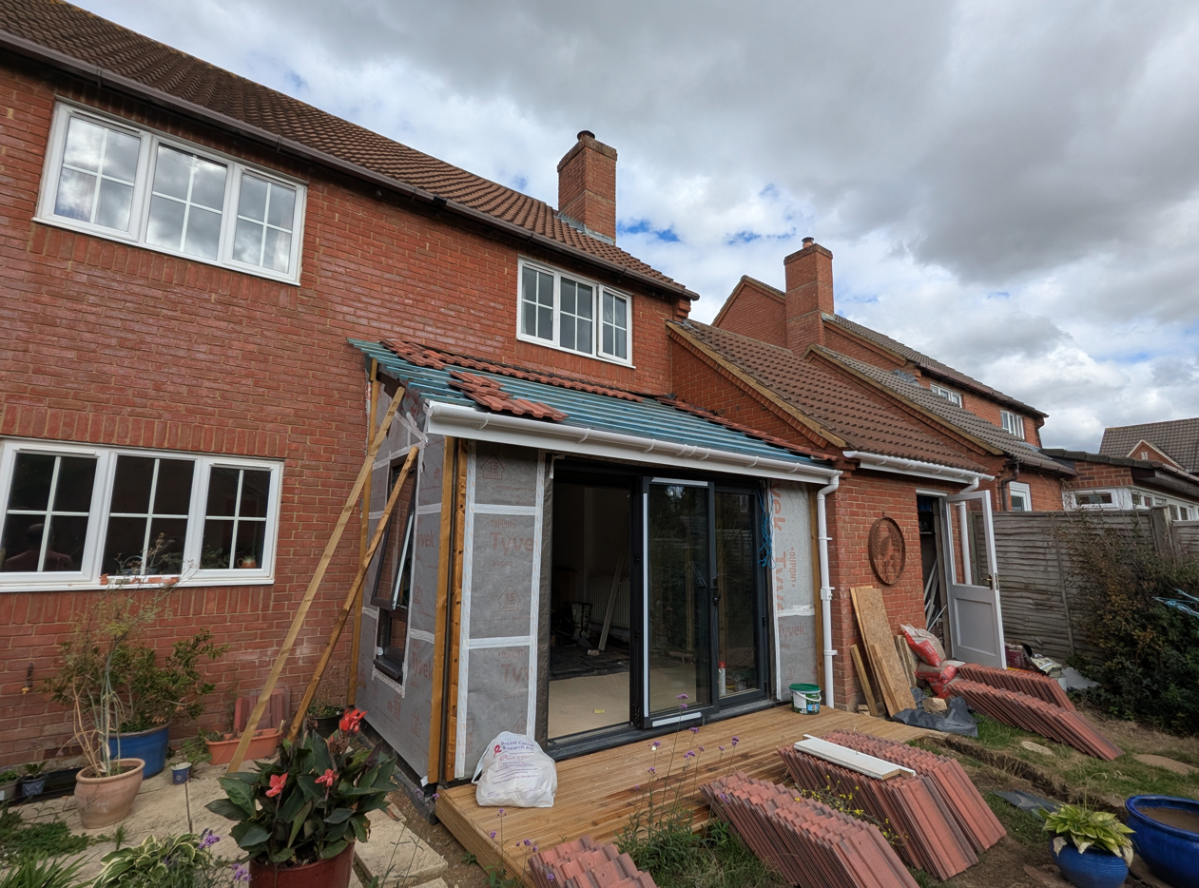
Site Visit Image

Amenity

Core Policy 57 criterion vii seeks to ensure development does not have an unacceptable impact upon the amenities of neighbouring occupiers. Nationally, Policy P3 requires development proposals to provide healthy living conditions for occupiers and users and to avoid unacceptable impacts arising from loss of light, outlook, privacy, noise, disturbance or other forms of pollution. Policy DP3 additionally requires development to create liveable and attractive places for existing and future users. Accordingly, the assessment below considers the effect of the proposal upon neighbouring occupiers and whether acceptable living conditions would be maintained.

By virtue of its single-storey form, modest dimensions and position to the rear of the dwelling, the proposal would not give rise to any unacceptable impacts upon the amenities of neighbouring occupiers. The development would not result in significant overlooking, loss of privacy, overshadowing or an overbearing impact. Given the limited scale and massing proposed, the extension is considered to integrate comfortably within the site without detriment to the living conditions currently enjoyed by surrounding residents. The proposal therefore accords with Core Policy 57 point vii in respect of safeguarding residential amenity and Appendix D of the Wiltshire Design Guide.

Transport and Highways

Core Policies 60, 61 and 64 of the Wiltshire Core Strategy seek to promote sustainable transport, secure safe access arrangements and ensure adequate parking provision. Nationally, Policies TR3 and TR4 of the National Planning Policy Framework require development to be located in sustainable locations where appropriate, provide safe access arrangements, prioritise walking, wheeling and cycling, and provide suitable parking provision having regard to the nature and location of the development. Policy TR6 confirms that development should be refused where it would result in a severe adverse impact on the transport network or an unacceptable impact on highway safety after consideration of any mitigation measures.

The proposal comprises an extension to existing internal living accommodation and does not create any additional bedrooms or separate residential units. As such, the development would not be expected to generate additional vehicle movements or increase parking demand beyond existing levels. The proposal therefore raises no highway safety concerns and would not adversely affect the adequacy of parking provision associated with the dwelling.

Ecology

Core Policy 50 of the Wiltshire Core Strategy seeks to protect and enhance biodiversity interests and ensure development avoids unacceptable harm to ecological assets. National policy is set out within Policies N2 and N6 of the National Planning Policy Framework. These policies require development proposals to minimise impacts upon biodiversity, protect important habitats and species, and secure opportunities for biodiversity enhancement where appropriate. Where significant harm to biodiversity cannot be avoided, adequately mitigated or compensated for, development should be refused. Biodiversity Net Gain (BNG) was established as a mandatory aspect of planning evaluation through Schedule 7A of the Town and Country Planning Act 1990 (as amended by the Environment Act 2021 Schedule 14). Householder development is exempt from the statutory Biodiversity Net Gain requirements introduced through Schedule 7A of the Town and Country Planning Act 1990 (as amended). Nevertheless, proposals should seek to avoid ecological harm and incorporate biodiversity enhancements where appropriate.

The site lies within the Trowbridge and Westbury Bat Mitigation Strategy Grey Zone and within identified Bechstein Bat Core Roost Buffers. Notwithstanding these constraints, the proposal relates to a small-scale rear extension at ground-floor level and does not involve the alteration, removal or disturbance of the existing roof structure where bat roosting potential would typically arise. The works are largely confined to an existing domestic garden area comprising hardstanding and managed residential land. Given the limited scope of the development and the absence of any direct interaction with features likely to support protected species, it is considered that the proposal would give rise to negligible, if any, ecological impacts.

Flooding and Drainage

Core Policy 67 of the Wiltshire Core Strategy seeks to ensure that development is directed away from areas at greatest risk of flooding and is designed to minimise vulnerability to flooding whilst avoiding any increase in flood risk elsewhere. National planning policy relating to flood risk and drainage is contained within Policies F4 to F8 of the National Planning Policy Framework. Collectively, these policies establish a risk-based approach to the location and assessment of development proposals. The Framework requires flood risk to be properly assessed where necessary, seeks to direct development towards areas at the lowest risk of flooding through the application of the sequential approach where applicable, and ensures that development remains safe for its lifetime without increasing flood risk elsewhere. The policies also support the incorporation of sustainable drainage measures where appropriate in order to manage surface water runoff and reduce the potential for flooding.

The application site is located within Flood Zone 1 and the Council's Strategic Flood Risk Assessment identifies a negligible risk of flooding from both surface water and groundwater sources. Furthermore, the proposed extension would result in only a very minor increase in built form, extending approximately 2 metres by 3.9 metres. Given the limited increase in impermeable area and the absence of any identified drainage constraints affecting the site, it is not considered that the development would adversely affect flood risk or drainage conditions either within the site or elsewhere.

CONCLUSION

The proposed development represents a modest and well-designed extension that is acceptable in principle within the settlement boundary. The proposal would preserve the character and appearance of the host dwelling and surrounding area, safeguard neighbouring residential amenity, give rise to no significant ecological, drainage or highway impacts, and accords with the relevant policies of the development plan when read as a whole. Accordingly, the application is recommended for approval.

RECOMMENDATION: That Planning Permission be GRANTED subject to conditions

