APPLICATION FOR PERMISSION IN PRINCIPLE
CASE OFFICER REPORT

APPLICATION REFERENCE: | PL/2026/05252
APPLICATION TYPE: | Permission in Principle
SITE ADDRESS: | Land at Wayside, 12 Chittoe Heath, Bromham, Chippenham, SN15 2EH
DEVELOPMENT DESCRIPTION: | Permission in Principle for the proposed erection of up to six dwellings (One self build).
RECOMMENDATION: | Approve

SITE DESCRIPTION/CONTEXT

The application site comprises 0.49 hectares of land located to the side and rear of 12 Chittoe Heath, a single-storey chalet-style detached dwelling with an attic conversion. The property sits within a small cluster of residential homes in the open countryside of the Devizes Community Area. Surrounding properties are predominantly detached dwellings, ranging from traditional brick-built cottages to more modern rendered houses, with pitched roofs and a mix of slate and tile finishes. Many feature generous gardens and mature landscaping, contributing to the rural character of the area.

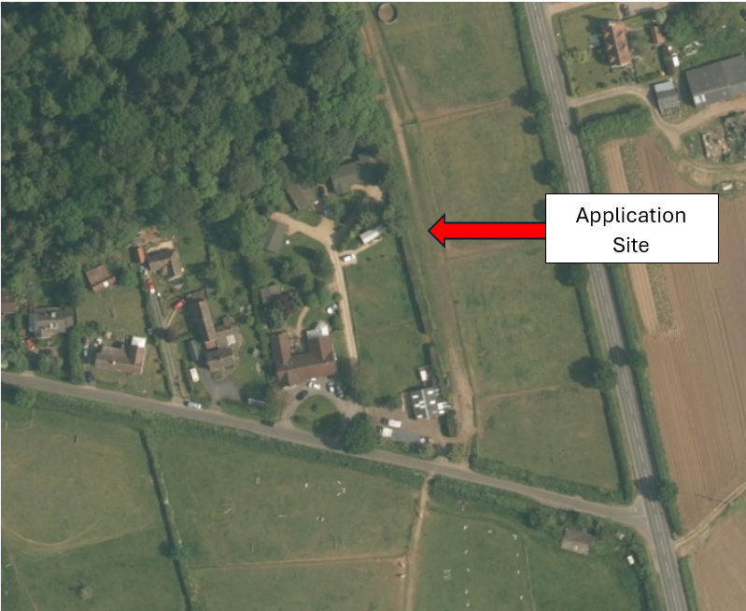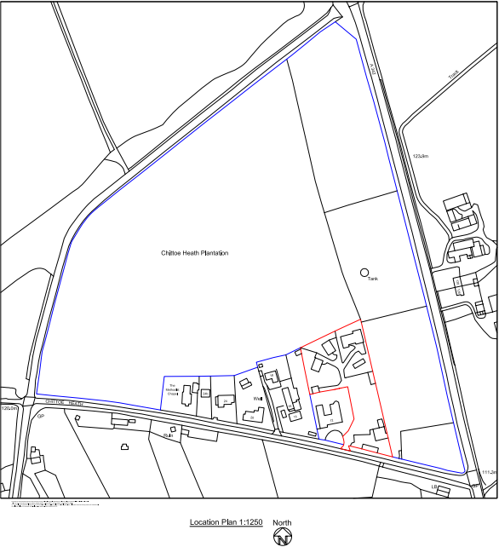

Aerial view of application site Location Plan

The site is approximately 0.9 kilometres north of the village of Bromham, which offers local amenities including a primary school, village shop, public house, and community facilities. Wider services are available in Devizes, located around 6 kilometres to the south-east. The site currently includes a driveway providing access to six holiday chalets situated to the rear of the property. The designated land use is restricted to tourist accommodation. To the side of the driveway, the land accommodates small grazing paddocks along with a garage and associated outbuildings.

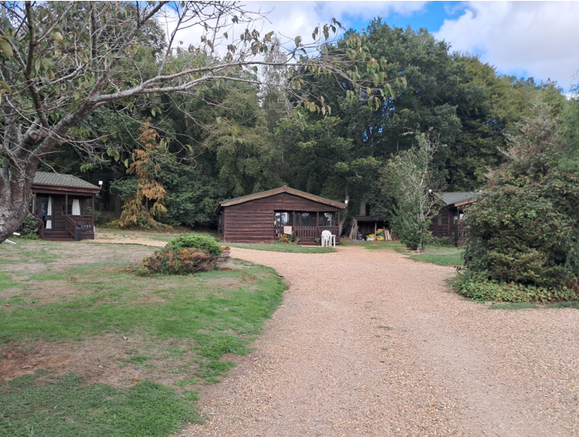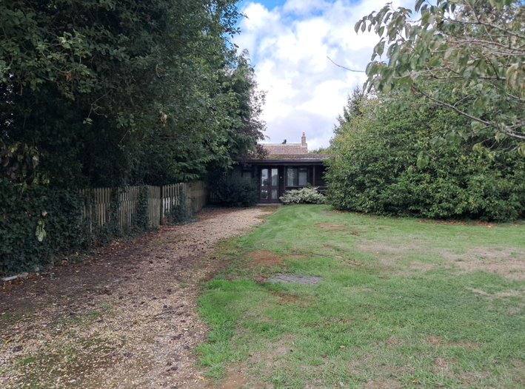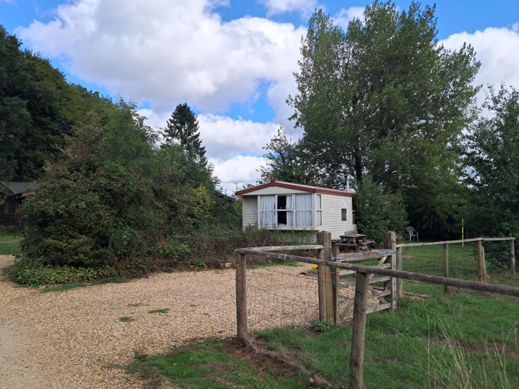

Case Officer photographs of existing holiday let units

Public rights of way are present in the vicinity, including a footpath running to the east of the site that connects Chittoe Heath to the wider countryside and Bromham village.

The land adjacent to the application site, which also falls within the applicant’s ownership, is the subject of a separate approved application (Ref: PL/2025/04466) for a change of use to equestrian purposes. This includes the provision of equestrian stables, a hay/machinery barn, a menage, and a sewage treatment plant.

The site is subject to a Tree Preservation Order (TPO E/84 (13 merged)) located in the south eastern corner of the site, adjacent to an existing outbuilding. The site is located in Flood Zone 1. The site does not form part of a conservation area, nor are there any listed buildings adjacent to the site or within the vicinity. Land adjacent to the site does hold archaeological significance. The woodland at Chittoe Heath Plantation is designated as forming Part of the Priority Habitat Inventory.

PROPOSAL

The application seeks Permission in Principle under the provisions of the Town and Country Planning Act 1990 (as amended).

An application for Permission in Principle (PiP) is limited to location, use and the amount of development. The proposal is for the erection of up to six dwellings, one being a self-build dwelling.

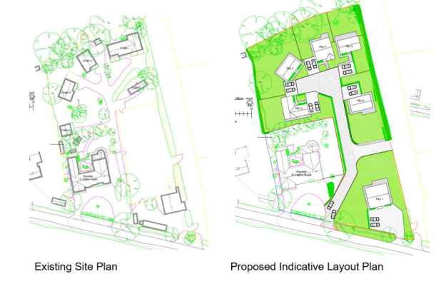

Existing and proposed site plans

All other matters would need to be considered at the ‘Technical Details’ consent stage.

No detailed matters of layout, scale, appearance, access, landscaping or drainage are submitted at this stage, as these are not required as part of a Permission in Principle application.

PLANNING HISTORY

Proposal / Summary
PL/2025/08122 - Holiday Lodges Wayside, 12 Chittoe Heath, Bromham, Chippenham, SN15 2EH - Full planning permission Decision - Withdrawn by Applicant Date: 12/12/2025 – Proposed Redevelopment of Previously Developed Land Through The Erection of Six detached dwellings
PL/2025/04466- Proposed Equestrian Stables, Hay/Machinery Barn & Menage & Sewage Treatment plant- Approved with Conditions
16/04791/OUT - Redevelopment of land, Erection of 4 dwellings and garages (outline application for access only)- Refused - 21/07/2016
(Ref: APP/Y3940/W/16/3156334) against the refusal of outline planning permission for four dwellings at the site was dismissed on 14 November 2016.
K/30314 – The erection of one new holiday chalet, use of existing timber building for a 1 bedroomed chalet, construction of detached garage and equipment store and hard surface – Approved 22.09.1994
Planning Application K/17208 – re-siting of chalet (plot no.2) – approved 28.03.1991
Planning Application K/16547 – erection of 2no, holiday chalets – Approved 25.10.1990
Planning Application K/12037 – alterations and extension – Approved 26.04.1988
Planning Application K/11609 – erection of extension and alterations – Approved 02.02.1988

RELEVANT LEGISLATION, POLICIES AND GUIDANCE

National Planning Policy:
- National Planning Policy Framework (NPPF)
- Planning Practice Guidance (PPG)
Development Plan:
The development plan for Wiltshire comprises the Wiltshire Core Strategy (WCS) (adopted January 2015) and any made neighbourhood plans, which remains the principal statutory planning document guiding development across the county. In line with Section 38(6) of the Planning and Compulsory Purchase Act 2004, planning decisions must be made in accordance with the development plan unless material considerations indicate otherwise.

Though the development plan is considered as a whole, those parts deemed to be particularly relevant to this application are listed below:

The adopted Wiltshire Core Strategy (WCS), with particular regard to:

- Core Policy 1 Settlement Strategy
- Core Policy 2 Delivery Strategy
- Core Policy 3 Infrastructure Requirements
- Core Policy 12 Spatial Strategy for the Devizes Community Area
- Core Policy 41 Sustainable Construction and Low-Carbon Energy
- Core Policy 43 Providing Affordable Homes
- Core Policy 45 Meeting Wiltshire’s Housing Needs
- Core Policy 48 Supporting Rural Life
- Core Policy 50 Biodiversity and Geodiversity
- Core Policy 51 Landscape
- Core Policy 57 Ensuring High Quality Design and Place Shaping
- Core Policy 60 Sustainable Transport
- Core Policy 62 Development Impacts on the Transport Network
- Core Policy 64 Demand Management
- Core Policy 67 Flood Risk

Draft Wiltshire Local Plan Policies
At Full Council on 19 May 2026, the elected members of Wiltshire Council agreed to withdraw the emerging Wiltshire Local Plan. The said Plan has no material weight for the purposes of the application.

In accordance with Regulation 19 of the Town and Country Planning (Local Planning) (England) Regulations 2026, on 30th June 2026 Wiltshire Council published a notice of intention to prepare a new local plan for Wiltshire. The next stage is a Scoping Consultation which commences on 2nd September 2026. This plan is at a very early stage and currently carries no weight for decision making.

Neighbourhood Plan:

The application site lies within the designated neighbourhood area of Bromham, which does not benefit from a ‘made’ neighbourhood plan.

Supplementary Planning Documents and other Guidance:
- Wiltshire Design Guide (adopted April 2024)
- Wiltshire Local Transport Plan 2011-2026, adopted 2015 - including the Car Parking Strategy and Cycling Strategy, adopted 2015
- Wiltshire Council’s Waste Storage and Collection: Guidance for Developers Supplementary Planning Document, January 2017

PERMISSION IN PRINCIPLE – PURPOSE AND SCOPE OF ASSESSMENT
Permission in Principle (PiP) is an alternative route to obtaining planning permission, introduced by the Housing and Planning Act 2016. It is intended to provide an early and proportionate decision on whether a site is suitable for development, before detailed design work is undertaken.

The PiP process operates as a two-stage planning permission route for housing-led development:
- Stage 1 – Permission in Principle:
Establishes whether the principle of development on a site is acceptable.
- Stage 2 – Technical Details Consent:
If PiP is granted, a subsequent application is required to consider the detailed proposals, including layout, scale, appearance, access, landscaping, drainage and infrastructure.

At the Permission in Principle stage, the assessment is deliberately high-level and limited in scope. The purpose of a PiP is not to approve detailed plans, but to provide certainty at an early stage about whether development of a particular type is acceptable in principle at a given location. This approach is intended to help streamline the planning process by allowing developers and communities to understand development potential before significant time and expense is committed to detailed designs.

Importantly, the grant of Permission in Principle does not authorise development to commence. Development can only proceed once Technical Details Consent has been granted.

Planning conditions cannot be imposed on the grant of PiP however conditions can be applied in the usual way at the technical details consent stage. Any PiP approved for residential development must be expressed indicating the minimum and maximum net number of dwellings which are, in principle, permitted. For a valid PiP application only a plan to identify the land to which the application relates is required.

Matters that Can Be Considered at the PiP Stage
Legislation restricts the assessment of a PiP application to the following matters only:

- The location of the development
- The proposed land use(s)
- The amount of development proposed

These are the only issues that can lawfully be taken into account when determining whether Permission in Principle should be granted or refused.

Matters Excluded from Consideration at the PiP Stage
Detailed matters, including (but not limited to) the following, are not considered as part of a PiP application:

- Detailed design and appearance
- Site layout and internal arrangements
- Access arrangements and parking
- Landscaping and boundary treatments
- Drainage and flood mitigation measures
- Utilities and other technical infrastructure

Such matters are reserved entirely for consideration at the Technical Details Consent stage, should Permission in Principle be granted.

KEY ISSUES FOR ASSESSMENT
In determining this application for Permission in Principle, the Local Planning Authority must consider the following key issues:

- Whether the location of the site is suitable for the proposed form of development, having regard to the spatial strategy set out in the development plan and relevant national policy.
- Whether the proposed land use is acceptable in principle at this location, taking into account the character and role of the settlement and surrounding area.
- Whether the amount of development proposed is appropriate, assessed at a high-level and in broad terms only.
- Whether there are any overriding constraints which would prevent development from coming forward in principle, even allowing for detailed matters to be addressed at the Technical Details Consent stage.

A Permission in Principle application should therefore only be refused where it is clearly demonstrated that the principle of the proposed development is unacceptable, and that such concerns could not reasonably be addressed through a subsequent Technical Details Consent application.

CONSULTATION RESPONSES

The views of consultees are material considerations in the determination of the application. However, the decision-maker must exercise their own planning judgement. Where consultees raise concerns or recommend conditions, these have been considered and are addressed within the assessment section of this report.

WC Arboricultural Officer: No objection

WC Archaeology: No objection

WC Drainage: No objection

WC Ecology: No objection

WC Highways: No objection

WC Rights of Way: No comment received at time of writing

Bromham Parish Council: Support

Cllr Laura Mayes: Application called-in should the application be recommended for refusal

REPRESENTATIONS
In accordance with the requirements of the Town and Country Planning (Development Management Procedure) (England) Order 2015 (as amended), the application was publicised by way of:

- Neighbour notification letters sent to adjoining and nearby properties; and
- A site notice displayed near the site

These methods were used to inform interested parties and provide a period of 21 days for comments to be submitted.

Below is a summary of the representations received during the consultation period. Only material planning considerations have been taken into account in the assessment of this application. Non-material issues, such as property values or private legal disputes, cannot be considered in the determination process.

One letter of objection was received:
- Objects on the grounds that the proposal is materially unchanged from a previously withdrawn application and remains inappropriate development in the open countryside.
- Site is outside any defined settlement boundary, remote from services and facilities, and considered an unsustainable location for residential development.
- Notes that a previous proposal for four dwellings was refused and dismissed at appeal due to sustainability concerns, with circumstances unchanged since that decision.
- Raises concerns over conflict with the Wiltshire Core Strategy settlement strategy and reliance on private car travel.
- Considers the development harmful to the character, rurality and landscape of the area, given its prominent position in open countryside near sensitive landscape designations.
- Objects to the loss of Best and Most Versatile agricultural land (Grades 2 and 3).
- States that six dwellings would represent overdevelopment of the area and would be out of keeping with the existing pattern of limited, low-key development at Chittoe Heath.
- Concerned that insufficient information has been provided regarding the scale, design and materials of the proposed dwellings.
- Raises highway safety concerns due to the site's remote location, narrow rural lane access, lack of footways, high-speed roads and nearby accident history.
- Questions the transport assessment and considers traffic generation from six permanent dwellings would be significantly greater than the existing holiday accommodation use.
- Seeks clarification regarding the potential loss of trees and associated impacts on biodiversity, habitat value and tree cover.
- Raises concerns that excessive shading from surrounding trees may affect the amenity of future gardens.
- Questions whether the proposal would meet local housing needs, suggesting there is a greater need for smaller and more affordable homes.
- Considers the proposal conflicts with Core Policies 1, 2, 51, 60 and 61 of the Wiltshire Core Strategy and should be refused.

A total of 12 letters of support received:
- Support the proposal as the redevelopment of a previously developed (brownfield) site rather than undeveloped countryside.
- Consider six dwellings to be a modest and proportionate form of development for the size and nature of the site.
- Note that the site already contains holiday accommodation/residential-type development, meaning the proposal would represent a reuse of an existing developed site.
- Consider that the development would not materially increase traffic movements, as the number of units would be similar to the existing use.
- Highlight the presence of a bus stop within approximately 200 metres of the site, providing access to public transport.
- Refer to national planning policy support for the redevelopment of brownfield land and the efficient use of previously developed sites.
- State that the proposal would help contribute towards housing delivery and address housing need within Wiltshire.
- Suggest the development would make a positive contribution to the local area and support the vitality of rural communities.
- Consider the proposal to be a sustainable and appropriate use of the site that would not result in significant environmental harm.
- Supporters generally regard the development as having no significant adverse impacts on the character of the area, highway network, or local community.

ASSESSMENT
Section 38(6) of the Planning and Compulsory Purchase Act 2004 states:

"If regard is to be had to the development plan for the purposes of any determination to be made under the planning Acts, the determination must be made in accordance with the plan unless material considerations indicate otherwise."

In accordance with this statutory requirement, this application has been assessed against the relevant policies of the Development Plan, including the Wiltshire Core Strategy (2015) and, where applicable, any made Neighbourhood Plans. Consideration has also been given to the policies of the National Planning Policy Framework (NPPF) as a material consideration in the assessment.

Principle of Development – Location
Policy Context
The development plan establishes a spatial strategy which seeks to direct new development towards defined settlements where residents have reasonable access to services, facilities and sustainable transport options. Development beyond these locations is generally more restricted in order to protect the countryside and promote sustainable patterns of growth.

The National Planning Policy Framework supports the delivery of sustainable development in appropriate locations and, where relevant, seeks to address identified housing needs through Policies HO1-HO13 and Policy S5, whilst ensuring development is directed to suitable and sustainable locations.

Assessment
At the Permission in Principle stage, consideration is limited to the location, land use and amount of development. Matters relating to detailed design, layout, access and appearance fall to be considered at the Technical Details Consent stage.

The application site lies outside the Limits of Development for Bromham and therefore conflicts with the settlement strategy set out within Core Policies 1 and 2 of the Wiltshire Core Strategy. The site is consequently regarded as being within open countryside for planning purposes, where new residential development would not ordinarily be supported by the adopted development plan.

Previous proposals on the site, including application ref. 16/04791/OUT and the subsequently withdrawn application ref. PL/2025/08122, were principally assessed against the spatial strategy of the development plan and were not supported due to concerns regarding the site's countryside location and sustainability. Whilst the Inspector's findings regarding the sustainability of the location remain material considerations, the appeal pre-dates the August 2026 NPPF and was determined against a materially different national policy framework. Consequently the appeal's conclusions regarding the acceptability of housing development in principle at this location are afforded reduced weight

Of particular relevance is Policy S5(1)(d), which identifies the redevelopment of previously developed land, including material changes of use to residential development, as a form of development that is acceptable in principle outside settlements unless the benefits are substantially outweighed by adverse effects.

The application site comprises previously developed land occupied by lawful holiday accommodation and associated development and is accepted to fall within the definition of previously developed land. The proposal seeks to redevelop the site to provide up to six dwellings and therefore falls squarely within the scope of Policy S5(1)(d). Furthermore, whilst the existing use is restricted to holiday accommodation, there are no adopted development plan policies which specifically seek to retain or protect self-catering holiday accommodation at this location.

The site is also not considered to be isolated. Submitted information demonstrates that bus stops serving regular routes to Bromham, Chippenham, Devizes, Calne, Melksham and Bath are located in close proximity to the site, with Bromham itself providing a range of day-to-day services and facilities including a primary school, local shop and public house. The nearest bus stops are located within approximately 200 metres of the site and provide connections to nearby settlements and services. Whilst it is acknowledged that future occupiers would continue to rely upon private vehicles for some journeys, this is not uncommon in a rural context and the NPPF recognises that opportunities to maximise sustainable transport solutions will vary between urban and rural areas.

Having regard to the above, and notwithstanding the conflict with Core Policies 1 and 2, the proposal benefits from direct policy support under Policy S5(1)(d) of the NPPF as the redevelopment of previously developed land for residential use. The site's accessibility to public transport and nearby services further supports the conclusion that residential development at this location is acceptable in principle.

Conclusion
The proposal conflicts with the settlement strategy of the adopted Wiltshire Core Strategy by virtue of its location outside a defined settlement boundary. However, the publication of the August 2026 National Planning Policy Framework represents a significant material consideration and a clear change in national policy since the assessment of previous proposals on the site.

The application site comprises previously developed land occupied by lawful holiday accommodation and associated development, and its redevelopment for residential use is expressly supported by Policy S5(1)(d) of the NPPF. In the absence of any adopted policy seeking to retain the existing holiday accommodation and having regard to the site's access to public transport and nearby services, the proposal is considered acceptable in principle in locational terms. Accordingly, the principle of residential development at this site is supported.

Principle of Development – Land Use
Policy Context
The development plan supports the provision of appropriate land uses in locations identified as suitable by the spatial strategy. In particular, policies seek to ensure that proposed uses are compatible with their surroundings and contribute positively to the function and character of settlements.

The National Planning Policy Framework supports sustainable patterns of development and seeks to ensure that land uses are located in appropriate locations having regard to the development plan, the characteristics of the site and surrounding area, and wider sustainability objectives.

Assessment
At the Permission in Principle stage, the key test is whether the type of development proposed is acceptable in principle at this location, not whether the finer details of how it would operate can be resolved.

The proposed land use is considered in the context of the site’s location and its relationship to surrounding land uses. In broad terms, the site comprises existing holiday accommodation and associated development and the surrounding area comprises a mixture of residential properties and other rural development.

The proposal seeks the redevelopment of an existing lawful holiday accommodation site to provide up to six dwellings. Whilst the existing accommodation is restricted to holiday use, it nevertheless comprises a residential-type use in character and activity. The proposed use would therefore not introduce a fundamentally different form of development or activity to that which already exists on the site. Furthermore, there are no adopted development plan policies which specifically seek to safeguard or retain self-catering holiday accommodation at this location.

The submitted planning statements also note that the proposal would largely replace existing built development on the site rather than extend development into an undeveloped area. As such, residential development would not appear as an unusual or incongruous land use in this location and would remain compatible with the site's existing character and established pattern of development.

Having regard to the above, there is nothing inherent in the proposed land use that would, in principle, conflict with the character or function of the area. Matters such as the precise mix of uses, scale of buildings, detailed design, and operational impacts are not for consideration at this stage and would be assessed as part of a subsequent application for Technical Details Consent, should Permission in Principle be granted.

Conclusion
Having regard to the development plan and relevant national policy, it is considered that the proposed land use is acceptable in principle.

The use of the site for the construction of up to 6 dwellings would be consistent with the general pattern of development in the area and does not raise any in-principle land use conflicts that would justify refusal at the PiP stage.

Amount of Development
Policy Context
The development plan seeks to ensure that the scale of new development is appropriate to its location, having regard to the size, role and character of the settlement, and the capacity of the area to accommodate change in principle.

The National Planning Policy Framework supports a proportionate approach to the assessment of scale at an early stage in the planning process, recognising that detailed matters of layout, design and appearance are to be addressed through subsequent stages of decision-making where appropriate.

Assessment
At the PiP stage, the assessment of the amount of development is necessarily broad-brush. The key question is whether the quantum of development proposed is so excessive, or so limited, that it would be inappropriate in principle, having regard to the site’s location and the settlement within which it sits.

The proposal seeks Permission in Principle for up to six dwellings. In assessing this matter, it is relevant that the application site already contains a number of holiday accommodation units and associated development and is therefore an established developed site. The proposal would redevelop the site for residential purposes rather than introduce development onto previously undeveloped land.

The submitted Planning Statement explains that the site currently accommodates holiday accommodation and that the proposed six dwellings would be arranged within the developed part of the site.

Having regard to the size of the site, the presence of existing built form and the proposed redevelopment of previously developed land, it is considered that up to six dwellings would not represent an excessive amount of development in principle. The proposal would constitute a modest scale of growth and there is no evidence at this stage to indicate that the quantum of development proposed could not reasonably be accommodated on the site.

No detailed conclusions are drawn at this stage regarding density, layout, or the precise form of development, as these matters fall to be considered through a subsequent Technical Details Consent application. The assessment at this stage is limited to whether the amount of development proposed could reasonably be accommodated in principle on the site.

Conclusion
Having regard to the development plan and relevant national policy, it is considered that the amount of development proposed is acceptable in principle.

The proposed quantum is not considered to be so excessive that it would result in an inherent conflict with the scale or role of the settlement. Subject to detailed matters being satisfactorily addressed at the Technical Details Consent stage, the amount of development proposed could be accommodated in principle on the site.

Constraints and Infrastructure Considerations (PiP Context)
Policy Context
The development plan and national planning policy recognise that sites may be subject to environmental, physical or policy constraints. At the Permission in Principle stage, the key consideration is whether any such constraints are of a nature or severity that they would prevent development from coming forward in principle, even allowing for detailed matters to be addressed at the Technical Details Consent stage.

The National Planning Policy Framework confirms that planning decisions should be proportionate, and that early-stage permissions should not seek to resolve detailed technical matters prematurely.

Assessment
Consideration has been given to the presence of any known constraints affecting the application site that are capable of undermining the principle of development.

These include:

- Ecology / Biodiversity
- Flood Risk / Drainage
- Highway safety / Access
- Archaeology
- Trees

The existence of a site constraint does not automatically render a site unsuitable for Permission in Principle. The key issue is whether the constraint is capable of being addressed in principle through subsequent Technical Details Consent or whether it fundamentally prevents development from taking place.

In this case, constraints relating to ecology, drainage, highways, archaeology and trees have been identified, and relevant consultees have been consulted. The purpose of this assessment is not to determine whether technical matters have been fully resolved, but whether there is evidence of any constraint that would fundamentally prevent development from taking place on the site. The consultation responses are summarised below.

Arboricultural Officer:
Commented “The site is characterised by several notable trees with an important woodland block to the north of significant amenity and possible habit value.

Concern is raised that the proposed scheme will result in a development that is not in harmony with the existing trees especially those on the woodland fringe and which will ultimately result in the future removal or inappropriate lopping of important trees and erosion of the woodland edge due to their perceived threat over tree size, shading and or the inconvenience of seasonal nuisance.

However, should permission be granted an Arboricultural Impact Assessment, Tree Protection Plan and where appropriate an Arboricultural Method Statement prepared by a suitably qualified Arboriculturalist and in accordance with BS5837:2012, should be required to demonstrate the potential impact and the feasibility of the proposed scheme in relation to the retained trees and hedges.”

The Arboricultural Officer provide a further response to clarify their position, commenting “Although I have reservations, I raise no arb objection to the principle as I believe that technical detail could be provided, or conditions imposed at the Technical Details Consent stage.”

Assistant County Archaeologist:
Commented “Whilst there is no need for any further archaeological information to be provided at this stage, the site is located within an area of high archaeological potential.

Should this permission in principle application be approved, I am likely to advise at the technical details stage that a programme of archaeological mitigation be secured via condition attached to any consent granted.”

Drainage Engineer:
A summary of their comment is as follows:

The LLFA advises that no significantly complex, novel or unusual drainage constraints have been identified. They raises no objection to the grant of Permission in Principle. The site lies within Flood Zone 1, with a low risk of fluvial and surface water flooding, although a medium groundwater flood risk has been identified. The LLFA advises that a detailed Flood Risk Assessment and Drainage Strategy will be required at the Technical Details Consent stage to demonstrate that surface water can be managed appropriately and that the development would not increase flood risk on or off site. The LLFA is satisfied that there are no significantly complex, novel or unusual flood risk or drainage constraints that would prevent the development from coming forward in principle.

Ecologist:
A summary of the comment is as follows:

No objection is raised to the principle of development. The Ecology Officer advises that further ecological information and assessment will be required at the Technical Details Consent stage to demonstrate compliance with Core Policy 50, including evidence of no net loss of biodiversity and the protection of ecological networks. Previous surveys identified bat roosts within the existing buildings and compensatory roost provision will need to be addressed as part of any future detailed submission. An updated ecology survey may also be required depending on the timing of any Technical Details Consent application. The Ecology Officer is satisfied that these matters can be considered at the subsequent stage and do not preclude development in principle.

Highways Officer:
Commented as follows:

“It is apparent that the location is one which is contrary to both local and national policies which encourage development to be location in a way which minimises the use of a private vehicle . The proposal will be almost wholly reliant on personal transport.

However, I am minded that in relation to NPPF and CP policies relating to highway safety , the access, road network and the fall back position in regards to vehicle movements all point to no highway refusal.

As such based on the information provided I am minded to raise no highway objection subject to the following conditions :

No development shall commence on site until visibility splays have been provided between the edge of the carriageway and a line extending from a point 2m back from the edge of the carriageway, measured along the centre line of the access, to the points on the edge of the carriageway [ 90 metres to the east and 90 metres to the west from the centre of the access in accordance with plans to be submitted to and approved by the Local Planning Authority. Such splays shall thereafter be permanently maintained free from obstruction to vision above a height of 900mm above the level of the adjacent carriageway.
REASON: In the interests of highway safety.

No part of the development hereby permitted shall be first brought into use until the access , turning area and parking spaces (to include EV provision for each plot) have been completed in accordance with the details shown on the approved plans. The areas shall always be maintained for those purposes thereafter and maintained free from the storage of materials.
REASON: In the interests of highway safety.”

Notwithstanding the above comment, conditions are not permitted at the Permission in Principle stage, and as such further clarification of the Highways Officer’s stance was sought. Following clarification with the Highway Officer, no objection is raised to the principle of development. The Highway Officer confirmed that the existing access arrangements are capable of serving the development in principle, noting that visibility can be achieved via the frontage verge. Whilst detailed matters relating to visibility splays, access design, parking, turning and EV charging provision would need to be secured and assessed at the Technical Details Consent stage, no highway constraints have been identified which would prevent the development from coming forward in principle.

Conclusion
As covered in the above assessment section, consultees have advised that further site-specific information, surveys and detailed proposals will be required at the Technical Details Consent stage to demonstrate that matters identified above can be appropriately addressed. However, no statutory consultee has raised an objection to the principle of development or identified a constraint that would prevent the site from coming forward in principle.

While these matters will require detailed assessment and, where necessary, mitigation, there is no evidence at this stage to demonstrate that they represent an overriding barrier to development in principle. At the Permission in Principle stage, it would be inappropriate to speculate on detailed technical solutions. Infrastructure constraints should only attract significant weight where there is clear evidence that they are incapable of being addressed through future technical detail approvals, planning obligations or infrastructure delivery mechanisms.

Having regard to the development plan and relevant national policy, it is considered that there
are no overriding constraints affecting the site which would prevent the proposed development from coming forward in principle.

The identified constraints are capable of being addressed through the submission of detailed proposals as part of a subsequent application for Technical Details Consent and do not justify refusal at the Permission in Principle stage.

Other Issues

Self-Build Housing
The application has been submitted on the basis that one of the proposed dwellings would be delivered as a self-build dwelling. Whilst this cannot be secured through the grant of Permission in Principle, in the event that Technical Details Consent is subsequently approved, the delivery and occupation of the self-build dwelling would be secured through an appropriate planning obligation in accordance with the relevant self-build provisions. It nonetheless is not being relied upon to justify approval of the scheme i.e. the benefit of providing self-build accommodation to meet our needs is not a determinative factor.

Public Sector Equality Duty (PSED)

In reaching this decision, due regard has been had to the Public Sector Equality Duty under Section 149 of the Equality Act 2010. This requires the Local Planning Authority to have regard to the need to eliminate discrimination, advance equality of opportunity and foster good relations between persons who share a protected characteristic and those who do not.

The Local Planning Authority is satisfied that the proposal would not result in any unlawful discrimination and that any impacts on protected groups have been appropriately considered as part of this assessment.

PLANNING BALANCE AND CONCLUSION

The assessment has focused solely on matters capable of being considered through the Permission in Principle process. No conclusions are reached regarding detailed design, access, drainage, layout or other technical matters, which remain for future consideration through Technical Details Consent.

In undertaking the planning balance, the Local Planning Authority has considered:

- the suitability of the site's location for the proposed development;
- the acceptability of the proposed land use in principle;
- the amount of development proposed;
- any site-specific constraints affecting the suitability of the site;
- the contribution towards housing delivery (where applicable); and
- all other material considerations.

These matters have been considered in reaching the recommendation below.

The proposal remains in conflict with the settlement strategy embodied within Core Policies 1 and 2 of the Wiltshire Core Strategy. This conflict attracts moderate negative weight in the planning balance, reflecting the importance of the adopted settlement strategy. However, for the reasons set out above, that harm is outweighed by the policy support afforded by Policy S5(1)(d), the absence of overriding constraints and the contribution towards housing delivery.

The reliance on private vehicle travel is acknowledged and weighs against the proposal to some degree. However, the Highway Authority raises no objection in respect of highway safety and the site's accessibility to public transport means this issue is not considered sufficient to outweigh the benefits identified.

However, whilst the proposal remains in conflict with the spatial strategy of the adopted Wiltshire Core Strategy by virtue of its location outside a defined settlement boundary, national policy has materially changed since the previous refusal and dismissed appeal through the publication of the August 2026 edition of the NPPF. Policy S5(1)(d) within the latest iteration of the NPPF identifies the redevelopment of previously developed land for residential use as a form of development that can be acceptable in principle outside settlements provided the benefits are not substantially outweighed by adverse effects. The application site falls within this category and this national policy support is afforded significant weight.

The application seeks Permission in Principle for up to six dwellings, one of which would be a self-build dwelling.

In reaching a decision on a Permission in Principle application, the Local Planning Authority is required to assess only the location of the development, the proposed land use, the amount of development and whether any overriding constraints exist that would prevent development from coming forward in principle.

Having had regard to the development plan and the National Planning Policy Framework, it is considered that the site is suitable in principle for the proposed development. The site’s location, the type of development proposed, and the amount of development sought do not raise any fundamental objections that would warrant refusal at this stage. No overriding constraints have been identified that would render the site unsuitable for development in principle.

Housing Need and Policy S5

Where relevant, regard has been had to the Council's current Housing Land Supply position and Policy S5 of the National Planning Policy Framework.

Where an identified unmet housing need exists, the delivery of additional housing is capable of attracting substantial weight as a material consideration (see Policy HO7 of the NPPF). However, within a Permission in Principle application, the assessment remains focused on the suitability of the location, the acceptability of the proposed land use, the amount of development proposed and whether any overriding constraints exist which would prevent development in principle.

The weight afforded to housing delivery in the planning balance will depend upon the Council's housing land supply position and all other material considerations relevant to the application.

The Council is currently unable to demonstrate a five-year housing land supply and can presently demonstrate approximately 2.8 years of deliverable housing land. This represents a significant shortfall against the national requirement to maintain a five-year supply of deliverable housing sites. In these circumstances, the delivery of additional housing carries increased weight as a material consideration, particularly where development can be accommodated in a sustainable location and no overriding constraints have been identified which would prevent development from coming forward.

Whilst HO7 indicates that substantial weight may be given to housing delivery where unmet need exists, the degree of weight remains a matter of planning judgement having regard to the scale of development proposed and the circumstances of the individual case. Taking account of the relatively limited scale of delivery, moderate positive weight is attributed to the housing benefit in this case. Furthermore, the inclusion of a proposed self-build dwelling has the potential to assist in meeting demand for this form of housing provision, although this carries limited weight at the Permission in Principle stage as delivery cannot be secured until the Technical Details Consent stage. Consequently, the housing benefits associated with the proposal attract moderate positive weight in the planning balance.

Whilst the housing land supply shortfall and delivery of up to six dwellings attract moderate positive weight, these matters are not the sole basis for supporting the proposal. Significant weight is also afforded to the site's redevelopment as previously developed land, which benefits from direct support under Policy S5(1)(d) of the NPPF. Taken together, these considerations are sufficient to outweigh the moderate conflict identified with the settlement strategy embodied in Core Policies 1 and 2.

Conclusion
Having regard to the matters capable of consideration at the Permission in Principle stage, it is concluded that the site is suitable in principle for residential development. The proposed use, location and amount of development are considered acceptable, and no overriding constraints have been identified that would prevent development from coming forward in principle.

Moderate positive weight is afforded to the delivery of up to six dwellings, including one self-build dwelling, particularly in the context of the Council's current housing land supply shortfall.

It is therefore concluded that Permission in Principle should be granted.

What This Permission in Principle Approves
The grant of Permission in Principle confirms only that the principle of development is acceptable on the site. It establishes that the site is suitable for development in accordance with:

- the broad location of development
- the type of development (use)
- and the maximum amount of development

No approval is given at this stage for the detailed form of development.

Matters Reserved for Technical Details Consent
Permission in Principle does not grant consent for development to commence. A separate application for Technical Details Consent will be required before any development can proceed.

The Technical Details Consent application will consider matters including, but not limited to:
- detailed site layout
- scale, design and appearance of buildings
- access arrangements and parking
- landscaping and boundary treatments
- drainage and flood risk mitigation
- ecological, heritage and other technical matters

These issues have been intentionally excluded from consideration at the Permission in Principle stage and will be assessed in detail at the subsequent stage of the planning process.

RECOMMENDATION:
That Permission in Principle be GRANTED

