APPLICATION FOR HOUSEHOLDER PLANNING PERMISSION
DELEGATED REPORT

APPLICATION REFERENCE: | PL/2026/05364
APPLICATION TYPE: | Householder planning permission
SITE ADDRESS: | 5 Deweys Lane, Ludgershall, Andover, SP11 9QU
DEVELOPMENT DESCRIPTION: | Partial first floor extension on top of the existing ground floor extension
RECOMMENDATION: | That Planning Permission be GRANTED

PROPOSAL

The application seeks planning permission for a partial first-floor extension above the existing single-storey rear extension at 5 Deweys Lane, Ludgershall. The proposed extension would be positioned on the rear elevation, above part of the existing flat-roofed ground-floor extension. It would have a simple lean-to roof form and project approximately 2 metres beyond the existing rear wall of the first floor. The extension would measure approximately 4.1 metres in width and would incorporate two obscurely glazed bathroom windows. External finishes would comprise grey slate-hanging tiles to the walls and an EPDM membrane roof covering.

The proposal also includes alterations to the existing ground-floor fenestration, with one existing window to be replaced by a set of double doors.

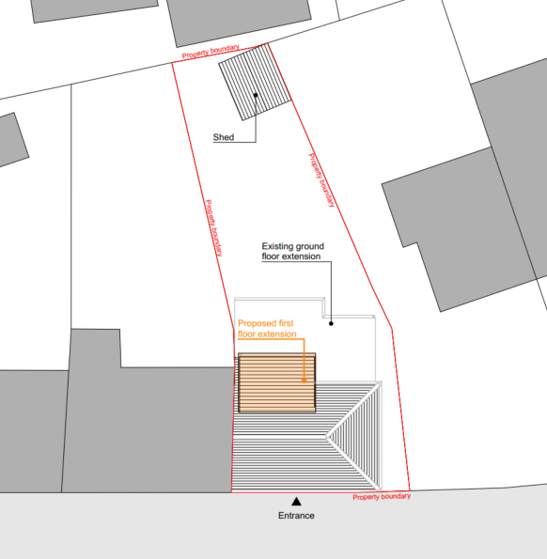

Block Plan

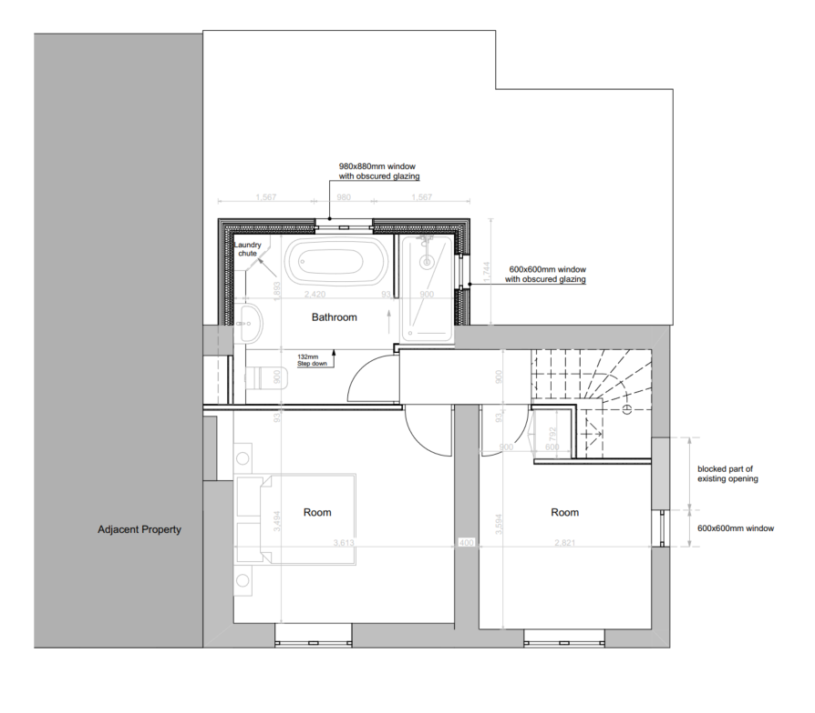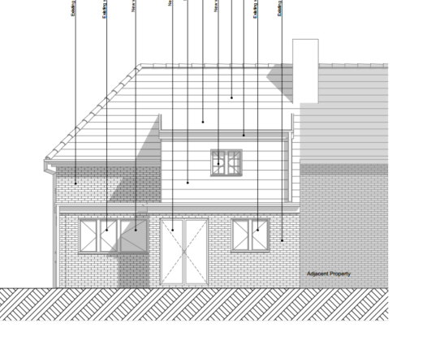

Proposed First Floor Plan and Rear Elevation

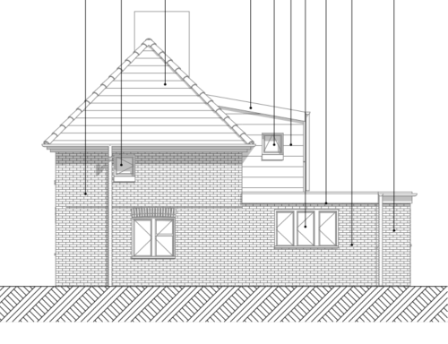

Proposed Side Elevation

SITE DESCRIPTION/CONTEXT

No. 5 Deweys Lane comprises an end-terrace dwelling within a row of three two-storey properties. Whilst the terrace has a substantial overall length of approximately 26 metres, the original two-storey elements are relatively shallow, with a depth of around 5.3 metres. As a consequence, all three dwellings have been extended at ground-floor level to the rear. The existing extension at No. 5 has a flat roof, whilst the neighbouring extension at No. 3 incorporates a lean-to roof design. No. 1 has been more extensively altered, with the addition of a first-floor rear extension above its ground-floor extension. The rear elevations face in a north-northwest direction.

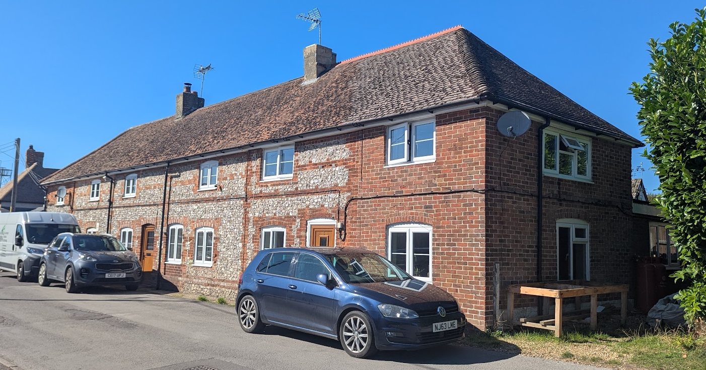

The terraced row – No 5 on the right

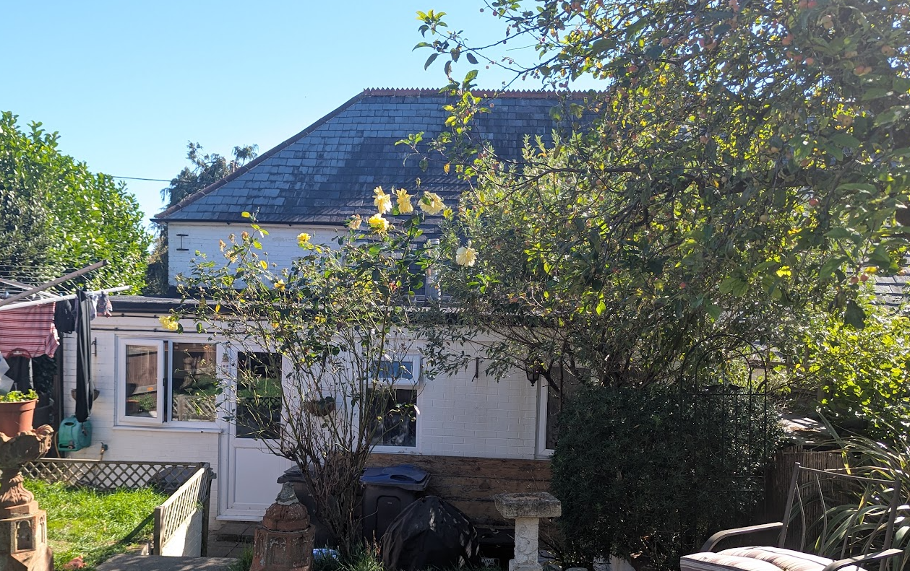

Existing Rear Elevation of No 5

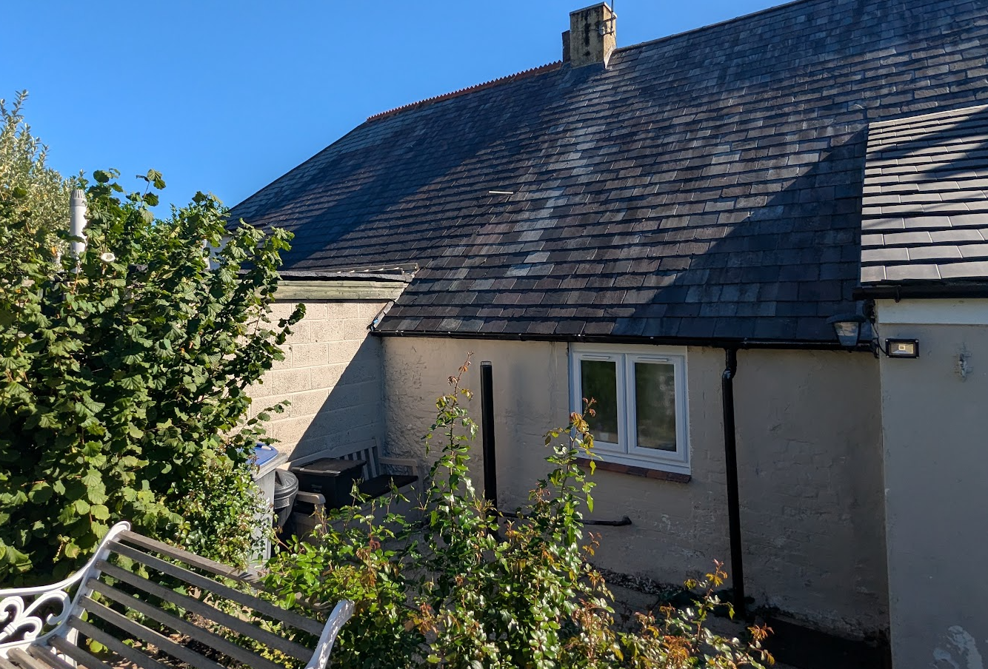

View of No 5 (left) from No 3’s rear garden

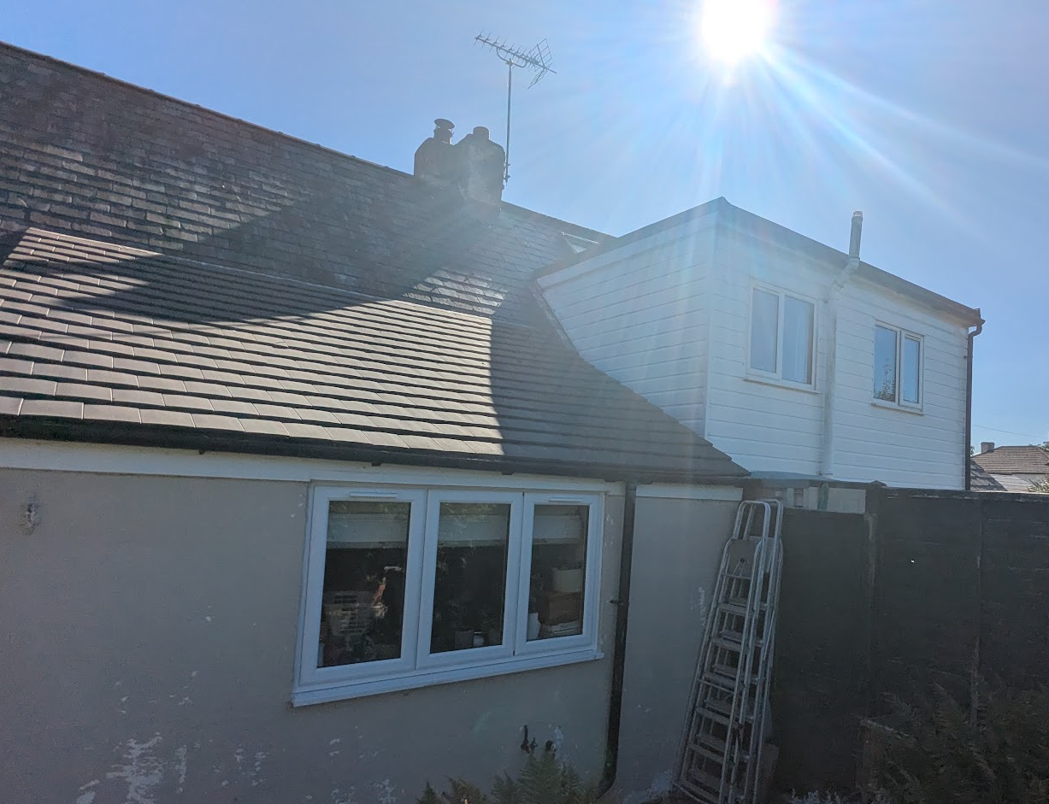

View from No 3 towards No 1 and its two storey rear extension/dormer

To the east of the application site is a pair of semi-detached dwellings, Nos. 7A and 7B Dewey's Lane. No. 7A contains two south-facing windows at ground-floor and first-floor level within a projecting section of the dwelling. These windows are orientated obliquely towards the application site rather than directly facing it, as can be more clearly seen on the approved plans for application E/09/1051/FUL.

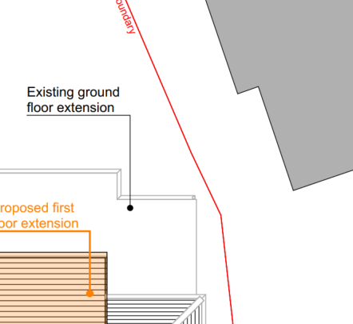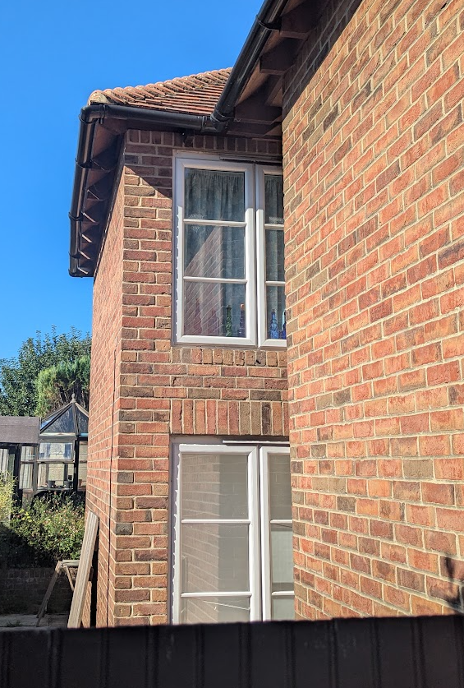

Block Plan Extract and the two identified windows

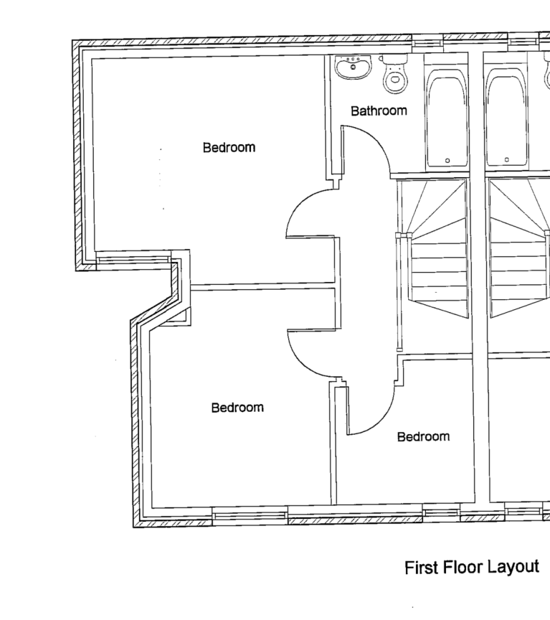

Extract from first floor plan in application E/09/1051/FUL from which No 7a was permitted

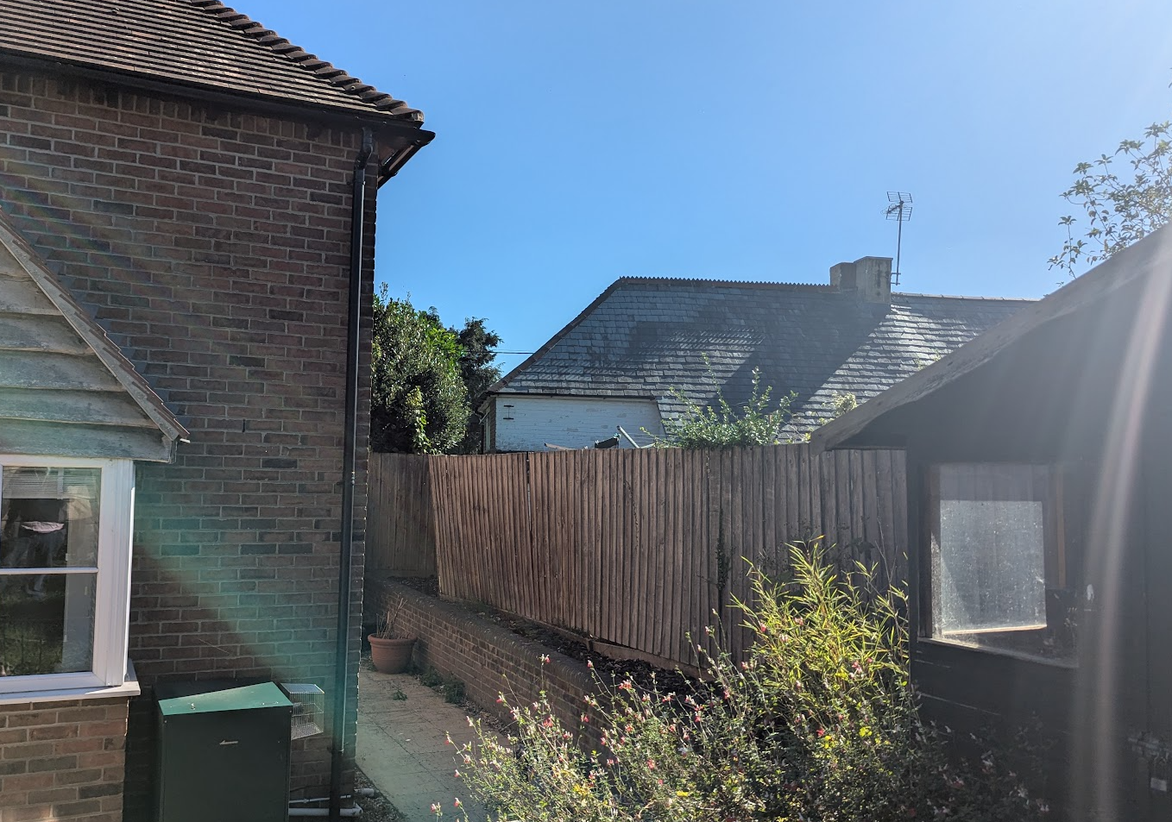

View from No 7a’s rear garden

The application site is subject to the following planning policy constraints:

- Ludgershall Conservation Area
- Listed as a significant unlisted building (the whole terrace is)
- 6.4km buffer zone of the Salisbury Plain Special Protection Area
- Ground water levels between 0.025-0.5m below the surface

PLANNING HISTORY

There is no relevant planning history on this site.

RELEVANT POLICIES AND GUIDANCE

Wiltshire Core Strategy:

- Core Policy 50: Biodiversity and Geodiversity
- Core Policy 57 Ensuring High Quality Design and Place Shaping
- Core Policy 58: Ensuring the Conservation of the Historic Environment
- Core Policy 67: Flood Risk

Ludgershall does not have a Neighbourhood Plan or Area Designation.

Wiltshire Design Guide: Appendix D – Design Guidance for Householder extensions

Ludgershall Conservation Area Character Appraisal and Management Proposals – March 2007

The National Planning Policy Framework (NPPF)

The Planning Practice Guidance

CONSULTATION RESPONSES

Ludgershall Town Council: No comments received

Wiltshire Council Conservation Officer: No comment to make

REPRESENTATIONS

4x neighbour notification letters were sent out allowing for 21 days consultation.

No comments were received.

ASSESSMENT

Section 38(6) of the Planning and Compulsory Purchase Act 2004 states:

"If regard is to be had to the development plan for the purposes of any determination to be made under the planning Acts, the determination must be made in accordance with the plan unless material considerations indicate otherwise."

In accordance with this statutory requirement, this application has been assessed against the relevant policies of the Development Plan, including the adopted Wiltshire Core Strategy (2015) and, where applicable, any made Neighbourhood Plans.

Design and Impact upon the character and context of the area
Core Policy 57 - Ensuring High Quality Design and Place Shaping of the Wiltshire Core Strategy seeks to ensure that all new development is of high design quality, reflecting local context, character, and distinctiveness.

Policies DP3 and DP4 of the National Planning Policy Framework require development to achieve a high standard of design that responds positively to local character and context. In assessing design quality, regard should be had to matters including scale, siting, form, appearance, materials and the relationship of development to its surroundings.

The proposed extension would be positioned to the rear of the dwelling above an existing flat-roofed ground-floor extension. Whilst the lean-to roof form does not replicate the principal roof design of the host dwelling, the extension would be modest in scale, projecting approximately 2 metres from the existing rear wall and remaining subordinate to the original building. It would also be set in from the eastern side elevation, ensuring that views of the extension from the public realm are limited and that the existing form of the terrace remains readily appreciable when viewed from Dewey's Lane.

The surrounding terrace has already undergone varying degrees of alteration and extension. In particular, No. 1 Dewey's Lane benefits from a substantially larger first-floor rear extension. In this context, the proposal would not appear incongruous or out of keeping with the established pattern of development. The proposed materials, comprising grey slate-hanging tiles and an EPDM roof covering, are considered appropriate for their location on a rear addition and would not result in unacceptable harm to the appearance of the dwelling or wider street scene.

Whilst the extension cannot be regarded as an exemplary design solution, its limited scale, subordinate form and largely screened position ensure that it would have a neutral and acceptable impact on the character and appearance of the host dwelling, the terrace as a whole and the surrounding area.

Having regard to the above, the proposal complies with the design principles set out in Core Policy 57 of the Wiltshire Core Strategy, Appendix D of the Wiltshire Design Guide and the NPPF.

Amenity
Point vii of Core Policy 57 - Ensuring High Quality Design and Place Shaping of the Wiltshire Core Strategy seeks to ensure that developments do not adversely affect neighbouring properties.

Policy P3 of the National Planning Policy Framework requires development to be appropriate for its location, taking account of its likely effects on health, living conditions and the environment. In particular, Policy P3(2)(b) requires development to avoid giving rise to unacceptable impacts on the living conditions of neighbouring residents and occupiers. In assessing amenity impacts, regard should be had to matters including daylight and sunlight, outlook, privacy, overbearing impacts and other effects on residential amenity.

The proposed development has been assessed in terms of its potential impact on the residential amenity of neighbouring properties, with particular regard to loss of light, overshadowing, loss of privacy, and overbearing effects.

Loss of Light / Overshadowing

The proposed extension would be modest in scale, projecting approximately 2 metres from the existing rear wall and being positioned above an existing ground-floor extension. Given the limited depth of the proposal, its siting on the rear elevation and the fact that the neighbouring rear gardens are located to the north of the terrace, it is not considered that the development would result in any materially greater loss of daylight or additional overshadowing than that already arising from the existing dwelling and its principal roof form. Accordingly, no unacceptable impact upon neighbouring residential amenity is identified in respect of daylight or sunlight.

Loss of Privacy

The proposed extension would incorporate two windows serving a bathroom. These windows would be obscurely glazed, secured by condition. Subject to this condition, the proposal would not give rise to unacceptable overlooking or loss of privacy to neighbouring occupiers. Nevertheless, consideration has been given to the relationship with both adjoining properties.

Impact on No 3

The rear-facing bathroom window would primarily overlook the application property's own rear garden. Whilst oblique views across parts of No. 3's rear garden may be possible, the proposed obscure glazing would prevent direct overlooking. The potential visibility of the window would increase towards the far end of No. 3's rear garden although this would be partially mitigated by existing boundary trees and hedging. By contrast, the area of garden closest to the dwelling, where residents are most likely to spend time on their patio, would experience limited visibility of the proposed window.

Due to the stepped nature of the gardens, the combination of the proposed bathroom window and replacement patio doors may result in a modest increase in awareness of neighbouring activity. However, such inter-visibility is characteristic of a terraced residential environment and the degree of harm arising would not be so significant as to justify refusal of the application.

Impact on No 7a

The rear-facing bathroom window would primarily overlook the application property's own rear garden. However, the shared boundary with No. 7A does not run perpendicular to the rear elevation and instead follows an approximate 30-degree angle. The straight-line separation distance between the proposed window and the rear garden of No. 7A, the only private amenity space, would be approximately 10 metres. Given the obscure glazing proposed, direct views towards the neighbouring property would not be possible with the installation of a ventilation stay to restrict opening.

In addition, the proposed side-facing bathroom window would be a relatively small secondary window serving a non-habitable room. Subject to the recommended condition requiring the glazing to remain obscure, the window would not permit direct views towards the habitable room windows within the side elevation of No. 7A. Accordingly, no unacceptable loss of privacy would arise from this element of the proposal.

Overbearing Impact

Particular consideration has been given to the relationship with No. 3 Dewey's Lane. Whilst that property benefits from a ground-floor rear extension, it does not extend across the full width of the rear elevation, and a ground-floor window is located close to the shared boundary. The proposed first-floor extension would therefore be fully visible from parts of No. 3's rear extension and garden and would introduce an increased sense of enclosure when compared with the existing situation.

However, the extension would be relatively modest in scale, projecting only approximately 2 metres beyond the existing rear wall and incorporating an eaves height of approximately 2.3 metres above the existing flat-roofed extension. Whilst some limited harm to outlook and a degree of increased enclosure would result, it is not considered that the impact would be so significant as to warrant refusal of the application. On balance, the relationship is considered acceptable having regard to the scale and design of the proposal and the existing built form surrounding the site.

The proposal therefore accords with Core Policy 57 point vii in respect of safeguarding residential amenity, Appendix D of the Wiltshire Design Guide and the NPPF.

Heritage Impact
Section 72(1) of the same Act requires special attention to be paid to the desirability of preserving or enhancing the character or appearance of Conservation Areas.

Core Policy 58 of the Wiltshire Core Strategy seeks to conserve and, where appropriate, enhance the significance of designated and non-designated heritage assets and their settings. Core Policy 57 requires development to respond positively to local character and historic context through high-quality design.

Policies HE4-HE10 of the National Planning Policy Framework recognise heritage assets as an irreplaceable resource and require proposals affecting heritage assets to be assessed having regard to their significance and the contribution made by their setting.

The application site lies within the Ludgershall Conservation Area and forms part of the terrace comprising Nos. 1-5 Dewey's Lane, which is identified within the Conservation Area Appraisal as a locally important unlisted building that makes a positive contribution to the character and appearance of the Conservation Area. The terrace derives its significance primarily from its traditional cottage form, modest scale and use of locally distinctive materials, including a combination of brick and stone elevations, which contribute to the area's local distinctiveness and historic townscape character. The site lies within Character Zone 2, an area characterised by modestly scaled historic cottages, simple building forms and a strong relationship with the historic street pattern.

The proposed extension would be located to the rear of the dwelling above an existing flat-roofed extension. Whilst the lean-to roof form does not reflect the design of the principal roof, the extension would be modest in scale, subordinate to the host dwelling and set well in from the side elevation. As a result, it would be largely screened from public views within Dewey's Lane, allowing the established form and appearance of the historic terrace to remain readily appreciable.

The proposal would not result in the loss, concealment or alteration of the features that contribute to the significance of the locally important unlisted building, namely its traditional cottage form, principal roofscape and the distinctive brick and stone front elevations experienced from the public realm. Furthermore, the extension would not interrupt or detract from views experienced within the Conservation Area. By reason of its rearward location, modest scale, subordinate form and limited visibility from Dewey's Lane, the proposal would preserve the contribution that the building makes to the character and appearance of the Conservation Area. In reaching this conclusion, regard has been had to the surrounding terrace having experienced varying degrees of alteration, including a substantially larger first-floor rear extension at No. 1 Dewey's Lane. In this context, the proposal would appear as a modest addition that would not detract from the character or appearance of the terrace or the wider Conservation Area

The development is therefore considered to comply with Core Policy 58 of the Wiltshire Core Strategy and Section 72 of the Planning (Listed Buildings and Conservation Areas) Act 1990. The proposal would preserve the character and appearance of the Ludgershall Conservation Area and accords with the relevant provisions of the NPPF.

Drainage and Flood Risk
Core Policy 67 seeks to ensure development does not increase flood risk on-site or elsewhere and includes appropriate drainage where necessary. Policies F7 and F8 of the NPPF seek to ensure flood risk and drainage are appropriately managed.

The application site is identified as being susceptible to groundwater flooding. However, the proposal relates to a first-floor extension above an existing ground-floor extension and would not increase the building footprint or result in any additional areas of hardstanding. As such, the development would not materially alter existing drainage arrangements or increase the risk of flooding either on the site or elsewhere.

Accordingly, the proposal is considered to comply with Core Policy 67 of the Wiltshire Core Strategy and the relevant provisions of the NPPF relating to flood risk and drainage.

Biodiversity Net Gain
Householder planning applications are exempt from the requirement to deliver Biodiversity Net Gain under Schedule 7A, Section 4(2)(a) of the Town and Country Planning Act 1990, as inserted by the Environment Act 2021.

Public Sector Equality Duty (PSED)
In reaching this decision, due regard has been had to the Public Sector Equality Duty under Section 149 of the Equality Act 2010. This requires the Local Planning Authority to have regard to the need to eliminate discrimination, advance equality of opportunity and foster good relations between persons who share a protected characteristic and those who do not.

The Local Planning Authority is satisfied that the proposal would not result in any unlawful discrimination and that any impacts on protected groups have been appropriately considered as part of this assessment.

CONCLUSION

The proposed development is considered to be acceptable in terms of its design, character and appearance, and would not result in any unacceptable harm to the amenities of neighbouring occupiers.

Furthermore, the proposal would not result in any unacceptable impacts in respect of any other material planning considerations.

The proposal is therefore considered to comply with the relevant policies of the Wiltshire Core Strategy, the National Planning Policy Framework and all other relevant material considerations. As such, the application is recommended for approval, subject to conditions.

RECOMMENDATION: That Planning Permission be GRANTED subject to conditions.

