Holly House, Ansty Coombe Lane, Ansty

DAS / Heritage Assessment Addendum

25.09.2026

Introduction

The proposed works to Holly House, Ansty will be visible from grade II listed Hillside Farm, Ansty and will therefore, necessarily, affect that heritage asset. This historic assessment looks at the listed building’s significance, the design concept of the proposed works to Holly House and the work’s impact in relation to the listed building.

from NPPF August 2026 HE5: Assessing effects on heritage assets

1. Development proposals affecting heritage assets should be accompanied by an assessment of the significance of the assets affected (including any contribution made by their setting) and of the potential effect of the proposal on their significance. The level of detail should be proportionate to the assets’ importance and no more than is necessary to understand the potential effect of the proposal on their significance. The relevant historic environment record should be referred to in making this assessment, and appropriate expertise employed where necessary.

2. Assessments of the potential effects of development proposals on the significance of heritage assets (including through effects on their setting) should identify whether proposals would be likely to:
a. Have a positive effect, which is where the significance of a heritage asset would be enhanced, or better revealed; or
b. Have no effect on the significance of a heritage asset; or
c. Result in harm to the significance of a heritage asset, either from work affecting the asset itself or from development within its setting. The degree of harm should be identified: substantial harm would occur where the development proposal would seriously affect a key element of the asset’s significance; or
d. Cause the total loss of the significance of a heritage asset.

3. In making this assessment it is the effect on a heritage asset’s significance rather than the scale of the development which should be considered.

4. Decision-makers should be satisfied that assessments accurately reflect the effects on heritage assets caused by development proposals.

5. Where a development proposal involves, or has the potential to involve, a heritage asset with archaeological interest, an appropriate desk-based assessment should be undertaken and, where necessary, a field evaluation. These should be used to help understand the asset’s significance and the potential effect of the proposal on this, which should inform the design, mitigation and implementation of the development.

Assessment of Significance

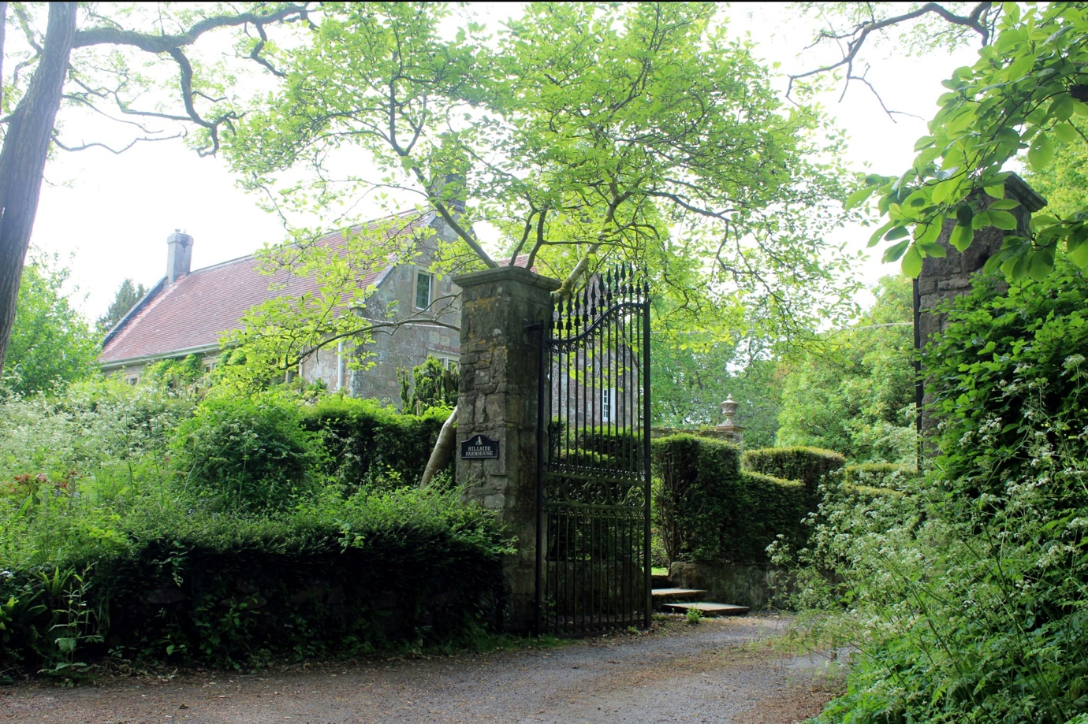

Figure 1 Hillside Farmhouse from drive

Hillside Farmhouse is set away from the village, against a treed landscape with a SSE view from the first floor of its principle elevation across a field. The eastern edge of that field is bounded by post war development {fig.7}. Holly House is part of that development.

The listed farmhouse is a mid 18thc century provincial building with aspirations of Georgian modernity with its double piled configuration and arched headed front door yet still holds onto its 17th century proportions and stone mullioned windows. It was certainly built to impress with its proud stone facades and gated approach from Ansty Coombe Lane. It was modernised later with sash windows and a flat roofed extension in the 20th c.

Listing from Historic England
3/30 Hillside Farmhouse
II
Detached house. Dated 1744 on keystone over door. Dressed limestone, tiled roof, gable-end rendered stacks. Double-pile; parallel range plan. 2-storey, 3-window. Central 4-panelled door with fanlight in beaded stone elliptically-arched case with keystone and impost, 1-light and 3-light beaded mullioned window either side. First floor has three 2-light beaded mullioned windows. Right return has 2-light mullioned window to front range and two small sashes to rear range, first floor has same windows. Left return has 2-light mullioned window to first floor and attached C20 single storey flat-roofed extension. Rear has half- glazed door with flat wooden hood on consoles, two 15-pane sashes either side, first floor has five 12-pane sashes with reset carved stone aprons with swags. Interior has newel stairs with three turned balusters per tread, doors with 6 panels and central bead, marble fireplace surrounds.
Listing NGR: ST9547026533

The Design Concept

Appearance

Holly House is built slightly sunken into the natural slope and hard up against the field in the foreground. Hillside Farm can see, looking across Ansty Coombe Lane from its upper bedroom windows, the upper half Holly House’s NW and SW elevations. Please see the converse views from Holly House to Hillside Farmhouse {fig 3&4}.

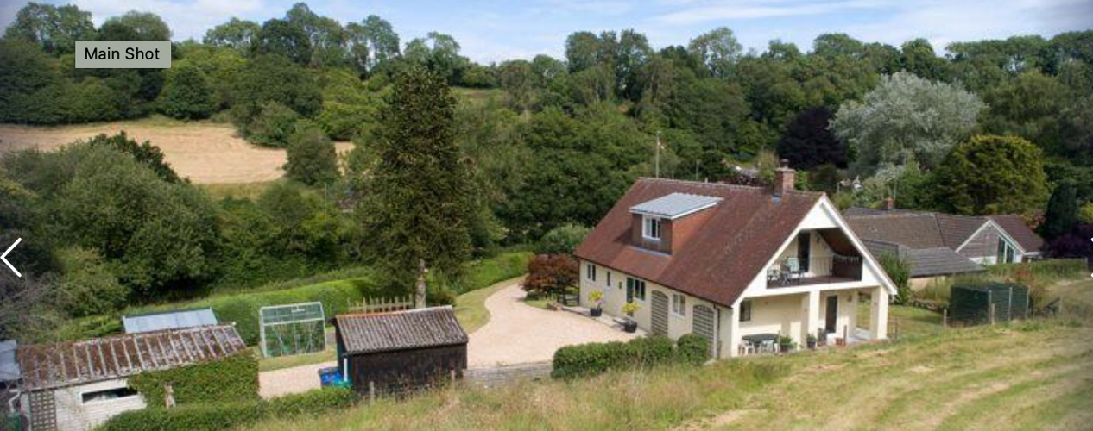

Figure 2 View from the West of Holly House’s NW and SW (gable) elevations

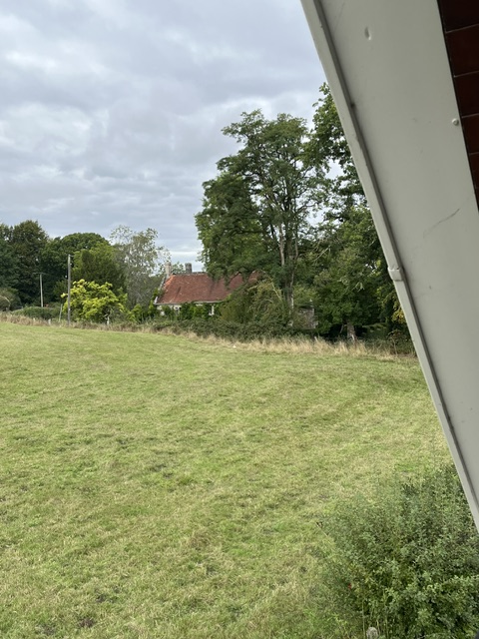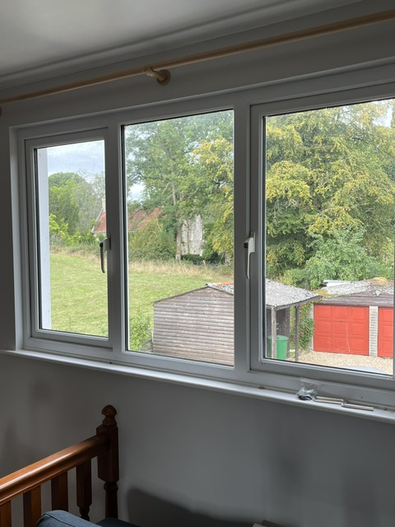

Figure 3 Oblique view of Hillside Farmhouse from existing 1st fl SW terrace
Figure 4 Oblique view of Hillside Farmhouse from existing 1st fl NW dormer

That oblique view from Hillside Farmhouse sees a chalet styles, post war building of no architectural merit with scruffy garden sheds and a large and a 1st floor terrace looking up the hill across the field towards the woodland.

The proposed works at Holly House that will effect the view from Hillside Farmhouse include the replacement of the garden sheds with one timber clad, tile roofed garage and reconfiguring the SW (gable elevation) with the section of roof rotated 90 degrees.

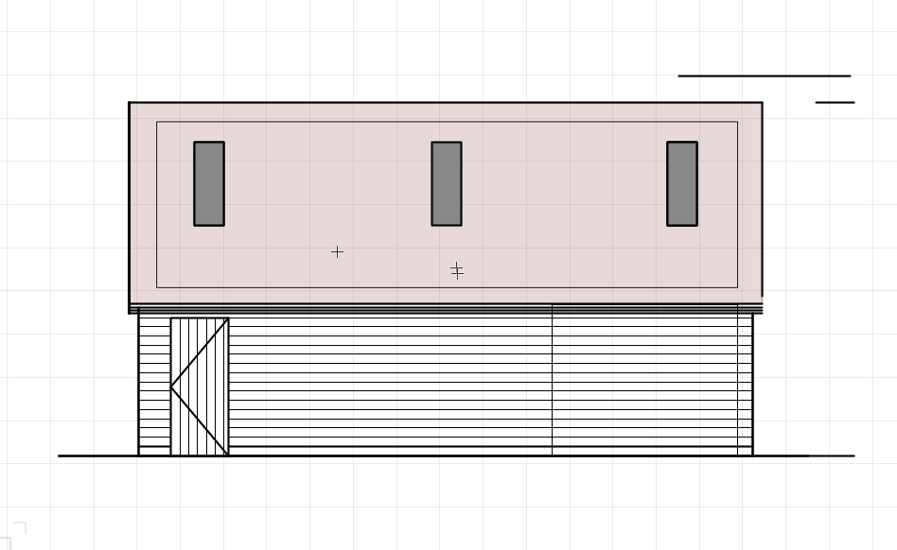
Figure 5 NW ele’ of Proposed Garage, perpendicular to the edge of the field

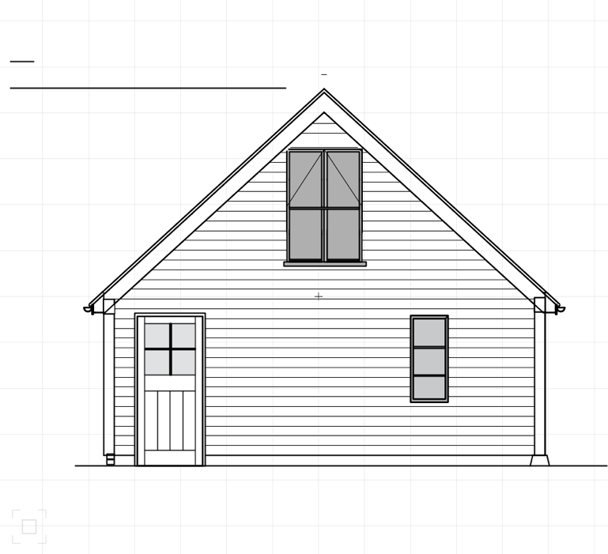
Figure 6 SW elevation of Proposed Garage

We believe plain clay tiles and tidy timber clad elevations of the proposed garage elevations will be visually more attractive than the bitumen felt and corrugated iron of the existing sheds and, in respect of the ancillary buildings of Holly House, enhance the limited view from Hillside Farm. Also, the windows in each of the garage gable elevations will look to ENE and WSW the over fields, not Hillside Farmhouse itself. Finally, the ridge of the proposed garage has now been lowered by over a foot (360mm) to reduce the scale of this single storey, ancillary building.

On Holly House itself the roof of the chalet style building will be reconfigured to provide a ‘I’ shaped roof plan (new ridges with gables under on either end). This will replace the large SW facing, 1st fl terrace with a smaller Juliet balcony framed by a pair of side lights.

The existing NW elevation is rendered and again, with its banal single flat roofed dormer, of no architectural merit. The proposed façade will defeat the inappropriate chalet style by framing the existing ridge and flat roofed dormer with prouder, timber clad gabled elevations. These picturesque features will enhance both the appearance of Holly House and the limited view from Hillside Farm

Impact Assessment

Inter-visibility

There is a line of sight between the proposed works to Holly House and the listed Hillside Farmhouse. However, there is a 60m gap between the two houses, mature trees screen partially the views, the sight line is from the upper stories of each house and those views, either way, is oblique.

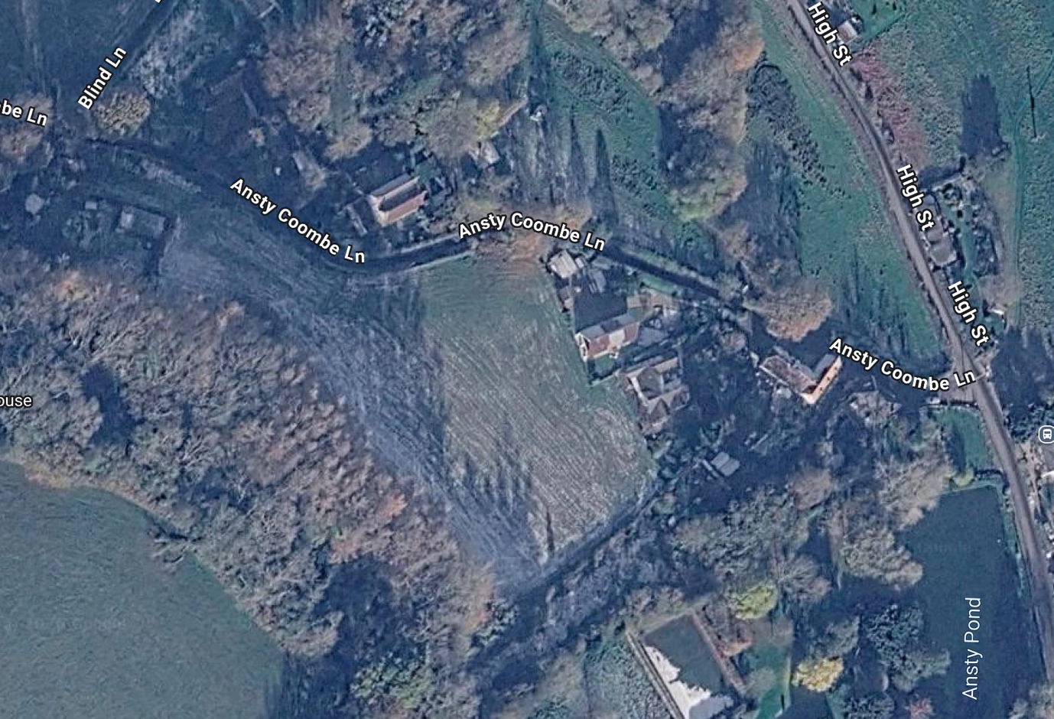

Figure 7 Google Earth view with Hillside Farmhouse left and above centre looking SSE across the centre ground field towards Manor House tennis court

Also, the proposed extension, reconfigured roof and garage do not block key historical views of the listed building from public roads (Ansty Coombe Lane), footpaths, or well-known vantage points (May Pole).

The impact of the proposed development to Holly House on the setting of the listed Hillside Farm will be either neutral (it does not interrupt an important view) or positive (the oblique view of Holly House and its ancillary garage will be improved).

Glazing and the Adjacent house to the SE
Despite the unconditional positive feedback from the adjacent neighbour to the SE the glazing of the proposed SE (flank) elevation of Holly House has been reduced by removing the window to the gable elevations (bed 1 and 3). Within the dormer between those two gable elevations the bathroom windows have been reduced and now specified to include obscured glazing. The existing central bedroom window has been reduced.

End of DAS / Historic Assessment Addendum

