Public Art comments: PL/2026/04685 - Hawke Ridge Business Park, Westbury, BS13 4LD
Erection of: (i) 1 No. retail convenience store (Class E), 3 No. flexible retail units (Class E), and roadside drive through unit (sui generis); (ii) a 64-bed care home (Class C2); and (iii) 249 No. residential dwellings (Class C3) with associated access, green and blue infrastructure works.

Applicant/Developer: Hawke Ridge Business Park Ltd and Bellway Homes Ltd

Background and context
Heywood is a civil parish and small village lying to the north of Westbury. The village has approximately 200 inhabitants. The parish also includes the hamlets of Hawkeridge and Norleaze. A number of historic buildings survive in the parish, including Brook Hall, a c.1600 farmhouse which incorporates a Grade I listed wing of a 15th century manor house, and the Grade II listed Heywood House built in Jacobean style in 1839.

Map showing outline of parish boundary
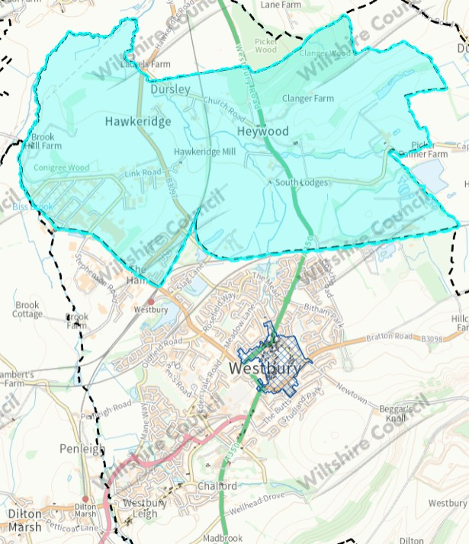

Outline of proposed site
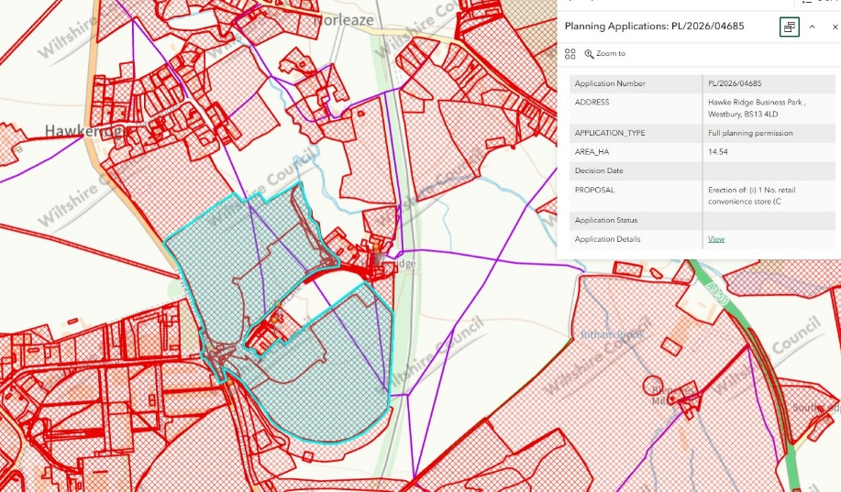

Within the context of the parish of Heywood, the proposed application of 249 residential dwellings, a 64-bed care home, various retail units and a roadside drive through constitutes, relatively speaking, a disproportionate amount of development. Developments of this size can disrupt the established character, identity, and social balance of small rural settlements.

In the context of a large amount of development, the provision of public art is justified as a proportionate and necessary measure to mitigate its impact and support successful integration.
We would therefore seek a public art contribution to integrate the development, create a linking identity with Heywood and the hamlets of Hawkeridge and Norleaze, and to address identity merge with The Hams in Westbury.
I note comments from Heywood Parish Council on 21/09/2026, that state the Parish Council resolved to object to the application.

A scheme to integrate the proposed development into the parish would support place-shaping, village identity, community cohesion, and enable a scheme that is accessible to existing members of the parish as well as new residents.

Rationale
The provision of public art is justified as a proportionate and necessary measure to both mitigate the impact of development, and support its successful integration.
Public art provides a means of embedding locally responsive elements that can reflect the area’s history, culture and environment, helping development to feel assimilated rather than imposed.
Our guidance on public art was adopted by Cabinet in 2024, and the Council is able to demonstrate a robust methodology benchmarked against several other authorities. There is an identified specific site-based requirement as a result of this development, and we can point to several appeals where public art contributions have been found compliant and secured.
You will also note the recent Secretary of State decision - dated 28 July 2026 - re: PL/2024/07097 - Land South of Snarlton Farm, Snarlton Lane, Melksham, SN12 7QP - APP/Y3940/W/25/3373278, which agrees with the submitted CIL compliance statement which makes reference to the public art contribution (as does the agreed S106):
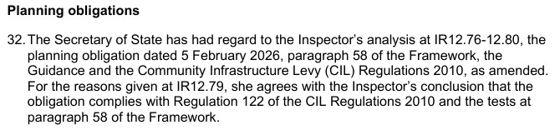
Public Art contributions provide a policy compliant mechanism that will help mitigate the impact of this development – address identity merge with Westbury – while also assisting integration with existing and incoming communities.

This is essential in the context of the parish of Heywood to create a sense of place and so as not to undermine community cohesion with regards to WCS CP3, WCS CP57 and NPPF.

Potential locations
There are several suitable locations for a public art scheme (TBD), especially at strategic points (marked by yellow dots) connecting to a RoW that links to Heywood village (with access to Heywood and Hawkeridge Village Hall) and the hamlets of Norleaze, and Hawkeridge (which has a public house).
Locations that connect to - or are visible by - existing communities or other developments can further assist with intergration, cohesion and place-shaping, while enabling a scheme that is accessible to as many residents as possible.

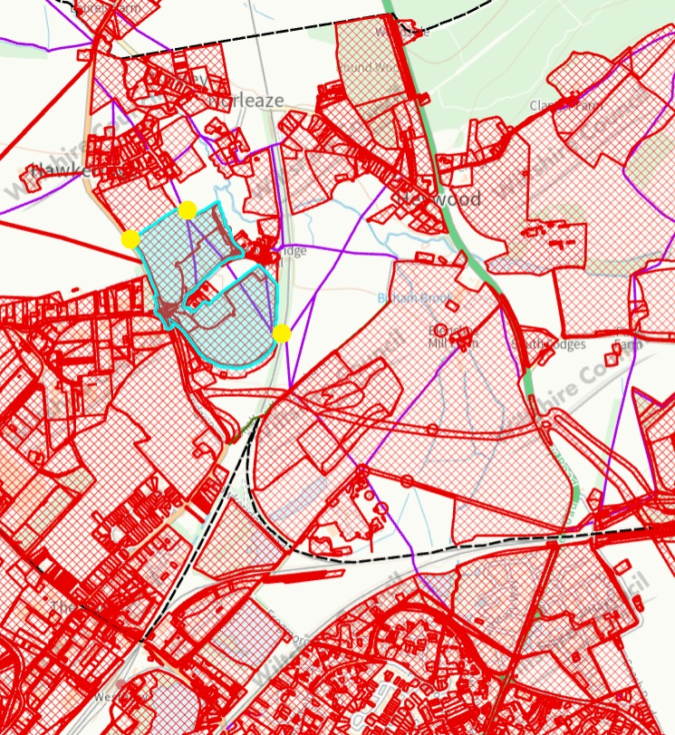

This approach would also align with Bellway’s internal-facing Placemaking Policy (June 2026) and their objective relating to creating “…environments that foster a sense of community and belonging.”

Contribution threshold
- Development of 50 dwellings and more
- £300 per residential dwelling

Indicative figure
Although there is more than one aspect of the application that could trigger a Public Art Contribution, I see nothing to justify looking at them individually so am using the greatest development implication, which are the residential dwellings.

Using planning obligations, the indicative public art contribution figure for a site of 249 dwellings would be £74,700 (see: contribution threshold and calculation) to be commuted prior to commencement to Wiltshire Council’s Arts Service to devise and manage the scheme/s.

The Public Art Officer (publicart@wiltshire.gov.uk) encourages early engagement from Developers regarding sites/schemes that may be incorporated into the Development or the vicinity of the Development
Contribution calculation
To provide a consistent, sustainable and transparent approach for our Public Art programme, our communities and Developers, Wiltshire Council has held its ‘fixed per dwelling’ figure since its implementation in 2009.

The 2009 figure was calculated* using the internationally established Public Art funding mechanism, Percent for Art** i.e. up to 1% of capital costs derived from an average build cost per residential dwelling in England. In this case, taking a conservative approach of 0.5% and the lower end of a typical standard newbuild.

[*build cost per dwelling (RICS) x average floor space per dwelling (English Housing Survey) = lower end of average cost per dwelling (c£60,000 in 2009) x 0.5%
**Percent for Art is an internationally established funding mechanism implemented by authorities, development corporations and housing associations for the commissioning of public art. Normal practice is for up to 1% of capital costs to be allocated for public art]
Summary
Public art is widely recognised within the planning system as a key component of place-making, contributing to distinctive, higher quality environments that go beyond purely functional design and instead create places that reflect local identity and aspirations.

Public art also plays an important role in supporting community cohesion and well-being by creating shared spaces and experiences that bring together existing and new residents, acting as a bridge between communities and helping to foster a sense of belonging.

Community involvement in the delivery of public art schemes encourages participation and dialogue, strengthening social connections, and helping communities adapt to change.

More broadly, it supports and contributes to civic pride, legibility and the usability of public spaces, while reinforcing a shared identity and delivering long-term social value.

As such, public art should not be viewed as decorative but as a legitimate planning tool that supports the assimilation of new development, and the creation of cohesive, inclusive communities.

As per our public art guidance and process, by locating a public art scheme/s around the boundary of the development – with particular interest regarding the RoW connections with the village and hamlets of the parish - it is possible to adopt a more effective and strategic approach to aid place-shaping, integration and support cohesion in accordance with the WCS CP3, WCS CP57, WDG 4.3 Expectation: Destinations, Landmarks and Focal Points, and the NPPF (Aug 2026).

Policy and guidance
- WCS CP3: Infrastructure Requirements [pg. 58, para 4.42]. This promotes and defines public art as a type of place-shaping infrastructure and states that the cost of providing infrastructure may be met through the use of planning obligations.
- WCS CP 57: Ensuring high quality design and place-shaping [page 287, paragraph xii] which promotes “…the integration of art and design in the public realm”
- WDG SPD 4.3.4: “Consider utilising public art to reinforce the landmark status of a place. Public art used for this purpose should have permanence and relevance to the local or wider context of the place. (See also Wiltshire’s Policy and guidance on Public Art and Design)”
- Planning Obligations Supplementary Planning Document (2016) refers to the 2011 guidance note for art and design in the public realm [pg. 31, para 10]. This is superseded by Art and design in the public realm in Wiltshire – 2024 Guidance which is also referenced in the aforementioned Wiltshire Design Guide Supplementary Planning Document (v9, 2024)

In addition, to support strong, vibrant and healthy communities, the NPPF (17.b) recognises “cultural wellbeing” as a ‘social objective’ - one of the three overarching objectives in achieving sustainable development.

