APPLICATION FOR A CERTIFICATE OF LAWFULNESS FOR EXISTING USE OR DEVELOPMENT

APPLICATION REFERENCE: | PL/2026/05031
APPLICATION TYPE: | Lawful development: Proposed use
SITE ADDRESS: | Annexe, 32 Woodmarsh, North Bradley, BA14 0SB
DEVELOPMENT DESCRIPTION: | Application for a certificate of lawfulness for the proposed addition of a caravan, within the curtilage of a commercial yard for ancillary purposes.
RECOMMENDATION: | That a Certificate of Lawfulness be GRANTED

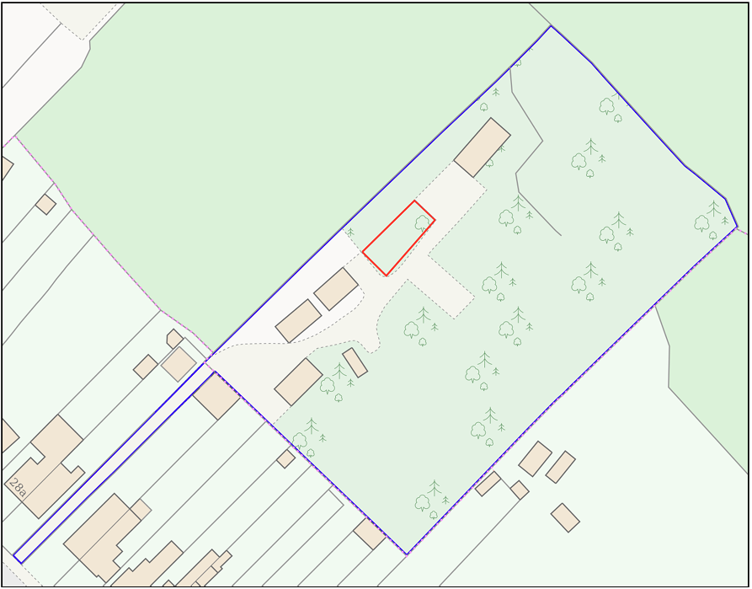

SITE DESCRIPTION AND PROPOSAL

This application seeks a Certificate of Lawfulness for a Proposed Use or Development (CLOPUD) under Section 192 of the Town and Country Planning Act 1990 (as amended).

The application relates to land rear of 32 Woodmarsh, North Bradley. The site comprises a parcel of land which has previously been confirmed as a lawful commercial yard (sui generis) under application PL/2024/02000. The site appears to have formerly been part of an agricultural field but now contains a number of buildings, storage containers and areas of hardstanding associated with the established commercial yard use.

The site lies within the Salisbury Plain SPA 6.4km buffer and within the Yellow Zone of the Trowbridge and Westbury Bat Mitigation Strategy. The site is located outside, but immediately adjacent to, the North Bradley settlement boundary and is situated within Flood Zone 1. The Council's Strategic Flood Risk Assessment identifies no significant surface water or groundwater flood risk affecting the site.

The proposal seeks a certificate confirming the lawful permanent stationing of a caravan within the commercial yard. The submitted plans show the caravan measuring approximately 12.3 metres in length and 5.5 metres in width. Internally, the caravan would provide welfare and administration facilities comprising a canteen, two offices, a storeroom and two WCs.

The applicant relies upon the lawful commercial yard use confirmed under application PL/2024/02000 and contends that the proposed structure falls within the statutory definition of a caravan contained within the Caravan Sites and Control of Development Act 1960 and the Caravan Sites Act 1968.

RELEVANT LEGISLATION AND CONSIDERATIONS

The application has been submitted under Section 192 of the Town and Country Planning Act 1990 (as amended), which enables any person to ascertain whether any proposed use of buildings or land, operational development, or other activity would be lawful if instituted or begun at the time of the application.

Section 192(2) states that a use or operation is lawful if no enforcement action may then be taken in respect of it and it would not contravene any existing enforcement notice in force at the time of the application. Where a Local Planning Authority is provided with information satisfying it that the proposed use or development would be lawful, a Certificate of Lawfulness should be granted.

The Planning Practice Guidance (PPG) on Lawful Development Certificates advises that applications under Section 192 are not applications for planning permission and that the planning merits of a proposal are not relevant considerations. The role of the Local Planning Authority is limited to determining whether the proposal would be lawful if carried out as described in the application.

The applicant relies upon the statutory definition of a caravan as set out within Section 29(1) of the Caravan Sites and Control of Development Act 1960 and Section 13 of the Caravan Sites Act 1968. The legislation provides that a structure designed or adapted for human habitation may be treated as a caravan where it is capable of being moved from one place to another and, where constructed in sections, is composed of no more than two sections designed to be assembled on site. The Caravan Sites Act 1968 further prescribes maximum dimensions of 20 metres in length, 6.8 metres in width and 3.05 metres in internal floor to ceiling height.

In determining this application, the principal considerations are:

- Whether the proposed structure falls within the statutory definition of a caravan contained within the Caravan Sites and Control of Development Act 1960 and the Caravan Sites Act 1968;
- Whether the siting of the caravan would constitute operational development requiring planning permission;
- Whether the proposed use of the caravan would remain ancillary and incidental to the lawful use of the site as a commercial yard;
- Whether the proposal would result in a material change of use of the land; and
- Whether the proposal would establish a separate planning unit.

The burden of proof rests with the applicant to provide sufficiently precise and unambiguous information to demonstrate that the proposal would be lawful if carried out as proposed. In considering the application, the Local Planning Authority must have regard solely to the facts of the case and the relevant legal framework. Matters relating to the planning merits, desirability or acceptability of the proposal are not material to the determination of the application.

REPRESENTATIONS

There is no legal requirement to undertake consultation in relation to an application for a Certificate of Lawfulness. No representations have been sought or received in relation to the application.

RELEVANT SITE HISTORY
The site has the following relevant planning history:

Of particular relevance to the current application is PL/2024/02000 which established the lawful use of the application site as a commercial yard (sui generis).

Reference | Proposal | Decision
20/02535/FUL | Construction of two detached houses on part of builders yard | Refused 02.06.2020
PL/2024/02000 | Certificate of Lawfulness for Existing Use of land rear of 32 Woodmarsh as a commercial yard (sui generis) | Approved 25.04.2024
PL/2025/01323 | Change of use and conversion of three buildings to holiday let accommodation | Approved with Conditions 19.03.2026

ASSESSMENT
Evidence Submitted by the Applicant

The applicant has submitted:

- Planning Statement.
- Existing and proposed site plans.
- Caravan floor plans and elevations.
- Block plan identifying the proposed siting of the caravan.
- Additional plans confirming the internal dimensions of the caravan.
- Details relating to the definition of a caravan within the Caravan Sites and Control of Development Act 1960 and Caravan Sites Act 1968.

The evidence is relevant as it enables the Local Planning Authority to consider whether the proposed structure falls within the statutory definition of a caravan and whether its proposed use would remain ancillary to the established lawful use of the site.

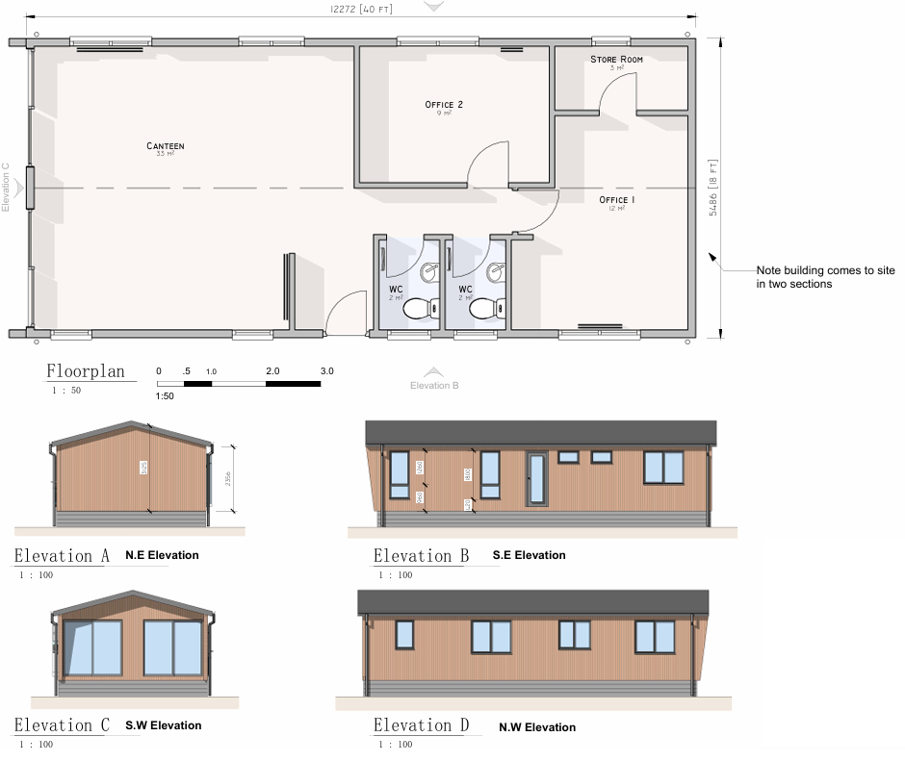
Proposed Floorplan and Elevations

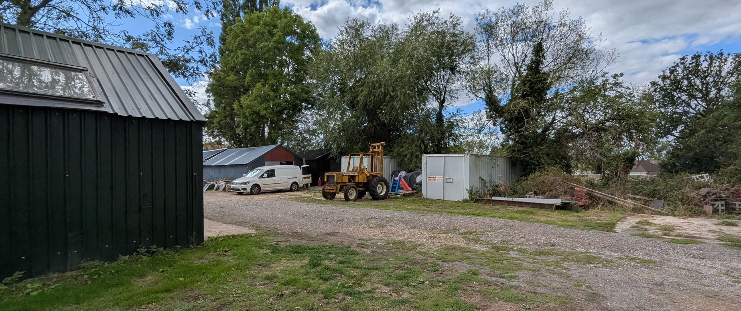
Site Visit (Proposed Location of Caravan)

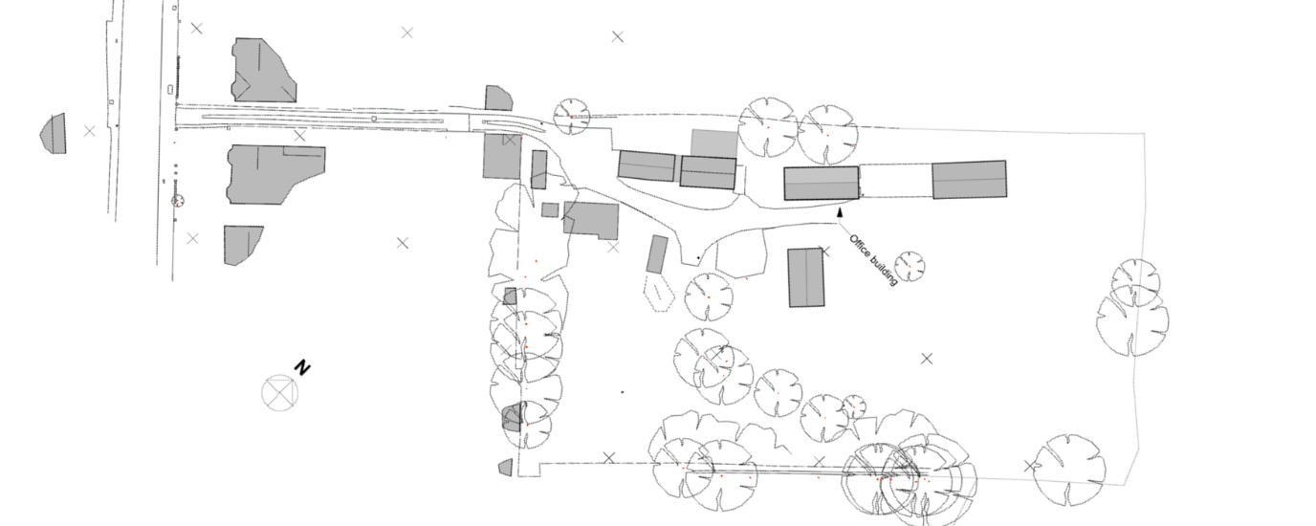
Proposed Block Plan

Assessment

The application relates to proposed development under Section 192 of the Town and Country Planning Act 1990. The assessment therefore turns upon whether the proposal, if carried out as described, would be lawful.

Section 29(1) of the Caravan Sites and Control of Development Act 1960 defines a caravan as a structure designed or adapted for human habitation which is capable of being moved from one place to another. Section 13 of the Caravan Sites Act 1968 extends this definition to include twin-unit caravans constructed in no more than two sections and assembled on site.

The submitted plans specify that the proposed structure would arrive on site in two sections before being assembled. The caravan would measure approximately 12.3 metres in length and 5.5 metres in width when assembled. These dimensions fall comfortably below the statutory maximum dimensions of 20 metres in length and 6.8 metres in width prescribed by the Caravan Sites Act 1968.

During the course of the application, clarification was sought regarding the internal floor-to-ceiling height of the proposed caravan. The originally submitted elevations contained a dimension of 3.125m which was not expressly identified as either an internal or external measurement. In response, the applicant submitted amended plans identifying the finished floor level and confirming that the 3.125m dimension did not represent the internal floor-to-ceiling height. The amended plans specify that the maximum internal height, measured from the finished floor level to the ceiling at its highest point beneath the ridge, is 2.965m. The Local Planning Authority is therefore satisfied that the caravan complies with the maximum internal height limitation of 3.05m prescribed by the Caravan Sites Act 1968 and meets the relevant dimensional requirements of the Act.

Having regard to the submitted plans and supporting information, the Local Planning Authority is satisfied that the proposed structure would meet the statutory definition of a caravan. As such, its stationing on the land would not amount to operational development in the same way as the erection of a building. The principal issue therefore becomes whether its siting would result in a material change of use of the land or creation of a separate planning unit.

The lawful use of the site as a commercial yard was established under application PL/2024/02000. The proposed caravan would provide welfare and administrative facilities comprising office accommodation, canteen facilities, storage and toilets associated with that established use. The proposed facilities are considered reasonably incidental and ancillary to the operation of a commercial yard.

A site inspection undertaken by the Case Officer confirmed the established commercial nature of the site. The site contains a mixture of buildings, hardstanding and storage areas associated with the lawful yard use. The proposed caravan would be sited within this existing commercial context and would serve the needs of those operating from the yard.

Whilst the internal layout includes two office rooms, the Local Planning Authority does not consider this sufficient to indicate the creation of a separate planning unit or a materially different use. The proposed use would remain ancillary to the lawful commercial yard use already established on the land. Given that the proposed accommodation comprises welfare, office and toilet facilities which are ordinarily associated with the operation of a commercial yard, the Local Planning Authority is satisfied that they would not represent an independent primary use of the site.

The submitted evidence demonstrates, on the balance of probability, that the proposed structure would satisfy the statutory definition of a caravan and that its siting for welfare and office purposes ancillary to the lawful commercial yard use would not result in a material change of use of the land.

Accordingly, the proposal would be lawful if carried out in accordance with the submitted plans.

CONCLUSION

On the balance of probability, sufficient information has been submitted to demonstrate that the proposed structure satisfies the statutory definition of a caravan contained within the Caravan Sites and Control of Development Act 1960 and the Caravan Sites Act 1968. Additional information provided during the course of the application confirms that the caravan complies with the dimensional limitations prescribed by the legislation.

Furthermore, the proposed siting of the caravan would serve a purpose ancillary and incidental to the lawful commercial yard use previously established under application PL/2024/02000. The proposal would not result in the creation of a separate planning unit, nor would it give rise to a material change in the lawful use of the land. Accordingly, planning permission would not be required.

The Local Planning Authority is therefore satisfied that the proposal described in the application would be lawful if carried out as proposed and that a Certificate of Lawfulness for Proposed Use should be granted.

RECOMMENDATION

It is recommended that a Certificate of Lawfulness for Proposed Use be granted for:

The stationing of a caravan for ancillary office, welfare, canteen, storage and toilet facilities in connection with the lawful commercial yard use of the land.

Reason for approval: The evidence submitted demonstrates that the proposed structure satisfies the statutory definition of a caravan contained within Section 29(1) of the Caravan Sites and Control of Development Act 1960 and Section 13 of the Caravan Sites Act 1968. The proposed use would remain ancillary and incidental to the lawful commercial yard use established under application PL/2024/02000 and would therefore be lawful if carried out in accordance with the submitted plans.

