APPLICATION FOR FULL PLANNING PERMISSION AND LISTED BUILDING CONSENT CASE OFFICER REPORT

APPLICATION REFERENCE: | PL/2026/04804 and PL/2026/05102
APPLICATION TYPE: | Full planning permission and Listed building consent
SITE ADDRESS: | 16 High Street, Downton, Salisbury, SP5 3PJ
DEVELOPMENT DESCRIPTION: | Proposed Partial Change of Use to Independent Artisan Coffee Shop and Café, Retention of Existing Cobbler Workshop, Internal Reconfiguration of Residential Accommodation and Formation of a timber pergola providing two covered residential parking spaces and associated private garden area to the rear of the site.
RECOMMENDATION: | Approve with Conditions

SITE DESCRIPTION/CONTEXT

The application site relates to number 16 High Street (not listed) which adjoins 14 High Street,
which is a Grade 2 listed building; there are a number of other Grade 2 listed buildings in the vicinity as shown on the map extract below marked with black hatching. The site lies within the designated conservation area of Downton.
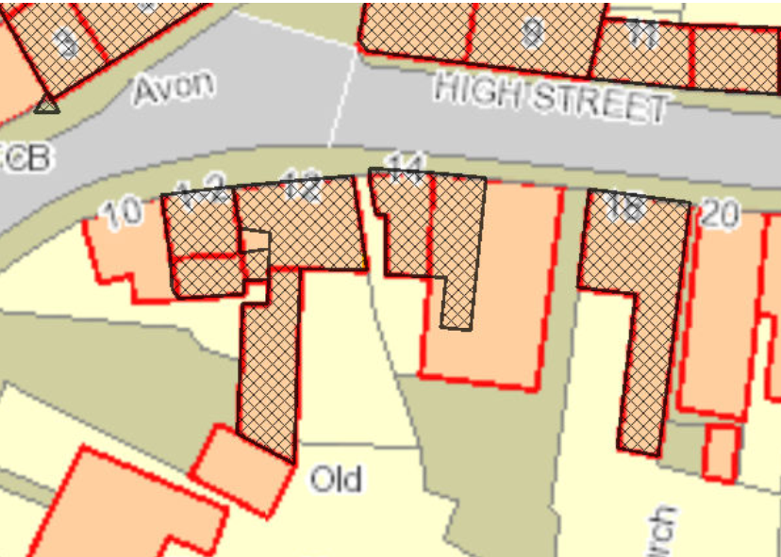

The site is situated in a Special Landscape Area, as defined by Salisbury District Local Plan saved policy C6. Whilst the site is not in close proximity to any river and is in Flood Zone 1; the site is within the catchment of the River Avon Special Area for Conservation (SAC); and is within the 13.8 kilometre recreational buffer zone of the New Forest Special Protection Area (SPA), SAC and RAMSAR site. The property is a mixed used building with commercial at ground floor and residential above; located on the south side of the High Street within an area of mixed use properties.

PROPOSAL

The application is seeking permission for the partial change of use of the ground floor of the property to create an independent artisan coffee shop and café, the existing Cobbler workshop to the rear will be retained. The application also seeks consent for the internal works to facilitate the reconfiguration of the residential accommodation. It is also proposed to erect a single storey timber pergola/car port to provide two covered residential parking spaces and an associated private garden area to the rear of the site.

Proposed site plan Proposed car port
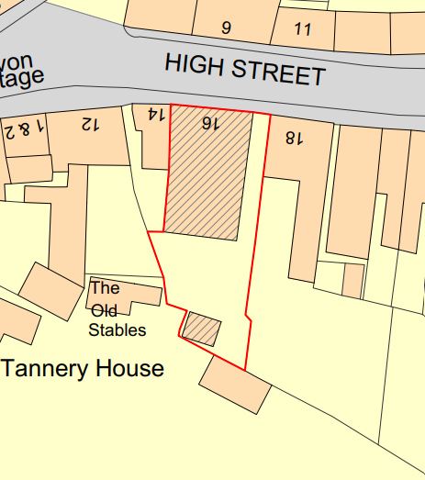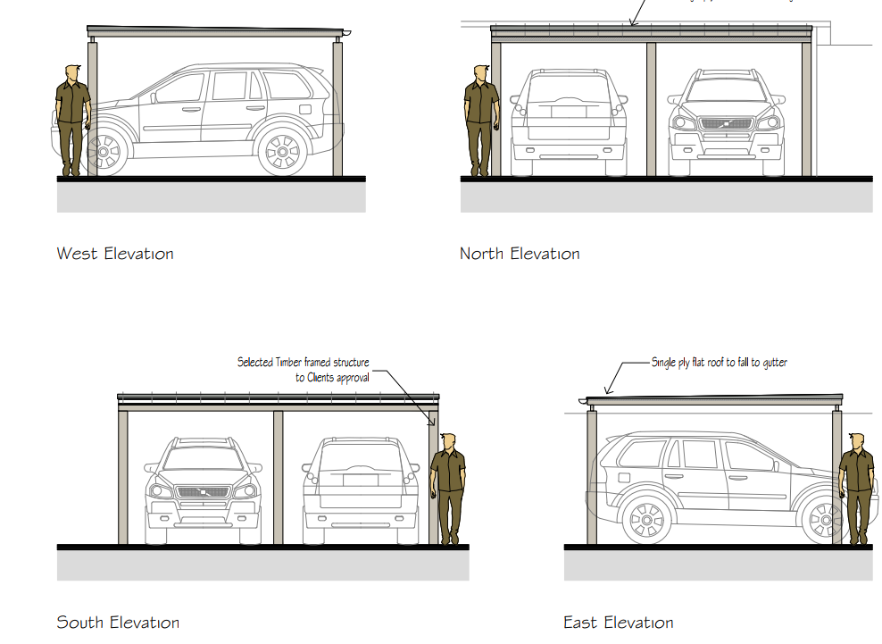

Existing and proposed ground floor plan

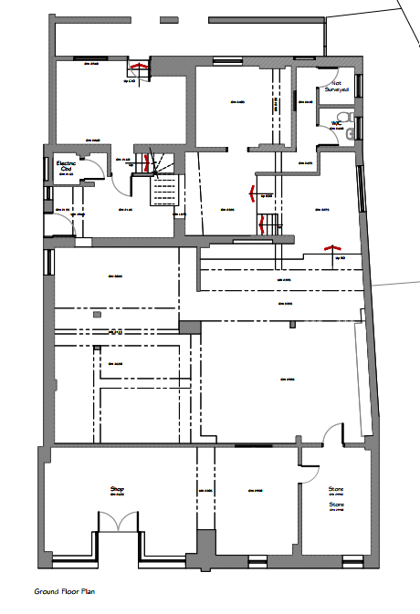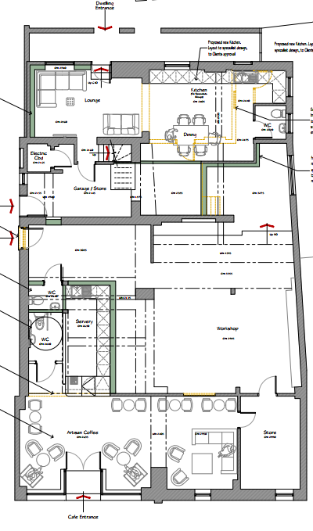
Existing and proposed first floor plan

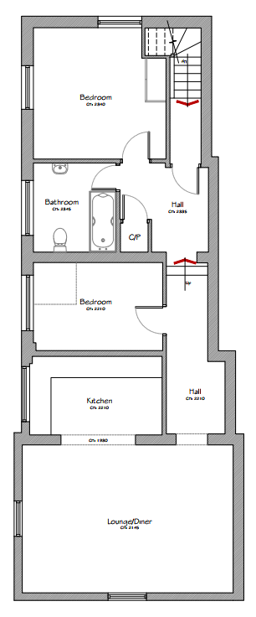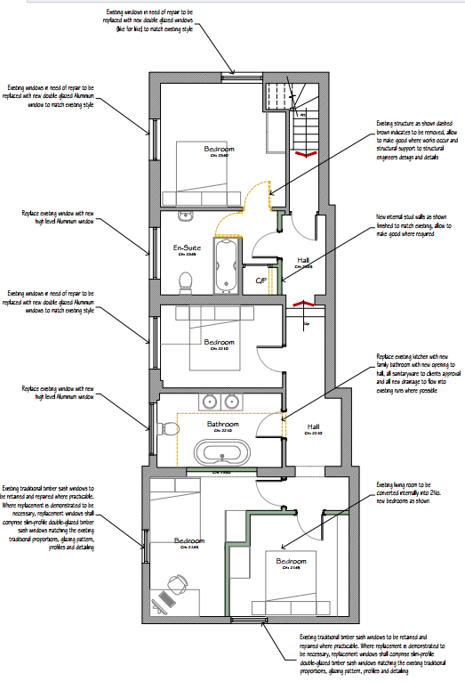

PLANNING HISTORY

S/1989/1029 - Full planning permission Decision - Approve with Conditions Date: 2/8/1989 – alteration to form first floor self-contained flat over existing shop.
13/01112/FUL - Full planning permission Decision - Approve with Conditions Date: 9/6/2014 – Change of use from ancillary office/store rooms on first floor to self-contained 2 bed flat, demolish existing cold store and associated alterations.
17/11564/FUL - Full planning permission Decision - Approve with Conditions Date: 13/6/2018 –Retention of an installed ATM through the shop front right hand window .
17/11837/ADV - Consent to display an advertisement Decision - Approve with Conditions Date: 13/6/2018 – Illuminated ATM fascia signage logos.

RELEVANT LEGISLATION, POLICIES AND GUIDANCE

Sections 16, 66 and 72 of the Planning (Listed Buildings and Conservation Areas) Act 1990

The National Planning Policy Framework (NPPF)
The Planning Practice Guidance
National Design Guide

Wiltshire Core Strategy:
CP1 (Settlement Strategy)
CP2 (Delivery Strategy)
CP3 (Infrastructure Requirements)
CP23 (South Wiltshire Community Area)
CP34 (Additional Employment Land)
CP35 (Existing Employment Land)
CP38 (Retail and Leisure)
CP48 (Supporting Rural Life)
CP49 (Protection of Rural Services and Community Facilities)
CP50 (Biodiversity and Geodiversity)
CP51 (Landscape)
CP57 (Ensuring High Quality Design & Space Shaping)
CP58 (Ensuring the Conservation of the Historic Environment)
CP61 (Transport & Development)
CP62 (Development Impacts on the Transport Network)
CP64 (Demand Management)
CP69 (Protection of the River Avon SAC)

Salisbury District Local Plan policies (Saved by Wiltshire Core Strategy):
C6 – Special Landscape Area

Wiltshire Housing Site Allocations Plan (February 2020) (WHSAP)
Supplementary Planning Documents:
Wiltshire Design Guide (March 2024)
Creating Places Design Guide SPG (April 2006)
Achieving Sustainable Development SPG (April 2005)
Downton Village Design Statement (VDS)
Downton Parish Neighbourhood Plan (NHP)
Wiltshire Local Transport Plan – Car Parking Strategy

Draft Wiltshire Local Plan
At Full Council on 19 May 2026, the elected members of Wiltshire Council agreed to withdraw the emerging Wiltshire Local Plan. The said Plan has no material weight for the purposes of the application.

In accordance with Regulation 19 of the Town and Country Planning (Local Planning) (England) Regulations 2026, on 30th June 2026 Wiltshire Council published a notice of intention to prepare a new local plan for Wiltshire. The next stage is a Scoping Consultation which commences on 2nd September 2026. This plan is at a very early stage and currently carries no weight for decision making.

CONSULTATION RESPONSES

Parish Council - Support

Highways – No objection

Conservation – No objection subject to condition

Public Protection – None received

Ecology – No objections

REPRESENTATIONS

Two third party representations have been received, points made are summarised below –

- Supportive of enterprising attitude of applicants
- Concerns relating to parking and the potential exacerbating of an existing difficult parking situation, with current pressure on parking through existing residents and people accessing existing businesses.

ASSESSMENT

Section 38(6) of the Planning and Compulsory Purchase Act 2004 states:

"If regard is to be had to the development plan for the purposes of any determination to be made under the planning Acts, the determination must be made in accordance with the plan unless material considerations indicate otherwise."

In accordance with this statutory requirement, this application has been assessed against the relevant policies of the Development Plan, including the Wiltshire Core Strategy (2015) and, where applicable, any made Neighbourhood Plans. Consideration has also been given to the policies of the NPPF (NPPF) as a material consideration in the assessment.

The assessment below considers each of the main issues in turn with reference to the relevant policy context, the evidence submitted, consultee responses, and all other material considerations, before a conclusion is reached.

Principle of Development

The site is situated within the defined settlement boundary for the Local Service Centre of Downton, which as per WCS policies CP1 (Settlement Strategy), CP2 (Delivery Strategy) and CP23 (South Wiltshire Community Area), is considered to be the most sustainable location for new development.

The unit already exists and is surrounded by a mix of other commercial uses and residential uses, as is typical of such a location. WCS policy CP38 (Retail & Leisure) recognises the importance of local service centres for the local community, with the supporting text for the latter confirming that ‘In addition to retail development, it is also important that other services and facilities are retained in the central areas of the Market Towns, in order to maintain the vitality and viability of the town centres.

Other Council policies regarding the economy are also relevant. The site is an existing mixed-use commercial and residential property located within an area characterised by a variety of commercial and residential uses. The continued mixed-use occupation of the site is therefore considered to accord with the aims of the Council's employment and economic policies.

Core Policy 48 seeks to support rural life and sets out certain circumstances under which development in rural areas will be supported, whilst Core Policy 49 seeks to safeguard the existing services and facilities which are integral to Wiltshire’s communities.

Core Policy 49 seeks to protect services and community facilities that support local communities. As the proposal would retain an active commercial use and introduce a cafe use within the village centre, it is considered to accord with the objectives of the policy.

The neighbourhood plan policy LE2 is relevant.

LE2 - Planning applications for the development of new or extended retail facilities to serve local needs within the Plan area will be supported where they have no unacceptable negative impacts on the residential amenity of the locality concerned or the safe and free flow of traffic on the highway network.

The proposal would retain an active commercial presence at the site through the continued operation of the cobbler's workshop and the introduction of a small-scale café use. As such, the proposal would not result in the loss of a commercial premises and is considered capable of supporting the vitality and viability of Downton village centre in accordance with the objectives of Core Policies 38, 48 and 49.

Character, Design, Impact on the Listed Building and Conservation Area.

From the point of view of the historic environment, the main statutory duties are set out within the Planning (Listed Buildings and Conservation Areas) Act 1990.

Sections 16 and 66(1) require special regard to be given to the desirability of preserving listed buildings, their settings and any features of special architectural or historic interest which they possess.

Section 72(1) requires special attention to be paid to the desirability of preserving or enhancing the character or appearance of Conservation Areas.

Core Policy 58 of the Wiltshire Core Strategy seeks to conserve and, where appropriate, enhance the significance of designated and non-designated heritage assets and their settings. Core Policy 57 requires development to respond positively to local character and historic context through high quality design.

Policies HE4-HE10 of the NPPF recognise heritage assets as an irreplaceable resource and require proposals affecting heritage assets to be assessed having regard to their significance and the contribution made by their setting.

Policies DP1-DP4 of the NPPF seek to ensure that development is well-designed, visually attractive, sustainable and responsive to its surroundings. Development should contribute positively to local character, create high quality places and support healthy and inclusive communities.

The Wiltshire Design Guide provides further guidance on achieving high quality, context-led design and should be taken into account where relevant.

The application site occupies a prominent position within the Downton Conservation Area and adjoins the Grade II listed building at 14 High Street; the Council’s conservation officer has been consulted and provided the following comments - we were consulted on these proposals at pre-application stage. As I noted, half of the building is listed, and half if not. However, it is clear that the ground floor floorplan (often an element of significance) has been much eroded with the original end wall separating number 14 and 16 having been removed at some stage to create a more open-plan layout.
In respect of the sash windows, I welcome the decision to repair these rather than replace with PVCu. However, in their planning statement they state that if the windows are beyond repair, then they will be replaced with slim double-glazed units. With respect to the windows in the listed element (front elevation, 2 ground floor windows and 2 first floor windows) this is not acceptable. They will need to make a separate standalone listed building application for just the replacement windows if it transpires, they are beyond reasonable repair (which they will need to evidence within the application). In respect of the other windows (1 at first floor, side windows and rear windows), I would recommend that a condition is attached to any consent requiring details. In respect of the proposed aluminium windows, a brochure detail would suffice (however they should be aware that we would be looking for slim frames that more closely reflect traditional window patterns).
A new workshop entrance is proposed via enlarging an existing window on the side of the building. As this is the unlisted element, I have no comment to make although I welcome the fact that it will be painted timber.
In respect of the first floor (the residential accommodation), this is all within the unlisted element of the building and as such I do not propose to comment.
I have no objection to the proposed parking bay and cover.

The proposal comprises the partial change of use of existing commercial floorspace, internal alterations to facilitate the reconfiguration of the commercial and residential accommodation, the formation of a new workshop access door, and the erection of a timber car port/pergola structure to the rear. The majority of the works are internal in nature and would not materially alter the established character or appearance of the building or wider streetscene.

The Conservation Officer raises no objection to the proposal and confirms that the historic ground floor layout has already been substantially altered through previous works. The proposed internal alterations are therefore not considered to result in harm to any feature of particular historic or architectural significance. Furthermore, the applicant proposes the repair and retention of the traditional sash windows wherever practicable, which is welcomed and assists in preserving the character of the building and the wider conservation area.

Externally, the alterations are limited in scale. The new workshop entrance utilises an existing opening and would incorporate a painted timber door, whilst the proposed car port would be sited to the rear of the property where it would be largely screened from public viewpoints and would not form a prominent feature within the streetscene. The proposed timber design ensures the structure remains modest in scale and subservient to the host building.

The proposal would retain the active commercial function of the property through the continued operation of the cobbler's workshop whilst introducing a modest café use that is compatible with the character and function of Downton High Street. The development would therefore sustain the mixed-use character that contributes positively to the vitality of the conservation area.

Overall, it is considered that the proposal would preserve the significance of the adjoining Grade II listed building and the character and appearance of the Downton Conservation Area and would not result in harm to the setting of nearby heritage assets. The proposal therefore accords with Core Policies 57 and 58 of the Wiltshire Core Strategy and the relevant provisions of the NPPF.

Amenity

Core Policy 57 (Point vii) of the Wiltshire Core Strategy requires development to respect the amenity of existing occupants and ensure appropriate amenity levels for future residents.

Policy P3 of the NPPF requires development to be appropriate for its location, taking account of its likely effects on health, living conditions and the environment. In particular, Policy P3(2)(b) requires development to avoid giving rise to unacceptable impacts on the living conditions of neighbouring residents and occupiers. In assessing amenity impacts, regard should be had to matters including daylight and sunlight, outlook, privacy, overbearing impacts and other effects on residential amenity.

The proposed café would operate from an existing commercial premises located within the centre of Downton where a mixture of commercial and residential uses already exists. The scale of the proposed café is relatively modest, providing approximately 22 covers and operating primarily during daytime hours. The submitted supporting information confirms that the use would function as an artisan coffee shop serving drinks together with light refreshments, with food predominantly prepared off-site and only limited reheating taking place within the premises. As such, no commercial-scale cooking, extraction flues or external plant are proposed. However, a condition will be added to any permission to restrict the hours of use for the café in line with the hours stated on the application form in the interests of protecting residential amenity.

Given the nature and scale of the proposed use, together with its village centre location, it is not considered that the development would create unacceptable levels of noise, odour, disturbance or general activity that would materially harm the living conditions of neighbouring occupiers. Public Protection were consulted and no comments were received, however, as no plant or flues are proposed there are no concerns raised in relation to noise/odour impacts from such additions. Should these be required at a later date an assessment would be made at that time, and if any issues arise there is separate legislation that could apply such as statutory noise nuisance through the Environment Health Team.

The proposal would not introduce any significant new opportunities for overlooking, loss of privacy, loss of light or overbearing impacts. The residential accommodation itself would also benefit from an improved internal layout and the creation of a private garden area to the rear of the property.

The scale, siting and design of the proposed pergola/car port is not considered to pose harm to neighbour amenity.

Accordingly, the proposal is considered to accord with Core Policy 57 of the Wiltshire Core Strategy and the relevant provisions of the NPPF.

Highways Impacts and Parking

Policies TR3-TR8 of the NPPF seek to ensure that development is supported by safe, suitable and sustainable transport arrangements. Development should provide appropriate access, promote sustainable travel choices where possible and avoid unacceptable impacts on highway safety and the operation of the transport network.

Core Policies 60-64 of the Wiltshire Core Strategy require development to provide safe access, promote sustainable transport, minimise transport impacts and provide appropriate parking arrangements.

The site benefits from an existing vehicular access and parking area which are to be retained. The proposal also includes the provision of two covered residential parking spaces beneath the proposed rear car port. No alterations are proposed to the existing access arrangements.
Whilst concerns have been raised by third parties regarding existing parking pressures within Downton High Street, it is noted that the site already comprises a mixed commercial and residential use and the Highway Officer raises no objection to the proposed development. The Highway Officer confirms that the additional commercial use is acceptable, that the existing access arrangements remain suitable and that sufficient space exists within the site to enable vehicle turning movements.

Taking into account the modest scale of the proposed café and the existing mixed-use nature of the site, it is not considered that the development would result in a severe impact upon highway safety, parking provision or the operation of the local highway network.

The proposal is therefore considered to accord with Core Policies 61, 62 and 64 of the Wiltshire Core Strategy and the relevant provisions of the NPPF.

Ecology and Biodiversity

Core Policy 50 of the Wiltshire Core Strategy requires development to protect and, where appropriate, enhance biodiversity and geodiversity interests.

Policy N2 of the NPPF seeks to conserve and enhance biodiversity, support nature recovery, protect habitats and species, and strengthen ecological networks.

This development falls within the catchment of the River Avon SAC and has potential to cause adverse effects alone or in combination with other developments through discharge of phosphorus in wastewater. Due to the nature of the development, which would not result in any net increase in units of overnight accommodation, there would be no mechanism by which the proposal could adversely affect the River Avon SAC through additional nutrient loading.

The proposed development site lies within the 13.8km zone of influence for the New Forest internationally protected sites, which comprises the New Forest SPA, New Forest SAC and New Forest Ramsar site and must therefore be considered under the Conservation of Habitats and Species Regulations 2017 (as amended) on account of its potential to cause adverse effects on the New Forest protected sites through increased recreational pressure which may occur alone and in-combination with other plans and projects. However, as the development would not increase the number of units of overnight accommodation, there are no mechanisms for additional recreational pressure on the New Forest protected sites. As such, there is no mechanism for adverse effects, and the proposal is not likely to have significant effects on the integrity of the designated sites.

From 12 February 2024 Biodiversity Net Gain (BNG) became mandatory under Schedule 7A of the Town and Country Planning Act 1990 (as inserted by Schedule 14 of the Environment Act 2021). Based on the information available the biodiversity gain planning condition is not considered to apply to this application as the application is for partial change of use with associated internal and external works to the property and the erection of a pergola/car port, the works are on a scale that is therefore exempt from providing BNG.

The Council's Ecologist has reviewed the submitted information and confirms that they have no significant ecological concerns to raise in relation to the proposed development.

In light of the scale and nature of the works proposed, it is considered that the development would not result in unacceptable impacts upon protected species, habitats or biodiversity interests. The proposal therefore accords with Core Policy 50 of the Wiltshire Core Strategy and the relevant provisions of the NPPF.

PLANNING BALANCE AND CONCLUSION

Section 38(6) of the Planning and Compulsory Purchase Act 2004 requires planning applications to be determined in accordance with the Development Plan unless material considerations indicate otherwise.

The proposal would retain and enhance the mixed-use function of the site through the continued operation of the established cobbler's workshop alongside the introduction of a modest café use. The development would support local economic activity, contribute to the vitality and viability of Downton village centre and secure the continued occupation and maintenance of the building.

The proposed alterations are limited in scale and have been carefully designed to respect the character and significance of the heritage assets. Having regard to the advice of the Conservation Officer, it is considered that the development would preserve the significance of the adjoining Grade II listed building and preserve the character and appearance of the Downton Conservation Area. The proposal would not result in unacceptable impacts on residential amenity, highway safety, ecology, biodiversity or any other matter of acknowledged importance.

Having taken account of all representations, consultee responses and material planning considerations, the proposal is considered to accord with the Development Plan when read as a whole, including the relevant policies of the Wiltshire Core Strategy, Downton Neighbourhood Plan and the National Planning Policy Framework. Furthermore, the works would preserve the special architectural and historic interest of the listed building and satisfy the statutory duties contained within the Planning (Listed Buildings and Conservation Areas) Act 1990.

RECOMMENDATION: That Planning Permission be GRANTED subject to conditions.

1. The development hereby permitted shall be begun before the expiration of three
years from the date of this permission.

REASON: To comply with the provisions of Section 91 of the Town and Country Planning Act 1990 as amended by the Planning and Compulsory Purchase Act 2004.

2. The development hereby permitted shall be carried out in accordance with the
following approved plans and documents:

Application form received 31/07/2026
Location plan received 31/07/2026
Proposed car port Dwg No. 600-838/07 received 31/07/2026
Proposed elevations Dwg No. 600-838/06 received 31/07/2026
Proposed floor plans Dwg No. 600-838/05 received 31/07/2026
Proposed site plan Dwg No. 600-838/07 received 31/07/2026
Proposed entrance door details Dwg no. 600-838-08 received 31/07/2026

REASON: For the avoidance of doubt and in the interests of proper planning and in the interests of providing adequate protection and mitigation for protected species.

3. The café use hereby permitted shall not operate outside the hours of 08:00 to 16:00 Monday to Friday and 09:00 to 14:00 on Saturdays and at no time on Sundays and Bank Holidays.

REASON: In the interests of neighbouring residential amenity

Informative

1. BNG not required

The effect of paragraph 13 of Schedule 7A to the Town and Country Planning Act 1990 is that planning permission granted for development of land in England is deemed to have been granted subject to the condition (biodiversity gain condition) that development may not begin unless:

(a) a Biodiversity Gain Plan has been submitted to the planning authority, and
(b) the planning authority has approved the plan.

The planning authority, for the purposes of determining whether to approve a Biodiversity Gain Plan, if one is required in respect of this permission would be Wiltshire Council.

There are statutory exemptions and transitional arrangements which mean that the biodiversity gain condition does not always apply. For further information on exempt developments please refer to:
https://www.gov.uk/guidance/biodiversity-net-gain-exempt-developments
Based on the information available this permission is considered to be one which will not require the approval of a biodiversity gain plan before development is begun because one or more of the statutory exemptions or transitional arrangements is considered to apply

RECOMMENDATION: That Listed Building Consent be GRANTED subject to conditions.

1. The works for which Listed Building Consent is hereby granted shall be begun before the expiration of three years from the date of this consent.

REASON: To comply with the provisions of Section 18 of the Planning (Listed Buildings and Conservation Areas) Act 1990 as amended by the Planning and Compulsory Purchase Act 2004.

2. The development hereby permitted shall be carried out in accordance with the
following approved plans and documents:

Application form received 31/07/2026
Location plan received 31/07/2026
Proposed car port Dwg No. 600-838/07 received 31/07/2026
Proposed elevations Dwg No. 600-838/06 received 31/07/2026
Proposed floor plans Dwg No. 600-838/05 received 31/07/2026
Proposed site plan Dwg No. 600-838/07 received 31/07/2026
Proposed entrance door details Dwg no. 600-838-08 received 31/07/2026

REASON: For the avoidance of doubt and in the interests of proper planning

3. Notwithstanding the approved plans, no works shall take place to any replacement non-sash windows, including the first-floor window, side elevation windows and rear elevation windows, until large-scale details, including elevations and sections, or manufacturers' brochure details in the case of metal windows, have been submitted to and approved in writing by the Local Planning Authority. The metal windows shall incorporate slim-profile frames reflecting traditional window proportions. The works shall thereafter be carried out in accordance with the approved details.

REASON: To safeguard the character and appearance of the Conservation Area and the setting of adjacent heritage assets.

INFORMATIVE

The applicant is advised that if the sash windows require replacing if it transpires, they are beyond reasonable repair, a standalone application for listed building consent for the replacement windows will be required. Any formal application will need to provide evidence of the condition of the windows and why they are beyond repair.

