Willow Tree in Drive at Bentley House, Harris Lane, Easton Royal, Pewsey, Wiltshire

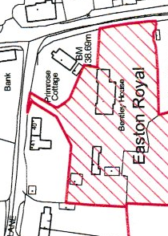
SN9 5LX – Proposed Felling - Position of Tree
Position of tree

