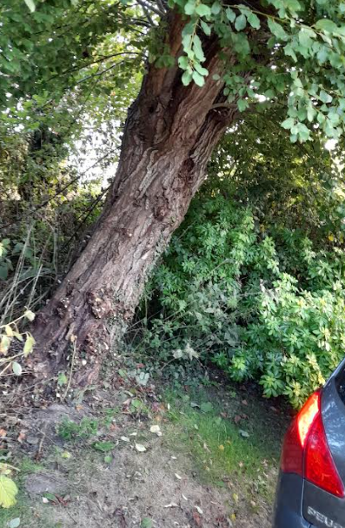
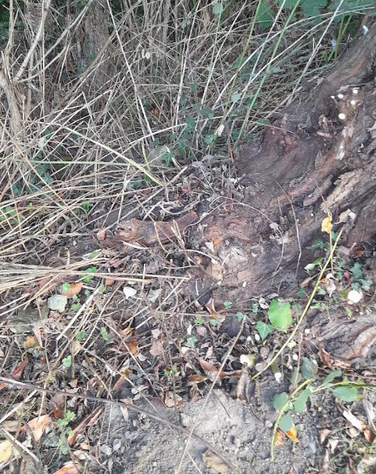
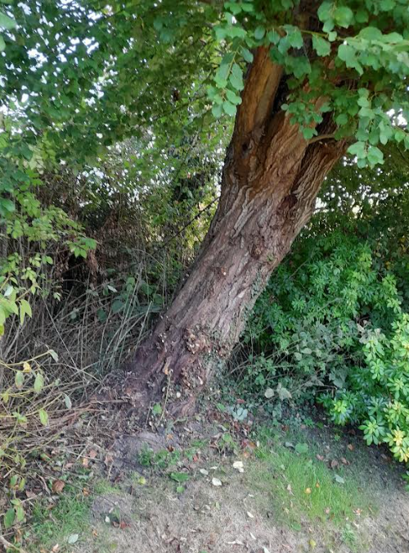
Willow Tree in Drive at Bentley House, Harris Lane, Easton Royal, Pewsey, Wiltshire SN9 5LX - Felling Proposal
Risk to cars on drive
Exposed roots
Willow tree leaning over drive

