APPENDIX 1
Plan showing location of tree to be reduced and description of works to be carried out on land registered to Mr/Mrs Midgley at The Old Mill on Public Footpath WORT10, and reasons for the work.
No TPO is involved, this notification is because the tree falls within Worton Conservation Area. Works are in the interests of H&S and because the tree is showing signs of mechanical stress because of the form in which it is growing and its size. Replanting is not appropriate because the tree is growing within the width of the Public Footpath.
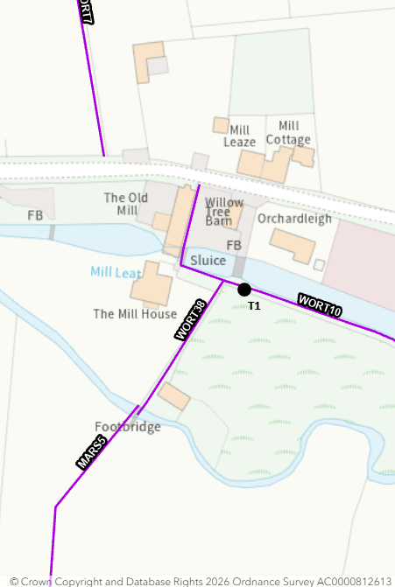
T1 – large weeping willow showing longitudinal mechanical stress marks indicating that it is experiencing significant movement or structural strain and is trying to compensate. QTRA assessment puts risk of harm in 1/30k which is tolerable, but issue will increase over time.
Works proposed – monolith to first union at approx. 2 metres high. All arisings to be removed from site.
W3W location - https://w3w.co/postcard.suiting.extent
Tree works advice provided by Dan Sheppard, Tree & Woodland Officer, Wiltshire Council and Conservation Contractors who will undertake the work.

A Rasey, Countryside Access Officer, 05.10.2026

