Environmental Control and Protection - Planning Consultation Response

To: James Taylor

From: Jenny Croman
Environmental Health Officer

Date: September 2026

Planning Application Reference: | PL/2026/04823
Description of Proposal: | Outline planning application with all matters reserved except access from the A4/London Road for up to 600 dwellings, together with land for a local centre (Use Classes E and F), areas of open space and landscaping, and associated infrastructure.
Address: | Land at Forest Farm, Chippenham
Background
The proposed development site is located to the southeast of Chippenham. There is a watercourse passing through the site broadly from east to west. The site surrounds a residential property known as at Forest Farm. There is a strip of woodland along the west boundary and trees line parts of a disused canal along the south boundary. The site is bounded by two roads: London Road to the north and Pewsham Road to the west. London Road.
There is a sewage treatment works around 1.11 mile away
The proposed development includes
600 dwellings, public open spaces, a local centre for use classes E and F. Call E can include places such as cafes, shops, indoor sports and recreation and day nurseries. Class F include learning and non-residential institutions and local community uses.

It is envisioned construction will start in 2029 and be completed by 2036. With the overall proposed development to take seven years to complete

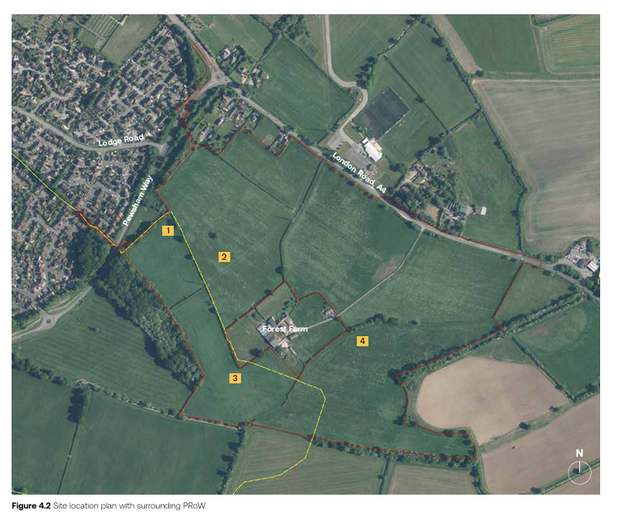

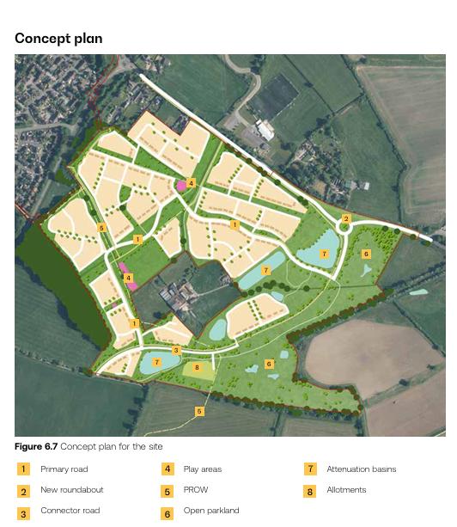

Lighting
The site has been assessed to be located within Environmental Lighting Zone E2,. For the outline element, it is not possible to provide modelling, calculations or lux contour plans for the site at this stage, as sufficient detail of the development is not available to enable this.

We have reviewed the submitted Lighting Impact Assessment prepared by The Lighting Bee Ltd. Doc ref, 1523-LB-XX-XX-RP-E-7080-02. Dated 03.07.2027.

The report proposes lighting designed to Environmental Zone E2 standards representative of a rural location with low district brightness. Due to insufficient details about the development, including the local centre (Use classes E&F), car parks, MUGA we recommend the following condition:

Before the first use of the lighting scheme hereby approved, the applicant shall appoint a suitably qualified member of the institute of lighting professionals (ILP) to validate that the lighting scheme as installed conforms to the recommendations for environmental zone E2 or better in the ILP document “Guidance Notes for the Reduction of Obtrusive Light - Guidance Note 01:20. A letter written by a suitably qualified member of the ILP confirming this shall be submitted to the Local Planning Authority. The scheme shall thereafter be permanently retained in accordance with the details submitted.

Core policy 57, Ensuring high design and place shaping such that appropriate levels of amenity are achievable.

Noise

An acoustic design scheme for protecting the proposed dwellings from external traffic noise shall be submitted to and approved in writing by the Local Planning Authority at Reserved Matters stage. The scheme shall ensure that, upon completion of the development, the following noise criteria shall be met, with windows open, in accordance with the Professional Practice Guidance: Planning and Noise – New Residential Development (May 2017):
- Bedrooms shall achieve an 8-hour LAeq (23:00-07:00) of 30dB(A) and an LAmax,F of 45dB(A);
- Living rooms and dining rooms shall achieve a 16-hour LAeq (07:00-23:00) of 35dB(A);
- External private amenity areas shall achieve a 16-hour LAeq (07:00-23:00) of 55dB(A).
The details as approved shall be implemented prior to occupation of the development and thereafter be permanently retained for the lifetime of the development.

Class E & F
An assessment of the acoustic impact arising from the operation of the proposed local centre uses, including plant, equipment, servicing and deliveries, shall be submitted to and approved in writing by the Local Planning Authority as part of the Reserved Matters submission relating to the local centre.
The assessment shall be undertaken in accordance with BS4142:2014+A1:2019 and demonstrate that the rating level of noise emitted from the proposed commercial uses will achieve at least 5dB below background noise levels at the nearest noise sensitive receptors.
Any required mitigation shall be implemented prior to first occupation or operation and thereafter permanently retained.

Reason: Core policy 57, Ensuring high design and place shaping such that appropriate levels of amenity are achievable.
Odour

The proposed local centre includes land within Use Classes E and F. Future occupiers may include uses that require commercial kitchen extraction or other plant capable of generating odour and noise impacts. Any future reserved matters or subsequent applications for such uses should be accompanied by appropriate details demonstrating that odour and noise impacts can be adequately controlled to protect neighbouring residential amenity.

Air Quality

The proposed development falls within the definition of a Type 2 site under the Wiltshire Air Quality SPD (2026). The submitted Air Quality Assessment demonstrates that operational impacts would be negligible and concentrations at existing and future receptors would remain below relevant air quality objectives. Mitigation measures include sustainable transport measures, electric vehicle charging provision, highly energy-efficient dwellings and low-carbon energy infrastructure.

A detailed construction dust mitigation strategy has been identified and should be controlled through as CEMP. We recommend the following conditions:

- Prior to the first occupation of the development hereby approved, a scheme of electric vehicle charging infrastructure shall be submitted and approved in writing by the local planning authority. The scheme shall comply with the requirements of the council’s Air Quality Supplementary Planning Document and be implemented in full thereafter prior to the first occupation of the development hereby approved.
Reason: Core Policy 55 - Development proposals, which by virtue of their scale, nature or location are likely to exacerbate existing areas of poor air quality, will need to demonstrate that measures can be taken to effectively mitigate emission levels in order to protect public health, environmental quality and amenity.

- No development shall commence, including any works of demolition, until a Construction Environmental Management Plan (CEMP) has been submitted and approved in writing by the local planning authority. The plan shall identify the steps and procedures that will be implemented during construction to minimise the creation and impact of dust resulting from the site preparation, demolition, groundwork and construction phases of the development.
The plan should include a site-specific risk assessment of likely dust impacts and propose appropriate mitigation measures to minimise emissions to air and restrict dust to within the site boundary. Risk assessments should be carried out in accordance with the Institute of Air Quality Management (IAQM) Guidance on the assessment of dust from demolition and construction (2024). The plan shall be implemented and maintained for the duration of the construction works.
Reason: Core Policy 55 - Development proposals, which by virtue of their scale, nature or location are likely to exacerbate existing areas of poor air quality, will need to demonstrate that measures can be taken to effectively mitigate emission levels in order to protect public health, environmental quality and amenity.

- Prior to the first occupation of the development hereby approved, a Low Emissions Travel Plan based on Appendix D of the council’s Air Quality Supplementary Planning Document shall be submitted to and approved in writing by the local planning authority. The plan shall be implemented in full prior to the first occupation of the development hereby approved and thereafter be permanently retained.

Reason: Core Policy 55 - Development proposals, which by virtue of their scale, nature or location are likely to exacerbate existing areas of poor air quality, will need to demonstrate that measures can be taken to effectively mitigate emission levels in order to protect public health, environmental quality and amenity.

- No construction or demolition work shall take place on Sundays or Public Holidays or outside the hours of 0800 to 18:00 Monday to Friday and 08:00 to 13:00 on Saturdays.
Reason: Core policy 57, Ensuring high design and place shaping such that appropriate levels of amenity are achievable.

Contaminated Land
The submitted contamination assessment statement, reference: Ref: BRD2483-OR3-A, dated 21st January 2025 refers to a Phase 1 Geo-Environmental Desk Study (BRD2483-OR1-B), dated November 2023 and a Geo-Environmental Site Investigation Report (BRD2483-OR2-B), dated September 2024. However, these reports have not been provided for review and therefore we are unable to provide comments or recommendations based on evidence. These reports should be submitted prior to determination at outline stage due to the ground gas risk and pipeline contamination risk.

