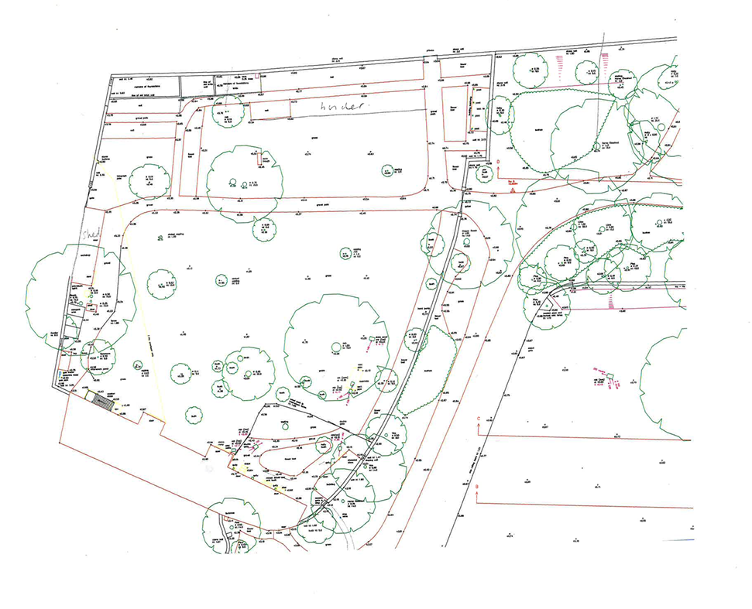
Walnut requesting permission to fell.
Retained Veteran trees planted by
Fox Talbot Mid 19th Century
Botanic Garden Sketch Plan for tree application

