APPLICATION FOR HOUSEHOLDER PLANNING PERMISSION AND LISTED BUILDING CONSENT DELEGATED REPORT

APPLICATION REFERENCE: | PL/2026/04431
APPLICATION TYPE: | Householder planning permission and Listed building consent
SITE ADDRESS: | The Old Livery, Livery Road, Winterslow, Salisbury, SP5 1RJ
DEVELOPMENT DESCRIPTION: | Conversion of garage and store to form studio for ancillary residential use and erection of carport and store. Resubmission of PL/2026/01889 and PL/2026/02910
RECOMMENDATION: | That Planning Permission and Listed Building Consent be GRANTED

PROPOSAL

The proposal seeks planning permission for the conversion of the existing single storey detached garage to create an annexe/ancillary accommodation along with associated works to facilitate the conversion. The proposals also include the erection of a detached single storey car port/store.

Existing plans and elevations of garage

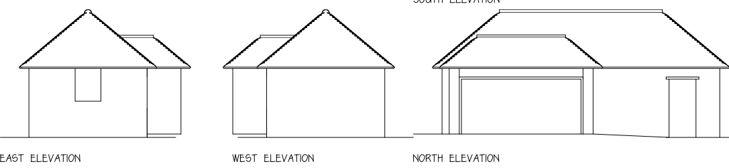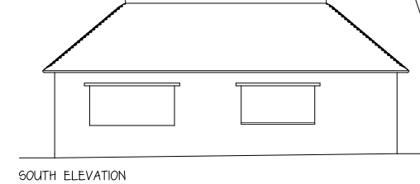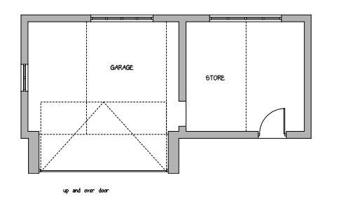

Proposed plans and elevations garage conversion/annexe

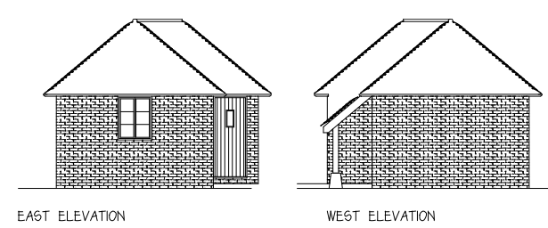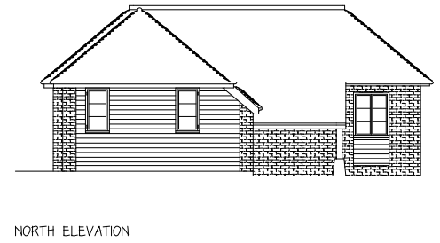

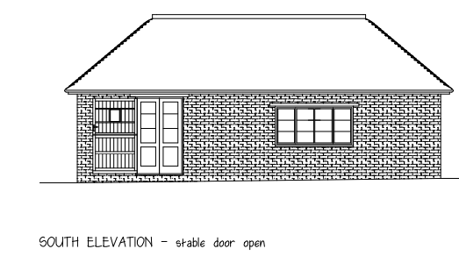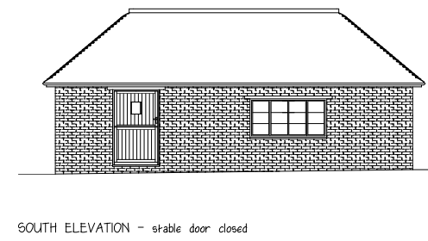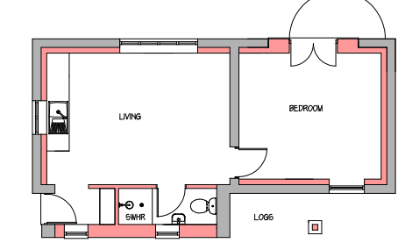

Existing photos

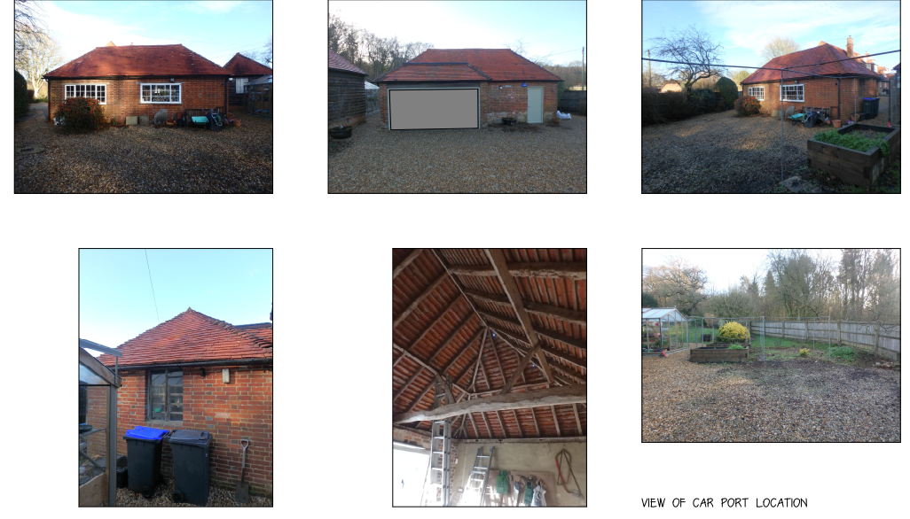

Proposed car port

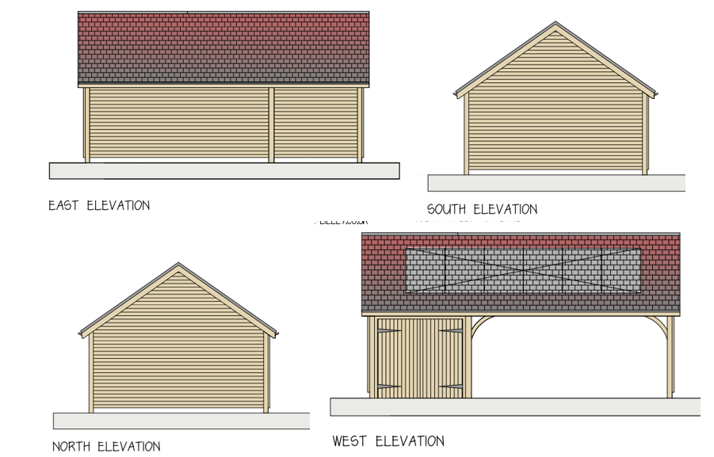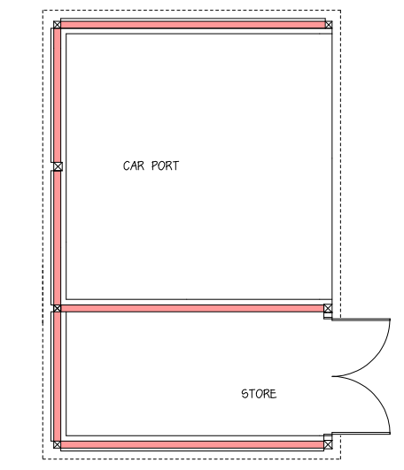

These applications follow a previous Householder and Listed Building application for similar works, both applications were withdrawn following objections from the Council, this new submission seeks to address previous concerns raised.

SITE DESCRIPTION/CONTEXT

The application site relates to a large, detached grade 2 listed dwelling with associated curtilage listed outbuilding located within a large residential curtilage on the east side of Livery Road on the north west edge of the Parish of West Dean. The site is located within a Special Landscape Area; within the Mottisfont Bat SAC and within the Test Valley Catchment.

Public right of way WDEA21 runs along the southern boundary of the site.

PLANNING HISTORY

Proposal / Summary
S/1985/0361 - The Old Livery Winterslow - Full planning permission Decision - Approved Date: 15/5/1985 – construction of new vehicular access
S/1991/0867 - The Old Livery, West Winterslow - Full planning permission Decision - Approve with Conditions Date: 24/7/1991 – demolish existing flat-roofed bay window, build new hipped roofed extension
S/1991/0868 - The Old Livery, Livery Road, West Winterslow - Listed building consent Decision - Approve with Conditions Date: 13/8/1991 – L/B application - demolish existing flat-roofed bay window (c1970), build new hipped roof extension
13/05395/FUL - The Old Livery Livery Road Winterslow Salisbury Wiltshire SP5 1RJ - Full planning permission Decision - Approve with Conditions Date: 9/12/2013 – Rear extension
13/05396/LBC - The Old Livery Livery Road Winterslow Salisbury Wiltshire SP5 1RJ - Listed building consent Decision - Approve with Conditions Date: 9/12/2013 – Rear extension
PL/2026/01889 - The Old Livery, Livery Road, Winterslow, Salisbury, SP5 1RJ - Householder planning permission Decision - Withdrawn by Applicant Date: 19/6/2026 – Conversion of garage and store to form studio for ancillary residential use and erection of car port and store
PL/2026/02910 - The Old Livery, Livery Road, Winterslow, Salisbury, SP5 1RJ - Listed building consent (Alt/Ext) Decision - Withdrawn by Applicant Date: 19/6/2026 – Conversion of garage and store to form studio for ancillary residential use and erection of car port and store

RELEVANT POLICIES AND GUIDANCE

The National Planning Policy Framework (NPPF)
The Planning Practice Guidance

Wiltshire Core Strategy:

Core Policy 1 Settlement Strategy
Core Policy 2 Delivery Strategy
Core Policy 23 Spatial Strategy South Wiltshire Community Area
Core Policy 50 Biodiversity and Geodiversity
Core Policy 51 Landscape
Core Policy 57 Ensuring High Quality Design and Place Shaping
Core Policy 58 Ensuring the Conservation of the Historic Environment
Core Policy 61 Transport and New Development
Core Policy 64 Demand Management

Saved policy C6 (Special Landscape Area) and H33 (ancillary accommodation) of the Salisbury District Local Plan

Wiltshire Design Guide: Appendix D – Design Guidance for Householder extensions
Creating Places Design Guide
West Dean Neighbourhood Plan

CONSULTATION RESPONSES

Parish Council: West Dean Parish Council has no objection to this application in principle. However, the diversion of path WDEA21 needs to be addressed as part of the planning process.

Highways: No objection subject to condition

Rights of way: No objection

Conservation: No objections subject to condition

Ecology: No objection subject to condition

REPRESENTATIONS

No comments were received.

ASSESSMENT

Section 38(6) of the Planning and Compulsory Purchase Act 2004 states:

"If regard is to be had to the development plan for the purposes of any determination to be made under the planning Acts, the determination must be made in accordance with the plan unless material considerations indicate otherwise."

In accordance with this statutory requirement, this application has been assessed against the relevant policies of the Development Plan, including the adopted Wiltshire Core Strategy (2015) and, where applicable, any made Neighbourhood Plans.

Character, Design, Impact on the Listed Building and its setting

Sections 16/66(1) of the Planning (Listed Buildings and Conservation Areas) Act 1990 requires special regard to be given to the desirability of preserving listed buildings, their settings and any features of special architectural or historic interest which they possess.

Core Policy 58 of the Wiltshire Core Strategy seeks to conserve and, where appropriate, enhance the significance of designated and non-designated heritage assets and their settings. Core Policy 57 requires development to respond positively to local character and historic context through high quality design.

Policies HE4-HE10 of the National Planning Policy Framework recognise heritage assets as an irreplaceable resource and require proposals affecting heritage assets to be assessed having regard to their significance and the contribution made by their setting.

Policies DP3 and DP4 of the National Planning Policy Framework require development to achieve a high standard of design that responds positively to local character and context. In assessing design quality, regard should be had to matters including scale, siting, form, appearance, materials and the relationship of development to its surroundings.

The application seeks the conversion of an existing garage and store building to ancillary residential studio accommodation together with the erection of a car port and store building within the curtilage of The Old Livery, a Grade II listed building.

The creation of an annexe within the garage complies with the Council’s saved policy relating to ancillary accommodation – H33.

H33 requires that

(i) the accommodation is created wholly or partly within the existing dwelling or takes the form of an extension to that dwelling;
(ii) the design and internal arrangement of the proposed unit of accommodation would allow it to be re-absorbed into the main dwelling when it is no longer required to house a dependent person; and
(iii) where an extension is proposed, its siting and design is acceptable and the remaining external space around the building is adequate
(iv) the accommodation is created as a result of a conversion of an existing building within the curtilage of the main dwelling.

The proposal satisfies the requirements of Policy H33 as the accommodation would be created through the conversion of an existing curtilage building and would remain ancillary to the main dwelling. A condition will be added to any permission to tie the annexe to the host dwelling.

The proposed works have been revised following the withdrawal of the previous applications and the removal of the previously proposed southern extension. In particular, the previously proposed southern extension has been omitted from the scheme, resulting in a form of development that better respects the character and significance of the curtilage listed building.

The amended scheme significantly reduces the extent of intervention to the existing building and retains its overall form and appearance. External alterations are limited and include replacement openings within areas of modern fabric, alterations to the modern garage extension and associated refurbishment works.

The proposed detached car port and store would be located to the rear of the annexe, close to the southern boundary of the site. This element of the proposal is considered to comprise a modest ancillary structure constructed using traditional materials appropriate to the established character of the site.

The Council's Conservation Officer raises no objection and confirms that the revised scheme has been designed to minimise physical harm to the curtilage listed building. It is considered that the proposal would preserve the character, appearance and significance of the curtilage listed structure and would preserve the setting of the Grade II listed dwelling. The omission of the previously proposed southern extension and associated amendments to the scheme have satisfactorily addressed the concerns identified in relation to the withdrawn applications.

The proposed works would be undertaken within the established residential curtilage of The Old Livery and would be relatively well screened from public viewpoints by existing boundary treatments, vegetation and the spatial relationship of the buildings within the site. Whilst limited views may be available from the adjacent public bridleway, the development would be seen in the context of the existing built form and would not appear visually intrusive within the wider landscape. As such, the proposal would not result in any harmful impact upon the character or appearance of the surrounding countryside and is considered to comply with Saved Policy C6 of the Salisbury District Local Plan.

The proposal also includes the installation of solar panels on the roof slope of the proposed car port. Whilst these would be visible to a degree, they would be associated with the new ancillary structure rather than the historic building itself. Given their limited scale and siting, the panels are not considered to detract from the character or appearance of the site, the wider landscape, or the significance and setting of the listed building. Furthermore, the incorporation of renewable energy measures is supported in principle by local and national planning policy.

The proposal is therefore considered to preserve the significance of the designated heritage asset and its setting in accordance with Section 66(1) of the Planning (Listed Buildings and Conservation Areas) Act 1990, Core Policies 57 and 58 of the Wiltshire Core Strategy and the relevant sections of the NPPF.

Amenity

Point vii of Core Policy 57 - Ensuring High Quality Design and Place Shaping of the Wiltshire Core Strategy seeks to ensure that developments do not adversely affect neighbouring properties.

Policy P3 of the National Planning Policy Framework requires development to be appropriate for its location, taking account of its likely effects on health, living conditions and the environment. In particular, Policy P3(2)(b) requires development to avoid giving rise to unacceptable impacts on the living conditions of neighbouring residents and occupiers. In assessing amenity impacts, regard should be had to matters including daylight and sunlight, outlook, privacy, overbearing impacts and other effects on residential amenity.

The site occupies a good sized residential plot and is relatively isolated from neighbouring residential properties. The proposal comprises the conversion of an existing outbuilding and erection of an ancillary car port and store within the established residential curtilage along the southern part of the site.

Given the scale, siting and nature of the proposed development, it is not considered that the proposal would give rise to any unacceptable impacts in respect of overlooking, loss of privacy, loss of light, overbearing impact or general residential amenity. The studio accommodation would remain ancillary to the host dwelling and would not create an additional independent residential unit.

The proposal therefore accords with Core Policy 57 of the Wiltshire Core Strategy.

Highways Impact and Impact in Rights of Way

Core Policy 57 (xiv) of the Wiltshire Core Strategy seeks to ensure that development must meet the requirements of Core Policy 61. This policy requires proposals to be capable of being served by safe access to the highway network. Core Policy 64 seeks to ensure compliance with parking standards set out in the Local Transport Plan.

The transport policies of the NPPF seek to ensure that development provides safe and suitable access for all users and that any impacts on highway safety are appropriately considered.

The Local Highway Authority raises no objection to the proposal. The development would utilise existing access arrangements and adequate off-street parking and manoeuvring space would remain available within the site. The proposal is therefore not considered to adversely affect highway safety. The development accords with Core Policy 61 of the Wiltshire Core Strategy.

The Highway Officer has advised that part of the application site is affected by existing highway rights and recommends that these are regularised through a stopping up order before development commences. Subject to an appropriately worded condition, no highway objection is raised.

In terms of public rights of way, the Council's mapping shows a version on the Council’s website where the bridleway runs through the application site and being affected by the proposed development. This has caused some concern with the Parish Council.

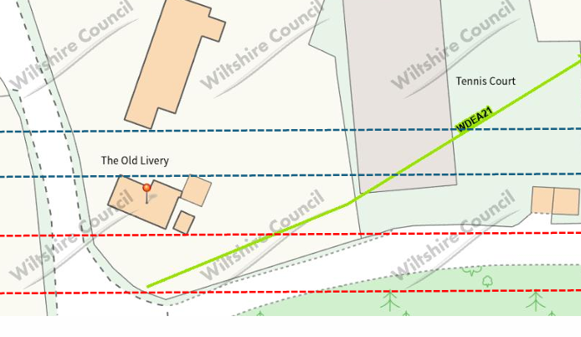

However, the Council’s rights of way officer has confirmed that the bridleway WDEA21 runs to the south of the site and would not be adversely affected by the proposed development. No objection has therefore been raised.

Extract below from the Definitive Map
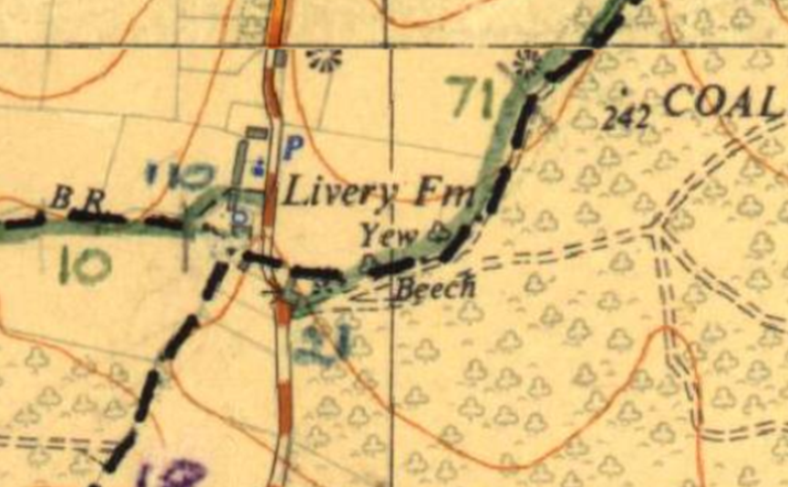
Enlarged extract from definitive map with digital rights of way layer
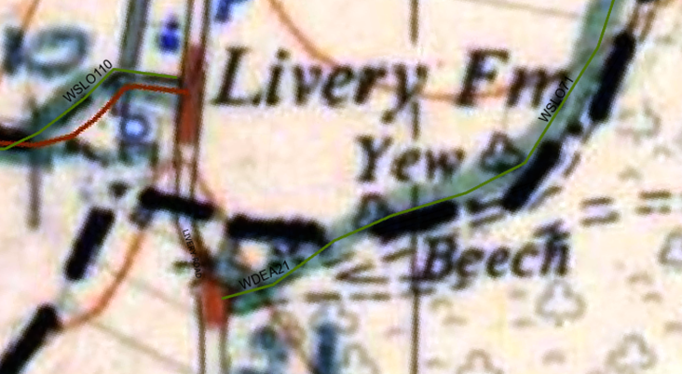

The proposed development would not result in any adverse impact on highway safety. Adequate parking and turning provision is provided in accordance with Wiltshire’s adopted parking standards, and access arrangements are acceptable.

The proposal is therefore considered to comply with Core Policies 57 (xiv), 61 and 64 of the Wiltshire Core Strategy, the NPPF, and the Wiltshire Local Transport Plan.

Ecology Impact
Core Policy 50 of the Wiltshire Core Strategy seeks to protect and enhance biodiversity and geodiversity, including through ensuring that development avoids harm to protected species and habitats.

Policy N2 of the NPPF seeks to conserve and enhance biodiversity and support nature recovery. Development proposals should minimise impacts on habitats and species and, where relevant, demonstrate that appropriate mitigation measures are secured where harm cannot be avoided.

Ecological surveys confirm the presence of a day roost used by low numbers of common pipistrelle bats within the existing outbuilding. Appropriate mitigation and compensation measures have been proposed, including the provision of alternative roosting opportunities, sensitive timing of works and ecological oversight during construction. Subject to adherence with the submitted mitigation strategy and the subsequent grant of an EPS licence, the proposal would not adversely affect the favourable conservation status of protected species.

The Council Ecologist is satisfied that the proposal would not result in unacceptable impacts upon protected species, habitats, nearby ancient woodland or internationally designated sites. Subject to implementation of the recommended mitigation, enhancement and lighting measures secured by condition, the proposal complies with Core Policy 50 of the Wiltshire Core Strategy and the relevant provisions of the NPPF.

Biodiversity Net Gain - Householder planning applications are exempt from the requirement to deliver Biodiversity Net Gain under Schedule 7A, Section 4(2)(a) of the Town and Country Planning Act 1990, as inserted by the Environment Act 2021.

CONCLUSION

The proposal is considered acceptable in terms of its scale, design and appearance and would preserve the character, appearance and significance of the Grade II listed dwelling and associated curtilage listed building. The development would not result in unacceptable impacts upon residential amenity, highway safety, biodiversity interests or any other material planning consideration. The proposal therefore accords with the relevant provisions of the Wiltshire Core Strategy, the West Dean Neighbourhood Plan and the NPPF and is recommended for approval subject to conditions.

RECOMMENDATION: That Planning Permission be GRANTED subject to conditions.

1. The development hereby permitted shall be begun before the expiration of three
years from the date of this permission.

REASON: To comply with the provisions of Section 91 of the Town and Country Planning Act 1990 as amended by the Planning and Compulsory Purchase Act 2004.

2. The development hereby permitted shall be carried out in accordance with the
following approved plans and documents:

Application form received 13/07/2026
Plans as existing Dwg no Rw/p/01 received 13/07/2026
Plans as proposed Dwg no Rw/p/02 received 13/07/2026
Proposed car port Dwg no Rw/p/03 received 13/07/2026
Solar panel specification received 06/08/2026
Mitigation Strategy detailed in Section 4.0 (Mitigation for Bats) of the Bat Survey & Mitigation Report (Aluco Ecology Ltd., August 2026)

REASON: For the avoidance of doubt and in the interests of proper planning and in the interests of providing adequate protection and mitigation for protected species.

3. The development shall be carried out in strict accordance with the recommendations, mitigation measures and enhancements contained within the Ecology- Bat Survey & Mitigation Report prepared by Aluco Ecology Ltd dated August 2026, in particular section 4.0 and 5.0 pages 22-28 The approved measures shall be implemented prior to the first occupation of the development and thereafter retained for the lifetime of the development.

REASON: To ensure adequate protection and mitigation for protected species

4. The annexe accommodation hereby permitted shall not be occupied at any time other than for purposes ancillary to the residential use of the main dwelling, known as The Old Livery, Livery Road, Winterslow, it shall not be sold or let separately from the main dwelling.

REASON: The additional accommodation is sited in a position where the Local Planning Authority, having regard to the reasonable standards of residential amenity, access, and planning policies pertaining to the area, would not permit a wholly separate dwelling and in the interests of protecting the River Test SAC and New Forest SAC.

5. The materials to be used in the construction of the external surfaces of the development hereby permitted (brick and tile) shall match in material, colour and texture to those detailed on the approved plans and to match the existing building.

REASON: For the avoidance of doubt and in the interests of visual amenity and the character and appearance of the area and in the interests of protecting the character of the heritage assets and their setting.

6. No development shall commence on site until evidence of the necessary stopping-up order, for the stopping up of the affected area of public highway, has been submitted to and approved in writing by the Local Planning Authority.

REASON: To ensure that the development does not encroach upon land forming part of the public highway and in the interests of highway safety.

7. Any new external lighting to be installed on the development hereby approved shall be in accordance with the appropriate Environmental Zone standards set out by the Institution of Lighting Professionals (ILP) Guidance Notes on the Avoidance of Obtrusive Light (GN 01/2021) and Guidance note GN08/23 “Bats and artificial lighting at night”, issued by the Bat Conservation Trust and Institution of Lighting Professionals.

REASON: To ensure adequate protection and mitigation for protected species

Informative

The applicant is advised that parts of the development affect land forming part of the public highway. The necessary stopping-up procedures must be completed separately from this planning permission. Information relating to the stopping-up of highways can be found at:

https://www.gov.uk/government/publications/stopping-up-and-diversion-of-highways

The applicant is advised to contact the relevant authority and may wish to seek independent legal advice regarding the process.

RECOMMENDATION: That Listed Building Consent be GRANTED subject to conditions.

1. The works for which Listed Building Consent is hereby granted shall be begun before the expiration of three years from the date of this consent.

REASON: To comply with the provisions of Section 18 of the Planning (Listed Buildings and Conservation Areas) Act 1990 as amended by the Planning and Compulsory Purchase Act 2004.

2. The development hereby permitted shall be carried out in accordance with the
following approved plans and documents:

Application form received 13/07/2026
Plans as existing Dwg no Rw/p/01 received 13/07/2026
Plans as proposed Dwg no Rw/p/02 received 13/07/2026
Proposed car port Dwg no Rw/p/03 received 13/07/2026
Solar panel specification received 06/08/2026
Mitigation Strategy detailed in Section 4.0 (Mitigation for Bats) of the Bat Survey & Mitigation Report (Aluco Ecology Ltd., August 2026)

REASON: For the avoidance of doubt and in the interests of proper planning

3. Notwithstanding the approved plans, no installation of any new or replacement windows associated with the approved garage conversion shall take place until large-scale details of the proposed windows have been submitted to and approved in writing by the Local Planning Authority.

The development shall be carried out in accordance with the approved details.

REASON: In the interests of preserving the special architectural and historic interest of the listed building and its setting

