Heritage Impact Assessment

General location of work to be carried out with OS grid reference
Lacock OS grid reference ST91759 68400

Specific location of work proposed:

Botanic Garden, Lacock Abbey, Lacock, Chippenham, Wiltshire SN15 2LG
Lacock Abbey

Is the heritage asset (please underline)

A listed building (within curtilage)
A scheduled monument
A site of archaeological interest
Within a designated conservation area
Within a registered historic park or garden
Within a registered battlefield
In the setting of/adjacent to one of the above
A non-designated heritage asset

The Nature and Significance of the Asset
Please describe the history, character and appearance of the heritage asset, eg listed building, conservation area or scheduled monument. You should refer to the statutory list description, scheduled monument description or conservation area character appraisal, CMP or Statement of Significance if available.
The Botanic Garden is within the GII listed NT Lacock Abbey ground and landscape. The garden is listed GII on the Register of Historic Parks and Gardens. The Property sits in the conservation area of Lacock.

Question: Would consent from Gardens trust or Historic England be needed for the removal of features (Not listed) and new planting?
No

Lacock Garden Conservation management plan 2011
Character area number 1 Lacock Abbey and Gardens

Significance
7.40 CMP - The park and garden are included on the English Heritage Register of Parks and Gardens of Special Historic Interest at Grade II making them of national importance and significance. Whilst the register entry refers to Capability Brown’s (1716 – 1783) involvement at Lacock, which is significant, there is no mention of Stephen Switzer (1682–1745) and William Emes (1729/30 – 1803).

7.44 From the late 18th century onwards the design of the landscape becomes less significant at Lacock, with the overall layout remaining largely unchanged (with the exception of the extension of the south terrace by William Henry Fox Talbot in 1827). Changes that did occur tended to be in a piecemeal fashion, such as the infilling of the canal also during Fox Talbot’s tenure, and did little to contribute to a cohesive overall design. As noted above it seems 17http://york.academia.edu/TimurTatlioglu/Papers/79738/Destruction_Identity_and_Dynasty_The_role _of_Martial_Architecture_in_Eighteenthcentury_Designed_Landscapes Land Use Consultants 45 apparent that Fox Talbot was more interested in botanical science than garden design, which in many instances he left to his mother, and as such the plant collections amassed by Fox Talbot are of greater interest and significance than the design changes that he made.
7.47 The re-creation of the Botanic Garden has gone some way to recognising the significance of the plant collections that Fox Talbot grew there, although there is still much scope for enhancement and greater interpretation of this area. The existing trees that have been identified as likely Fox Talbot plantings, such as the horse chestnuts and planes on the woodland walk and the walnut in the Botanic Garden, are significant in that they represent a living connection with his tenure. They will not last forever, however, with disease and other factors that may also play their part, as is the case currently with the horse chestnut. There is nevertheless significance attached to the species of tree that he planted, given his interest in exotic species and his pioneering role in planting them within his garden. It is worth noting that the type of tree he planted holds a greater significance than where he planted them, given his focus on collection over design as outlined above.
4.0 History

Brief history of garden, can cross reference to conservation management plan or other docs which include a history. A brief history (one paragraph or so) can be included per character area at the start of each character area.

1d: Fox Talbot’s Botanic Garden – a walled garden located behind the Abbey entrance and museum, predominantly laid to lawn, with a gravel path circuit and borders in its northern half. In the southern part several mature trees stand in front of the back of the Fox Talbot Museum. A small stone and timber outbuilding along the western wall is used as the gardeners' workroom, partially shielded by a willow screen. In the north west corner sits a recently restored glasshouse, whilst in the north east corner stands a tiled shelter.

William Henry Fox Talbot and botany Fox Talbot had a keen interest in plants from an early age, and he was a respected botanist and a Fellow of the Linnean Society by the age of 29. Perhaps his greatest contribution to botanical history was in helping to secure the establishment of the National Botanic Garden at Kew, plans for which floundered after the death of the 6th Duke of Bedford. He achieved this through petitions to the Chancellor of the Exchequer and the Council of the Linnean Society amongst others. Fox Talbot’s interests were expressed through an extensive correspondence (sometimes 4 or 5 letters written per day), much of which survives and is available as an online archive. His correspondence concerning plants had two facets: i) Botanical Science (taxonomy and plant morphology) ii) Horticulture (cultivation of plants in his garden and those of relatives)
The relationship between his observations in botany and his desire to make images and recording plant material is a fundamental one, and it is highly probable that he grew the plants for his earliest images c1836 (‘photogenic drawing negatives’). WH Fox Talbot’s interest in botanical science was focussed on taxonomy and classification. As was the case at that time, the naming and taxonomy of plants was based on the morphology of the reproductive parts and much of his work was focused on evidencing this aspect. He was also very interested in collecting samples and seeds from different locations, including the creation of area floras (for example, Westmorland and Isle of Wight) and overseas (including reference to collections from the Alps, Texas, Euphrates, and Sicily and Ionian Is). Much of this material was apparently obtained through correspondence with others in the field, either directly or via his uncle. Correspondence with his family and other gardeners reveal how important horticulture was to WHFT. He was especially interested in phenology – seasonal timing of flowering or seeding etc. The tone of WHFT’s correspondence with his female family members is quite different to that of his botanical correspondence and often included aesthetic considerations such as advice from his mother and aunts regarding colours. There is also correspondence between WHFT and his daughters who had their own gardens at Lacock.
7.29 One of the major changes of recent years was the re-creation of the Botanic Garden towards the end of the 1990s, reclaiming it from its then use as allotments. Following the death of William Henry Fox Talbot the glasshouses had fallen into disrepair (his son Charles apparently lacked his enthusiasm for plants) and were probably removed in the 1940s13. The National Trust re-created a glasshouse in the same location in 2001.

7.47 The re-creation of the Botanic Garden has gone some way to recognising the significance of the plant collections that Fox Talbot grew there, although there is still much scope for enhancement and greater interpretation of this area. The existing trees that have been identified as likely Fox Talbot plantings, such as the horse chestnuts and planes on the woodland walk and the walnut in the Botanic Garden, are significant in that they represent a living connection with his tenure. They will not last forever, however, with disease and other factors that may also play their part, as is the case currently with the horse chestnut. There is nevertheless significance attached to the species of tree that he planted, given his interest in exotic species and his pioneering role in planting them within his garden. It is worth noting that the type of tree he planted holds a greater significance than where he planted them, given his focus on collection over design as outlined above. It is also worth noting that design additions such as the Rose Garden, whilst of interest, are not of as great a significance as Fox Talbot’s purely botanical-related additions for the reasons outlined above.

Current condition of heritage asset:

Condition

Henry Fox Talbot’s Botanic Grden is the only working botanic garden in National Trust ownership. The current selection of plants are not of significant scientific interest and are reduced in scale and variety following the conversion from botanic garden to allotments in the 20th Century. The over planting of very many trees in 2005 have compromised the ability to display and develop the botanic garden to its important heritage significance. The National Trust has an opportunity in the 21st Century to create a world class botanic garden that will reflect the historic links to Henry Fox Talbot’s plant collecting and the link to his photographic invention via those plants grown in this botanic garden.

Veteran trees are compromised in their long-term health by additional trees being planted since 2005. These trees are encroaching on the veteran’s root systems and ability to grow and could be selectively removed to improve the lifespan of those veterans as well as providing space to better educate visitors about plants and their scientific importance in the 21st Century.

The Glasshouse is in very poor condition despite being a 21st Century recreation of the glasshouse pulled down in the early 20th Century. It’s ongoing cost to keep safely intact has been disproportionate to its importance as a historic building and dismantling or part dismantling could be considered with a view to creating a modern glasshouse fit for modern horticultural display and practice, whilst maintaining a link to the space and its historical past.

Glasshouse showing rot to timbers despite being restored in recent years.

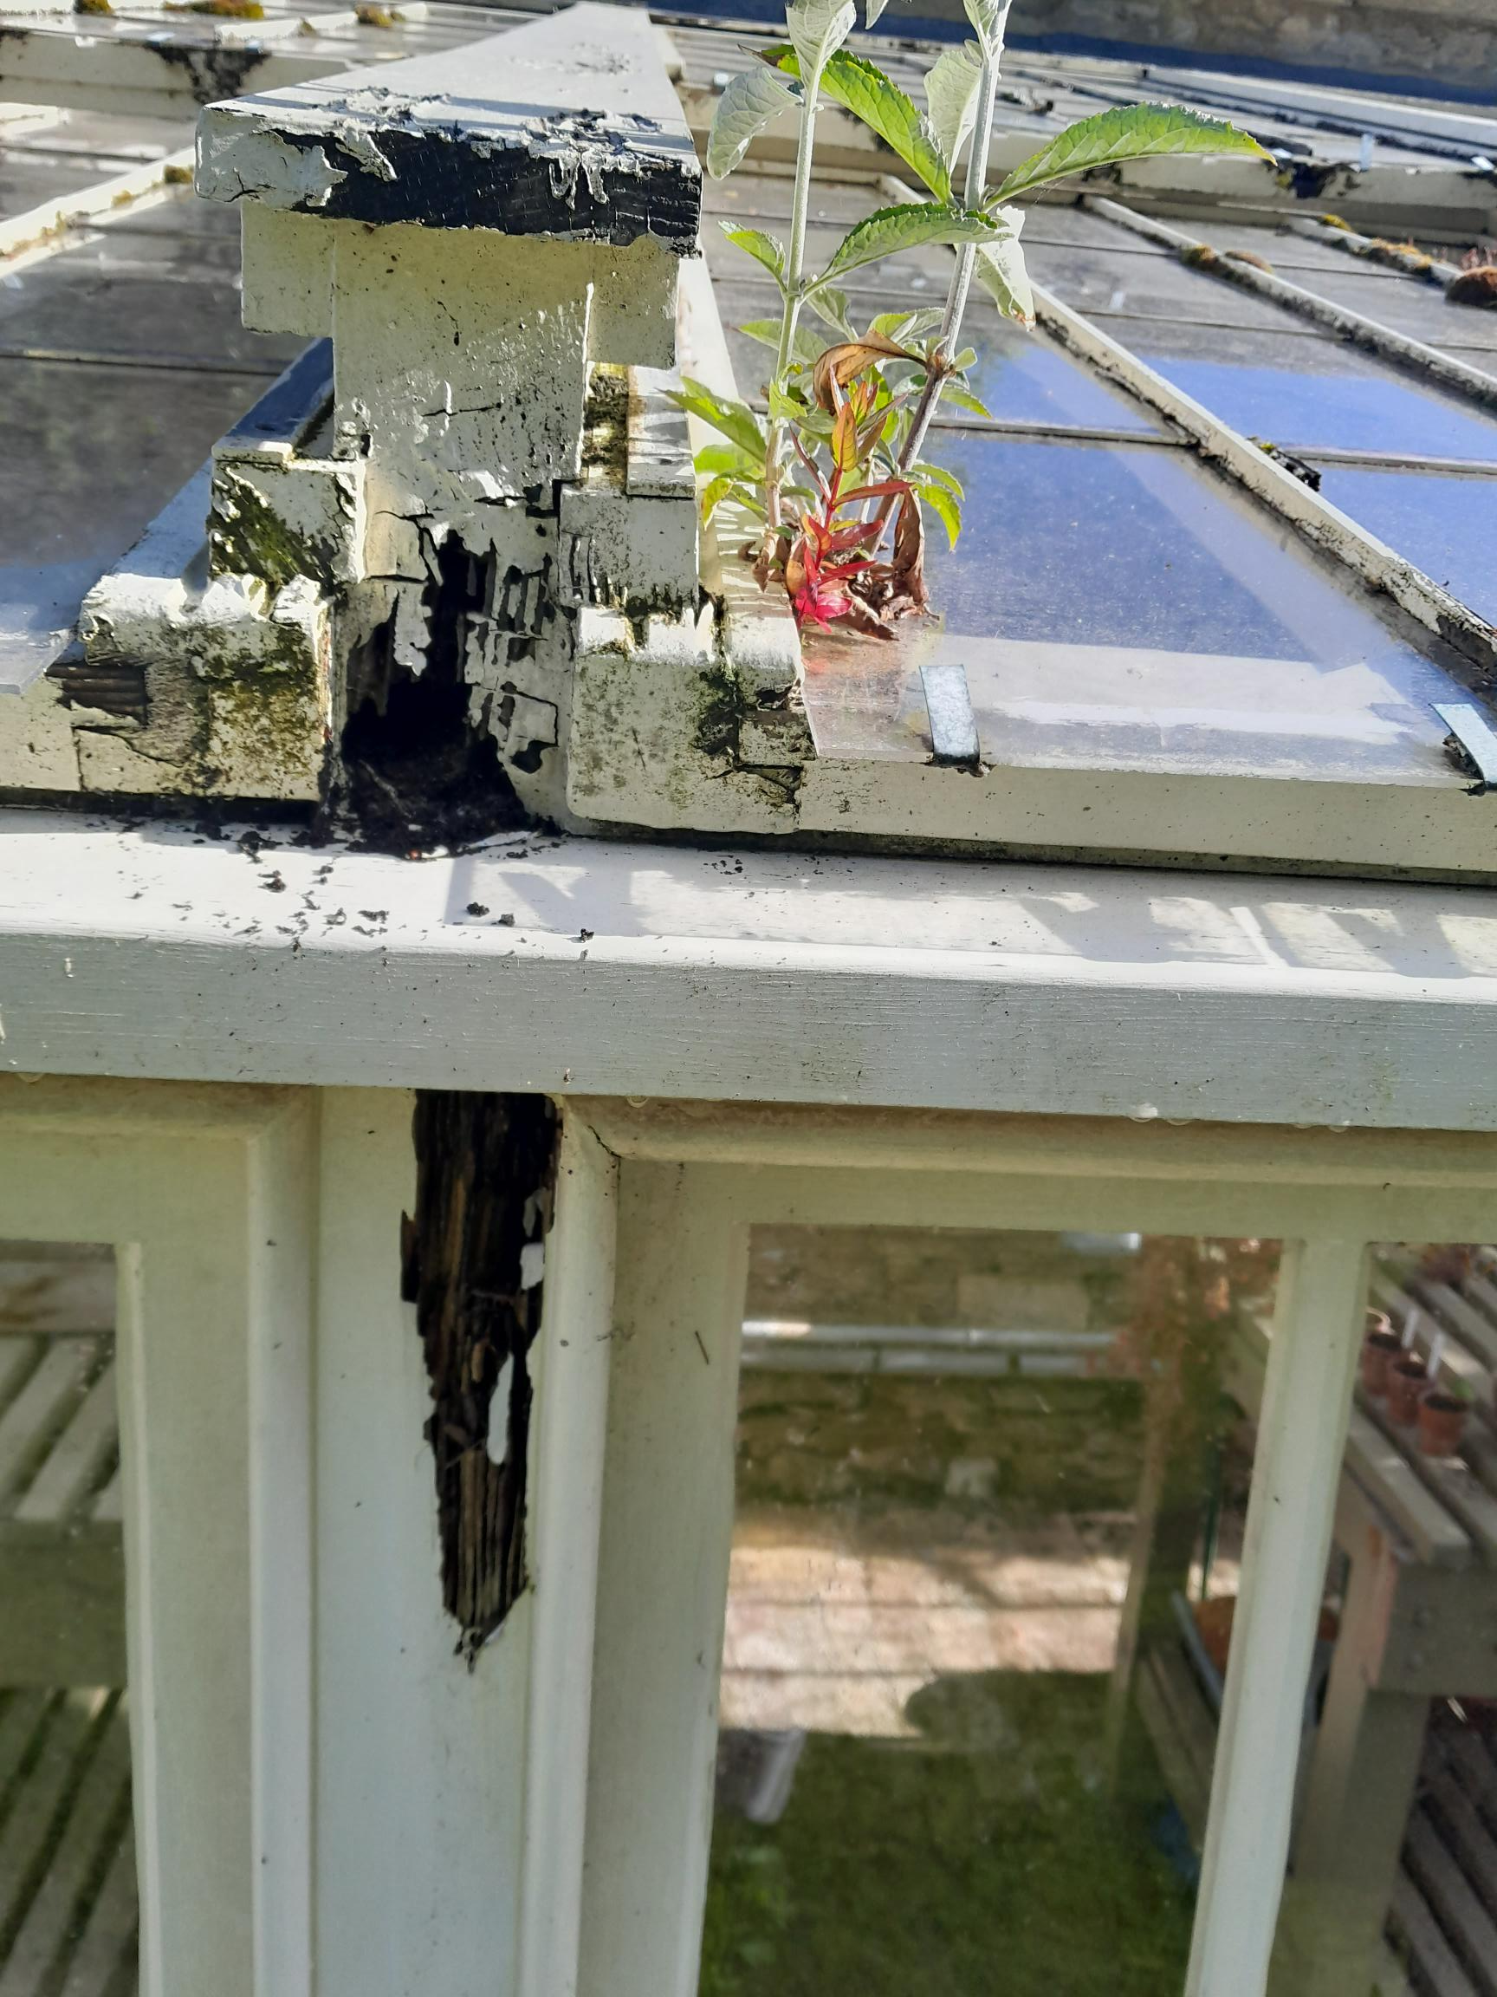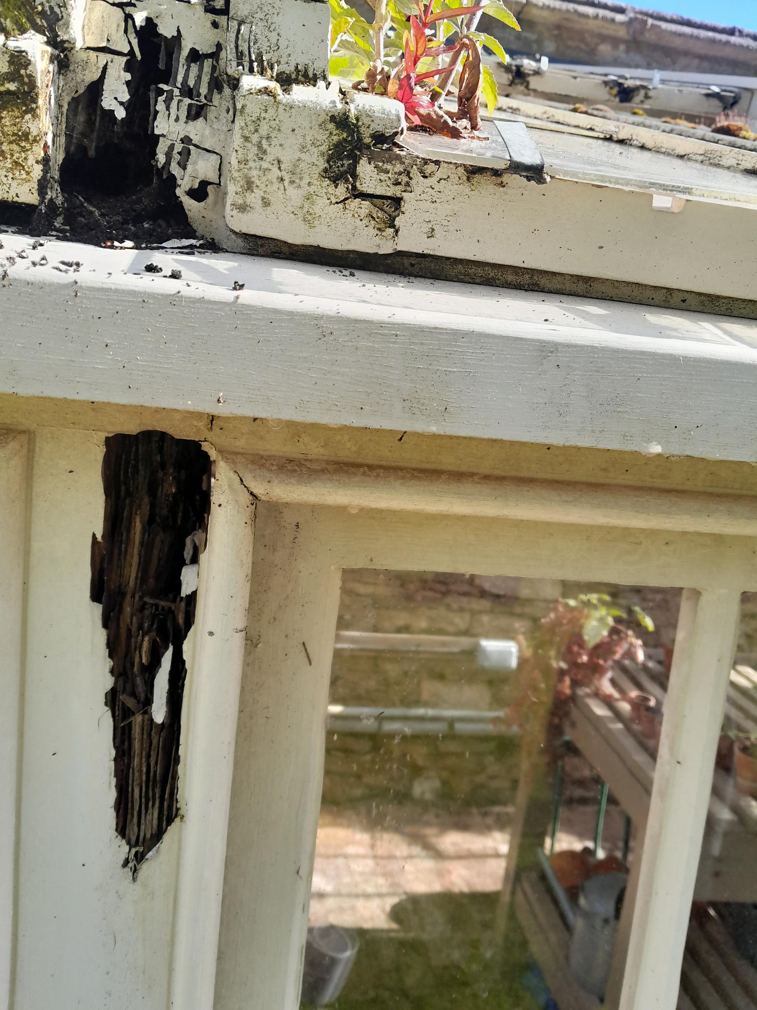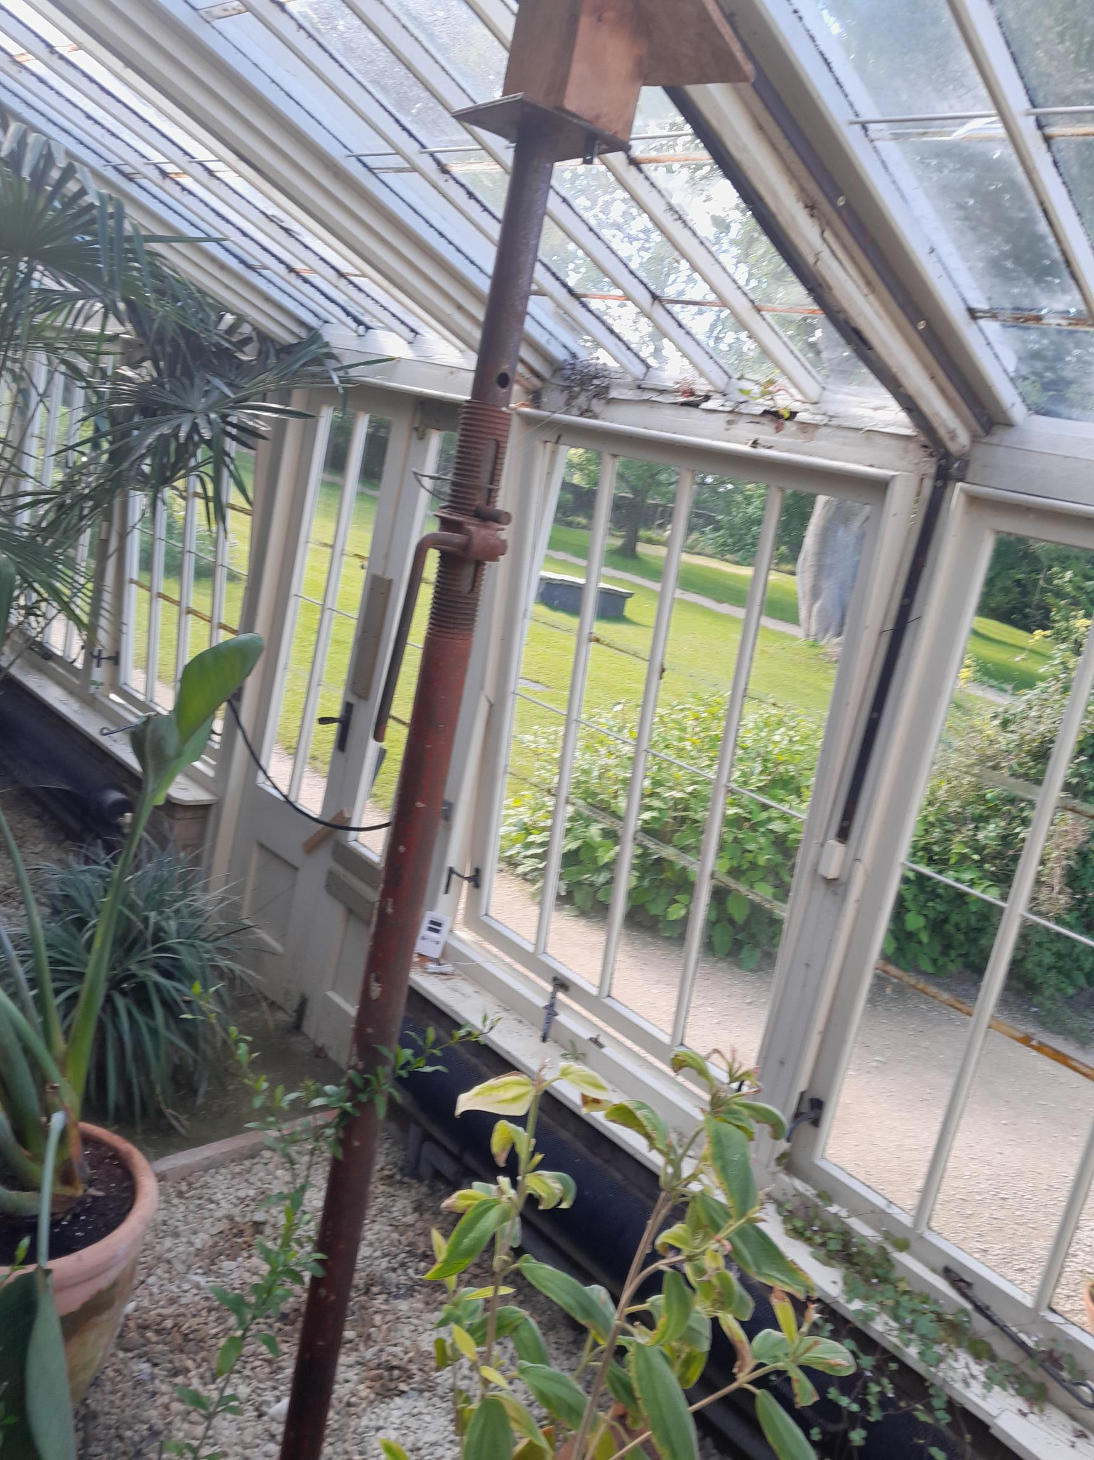

The proposed works

Please describe the proposed works including scale, height, construction, materials, design details and any associated landscaping works. For internal works to listed buildings this should also include details of any historic fabric or architectural features which would be lost as part of the proposals. For archaeological sites this should include details of any new foundations, ground disturbance or provision of services.

Our Vision
The plan is to create a botanic garden that is fit for the 21st Century that can help to explain the links between the plants grown and photographed at Lacock in a scientific way, whilst also providing information and opportunities to research plants, climate change and nature friendly horticulture. A botanic garden that will be a jewel in the National Trust South West’s crown. A design that is world class and will be accessible to all.

We intend to improve the selection of plants throughout the Botanic Garden location. We would like to reduce the number of trees in the space to protect the important three veteran trees planted by Henry in the mid 19th Century, the Taxodium distichum, Juglans nigra and Ailanthus altissima.

Our Proposal

- To Remove large shrubs to create access from the Fox Talbot Museum as a main entrance to Lacock via the Botanic Garden.
- Create access for all through glass automatic doors inside the museum barn
- To vastly increase and improve the selection and design of plants.
- Better inform our visitors about the link between Lacock’s plant collection and Fox Talbots invention of the photographic negative.
- Improve circulation and dwell time to facilitate a better horticultural and experience for our visitors.

Plan of Botanic Garden

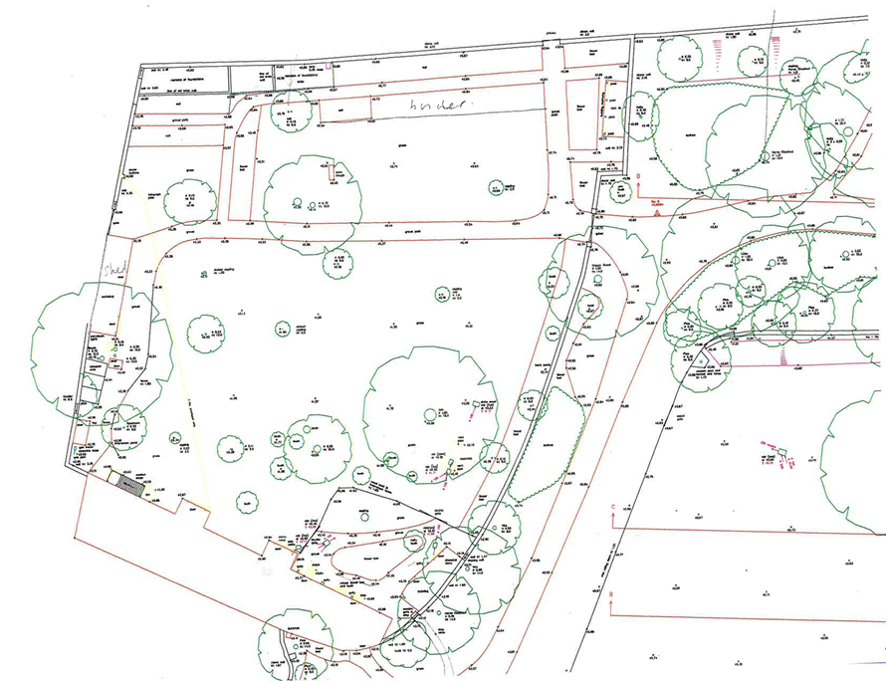
Managing change to significant places

Question | Response
Do you have sufficient information?  Please list the documents referenced ie CMP, listing descriptions and key consultations ie, Subject Specialists | The Lacock Conservation Management Plan 2011/12  The Lacock Management Plan 2024 - 2028 – Michael Brewer, Paul Alexander and Mike Beeston 2024  Paul Alexander – Head Gardener  Michael Brewer – Senior Gardener  Mike Beeston – Regional Gardens Consultant  Julie Reynolds - Cultural Heritage Curator
The Impact on the Asset  Please describe the impact the proposals will have on the significance of the asset or its setting. This may include example loss or concealment of key features or historic fabric, blocking key views, impact on relationships between buildings, or effect on authenticity or integrity. | The restoration of this area will only be an improvement to the property and make the area more accessible to enjoy the connection the story of Fox Talbot and Lacock as the Home of Photography.  Improved presentation standards and plant collection, space for visitors to linger and enjoy this part of the gardens.  Visual and physical connection photography and plant collecting.  Additional, more direct access to the space will increase visitors finding and enjoying the space.
Preserve, Enhance, Mitigate?  Does the proposal preserve or enhance the heritage asset or better reveal its significance? What steps have been taken to mitigate any harm? | Performing these works although will enhance the area and preserve the feel of this garden space as a more formal area connected directly to the story of photography, plant collecting and Henry Fox Talbot.
How have you considered sustainability – For Ever | Yes, we will put a long-term maintenance plan in place. This will ensure all new plantings are maintained correctly and weeded and maintained to prolong their lifespan.
Are the changes reversible? | No
What options are there? | Option 1 – Leave the botanic garden as is and keep finding funds to regularly repair the glasshouse.  Option 2 – Proposal as stated above.
How will you monitor and evaluate outcomes | Once established planting is in place, gathering feedback from visitors and consultation team.

Completed by: Paul Alexander, Head Gardener Date: 24th July 2025
Recommendation

Periodic renewal – periodic renewal of element of a significant place (ie roof tiles) intended or inherent in the design, is normally desirable unless any harm caused to the heritage values would not be recovered over time, ie patina of age,
Repair – repair necessary to sustain the heritage values of a significant plane is normally desirable if:
- There is sufficient information to comprehensively understand the impacts of the proposals on the significance of the place; and
- The long term consequences of the proposals can, from experience, be demonstrated to be benign, or the proposals are designed not to prejudice alternative solutions in the future; and
- The proposals are designed to avoid or minimise harm, if actions necessary to sustain particular heritage values tend to conflict.

Intervention to increase knowledge of the past
Intervention in significant places primarily to increase knowledge of the past, involving materials loss or evidential value, should normally be acceptable if:
- Preservation in situ is not reasonably practicable; or
- It is demonstrated that the potential increase in knowledge
  - Cannot be achieved using non –destructive techniques;
And
  - Is unlikely to be achieved at another place whose destruction is inevitable ; and
  - Is predicted decisively to outweigh the loss of the primary resource

If acceptable, an intervention demands:
- A skilled team, with the resources to implement a project design based on explicit research objectives;
- Funded arrangements for the subsequent conservation and public deposit of the site archives, and for appropriate analysis and dissemination of the results within a set timetable:
- A strategy to ensure that other elements and values of the place are not prejudiced by the work, whether at the time or subsequently, including conservation of any elements left exposed.

Restoration
Restoration to a significant place should normally be acceptable if:
- The heritage values of the elements that would be restored decisively outweigh the values of those that would be lost;
- The work proposed is justified by compelling evidence of the evolution of the place, and is executed in accordance with that evidence;
- The form in which the place currently exists is not the result of an historically-significant event;
- The work proposed respects previous forms of the place;
- The maintenance implications of the proposed restoration are considered to be sustainable.

New work and alteration
New work or alteration to a significant place should normally be acceptable if:
- There is sufficient information comprehensively to understand the impacts of the proposal on the significance of a place;
- The proposal would not materially harm the values of the place, which where appropriate, would be reinforced or further revealed;
- The proposals aspire to a quality of design and execution which may be valued now and in the future;
- The long term consequences of the proposals can, from experience, be demonstrated to be benign, or the proposals are designed not to prejudice alternative solutions in the future.
Integrating conservation with other public interests – not likely consideration
Enabling development – not likely consideration

