APPLICATION FOR FULL PLANNING PERMISSION CASE OFFICER REPORT

APPLICATION REFERENCE: | PL/2026/04186
APPLICATION TYPE: | Full planning permission
SITE ADDRESS: | Wyndham Park Conservative Club, College Street, Salisbury, SP1 3AL
DEVELOPMENT DESCRIPTION: | Change of use from social club to (Use Class C3) single-story dwelling, partial demolition of existing building.
RECOMMENDATION: | Approve with Conditions

SITE DESCRIPTION/CONTEXT

The application site relates to the former Wyndham Park Conservative Club, located on the south west side of College Street and situated within the defined settlement boundary of Salisbury, which is designated as a Principal Settlement by Wiltshire Core Strategy (WCS) policies CP1 (Settlement Strategy), CP2 (Delivery Strategy) and CP20 (Salisbury Community Area). It is surrounded on all sides by other residential properties and their associated amenity provision.

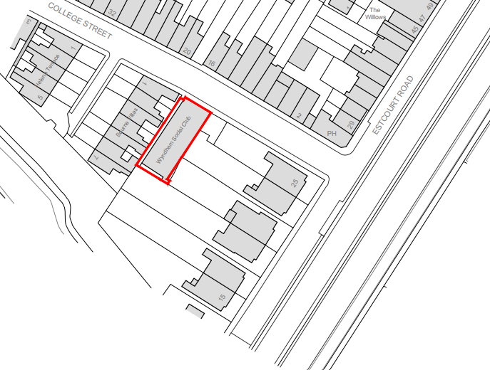

The site currently consists of a redundant, single storey, shallow pitched brick built building which fronts College Street; the building takes up the majority of the plot with a small slither of land to the rear and side (north west).

The site is situated in Flood Zone 1 but is within the catchment area for the River Avon Special Area for Conservation (SAC). It is also within the Salisbury Skyline Area (as defined by WCS policy CP22 (Salisbury Skyline) and saved Salisbury District Local Plan policies H7 and E3). In addition, the site is located just to the north of the Salisbury City Conservation Area (shaded green on the map below), which includes in the vicinity, the Salisbury Arts Centre and Bourne Hill House (both Grade II* and Grade 2 listed buildings and shown with black hatching on the map below); a Scheduled Ancient Monument (city ramparts); and the grounds of Bourne Hill (a Grade II Registered Park and Garden). The site also lies within the 13.8km zone of influence for the New Forest internationally protected sites, which comprises the New Forest SPA, New Forest SAC and New Forest Ramsar site.

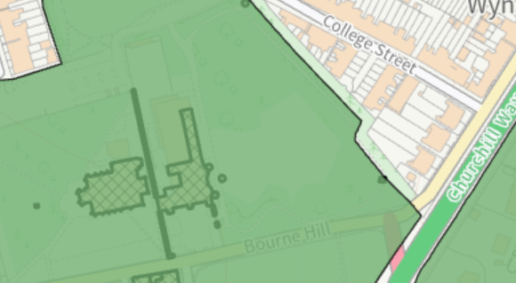

PROPOSAL

The application is seeking consent for the change of use of the existing Conservative (social) club to create a single C3 residential dwelling. The proposals also include part demolition of the existing building and associated works to all elevations.

Existing and proposed south west elevation

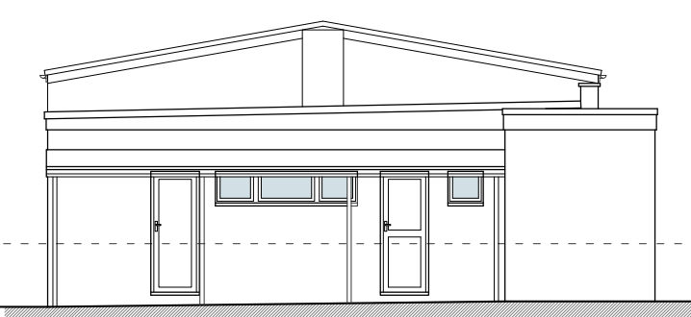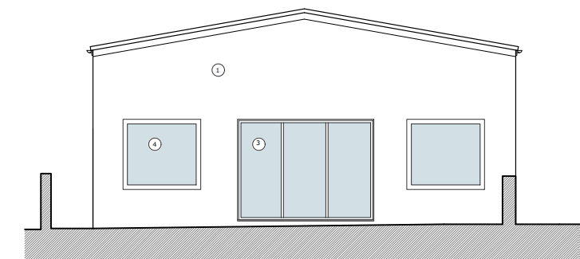

Existing and proposed north east elevation

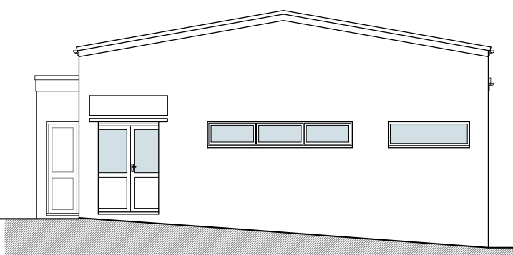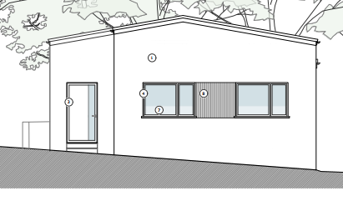

Existing north west elevation
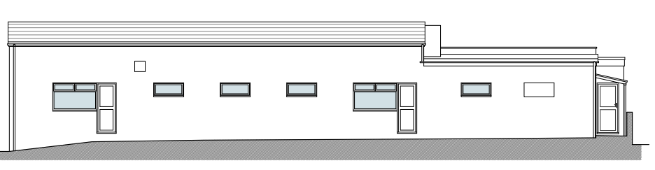
Proposed north west elevation

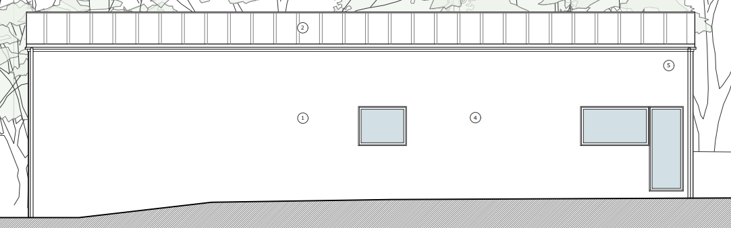

Existing south east elevation
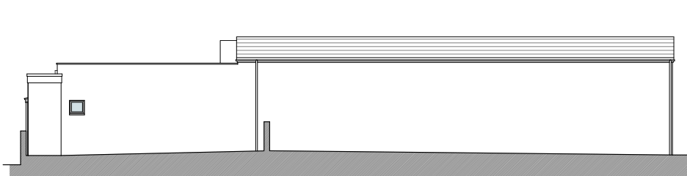
Proposed south east elevation

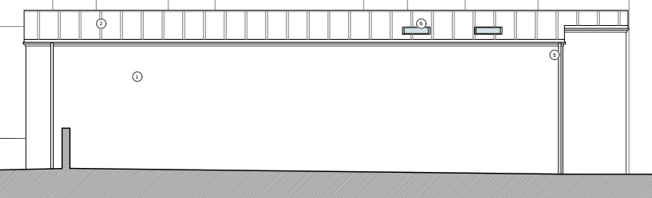

Existing and proposed block plan

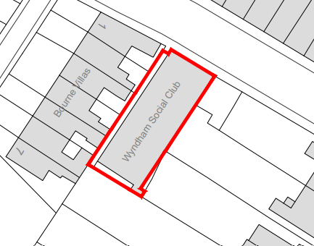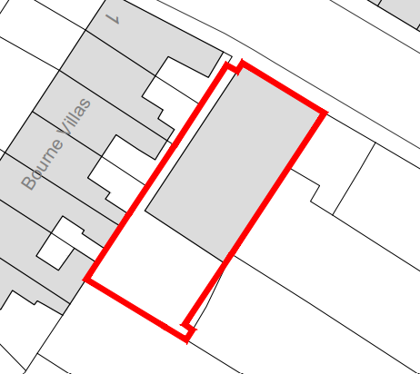

Existing ground floor plan

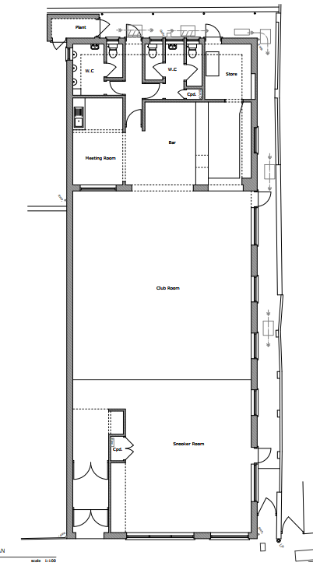

Proposed ground floor and roof plans

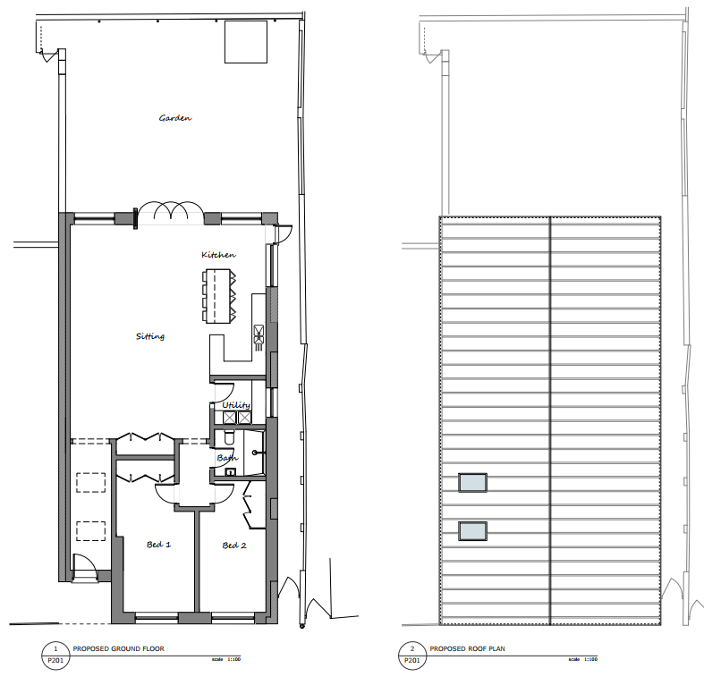
Proposed materials schedule

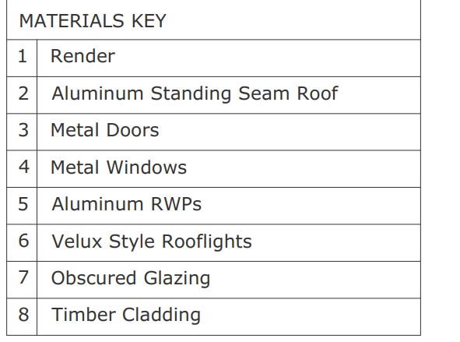

This application is the third application following two previous submissions for the same development, both of which were withdrawn following objections from Officers in relation to the design, scale, materials and amenity impact of the proposed works. It is understood that development has started on site through some demolition works.

PLANNING HISTORY

Proposal / Summary
PL/2025/03987 - Full planning permission Decision - Withdrawn by Applicant Date: 16/10/2025 – Change of use from social club to private dwelling. Partial demolition of existing building. First floor extension.
PL/2026/01472 - Full planning permission Decision - Withdrawn by Applicant Date: 11/6/2026 – Change of use from social club to private dwelling. Partial demolition of existing building. Replacement roof.

RELEVANT LEGISLATION, POLICIES AND GUIDANCE

Statutory Legislation:

National Planning Policy:
- National Planning Policy Framework (NPPF)
- Planning Practice Guidance (PPG)

Development Plan:

The development plan for Wiltshire comprises the Wiltshire Core Strategy (WCS) (adopted January 2015) and any made neighbourhood plans, which remains the principal statutory planning document guiding development across the county. In line with Section 38(6) of the Planning and Compulsory Purchase Act 2004, planning decisions must be made in accordance with the development plan unless material considerations indicate otherwise.

Though the development plan is considered as a whole, those parts deemed to be particularly relevant to this application are listed below:

Salisbury District Local Plan policies (Saved by Wiltshire Core Strategy) (SDLP):
R2 – Public Open Space Provision
H7 – Housing
H8 – Housing
E3 – Employment

Wiltshire Core Strategy (January 2015) (WCS):
CP1 (Settlement Strategy)
CP2 (Delivery Strategy)
CP3 (Infrastructure Requirements)
CP20 (Salisbury Community Area)
CP22 (Salisbury Skyline)
CP45 (Meeting Wiltshire’s Housing Needs)
CP50 (Biodiversity and Geodiversity)
CP57 (Ensuring High Quality Design & Space Shaping)
CP58 (Ensuring the Conservation of the Historic Environment)
CP60 (Sustainable Transport)
CP61 (Transport & Development)
CP62 (Development Impacts on the Transport Network)
CP69 (Protection of the River Avon SAC)

Wiltshire Housing Site Allocations Plan (February 2020) (WHSAP)

Salisbury Neighbourhood Plan

Supplementary Planning Documents:

Wiltshire Design Guide
National Design Guide
Creating Places Design Guide SPG (April 2006)
Achieving Sustainable Development SPG (April 2005)
Affordable Housing SPG (Adopted September 2004)
Wiltshire Local Transport Plan – Car Parking Strategy

Draft Wiltshire Local Plan
At Full Council on 19 May 2026, the elected members of Wiltshire Council agreed to withdraw the emerging Wiltshire Local Plan. The said Plan has no material weight for the purposes of the application.

In accordance with Regulation 19 of the Town and Country Planning (Local Planning) (England) Regulations 2026, on 30th June 2026 Wiltshire Council published a notice of intention to prepare a new local plan for Wiltshire. The next stage is a Scoping Consultation which commences on 2nd September 2026. This plan is at a very early stage and currently carries no weight for decision making.

ISSUES

The main issues that need to be addressed in this case include:

Principle
Character and Design
Amenity
Highways
Ecology

CONSULTATION RESPONSES

City Council: Support

Highways: No objection subject to condition

Ecology: No objection subject to condition

Natural England: No objection – Subject to mitigation in line with the Council’s proposed mitigation for New Forest SAC.

REPRESENTATIONS

Three third party representations have been received from two neighbouring properties; comments are included in full below.

1. This is a far better design for the building, with just the single storey, the main entrance moved to the front and windows reduced on our side, our light and privacy will not be affected to anything like the extent it would have been with the previous plan.
It will be good to see the building back in use, hopefully the build will not make too much of a mess of our patio.

2. Our property shares a boundary with the proposed building. There has always been a disputed section of the wall which encroaches on our garden. When the Conservative Club was housed there, they tried to say they had access across our garden to a door which led to the boiler room. This was denied, and they had legal advice which said they could only access the boiler room within their building . I was very pleased when the present owner said he would build the wall in a straight line across the boundary and give us the old space for a tool shed . He has now reneged on this promise saying he has changed his mind. Needless to say, I am very disappointed and shocked he could do that.

3. this is far a better design that will not impinge on our privacy and light to anything like the same extent as previous proposals, with lower roof and main entrance now at the front of the property (with previous emergency exit and adjacent window removed). Sense has prevailed.

ASSESSMENT
Section 38(6) of the Planning and Compulsory Purchase Act 2004 states:

"If regard is to be had to the development plan for the purposes of any determination to be made under the planning Acts, the determination must be made in accordance with the plan unless material considerations indicate otherwise."

In accordance with this statutory requirement, this application has been assessed against the relevant policies of the Development Plan, including the Wiltshire Core Strategy (2015) and, where applicable, any made Neighbourhood Plans. Consideration has also been given to the policies of the NPPF (NPPF) as a material consideration in the assessment.

The assessment below considers each of the main issues identified above. Each topic is assessed in turn with reference to the relevant policy context, the evidence submitted, consultee responses, and all other material considerations, before a conclusion is reached.

Principle of Development

As is identified above, the site is situated within the defined settlement boundary of Salisbury, which is designated as a Principal Settlement by WCS policies CP1 (Settlement Strategy), CP2 (Delivery Strategy) and CP20 (Salisbury Community Area). WCS policy CP1 (Settlement Strategy) confirms that ‘Principal Settlements are strategically important centres’ and should be ‘…the primary focus for development’ and that the growth of the principal settlements will therefore be supported. WCS policy CP2 (Delivery Strategy) continues that ‘Within the limits of development…there is a presumption in favour of sustainable development at the Principal Settlements’. WCS policy CP20 (Salisbury Community Area) further confirms that ‘Over the plan period (2006 to 2026)…approximately 6,060 new homes will be provided within the Community Area, which should occur either within Salisbury or the town of Wilton’. The principle of the site’s redevelopment for housing is therefore accepted within this context.

The NPPF also contains national policies relating to the location of development. Policies S3-S5 distinguish between development within settlements and development in the countryside, support sustainable patterns of growth, and require decisions to have regard to the role and function of settlements, accessibility to services and facilities, and other site-specific considerations.

The principle of development should be assessed having regard to the Development Plan as a whole, the NPPF and all other material considerations. The weight afforded to individual policies will depend upon the nature, scale and location of the development proposed.

Where relevant, Policy S6 provides additional protection to qualifying neighbourhood plans. Where a housing proposal conflicts with a neighbourhood plan that became part of the development plan within the last five years and contains allocations to meet its identified housing requirement, the Framework indicates that the benefits of approving development are likely to be substantially outweighed by the adverse effects.

In addition, the Salisbury Neighbourhood Development Plan (2020-2038) supports the delivery of additional housing within the city, recognising both the need to provide homes for a range of household types and the role that windfall and previously developed sites can play in meeting identified housing needs. The Plan notes that the city has historically accommodated housing through the redevelopment of brownfield land and conversions, and seeks to support the provision of new homes in sustainable locations within the city boundary. The proposal would contribute a modest addition to the local housing stock through the re-use of an existing previously developed site and is therefore consistent with the housing objectives of the Neighbourhood Plan

Policy HO7 of the NPPF recognises the importance of delivering homes which contribute towards meeting the evidenced accommodation needs of the community and states that substantial weight should be given to the benefits of providing such homes.

The existing building operates as a former Conservative Club and therefore falls within a sui generis use. As such, there is no specific development plan policy requirement for the applicant to demonstrate the continued viability of the existing use through a marketing exercise prior to its loss. This differs from proposals involving the loss of community facilities protected by specific policies where evidence of need, viability or appropriate replacement provision may be required such as CP49. In this case, the building has ceased operating as a social club and no evidence has been submitted to suggest that the use remains active or continues to fulfil an important community function. The proposed re-use of the vacant building to provide a dwelling in a sustainable location is therefore considered acceptable in principle.

Notwithstanding the above, the acceptability of the proposal must be considered having regard to all other relevant material considerations, including design, the impacts on the character and appearance of the area, neighbouring amenity, highway safety and ecological interests. These matters are assessed below.

5 Year Housing Land Supply

The Council's latest Housing Land Supply Statement provides the most up-to-date position regarding the availability of deliverable housing land within Wiltshire and is a material consideration in the determination of planning applications.

The NPPF requires local planning authorities to identify and maintain a supply of specific deliverable housing sites. Housing need, housing requirements, and the supply of deliverable sites are addressed through Policies HO1 to HO6 (for plan-making) and HO7 to HO13 (for decision taking) and Annex D of the NPPF. Annex D sets out the methodology for calculating housing need, assessing land supply, the application of housing land supply buffers using the latest Housing Delivery Test results, and establishing a five-year supply of deliverable housing sites.

The Council's current housing land supply position demonstrates a supply of 2.8 years of deliverable housing land against the relevant housing requirement. This position is a material consideration when assessing proposals for residential development. Where a shortfall exists, this indicates that the Council is unable to demonstrate a full five-year supply of deliverable housing sites and this is capable of attracting significant weight in favour of proposals which would contribute towards meeting identified housing needs. Conversely, where a five-year supply can be demonstrated, this is also a material consideration to be afforded appropriate weight in the overall planning balance.

In determining this application, regard has been had to the Council's current housing land supply position, the relevant housing policies of the development plan, the housing objectives of the NPPF, and all other material considerations. The extent to which the Council's housing land supply position affects the weight to be afforded to housing delivery and other material considerations has been considered as part of the planning balance set out below.

The contribution that this proposal would make towards meeting housing needs, together with any other benefits and harms arising from the development, is assessed within the overall planning balance and conclusion sections of this report.

Design and Impact on the Character and Appearance of the Area

Core Policy 57 of the Wiltshire Core Strategy requires development to achieve a high standard of design that responds positively to local character, context and distinctiveness.

Policies DP1-DP4 of the NPPF seek to ensure that development is well-designed, visually attractive, sustainable and responsive to its surroundings. Development should contribute positively to local character, create high quality places and support healthy and inclusive communities.

The Wiltshire Design Guide provides further guidance on achieving high quality, context-led design and should be taken into account where relevant.

The application represents the third submission seeking the conversion of the former social club to residential use, with previous schemes having been withdrawn following concerns regarding matters including scale, design and impact on neighbouring amenity. In response, the current proposal has undergone significant revision and now seeks the retention of a simple single-storey form, incorporating the partial demolition of the rear section of the building and the removal of the previously proposed extensions and enlarged roof forms. This reduction in built mass represents a notable improvement when compared to previous iterations of the scheme and results in a more proportionate relationship with the surrounding residential development.

The proposed external appearance adopts a contemporary architectural approach through the use of rendered walls, timber cladding and a standing seam metal roof. Whilst these materials differ from the more traditional brick-built dwellings which characterise much of the surrounding area, the building is already distinct in its form and appearance as a former social club. The dwelling would remain modest in scale and, whilst it would be visible within the street scene, its siting, scale and overall form are not considered to result in any unacceptable harm to the character or appearance of the area.

The proposals would also secure the long-term re-use of a redundant building within a sustainable location and make more efficient use of previously developed land. The creation of a single two-bedroom dwelling would make a positive, albeit modest, contribution towards the Council's housing supply at a time when the authority is unable to demonstrate a five-year supply of deliverable housing land. This benefit weighs in favour of the proposal.

The application would result in the loss of a former social club. However, the building has ceased operating in this capacity and there is no evidence before the Local Planning Authority that it continues to serve an active community function. Furthermore, the site is located within Salisbury where a wide range of alternative community, leisure and social facilities remain available. Having regard to the circumstances of this case and the proposed re-use of a redundant building to provide an additional dwelling in a sustainable location, no objection is raised to the loss of the former social club use.

Taking all matters into account, the scale, design and appearance of the development are considered acceptable and would not result in harm to the character or appearance of the area. The proposal therefore complies with Core Policy 57 of the Wiltshire Core Strategy and the design objectives of the NPPF.

Officers note that the application has been supported by a landscape plan, however, the trees shown on this plan are outside of the boundary of the site and therefore cannot be considered as part of the application.

Amenity

Core Policy 57 (Point vii) of the Wiltshire Core Strategy requires development to respect the amenity of existing occupants and ensure appropriate amenity levels for future residents.

Policy P3 of the NPPF requires development to be appropriate for its location, taking account of its likely effects on health, living conditions and the environment. In particular, Policy P3(2)(b) requires development to avoid giving rise to unacceptable impacts on the living conditions of neighbouring residents and occupiers. In assessing amenity impacts, regard should be had to matters including daylight and sunlight, outlook, privacy, overbearing impacts and other effects on residential amenity.

These policies guide the assessment of amenity impacts. Each of the below matters has been assessed having regard to the specific site context and layout of the proposal.

The proposal involves the conversion of the existing building to a single residential dwelling together with the partial demolition of the rear section of the structure. As a result, the overall built form would be reduced when compared to the existing building, creating a more spacious relationship with neighbouring properties and allowing for the provision of private garden space.

It is noted that the majority of the third party comments received acknowledge that the current proposal represents a significant improvement over previous iterations of the scheme, particularly in terms of its reduced scale and impacts upon neighbouring amenity.

One representation raises concerns regarding an alleged boundary encroachment and historic access arrangements associated with part of the existing building. Whilst those concerns are noted, matters relating to land ownership, boundary positions, rights of access and any associated covenants are private civil matters between the relevant parties and do not fall within the remit of the planning system. The application has therefore been assessed on the basis of the submitted plans and the planning merits of the proposal. Furthermore, the proposal does not introduce any new built form or openings in this location that would give rise to material harm to the living conditions of neighbouring occupiers

In assessing the impacts upon neighbouring occupiers, particular regard has been had to the scale, siting and design of the proposed dwelling and its relationship with surrounding residential properties. The building would remain single storey in form and, given its modest height and established position within the site, would not give rise to any significant overbearing, overshadowing or loss of light impacts. Furthermore, the proposed fenestration serves habitable rooms in a manner typical of a residential area and would not result in unacceptable overlooking or loss of privacy to neighbouring occupiers.

Particular regard has been had to the proposed window arrangement given the constrained nature of the site and proximity of neighbouring properties. However, all proposed windows would be located at ground floor level within a single-storey building and would therefore provide views comparable to those typically experienced within a residential environment. Appropriate boundary treatment such as up to 2m high fencing can ensure that the proposed openings would not result in direct overlooking of neighbouring dwellings and are not considered to create an unacceptable loss of privacy.

In respect of future occupiers, the proposal would create a modest two-bedroom dwelling providing appropriate internal living accommodation. Whilst the associated garden area is relatively compact, this reflects the highly sustainable city centre location of the site and nevertheless provides a useful and private area of external amenity space. Overall, the proposal would provide an acceptable standard of amenity for future residents.

Accordingly, the proposal is considered to comply with Core Policy 57 of the Wiltshire Core Strategy and the relevant provisions of the NPPF.

Highways Impacts and Parking

Policies TR3-TR8 of the NPPF seek to ensure that development is supported by safe, suitable and sustainable transport arrangements. Development should provide appropriate access, promote sustainable travel choices where possible and avoid unacceptable impacts on highway safety and the operation of the transport network.

Core Policies 60-64 of the Wiltshire Core Strategy require development to provide safe access, promote sustainable transport, minimise transport impacts and provide appropriate parking arrangements.

Where relevant, regard should also be had to the Wiltshire Local Transport Plan, the Council's parking standards and any applicable Local Cycling and Walking Infrastructure Plans (LCWIPs).

The site occupies a highly sustainable location within the built-up area of Salisbury, within easy walking and cycling distance of a wide range of services, facilities, employment opportunities and public transport connections. The existing social club operates without any dedicated off-street parking, and the proposed development likewise makes no provision for private vehicle parking.

The Council's Highway Officer has reviewed the proposal and raises no objection. It is noted that on-street parking within College Street is managed through the residents' parking scheme and future occupants may not be eligible for a parking permit. However, given the site's sustainable location and the modest scale of the proposal, the absence of off-street parking is not considered to result in severe highway impacts. Furthermore, the proposal includes provision for secure cycle storage within the rear garden, encouraging sustainable modes of transport.

Having regard to the site's location, the existing parking circumstances and the consultation response received from the Highway Authority, the proposal is considered to accord with Core Policies 60 and 61 of the Wiltshire Core Strategy and the relevant provisions of the NPPF

Ecology and Biodiversity

Core Policy 50 of the Wiltshire Core Strategy requires development to protect and, where appropriate, enhance biodiversity and geodiversity interests.

Policy N2 of the NPPF seeks to conserve and enhance biodiversity, support nature recovery, protect habitats and species, and strengthen ecological networks.

Where relevant, proposals should assess impacts upon protected species, habitats, ecological networks and green and blue infrastructure and demonstrate that any adverse impacts can be appropriately avoided, mitigated or compensated for.

Biodiversity Net Gain (BNG) is mandatory for most development and proposals should demonstrate compliance with the statutory requirements unless an exemption applies.

The Council's Ecologist has reviewed the application and raises no objection subject to conditions. The site lies within the catchment of the River Avon SAC and within the zone of influence of the New Forest internationally designated sites. Appropriate mitigation is required in relation to both recreational impacts upon the New Forest protected sites and nutrient neutrality within the River Avon catchment. Subject to the securing of the required mitigation measures and legal agreements, the Council is able to conclude that the proposal would not result in adverse effects upon the integrity of these internationally important ecological designations.

Natural England have confirmed that subject to securing of appropriate mitigation for New Forest SAC they have no objection.

It is advised that the costs stated within the Ecology consultation response are correct at the time of writing this report. The applicant should note that, depending on any delay between the issuing of a decision and the purchase of credits, the costs may increase.

In respect of Biodiversity Net Gain, the Council's Ecologist confirms that the proposal falls below the de minimis threshold and is therefore exempt from the mandatory Biodiversity Net Gain requirements. Nevertheless, biodiversity enhancements, including ecological enhancement features, can be secured by condition in accordance with Core Policy 50 of the Wiltshire Core Strategy.

Subject to the completion of the required mitigation measures and the imposition of the recommended planning conditions, the proposal is considered to comply with Core Policies 50 and 69 of the Wiltshire Core Strategy.

CIL
The proposed development may be liable for CIL as set out in the Wiltshire CIL Charging Schedule dated May 2015. This is a charge that local authorities can impose on new developments in their area. The money generated through the levy will contribute towards the funding of infrastructure to support growth and is payable upon commencement of development.

PLANNING BALANCE AND CONCLUSION

The application seeks the change of use and conversion of a former social club to a single two-bedroom dwelling, together with associated external alterations and the partial demolition of the existing building.

The site is located within the defined settlement boundary of Salisbury where the principle of residential development is supported by the spatial strategy of the Wiltshire Core Strategy. The proposal would secure the beneficial re-use of a vacant building within a highly sustainable location and would provide an additional dwelling at a time when the Council is currently unable to demonstrate a five-year supply of deliverable housing land. These benefits attract significant weight in favour of the development.

The proposed alterations have been substantially revised from previous iterations of the scheme and are considered acceptable in terms of their scale, design and impact on the character and appearance of the area. The proposal would not result in unacceptable impacts upon neighbouring residential amenity, would not give rise to highway safety concerns and, subject to the recommended mitigation measures and conditions, would not adversely affect ecological interests.

Having regard to the Development Plan as a whole, the National Planning Policy Framework and all other material considerations, the proposal is considered to constitute sustainable development. The application is therefore recommended for approval, subject to the conditions set out below.

RECOMMENDATION: That Planning Permission be GRANTED, subject to conditions

1. The development hereby permitted shall be begun before the expiration of three years from the date of this permission.

REASON: To comply with the provisions of Section 91 of the Town and Country Planning Act 1990 as amended by the Planning and Compulsory Purchase Act 2004

2. The development hereby permitted shall be carried out in accordance with the following approved plans:

Application form received 06/07/2026
Site location plan Drg no 24 / 842 / E001 received 06/07/2026
Proposed block plan Drg no 24 / 842 / P002 received 06/07/2026
Proposed south and west elevations Drg no 24 / 842 / P211 Rev A received 06/07/2026
Proposed north and east elevations Drg no 24 / 842 / P210 Rev C received 06/07/2026
Proposed ground and roof plan Drg no 24 / 842 / P201 Rev C received 06/07/2026
Landscape plan Drg no 24 / 842 / P200 A Rev A received 13/07/2026
Natural England Nutrient Neutrality budget calculator for the River Avon SAC received 03/08/2026
Planning Statement. 31 July 2026. Atlas Planning Group received 04/08/2026

REASON: For the avoidance of doubt and in the interests of proper planning and for the protection, mitigation and enhancement of biodiversity.

3. Notwithstanding the approved plans, no external facing or roofing materials shall be installed until details and samples of such materials have been submitted to and approved in writing by the Local Planning Authority.

The development shall thereafter be carried out in accordance with the approved details.

REASON: To ensure that the external appearance of the development is satisfactory and preserves the character and appearance of the area.

4. Prior to the first occupation of the dwelling hereby approved, details of covered and secure cycle parking facilities for a minimum of two bicycles shall be submitted to and approved in writing by the Local Planning Authority. The facilities shall be provided in accordance with the approved details prior to first occupation and retained for the lifetime of the development.

REASON: To ensure adequate provision for cycle parking and to promote sustainable modes of transport in accordance with the aims of the Local Transport Plan Cycling Strategy.

5. The development hereby permitted shall not be occupied until evidence of compliance to the Wiltshire Council River Avon Special Area of Conservation Mitigation scheme, or an alternative approved mitigation package addressing the additional nutrient input arising from the development, has been submitted to, and approved in writing by the Local Planning Authority.

REASON: To accord with the Conservation of Habitats and Species Regulations 2017, and Wiltshire Core Strategy Core Policy 69

6. The development hereby permitted shall not be occupied until evidence of compliance to the Wiltshire Council New Forest Protected Sites Recreational Impacts Mitigation Scheme, or an alternative approved mitigation package addressing the recreational pressure arising from the development, has been submitted to, and approved in writing by the Local Planning Authority.

REASON: To accord with the Conservation of Habitats and Species Regulations 2017.

7. Notwithstanding the provisions of the Town and Country Planning (General Permitted Development) (England) Order 2015 (as amended by the Town and Country Planning (General Permitted Development) (Amendment) (No.3) (England) Order 2020 (or any Order revoking or re-enacting or amending those Orders with or without modification), no development within Part 1, Classes A, B or C, shall take place on the dwellinghouse hereby permitted.

REASON: In the interests of the character and amenity of the area and to enable the Local Planning Authority to consider individually whether planning permission should be granted for additions, alterations, extensions or enlargements and due to the constrained nature of the site.

8. The overnight development hereby approved shall be designed to ensure it does not exceed 110 litres per person per day water consumption levels (which includes external water usage)

REASON: To ensure compliance with the prevailing mitigation strategy for nutrient neutrality in the water catchment within which this development is located.

9. Prior to the first occupation of the development hereby approved, details of the number, design and locations of ecological enhancement features, including bat boxes, bird boxes and hedgehog hibernacula, shall be submitted to and approved in writing by the Local Planning Authority.

The approved details shall be implemented prior to occupation and retained for the lifetime of the development.

REASON: To provide mitigation /enhancement for biodiversity

10. All lighting provided on site shall be in accordance with the appropriate Environmental Zone standards set out by the Institute of Lighting Engineers in their publication GN01:2021, ‘Guidance for the Reduction of Obtrusive Light’ (ILP, 2021), and Guidance note GN08/23 “Bats and artificial lighting at night”, issued by the Bat Conservation Trust and Institution of Lighting Professionals.

REASON: In the interests of the amenities of the area and to minimize impacts on biodiversity caused by light spillage to areas above and outside the development site

11. No construction or demolition work shall take place on Sundays or Bank or Public Holidays; or outside the hours of 08:00 to 18:00 Monday to Friday; and 08:00 to 13:00 on Saturdays.

REASON: In the interests of neighbouring residential amenities

INFORMATIVES

1. BNG not required

The effect of paragraph 13 of Schedule 7A to the Town and Country Planning Act 1990 is that planning permission granted for development of land in England is deemed to have been granted subject to the condition (biodiversity gain condition) that development may not begin unless:

(a) a Biodiversity Gain Plan has been submitted to the planning authority, and
(b) the planning authority has approved the plan.

The planning authority, for the purposes of determining whether to approve a Biodiversity Gain Plan, if one is required in respect of this permission would be Wiltshire Council.

There are statutory exemptions and transitional arrangements which mean that the biodiversity gain condition does not always apply. For further information on exempt developments please refer to:
https://www.gov.uk/guidance/biodiversity-net-gain-exempt-developments
Based on the information available this permission is considered to be one which will not require the approval of a biodiversity gain plan before development is begun because one or more of the statutory exemptions or transitional arrangements is considered to apply

2. Hampshire Avon Phosphorus Mitigation

In relation to condition 5 above, evidence of compliance to the Wiltshire Council River Avon Special Area of Conservation Mitigation Scheme means the certificate of allocation of credits and confirmation of financial contribution to the scheme. An alternative mitigation package must be approved by the local planning authority and Natural England with evidence of allocation to the scheme. The cost of purchasing Council Credits will be confirmed when a formal application to purchase is made.

3. New Forest SAC

In relation to condition 6 above, evidence of compliance to the Wiltshire Council New Forest Protected Sites Recreational Impacts Mitigation Scheme means confirmation of payment of the financial contribution to the scheme. An alternative mitigation package must be approved by the local planning authority and Natural England with evidence of allocation to the scheme.

4. Building Regulations

Any alterations to the approved plans, brought about by compliance with Building Regulations or any other reason must first be agreed in writing with the Local Planning Authority before commencement of work.

5. Protected Species
The applicant should note that under the terms of the Wildlife and Countryside Act (1981) and the Conservation of Habitats and Species Regulations 2017 (as amended) it is an offence to disturb or harm any protected species including for example, breeding birds and reptiles. The protection offered to some species such as bats, extends beyond the individual animals to the places they use for shelter or resting. Please note that this consent does not override the statutory protection afforded to any such species. In the event that your proposals could potentially affect a protected species you should seek the advice of a suitably qualified and experienced ecologist and consider the need for a licence from Natural England prior to commencing works. Please see Natural England’s website for further information on protected species.

6. CIL

The applicant is advised that the development hereby approved may represent chargeable development under the Community Infrastructure Levy Regulations 2010 (as amended) and Wiltshire Council's CIL Charging Schedule. If the development is determined to be liable for CIL, a Liability Notice will be issued notifying you of the amount of CIL payment due. If an Additional Information Form has not already been submitted, please submit it now so that we can determine the CIL liability. In addition, you may be able to claim exemption or relief, in which case, please submit the relevant form so that we can determine your eligibility. The CIL Commencement Notice and Assumption of Liability must be submitted to Wiltshire Council prior to commencement of development. Should development commence prior to the CIL Liability Notice being issued by the local planning authority, any CIL exemption or relief will not apply and full payment will be required in full and with immediate effect. Should you require further information or to download the CIL forms please refer to the Council's Website:
www.wiltshire.gov.uk/planninganddevelopment/planningpolicy/communityinfrastructurelevy

7. Party Wall

The applicant is requested to note that this permission does not affect any private property rights and therefore does not authorise the carrying out of any work on land outside their control. If such works are required, it will be necessary for the applicant to obtain the landowners consent before such works commence.

If you intend carrying out works in the vicinity of the site boundary, you are also advised that it may be expedient to seek your own advice with regard to the requirements of the Party Wall Act 1996.

