APPLICATION FOR HOUSEHOLDER PLANNING PERMISSION
DELEGATED REPORT

APPLICATION REFERENCE: | PL/2026/04240
APPLICATION TYPE: | Householder planning permission
SITE ADDRESS: | 15 Avenue Road, Trowbridge, BA14 0AQ
DEVELOPMENT DESCRIPTION: | Loft conversion with rear dormer
RECOMMENDATION: | That Planning Permission be GRANTED

PROPOSAL

The application seeks planning permission for a loft conversion including the construction of a rear dormer extension and the installation of two rooflights within the front roofslope, together with associated internal alterations.

SITE DESCRIPTION/CONTEXT

The application site comprises a two-storey mid-terrace dwelling situated on Avenue Road, Trowbridge. The property forms part of an established residential terrace located within the Newtown Conservation Area.

The dwelling benefits from a rear garden and is bounded by neighbouring residential properties. Rear dormer extensions have previously been approved and constructed on the adjoining properties, forming an established feature of the rear roofscape within this section of the terrace.

The site also lies within the Bath and Bradford on Avon Bat SAC Core Roost Buffer.

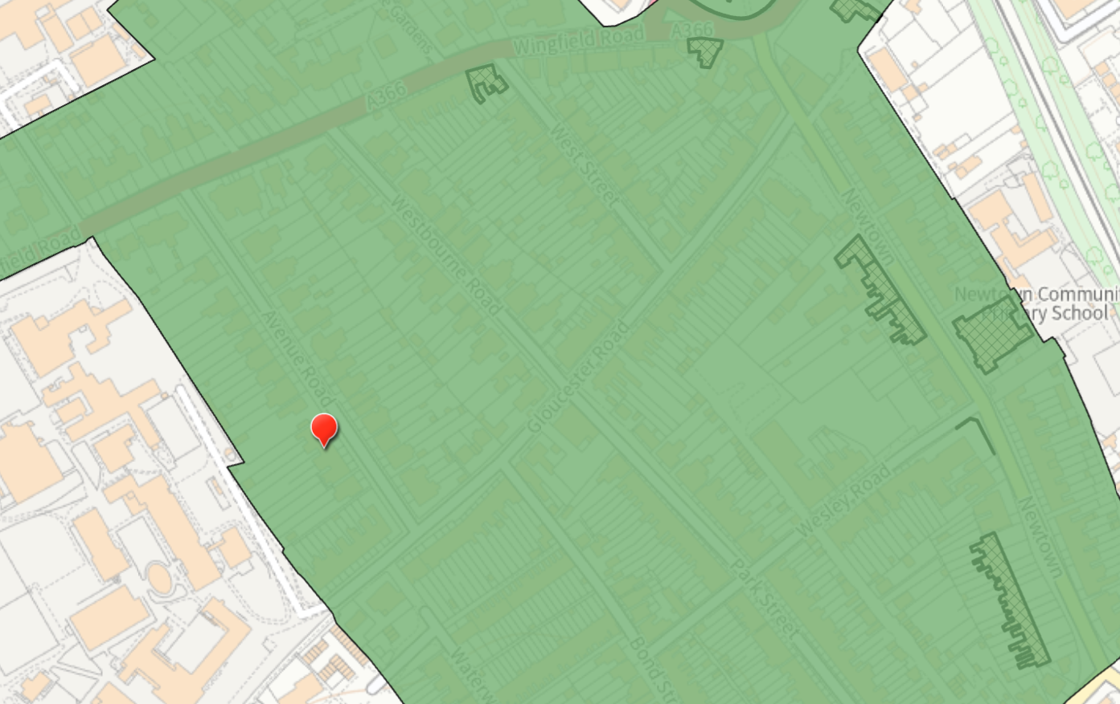

Figure 1: The application site (red pin) located within the Newtown Conservation Area.

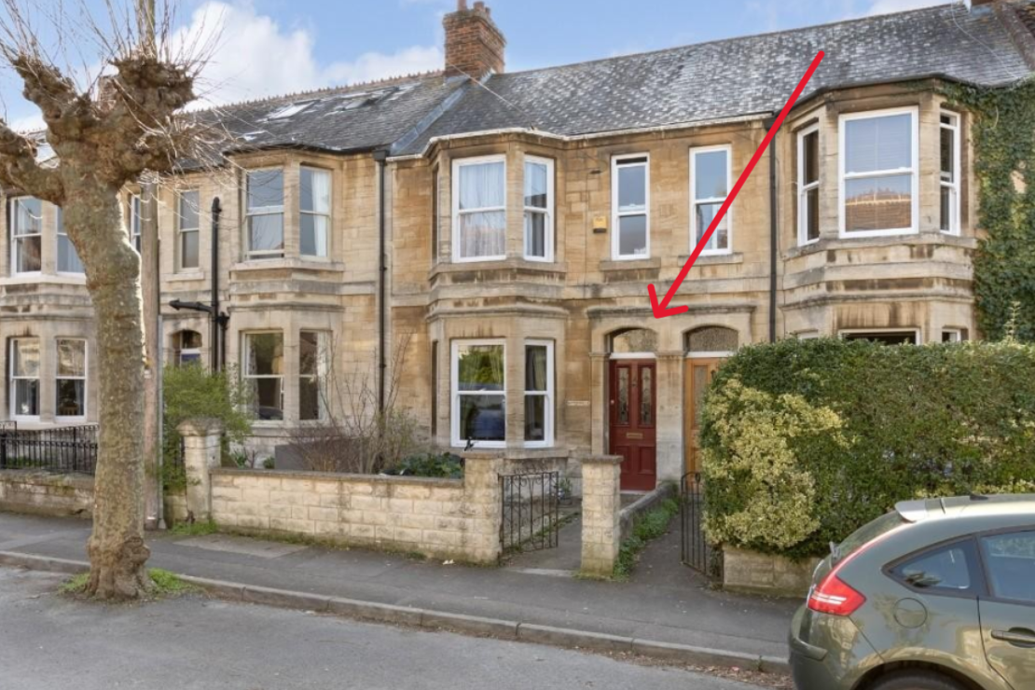

Figure 2: Front elevation of No. 15 Avenue Road viewed from Avenue Road.

PLANNING HISTORY
None of relevance

RELEVANT POLICIES AND GUIDANCE

The 2015 adopted Wiltshire Core Strategy:

- Core Policy 50: Biodiversity and Geodiversity
- Core Policy 57 Ensuring High Quality Design and Place Shaping
- Core Policy 58: Ensuring the Conservation of the Historic Environment

Wiltshire Design Guide: Appendix D – Design Guidance for Householder extensions

The National Planning Policy Framework (NPPF) and Planning Practice Guidance

National Desing Guide

New Wiltshire Local Plan
At Full Council on 19 May 2026, the elected members of Wiltshire Council agreed to withdraw the emerging Wiltshire Local Plan. The said Plan has no material weight for the purposes of the application.

In accordance with Regulation 19 of the Town and Country Planning (Local Planning) (England) Regulations 2026, on 30th June 2026 Wiltshire Council published a notice of intention to prepare a new local plan for Wiltshire. The next stage is a Scoping Consultation which commences on 2nd September 2026. This plan is at a very early stage and currently carries no weight for decision making
CONSULTATION RESPONSES

Trowbridge Town Council: No objection

Highways: No objection

REPRESENTATIONS

No comments were received.

ASSESSMENT

Section 38(6) of the Planning and Compulsory Purchase Act 2004 states:

"If regard is to be had to the development plan for the purposes of any determination to be made under the planning Acts, the determination must be made in accordance with the plan unless material considerations indicate otherwise."

In accordance with this statutory requirement, this application has been assessed against the relevant policies of the Development Plan, including the adopted Wiltshire Core Strategy (2015) and, where applicable, any made Neighbourhood Plans.

Design and Impact upon the character and context of the area

Core Policy 57 - Ensuring High Quality Design and Place Shaping of the Wiltshire Core Strategy seeks to ensure that all new development is of high design quality, reflecting local context, character, and distinctiveness.

Policies DP3 and DP4 of the National Planning Policy Framework require development to achieve a high standard of design that responds positively to local character and context. In assessing design quality, regard should be had to matters including scale, siting, form, appearance, materials and the relationship of development to its surroundings.

The proposal comprises the construction of a rear dormer extension and the installation of two rooflights within the front roofslope to facilitate the conversion of the existing loft space.
It is acknowledged that the proposed dormer would represent a noticeable addition to the rear roofscape. However, rear dormer extensions have previously been approved and constructed on the adjoining properties and therefore already form an established feature within this section of the terrace.

During the course of the application, concerns were raised regarding the relationship of the proposed dormer with the surrounding roofscape. Following negotiations, amended plans were submitted and the dormer has been stepped back to a satisfactory degree, resulting in a more subordinate form of development that better reflects the established pattern of development within the terrace.

Whilst the proposed dormer remains of a generous size, the revised scheme would remain set below the ridge and above the eaves and would not dominate the rear roof slope. Having regard to its scale, siting and design, the dormer is considered to remain subordinate to the host dwelling and would not appear as an incongruous addition within the roofscape.

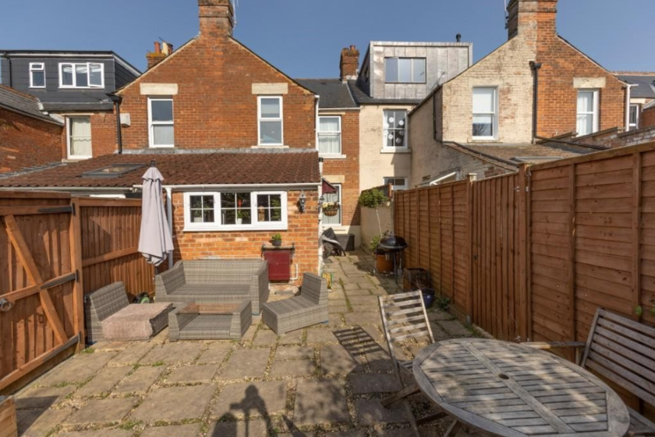

Figure 3: Rear elevation of the application property showing existing dormer extensions on adjoining properties.

The proposed slate/tile hanging, uPVC windows and EPDM roof are considered appropriate materials which would integrate satisfactorily with the existing dwelling and wider roofscape.

With regard to the proposed rooflights within the front roofslope, it is noted that such alterations can ordinarily be undertaken under Schedule 2, Part 1, Class C of the Town and Country Planning (General Permitted Development) (England) Order 2015, subject to compliance with the relevant limitations and conditions. Furthermore, it was evident during the case officer's site visit that a number of properties along Avenue Road have installed rooflights within their front roofslopes. In this context, the proposed rooflights are not considered to result in any significant harm to the character and appearance of the host dwelling, street scene or wider Conservation Area.

Having regard to its scale, design, materials and siting, the dormer is not considered to appear overly prominent or incongruous. The proposal would remain subservient to the host dwelling and would not detract from the character or appearance of the existing property or wider area.
Accordingly, the proposal is considered to complies with the design principles set out in Core Policy 57 of the Wiltshire Core Strategy, Appendix D of the Wiltshire Design Guide and the NPPF.

Heritage Impact

Section 72(1) of the same Act requires special attention to be paid to the desirability of preserving or enhancing the character or appearance of Conservation Areas.

Core Policy 58 of the Wiltshire Core Strategy seeks to conserve and, where appropriate, enhance the significance of designated and non-designated heritage assets and their settings. Core Policy 57 requires development to respond positively to local character and historic context through high quality design.

Policies HE4-HE10 of the National Planning Policy Framework recognise heritage assets as an irreplaceable resource and require proposals affecting heritage assets to be assessed having regard to their significance and the contribution made by their setting.

The application site is located within the Newtown Conservation Area. The significance of this part of the Conservation Area derives principally from the consistent terrace form, traditional materials and the appearance of the principal elevations facing Avenue Road.

The proposal comprises a rear dormer extension and two rooflights within the front roofslope. Whilst the dormer would be visible from neighbouring rear gardens, it would be confined to the rear roofslope and would be experienced primarily within the context of the rear roofscape. The proposal would not materially alter the appearance of the terrace when viewed from the public realm.

It is also noted that rear dormer extensions have previously been approved and constructed on the adjoining properties and already form part of the established rear roofscape within this section of the terrace.

Having regard to its siting, scale, design and materials, the proposal would preserve the character and appearance of the Newtown Conservation Area. The proposal is therefore considered to accord with Core Policy 58 of the Wiltshire Core Strategy and the statutory duty under Section 72(1) of the Planning (Listed Buildings and Conservation Areas) Act 1990.

Amenity
Point vii of Core Policy 57 - Ensuring High Quality Design and Place Shaping of the Wiltshire Core Strategy seeks to ensure that developments do not adversely affect neighbouring properties.
Policy P3 of the National Planning Policy Framework requires development to be appropriate for its location, taking account of its likely effects on health, living conditions and the environment. In particular, Policy P3(2)(b) requires development to avoid giving rise to unacceptable impacts on the living conditions of neighbouring residents and occupiers. In assessing amenity impacts, regard should be had to matters including daylight and sunlight, outlook, privacy, overbearing impacts and other effects on residential amenity.

The proposed development has been assessed in terms of its potential impact on the residential amenity of neighbouring properties, with particular regard to loss of light, overshadowing, loss of privacy, and overbearing effects.

Loss of Light / Overshadowing
It is noted that the dormer at No. 13 Avenue Road contains a small side-facing window within its side elevation. The proposed dormer would be positioned adjacent to this opening. However, it is also noted that the dormer at No. 13 Avenue Road benefits from larger rear-facing windows which provide the principal source of outlook and natural light to the accommodation served.

Given the limited scale of the side-facing window, together with its orientation and the availability of alternative sources of natural light, it is not considered that the proposal would result in any significant loss of light or unacceptable overshadowing to the neighbouring property.

Loss of Privacy
The proposed dormer would introduce an additional habitable room within the roofspace served by rear-facing windows. Whilst these windows would allow views across neighbouring rear gardens, such views would be comparable to those already available from existing first-floor windows within the dwelling and would not result in a materially greater level of overlooking.

The proposal is therefore not considered to result in an unacceptable loss of privacy to neighbouring occupiers.

Overbearing Impact
The proposed dormer would be located on the rear roofslope, remaining set below the ridge and above the eaves. By virtue of its scale, siting and design, the dormer would remain subordinate to the host dwelling and would not appear unduly dominant when viewed from neighbouring residential properties.
The proposal would therefore not result in an unacceptable overbearing impact or sense of enclosure.

The proposal therefore accords with Core Policy 57 point vii in respect of safeguarding residential amenity, Appendix D of the Wiltshire Design Guide and the NPPF.
Ecology Impact
Core Policy 50 of the Wiltshire Core Strategy seeks to protect and enhance biodiversity and geodiversity, including through ensuring that development avoids harm to protected species and habitats.

Policy N2 of the NPPF seeks to conserve and enhance biodiversity and support nature recovery. Development proposals should minimise impacts on habitats and species and, where relevant, demonstrate that appropriate mitigation measures are secured where harm cannot be avoided.

The application relates to a Victorian terraced dwelling located within the built-up area of Trowbridge. Whilst the site lies within the Bath and Bradford on Avon Bat SAC Core Roost Buffer, the proposal is limited to the construction of a dormer extension within an established residential terrace where neighbouring properties have undertaken similar roof alterations.

The dwelling is not considered to possess features that would indicate significant potential for roosting bats and there is no evidence before the Local Planning Authority to indicate the presence of protected species. Having regard to the scale and nature of the works, it is considered unlikely that the proposal would result in harm to bats or their habitats and no further ecological assessment is considered necessary in this instance.

The application site is not subject to any statutory or non-statutory ecological designations, and the scale and nature of development is such that significant harm to biodiversity is unlikely.

No objections have been raised by the Council’s Ecologist.

As such, the development complies with Core Policy 50 of the Wiltshire Core Strategy and the relevant provisions of the NPPF.

Informative
The applicant is reminded that all species of bat and their roosts are protected under the Wildlife and Countryside Act 1981 (as amended) and the Conservation of Habitats and Species Regulations 2017. Should evidence of bats be discovered during works, all works must cease immediately and advice should be sought from a suitably qualified ecologist and Natural England before works recommence.

Other issues
N/A

Biodiversity Net Gain

Householder planning applications are exempt from the requirement to deliver Biodiversity Net Gain under Schedule 7A, Section 4(2)(a) of the Town and Country Planning Act 1990, as inserted by the Environment Act 2021.

CONCLUSION
The proposed development is considered to be acceptable in terms of its design, character and appearance, and would not result in any unacceptable harm to the amenities of neighbouring occupiers.

Furthermore, the proposal would not result in any unacceptable impacts in respect of any other material planning considerations.

The proposal is therefore considered to comply with the relevant policies of the Wiltshire Core Strategy, the National Planning Policy Framework and all other relevant material considerations. As such, the application is recommended for approval, subject to conditions.

RECOMMENDATION: That Planning Permission be GRANTED subject to conditions.

Conditions

- The development hereby permitted shall be begun before the expiration of three years from the date of this permission.
REASON: To comply with the provisions of Section 91 of the Town and Country Planning Act 1990 as amended by the Planning and Compulsory Purchase Act 2004.

- The development hereby permitted shall be carried out in accordance with the following approved plans and documents:

Application Form
Location Plan/ Existing Plans, Section and Elevations
Heritage, Design and Access Statement
Received 07/07/2026

Existing and Proposed Site Plans – A3248 – 03 – A
Proposed Plans, Section & Elevation – A3248 02 – A
Received 29/09/2026

REASON: For the avoidance of doubt and in the interests of proper planning.

