APPLICATION FOR FULL PLANNING PERMISSION
DELEGATED REPORT

APPLICATION REFERENCE: | PL/2026/04026
APPLICATION TYPE: | Full Planning Permission
SITE ADDRESS: | 18 Stallard Street, Trowbridge, BA14 9AJ
DEVELOPMENT DESCRIPTION: | Replace timber central sash windows and fixed side lights to both front facing bays. To be replaced with u-pvc sash and fixed windows to modern standards. First floor elevation the existing 6 over 6 sash windows are to be replaced with u-pvc of a similar style. Ground floor timber door and hidden fanlight are to be replaced with new u-pvc units in keeping with the replacement windows.
RECOMMENDATION: | That Planning Permission be GRANTED

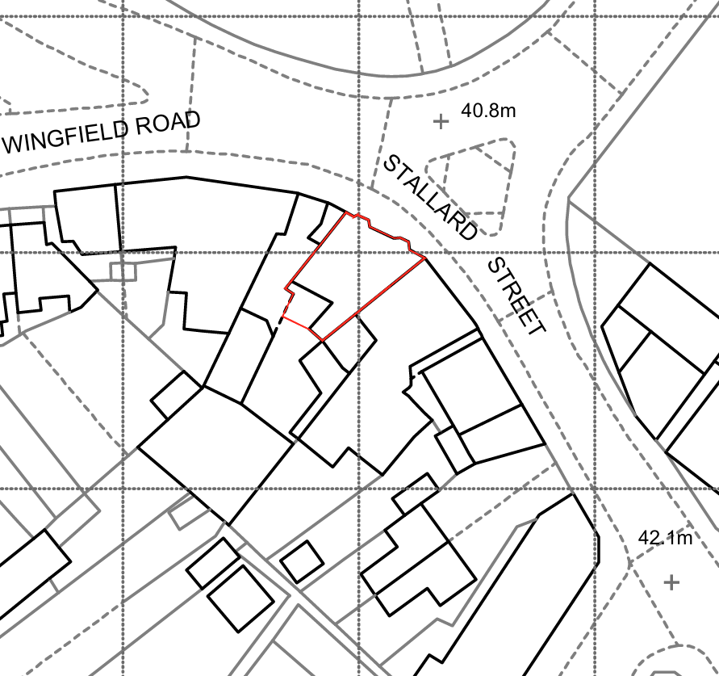
PROPOSAL

Planning permission is sought for the replacement of existing front elevation timber windows and entrance door at 18 Stallard Street. The proposal comprises the replacement of the central sliding sash windows and fixed sidelights within the projecting bay windows at ground floor level, replacement of the first floor six-over-six timber sash windows, and replacement of the existing front door and fanlight. The proposed replacements would be constructed in uPVC and broadly replicate the existing opening arrangement and window style. The application follows previously approved works associated with the conversion of the property into two residential flats.

SITE DESCRIPTION / CONTEXT

The application site comprises an unlisted mid-terrace property located on Stallard Street within the Trowbridge (Newtown) Conservation Area. The building occupies a prominent position at the junction of Stallard Street and Newtown, opposite the Grade II* listed Church of the Holy Trinity and in proximity to a number of other designated heritage assets, including the Grade II listed Stallards Public House. The property forms part of an historic terrace characterised by traditional stone construction, parapeted frontages and vertically proportioned sash windows. The surrounding townscape is varied, comprising historic terraces, listed and non-designated heritage assets, later commercial premises and more modern development. The site also falls within the Trowbridge and Westbury Bat Mitigation Strategy Grey Zone and within the 4km Greater Horseshoe Bat Core Sustenance Zone. The Council's Strategic Flood Risk Assessment identifies groundwater flood susceptibility in the locality, although no significant surface water flood risk constraints are identified.

PLANNING HISTORY

Reference No. | Proposal / Summary | Decision
PL/2025/04764 | Prior Notification - Class MA: The ground floor of 18 Stallard Street is proposed to be converted into 2 number flats | Approved
PL/2025/04686 | New windows and doors to the ground floor rear elevations, render to be refurbished following creation of new structural openings | Approved

RELEVANT LEGISLATION, POLICIES AND GUIDANCE

Wiltshire Core Strategy:

Core Policy 1 Settlement Strategy;
Core Policy 2 Delivery Strategy;
Core Policy 29 Spatial Strategy: Trowbridge Community Area;
Core Policy 50 Biodiversity and Geodiversity;
Core Policy 51 Landscape;
Core Policy 57 Ensuring High-Quality Design and Place Shaping;
Core Policy 58 Ensuring Conservation of the Historic Environment;
Core Policy 60 Sustainable Transport;
Core Policy 61 Transport and Development;
Core Policy 64 Demand Management;
Core Policy 67 Flood Risk;

The National Planning Policy Framework (NPPF) and The Planning Practice Guidance (PPG)

Wiltshire Design Guide

The Wiltshire Local Transport Plan 2011 – 2026: Car Parking Strategy (March 2015).

The Wiltshire Local Transport Plan 4 (LTP4) (March 2025)

New Wiltshire Local Plan

At Full Council on 19 May 2026, the elected members of Wiltshire Council agreed to withdraw the emerging Wiltshire Local Plan. The said Plan has no material weight for the purposes of the application.

In accordance with Regulation 19 of the Town and Country Planning (Local Planning) (England) Regulations 2026, on 30th June 2026 Wiltshire Council published a notice of intention to prepare a new local plan for Wiltshire. The next stage is a Scoping Consultation which commences on 2nd September 2026. This plan is at a very early stage and currently carries no weight for decision making.

CONSULTATION RESPONSES

Trowbridge Town Council – Objects

Conservation (Wiltshire Council) – Objects

REPRESENTATIONS

One third-party objection was received. The concerns raised relate to the loss of existing timber windows, with the objector stating that repair should be considered before replacement. In the event that replacement is necessary, it was suggested that timber-framed windows or heritage-style double glazing should be used. The objector also raised concerns regarding the effect of the proposal on the character and appearance of the Conservation Area.

ASSESSMENT

Section 38(6) of the Planning and Compulsory Purchase Act 2004 states:

"If regard is to be had to the development plan for the purposes of any determination to be made under the planning Acts, the determination must be made in accordance with the plan unless material considerations indicate otherwise."

In accordance with this statutory requirement, this application has been assessed against the relevant policies of the Development Plan, including the adopted Wiltshire Core Strategy (2015) and, where applicable, any made Neighbourhood Plans.

The proposal relates to alterations to an existing residential building and does not involve a change of use, extension, or increase in floorspace. The principle of replacing windows and doors is considered acceptable in principle, subject to the detailed assessment of the impact upon the character and appearance of the host building, the wider Conservation Area and the setting of nearby heritage assets.

The below images are designed to given context for what the existing surrounding street scene is like in presentation. As noted in image A, there is the modern flats on the left and the Victorian terrace on the right both of which feature extensive white UPVC fenestration. And in image B, on the left side of the image is 25A and 25 B Stallard Street, as well as on the right side of the image 20-21 Stallard Street, all of which also feature extensive UPVC fenestration. As noted in the plan, the application site sits directly between these two views. The shaded green area indicates the extent of the conservation area, and the hatched areas indicate listed heritage assets.

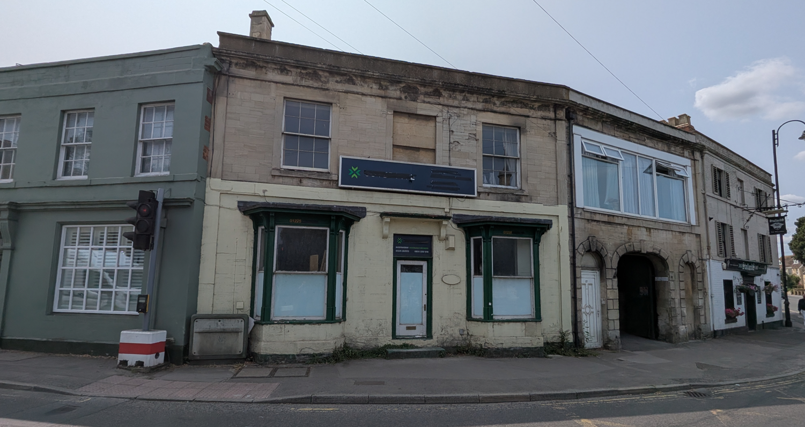
Site Image

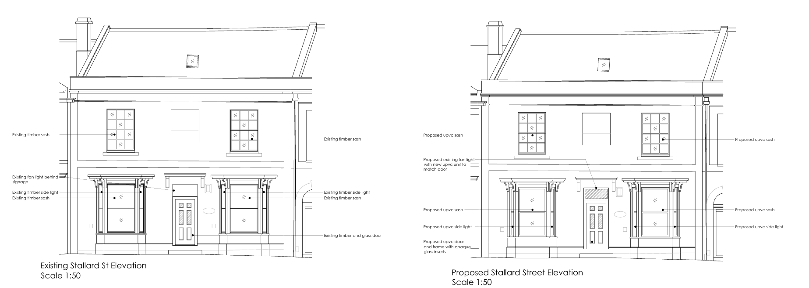
Existing and Proposed Elevations

Conservation and Heritage

Core Policy 58 seeks to ensure that designated and non-designated heritage assets and their settings are conserved and, where appropriate, enhanced. Section 72(1) of the Planning (Listed Buildings and Conservation Areas) Act 1990 places a statutory duty on decision makers to pay special attention to the desirability of preserving or enhancing the character or appearance of conservation areas. In addition, Section 66(1) of the Act requires special regard to be given to the desirability of preserving the setting of listed buildings.

The application property is not itself a listed building but is located within the Trowbridge (Newtown) Conservation Area and occupies a visually prominent position within the street scene. The site sits opposite the Grade II* Church of the Holy Trinity and in proximity to other listed buildings, including the Grade II listed Stallards Public House. The property forms part of an established historic terrace and retains a traditional stone frontage with projecting bay windows and vertically proportioned sash windows which contribute positively to the character and appearance of the Conservation Area.

The Council's Conservation Officer objects to the proposal, raising concern regarding the replacement of traditional timber windows with uPVC units and the potential impact on the significance of the Conservation Area and nearby designated heritage assets. Concerns were also initially raised regarding the condition of the existing windows and the level of detail submitted in support of the proposed replacement product.

In response, the applicant has provided additional information including a revised Design and Access Statement, details of the proposed window system and further commentary regarding the condition of the existing windows. The submitted information confirms that the proposal relates solely to the replacement of the existing window units and associated frames. The decorative bay window structures, including the canopies and supporting brackets, are to be retained and refurbished separately. The submitted information also confirms that the replacement windows are intended to follow the proportions shown on the approved elevation drawings and are to be installed within the existing recessed window reveals.

It is acknowledged that the retention and repair of historic timber windows would generally represent the preferred heritage outcome and that timber replacement windows would more closely replicate traditional construction methods. However, the application must be assessed in its particular context. The applicant has provided additional information regarding the existing condition of the windows, including evidence that substantial deterioration has occurred and that replacement is considered necessary as part of the ongoing refurbishment of the building. Additionally, whilst the building occupies a prominent corner position within the Conservation Area, the surrounding streetscape displays a varied character comprising historic terraces, commercial premises, modern residential development and a number of nearby properties which already incorporate uPVC fenestration. As illustrated within the report, examples of uPVC windows are present on a number of surrounding properties both within and immediately adjacent to views of the application site.

The presence of existing uPVC windows within the surrounding area does not, in itself, justify the unrestricted replacement of traditional timber windows elsewhere within the Conservation Area, nor does it negate the desirability of retaining historic fabric where possible. However, the existing character of the townscape remains a material consideration in assessing the visual impact of the proposal. In this regard, uPVC fenestration already forms a noticeable component of the immediate streetscape and contributes to the established visual context within which the application site is experienced. The assessment therefore turns not on the principle of introducing a wholly unfamiliar material, but on whether the particular design proposed would preserve the character and appearance of the Conservation Area. Having regard to the retention of the existing openings, proportions, recessed positioning and principal architectural features of the building, together with the submitted product information and supporting details, it is considered that the visual change arising from the development would be limited and would not result in material harm to the significance, character or appearance of the Conservation Area or the setting of nearby listed buildings.

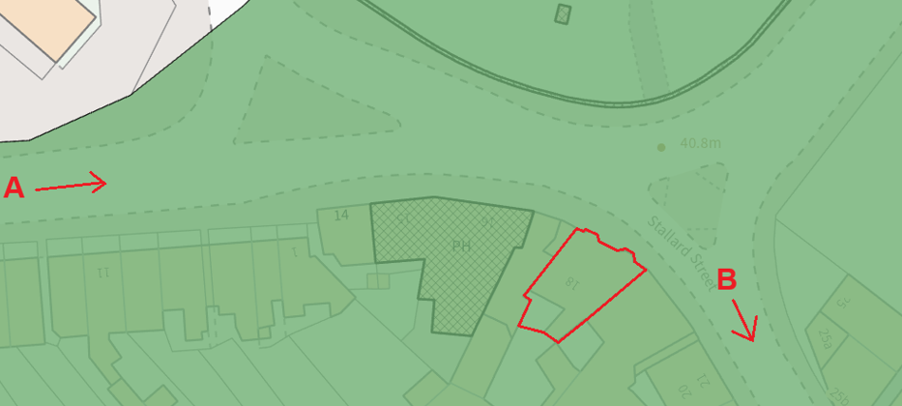
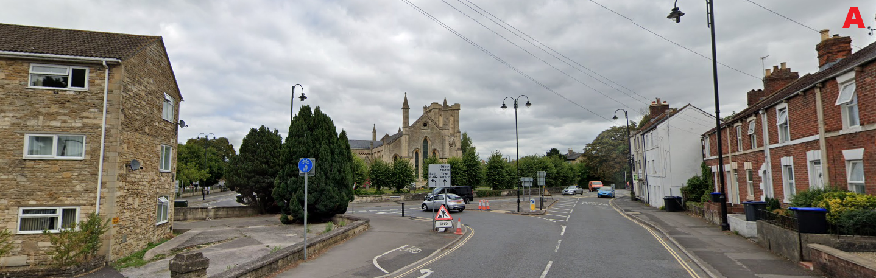
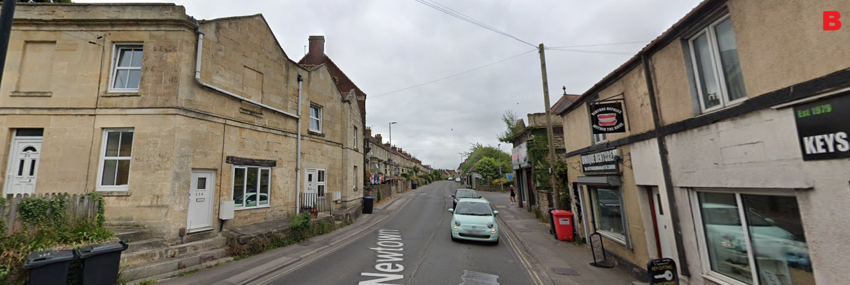
Existing Streetscene

The proposal would not result in any alteration to the size, arrangement or overall appearance of the window openings, nor would it result in the loss of the building's principal architectural features including the projecting bay windows, stone façade, parapet detailing or overall form and massing. The submitted plans indicate that the existing recessed positioning of the windows would be retained and that the replacement units would broadly replicate the proportions of the existing fenestration. Having regard to the submitted plans, supporting information and applicant clarification, it is considered that the proposal has been sufficiently defined to enable a full assessment of its likely impact.

Whilst the use of uPVC does not represent the optimum conservation solution, the proposed development would preserve the overall architectural composition of the building and would retain those features which make the greatest contribution to its appearance within the street scene. When considered within the context of the wider area, including the varied character of surrounding development and existing examples of non-traditional fenestration, the proposal is not considered to result in material harm to the character or appearance of the Trowbridge (Newtown) Conservation Area. Furthermore, given the nature and extent of the works proposed, the development would preserve the setting and significance of nearby listed buildings, including the Church of the Holy Trinity and the Stallards Public House. Although the application site is visible within the wider street scene, the proposal would not alter the form, scale, massing or architectural composition of the building and is therefore not considered to materially affect the contribution made by the site to the setting of nearby listed buildings.

As such, the proposal is considered to accord with the statutory duties of Sections 66(1) and 72(1) of the Planning (Listed Buildings and Conservation Areas) Act 1990, Core Policy 58 of the Wiltshire Core Strategy and the heritage objectives of the National Planning Policy Framework.

Design and Impact upon the character and context of the area

Core Policy 57 Ensuring High Quality Design and Place Shaping of the Wiltshire Core Strategy requires all new development to achieve a high standard of design that responds positively to its local context. Proposals must reinforce and enhance local character and distinctiveness, relate appropriately to the surrounding landscape, and demonstrate a thoughtful response to existing townscape features. This includes careful consideration of elements such as building height, scale, massing, building line, materials, and overall appearance, ensuring new development integrates harmoniously with its setting.

The proposal would retain the existing openings, proportions and overall fenestration pattern of the building. Whilst the use of uPVC is not a traditional material and is less reflective of the historic character of the building than timber, the surrounding streetscene contains numerous examples of modern replacement windows and a broad mix of building types, ages and materials. Given the retention of the overall appearance and architectural composition of the frontage, the proposal is considered to achieve an acceptable design outcome and would not appear unduly incongruous within the wider street scene.

Having regard to the above, the proposal complies with the design principles set out in Core Policy 57 of the Wiltshire Core Strategy and Appendix D of the Wiltshire Design Guide.

Amenity

Point vii of Core Policy 57 Ensuring High Quality Design and Place Shaping of the Wiltshire Core Strategy seeks to ensure that developments do not adversely affect neighbouring properties. The National Planning Policy Framework (NPPF), particularly Paragraph 135, stresses that planning decisions should ensure developments provide a high standard of amenity for existing and future users.

The proposal relates solely to the replacement of existing windows and entrance door and does not involve any increase in building volume, new openings, extension works or changes to the pattern of overlooking. As such, no adverse impacts upon the amenities of neighbouring occupiers are anticipated in respect of privacy, overbearing impact, outlook or loss of light.

The proposal therefore accords with Core Policy 57 point vii in respect of safeguarding residential amenity and Appendix D of the Wiltshire Design Guide.

Transport and Highways

Core Policy 60 of the WCS states that Council will support and encourage safe and efficient movement of people and, where necessary, mitigate the impact of development on transport users and local communities. Core Policy 61 specifies that development should demonstrate that consideration has been given to a hierarchy of transport users and that proposals must, where relevant, serve as a safe access to the highway network. Paragraph 116 of the NPPF states that “Development should only be prevented or refused on highways grounds if there would be an unacceptable impact on highway safety, or the residual cumulative impacts on the road network, following mitigation, would be severe, taking into account all reasonable future scenarios”.

The proposal does not alter the use of the site, parking arrangements, access arrangements or traffic generation associated with the property. Accordingly, no highway safety or transportation impacts would arise as a consequence of the development.

Ecology

The WCS, through Core Policy 50, states that development proposals are expected to avoid and reduce disturbance of sensitive wildlife species and habitats. Biodiversity Net Gain (BNG) was established as a mandatory aspect of planning evaluation through Schedule 7A of the Town and Country Planning Act 1990 (as amended by the Environment Act 2021 Schedule 14). The application relates solely to the replacement of existing windows and doors within an existing building and does not involve any operational development affecting habitats, hedgerows, watercourses or other ecological features. The proposal does not result in the loss of any habitat and falls below the statutory de minimis threshold for Biodiversity Net Gain. Accordingly, the development is exempt from the Biodiversity Net Gain requirements, and no Biodiversity Gain Plan is required.

The proposal comprises replacement windows and doors within existing openings and does not involve roof works, demolition or alterations to features typically associated with bat roosting opportunities. Whilst the site lies within the Trowbridge and Westbury Bat Mitigation Strategy Grey Zone and within the Greater Horseshoe Bat consultation area, the development would not give rise to habitat loss or impact upon ecological networks. No ecology-related concerns are therefore raised.

Flooding and Drainage

Core Policy 67 Flood Risk of the Wiltshire Core Strategy requires all development to be located, designed, and constructed to minimise vulnerability to flooding and to avoid increasing flood risk elsewhere. Proposals must demonstrate that surface water can be managed safely and sustainably, incorporating appropriate drainage solutions—such as sustainable drainage systems (SuDS)—that ensure runoff rates and volumes do not exceed pre‑development levels. Development should provide measurable betterment where necessary, ensuring that drainage strategies are robust, technically compliant, and aligned with national policy. The NPPF sets out the application of a sequential, risk-based approach to the location of new development in paragraph 172.

The proposal does not create additional floorspace, increase impermeable surfacing, or alter the drainage characteristics of the site. Although the Council's Strategic Flood Risk Assessment identifies potential groundwater flood susceptibility within the locality, the nature and scale of the works are such that no flood risk or drainage concerns arise. The proposal is therefore acceptable in drainage terms.

CONCLUSION

The application seeks planning permission for the replacement of existing timber windows and a front entrance door with uPVC units at an unlisted property situated within the Trowbridge (Newtown) Conservation Area and in the vicinity of listed buildings, including the Grade II* Church of the Holy Trinity and the Grade II listed Stallards Public House.

The Council's Conservation Officer and third-party representations have raised concerns regarding the loss of traditional timber joinery and the potential impact upon the character and appearance of the Conservation Area. However, during the course of the application the applicant has provided additional supporting information regarding both the condition of the existing windows and the detailed nature of the proposed replacements. This information confirms that the proposal is limited to replacement of the existing windows and door, that the principal architectural features of the building including the bay window structures will be retained, and that the replacement units are intended to follow the proportions, arrangement and recessed positioning shown on the submitted plans.

It is acknowledged that repair of the existing windows, or replacement with timber units, would represent the preferred heritage outcome. Nevertheless, planning decisions must be based on an assessment of the development that is actually proposed. In this case, the proposal would retain the established window openings, overall fenestration pattern, bay projections, stone façade and architectural composition of the building. Furthermore, whilst the site occupies a prominent position within the Conservation Area, it is also located within a varied townscape where examples of modern uPVC fenestration already form part of the existing visual context.

Having regard to the submitted plans, supporting information, statutory duties under Sections 66(1) and 72(1) of the Planning (Listed Buildings and Conservation Areas) Act 1990, the character of the surrounding area, and the nature and extent of the works proposed, it is considered that the development would preserve the character and appearance of the Trowbridge (Newtown) Conservation Area and preserve the setting and significance of nearby listed buildings. The development would not give rise to unacceptable impacts in respect of design, residential amenity, ecology, highways, drainage or flood risk.

Accordingly, the proposal is considered to accord with the relevant provisions of the Wiltshire Core Strategy, including Core Policies 50, 57, 58, 60, 61 and 67, together with the relevant guidance contained within the National Planning Policy Framework. The application is therefore recommended for approval.

RECOMMENDATION: That Planning Permission be GRANTED subject to conditions

