Public Art Officer comments
Re: PL/2026/04916 Land west of Semington Road Berryfield Melksham, SN12 6DN

Outline application for up to 225 dwellings, with access from Semington
Road, along with public open space and landscape buffers to incorporate existing rights
of way and to accommodate the route of the proposed Melksham Link Canal (under
separate application W/12/01080/FUL). Demolition and clearance of all existing
buildings and structures on the site. All matters reserved other than vehicular access
from Semington Road.

Developer/Agent: Bellway Strategic Land c/o Savills

Background and context
Melksham Without is a civil parish in Wiltshire that surrounds, but does not include, the town of Melksham. It has population of circa 7,500 which is spread across the villages of: Beanacre, Berryfield, Bowerhill, Shaw, The Spa, and Whitley, along with other rural settlements such as Sandridge.

The area has historical links. The eastern part of the parish, bounded by the Avon to the west and the Semington Brook to the south, was once part of the royal forest of Melksham whose bounds were first set in 1228.

Melksham Without Parish boundary map – lying predominantly to the north, east and south of Melksham:
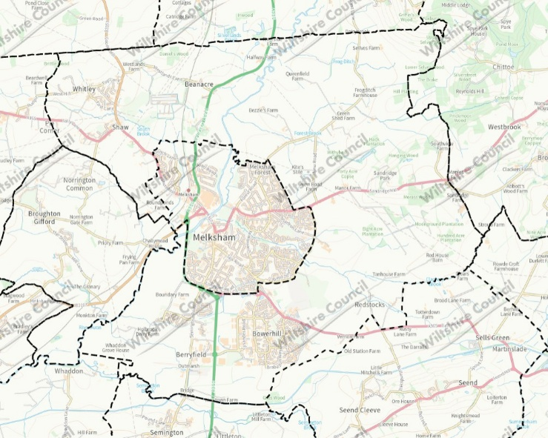

The proposed site of up to 225 dwellings (Bellway) lies withing the boundary of Melksham Without (highlighted blue):
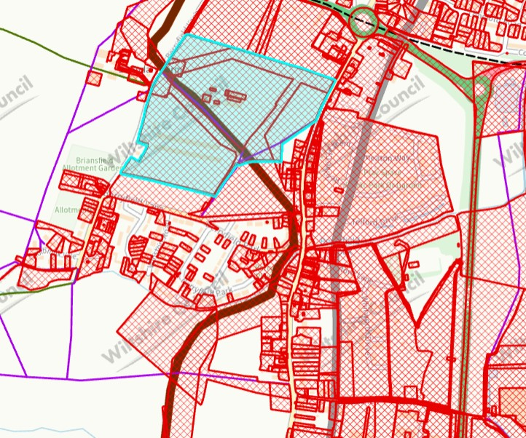

This site is bounded by agricultural land/buildings to the west, further development/applications to the north and south and residential development to the east – including a previous Bellway development of 144 dwellings, Bowood View (PL/2022/02749 Reserved Matters – following Outline 20/10938/OUT):
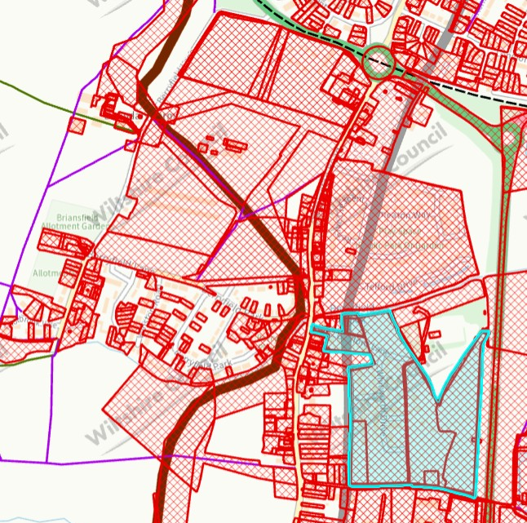
A Public Art contribution was secured for this site at £300 per dwelling, paid prior to commencement.

The Public Art Officer has had positive communication with Bellway Homes Ltd (SW) regarding this site and - as it has been agreed to use the Public Art Contribution ‘in the vicinity’ in this instance – there is now an opportunity pool this contribution with this proposed site to enable a more impactful scheme linking the two sites with the existing community. There is also the potential to link with the canal corridor (see: Canal application)

The proposed site of up to 225 dwellings equates, relatively speaking, to a disproportionate amount of development within this parish. This level of development can disrupt the established character, identity, and social balance of a settlement. We would therefore seek a public art contribution to integrate this development, create a cohesive/linking identity, and address the parish’s identity merge with Melksham Town.

Rationale
In the context of a relatively large amount of development, the provision of public art is justified as a proportionate and necessary measure to both mitigate its impact, and support successful integration.
Public art provides a means of embedding locally responsive elements that can reflect the area’s history, culture and environment, helping development to feel assimilated rather than imposed.
Our guidance on public art was adopted by Cabinet in 2024, and the Council is able to demonstrate a robust methodology benchmarked against several other authorities. There is an identified specific site-based requirement as a result of this development, and we can point to several appeals where public art contributions have been found compliant and secured.
You will note the recent Secretary of State decision dated 28 July 2026 re: PL/2024/07097 - Land South of Snarlton Farm, Snarlton Lane, Melksham, SN12 7QP - APP/Y3940/W/25/3373278 which agrees with the submitted CIL compliance statement that references the Public Art Contribution (as does the agreed S106):
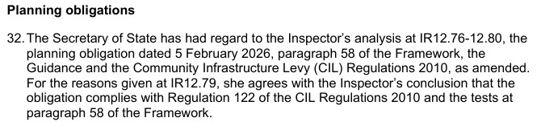
Public Art contributions provide a policy compliant mechanism that would help to mitigate the impact of this development, while also assisting integration with existing and incoming communities.
This is essential in the context of Melksham Without, to create sense of place and so as not to undermine community cohesion with regards to WCS CP57 & the NPPF (Aug. 2026).

Canal application:
From an art in the public realm perspective, we note that the proposed site is bisected by a proposal to connect the River Avon (to the west of Melksham) to the Kennet and Avon Canal (to the south of Melksham / Bowerhill) with a new canal. This is subject of Core Policy 16, from the 2015 Core Strategy and a live planning application by the Wiltshire and Berkshire Canal Trust (WBCT) submitted in 2012 (W/12/01080/FUL).
My understanding is that Bellway has committed to leaving a corridor through the proposed site to facilitate this.
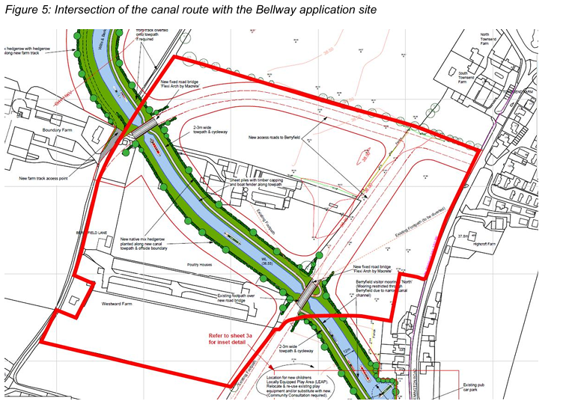

Possible locations
Several locations for a public art scheme/s (TBD) have been identified (marked by yellow dots below) along Semington Road (east of the proposed site and west of the Bowood site), at strategic points connecting to a RoW and/or the canal corridor, or - without pooling - around the north, south and west of the proposed site. Locations that connect - or are visible by - existing communities or other developments can further assist with intergration, cohesion and place-shaping, while enabling a scheme that is accessible to as many residents as possible.
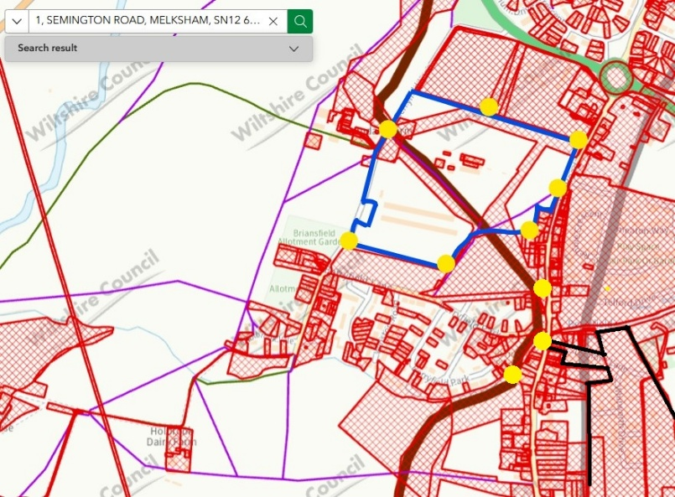
This approach would align with Bellway’s own internal-facing Placemaking Policy (June 2026) and the objective relating to creating “…environments that foster a sense of community and belonging.”

Contribution threshold
- Development of 50 dwellings and more
- £300 per residential dwelling

Indicative figure
Using planning obligations, the indicative public art contribution figure for a site of 225 dwellings would be £67,500 (see: threshold and calculation) to be commuted prior to commencement to Wiltshire Council’s Arts Service to devise and manage the scheme/s.

The Public Art Officer (publicart@wiltshire.gov.uk) encourages early engagement from Developers to discuss how the scheme/s may be incorporated into the Development or the vicinity of the Development.

Contribution calculation
To provide a consistent, sustainable and transparent approach for our Public Art programme, our communities and Developers, Wiltshire Council has held its ‘fixed per dwelling’ figure since its implementation in 2009.

The 2009 figure was calculated* using the internationally established Public Art funding mechanism, Percent for Art** i.e. up to 1% of capital costs derived from an average build cost per residential dwelling in England. In this case, taking a conservative approach of 0.5% and the lower end of a typical standard newbuild.

[*build cost per dwelling (RICS) x average floor space per dwelling (English Housing Survey) = lower end of average cost per dwelling (c£60,000 in 2009) x 0.5%
**Percent for Art is an internationally established funding mechanism implemented by authorities, development corporations and housing associations for the commissioning of public art. Normal practice is for up to 1% of capital costs to be allocated for public art]
Summary
Public art is widely recognised within the planning system as a key component of place-making, contributing to distinctive, higher quality environments that go beyond purely functional design and instead create places that reflect local identity and aspirations.

Public art also plays an important role in supporting community cohesion and well-being by creating shared spaces and experiences that bring together existing and new residents, acting as a bridge between communities and helping to foster a sense of belonging.

Community involvement in the delivery of public art schemes encourages participation and dialogue, strengthening social connections, and helping communities adapt to change.

More broadly, it supports and contributes to civic pride, legibility and the usability of public spaces, while reinforcing a shared identity and delivering long-term social value.

As such, public art should not be viewed as decorative but as a legitimate planning tool that supports the assimilation of new development, and the creation of cohesive, inclusive communities.
As per our public art guidance and process, by locating a public art scheme/s along the boundary with Semington Road - and/or the RoW / canal corridor - it is possible to adopt a more effective and strategic approach to aid place-shaping, integration and support cohesion in accordance with the WCS CP3, WCS CP57, WDG 4.3 Expectation: Destinations, Landmarks and Focal Points, and the NPPF (Aug 2026).
Policy and guidance
- WCS CP3: Infrastructure Requirements [pg. 58, para 4.42]. This promotes and defines public art as a type of place-shaping infrastructure and states that the cost of providing infrastructure may be met through the use of planning obligations.
- WCS CP 57: Ensuring high quality design and place-shaping [page 287, paragraph xii] which promotes “…the integration of art and design in the public realm”
- WDG SPD 4.3.4: “Consider utilising public art to reinforce the landmark status of a place. Public art used for this purpose should have permanence and relevance to the local or wider context of the place. (See also Wiltshire’s Policy and guidance on Public Art and Design)”
- Planning Obligations Supplementary Planning Document (2016) refers to the 2011 guidance note for art and design in the public realm [pg. 31, para 10]. This is superseded by Art and design in the public realm in Wiltshire – 2024 Guidance which is also referenced in the aforementioned Wiltshire Design Guide Supplementary Planning Document (v9, 2024)

In addition - to support strong, vibrant and healthy communities, the NPPF (17.b) recognises “cultural wellbeing” as a ‘social objective’ - one of the three overarching objectives in achieving sustainable development.

While awaiting the consolidation of the new PPG - the National Design Guide (NDG) still stands as a material consideration and complements the NPPF and states: “The quality of the spaces between buildings is as important as the buildings themselves. Public spaces are streets, squares, and other spaces that are open to all. They are the setting for most movement. The design of a public space encompasses its siting and integration into the wider network of routes as well as its various elements. These include areas allocated to different users – cars, cyclists and pedestrians – for different purposes such as movement or parking, hard and soft surfaces, street furniture, lighting, signage and public art.” [Public spaces – safe, social and inclusive]

