APPLICATION FOR FULL-PLANNING PERMISSION (MINOR DEVELOPMENT) & LISTED BUILDING CONSENT
CASE OFFICER REPORT

APPLICATION REFERENCE: | PL/2026/04945 & PL/2026/05406
APPLICATION TYPE: | Full Planning Permission & Listed Building Consent
SITE ADDRESS: | The Wheatsheaf Inn, Chilton Foliat, Hungerford, RG17 0TE
DEVELOPMENT DESCRIPTION: | Creation of new door opening, construction of external staircase, change to hard landscaping and car park surfacing.
RECOMMENDATION: | Refuse

SITE DESCRIPTION/CONTEXT

The application relates to the Wheatsheaf PH in Chilton Foliat. The PH is a Grade II listed building which benefits from a number of outbuildings, beer garden and parking to the rear. The site lies within the North Wessex Downs National Landscape and the Chilton Foliat Conservation Area.

The Historic England listing description reads as follows:

House, now public house. Early C19. Daiper brickwork with laced flintwork on return. Thatched roof. 2-storey, 3 bays with 2 half glazed 6-panel doors with bracketed pent roofs. 2 late C19 canted and hipped bays. First floor has 3-light segmental headed windows. Blue vitrified brick band at first floor level. Gable stacks and stack between 1st and 2nd bays. To left, rear 2-bay wing of early C19 with 12- and 20-pane sashes.

The key site constraints are as follows:

- Within the built-up area of Chilton Foliat
- Chilton Foliat Conservation Area
- The Wheatsheaf Inn is a grade II building
- The outbuilding within the grounds of the pub forming part of this application is considered to be curtilage listed
- Proximity to grade II listed buildings (No. 67 and 72-78 Chilton Foliat)
- The village of Chilton Foliat is washed over by the North Wessex Downs National Landscape

The site is neighboured to the north and west by residential properties and the village hall to the east. Planning permission has also been previously granted for the erection of a building in the north-east corner of the site together with the conversion of an existing curtilage listed outbuilding for guest accommodation and office space.

PROPOSAL

The application proposes the creation of new door opening, construction of external staircase and change to hard landscaping and car park surfacing.

This report covers both the full planning permission (ref: PL/2026/04945) and listed building consent (ref: PL/2026/05406) applications.

PLANNING HISTORY

Proposal / Summary
K/50671/LBC - The Wheatsheaf, -, Chilton Foliat, Hungerford, RG17 0TE - Listed building consent Decision - Approve with Conditions Date: 29/9/2004 – Remove existing kitchen extract duct and cowl and fit wall mounted unit at low level. Retain chimney at existing height with spark arrester. Install new door in passage adjacent to kitchen.
K/74/0007/AD - The Wheatsheaf B4192 Newtown Road And Eastridge Crossroads East To Hungerford Road And Bridge In Chilton Foliat Chilton Foliat Hungerford RG17 0TE - Consent to display an advertisement Decision - Refused Date: 23/4/1974 – Illuminated sign
K/79/0005/AD - The Wheatsheaf B4192 Newtown Road And Eastridge Crossroads East To Hungerford Road And Bridge In Chilton Foliat Chilton Foliat Hungerford RG17 0TE - Consent to display an advertisement Decision - Refused Date: 27/10/1980 – Illuminated polesign
K/10040 - WHEATSHEAF PUBLIC HOUSE, CHILTON FOLIAT. - Full planning permission Decision - Approve with Conditions Date: 19/2/1987 – CONSTRUCTION OF ADDITIONAL CAR PARKING AREA.
15/12723/FUL - The Wheatsheaf Inn Chilton Foliat Wiltshire RG17 0TE - Full planning permission Decision - Approve with Conditions Date: 28/4/2016 – Proposed alterations, minor extension, alterations to outbuilding and alterations to parking & garden
16/00162/LBC - The Wheatsheaf Inn Chilton Foliat Wiltshire RG17 0TE - Listed building consent Decision - Approve with Conditions Date: 28/4/2016 – Proposed alterations, minor extension, alterations to outbuilding and alterations to parking & garden
K/47343/L - The Wheatsheaf, Chilton Foliat - Listed building consent Decision - Refused Date: 14/5/2004 – Extract flue and ducting from trade kitchen
20/01218/FUL - The Wheatsheaf Inn Chilton Foliat Wiltshire RG17 0TE - Full planning permission Decision - Approve with Conditions Date: 27/4/2020 – Proposed guest accommodation ancillary to the Wheatsheaf PH, including the conversion and extension of the existing outbuilding.
20/01831/LBC - The Wheatsheaf Inn Chilton Foliat Wiltshire RG17 0TE - Listed building consent Decision - Approve with Conditions Date: 27/4/2020 – Proposed guest accommodation ancillary to the Wheatsheaf PH, including the conversion and extension of the existing outbuilding.
K/46694/A - The Wheatsheaf, Main Street, Chilton Foliat, Hungerford. - Consent to display an advertisement Decision - Approve with Conditions Date: 21/1/2004 – New Signage and Lighting.
20/03978/LBC - The Wheatsheaf Inn Chilton Foliat Hungerford Berkshire RG17 0TE - Listed building consent Decision - Approve with Conditions Date: 12/4/2021 – Minor internal alterations
PL/2023/10269 - THE WHEATSHEAF INN, CHILTON FOLIAT, HUNGERFORD, RG17 0TE - Notification of proposed works to trees in a conservation area Decision - No Objection Date: 5/1/2024 – Tree 1 - (Populus) Remove side leaning limb, reduce crown by 30% and remove any dead wood. Tree 2 - (Taxus baccata) Crown lift by 2 meters and remove dead wood. Tree 3 - (Taxus baccata) Crown lift by 2 meters remove dead wood. All arisings genera
PL/2023/03563 - The Wheatsheaf Inn, Chilton Foliat, Hungerford, RG17 0TE - Listed building consent (Alt/Ext) Decision - Approve with Conditions Date: 29/6/2023 – Proposed guest accommodation ancillary to the Wheatsheaf PH, including the conversion and extension of the existing outbuilding.
PL/2023/03749 - The Wheatsheaf Inn, Chilton Foliat, Hungerford, RG17 0TE - Full planning permission Decision - Approve with Conditions Date: 14/12/2023 – Change of use of Staff Accommodation and Gallery Space to Guest Accommodation ancillary to the Wheatsheaf PH, comprising internal alterations and new external staircase.
PL/2023/03985 - The Wheatsheaf Inn, Chilton Foliat, Hungerford, RG17 0TE - Listed building consent (Alt/Ext) Decision - Approve with Conditions Date: 14/12/2023 – Change of use of Staff Accommodation and Gallery Space to Guest Accommodation ancillary to the Wheatsheaf PH, comprising internal alterations and new external staircase.
PL/2023/05571 - The Wheatsheaf Inn, Chilton Foliat, Hungerford, RG17 0TE - Approval of details reserved by a condition Decision - Approve Date: 11/7/2023 – Discharge of Condition No 2 on PL/2023/01602 (Variation of condition 2 of 20/01218/FUL (Proposed guest accommodation ancillary to the Wheatsheaf PH, including the conversion and extension of the existing outbuilding) - to allow alterations to the internal
PL/2024/03175 - The Wheatsheaf Inn, Chilton Foliat, Hungerford, RG17 0TE - Removal/variation of conditions Decision - Approve with Conditions Date: 30/9/2024 – Variation of condition 2 (approved plans) on 20/01218/FUL to amend the proposed site layout, plan and elevations of the new accommodation barn
PL/2024/03348 - The Wheatsheaf Inn, Chilton Foliat, Hungerford, RG17 0TE - Full planning permission Decision - Approve with Conditions Date: 2/5/2025 – Construction of restaurant extension to rear, internal alterations to create a new kitchen servery hatch, insertion of rear door to kitchen, construction of cellar access, creation of new bay window to front elevation, raising of ceilings in the 3 first f
PL/2024/03701 - The Wheatsheaf Inn, Chilton Foliat, Hungerford, RG17 0TE - Listed building consent (Alt/Ext) Decision - Approve with Conditions Date: 2/5/2025 – Construction of restaurant extension to rear, internal alterations to create a new kitchen servery hatch, insertion of rear door to kitchen, construction of cellar access, creation of new bay window to front elevation, raising of ceilings in the 3 first f
PL/2024/04900 - THE WHEATSHEAF INN, CHILTON FOLIAT, HUNGERFORD, RG17 0TE - Full planning permission Decision - Withdrawn by Council Date: 5/6/2024 – Extension of restaurant to rear with servery hatch to kitchen, construction of cellar access and delivery door to Kitchen, creation of new bay window to front elevation and raising of ceilings in the 3 first floor bedrooms. Alteration to car park layout,
PL/2024/10731 - THE WHEATSHEAF INN, CHILTON FOLIAT, HUNGERFORD, RG17 0TE - Full planning permission Decision - Approve with Conditions Date: 20/5/2025 – Change of use of ground floor of detached accommodation barn to 4no. self-contained offices.
PL/2025/00588 - The Wheatsheaf Inn, Chilton Foliat, Hungerford, RG17 0TE - Approval of details reserved by a condition Decision - Approve Date: 4/3/2025 – Discharge of Condition 3 - Materials for new accommodation building & Condition 10 - Details of the external staircase screen (Variation of condition 2 (approved plans) on 20/01218/FUL to amend the proposed site layout, plan and elevations of the new acco
PL/2025/02378 - The Wheatsheaf Inn, Chilton Foliat, Hungerford, RG17 0TE - Listed Building Discharge of Condition Decision - Approve Date: 9/4/2025 – Discharge of conditions 3 (Elevation Drawings of New Openings), 5 (Details of Timber Cladding for New External Staircase) & 7 (Details of New Vents and Flues) relating to application PL/2023/03985.
PL/2025/06814 - The Wheatsheaf Inn, Chilton Foliat, Hungerford, RG17 0TE - Approval of details reserved by a condition Decision - Approve Date: 5/1/2026 – Discharge of Conditions 3 materials, 5 joinery, 6 orangery sectional drawings, 7 method statement of planning application PL/2024/03701 (Construction of restaurant extension to rear, internal alterations to create a new kitchen servery hatch, insertion of
PL/2026/02659 - THE WHEATSHEAF INN, CHILTON FOLIAT, HUNGERFORD, RG17 0TE - Notification of proposed works to trees in a conservation area Decision - No Objection Date: 1/6/2026 – T1 Populus - Remove side leaning limb, reduce crown by 35% and remove any dead wood. T2 Taxus Baccata - Crown lift by 2 meters and remove dead wood. T3 Taxus Baccata - Crown lift by 2 meters remove dead wood.
PL/2026/02719 - The Wheatsheaf Inn, Chilton Foliat, Hungerford, RG17 0TE - Full planning permission Decision - Refuse Date: 16/7/2026 – Creation of new door opening, construction of external staircase and installation of new window opening in rear gable wall, change to hard landscaping and car park surfacing.
PL/2026/02976 - The Wheatsheaf Inn, Chilton Foliat, Hungerford, RG17 0TE - Listed building consent (Alt/Ext) Decision - Refuse Date: 16/7/2026 – Creation of new door opening, construction of external staircase and installation of new window opening in rear gable wall, change to hard landscaping and car park surfacing.
PL/2026/04077 - The Wheatsheaf Inn, Chilton Foliat, Hungerford, RG17 0TE - Approval of details reserved by a condition Decision - Refuse Date: 17/7/2026 – Discharge of condition 4 (Rights/ Permissions over Parking Spaces) relating to application PL/2024/03348

RELEVANT LEGISLATION, POLICIES AND GUIDANCE

Statutory Legislation:
Town and Country Planning Act 1990
Sections 16, 66 & 72 of the Planning (Listed Buildings and Conservation Areas) Act 1990

National Planning Policy:
- National Planning Policy Framework (NPPF)
- Planning Practice Guidance (PPG)
- National Design Guide

Development Plan:
The development plan for Wiltshire comprises the Wiltshire Core Strategy (WCS) (adopted January 2015) and any made neighbourhood plans, which remains the principal statutory planning document guiding development across the county. In line with Section 38(6) of the Planning and Compulsory Purchase Act 2004, planning decisions must be made in accordance with the development plan unless material considerations indicate otherwise.

Though the development plan is considered as a whole, those parts deemed to be particularly relevant to this application are listed below:

The adopted Wiltshire Core Strategy (WCS), with particular regard to:

- Core Policy 1: Settlement Strategy
- Core Policy 2: Delivery Strategy
- Core Policy 14: Spatial Strategy Marlborough Community Area
- Core Policy 40: Hotels, Bed & Breakfasts, Guest Houses and Conference Facilities
- Core Policy 41: Sustainable construction and low carbon energy
- Core Policy 49: Protection of rural services and community facilities
- Core Policy 50: Biodiversity and Geodiversity;
- Core Policy 51: Landscape
- Core Policy 57: Ensuring High Quality Design and Place Shaping;
- Core Policy 58: Ensuring the Conservation of the Historic Environment;
- Core Policy 60: Sustainable Transport
- Core Policy 61: Transport and New Development
- Core Policy 64: Demand Management

Draft Wiltshire Local Plan
At Full Council on 19 May 2026, the elected members of Wiltshire Council agreed to withdraw the emerging Wiltshire Local Plan. The said Plan has no material weight for the purposes of the application.

In accordance with Regulation 19 of the Town and Country Planning (Local Planning) (England) Regulations 2026, on 30th June 2026 Wiltshire Council published a notice of intention to prepare a new local plan for Wiltshire. The next stage is a Scoping Consultation which commences on 2nd September 2026. This plan is at a very early stage and currently carries no weight for decision making.

Neighbourhood Plan:
Area currently not designated for a Neighbourhood Plan

Supplementary Planning Documents and other Guidance:
- Wiltshire Local Transport Plan 2011 – 2026 – Car Parking Strategy (March 2011)
- Chilton Foliat Conservation Area Statement December 2003
- Wiltshire Design Guide March 2024
- Historic England - GPA 2 - Managing Significance in Decision-Taking in the Historic Environment
- Historic England - GPA3 - The setting of Heritage Assets

ISSUES

The main issues that need to be addressed in this case include:

- Whether the proposal constitutes EIA development
- Whether the development is acceptable in principle (CP 1 and 2)
- Whether the scheme constitutes high quality design (CP 57)
- Whether the scheme would have an acceptable impact upon the reasonable living conditions of the adjoining occupants (CP 57)
- Whether the scheme would preserve or enhance the historic environment (CP 58)
- Whether the scheme would have an acceptable landscape impact (CP 51)
- Whether the proposal would have a negative effect upon highway safety, including if there is sufficient parking for the proposed development (CP 61 and 64)
- Whether the site can be adequately drained without increasing flood risk elsewhere (CP 67)

CONSULTATION RESPONSES

The views of consultees are material considerations in the determination of the application. However, the decision-maker must exercise their own planning judgement. Where consultees raise concerns or recommend conditions, these have been considered and are addressed within the assessment section of this report.

WC Arboricultural Officer: Commented “The Arboricultural Officer is unable to provide any comments in respect of the proposed works in the vicinity of the retained trees as this has already completed.”

WC Highways: No objection subject to conditions

WC Conservation: Objection (refer to ‘Impact on Heritage Assets’ section and website for full comment)

Chilton Foliat Parish Council: Support, commenting “Chilton Foliat Parish Council supports the application with the recommendation that the oak louvered screen for privacy to the neighbouring garden is widened or extended and recommend that the parking area for deliveries is marked out in grey rather than white.”

The consultee responses have been carefully considered. Whilst significant weight is afforded to specialist technical advice, the decision remains a matter for the Local Planning Authority and the officer assessment below reaches an independent planning judgement on the issues raised.

REPRESENTATIONS

In accordance with the requirements of the Town and Country Planning (Development Management Procedure) (England) Order 2015 (as amended), the application was publicised by way of:

- Neighbour notification letters sent to adjoining and nearby properties;
- A site notice displayed near the site; and
- An advertisement placed in the local press.

These methods were used to inform interested parties and provide a period of 21 days for comments to be submitted.

Below is a summary of the representations received during the consultation period. Only material planning considerations have been taken into account in the assessment of this application. Non-material issues, such as property values or private legal disputes, cannot be considered in the determination process.

The following representations were received at the time of writing:

Owner/occupier of Mill Race House (summary of comment):
- The enlarged staircase and landing to the staff room create a space capable of accommodating seating, allowing staff to sit, relax, and smoke, rather than serving solely as an access route.
- The increased size of the landing results in overlooking of the garden at Calstone House, creating concerns regarding loss of privacy.
- Screening or cladding of the structure would only partially mitigate overlooking unless the staircase and landing are fully enclosed.
- The enlarged landing effectively changes the use of the area, creating an external resting or loitering space.
- The staircase approved under planning permission PL/2024/03348 was of a size intended solely for access purposes.
- Concerns are raised regarding the paved area at the front of the pub, part of which the Highways Officer has identified as highway land.
- The current arrangement of paving, planters, pots and tables restricts the available pedestrian route.
- Wheelchair users and those with pushchairs may be forced into the carriageway due to insufficient unobstructed footway width.
- This is considered particularly problematic given the narrow and busy nature of the road, existing parking pressures, the inadequate pavement on the opposite side of the road, and the nearby blind corner.
- Alterations to the car park have reportedly resulted in vehicles reversing into the dwarf wall surrounding the garden area, as it is not readily visible from within vehicles.
- Concerns are also raised that there is inadequate disabled access into the garden area.
- Although a side door opening onto the lane was not part of the original intention for the development, it is acknowledged that a Deed of Easement has been agreed with the Parish Council governing use of the lane.
- Should permission for the side door be retained, it is requested that a condition requires ongoing compliance with the terms of the Deed of Easement.
- No information has been provided within the application regarding the delivery hatch located in the lane to the west of the building.
- It is alleged that the delivery hatch does not accord with the plans approved under planning permission PL/2024/03348.
- The hatch is considered harmful to the character and appearance of the listed building and is described as visually intrusive.
- Concerns are raised that the structure narrows the lane, creating difficulties and potential hazards for vehicles entering and leaving Calstone House.
- The hatch is also considered to present a trip hazard for pedestrians, particularly during hours of darkness due to an absence of lighting.
- It is alleged that the hatch restricts access for larger vehicles seeking to travel to or from Calstone House.
- Previous approved plans reportedly indicated that the hatch would be flush with the lane surface and capable of being driven over, whereas the installed structure is said to stand approximately 30cm above the lane and incorporates two substantial projecting posts.

Owner/occupier of Calstone House (summary of comment)
- The external staircase has been constructed in breach of the original planning permission due to its increased size and because works commenced before approval was granted.
- Construction began in April 2025 and remains incomplete, including the omission of the approved privacy screening.
- The privacy screening was intended to prevent overlooking into Calstone House and its garden but has not yet been installed.
- The enlarged staircase facilitates a greater level of use by both staff and customers than would have occurred had the approved scheme been implemented as originally proposed.
- As a result of the staircase's increased size, the proposed privacy screening is no longer considered adequate.
- The screening would not provide comprehensive protection of privacy for Calstone House, as views from parts of the enlarged staircase are not addressed by the current screening proposal.
- Consequently, the development gives rise to ongoing concerns regarding overlooking and loss of privacy for the occupiers of Calstone House.

Owner occupier of 2 Popham Close (summary of comment):
- Questions why residents are being asked to comment on plans that show no substantial revisions to development already carried out without planning permission.
- Notes that Wiltshire Council has previously refused retrospective planning permission for the development.
- States an understanding that, following refusal of retrospective permission, the options would normally be either substantial revisions to the scheme or an appeal.
- Reiterates that if the kitchen door were located on the north wall, as shown on the original approved plans, delivery vans could use the Wheatsheaf’s vehicular access and safely turn around before departing.
- Raises concerns that the current east-facing door arrangement requires delivery vehicles either:
  - To reverse into the pedestrian alley from the main road; or
  - To reverse out of the alley onto the main road.
- Advises that small delivery vans are already driving, or attempting to drive, up to the kitchen door.
- States that vehicles accessing the kitchen door via the alley is contrary to the deed of easement.
- Explains that the north-south walkway was intended to provide a safe pedestrian route through the village.
- Concludes that, for safety reasons, the kitchen door should be located on the north wall rather than the east elevation.

Each material planning issue raised is addressed within the assessment below.

ASSESSMENT

Section 38(6) of the Planning and Compulsory Purchase Act 2004 states:

"If regard is to be had to the development plan for the purposes of any determination to be made under the planning Acts, the determination must be made in accordance with the plan unless material considerations indicate otherwise."

In accordance with this statutory requirement, this application has been assessed against the relevant policies of the Development Plan, including the Wiltshire Core Strategy (2015) and, where applicable, any made Neighbourhood Plans. Consideration has also been given to the policies of the NPPF (NPPF) as a material consideration in the assessment.

The assessment below considers each of the main issues identified above. Each topic is assessed in turn with reference to the relevant policy context, the evidence submitted, consultee responses, and all other material considerations, before a conclusion is reached.

Principle of Development

Policy Context
Core Policies 1 and 2 of the Wiltshire Core Strategy establish the overarching spatial strategy for Wiltshire and provide the primary Development Plan framework for determining whether development is appropriately located. Together, these policies seek to direct growth towards the most sustainable locations whilst protecting the intrinsic character and beauty of the countryside. The strategy prioritises development within Principal Settlements, Market Towns, Local Service Centres and larger villages, whilst development in the countryside will only be supported where it accords with specific development plan policies or where material considerations indicate otherwise.

The NPPF also contains national policies relating to the location of development. Policies S3-S5 distinguish between development within settlements and development in the countryside, support sustainable patterns of growth, and require decisions to have regard to the role and function of settlements, accessibility to services and facilities, and other site-specific considerations.

The principle of development should be assessed having regard to the Development Plan as a whole, the NPPF and all other material considerations. The weight afforded to individual policies will depend upon the nature, scale and location of the development proposed.

The Wiltshire Core Strategy (2015) includes several policies that support the enhancement of community facilities in rural areas, as follows:

Core Policy 49 - Protection of Rural Services and Community Facilities:
  - This policy aims to protect existing community facilities, such as shops, pubs, and community centres, from unnecessary loss in rural areas.
  - It encourages the retention of these facilities and supports efforts to enhance their viability, including the development of new services where there is a clear need.
  - Proposals that improve or add to community facilities in rural areas are encouraged, particularly where they enhance local accessibility and contribute to the overall sustainability of communities.

Core Policy 40 - Tourist Accommodation and Visitor Attractions:
- This policy promotes the development of tourist accommodation and facilities in sustainable locations, including rural areas. It supports developments that enhance the visitor economy.
- The policy stresses the importance of maintaining the character and scale of rural settlements, and encourages high-quality development that complements the area’s environment. In all cases it must not have a detrimental impact on the vitality of the town centre and it must avoid unacceptable traffic generation.

Core Policy 14 - Marlborough Community Area:
- This policy highlights the importance of supporting new tourist accommodation in the Marlborough Community Area, where there is identified demand. It emphasises the role of these facilities in supporting rural economies and local services, particularly in areas where existing provision is limited.

Planning History
The planning history of the site has been reviewed.

The full planning and listed building consent applications have been submitted following refusal of the previous full planning (PL/2026/02719) and listed building consent (PL/2026/02976) applications.

The applications were refused for the following reasons:

PL/2026/02719 (full planning application)
1. The proposed works, comprising the formation of a new external doorway, insertion of a new window opening, construction of an external staircase and associated alterations, by reason of the loss of historic fabric and their cumulative impact of these works on the form, character, appearance and significance of the Grade II listed Wheatsheaf Inn, would cause less than substantial harm to the significance of the designated heritage asset and would fail to preserve the character and appearance of the Chilton Foliat Conservation Area. Whilst the Local Planning Authority acknowledges the importance of the continued operation of the public house as a community facility, the public benefits advanced by the applicant are not considered sufficient to outweigh the identified heritage harm. The proposal therefore conflicts with Sections 66(1) and 72(1) of the Planning (Listed Buildings and Conservation Areas) Act 1990, paragraphs 212, 213 and 215 of the National Planning Policy Framework and Core Policy 58 of the Wiltshire Core Strategy.

PL/2026/02976 (listed building consent application)
1. The proposed works, comprising the formation of a new external doorway, insertion of a new window opening, construction of an external staircase and associated alterations, by reason of the loss of historic fabric and their cumulative impact of these works on the form, character, appearance and significance of the Grade II listed Wheatsheaf Inn, would cause less than substantial harm to the significance of the designated heritage asset. Whilst the Local Planning Authority acknowledges the importance of the continued operation of the public house as a community facility, the public benefits advanced by the applicant are not considered sufficient to outweigh the identified heritage harm. The proposal therefore fails to preserve the special architectural and historic interest of the listed building, contrary to Section 16(2) of the Planning (Listed Buildings and Conservation Areas) Act 1990, paragraphs 212, 213 and 215 of the National Planning Policy Framework and Core Policy 58 of the Wiltshire Core Strategy.

Existing Situation / Background
It was noted during the course of the site inspection that a number of works have been undertaken within the site, some of which do not form part of the current applications and do not appear to correspond with the approved plans held on the Council's records. The works observed include alterations affecting the listed building itself, together with operational development and other alterations within the curtilage of the listed building.

Such works have not formed part of the assessment of the current applications and may require further investigation by the Council's Enforcement Team. Any requirement for planning permission and/or listed building consent in respect of those works would be a separate matter for the Local Planning Authority.

For the avoidance of doubt, the current applications have been assessed on the basis of the proposals submitted for determination and the site circumstances observed at the time of the officer's site inspection.

Assessment
The proposal is considered to accord with Core Policies 14, 40 & 49 of the adopted Witlshire Core Strategy which supports rural services and tourist facilities in this location.

The Wiltshire Core Strategy strongly supports the enhancement of community facilities in rural areas through policies that protect existing services and encourage the development of new, sustainable amenities, including tourist accommodation and local services. These policies aim to ensure that rural communities remain vibrant, sustainable, and well-served by essential facilities.

Although there is no specific policy solely focused on the enhancement of rural community facilities, the policies outlined above strongly suggest that support should be given towards the principle of the proposed development – namely, the improvement of a highly valued community asset. In this regard, it is important to note the recent planning history outlined above, which demonstrates that the Council has been proactive in permitting the expansion of accommodation and facilities at the pub to support its vitality and long-term viability.

However, it is equally crucial to recognise that support for the enhancement of community facilities is conditional upon the acceptance of the detailed design elements of the proposal. These must adhere to the relevant place-shaping policies within the local plan, including Core Policies 57, 58, 61, and 64. These policies ensure that the development's design and its broader impact are in harmony with the character, quality, and sustainability of the surrounding area.

As such, while officers may be supportive of the principle of development and commend the applicant’s efforts to protect a well-loved village asset, this must be carefully weighed in the planning balance against any potential conflicts with other policies of the development plan which are covered in this report.

Neighbourhood Plan
The site is not located within a neighbourhood plan area, or there are no neighbourhood plan policies relevant to the principle of development.

Accordingly, neighbourhood plan considerations attract neutral weight in the assessment of the principle of development.

Conclusion
The proposal accords with the Development Plan and the principle of development is supported in this location.

The proposal must nevertheless be assessed against all other relevant Development Plan policies, national policy and material considerations. Subject to that assessment, the principle of development is considered acceptable.

Design and Impact on the Character and Appearance of the Area

Policy Context
Core Policy 57 of the Wiltshire Core Strategy requires development to achieve a high standard of design that responds positively to local character, context and distinctiveness.

Policies DP1-DP4 of the NPPF seek to ensure that development is well-designed, visually attractive, sustainable and responsive to its surroundings. Development should contribute positively to local character, create high quality places and support healthy and inclusive communities.

The Wiltshire Design Guide provides further guidance on achieving high quality, context-led design and should be taken into account where relevant.

Assessment
In assessing this aspect of the proposal, regard has been had to the site context, the details of the proposed development, the relevant development plan policies, and all other material considerations.

The full planning and listed building consent applications are principally the same as the recently refused full planning and listed building consent applications, except for a few minor omissions, namely the omission of the first floor window in the rear elevation serving the office and omission of 2no. high level windows in the east elevation of the restaurant extension.

The current full planning and listed building consent applications relate to a series of relatively modest alterations to the existing public house, comprising the provision of a kitchen access door, amendments to the external staircase, alterations to hard surfacing, and associated landscaping works within the site's curtilage. The works shown on the proposed plans appear to be limited in scale and do not involve any significant enlargement of the building or substantial alteration to its overall form. The works described above have largely been carried out.

The submitted plans indicate that the staircase is constructed as an oak-framed structure with a slate-roofed canopy. The hard landscaping includes the replacement of areas of tarmac with natural stone flags and pavers to the forecourt, alongside revised surfacing arrangements within the rear car park and additional planting beds, steps and dwarf walls within the beer garden. These materials are considered to be of a high quality and are appropriate to the character of the building and its surroundings.

Significant weight is afforded to the fact that the majority of the works have already been undertaken. The Local Planning Authority has therefore been able to assess the alterations in situ rather than relying solely on the submitted drawings. Based on the site inspection and submitted plans, the works are considered to be subordinate to the host building and remain proportionate in scale. The new door and window are minor interventions, whilst the staircase and associated structures are located to the rear of the building and do not appear visually dominant or incongruous.

It is noted that, at the time of the site inspection, the louvred screen shown on the proposed plans had not been constructed as approved as shown in the images below:

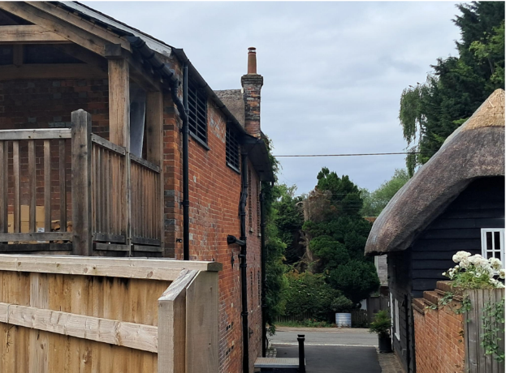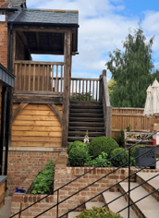

Case Officer photo showing missing screening on western side of balcony

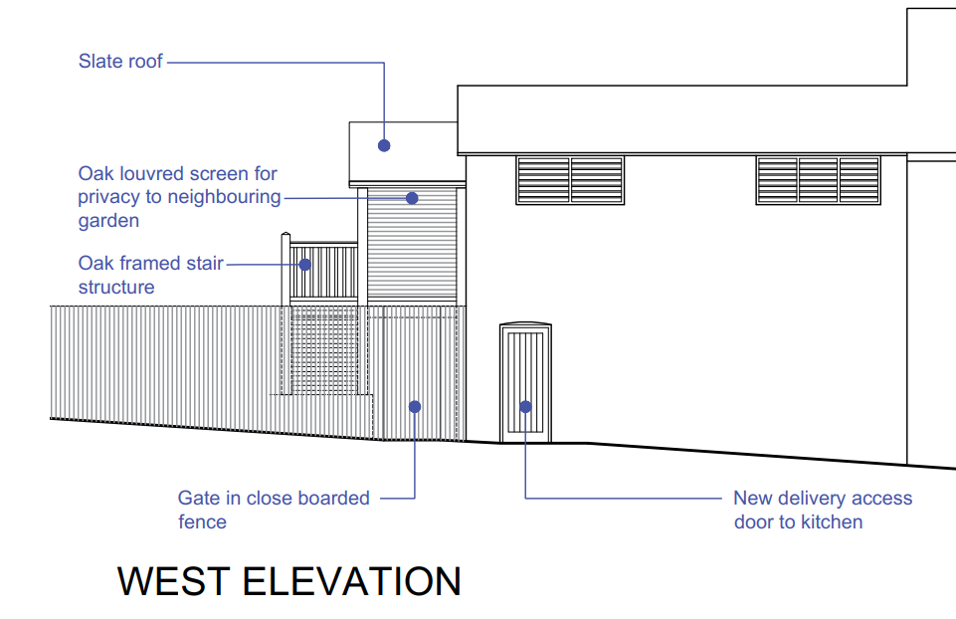
Proposed elevation showing the louvered screen full height on the western elevation

Whilst this matter is not considered to materially alter the conclusions reached in respect of the design, scale and appearance of the development, it has implications for neighbouring amenity and is considered separately later within this report.

It is also noted at the time of the site inspection that the new kitchen door is stable door design, and appears to be a different design to that shown on the proposed plans as shown in the images below:

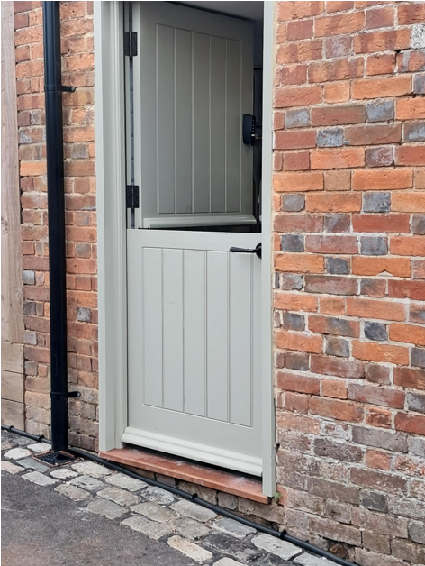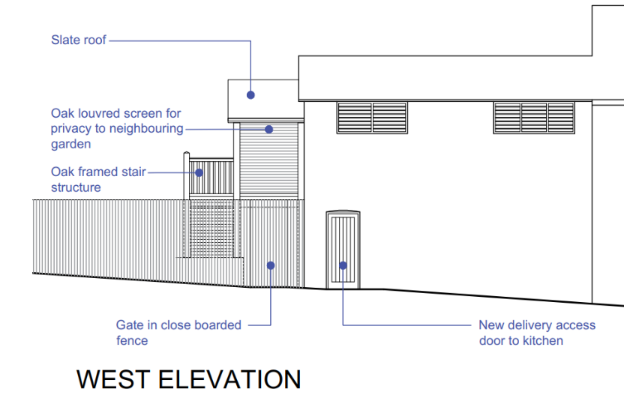

Case Officer photo of kitchen door Proposed elevation not representative of door installed

It is also noted that there are anomalies between the proposed plans subject of the current applications and what has actually been built. Furthermore, site inspections identified a number of additional works which either do not appear to accord with approved plans or do not form part of the current applications. The examples below are illustrative only and are not intended to represent a definitive schedule of all works undertaken at the site. These examples are provided for contextual purposes and have not formed part of the substantive assessment of the current applications.

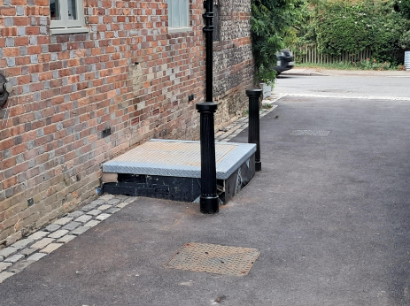
Case Officer photo showing raised cellar hatch as built

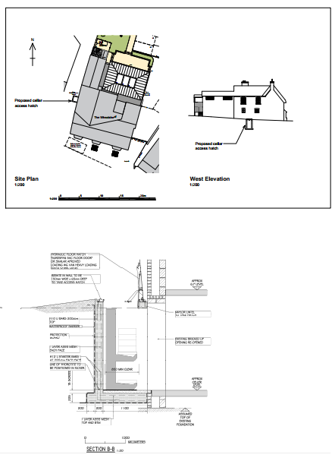

Plan of cellar hatch approved under PL/2024/03348 & PL/2024/03701

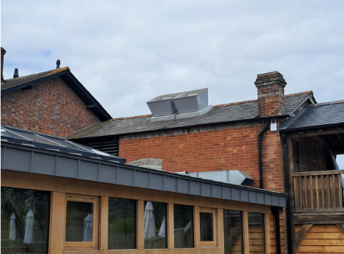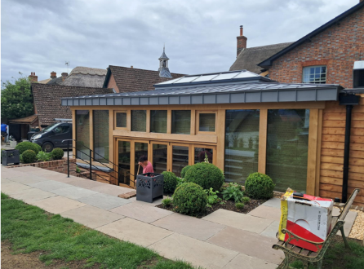
Case Officer photo of ducts/ventilation installed Case Officer photo of rear elevation

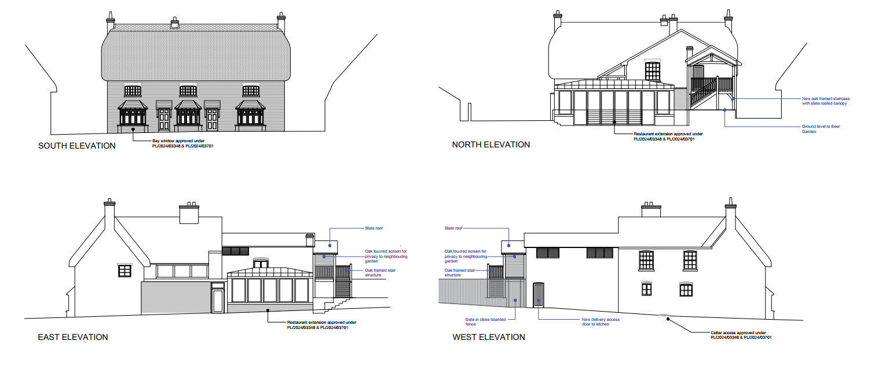
Proposed elevations (current application)

Conclusion
Notwithstanding the above assessment, overall, the alterations are considered to be modest, subservient to the existing building and in keeping with the character of the area. The use of traditional and high-quality materials, including oak framing, slate roofing, timber joinery and natural stone paving, ensures that the development integrates satisfactorily with its surroundings. The proposal is therefore considered to accord with the design objectives of the NPPF and Core Policy 57 of the Wiltshire Core Strategy.

Whilst the proposals are considered in isolation, to represent works of an appropriate quality and design having regard to Core Policy 57 and national design guidance, this does not override the statutory and policy tests relating to designated heritage assets. Compliance with general design principles does not in itself justify harm to the significance of a listed building or the character and appearance of a conservation area, which is considered in detail below.

Notwithstanding the above assessment, the site comprises a Grade II listed building located within the Chilton Foliat Conservation Area. As such, the impact of the development on the significance of the listed building and on the character and appearance of the conservation area are material planning considerations. These matters are considered separately within the heritage section of this report.

Impact on Heritage Assets

Policy Context
From the point of view of the historic environment, the main statutory duties are set out within the Planning (Listed Buildings and Conservation Areas) Act 1990.

Section 66(1) requires special regard to be given to the desirability of preserving listed buildings, their settings and any features of special architectural or historic interest which they possess.

Section 72(1) requires special attention to be paid to the desirability of preserving or enhancing the character or appearance of Conservation Areas.

Core Policy 58 of the Wiltshire Core Strategy seeks to conserve and, where appropriate, enhance the significance of designated and non-designated heritage assets and their settings.

Core Policy 57 requires development to respond positively to local character and historic context through high quality design.

Policies HE4-HE10 of the NPPF recognise heritage assets as an irreplaceable resource and require proposals affecting heritage assets to be assessed having regard to their significance and the contribution made by their setting.

Assessment
In assessing this aspect of the proposal, regard has been had to the site context, the details of the proposed development, the relevant development plan policies, and all other material considerations.

In accordance with the heritage policies of the NPPF, any harm to the significance of a heritage asset must be clearly identified and assessed. Where harm is identified, it should be categorised having regard to the relevant heritage policies and weighed against any public benefits arising from the proposal.

The full planning and listed building consent applications are principally the same as the recently refused full planning and listed building consent applications, except for a few minor omissions, namely the omission of the first floor window in the rear elevation serving the office and omission of 2no. high level windows in the east elevation of the restaurant extension.

In consideration of the previous refused applications, the Council’s Conservation Officer provided the following assessment, summary and conclusion:

“The Wheatsheaf Public House is a grade II listed building located in the Chilton Foliat Conservation Area.

The main frontage building runs parallel to the road and is probably mid-to-late 18th century rather than the early 19th century as per the list description. In any case, the frontage building is the oldest part of the listed building and was originally a house but had become an Inn by the mid-19th century. The rear parts of the building are mid-Victorian, and the portion to the rear, at right-angles to the main building, is a former brew house.

Internally the thatched building has been altered to the point that the ground floor is more-or-less open plan, and the original staircase(s) have been lost, the access to the first floor being beyond the original external wall within the mid-Victorian part of the building, to address the changes in floor levels.

The position within the village (a designated conservation area) contributes to the character and significance of the building. Many public houses and inns within villages were formed from mixed use developments, and this can be seen within the historic OS maps that show a collection of outbuildings which would have offered a range of facilities and services and were not solely reliant of the function of the inn (a pub with letting rooms). It is acknowledged that the role of a pub/ inn has altered in the recent years, but the basic function of offering accommodation, food and beverage remain.

In this case the significance of the building lies largely with its historic fabric and architecture - its form, layout and vernacular design, and its long-term use as a village Inn, which have significant aesthetic and architectural interest, and which contribute to the character of the conservation area.

Assessment: The submitted application looks to undertake the ‘Creation of new door opening, construction of external staircase and installation of new window opening in rear gable wall, change to hard landscaping and car park surfacing’. This is a regularising application as the works have been completed. Under the Planning (Listed Buildings and Conservation Areas) Act 1990, it is not possible to submit a ‘retrospective application’ as the Act is there to protect (or enhance) the significance of the listed building. Being a listed building and a commercial property, there is a restriction on permitted development rights (PDR’s), and therefore some aspects, like the external landscaping are subject to planning control, as these need to consider the setting of the designated heritage assets, which include the host building, the adjoining listed buildings and the conservation area.

The submitted Heritage Statement has provided an Impact Assessment and this has been used as part of the assessment process. The justification of the works within the Heritage Statement Assessment are shown in italics for ease of reference.

Installation of new door opening
The proposed addition of the external door will result in a low level of less than substantial harm being caused to the designated heritage asset through the removal of historic fabric. Whilst there are no heritage benefits arising directly through this, it is recognised that the works form part of a wider scheme of regeneration and development at the site. This element of the scheme was identified as required owing to the completion of a detailed kitchen layout scheme. Such works will ensure the successful operation of the site, subsequently helping ensure business longevity and retention of the pub use within the building. The door has changed location from the previously consented location on the rear gable wall.

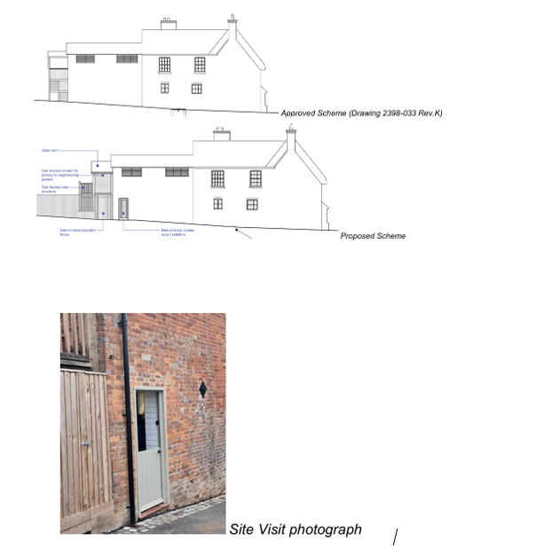

The insertion of a stable door to the rear of the kitchen extension to the former Brewery Room (outbuilding) has resulted in the loss of historic fabric and has changed the external appearance of the side elevation, which until the recently approved works to create staff facilities to the first floor/ kitchen extension, was a blank elevation. As part of the consented works, new windows were installed to the first floor, but these were screened with louvres which retain the simplicity of this former outbuilding and the entrance door to the kitchen was in the gable/ rear elevation.

The rear of the historic inn complex would have looked inwardly, both for ease of operation but also for security. The new door changes this approach and creates a new link to the public realm where there would not historically be one. Due to the staircase structure, it would not be possible to insert the door to the approved position, so this has had a cumulative impact on the unauthorised works. It has not been demonstrated why the door needs to be inserted here, or why the kitchen layout needed to be amended from the approved layout of the building necessitating the relocation of the door.

The inserted doorway has resulted in a change of appearance and relationship with the wider street scene and has resulted in a loss of fabric. No information in the submitted application has been provided on how the door opening was formed (ie, type of lintel), joinery details or if any historic/ significant details have been lost or altered internally. Whilst it is acknowledged that the interior was consented to be altered, this does not mean that there were no elements of significance. There is no discussion with the submitted application for the change of floor plan.

The relocation of the door has resulted in harm due to the visual impact on the side elevation and the loss of fabric. Whilst it is acknowledged that some loss of fabric was accepted by creating the door in the gable end, this would retain the appearance of the side elevation and retain the openings within the curtilage.

Staircase to rear gable
The addition of an external staircase was permitted under previous applications. The design of this has been amended slightly in order to provide a concealed bin store and to descend to the ground level in the garden area which are higher than the ground floor of the building. The alterations to the design are minimal and the high-quality workmanship of this element means these alterations do not change the impact of this intervention.

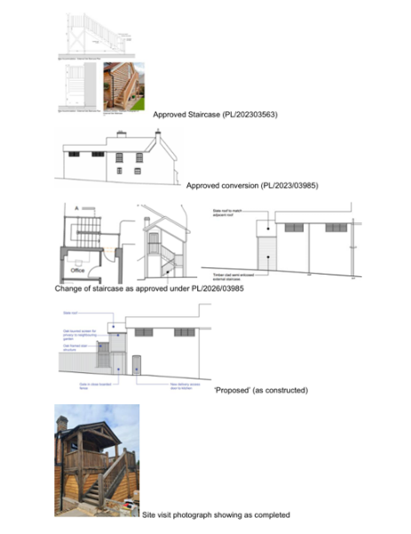

The first approved staircase did not create a balcony or roof and followed a traditional form that is common on outbuildings of a single flight and landing that sat flush with the building. A later application looked to alter and adjust the design, and consent was granted for a small, pitched roof to the staircase which allow access to the staff facilities to the first floor. This retained an open appearance of the treads, reducing the appearance of bulk, and did not create a space that would encourage loitering or seating which would reduce the need for privacy screening. The width was limited to allow for safe access and therefore responded to the relationship between the outbuilding and the main pub building.

The constructed staircase creates a balcony with an extended roof form, which is not a typical detail found on outbuildings. This staircase has been fully enclosed with timber cladding creating a bulky appearance, with complexity of the structure contrasting with the former gable elevation, increasing the dominance of the structure within the garden and the public realm.

The proposed scheme (drawing) looks to create additional screening to prevent overlooking to the neighbour by infilling the side elevation. This is considered to add to the bulkiness of the addition that is already in existence. As previously noted, the original staircase would not encourage loitering and seating, and therefore there would be limited requirement to add in privacy measures.

The submitted Heritage Statement notes that the staircase now allows for an enclosed bin store to be formed underneath the balcony, but this raises safety concerns as this is a means of escape for the staff faculties.

The undertaken works create a more cluttered appearance to the side elevation, and whilst each element on its own could be considered to cause limited harm, the accumulation of the elements of the door and staircase are considered to create harm (less than substantial), and it is considered that it has not been demonstrated that there is justification for the extent of the harm. This part of the application is not supported as it has not been demonstrated that these elements are required to outweigh the harm.

Window in rear gable
The addition of a window to the gable of the attached outbuilding at first floor will cause a low level of less than substantial harm to the designated heritage asset through the removal of historic fabric. The window opening has been designed to replicate those existing on the rear of the property to ensure consistency in design. The provision of the window will provide natural light to the office.

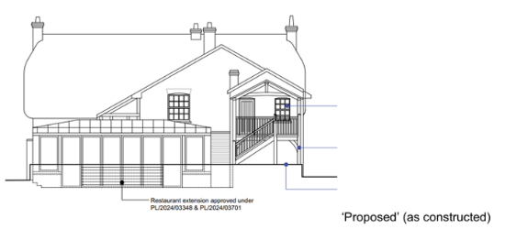

The window replicates the window found on the main building, therefore does not respond to the relationship of the outbuilding and the main building. The previously approved scheme ensured the balance between function and significance by retaining the external appearance of an outbuilding with the louvred windows to both elevations and placing the doors to the gabled elevation. The insertion of a window introduces a domestic appearance, which is further enhanced by replicating the window of the main building which raises the status of the outbuilding to main building.

It is recommended that if a window is required, then this should be of a scale and form to suit the appearance of the outbuilding, so a smaller scale opening in a casement design, rather than the larger sash window. This would be a compromise to allow some natural light and ventilation into the office whilst respecting the significance of the structure.

No information in the submitted application has been provided on how the window opening was formed (ie, type of lintel), joinery details or if any historic/ significant details have been lost or altered internally. Whilst it is acknowledged that the interior was consented to be altered, this does not mean that there were no items of significance. There is no discussion with the submitted application for the change of floor plan.

The undertaken works create a more cluttered appearance to the side elevation, and whilst each element on its own could be considered to cause limited harm, the accumulation of the elements of the door and staircase are considered to create harm (less than substantial), and it is considered that is has not been demonstrated that there is justification for the extent of the harm. This part of the application is not supported as it has not been demonstrated that these elements are required to outweigh the harm.

Hard Landscaping to Forecourt
The hard landscaping provided to the front of the property includes yorkstone flags and red brick. The area was previously covered with asphalt which had downgraded the buildings setting. The reinstatement of a traditional surface treatment has created public benefit in the form of heritage benefit thereby enhancing the listed building and wider conservation area.

These could be seen as a positive improvement to the external elevation of the pub as it could be considered to create a more welcoming or attractive entrance. There is concern that the external levels have been altered which will prevent the vapour permeability (breathability) of the front elevation, which has the potential to cause long term issues with the historic fabric. This concern can be easily resolved by reducing the level of the shingle and ensuring the slabs allow ventilation to the front elevation.

The use of York stone flags is not a local material but is recognised as a hard-wearing stone. Brick is a local material, and the use of this as a finish is considered acceptable. The installed planters could be considered to offer a more urban appearance due to the material choice, but as these are removable, these are considered to have limited impact to the setting of the listed building.

The installation of the hedges and planters will need to ensure viability of the property the visibility of the pub should be retained from the street scene and the safe access (vision splays) to the parking to the rear as parking to the front of the building would be seen as a negative to the significance of the designated heritage assets. It could also deter possible patrons if they felt usure or unsafe accessing the parking due to the height of the plants or restriction of the turning space due to the planters.

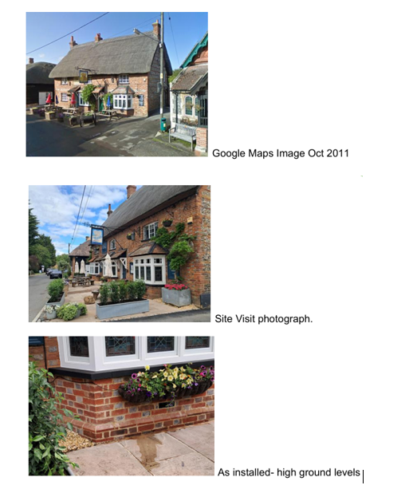

Car Park surface
The carparking surface is a mixture of asphalt and gravel which will be retained through a slight redesign of the layout. These works will have a neutral impact on the setting of the listed building.

The proposed works are not considered to cause harm to the setting of the designated heritage assets. As noted above, ensuring safe access/ egress and sufficient parking to support the use of the pub is required as parking to the front will cause harm to the setting and have the potential to discourage visitors.

Steps, dwarf walls and raised planting beds
The addition of some formal features within the garden of the public house has had a neutral impact on the character and significance of the setting of the listed building. Previously, external seating was provided in a hard landscaped area on the site of the orangery which included dwarf walls and hardcore surfacing. The new landscaping scheme sees tables situated on grass with small dwarf walls and raised planting beds which gives a more informal appearance to the garden.

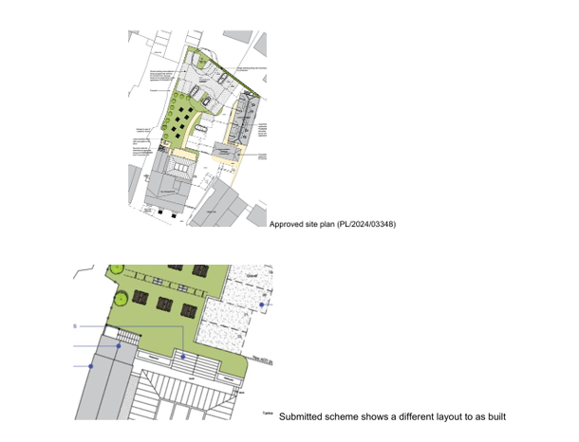
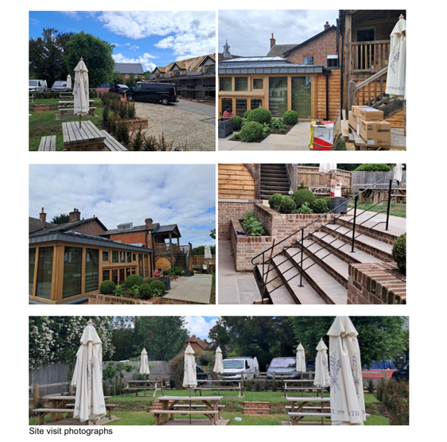

The patio outside of the Orangery has been altered to create a stepped planting either side of the steps. This is different from the proposed plan which forms part of this submission which shows less hardstanding and planting and an increase in the grass area. The proposed scheme offers a softer appearance than the more formal, urban form of formal planters (as built). The proposed drawing of the garden offers a balanced approach between creating an attractive and useable beer garden and the change of levels. The current layout would not be supported from a heritage consideration due to its more urban form and the extent of the hard landscaping.

The introduction of the dwarf walls and hedging create a visual separation within the open courtyard, disconnecting the buildings. Whilst some separation is understandable to allow the garden to be enjoyed without views of the car park or creating a safe space for families, the use of low-level brick walls introduces a more permanent separation of the space, and if some separation was required, the use of an open fence could be considered which has been used at the end of the garden to separate the garden/ seating area and the parking. This fence is open and is not considered to cause harm to the setting of the listed building but allow some separation between garden and parking but is not shown on the proposed plans.

To the public path at the side of the property, a tall, close boarded fence has been erected further than the approved scheme which noted the closed boarded fence with new gates to the bin store. As the bin store has currently been installed under the rear staircase structure, it is unclear why the close boarded fence has been extended blocking the garden from the public realm which might prevent public from seeing the garden.

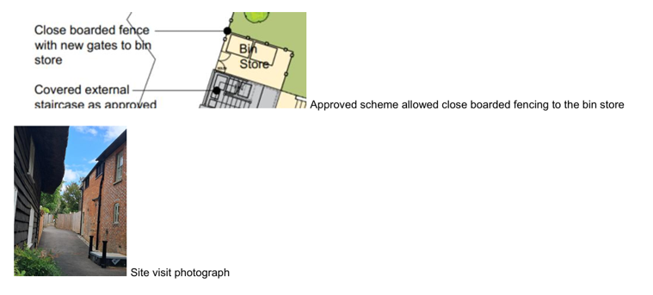

Conclusion
On balance it is seen that the proposed works captured within this application will have a neutral impact on the character and significance of the listed building and wider conservation area.

The works have been undertaken, and therefore the application is to regulate the unauthorised works. Whilst each element on their own could be deemed as causing limited harm, the accumulation of the elements, is considered to result in less than substantial harm. Under the NPPF, this could be offset by public benefits, which could include heritage benefits. It is deemed that within this application, no evidence has been provided to support the heritage benefits. There is some benefit with the forecourt works, but this is not considered to outweigh the balance of harm from a heritage perspective.

The application has provided limited information on how the works were undertaken, so it is not possible to make an informed decision regarding any additional harm that may have been caused, such as the loss of fabric or plan form.

Consideration
It is acknowledged that the public houses have been struggling to operate over recent years. However, there is evidence that the more traditional drinking pubs are making a positive increase in trade, resulting in a shift in the type of pubs that are becoming profitable and/ or visited. This is not uncommon with long running institutions who adapt and alter to suit the changing demands.

The works to the rear staircase which are considered the most harmful to the significance of the listed building are not part of the public area as they offer access for staff facilities only, therefore there original or amended scheme could be installed without affecting trade potential. This would then allow for the consented position of the doorway in the gable to be installed and allowing this elevation to return to have limited openings. The location of the bin store within an enclosed space which is also a means of escape for the staff does raise concerns from a Building Control/ Means of Escape consideration. Enclosed bin stores can help keep commercial properties tidy but installing them in enclosed or restricted spaces requires careful planning around ventilation, fire safety, and access. Failing to manage these factors can lead to trapping foul odours, attracting pests, or creating serious fire hazards.

There is limited information submitted within the application on how the new door and window opening were made, the significance of the fabric lost, or how the opening were made good. There are no joinery details which would be expected within a LBC application (which could be conditioned) to ensure the protection of the significance of the listed building.

Unconsented changes
Reviewing the application, the site visit and the various approved drawings, there are a few elements that have not been built as consented.

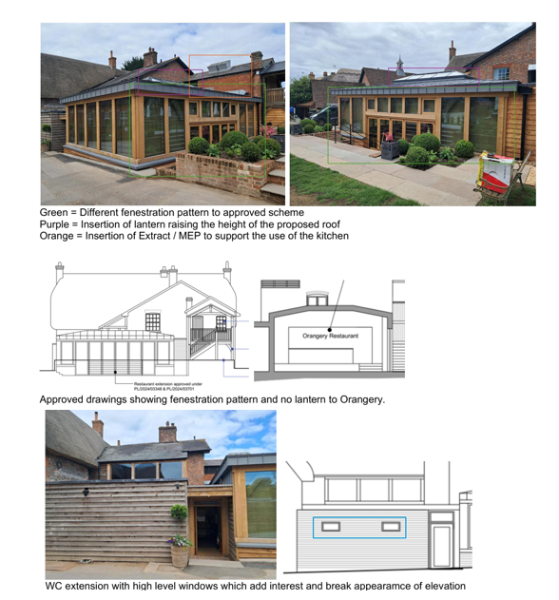

These elements should be regularised via an application or altered to suit the approved scheme.

It also appears that the signage has altered. The attachment of signs, menu boards, notices, etc., to a listed building requires LBC. The pub had a sign painted directly onto the building, and this has been covered with a new sign. The painted sign responds to the rural village nature of the inn, and forms part of the character.

Summary & conclusion: The NPPF confirms that when considering the impact of a proposed development on the significance of a designated heritage asset, great weight should be given to the asset’s conservation (and the more important the asset, the greater the weight should be). It makes clear that any harm to a designated heritage asset requires clear and convincing justification.

The proposals will result in harm to the building via the loss of historic fabric and character and via change to its layout and original external form. The proposals involve only part of the building and could therefore be considered as causing ‘less than substantial harm’ for the purposes of interpreting the NPPF, but they involve the loss of important structural historic fabric and should not be seen as being of lesser consequence. Indeed, the wording of the NPPF and the ‘special regard’ by Sections 16 and 66 of the Act requires that any level harm caused should be taken seriously.

Whilst paragraph 215 allows that a level of harm may be offset by public benefits, which could include conservation benefits, in this case no objective justification has been provided for the works and it has not been demonstrated that the works will result in any public benefit. As a result, the proposals fail to meet with the requirements of current conservation legislation, policy or guidance and I therefore recommend refusal.”

The current full planning and listed building consent applications are essentially the same as the recently refused applications, and relate to a series of alterations to the existing public house, comprising the provision of a kitchen access door, amendments to the external staircase, alterations to hard surfacing, and associated landscaping works within the site's curtilage. The works described above have largely been carried out as evidenced during the Case Officer’s recent site visit accompanied by the Council’s Conservation Officer and Enforcement Officer.

In consideration of the current applications, the Council’s Conservation Officer maintains their previous objection, commenting as follows:

“The application is essentially a resubmission of previous applications PL/2026/02976 & PL/2026/02719, which were refused. The proposed plans submitted are trying to address the changes to the design of previously approved alterations and extensions to the building (applications for which have been fairly extensive since 2023, having been based on approvals in 2020 under a different applicant).

The approved plans were implemented, but the scheme has not been built out in accordance with the approved plans, hence the current (and recent) applications to try and regularise these differences.

It should be noted that, as part of the review of the application (which included a site visit), there are other works that are not as approved and are out outside of this application, and should be subject to enforcement action.

Considering the attempts made to regularise the situation, a site visit (undertaken with the Case Officer and Enforcement Officer) on the 4th August 2026 confirmed the current situation and it is clear that the proposed plans provided still do not fully reflect the scheme has it has been built now.

In addition to this, concerns had been raised over some elements of the works done without consent, which should not be regularised by the application, and the original approved scheme should be adhered to on these elements. These comments are on the previous application(s) and have been appended to this consultation response, for ease of reference rather than replicating them.

Further tweaks to the approved scheme weaken it, undermining the original decision to approve the original applications at the Eastern Area Planning Committee, and should not be approved to simply regularise the changes, as harm has been identified if some of these elements are retained. However, as the proposed plans do not accurately reflect the situation as built, this is rather a moot point, and the application should be refused due to the above inaccuracies.”

The current full planning and listed building consent applications are substantially the same as the recently refused applications and seek to regularise a number of alterations undertaken otherwise than in accordance with previously approved planning permissions and listed building consents. The proposals comprise the formation of a new kitchen access door, amendments to the external staircase, alterations to hard surfacing, and associated landscaping works within the curtilage of the Grade II listed building.

The current application omits the rear first-floor window previously proposed under applications PL/2026/02719 and PL/2026/02976. Whilst this amendment marginally reduces the extent of the heritage harm identified in relation to the earlier refused scheme, officers do not consider that it materially alters the overall heritage assessment. The principal concerns relating to the relocated doorway, amended staircase and the cumulative impact of the alterations on the significance of the listed building and the character and appearance of the Conservation Area remain.

The Council's Conservation Officer has undertaken a detailed assessment of the proposals, including a further site visit, and maintains an objection. The Conservation Officer concludes that the retention of certain unauthorised alterations would result in harm to the significance of the listed building and the character and appearance of the Conservation Area. It is also noted that the proposals do not fully reflect the development as built and that further departures from the previously approved scheme undermine the carefully considered design approach which formed the basis of the earlier approvals.

The Local Planning Authority concurs with the Conservation Officer's findings that the proposals cause harm to the significance of heritage assets.

The Local Planning Authority acknowledges that the applicant has identified a number of public benefits arising from the proposals, including operational improvements to the public house, support for the long-term viability of the business and enhancements to areas of hard landscaping. However, whilst these matters have been taken into account as part of the assessment, the Local Planning Authority affords them only limited weight for the reasons set out below.

Having had special regard to the desirability of preserving the listed building, its setting and features of special architectural and historic interest, and having paid special attention to the desirability of preserving the character and appearance of the Conservation Area, the Local Planning Authority concludes that the proposals fail to satisfy the requirements of the Planning (Listed Buildings and Conservation Areas) Act 1990, the NPPF, and Core Policies 57 and 58 of the Wiltshire Core Strategy.

Conclusion
Having had special regard to the desirability of preserving the Grade II listed building, its setting and those features of special architectural and historic interest which it possesses, and having paid special attention to the desirability of preserving or enhancing the character and appearance of the Chilton Foliat Conservation Area, the Local Planning Authority concludes that the proposals would result in unjustified harm to the significance of the designated heritage assets. The identified public benefits are not considered sufficient to outweigh that harm.

Accordingly, the proposals conflict with the National Planning Policy Framework, including Policies HE4, HE5 and HE6, Core Policies 57 and 58 of the Wiltshire Core Strategy, and the statutory duties contained within the Planning (Listed Buildings and Conservation Areas) Act 1990.

For the reasons set out above, it is recommended that planning permission and listed building consent be refused.

Amenity

Policy Context
Core Policy 57 (Point vii) of the Wiltshire Core Strategy requires development to respect the amenity of existing occupants and ensure appropriate amenity levels for future residents.

Policy P3 of the NPPF requires development to be appropriate for its location, taking account of its likely effects on health, living conditions and the environment. In particular, Policy P3(2)(b) requires development to avoid giving rise to unacceptable impacts on the living conditions of neighbouring residents and occupiers. In assessing amenity impacts, regard should be had to matters including daylight and sunlight, outlook, privacy, overbearing impacts and other effects on residential amenity.

These policies guide the assessment of amenity impacts. The current application is broadly the same as the previous refused application apart from a couple of omissions, such as the first floor window in the rear elevation.

The current applications relate to a number of alterations to the Grade II listed public house, including the retention of a revised external staircase to the rear elevation, insertion of a kitchen access door, hard landscaping works and alterations within the beer garden and car park. The submitted Design and Access Statement confirms that the previously approved staircase incorporated a privacy screen to prevent overlooking of neighbouring residential properties and that this principle has been retained within the current proposal through the provision of an oak louvred screen.

Having regard to the nature and scale of the proposed works, it is considered that the kitchen access door, surfacing alterations and landscaping works would not give rise to any significant adverse impacts in terms of overlooking, loss of privacy, loss of light, overbearing impact, noise or disturbance to neighbouring occupiers. The proposed kitchen access door would facilitate the operation of an established public house and is unlikely to result in such a material increase in activity beyond that associated with the lawful use of the site to warrant a reason for refusal.

Particular consideration has however been given to the external staircase and raised platform on the western side of the building, given its proximity to neighbouring residential properties. The approved drawings show the provision of an oak louvred privacy screen to the western side of the staircase and landing to prevent views towards adjacent private garden areas.

It was noted during the site inspection that the staircase and platform have been constructed without the louvred privacy screen shown on the submitted drawings as evidenced in the image below:

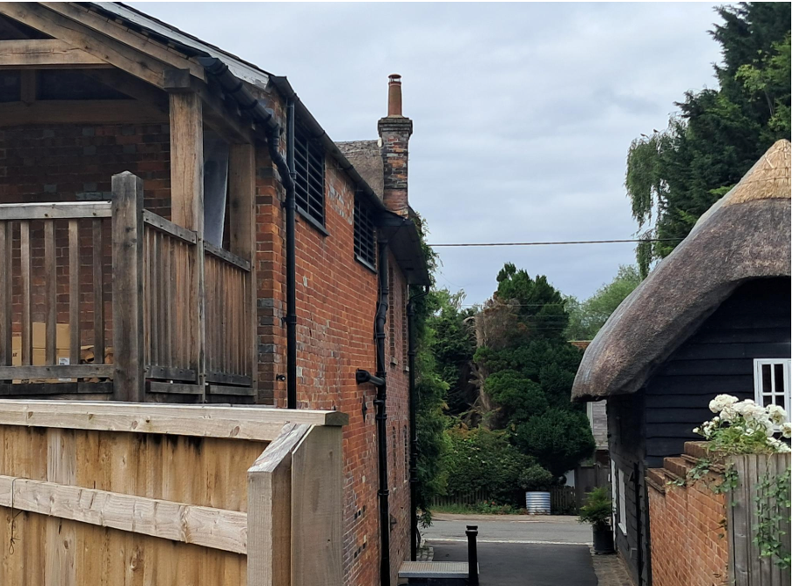
In the absence of this screening, the development has the potential to result in overlooking and a consequent loss of privacy to neighbouring occupiers to the west. The louvred screen is therefore considered an essential component of the development in amenity terms.

In the event that planning permission were to be granted, it is considered that a condition would be necessary to ensure that the oak louvred privacy screen is installed and thereafter retained in perpetuity. Subject to this being conditioned, it is considered that the proposed development would not result in unacceptable harm to neighbouring residential amenity as a consequence of overlooking or loss of privacy. The proposal is therefore considered to comply with Core Policy 57 of the Wiltshire Core Strategy.

Whilst the amenity impacts associated with the staircase could be adequately mitigated through the provision and retention of the proposed louvred privacy screen, this conclusion relates solely to residential amenity and does not alter the separate assessment undertaken in relation to the impact of the development on the significance of the listed building and the character and appearance of the Conservation Area.

Highways Impacts and Parking

Policy Context
Policies TR3-TR8 of the NPPF seek to ensure that development is supported by safe, suitable and sustainable transport arrangements. Development should provide appropriate access, promote sustainable travel choices where possible and avoid unacceptable impacts on highway safety and the operation of the transport network.

Core Policies 60-64 of the Wiltshire Core Strategy require development to provide safe access, promote sustainable transport, minimise transport impacts and provide appropriate parking arrangements.

Where relevant, regard should also be had to the Wiltshire Local Transport Plan, the Council's parking standards and any applicable Local Cycling and Walking Infrastructure Plans (LCWIPs).

Assessment
In assessing this aspect of the proposal, regard has been had to the site context, the details of the proposed development, the relevant development plan policies, and all other material considerations.

The application includes alterations to the front forecourt, rear car park and associated external areas of The Wheatsheaf Inn. The front forecourt has been resurfaced, replacing the existing tarmac with stone flags and pavers. These works have already been undertaken and form part of the retrospective application.

To the rear, amendments are proposed to the approved car park surfacing, involving changes to the extent of tarmac and gravel-filled permeable geogrid paving.

The proposals also include an alternative external access door serving the commercial kitchen and relocating the delivery/collection parking space from the front forecourt to the access track between the public house and the neighbouring property (Calstone House).

In consideration of the application, the Council’s Highways Officer has provided the following comment:

“I refer to the above planning application for the creation of a new door opening, construction of external staircase, change to hard landscaping and car park surfacing.

In highway terms this application is the same as Pl/2026/02719 and I will therefore offer the same comments:

The number of parking spaces is remaining the same as in the previous proposal which was given permission under PL/2024/03348 and objected to by the Highway Authority on lack of parking. I note however that this application shows the delivery parking space located in the track to the side of the pub rather than to the front of the pub as in the previous application. I understand that the adjacent track is owned by a third party and serves as access to residential properties and therefore access rights and permission to use this area as a parking space must be ensured.

The submitted plans show the whole of the area to the front of the pub paved with flag stones and pavers and I note that these works have already been undertaken. Please note, however that the majority of this area is public highway and it was permitted to be used as a delivery parking space by the LHA under the previous application (PL/2024/03348) as the site lacked parking provision. However for this application, the tables and chairs and planters could be allowed on the highway if The Council issue the applicant with a ‘Pavement Licence’ although the planters and tables and chairs need to be set back from the carriageway edge by a minimum of 450mm. I have copied Highway Enforcement into this email and request that an application form for a Pavement Licence is sent to the applicant, however should this planning applicant not be successful and permission is not granted, the area to the front of the pub must revert to being a delivery van parking space. Please note that having the tables, chairs and planters on the highway currently without a licence is an enforcement issue and the positioning of the tables, chairs and planters are preventing the parking as permitted under the previous application (PL/2024/03348), so the applicant is in breach of their current permission.

The applicant must also be aware that the area remains public highway and should these pavers or flags get broken, Wiltshire Council as the highway authority would only make repairs by removing the damaged pavers or flags and filling the area with preparatory Cold Lay Bitumen.

Therefore providing a delivery parking bay is maintained, and taking all of the above into account, I do not object to the current proposal, however, I must stress again that the lack of parking provision for the site as a whole remains a concern to the LHA and an objection is only being withheld due to the fact that the previous application was approved against the LHA’s advice and this application provides the same amount of parking spaces as that.”

The Highways Officer has reviewed the application and raises no objection to the proposed development, subject to the retention of a delivery parking space serving the public house. The Highway Officer notes that the proposals do not reduce the number of parking spaces previously approved under application PL/2024/03348 and therefore do not materially worsen the existing parking situation. Whilst concerns remain regarding the overall level of parking provision at the site, these concerns are longstanding and were previously considered under earlier permissions. The Highway Authority confirms that an objection is withheld on the basis that the current proposals provide the same level of parking provision as the previously approved scheme.

Concerns have been raised by a local resident regarding the potential for delivery vehicles to reverse into and out of the access lane to the west of the public house, and the implications this may have for pedestrian safety. These concerns have been noted and have been taken into account in the assessment of the application. However, the Council's Highway Officer, having reviewed the proposal and the revised servicing arrangements, raises no objection on highway safety grounds. In reaching this conclusion, significant weight is afforded to the specialist advice of the Highway Authority. No technical evidence has been submitted to demonstrate that the proposed arrangements would result in a severe or unacceptable impact on highway or pedestrian safety.

The Highway Officer has also highlighted that the area to the front of the public house forms part of the public highway and that the existing tables, chairs and planters require appropriate licensing if they are to remain in situ. However, these matters are subject to separate highway and licensing controls and do not form a reason to object to the current application.

The Highways Officer notes that the proposed delivery parking space is shown within the access lane to the west of the site, which is understood to be in third-party ownership. Whilst land ownership is not a material planning consideration and does not prevent the submission or determination of a planning application, the use of the parking space for servicing purposes would be dependent upon the applicant securing the necessary legal rights and permissions from the landowner. The Local Planning Authority notes that planning permission PL/2024/03348 included a condition requiring written confirmation of third-party agreement in relation to works and parking arrangements on adjoining land. In the event that planning permission were to be granted, it is considered that a similarly worded condition would be necessary to secure evidence that the proposed delivery parking space could be lawfully provided and retained for the benefit of the development.

Conclusion
Having carefully considered the comments of the Highways Officer, the Case Officer agrees with their assessment and concludes that the proposals would not result in an unacceptable impact on highway safety or parking provision. Subject to the continued availability of a delivery parking space serving the site, no highway reason exists to warrant refusal of the application. Accordingly, the proposal is considered to accord

Having regard to the above, it is considered that the proposal accords with the relevant objectives of Core Policy 61 of the Wiltshire Core Strategy.

Ecology and Biodiversity

Policy Context
Core Policy 50 of the Wiltshire Core Strategy requires development to protect and, where appropriate, enhance biodiversity and geodiversity interests.

Policy N2 of the NPPF seeks to conserve and enhance biodiversity, support nature recovery, protect habitats and species, and strengthen ecological networks.

Where relevant, proposals should assess impacts upon protected species, habitats, ecological networks and green and blue infrastructure and demonstrate that any adverse impacts can be appropriately avoided, mitigated or compensated for.

Biodiversity Net Gain (BNG) is mandatory for most development and proposals should demonstrate compliance with the statutory requirements unless an exemption applies.

Assessment
In assessing this aspect of the proposal, regard has been had to the site context, the details of the proposed development, the relevant development plan policies, and all other material considerations.

Mandatory Biodiversity Net Gain (BNG) was introduced through the Environment Act 2021 and Schedule 7A of the Town and Country Planning Act 1990. Since February 2024, most planning permissions have been required to deliver a minimum 10% biodiversity net gain, measured using the statutory biodiversity metric, unless a statutory exemption applies. The requirement is supported by the National Planning Policy Framework (NPPF), Planning Practice Guidance (PPG) and Wiltshire Core Strategy Core Policy 50 (Biodiversity and Geodiversity).

The proposed development comprises minor alterations to the existing public house, including the provision of a kitchen access door, amendments to the external staircase, insertion of a window, alterations to hard surfacing, and associated landscaping works within the existing curtilage of the site. The submitted information indicates that the works are largely confined to existing built form and previously developed areas, with existing trees within the car park retained and protected.

Having regard to the nature and scale of the development, and based on the information submitted, the proposal is considered to constitute a de minimis development for the purposes of the Biodiversity Gain Requirements (Exemptions) Regulations. There is no evidence that the proposal would result in the loss of more than 25 square metres of habitat, more than 5 metres of hedgerow, or any priority habitat.

Accordingly, the proposal is considered to be exempt from the mandatory Biodiversity Net Gain requirements and the submission of a Biodiversity Gain Plan or statutory biodiversity metric calculation is not required. Notwithstanding this exemption, the proposed planting within the site is welcomed and is capable of providing a modest biodiversity enhancement.

Conclusion
Having regard to the above, it is considered that the proposal accords with Core Policy 50 of the adopted Wiltshire Core Strategy and the relevant provisions of the BNG legislation.

Landscape and Visual Impact

Policy Context
Core Policy 51 of the Wiltshire Core Strategy seeks to protect, conserve and enhance landscape character and quality and requires development to respond appropriately to its landscape setting.

Policy N2 of the NPPF seeks to conserve and enhance the natural environment and requires development to take account of landscape character, local distinctiveness and the natural beauty of the countryside.

The Wiltshire Design Guide promotes a context-led approach that integrates development with landscape features and local character.

Policy N4 of the NPPF affords significant protection to National Landscapes and requires development proposals to conserve and enhance their natural beauty and special qualities.

Under Section 245 of the Levelling-up and Regeneration Act 2023, the Council must seek to further the purposes of National Landscapes when exercising its planning functions.

Assessment
In assessing this aspect of the proposal, regard has been had to the site context, the details of the proposed development, the relevant development plan policies, and all other material considerations.

The proposed development comprises alterations to the existing public house, including the provision of a kitchen access door, amendments to the external staircase, insertion of a window, alterations to hard surfacing, and associated landscaping works within the existing curtilage of the site. The submitted information indicates that the works are largely confined to existing built form and previously developed areas, with existing trees within the car park retained and protected.

Whilst the proposals do not necessarily seek to further the purposes of the protected landscape, the proposed development would be read in the context of the existing buildings on site and neighbouring properties and as there would be no encroachment into open countryside, the proposed development would have a neutral impact upon the special qualities of the North Wessex Downs National Landscape.

Conclusion
Having regard to the above, it is considered that proposal accords with Core Policy 51 of the adopted Wiltshire Core Strategy and the relevant provision of the NPPF.

Trees and Arboricultural Impact

Policy Context
Core Policy 51 of the Wiltshire Core Strategy seeks to protect and enhance landscape character, including important trees and woodland features.

Policy N2 of the NPPF requires decision-makers to consider the environmental qualities of land proposed for development and to conserve and enhance existing natural features of visual, historic or nature conservation value, including established trees and hedgerows where possible. The policy also seeks to ensure that landscaping and natural features are used to help integrate development into its surroundings.

Assessment
Consideration has been given to:
- The impact of the development on existing trees;
- Whether any trees are subject to Tree Preservation Orders;
- The adequacy of any submitted arboricultural information;
- The retention, protection and replacement of trees.

The Council's Arboricultural Officer was consulted on the application and advised that they were unable to provide any formal comments as the proposed hard landscaping and car park resurfacing works have already been undertaken.

The proposals comprise alterations to the existing public house, including the provision of a kitchen access door, amendments to the external staircase, alterations to hard surfacing, and associated landscaping works within the existing curtilage of the site. The submitted information indicates that the works are largely confined to existing built form and previously developed areas. Furthermore, the Design and Access Statement confirms that the two existing trees within the car park are to be retained and references an Arboricultural Method Statement which sought to ensure their protection throughout the works.

Conclusion
Given that the trees are to be retained and the application relates primarily to minor alterations within an established commercial curtilage, it is not considered that the proposal would result in unacceptable harm to existing trees or would conflict with the aims of Core Policy 51 of the Wiltshire Core Strategy.

Flood Risk and Drainage

Policy Context
Core Policy 67 of the Wiltshire Core Strategy seeks to ensure that development is appropriately located and designed to avoid increasing flood risk on-site or elsewhere. Sustainable drainage measures should be incorporated where appropriate.

Policies F4-F8 of the NPPF require flood risk to be taken into account in planning decisions and seek to ensure that development is safe for its lifetime, does not increase flood risk elsewhere and incorporates appropriate drainage measures.

Assessment
In assessing this aspect of the proposal, regard has been had to the site context, the details of the proposed development, the relevant development plan policies, and all other material considerations.

The application does not propose any fundamental change to the approved drainage strategy. The revised parking layout includes a combination of permeable geogrid paving with gravel infill and areas of tarmac surfacing. The submitted Design and Access Statement indicates that permeable surfacing will continue to be used within the parking area and there is no evidence that foul drainage arrangements have changed from those previously approved. Subject to the approved drainage arrangements being maintained, it is considered that the proposal would not result in an unacceptable increase in surface water runoff.

Conclusion
Having regard to the above, it is considered that the proposals accord with Core Policy 67 of the adopted Wiltshire Core Strategy and the relevant provision of the NPPF.

Other Issues

A concern has been raised by a member of the public, regarding the completion of the application forms, the identity of the applicant and agent, and an alleged conflict of interest involving an elected member. These matters are administrative and governance issues and are not material planning considerations. They do not affect the assessment of the proposal against the Development Plan and other material planning considerations and have therefore not been afforded weight in the determination of the application.

Public Sector Equality Duty (PSED)

In reaching this decision, due regard has been had to the Public Sector Equality Duty under Section 149 of the Equality Act 2010. This requires the Local Planning Authority to have regard to the need to eliminate discrimination, advance equality of opportunity and foster good relations between persons who share a protected characteristic and those who do not.

The Local Planning Authority is satisfied that the proposal would not result in any unlawful discrimination and that any impacts on protected groups have been appropriately considered as part of this assessment.

PLANNING BALANCE AND CONCLUSION

Policy Context
In reaching a decision, all identified harms and benefits must be weighed in the overall planning balance, having regard to Section 38(6) of the Planning and Compulsory Purchase Act 2004, the provisions of the Development Plan and the NPPF.

The NPPF contains a presumption in favour of sustainable development. Applications should be determined in accordance with the development plan unless material considerations indicate otherwise.

The weight to be afforded to any identified benefits must be considered alongside all other material considerations, including whether the proposal accords with the Development Plan and whether any other policies of the NPPF indicate that development should be refused or that substantial weight should be attributed to identified harms.

Having regard to Section 38(6) of the Planning and Compulsory Purchase Act 2004, the proposal is considered to accord with the Development Plan when read as a whole.

The proposal is also considered to accord with the relevant policies of the NPPF.

The principle of development is therefore considered acceptable, subject to the detailed assessment of all other material planning considerations set out elsewhere in this report.

The Balance

The principle of development has been assessed elsewhere within this report having regard to the Development Plan, the National Planning Policy Framework (NPPF) and all other material considerations.

For clarity, the principal harms and benefits identified through that assessment are summarised below and weighed against one another in the overall planning balance.

The assessment above has identified harm arising to the significance of the Grade II listed building and to the character and appearance of the Chilton Foliat Conservation Area. The application is largely a resubmission of recently refused proposals and primarily seeks to regularise alterations that have been carried out contrary to previously approved planning permissions and listed building consents.

Officers acknowledge that The Wheatsheaf Inn represents an important community facility within the village and that both national and local planning policy support the retention and long-term viability of public houses within rural communities. The Local Planning Authority also recognises that a number of planning permissions and listed building consents have previously been granted to facilitate the continued operation and enhancement of the business, including extensions, alterations and guest accommodation. These permissions demonstrate the Council's previous support for securing the optimum viable use of the listed building whilst safeguarding its significance.

The applicant identifies a number of benefits arising from the proposals, including improved operational efficiency within the commercial kitchen through the provision of a relocated external doorway, the continued viability of the public house business, the retention of an important community facility and some enhancement arising from the replacement of areas of hardstanding with more traditional surfacing materials.

Notwithstanding these benefits, the Conservation Officer concludes that the cumulative impact of the alterations, including the relocated doorway, amended staircase and associated works, results in harm to the significance of the Grade II listed building through the loss of historic fabric and erosion of its special architectural and historic interest. Harm has also been identified to the character and appearance of the Conservation Area. The Case Officer agrees with this assessment.

Whilst the applicant's Heritage Statement seeks to characterise the impacts of individual elements as resulting in either low levels of harm or neutral effects, the Local Planning Authority considers that greater weight should be attributed to the cumulative impact of the alterations when considered as a whole. The proposals represent further departures from schemes previously assessed and approved by the Council and are considered to weaken the earlier decisions.

In reaching its conclusion, the Local Planning Authority has had special regard to the desirability of preserving the listed building, its setting and those features which contribute to its special architectural and historic interest, in accordance with Sections 16 & 66(1) of the Planning (Listed Buildings and Conservation Areas) Act 1990. The Council has also paid special attention to the desirability of preserving or enhancing the character and appearance of the Conservation Area in accordance with Section 72(1) of the Act.

Policy HE6(1) of the NPPF requires substantial weight to be given to the conservation of designated heritage assets, whilst Policy HE6(3) confirms that any harm to a designated heritage asset is a matter of considerable importance and weight. The Local Planning Authority has therefore afforded substantial weight to the conservation of the Grade II listed building and considerable importance and weight to the identified harm arising from the proposals.

In accordance with Policy HE6(4) of the NPPF, the effect on the significance of the designated heritage assets has been weighed against the public benefits resulting from the proposal. Officers afford moderate weight to the continued operation of the public house and its contribution to the vitality of the rural community. However, only limited weight is afforded to the claimed operational efficiencies arising from the altered layout, as no robust evidence has been provided to demonstrate that the alterations are necessary to secure the ongoing viability of the business. Furthermore, no substantive evidence has been submitted to demonstrate why the benefits relied upon could not be achieved through implementation of the previously approved schemes, which would result in less harm to the significance of the heritage assets.

Significant weight is afforded to the fact that the Local Planning Authority has previously granted planning permission and listed building consent for schemes intended to facilitate the continued operation and enhancement of the public house. Those approved schemes were capable of delivering substantially the same operational and business objectives whilst resulting in a lower level of harm to the significance of the listed building and Conservation Area. Limited evidence has been provided to demonstrate why the departures now proposed are necessary to secure those objectives.

Whilst some modest benefit may arise from elements of the landscaping and replacement surfacing, these enhancements attract limited weight and do not materially alter the overall planning balance. The Local Planning Authority also notes that the proposals largely seek to retrospectively regularise unauthorised departures from previously approved schemes rather than deliver substantial new public benefits.

Having carefully weighed the identified public benefits against the harm arising to the significance of the Grade II listed building and the character and appearance of the Conservation Area, the Local Planning Authority concludes that the public benefits of the proposal are not sufficient to outweigh that harm. The proposal therefore fails to conserve the significance of the designated heritage assets and would result in unjustified harm to their significance. As such, the development conflicts with Sections 16, 66 and 72 of the Planning (Listed Buildings and Conservation Areas) Act 1990, the relevant provisions of the National Planning Policy Framework, and Core Policy 58 of the Wiltshire Core Strategy.

The proposal is therefore considered unacceptable in planning terms.

Conclusion

For the reasons set out above, the proposal would result in unjustified harm to the significance of the Grade II listed building and the character and appearance of the Chilton Foliat Conservation Area, which is not outweighed by the public benefits of the development, and it is therefore recommended that planning permission and listed building consent be refused.

RECOMMENDATION:
That Planning Permission be REFUSED for the following reason:

1. The proposed works, comprising the formation of a new external doorway, construction of an external staircase and associated alterations, by reason of the loss of historic fabric and their cumulative impact on the form, character, appearance and significance of the Grade II listed Wheatsheaf Inn, would cause less than substantial harm to the significance of the designated heritage asset and would fail to preserve the character and appearance of the Chilton Foliat Conservation Area. Whilst the Local Planning Authority acknowledges the importance of the continued operation of the public house as a community facility, the public benefits advanced by the applicant are not considered sufficient to outweigh the identified heritage harm. The proposal therefore conflicts with Sections 66(1) and 72(1) of the Planning (Listed Buildings and Conservation Areas) Act 1990, relevant provisions of the National Planning Policy Framework and Core Policy 58 of the Wiltshire Core Strategy.

That Listed Building Consent be REFUSED for the following reason:

1. The proposed works, comprising the formation of a new external doorway, insertion of a new window opening, construction of an external staircase and associated alterations, by reason of the loss of historic fabric and their cumulative impact on the form, character, appearance and significance of the Grade II listed Wheatsheaf Inn, would cause less than substantial harm to the significance of the designated heritage asset. Whilst the Local Planning Authority acknowledges the importance of the continued operation of the public house as a community facility, the public benefits advanced by the applicant are not considered sufficient to outweigh the identified heritage harm. The proposal therefore fails to preserve the special architectural and historic interest of the listed building, contrary to Section 16(2) of the Planning (Listed Buildings and Conservation Areas) Act 1990, relevant provisions of the National Planning Policy Framework and Core Policy 58 of the Wiltshire Core Strategy.

