APPLICATION FOR A CERTIFICATE OF LAWFULNESS FOR EXISTING USE OR DEVELOPMENT

APPLICATION REFERENCE: | PL/2026/04667
APPLICATION TYPE: | Lawful development: Existing use
SITE ADDRESS: | Wingfield Court, Arnolds Hill, Wingfield, Trowbridge, BA14 9LB
DEVELOPMENT DESCRIPTION: | Certificate of Lawfulness (Existing Use) to establish that conservatory link and tennis court, together with associated operations development is lawful
RECOMMENDATION: | Approve with Conditions

SITE DESCRIPTION AND PROPOSAL
This application is for a Certificate of Lawfulness for an Existing Use or Development (CLUED) under Section 191 of the Town and Country Planning Act 1990 (as amended). The applicant seeks to establish the lawfulness of a conservatory link building and tennis court, which has been in operation at the site since 2014. The application relates to the erection of the conservatory and the tennis court as being lawful.

RELEVANT LEGISLATION AND CONSIDERATIONS
The statutory framework governing Certificates of Lawfulness for Existing Use or Development (CLUED) is primarily set out in Section 191(2) of the Town and Country Planning Act 1990 (as amended). This section establishes that "lawful development" refers to development against which no enforcement action may be taken and where no enforcement notice is in force, or development for which planning permission is not required.

Section 191(4) of the Town and Country Planning Act 1990 (as amended) further stipulates that a Local Planning Authority (LPA) shall issue a Certificate of Lawfulness upon request, provided that, on the balance of probabilities, the LPA is satisfied that the existing development or use described in the application is lawful. The time limits for taking enforcement action are set out in s171B of the Act.

The Planning Practice Guidance (PPG) on Lawful development certificates clarifies that the burden of proof lies with the applicant. It is the applicant's responsibility to provide sufficiently clear, precise, and unambiguous evidence to demonstrate the lawfulness of the existing development or use.

In considering whether the use or development has become immune from enforcement action, the test for granting a Certificate of Lawfulness is whether, on the balance of probabilities:
- the works were substantially completed, or,
- the use has been continuous for the required time period without interruption.

The applicant must prove that the use or development has occurred for the necessary period. A continuous use must be demonstrated without significant interruption.

It is important to note that when determining a CLUED application, the LPA must focus solely on whether, based on the facts and applicable planning law, the specific use or development is lawful. Planning merits or considerations relating to the quality or suitability of the development are not relevant.

REPRESENTATIONS
There is no legal obligation to consult third parties for this type of application, including Town/Parish Councils or neighbouring properties. However, the PPG recognises that it may be reasonable for a local planning authority to seek evidence from these sources, if there is good reason to believe they may possess relevant information about the content of a specific application.

RELEVANT SITE HISTORY
The site has the following relevant planning history:

W/78/00083/HIS - Historic apps 1974 to 1983 Decision - Approve with Conditions Date: 28/4/1978 – Use of land as animal boarding kennels

W/09/01153/FUL - Full planning permission Decision - Approve with Conditions Date: 2/6/2009 – Alterations to existing access and new section of driveway with landscaped screen planting

W/09/02381/CLP Lawful Development Certificate -Granted - Proposed outbuilding to enclose swimming pool

W/09/01338/CLP Lawful Development Certificate -Granted - Erection of garage

ASSESSMENT
Time Limits for immunity for enforcement action
4 years applies for:
  - Operational development that was substantially completed before 25 April 2024
The applicant has submitted this application seeking confirmation that the works that have been carried out are lawful due to the fact that the works described were substantially completed by April 2014, prior to the date of 25th April 2024 and therefore the 4-year rule applies.

Evidence Submitted by the Applicant
The applicant has submitted the following evidence to support the application:

Evidence Submitted by the Applicant
The applicant has submitted the following evidence to support the application:
Planning Statement – setting out the timeline of development containing;
Aerial photos illustrating the conservatory and tennis court in situ with a timeline from 2014-2025
Contractor Invoices and receipts from contractors and suppliers dating from August 2015 – January 2016.
Site Photographs spanning over a period of years.
Location Plan
Existing Site Plan
Existing Link and Pool Plans
Existing Link and Pool Elevations
Existing Tennis Court Plans and Elevations

Assessment
Officers are cognisant that the application site has been subject to consent given in 2009 for three applications, W/09/01153/FUL, a full planning application for ‘Alterations to existing access and new section of driveway with landscaped screen planting’ and Lawful Development Certificates W/09/02381/CLP for ‘Proposed outbuilding to enclose swimming pool’, and W/09/01338/CLP for ‘Erection of garage’.

The tennis court and conservatory link where not included within these applications and there have not been any subsequent applications, so this Lawful Development Certificate application has been submitted to evidence that the development is lawful having been in situ for a period in excess of 4 years.

Appendix 1 of the planning statement illustrates a series of aerial photographs with dates from 2014 to 2025, evidencing both the conservatory link and tennis court were in situ from as early as 2014.

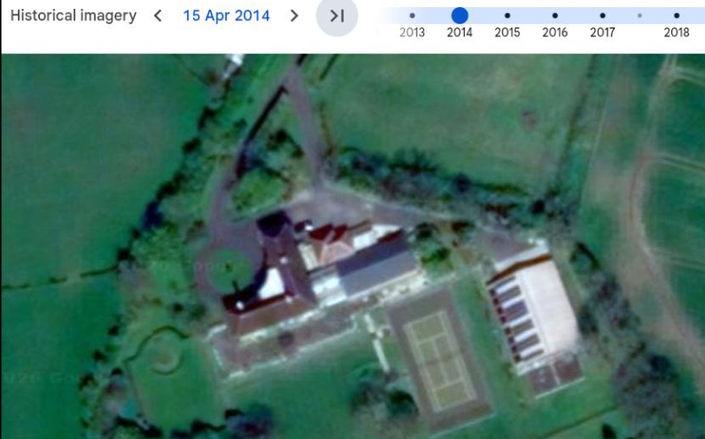

An invoice for the structural design works of the swimming pool enclosure and the conservatory has been submitted evidencing that the survey works for the structures was undertaken in 2009, alongside an invoice for the installation of the tennis court in June of 2010.

The site photographs supplied within the planning statement are useful evidence however given the photographs cannot be dated cannot be relied upon to support the Lawful Development Certificate application as evidence alone. However, officers have surveyed the development in situ and are of the opinion that the structures are well established and are believed to have been present on site for a number of years.

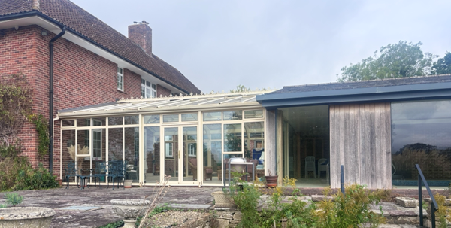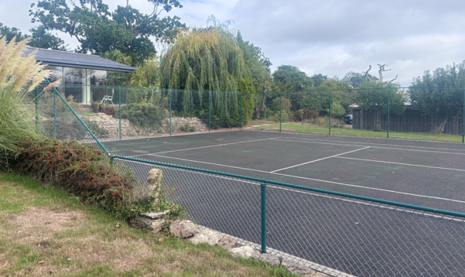
Site visit photos

The evidence submitted by the applicant demonstrates, on the balance of probabilities, that the development (including any associated building works) was substantially completed at least 4 years prior to the application date, and does not contravene any planning conditions or restrictions. The development is therefore lawful under the provisions of the Town and Country Planning Act 1990 (as amended). The application for a Certificate of Lawfulness for an Existing Development is recommended for approval.

Specifically, the evidence submitted confirms that the conservatory building has been functioning as ground floor accommodation and the tennis court has been functioning as a sports recreational area for a number of years. There are no apparent gaps in the evidence or contradictions that would cast doubt on the lawfulness of the development.

CONCLUSION
On the balance of probability, sufficient evidence has been provided to demonstrate that the erection of a conservatory link building and a tennis court as identified on the site plan, has been substantially completed at the point of submitting the application for a period in excess of 4 years.

As there is no clear or unambiguous evidence to the contrary submitted to or readily available to the Council, and as no formal enforcement action has been taken by the Council, it is recommended that a certificate of lawfulness be issued for the lawful erection of the conservatory and the tennis court.

RECOMMENDATION
It is recommended that a Certificate of Lawfulness for Existing Use or Development be granted for the following development:

The erection of a conservatory link building and a tennis court

Reason for approval: The evidence submitted satisfies the criteria set out in the Town and Country Planning Act 1990 (as amended), and the use meets the relevant time limits and planning law requirements.

