APPLICATION FOR HOUSEHOLDER PLANNING PERMISSION
DELEGATED REPORT

APPLICATION REFERENCE: | PL/2026/05121
APPLICATION TYPE: | Householder planning permission
SITE ADDRESS: | Dry Hill House, 32 Dry Hill, Crockerton, Warminster, BA12 8AT
DEVELOPMENT DESCRIPTION: | Proposed entrance porch
RECOMMENDATION: | That Planning Permission be GRANTED

PROPOSAL

The proposal seeks planning permission for Proposed entrance porch at Dry Hill House, 32 Dry Hill, Crockerton, Warminster, BA12 8AT.

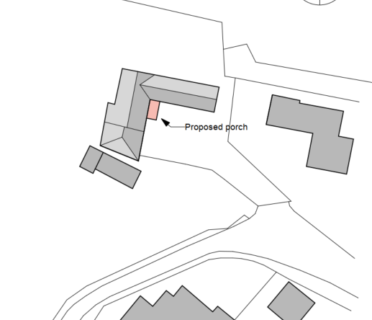

Proposed Block Plan

The porch would have a timber frame support and would have double roman roof tiles to match those on the existing dwelling.

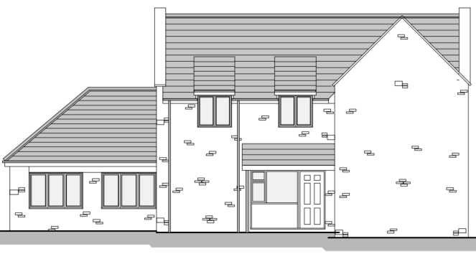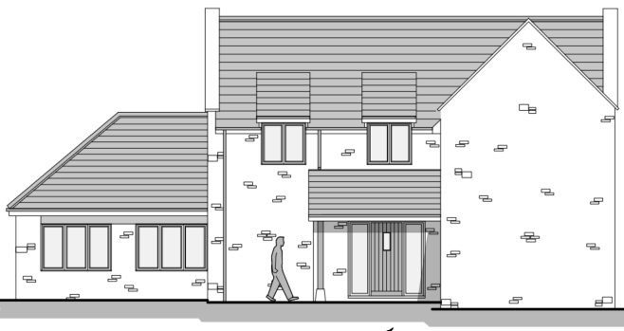

Existing Elevation and Proposed Elevation

SITE DESCRIPTION/CONTEXT

Dry Hill House is a substantial detached dwelling situated on Dry Hill. Although geographically closer to Sutton End than Crockerton, it is located on the road leading into Crockerton itself. The property occupies an elevated position above the highway, as illustrated in the photograph below. The dwelling is currently served by a modest porch canopy, which is proposed to be replaced with a slightly larger porch, as shown on the previous page.

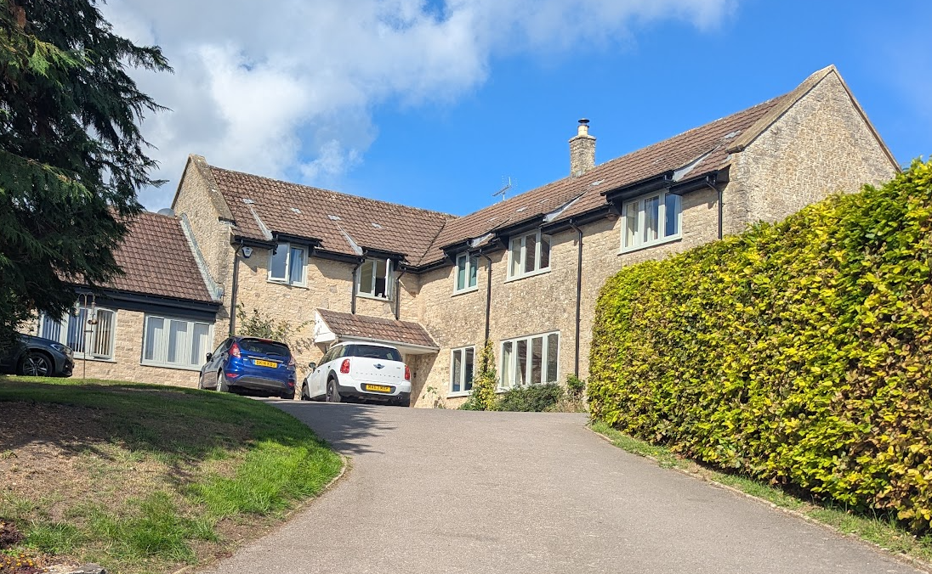

Site Visit Photo

Dry Hill House forms part of a small group of approximately nine dwellings along Dry Hill. The closest neighbouring property, South Riding, is situated approximately 12 metres from the application site's boundary and approximately 18 metres from the host dwelling.

The application site is subject to the following planning policy constraints:

- Within the 6.4km buffer zone of the Salisbury Plain Special Protection Area
- River Avon Catchment Area
- Public Rights of Way LDEV25 passes between the application site and ‘South Riding’

It is important to note that the site is not within the Cranborne Chase and West Wiltshire Downs National Landscape, is within flood zone 1 and has no ground water or surface water flood risk.

PLANNING HISTORY

Proposal / Summary
W/95/00371/FUL - Dry Hill House, 32 Dry Hill, Crockerton, Wiltshire, BA12 8AT - Full planning permission Decision - Approve with Conditions Date: 15/5/1995 – Convert flat garage roof into pitched roof with store room over
PL/2022/09832 - SOUTH RIDING, DRY HILL, CROCKERTON, WARMINSTER, BA12 8AT - Householder planning permission Decision - Approve with Conditions Date: 8/2/2023 – Demolition of existing single storey extension and bay window and construction of single storey replacement. Replacement of windows. Re-cladding of existing dormer windows. Demolition of existing patio and construction of new patio area at a lower level.
PL/2025/09181 - South Riding, Dry Hill, Crockerton, Warminster, BA12 8AT - Householder planning permission Decision - Approve with Conditions Date: 20/1/2026 – Replacement Utility Room and Shower Room Extension - Single Storey Extension to Rear

RELEVANT POLICIES AND GUIDANCE

Wiltshire Core Strategy:

- Core Policy 50: Biodiversity and Geodiversity
- Core Policy 57 Ensuring High Quality Design and Place Shaping
Longbridge Deverill does not have a Neighbourhood Plan or Area Designation

Wiltshire Design Guide: Appendix D – Design Guidance for Householder extensions

The National Planning Policy Framework (NPPF)

The Planning Practice Guidance

CONSULTATION RESPONSES

Longbridge Deverill Parish Council: No comments received

REPRESENTATIONS

9 neighbour notification letters were sent out allowing for 21 days consultation.

No comments were received.

ASSESSMENT

Section 38(6) of the Planning and Compulsory Purchase Act 2004 states:

"If regard is to be had to the development plan for the purposes of any determination to be made under the planning Acts, the determination must be made in accordance with the plan unless material considerations indicate otherwise."

In accordance with this statutory requirement, this application has been assessed against the relevant policies of the Development Plan, including the adopted Wiltshire Core Strategy (2015) and, where applicable, any made Neighbourhood Plans.

Design and Impact upon the character and context of the area

Core Policy 57 - Ensuring High Quality Design and Place Shaping of the Wiltshire Core Strategy seeks to ensure that all new development is of high design quality, reflecting local context, character, and distinctiveness.

Policies DP3 and DP4 of the National Planning Policy Framework require development to achieve a high standard of design that responds positively to local character and context. In assessing design quality, regard should be had to matters including scale, siting, form, appearance, materials and the relationship of development to its surroundings.

The application site lies outside a defined settlement boundary. Policy S5(1)(c) of the NPPF recognises the extension, alteration, reuse or replacement of existing lawful buildings outside settlements as a form of development that may be acceptable in principle, provided the building is lawful, permanent and substantial in construction and that any extension would not result in a disproportionate increase in size.

In this case, the proposal relates to the replacement of an existing porch canopy with a slightly larger porch attached to an existing lawful dwelling. Given the modest scale of the proposed works, the development would not result in a disproportionate increase in the size of the dwelling and is therefore capable of support under Policy S5(1)(c).

In design terms, the proposed porch would remain clearly subordinate to the host dwelling and would read as a minor addition to the principal elevation. The scale, form and appearance of the porch are considered appropriate to the size and character of the dwelling and would not appear incongruous or visually dominant within the street scene. Furthermore, due to the limited extent of the works, the proposal would not adversely affect the character or appearance of the surrounding area.

Having regard to the above, the proposal is considered to comply with Core Policy 57 of the Wiltshire Core Strategy, Appendix D of the Wiltshire Design Guide and Policy S5(1)(c) of the NPPF.

Amenity

Point vii of Core Policy 57 - Ensuring High Quality Design and Place Shaping of the Wiltshire Core Strategy seeks to ensure that developments do not adversely affect neighbouring properties.

Policy P3 of the National Planning Policy Framework requires development to be appropriate for its location, taking account of its likely effects on health, living conditions and the environment. In particular, Policy P3(2)(b) requires development to avoid giving rise to unacceptable impacts on the living conditions of neighbouring residents and occupiers. In assessing amenity impacts, regard should be had to matters including daylight and sunlight, outlook, privacy, overbearing impacts and other effects on residential amenity.

The proposed development has been assessed in terms of its potential impact on the residential amenity of neighbouring properties, with particular regard to loss of light, overshadowing, loss of privacy, and overbearing effects.

The proposed development would result in only a modest increase in the size of the existing porch. Given its limited scale and position on the dwelling, the proposal would not appear unduly prominent or overbearing when viewed from neighbouring properties. The nearest dwelling, South Riding, is located approximately 12 metres from the application site's boundary and around 18 metres from the host dwelling itself, ensuring a substantial degree of separation between the properties.

The proposal would not introduce any windows or other openings that would give rise to overlooking, nor would it result in any material loss of privacy. Having regard to the scale of the extension and the separation distances involved, it is considered that the development would not have an unacceptable impact on the living conditions of neighbouring occupiers through overlooking, loss of privacy, overbearing impact or loss of outlook.

The proposal therefore accords with Core Policy 57 point vii in respect of safeguarding residential amenity, Appendix D of the Wiltshire Design Guide and the NPPF.

Ecology Impact

Core Policy 50 of the Wiltshire Core Strategy seeks to protect and enhance biodiversity and geodiversity, including through ensuring that development avoids harm to protected species and habitats.

Policy N2 of the NPPF seeks to conserve and enhance biodiversity and support nature recovery. Development proposals should minimise impacts on habitats and species and, where relevant, demonstrate that appropriate mitigation measures are secured where harm cannot be avoided.

The Council’s Ecology Officer has not been consulted on this application. However, the application site lies within the 6.4km zone of influence of the Salisbury Plain SPA and, in light of the Habitats Regulations Assessment (HRA) prepared for the Wiltshire Core Strategy and Wiltshire Housing Site Allocations Plan, development within this zone is screened for potential recreational impacts upon stone curlew.

A strategic Appropriate Assessment (AA) has been prepared pertaining to development within the zone of influence that could result in a likely significant effect on the SPA through increased recreational pressure. The AA concluded that there would be no adverse effect on the integrity of the SPA or its qualifying features provided the Council’s mitigation strategy continues to be implemented. Annual stone curlew monitoring and associated protection measures continue to be secured by the Council.

In January 2026, Natural England confirmed its continued support for the Council’s strategic Appropriate Assessment for Salisbury Plain SPA.

The proposed development relates solely to the increase in the size of the existing porch canopy. The works would not result in habitat loss, the removal of trees or hedgerows, alterations to supporting habitat, or the introduction of any further external lighting. No specific impact pathway affecting protected species, priority habitats, ancient woodland or other ecological receptors has been identified.

Whilst the site lies within the identified zone of influence for Salisbury Plain SPA, the proposal would not create a new dwelling, increase the number of residential units, increase overnight accommodation, or otherwise generate additional recreational pressure upon the SPA. As such, no likely significant effect has been identified, either alone or in combination with other plans or projects.

Furthermore, as the proposal would not result in any increase in overnight accommodation, there would be no increase in foul wastewater generation. The development would therefore not contribute to nutrient loading within the River Avon catchment and phosphate mitigation is not required in this instance.

Accordingly, the proposal is considered to comply with Core Policy 50 of the Wiltshire Core Strategy and Policy N2 of the National Planning Policy Framework.
Biodiversity Net Gain

Householder planning applications are exempt from the requirement to deliver Biodiversity Net Gain under Schedule 7A, Section 4(2)(a) of the Town and Country Planning Act 1990, as inserted by the Environment Act 2021.

Public Sector Equality Duty (PSED)

In reaching this decision, due regard has been had to the Public Sector Equality Duty under Section 149 of the Equality Act 2010. This requires the Local Planning Authority to have regard to the need to eliminate discrimination, advance equality of opportunity and foster good relations between persons who share a protected characteristic and those who do not.

The Local Planning Authority is satisfied that the proposal would not result in any unlawful discrimination and that any impacts on protected groups have been appropriately considered as part of this assessment.

CONCLUSION

The proposed development is considered to be acceptable in terms of its design, character and appearance, and would not result in any unacceptable harm to the amenities of neighbouring occupiers.

Furthermore, the proposal would not result in any unacceptable impacts in respect of any other material planning considerations.

The proposal is therefore considered to comply with the relevant policies of the Wiltshire Core Strategy, the National Planning Policy Framework and all other relevant material considerations. As such, the application is recommended for approval, subject to conditions.

RECOMMENDATION: That Planning Permission be GRANTED subject to conditions.

