APPLICATION FOR HOUSEHOLDER PLANNING PERMISSION
DELEGATED REPORT

APPLICATION REFERENCE: | PL/2026/03329
APPLICATION TYPE: | Householder planning permission
SITE ADDRESS: | 14 Tinhead Road, Edington, Westbury, BA13 4PJ
DEVELOPMENT DESCRIPTION: | Erection of glass roof conservatory to side of property
RECOMMENDATION: | That Planning Permission be REFUSED

PROPOSAL

The application seeks planning permission for the erection of a single-storey conservatory attached to the side elevation of the dwelling following the removal of the existing pergola structure.

The proposed conservatory would measure approximately 4.8 metres in width by 2.9 metres in depth and would incorporate a shallow mono-pitched roof form. The submitted plans indicate that the roof would descend from approximately 2.6 metres adjacent to the host dwelling to approximately 2.4 metres at the outer elevation.

The submitted application indicates that the proposal would utilise red brickwork, anthracite grey uPVC windows and doors and a low-profile roof covering.

During the course of the application revised plans were submitted and it is the revised proposal that forms the basis of the current assessment.

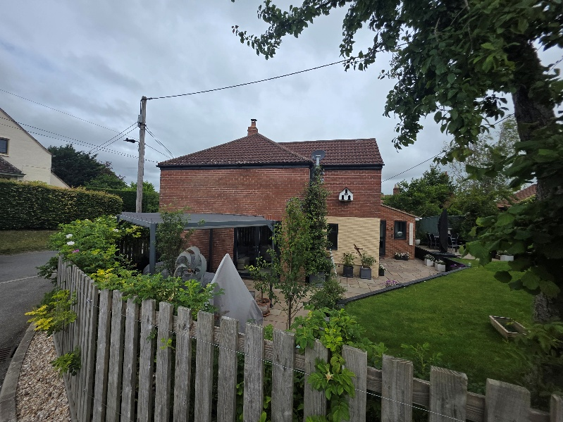

Site Photo 1. Existing pergola structure attached to the side elevation of the dwelling.

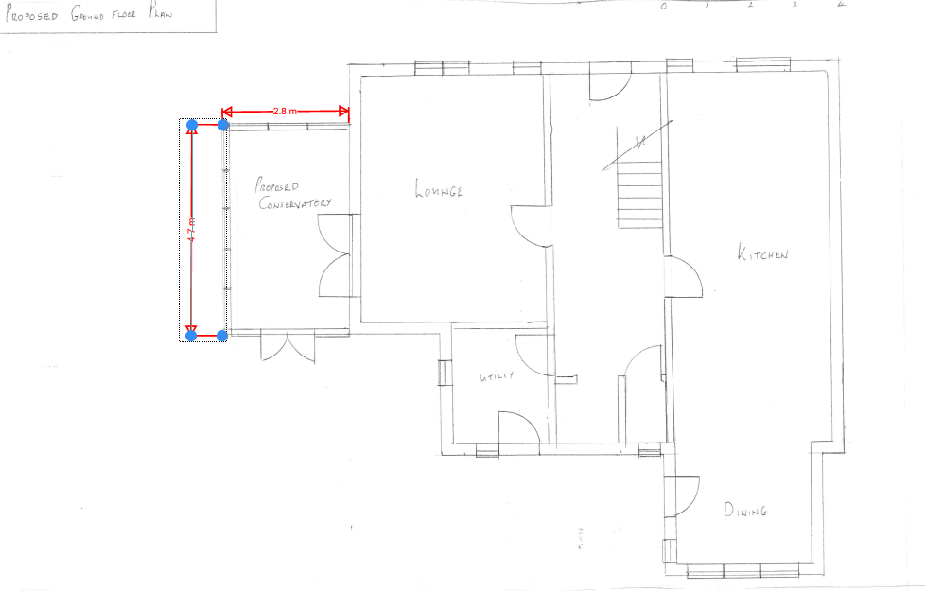

Figure 1. Proposed ground floor plan showing the location and footprint of the conservatory in relation to the host dwelling.

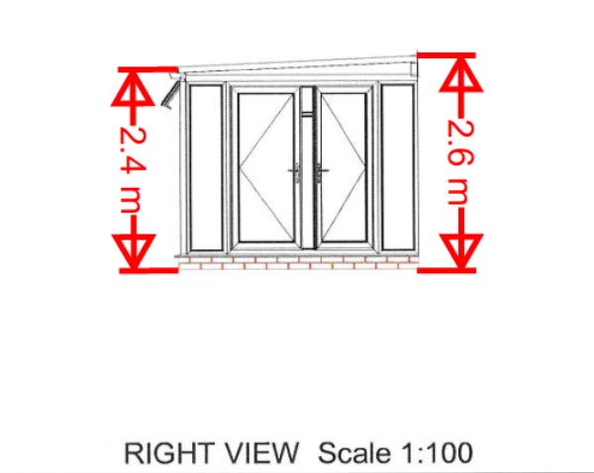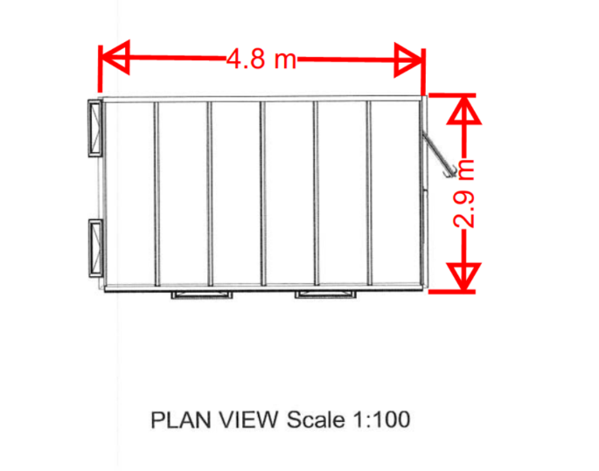

Figure 2. Proposed conservatory plan and elevation illustrating the overall footprint, dimensions and low-profile roof form of the revised scheme.

SITE DESCRIPTION/CONTEXT

The application site comprises a two-storey end-of-terrace dwelling situated on Tinhead Road, Edington. The property forms part of a small terrace of traditional brick cottages located within the Edington Conservation Area and occupies a prominent corner position at the junction of Tinhead Road and an adjoining lane.

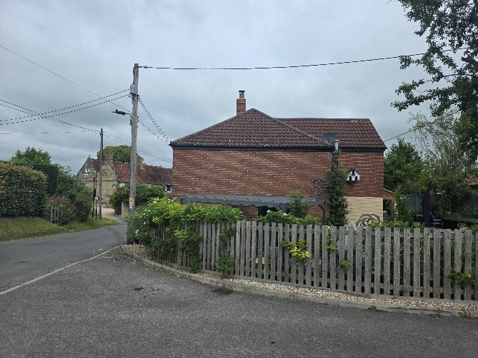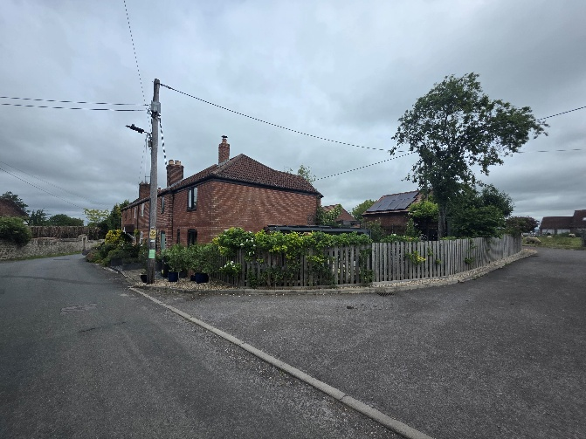

Figure 3. Views of the application property from Tinhead Road and the adjoining lane demonstrating the prominent corner position and public visibility of the dwelling within the street scene.

Historic mapping indicates that the terrace formed part of the wider Ballard's Farm holding and is likely to have originated as agricultural workers' cottages. The terrace derives significance from its simple vernacular form, modest scale and historic relationship with the surrounding farmstead and village environment. As a group, the cottages make a positive contribution to the character and appearance of the Edington Conservation Area and form an important component of the historic village street scene.

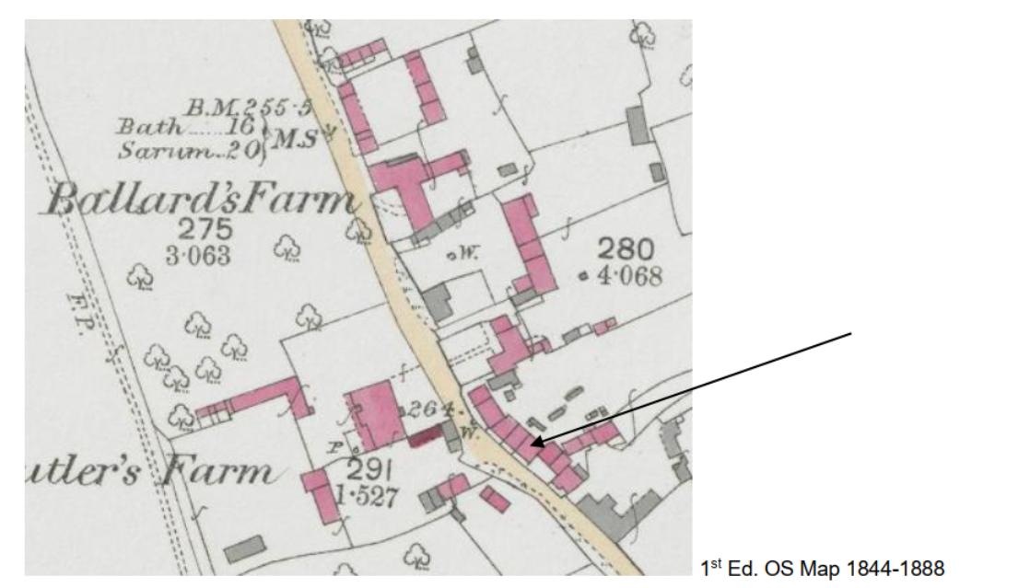

Figure 4. Historic mapping illustrating the relationship between the terrace and Ballard's Farm.

The application site forms part of the historic core of the village and lies within the Edington Conservation Area. The site also lies within the wider historic environment surrounding the Grade II listed Becketts House (List Entry No. 1364264) and the Grade II listed Wall and Gate to Front of Becketts House (List Entry No. 1181408).

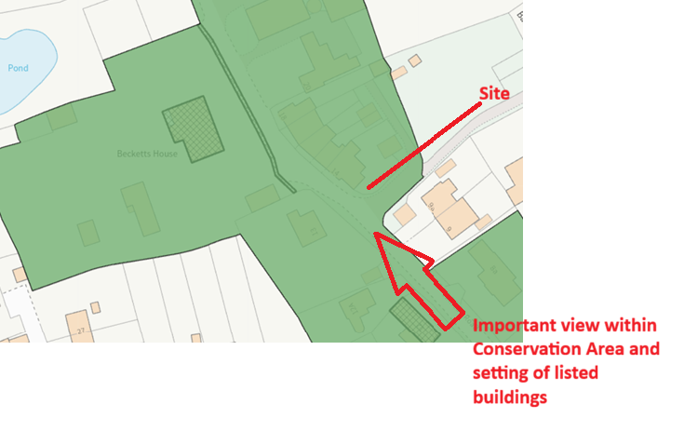

Figure 5. Application site within the Edington Conservation Area (green) and the location of nearby listed buildings (hatched).

The application property has been altered and extended over time, most notably through the construction of a two-storey side extension approved under planning application reference W/86/00882/FUL. More recent domestic alterations and extensions have also taken place. An open pergola structure is currently attached to the side elevation of the dwelling.
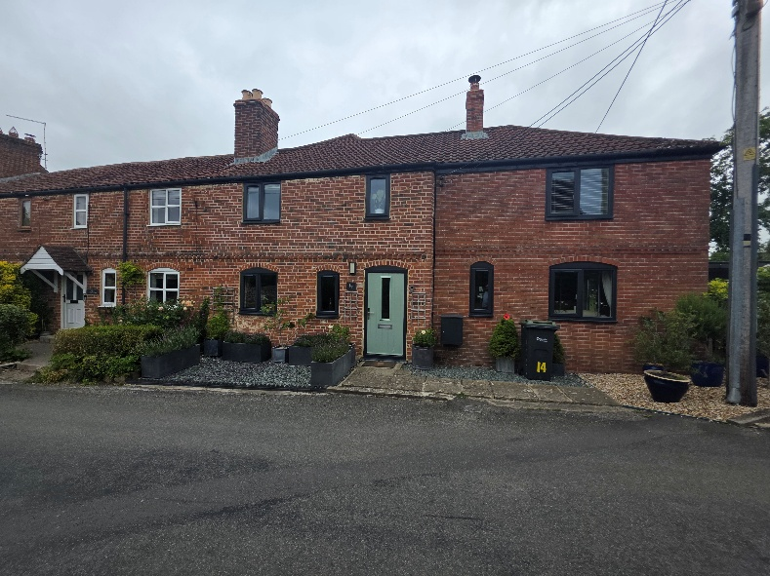

Figure 6. Front elevation of the application property forming part of the terrace of traditional cottages.

The surrounding area is predominantly residential in character and contains a number of traditional dwellings and heritage assets reflective of the historic village setting.

PLANNING HISTORY

Proposal / Summary
W/86/00882/FUL - Two-storey side extension - Approved.

RELEVANT POLICIES AND GUIDANCE
The 2015 adopted Wiltshire Core Strategy:

- Core Policy 57: Ensuring High Quality Design and Place Shaping
- Core Policy 58: Ensuring the Conservation of the Historic Environment

Wiltshire Design Guide: Appendix D – Design Guidance for Householder extensions

The National Planning Policy Framework (NPPF)

- Section 14 – Achieving well designed places
- Section 20 – Conserving and enhancing the historic environment

Planning Practice Guidance (PPG)

National Design Guide

New Wiltshire Local Plan
At Full Council on 19 May 2026, the elected members of Wiltshire Council agreed to withdraw the emerging Wiltshire Local Plan. The said Plan has no material weight for the purposes of the application.

In accordance with Regulation 19 of the Town and Country Planning (Local Planning) (England) Regulations 2026, on 30th June 2026 Wiltshire Council published a notice of intention to prepare a new local plan for Wiltshire. The next stage is a Scoping Consultation which commences on 2nd September 2026. This plan is at a very early stage and currently carries no weight for decision making

CONSULTATION RESPONSES
The application was publicised in accordance with the Council's statutory requirements. Consultation responses were received from the Conservation Officer, Edington Parish Council and adjoining occupiers.

Edington Parish Council: No objection
Conservation Officer: Objection
The Conservation Officer has objected to the proposal throughout the application process, including following the submission of amended plans and subsequent site visits.
The Conservation Officer considers that the proposal would fail to preserve or enhance the character and appearance of the Edington Conservation Area and would result in less than substantial harm to its significance.

The Conservation Officer notes that the application property forms part of a terrace of traditional cottages which contribute positively to the character and appearance of the Conservation Area and considers that the proposed conservatory-style extension, by reason of its form, appearance and prominent siting, would fail to preserve that character and appearance. Full comments are considered within the assessment section below.

The Conservation Officer advises that the proposal would result in less than substantial harm to the significance of the Conservation Area and concludes that insufficient public benefits have been identified to outweigh that harm.

REPRESENTATIONS
The application was advertised in accordance with the Council's statutory requirements.

Two representations were received in support of the application.

No objection to the proposal. The representation states that the proposal is considered likely to enhance the dwelling and improve the outlook from the adjoining lane.

ASSESSMENT

Section 38(6) of the Planning and Compulsory Purchase Act 2004 states:

"If regard is to be had to the development plan for the purposes of any determination to be made under the planning Acts, the determination must be made in accordance with the plan unless material considerations indicate otherwise."

In accordance with this statutory requirement, this application has been assessed against the relevant policies of the Development Plan, including the adopted Wiltshire Core Strategy (2015).

Design and Impact upon the Character and Context of the Area
Core Policy 57 - Ensuring High Quality Design and Place Shaping of the Wiltshire Core Strategy seeks to ensure that all new development is of high design quality, reflecting local context, character and distinctiveness.
Policies DP3 and DP4 of the National Planning Policy Framework require development to achieve a high standard of design that responds positively to local character and context. In assessing design quality, regard should be had to matters including scale, siting, form, appearance, materials and the relationship of development to its surroundings.

The proposal seeks the erection of a conservatory attached to the side elevation of the dwelling in place of the existing pergola structure. During the course of the application amended plans were submitted which reduced the overall height and visual prominence of the originally submitted scheme.

Whilst the proposal would remain subordinate in scale to the host dwelling, it would introduce an enclosed structure characterised by extensive glazing and a contemporary design approach with incongruous materials inconsistent with the prevailing character of the street scene. Officers have concerns regarding the extent to which the proposal does not respond positively to the character and distinctiveness of the host dwelling and its surroundings, but rather would detract from the visual relationship between the surrounding properties.

Given the site's location within the Edington Conservation Area, these concerns are intrinsically linked to the significance of the heritage asset and are therefore considered in greater detail within the Heritage Impact section below.

Heritage Impact
Section 72(1) of the Planning (Listed Buildings and Conservation Areas) Act 1990 requires special attention to be paid to the desirability of preserving or enhancing the character or appearance of Conservation Areas.

Core Policy 58 of the Wiltshire Core Strategy seeks to conserve and, where appropriate, enhance the significance of designated and non-designated heritage assets and their settings. Core Policy 57 further requires development to respond positively to local character and historic context through high quality design.

Policies HE5, HE6 and HE9 of the National Planning Policy Framework recognise heritage assets as an irreplaceable resource and require proposals affecting heritage assets to be assessed having regard to their significance, the contribution made by their setting and the degree of harm arising from development proposals.

The application site lies within the Edington Conservation Area and forms part of a terrace of traditional cottages which contribute positively to its character and appearance. Historic mapping indicates that the terrace formed part of the wider Ballard's Farm holding and is likely to have originated as agricultural workers' cottages associated with that holding.
The significance of the terrace derives from its simple vernacular form, modest scale and historic relationship with the surrounding farmstead and village environment.
These characteristics contribute positively to the significance and local distinctiveness of this part of the Conservation Area and form an important component of the historic village street scene.

The application site also lies within the wider historic environment surrounding the Grade II listed Becketts House (List Entry No. 1364264) and the Grade II listed Wall and Gate to Front of Becketts House (List Entry No. 1181408). Whilst these heritage assets form part of the wider historic environment surrounding the site, officers agree with the Conservation Officer's assessment that the principal heritage issue in this instance relates to the effect of the proposal upon the character and appearance of the Edington Conservation Area.

As illustrated by Figures 3 and 5 above, the application property occupies a prominent corner position at the junction of Tinhead Road and the adjoining lane. The side elevation is readily visible from public viewpoints and forms a noticeable component of the surrounding street scene. Consequently, alterations to this elevation have a greater capacity to influence the character and appearance of the Conservation Area than development located on less visible or more secluded elevations.

The proposal seeks to replace the existing pergola structure with an enclosed conservatory attached to the side elevation of the dwelling. Officers acknowledge that amended plans were submitted during the course of the application which reduced the overall height and visual prominence of the originally submitted scheme. Officers further acknowledge that genuine efforts were made by the applicant and agent to address concerns raised during the application process.

The application was subject to multiple site visits, including a site visit by the case officer, a subsequent site visit involving a senior officer together with the applicant and agent, and a further site visit undertaken by the Conservation Officer in assessing the revised proposal.

The dwelling has been altered and extended over time, including the construction of a two-storey side extension approved under application reference W/86/00882/FUL. Whilst these previous alterations are acknowledged, officers consider that the proposal would result in a further extension to the side elevation and contribute to the cumulative alteration of a terrace whose significance derives in part from its simple form and modest scale.

Officers acknowledge that the revised proposal is materially reduced in height and overall visual prominence when compared to the originally submitted scheme. Notwithstanding these amendments, it is considered that the proposal would still introduce an enclosed conservatory-style addition upon a prominent and visually sensitive elevation, the form and appearance of which would remain readily apparent within public views of the site.

Whilst modest in scale, the proposal would replace the existing lightweight and visually recessive pergola with a more substantial enclosed structure extending across the side elevation. By reason of its form, appearance, use of incongruous materials and extensive glazing, the proposal would introduce an enclosed conservatory-style addition across a highly visible elevation, diminishing the simple and modest character that contributes positively to the significance of the host dwelling and the wider terrace of traditional cottages within the Conservation Area.

It is acknowledged that the house has uPVC windows, the conservatory however would be a complete structure made of this modern material that would not respect the prevailing character of the Conservation Area. The high prominence of the uPVC structure is such that the material is considered to be incongruous and unsympathetic within this historically sensitive context.

Particular regard has been had to the location of the site within the Conservation Area and the degree to which the extension would be visible from public viewpoints along Tinhead Road and the adjoining lane. Officers acknowledge that the garden is set at a lower level than the adjoining highway and that existing planting provides a degree of screening. However, the proposal would nevertheless remain readily perceptible from the public realm and would form a noticeable addition within public views of the Conservation Area.

Furthermore, whilst hedge planting may provide some screening, there is no certainty that such planting would be retained at its existing height in perpetuity and therefore it should not be relied upon to mitigate identified heritage harm.

Officers have also considered comments regarding conservatories and other modern alterations elsewhere within the Conservation Area. Whilst each proposal must be assessed on its own merits having regard to its particular context and relationship to heritage significance, the examples referred to are not considered directly comparable to the current proposal. In particular, those examples are experienced only in limited public views and do not occupy the same prominent position within the street scene. By contrast, the application site occupies a prominent corner position and the proposed extension would be readily visible within the public realm, where it would be experienced in association with a traditional terrace that contributes positively to the character and appearance of the Conservation Area.

Significant weight is afforded to the specialist advice of the Council's Conservation Officer, who has maintained an objection throughout the application process, including following consideration of amended plans and subsequent site visits. Officers concur
with the Conservation Officer's assessment that the proposal would fail to preserve or enhance the character and appearance of the Edington Conservation Area.

Having regard to the significance of the Conservation Area, the contribution made by the terrace of traditional cottages and the prominence of the site within the public realm, officers conclude that the proposed conservatory-style extension, by reason of its form, appearance, use of incongruous materials and prominent siting, would fail to preserve the character and appearance of the Edington Conservation Area. The proposal would therefore result in less than substantial harm to the significance of this designated heritage asset.

In accordance with the National Planning Policy Framework, the identified less than substantial harm must be weighed against the public benefits of the proposal. Officers acknowledge that the proposal would provide additional living accommodation for the occupiers of the dwelling. These are private benefits of no consequence to the wider public and therefore attract no weight in regards to the proposal. However, having regard to the nature and scale of the development, officers do not consider that the benefits identified are sufficient to outweigh the less than substantial harm arising to the significance of the Edington Conservation Area.

Accordingly, the proposal conflicts with Core Policies 57 and 58 of the Wiltshire Core Strategy, Policies HE5, HE6 and HE9 of the National Planning Policy Framework and the statutory duty contained within Section 72(1) of the Planning (Listed Buildings and Conservation Areas) Act 1990.

Amenity
Point vii of Core Policy 57 - Ensuring High Quality Design and Place Shaping of the Wiltshire Core Strategy seeks to ensure that developments do not adversely affect neighbouring properties.

Policy P3 of the National Planning Policy Framework requires development to be appropriate for its location, taking account of its likely effects on health, living conditions and the environment. In particular, Policy P3(2)(b) requires development to avoid giving rise to unacceptable impacts on the living conditions of neighbouring residents and occupiers. In assessing amenity impacts, regard should be had to matters including daylight and sunlight, outlook, privacy, overbearing impacts and other effects on residential amenity.

The proposed development has been assessed in terms of its potential impact on the residential amenity of neighbouring properties, with particular regard to loss of light, overshadowing, loss of privacy and overbearing effects.

Loss of Light / Overshadowing
The proposed conservatory is single-storey in scale and would be positioned alongside the existing side elevation of the dwelling. Having regard to its scale, siting and relationship with neighbouring properties, officers do not consider that the proposal would result in any material loss of light or unacceptable overshadowing to adjoining occupiers.

Loss of Privacy
The proposed development would not introduce any additional opportunities for overlooking beyond those typically associated with a domestic conservatory. Given its scale, design and relationship with neighbouring properties, the proposal is not considered likely to result in any material loss of privacy.

Overbearing Impact
By reason of its modest scale, single-storey form and relationship with adjoining properties, the proposal would not appear unduly dominant or overbearing and would not result in any unacceptable impact upon the living conditions of neighbouring occupiers.

Furthermore, two neighbouring occupiers have submitted representations confirming that they raise no objection to the proposal. Whilst these comments are noted and support the conclusion that the proposal would not result in unacceptable impacts upon residential amenity, officers have undertaken an independent assessment of the proposal against the relevant planning policies.

The proposal is therefore considered to accord with Core Policy 57 (vii) of the Wiltshire Core Strategy, Appendix D of the Wiltshire Design Guide and Policy P3(2)(b) of the National Planning Policy Framework.

Other issues
N/A

CONCLUSION
The application seeks planning permission for the erection of a single-storey conservatory attached to the side elevation of a dwelling located within the Edington Conservation Area.

Whilst amendments submitted during the course of the application are acknowledged and are considered to have reduced the visual prominence of the development when compared to the originally submitted scheme, officers remain of the view that the proposal would fail to preserve or enhance the character and appearance of the Edington Conservation Area and would result in less than substantial harm to its significance.
Particular regard has been given to the significance of the Edington Conservation Area, the contribution made by the terrace of traditional cottages, its historic relationship with the former Ballard's Farm holding and the prominent position of the application property within the public realm. Having carefully assessed the proposal, officers conclude that the conservatory-style extension, by reason of its form, appearance, incongruous and unsympathetic materials and prominent siting, would fail to preserve the character and appearance of the Conservation Area, appearing as an incongruous addition within prominent public views of the terrace, and would result in less than substantial harm to the significance of the heritage assets. The identified heritage harm is not considered to be outweighed by any public benefits arising from the proposal.

Accordingly, the proposal conflicts with Core Policies 57 and 58 of the Wiltshire Core Strategy, the National Planning Policy Framework and the statutory duty contained within Section 72(1) of the Planning (Listed Buildings and Conservation Areas) Act 1990.

The application is therefore recommended for refusal.

RECOMMENDATION: That Planning Permission be REFUSED.

Heritage Reason for Refusal:
The proposed conservatory, by reason of its modern conservatory-style form, extensive glazing, enclosed appearance, use of incongruous and unsympathetic materials and prominent siting on a highly visible side elevation, would fail to respond positively to the simple vernacular character of the host dwelling and the wider terrace of traditional cottages (non-designated heritage assets) which make a positive contribution to the significance of the Edington Conservation Area, appearing as an incongruous addition within prominent public views of the terrace.

The proposal would fail to preserve or enhance the character and appearance of the Edington Conservation Area and would result in less than substantial harm to its significance. No public benefits have been demonstrated that would outweigh the identified harm.

The proposal is therefore contrary to Core Policies 57 and 58 of the Wiltshire Core Strategy (2015), Section 72(1) of the Planning (Listed Buildings and Conservation Areas) Act 1990 and Policies HE5, HE6 and HE9 of the National Planning Policy Framework, which collectively seek to conserve heritage assets in a manner appropriate to their significance.

