APPLICATION FOR HOUSEHOLDER PLANNING PERMISSION
DELEGATED REPORT

APPLICATION REFERENCE: | PL/2026/04197
APPLICATION TYPE: | Householder planning permission
SITE ADDRESS: | Dairy House Farm, Lambourn Lane, Edington, Westbury, BA13 4NP
DEVELOPMENT DESCRIPTION: | Two storey extension to detached dwelling
RECOMMENDATION: | That Planning Permission be GRANTED

PROPOSAL

The proposal seeks planning permission for Two storey extension to detached dwelling at Dairy House Farm, Lambourn Lane, Edington, Westbury, BA13 4NP.

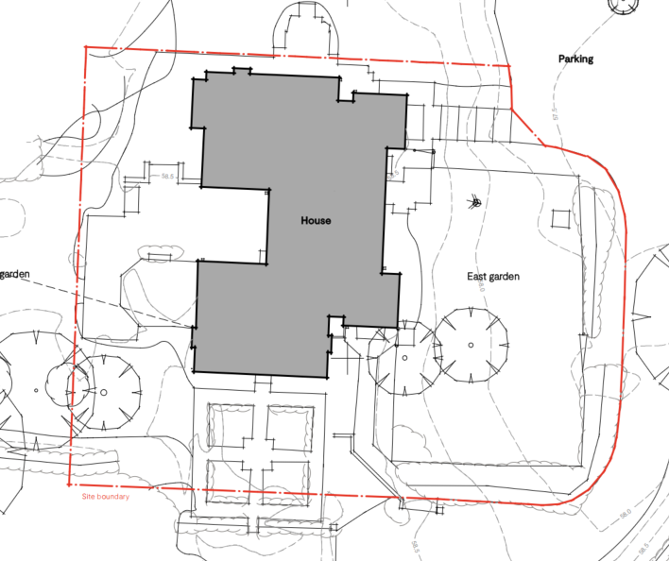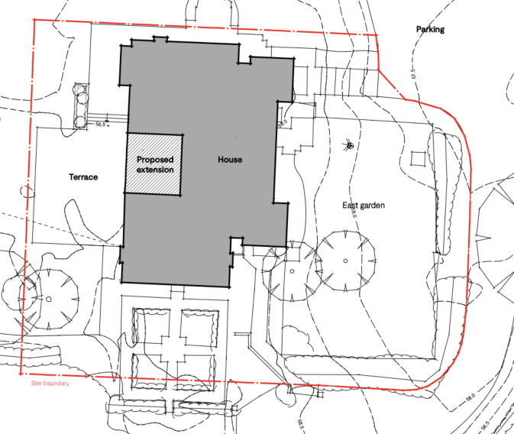

Existing and Proposed Site Plan

This application has been submitted following the lapse of planning permission granted under application PL/2021/09634 for a similar proposal. That permission was not implemented within the prescribed timescale.

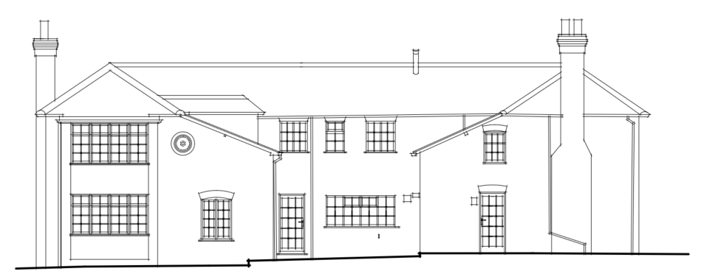

Existing Western Elevation

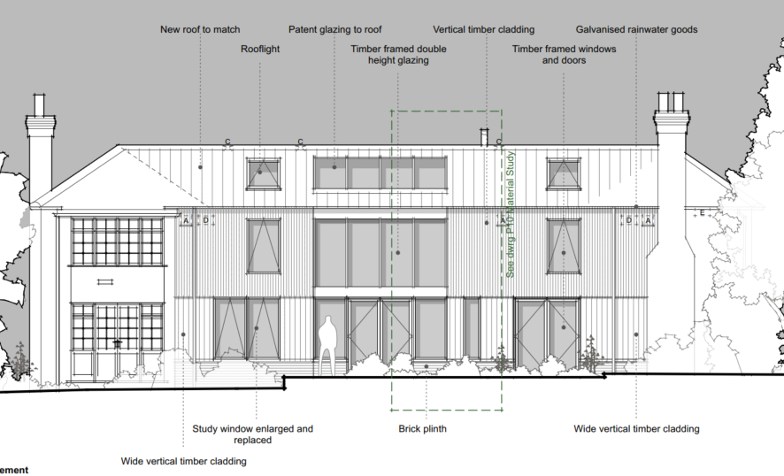

Approved Western Elevation under application PL/2021/09634

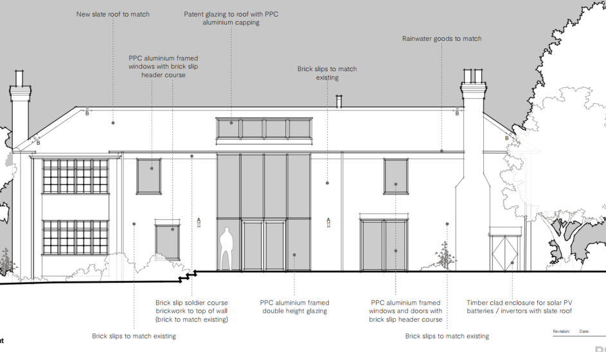

Proposed Western Elevation

The proposal continues to involve the infilling of the central courtyard, effectively squaring off the footprint of the host dwelling. This would create a substantial flat-roofed section concealed behind the surrounding roof slopes, within which solar panels are proposed to be installed.

As illustrated above, the design has been amended from that approved under application PL/2021/09634. The current proposal omits the two large rooflights previously approved and incorporates a modest reduction in the extent of glazing on the western elevation. In addition, the vertical timber cladding approved previously has been replaced with brick slips to match the existing brickwork of the host dwelling. The new roof covering would comprise matching slate.

The proposal also includes the installation of a new first-floor window within the eastern elevation, which did not form part of the previously approved scheme.

The proposal also includes a further minor extension with a small timber clad enclosure to house solar pv batteries and would be located adjacent to the chimney stack. The proposal also includes the raising of ground level immediately behind the extension for a patio terrace by circa 300mm. The existing stepped ground levels can be seen on the existing western elevation image above.

The application has been submitted with an Ecological Impact Assessment (Darwin Ecology – July 2026), which was supplemented with an updated mitigation, compensation and Enhancement Plan (also dated July 2026).

SITE DESCRIPTION/CONTEXT

Dairy House is a large detached two storey dwelling located in the open countryside. The closest neighbouring property ‘Newgrounds Farm’ is located approximately 500m to the west.

The application site is subject to the following planning policy constraints:

- Sailsbury Plain Special Protection Area 6.4km buffer zone

Despite its proximity to the Milebourne Stream, the red outline of the application site lies wholly within Flood Zone 1 and is not identified as being at risk from groundwater flooding. Surface water flood mapping indicates that limited parts of the site fall within the extent of the 0.1% Annual Exceedance Probability (1 in 1,000 year) surface water flood event, although the existing dwelling and proposed development area are located outside the mapped flood extent.

Public Right of Way EDIN16 passes diagonally across a field to the south west and would be approximately 100m from the western elevation at its closest point.

The site is well screened with a combination of trees and hedgerows both within the site and on its boundaries with the open countryside.

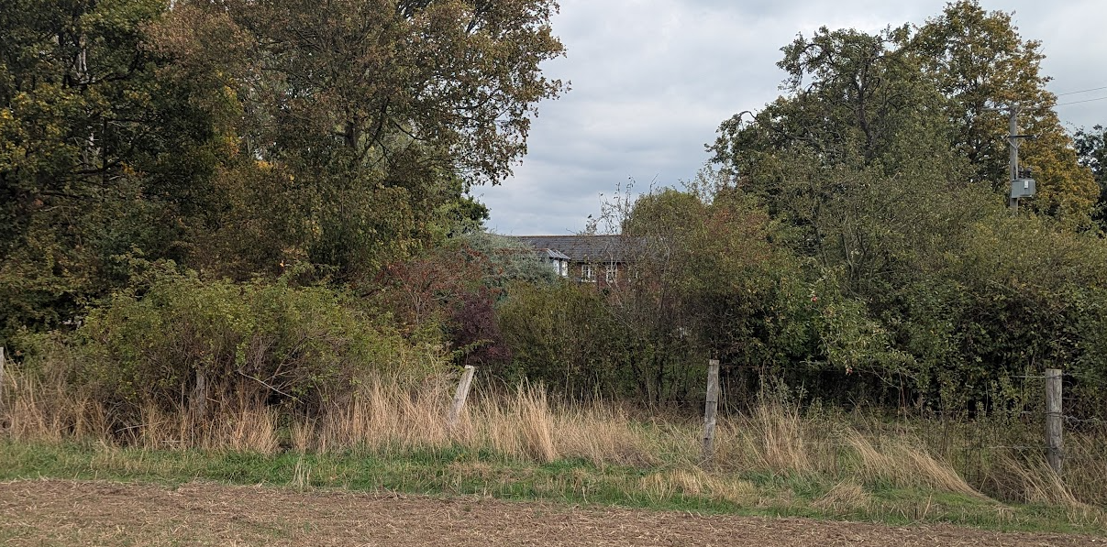

View from western boundary of the application site approximately 60m from the proposed extension

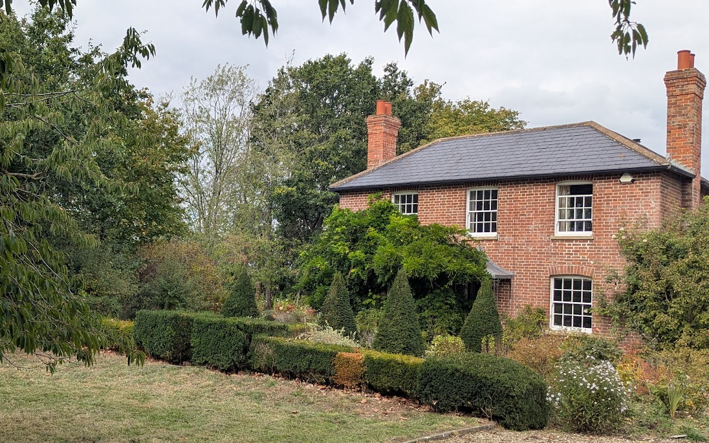

View of Front Elevation and hedgerow/tree boundary to the west (left)

PLANNING HISTORY

Proposal / Summary
PL/2021/09634 - Householder planning permission Decision - Approve with Conditions Date: 21/9/2022 – Two storey extension to detached dwelling
W/03/02215/PUD - Lawful development: Proposed use Decision - Refused Date: 6/9/2004 – Conversion of existing outbuildings to form additional living accommodation ancillary to the existing house
W/93/00560/FUL - Full planning permission Decision - Approve with Conditions Date: 14/6/1993 – Extensions to dwelling
W/01/01609/FUL - Full planning permission Decision - Refused Date: 2/5/2002 – Conversion of redundant farm buildings to living accommodation, demolition of redundant structures and construction of swimming pool in their place
W/09/01519/FUL - Full planning permission Decision - Approve with Conditions Date: 15/7/2009 – Conversion of barn complex to domestic annexe
W/85/00599/FUL - Full planning permission Decision - Approve with Conditions Date: 9/7/1985 – Conversion of stable building to elderly persons accommodation

RELEVANT POLICIES AND GUIDANCE

Wiltshire Core Strategy:

- Core Policy 50: Biodiversity and Geodiversity
- Core Policy 57 Ensuring High Quality Design and Place Shaping

Wiltshire Council Strategic Flood Risk Assessment 2024

Wiltshire Design Guide: Appendix D – Design Guidance for Householder extensions

The National Planning Policy Framework (NPPF)

The Planning Practice Guidance

CONSULTATION RESPONSES

Steeple Ashton Parish Council: No objection

Wiltshire Council Ecology Officer: No objection subject to conditions

REPRESENTATIONS

Due to there being no immediate neighbours a site notice was erected at the front of the site allowing for 21 days of public consultation.

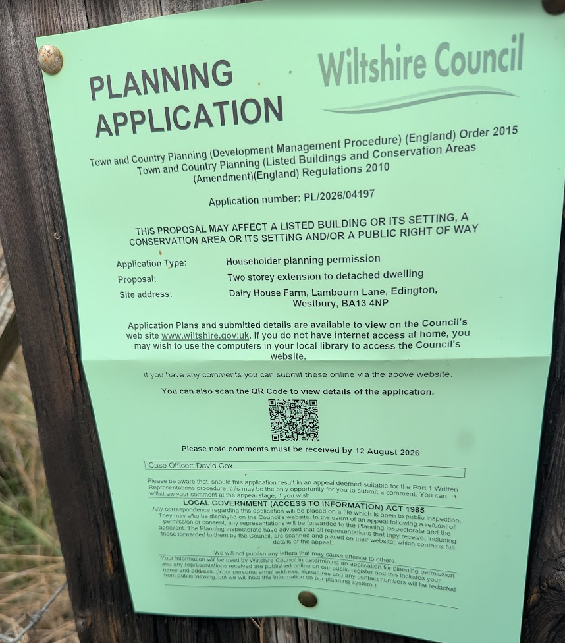

No comments were received.

ASSESSMENT

Section 38(6) of the Planning and Compulsory Purchase Act 2004 states:

"If regard is to be had to the development plan for the purposes of any determination to be made under the planning Acts, the determination must be made in accordance with the plan unless material considerations indicate otherwise."

In accordance with this statutory requirement, this application has been assessed against the relevant policies of the Development Plan, including the adopted Wiltshire Core Strategy (2015) and, where applicable, any made Neighbourhood Plans.

Design and Impact upon the character and context of the area

Core Policy 57 (Ensuring High Quality Design and Place Shaping) of the Wiltshire Core Strategy seeks to ensure that all new development is of a high standard of design that responds positively to local character, distinctiveness and sense of place.

Policies DP3 and DP4 of the National Planning Policy Framework require development to achieve a high standard of design that responds positively to local character and context. In assessing design quality, regard should be had to matters including scale, siting, form, appearance, materials and the relationship of development to its surroundings.

The application site lies outside a defined settlement. Policy S5(1)(c) of the NPPF recognises the extension and alteration of existing lawful buildings outside settlements as a form of development that may be acceptable in principle, provided that the proposal would not result in a disproportionate increase in size and complies with the detailed requirements of the policy.

The application relates to the alteration and extension of an existing lawful dwelling. The principle of the proposed development is therefore capable of being supported under Policy S5(1)(c), subject to ensuring compliance with the specific requirements of that policy and the detailed assessment below.

The dwelling is a large, detached property occupying a substantial plot in a highly isolated rural location at the end of a country lane with no through route. The site benefits from extensive boundary vegetation and is well screened from the surrounding countryside. Whilst a public right of way is located to the west, views towards the dwelling are limited owing to the significant separation distance of approximately 100 metres and the presence of mature hedgerows and tree planting along the site boundaries.

The proposal would infill the existing courtyard area, creating a more regular building footprint and introducing a substantial new roof form. Whilst the development would not be subordinate to the host dwelling, it has been designed to respect the scale, proportions and roof geometry of the existing building. The new roof would reflect the design and pitch of the existing roof slopes on the remaining elevations, ensuring that the addition integrates appropriately with the established form of the dwelling. Given the highly contained nature of the site, the substantial screening provided by existing boundary vegetation and the limited opportunities for public views, the proposal would not appear unduly prominent within the wider landscape and would have a negligible effect upon the rural character of the surrounding area.

The current scheme represents a visual improvement over the previously approved proposal. The removal of the two large rooflights and the reduction in the extent of glazing results in a less visually intrusive form of development. Furthermore, the replacement of the previously proposed timber cladding with brick slips to match the existing brickwork provides a more cohesive appearance and strengthens the visual relationship between the extension and the host dwelling. The proposed slate roofing would continue to match the existing roof covering.

It is acknowledged that the proposed western elevation glazing adopts a more contemporary appearance than that found within the traditional cottage-style dwelling. However, there is no requirement for extensions to replicate historic detailing precisely, and it is common for modern additions to remain legible as later interventions. In this instance, the contemporary elements would clearly read as part of the extension whilst the character of the original dwelling would remain readily appreciable. The proposal would not detract from the appearance of the host building, particularly given that three elevations would remain unaltered.

The introduction of a new first-floor window within the eastern elevation is also considered acceptable. The elevation already contains six first-floor windows and the additional opening would appear proportionate and well-integrated within the existing fenestration pattern. As such, it would not result in visual harm to the character or appearance of the dwelling.

The proposal also includes a small timber enclosure and the raising of ground levels to create a rear patio terrace. The timber enclosure would be modest in scale and, owing to the secluded nature of the site and existing boundary screening, would not be readily visible from public viewpoints. Its appearance would be comparable to that of a typical domestic storage building and would not appear incongruous within the residential curtilage. The proposed regrading of land to form the patio terrace would similarly have a limited visual impact and would assist in regularising the external amenity space, which is currently fragmented into three stepped sections, as illustrated on the existing west elevation and ground floor plans. Neither element is considered to result in harm to the character or appearance of the host dwelling, its setting, or the wider rural landscape.

Overall, having regard to the scale, form, design, materials and limited visibility of the development, the proposal would not result in harm to the character or appearance of the host dwelling, the surrounding landscape or the wider rural area. The extension is considered proportionate to the existing building and complies with the requirements of Policy S5(1)(c) of the NPPF.

Having regard to the above, the proposal complies with the design principles set out in Core Policy 57 of the Wiltshire Core Strategy, Appendix D of the Wiltshire Design Guide and the NPPF.

Amenity

Point vii of Core Policy 57 - Ensuring High Quality Design and Place Shaping of the Wiltshire Core Strategy seeks to ensure that developments do not adversely affect neighbouring properties.

Policy P3 of the National Planning Policy Framework requires development to be appropriate for its location, taking account of its likely effects on health, living conditions and the environment. In particular, Policy P3(2)(b) requires development to avoid giving rise to unacceptable impacts on the living conditions of neighbouring residents and occupiers. In assessing amenity impacts, regard should be had to matters including daylight and sunlight, outlook, privacy, overbearing impacts and other effects on residential amenity.

The proposed development has been assessed in terms of its potential impact on the residential amenity of neighbouring properties, with particular regard to loss of light, overshadowing, loss of privacy, and overbearing effects.

Loss of Light / Overshadowing
The site occupies a highly isolated rural location and there are no neighbouring residential properties in close proximity to the dwelling. As a result, the proposed extension would not result in any material loss of light or overshadowing to neighbouring occupiers.

Loss of Privacy
Given the absence of nearby neighbouring properties, the proposal would not result in any unacceptable overlooking or loss of privacy. Whilst the development includes the introduction of an additional first-floor window within the eastern elevation, this would not afford direct views towards the private amenity areas of any neighbouring dwelling due to the separation distances involved and the rural nature of the site.

Overbearing Impact
The proposal would increase the footprint and overall massing of the dwelling through the infilling of the existing courtyard. However, owing to the substantial separation from neighbouring properties, the development would not appear overbearing or oppressive when viewed from any neighbouring residential property. The proposal would therefore not adversely affect the outlook enjoyed by neighbouring occupiers.

Overall, the site is sufficiently isolated that the proposal would not give rise to any material adverse impacts upon the living conditions of neighbouring residents in terms of loss of light, overshadowing, privacy, outlook or overbearing impact.

The proposal therefore accords with Core Policy 57 point vii in respect of safeguarding residential amenity, Appendix D of the Wiltshire Design Guide and the NPPF.

Ecology Impact

Core Policy 50 of the Wiltshire Core Strategy seeks to protect and enhance biodiversity and geodiversity, including through ensuring that development avoids harm to protected species and habitats.

Policy N2 of the NPPF seeks to conserve and enhance biodiversity and support nature recovery. Development proposals should minimise impacts on habitats and species and, where relevant, demonstrate that appropriate mitigation measures are secured where harm cannot be avoided.

The application is supported by an Ecological Impact Assessment (EcIA) prepared by Darwin Ecology. The assessment identifies a common pipistrelle maternity roost within the building, together with evidence of soprano pipistrelle and Natterer's bat day roosts within the roof space. The survey work recorded a peak emergence count of eight common pipistrelles in 2026, whilst previous surveys undertaken in 2022 recorded a peak emergence count of 35 common pipistrelles emerging from the northern gable. The EcIA concludes that the common pipistrelle maternity roost would be retained in situ as part of the development and that, subject to mitigation and compensation measures, the favourable conservation status of the species can be maintained.

The EcIA proposes a comprehensive package of mitigation and compensation measures including the retention and protection of the maternity roost, ecological supervision of works, timing restrictions to avoid the maternity season, the provision of bat boxes, incorporation of ridge tile crevice features within the new roof and controls over external lighting. The report further recommends biodiversity enhancements including additional bat roosting features and a bird box within the site.

The Council's Ecologist reviewed the submitted information and raised no objection subject to conditions securing compliance with the EcIA, the Mitigation, Compensation and Enhancement Plan and a sensitive lighting scheme. The Ecologist advised that the submitted EcIA provides a proportionate assessment of the ecological constraints associated with the development and confirmed that, subject to implementation of the proposed mitigation measures and obtaining the necessary protected species licence, the residual ecological effects of the development would be acceptable.

During the course of the application, officers sought further clarification regarding the reduction in recorded bat emergence numbers between the 2022 and 2026 surveys, the capacity of the proposed mitigation measures to accommodate the maternity colony should numbers recover to previously recorded levels, and whether additional controls were required in relation to potential light spill from the proposed glazing. In response, the Council's Ecologist confirmed that as the common pipistrelle maternity roost would be retained and protected in accordance with the Mitigation, Compensation and Enhancement Plan, they were satisfied that the proposed mitigation and compensation measures would be sufficient to accommodate the colony should numbers recover to previously recorded levels. The Ecologist also confirmed that the proposed lighting condition was acceptable and that no additional controls were considered necessary.

Subject to the recommended conditions and the requirement to obtain the necessary European Protected Species Licence, it is considered that the proposal would not result in unacceptable harm to protected species or biodiversity interests and would provide appropriate mitigation, compensation and enhancement measures.

The application site lies within the 6.4km buffer zone of the Salisbury Plain Special Protection Area (SPA). However, the proposal does not involve the creation of any new residential accommodation and would not give rise to an increase in recreational pressure on the SPA. Furthermore, no other pathway through which the development could result in an adverse effect on the integrity of the designated site has been identified. Consequently, the proposal is not considered likely to have a significant effect on the Salisbury Plain SPA, either alone or in combination with other plans or projects, and an Appropriate Assessment under Regulation 63 of the Conservation of Habitats and Species Regulations 2017 (as amended) is not required.

As such, the development complies with Core Policy 50 of the Wiltshire Core Strategy and the relevant provisions of the NPPF.

Biodiversity Net Gain

Householder planning applications are exempt from the requirement to deliver Biodiversity Net Gain under Schedule 7A, Section 4(2)(a) of the Town and Country Planning Act 1990, as inserted by the Environment Act 2021.

Public Sector Equality Duty (PSED)
In reaching this decision, due regard has been had to the Public Sector Equality Duty under Section 149 of the Equality Act 2010. This requires the Local Planning Authority to have regard to the need to eliminate discrimination, advance equality of opportunity and foster good relations between persons who share a protected characteristic and those who do not.

The Local Planning Authority is satisfied that the proposal would not result in any unlawful discrimination and that any impacts on protected groups have been appropriately considered as part of this assessment.

CONCLUSION

The proposed development is considered to be acceptable in terms of its design, character and appearance, and would not result in any unacceptable harm to the amenities of neighbouring occupiers.

Furthermore, the proposal would not result in any unacceptable impacts in respect of any other material planning considerations.

The proposal is therefore considered to comply with the relevant policies of the Wiltshire Core Strategy, the National Planning Policy Framework and all other relevant material considerations. As such, the application is recommended for approval, subject to conditions.

RECOMMENDATION: That Planning Permission be GRANTED subject to conditions.

