APPLICATION FOR FULL PLANNING PERMISSION AND LISTED BUILDING CONSENT CASE OFFICER REPORT

APPLICATION REFERENCE: | PL/2026/04819 & PL/2026/04269
APPLICATION TYPE: | Full planning permission and Listed building consent
SITE ADDRESS: | Outbuildings at Teffont Manor, Teffont Evias, Wiltshire, SP3 5RJ
DEVELOPMENT DESCRIPTION: | Demolition of existing store outbuilding and lean-to
RECOMMENDATION: | Approve with Conditions

SITE DESCRIPTION/CONTEXT

The application site relates to an existing store/outbuilding and attached lean-to located within the grounds of Teffont Manor, Teffont Evias. The structure is attached to a historic boundary wall associated with Teffont Manor. The boundary wall is to be retained. The site lies immediately to the north-west of the Grade II listed Teffont Manor house and forms part of a wider group of heritage assets including the Grade II* Church of St Michael and All Angels. The site is situated within the Teffont Magna and Evias Conservation Area and the Cranborne Chase National Landscape.

Listed buildings marked with black hatching on the map extract below with the green wash showing the conservation area.

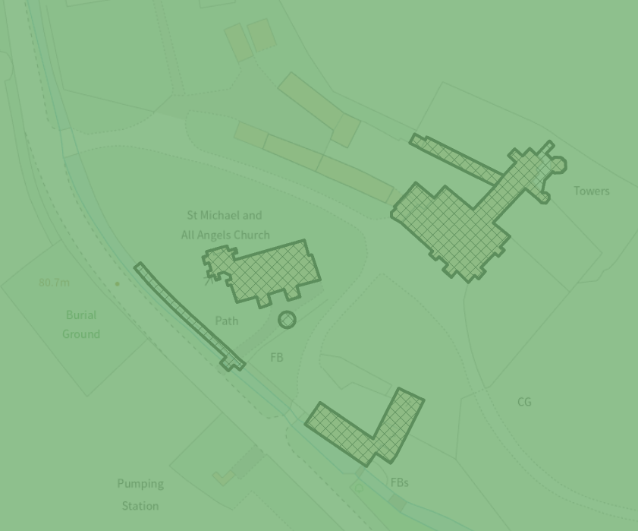

The site lies within the Chilmark Bat SAC and within the Hampshire River Avon Catchment.

The site lies on the edge of flood zone 2 and outside of flood zone 3.

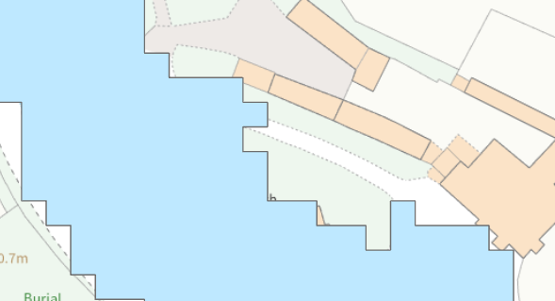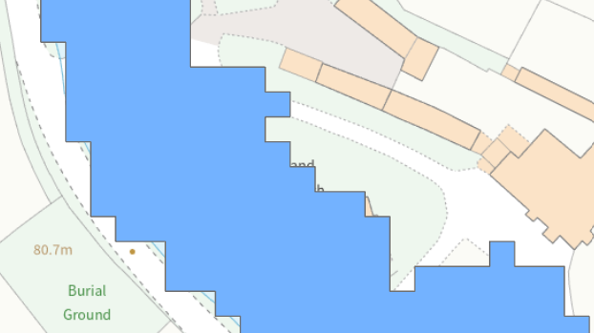

The site lies partly in an area at risk of surface water flooding but is not at risk of groundwater flooding.

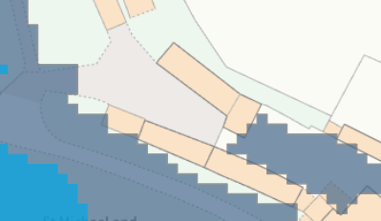

PROPOSAL

The applicant is seeking consent to demolish an existing outbuilding and lean-to.

Existing building shown below.

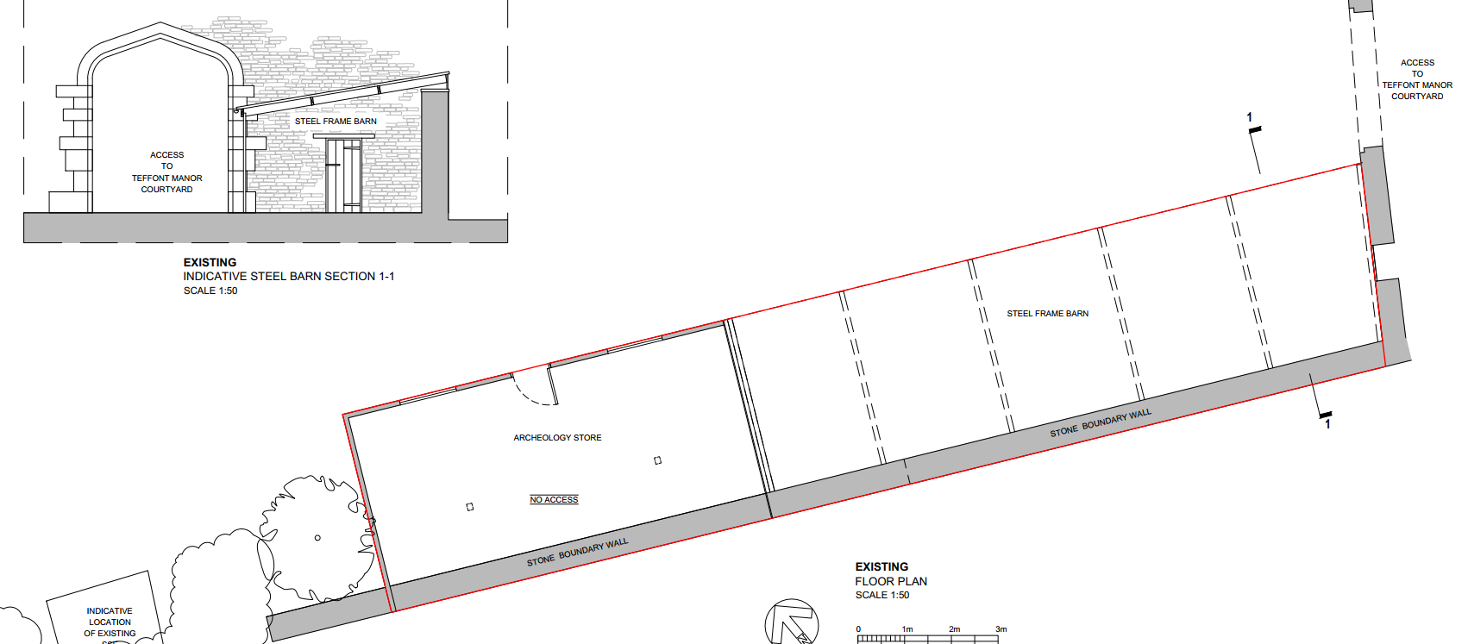
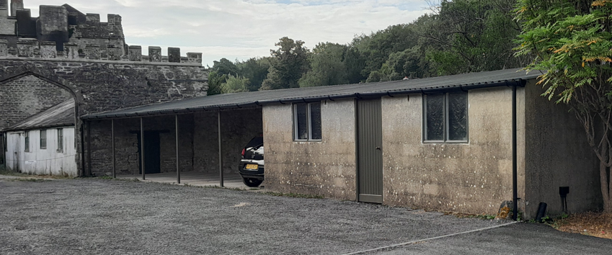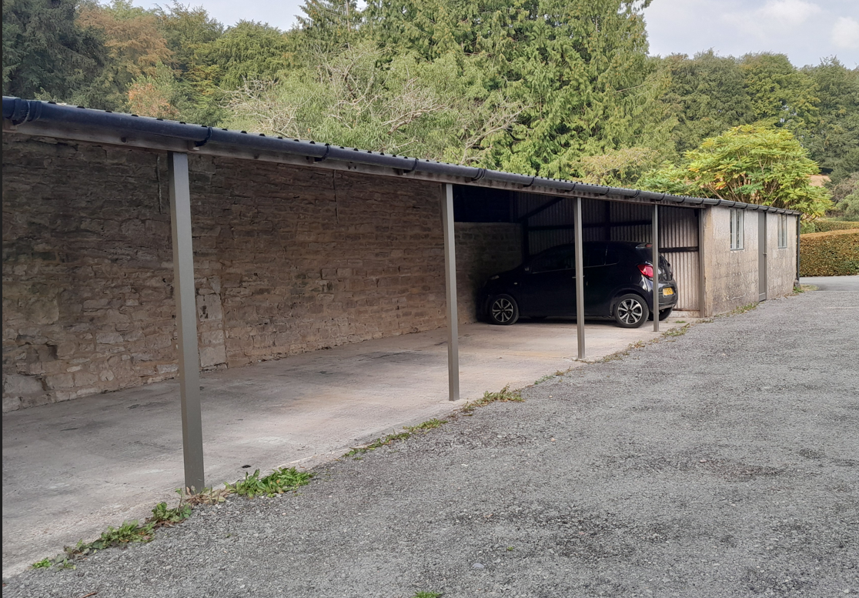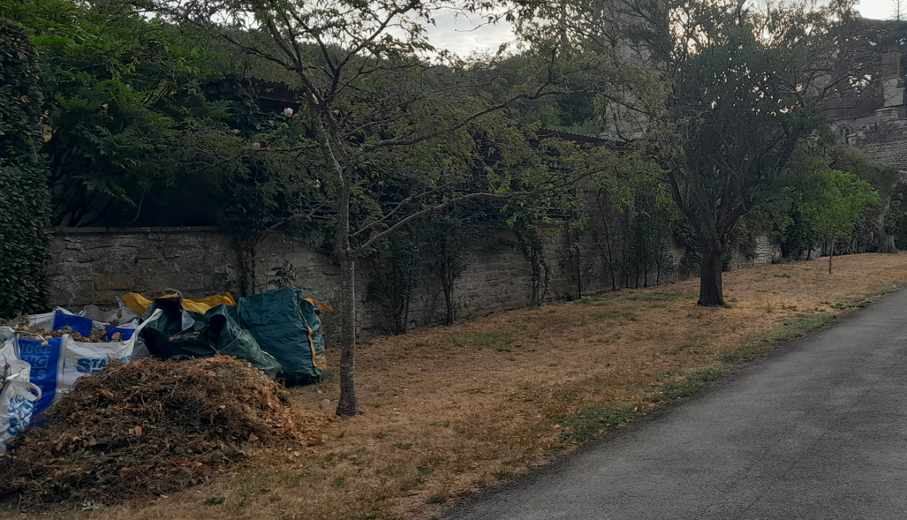

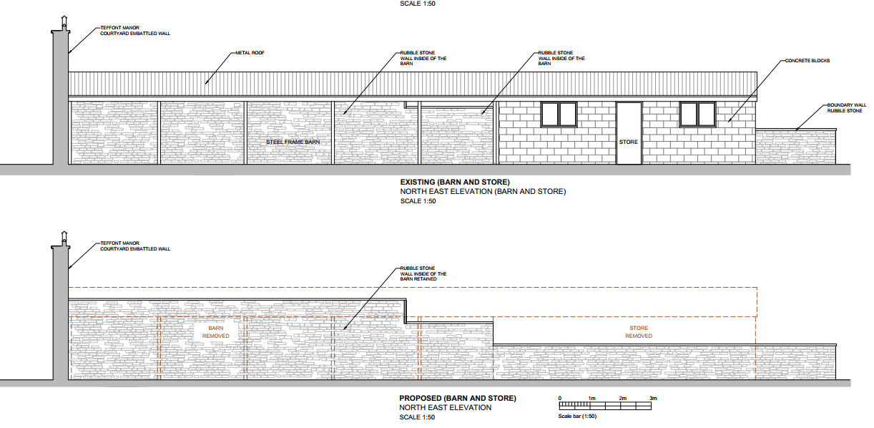
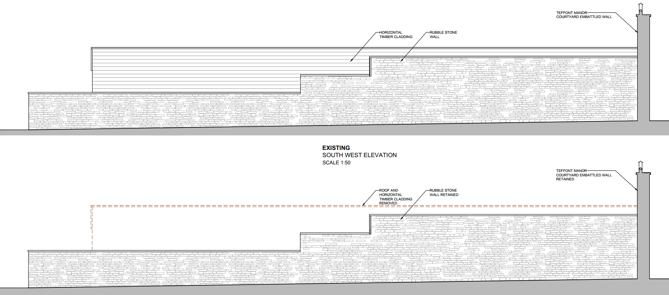
The structures are currently used for ancillary storage purposes and are located adjacent to a historic boundary wall serving Teffont Manor. The existing stone boundary wall is to be retained and made good following the removal of the structures.

PLANNING HISTORY

None relevant

RELEVANT LEGISLATION, POLICIES AND GUIDANCE

Statutory Legislation:

The Planning (Listed Buildings and Conservation Areas) Act 1990
- Section 16: Listed Building Decisions
- Section 66: Special considerations affecting planning functions
- Section 72: General duty as respects conservation areas in exercise of planning functions

National Planning Policy:
National Planning Policy Framework (NPPF)
Planning Practice Guidance (PPG)

Development Plan:

The development plan for Wiltshire comprises the Wiltshire Core Strategy (WCS) (adopted January 2015) and any made neighbourhood plans, which remains the principal statutory planning document guiding development across the county. In line with Section 38(6) of the Planning and Compulsory Purchase Act 2004, planning decisions must be made in accordance with the development plan unless material considerations indicate otherwise.

Though the development plan is considered as a whole, those parts deemed to be particularly relevant to this application are listed below:

The adopted Wiltshire Core Strategy (WCS), with particular regard to:

Core Policy 1 (Settlement Strategy)
Core Policy 2 (Delivery Strategy)
Core Policy 17 (Spatial Strategy Tisbury Community Area)
Core Policy 50 (Biodiversity and Geodiversity)
Core Policy 51 (Landscape)
Core Policy 57 (Ensuring high Quality Design and Place Shaping)
Core Policy 58 (Ensuring the Conservation of the Historic Environment)
Core Policy 67 (Flood risk)
Core Policy 69 ( Hampshire River Avon Catchment)

Draft Wiltshire Local Plan
At Full Council on 19 May 2026, the elected members of Wiltshire Council agreed to withdraw the emerging Wiltshire Local Plan. The said Plan has no material weight for the purposes of the application.

In accordance with Regulation 19 of the Town and Country Planning (Local Planning) (England) Regulations 2026, on 30th June 2026 Wiltshire Council published a notice of intention to prepare a new local plan for Wiltshire. The next stage is a Scoping Consultation which commences on 2nd September 2026. This plan is at a very early stage and currently carries no weight for decision making.

Supplementary Planning Documents and other Guidance:

Wiltshire Design Guide (adopted April 2024)
National Design Guide
National Landscape Management Plan
Creating Places Design Guide
Teffont Village Design Statement

CONSULTATION RESPONSES

Parish Council- no objection to proposed demolition

Also comment that they welcome the installation of the new electricity substation. The Parish Council trusts that appropriate measures will be taken to minimise the visual impact of the substation and ensure that it is suitably integrated within its surroundings. However the proposed development relates solely to the demolition of the outbuilding/lean to.

Conservation – no objection

Ecology – no objection subject to condition

Archaeology- There are no archaeological issues to raise in this instance.

REPRESENTATIONS

None received

ASSESSMENT

Section 38(6) of the Planning and Compulsory Purchase Act 2004 states:

"If regard is to be had to the development plan for the purposes of any determination to be made under the planning Acts, the determination must be made in accordance with the plan unless material considerations indicate otherwise."

In accordance with this statutory requirement, this application has been assessed against the relevant policies of the Development Plan, including the Wiltshire Core Strategy (2015) and, where applicable, any made Neighbourhood Plans. Consideration has also been given to the policies of the NPPF (NPPF) as a material consideration in the assessment.

The assessment below considers each of the main issues, assessed in turn with reference to the relevant policy context, consultee responses, and all other material considerations, before a conclusion is reached.

Impact on the Character and Appearance of the Area, Landscape Impacts and Heritage Impacts

From the point of view of the historic environment, the main statutory duties are set out within the Planning (Listed Buildings and Conservation Areas) Act 1990.

Sections 16 and 66 of the Planning (Listed Building and Conservation Areas) Act 1990 place a duty on the local planning authority to have special regard to the desirability of preserving the building or its setting or any features of special architectural or historic interest which it possesses and Section 72(1) requires the local planning authority to pay special attention to the desirability of preserving or enhancing the character or appearance of the designated Conservation Area.

Core Policy 58 of the Wiltshire Core Strategy seeks to conserve and, where appropriate, enhance the significance of designated and non-designated heritage assets and their settings.

Core Policy 57 requires development to respond positively to local character and historic context through high quality design.

Core Policy 51 of the Wiltshire Core Strategy seeks to protect, conserve and enhance landscape character and quality and requires development to respond appropriately to its landscape setting.

Policy N2 of the NPPF seeks to conserve and enhance the natural environment and requires development to take account of landscape character, local distinctiveness and the natural beauty of the countryside.

Policy N4 of the NPPF affords significant protection to National Landscapes and requires development proposals to conserve and enhance their natural beauty and special qualities.

Under Section 245 of the Levelling-up and Regeneration Act 2023, the Council must seek to further the purposes of National Landscapes when exercising its planning functions.

Policies HE4-HE10 of the NPPF recognise heritage assets as an irreplaceable resource and require proposals affecting heritage assets to be assessed having regard to their significance and the contribution made by their setting.

Policies DP1-DP4 of the NPPF seek to ensure that development is well-designed, visually attractive, sustainable and responsive to its surroundings. Development should contribute positively to local character, create high quality places and support healthy and inclusive communities.

The Wiltshire Design Guide provides further guidance on achieving high quality, context-led design and should be taken into account where relevant and also promotes development that integrates with landscape features and local character.

The application site is located within the Teffont Magna and Evias Conservation Area and forms part of the wider setting of several designated heritage assets, including the Grade II listed Teffont Manor and the Grade II* Church of St Michael and All Angels. The submitted Heritage Statement demonstrates that the existing store and lean-to are relatively modern structures dating from the mid to late twentieth century and are of limited architectural, historic or evidential significance. The historic boundary wall to which the structures are attached is proposed to be retained.

The Council's Conservation Officer has reviewed the proposal and raises no objection, advising that the structures proposed for demolition are modern additions which do not contribute positively to the special interest of the listed building, the setting of surrounding listed buildings or the character and appearance of the conservation area. The demolition of the structures would not result in harm to the significance of the designated heritage assets or their settings. Indeed, their removal has potential to better reveal the historic boundary wall and the setting of Teffont Manor.

Given the limited visibility of the structures, their limited architectural merit and lack of historic significance, the proposal would have no adverse impact on the character or appearance of the area, the surrounding landscape, the Cranborne Chase National Landscape, the Teffont Magna and Evias Conservation Area, or the significance and setting of nearby listed buildings. The proposal is therefore considered to accord with Core Policies 51, 57 and 58 of the Wiltshire Core Strategy and the relevant heritage provisions of the NPPF.

Officers note the comments from the Parish Council regarding the new substation; however, this is not part of the current application. Comments were sought from the agent regarding the substation, and they have advised that “the substation does not form part of the application. We are developing proposals with SSE for the installation of a substation upgrade to support the hotel and wider Village (the current one is significantly undersized). However, it's installation would be permitted by Part 15, Class B of the GPDO 2015 so it is being dealt with separately by SSE as the statutory undertaker”.

Amenity

Core Policy 57 (Point vii) of the Wiltshire Core Strategy requires development to respect the amenity of existing occupants and ensure appropriate amenity levels for future residents.

Policy P3 of the NPPF requires development to be appropriate for its location, taking account of its likely effects on health, living conditions and the environment. In particular, Policy P3(2)(b) requires development to avoid giving rise to unacceptable impacts on the living conditions of neighbouring residents and occupiers. In assessing amenity impacts, regard should be had to matters including daylight and sunlight, outlook, privacy, overbearing impacts and other effects on residential amenity.

The proposal relates solely to the demolition of an existing outbuilding and lean-to whilst retaining the boundary wall. No replacement structure or additional built form is proposed. The nearest residential properties are located to the east within Teffont Manor itself and to the south east at Teffont Manor Cottages.

Given the nature of the proposed development, the proposal would not result in any loss of privacy, outlook, light or other adverse impact on residential amenity. Any disturbance arising from the demolition works would be temporary and limited in duration. The proposal is therefore considered acceptable in amenity terms and complies with Core Policy 57 of the Wiltshire Core Strategy.

Ecology and Biodiversity

Core Policy 50 of the Wiltshire Core Strategy requires development to protect and, where appropriate, enhance biodiversity and geodiversity interests.

Policy N2 of the NPPF seeks to conserve and enhance biodiversity, support nature recovery, protect habitats and species, and strengthen ecological networks.

Where relevant, proposals should assess impacts upon protected species, habitats, ecological networks and green and blue infrastructure and demonstrate that any adverse impacts can be appropriately avoided, mitigated or compensated for.

The application is accompanied by a Preliminary Roost Assessment prepared by Fenswood Ecology which assesses the ecological implications of the proposed demolition works. The assessment concludes that the existing store outbuilding and lean-to are largely constructed of materials unsuitable for bat roosting and, due to their condition, are considered to have negligible suitability for roosting bats. The structures are also considered to have low suitability for nesting birds.

Wiltshire Council's Ecologist has reviewed the submitted information and raises no objection to the proposal subject to conditions. It is noted that demolition works should take place outside of the bird nesting season (March to August inclusive), or alternatively a nesting bird check should be undertaken by a suitably qualified ecologist prior to the commencement of works if demolition is required during this period.

The application proposes the retention and repair of the existing boundary wall. In accordance with Core Policy 50 of the Wiltshire Core Strategy and the objectives of the NPPF, opportunities for biodiversity enhancement have been incorporated into the proposal. The applicant has submitted details of ecological enhancement measures comprising the installation of a bird box and bat boxes; the bat box will be a 2F Schwegler Bat Box and the bird box will be a Vivara Pro Seville 32mm WoodStone® Nest Box. These measures are considered appropriate and will provide biodiversity enhancements associated with the development. The submitted ecological enhancement measures shall be secured by condition and implemented as part of the development.

The Council's Ecologist has also confirmed that, having regard to the scale and nature of the proposal, there would be no likely significant effects on the Chilmark Quarries Bat SAC or the Hampshire Avon SAC. Furthermore, the proposal falls below the de minimis threshold for Mandatory Biodiversity Net Gain and is therefore exempt from the statutory BNG requirements.

Subject to compliance with the submitted ecological documents and implementation of the ecological enhancement measures, the proposal is considered to accord with Core Policy 50 of the Wiltshire Core Strategy and the relevant provisions of the NPPF.

Flood Risk

Core Policy 67 of the Wiltshire Core Strategy seeks to ensure that development is appropriately located and designed to avoid increasing flood risk on-site or elsewhere. Sustainable drainage measures should be incorporated where appropriate.

Policies F4-F8 of the NPPF require flood risk to be taken into account in planning decisions and seek to ensure that development is safe for its lifetime, does not increase flood risk elsewhere and incorporates appropriate drainage measures.

The proposal relates solely to the demolition of an existing outbuilding and lean-to. No replacement structure is proposed, and the existing hardstanding is to be retained. Given the nature of the works, the proposal would have no adverse implications in respect of flood risk and complies with Core Policy 67 of the Wiltshire Core Strategy.

PLANNING BALANCE AND CONCLUSION

In reaching a decision, all identified harms and benefits must be weighed in the overall planning balance, having regard to Section 38(6) of the Planning and Compulsory Purchase Act 2004, the provisions of the Development Plan and the NPPF.

The application relates solely to the demolition of a modern store outbuilding and attached lean-to of limited architectural, historic and visual merit. The structures make no positive contribution to the significance of the listed building, the conservation area or the wider landscape setting. Their removal would not result in harm to heritage assets, residential amenity, ecology or flood risk implications. A modest public benefit arises through the removal of modern structures and the improved visuals of the retained historic boundary wall.

Subject to the recommended conditions, the proposal is considered to comply with Core Policies 50, 51, 57, 58, 67 and 69 of the Wiltshire Core Strategy, the provisions of the NPPF and the statutory duties contained within the Planning (Listed Buildings and Conservation Areas) Act 1990.

RECOMMENDATION: That Planning Permission be GRANTED, subject to conditions

1. The development hereby permitted shall be begun before the expiration of three
years from the date of this permission.

REASON: To comply with the provisions of Section 91 of the Town and Country Planning Act 1990 as amended by the Planning and Compulsory Purchase Act 2004.

2. The development hereby permitted shall be carried out in accordance with the
following approved plans and documents:

Application form received 31/07/2026
Site location plan and block plan Drg no 3875 – 400 Rev B received 06/08/2026
Proposed plans Drg no 402 Rev A received 08/07/2026
Existing and proposed elevations north west and north east Drg no 3875 – 403 received 08/07/2026
Existing and proposed south west Drg no 3875 - 404 received 08/07/2026
Preliminary roost assessment by Fenswood Ecology received 08/07/2026
Ecology enhancements Drg no 3875 - 410 received 28/09/2026
Details of bird and bat box provided by email from Dolman Building Surveyors Limited Liability Partnership received 30/09/2026

REASON: For the avoidance of doubt and in the interests of proper planning

3. The development shall be carried out in strict accordance with the recommendations and measures contained within the Preliminary Roost Assessment prepared by Fenswood Ecology dated July 2026, the ecological enhancement measures shown on approved drawing 3875-410, and the bat and bird box details submitted by Dolman Building Surveyors LLP on 30/09/2026. The approved measures shall be implemented prior to the completion of the development and thereafter retained for the lifetime of the development.

REASON: To ensure adequate protection and mitigation for protected species

4. No construction/demolition works shall take place on Sundays or Public Holidays or outside the hours of 08:00 to 18:00 Monday to Friday and 08:00 to 13:00 on Saturdays.

REASON: To minimise disturbance to nearby residents during the works

INFORMATIVES

1. BNG not required

The effect of paragraph 13 of Schedule 7A to the Town and Country Planning Act 1990 is that planning permission granted for development of land in England is deemed to have been granted subject to the condition (biodiversity gain condition) that development may not begin unless:

(a) a Biodiversity Gain Plan has been submitted to the planning authority, and
(b) the planning authority has approved the plan.

The planning authority, for the purposes of determining whether to approve a Biodiversity Gain Plan, if one is required in respect of this permission would be Wiltshire Council.

There are statutory exemptions and transitional arrangements which mean that the biodiversity gain condition does not always apply. For further information on exempt developments please refer to:
https://www.gov.uk/guidance/biodiversity-net-gain-exempt-developments
Based on the information available this permission is considered to be one which will not require the approval of a biodiversity gain plan before development is begun because one or more of the statutory exemptions or transitional arrangements is considered to apply

RECOMMENDATION: That Listed Building Consent be GRANTED subject to conditions.

1. The works for which Listed Building Consent is hereby granted shall be begun before the expiration of three years from the date of this consent.

REASON: To comply with the provisions of Section 18 of the Planning (Listed Buildings and Conservation Areas) Act 1990 as amended by the Planning and Compulsory Purchase Act 2004.

2. The development hereby permitted shall be carried out in accordance with the
following approved plans and documents:

Application form received 31/07/2026
Site location plan and block plan Drg no 3875 – 400 Rev B received 06/08/2026
Proposed plans Drg no 402 Rev A received 08/07/2026
Existing and proposed elevations north west and north east Drg no 3875 – 403 received 08/07/2026
Existing and proposed south west Drg no 3875 - 404 received 08/07/2026
Preliminary roost assessment by Fenswood Ecology received 08/07/2026
Ecology enhancements Drg no 3875 - 410 received 28/09/2026
Details of bird and bat box provided by email from Dolman Building Surveyors Limited Liability Partnership received 30/09/2026

REASON: For the avoidance of doubt and in the interests of proper planning

3. Following demolition of the outbuilding and lean-to, the retained historic stone boundary wall shall be made good to match the existing wall.
REASON: To safeguard the character, appearance and significance of the listed building and its setting.

