APPLICATION FOR FULL-PLANNING PERMISSION
CASE OFFICER REPORT

APPLICATION REFERENCE: | PL/2026/01667
APPLICATION TYPE: | Full planning permission
SITE ADDRESS: | Center Parcs, Picket Post, Corsley, Warminster, BA12 7PU
DEVELOPMENT DESCRIPTION: | Installation of Treetop Glider, Tower Platform and associated Works.
RECOMMENDATION: | Approve with Conditions

SITE DESCRIPTION/CONTEXT

Center Parcs Longleat Forest is a substantial forest holiday village extending to approximately 400 acres. The resort is set within Longleat Forest and is characterised by extensive woodland cover, mature trees and landscaped recreational areas that form an integral part of its character. The holiday village has evolved progressively since opening in 1994 and contains a wide range of leisure, recreational and accommodation facilities.

The application site is located on the southern side of the holiday village adjacent to the central lake, between the existing Sports Plaza and Mini Golf facilities. This part of the resort forms one of the principal activity hubs and contains a number of recreational attractions and organised activities. The lake and surrounding area are already characterised by a relatively high level of visitor activity, movement and associated noise, including watersports and the existing zip wire attraction that traverses the lake. As such, the application site is located within an established leisure and recreation setting rather than a quiet or undisturbed area of the forest.

The site comprises an area of soft landscaping including grassed areas and shrub planting within a wooded setting. It is situated amongst existing mature trees and woodland and currently contains an outdoor pavilion/bandstand. The proposal would involve the removal of the existing pavilion together with associated infrastructure to facilitate the construction of the proposed Treetop Glider tower platform and associated facilities.

There are no trees within the application site that are protected by a Tree Preservation Order. Furthermore, the site is not located within or adjacent to a Site of Special Scientific Interest (SSSI) or Special Protection Area (SPA). The site lies within Flood Zone 1, which is identified as having a low probability of flooding, and is not affected by any known significant surface water or groundwater flood risk.

The site is subject to the following key constraints and designations:

- Located within the River Avon Special Area of Conservation (SAC) Hampshire Catchment.
- Situated within the Cranborne Chase and West Wiltshire Downs National Landscape.
- Whilst the application site itself is not designated for nature conservation, the wider Center Parcs estate supports a range of protected species, including bats, great crested newts, nesting birds, badgers and otters.
- The existing pavilion was assessed as having negligible potential to support roosting bats.
- The site lies outside any biodiversity-sensitive areas identified within the Center Parcs Biodiversity Action Plan.
- The affected trees are not located within a Priority Habitat parcel.

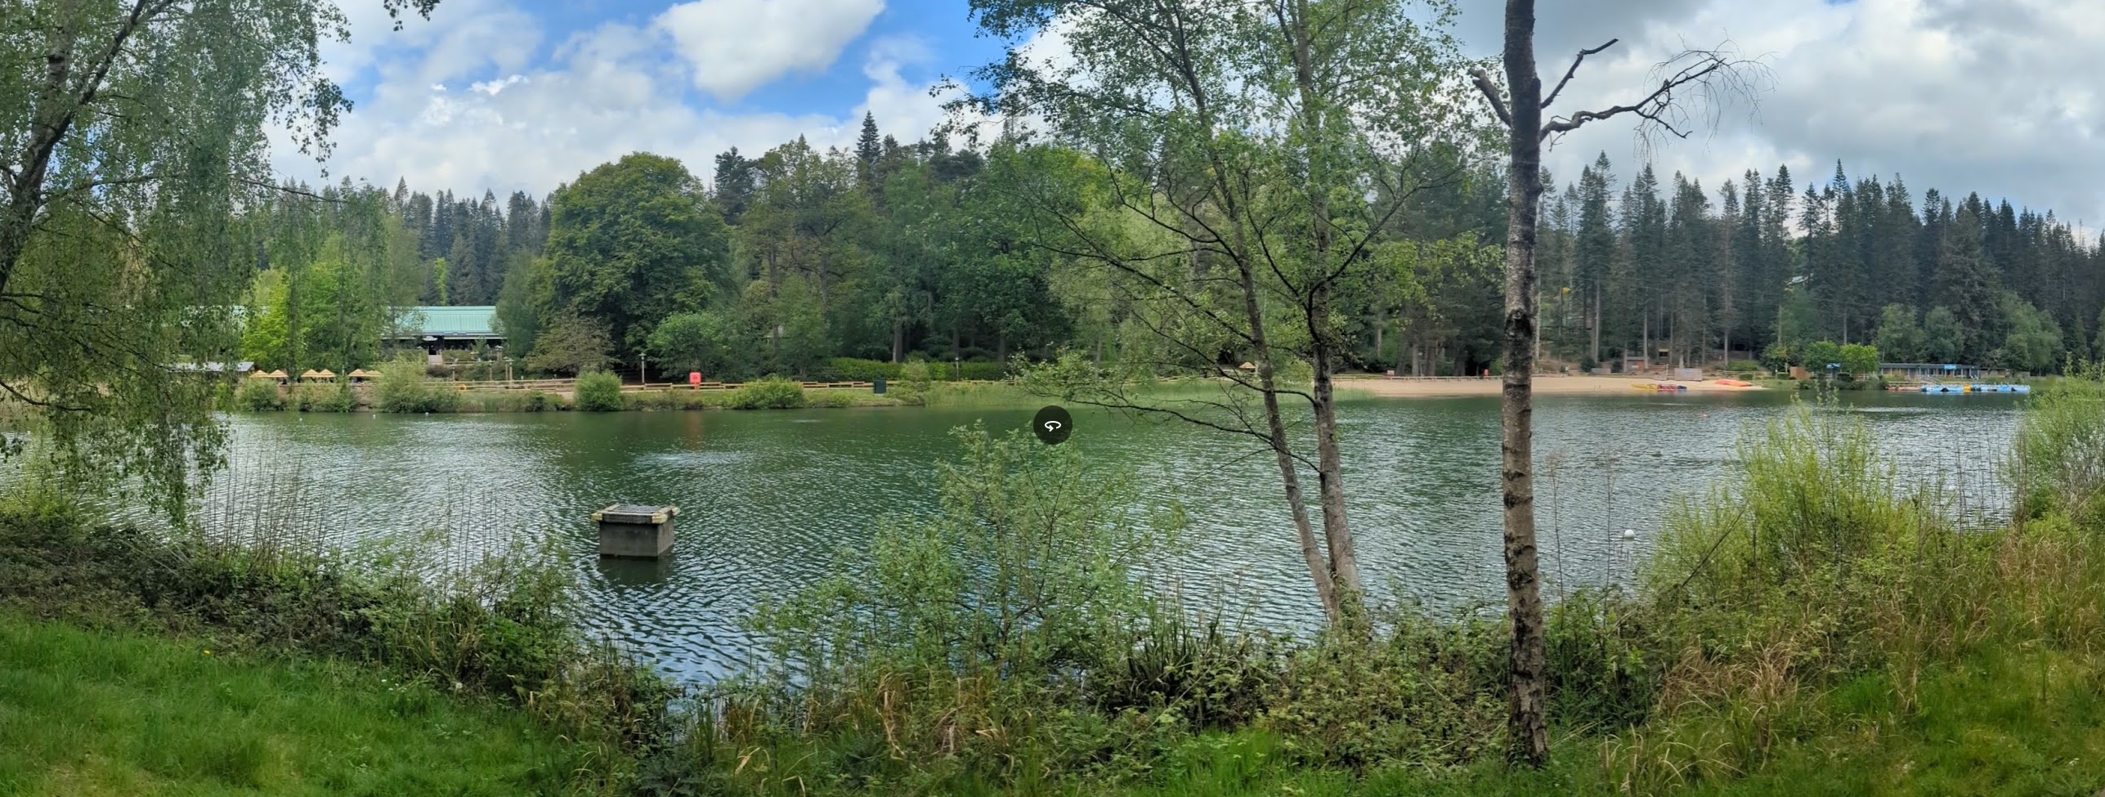

View of Sports Café and mini golf (left), application site (centre) and leisure activities including zip line across lake (right)

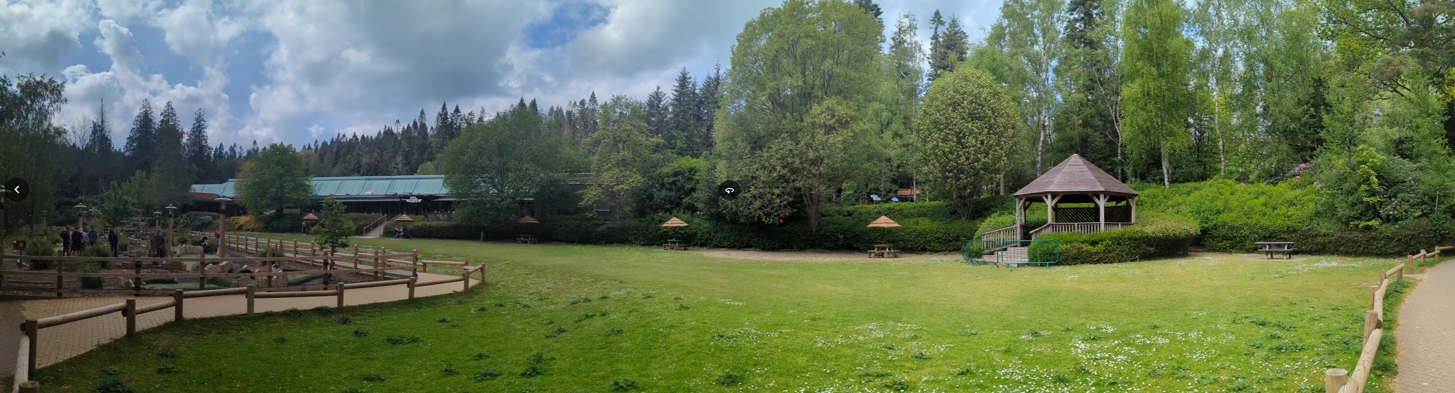

View of Mini Golf and Café (left) and existing pavilion (right)

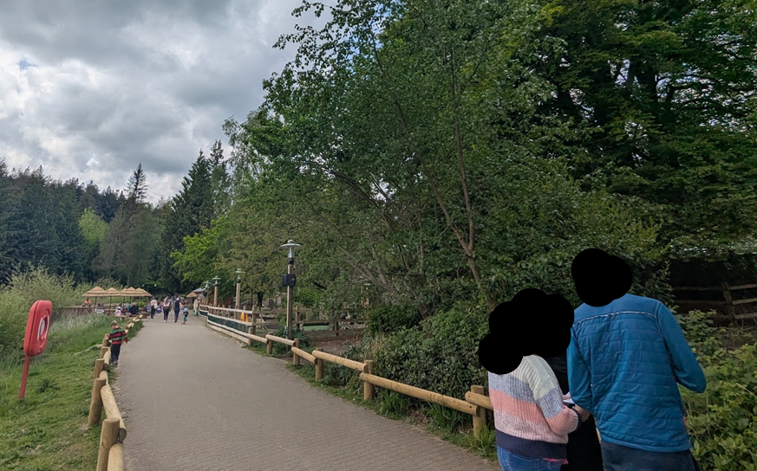

View from path– the glider support posts would run alongside the path

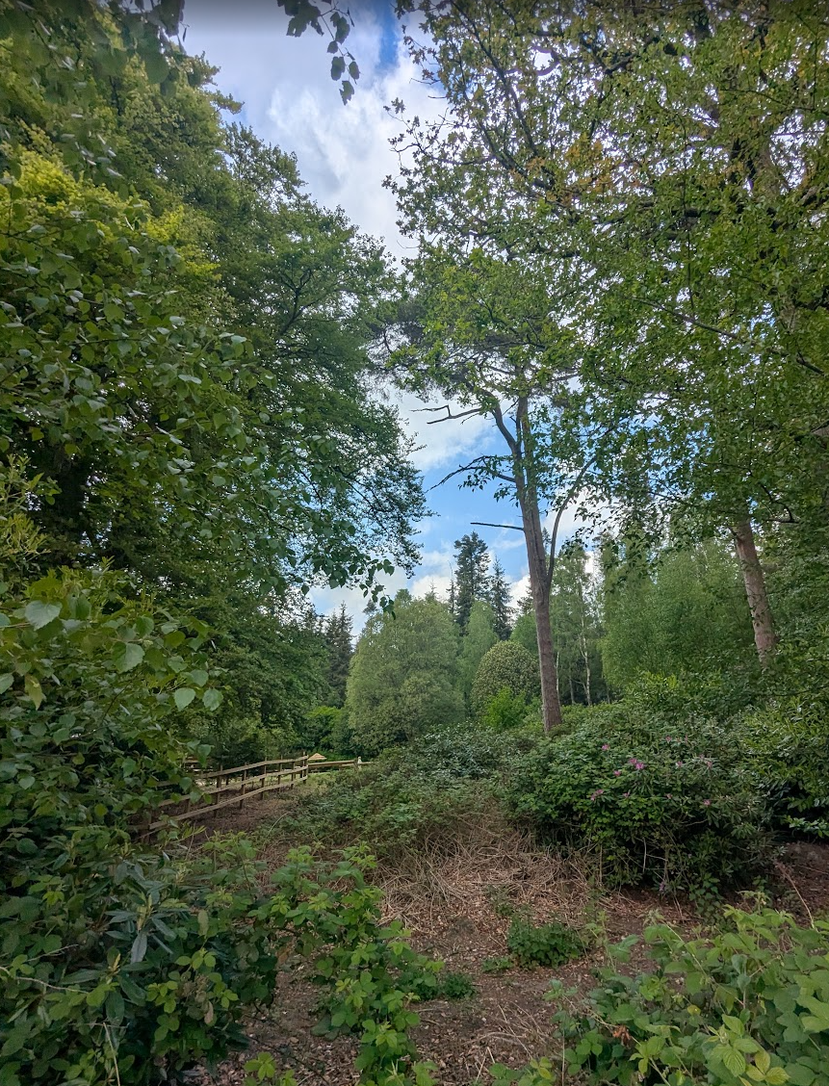

View through gap in existing trees where proposed route of the glider will pass

PROPOSAL

The application seeks full planning permission for the installation of a Treetop Glider (aerial zipline attraction), tower platform and associated infrastructure. The development includes the erection of a small single-storey timber clad log cabin to support operation of the activity, together with associated access arrangements and ancillary works. The proposal also requires the demolition of an existing outdoor pavilion/bandstand located between the Sports Plaza and Mini Golf facilities in order to facilitate the take-off zone for the attraction.

The Treetop Glider would comprise an elevated aerial ride extending through the woodland, with the track weaving between existing mature trees. The structure would have a maximum height of approximately 12.9 metres and be constructed from structural steel with timber cladding designed to blend with the surrounding forest environment.

The proposed Treetop Glider would be supported by a series of approximately 20 principal support columns positioned along the route of the attraction. The installation would require 14 concrete pad foundations, typically measuring approximately 0.9 metres by 0.45 metres deep. The support structures would also be stabilised by a network of backstays, which function in a similar manner to guy ropes used to secure and brace a tent, providing additional structural support and load distribution.

The submitted information indicates that a few of the support columns would not be installed vertically but at an angle of approximately 15 degrees. This design approach allows the concrete foundation pads to be positioned adjacent to existing footpaths whilst enabling the support columns themselves to extend over the path corridor. As a result, the structures can accommodate the required alignment of the glider whilst maintaining safe pedestrian access beneath and alongside the installation.

Importantly, whilst some support structures would oversail sections of the footpath, the glider line itself would not pass directly above pedestrian routes. The ride has been designed so that the track remains offset from the footpath network, thereby avoiding conflict with pedestrian movement and helping to integrate the attraction within the existing recreational layout of the holiday village.

The associated log cabin would measure approximately 35 square metres and provide facilities for participants to prepare for and conclude the activity, including equipment storage and operational space for staff. An adjoining covered external waiting area would also be provided. Access would be primarily via existing pedestrian routes serving the Sports Plaza and Mini Golf areas.

The proposal also includes an area for BNG provision on another part of the estate – with its own red outline.

The application has been supported with an extensive range of plans and supporting documents including:

- Design and Access Statement
- Revised Arboricultural Impact Assessment and Method Statement
- Preliminary Ecological Appraisal and BNG Assessment
- Habitat Management and Monitoring Plan – Version 5 (amended September 2026)

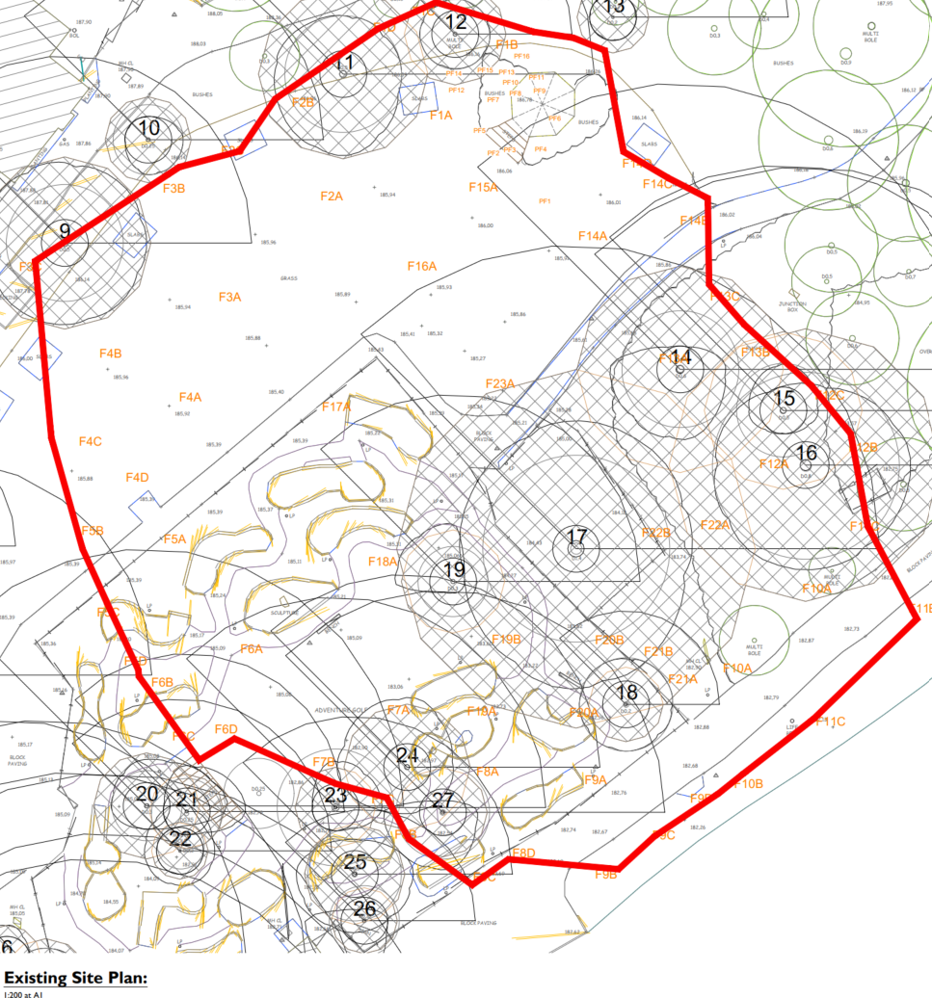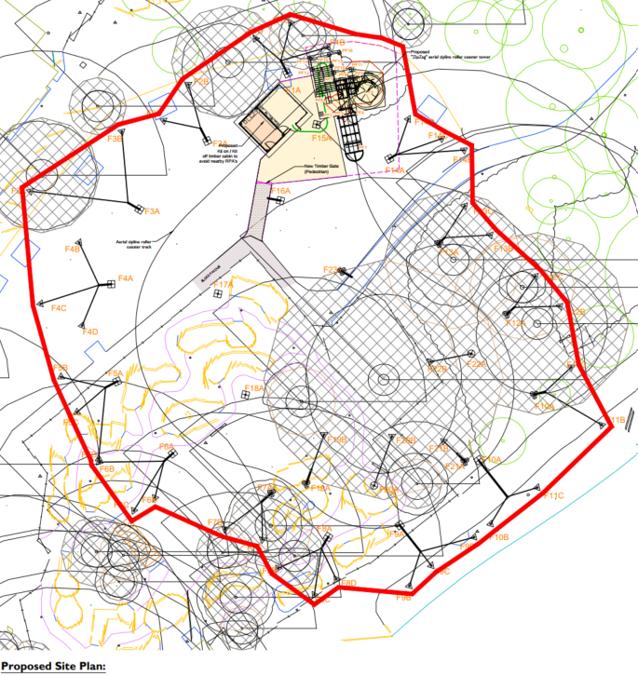

Existing and Proposed Site Plans

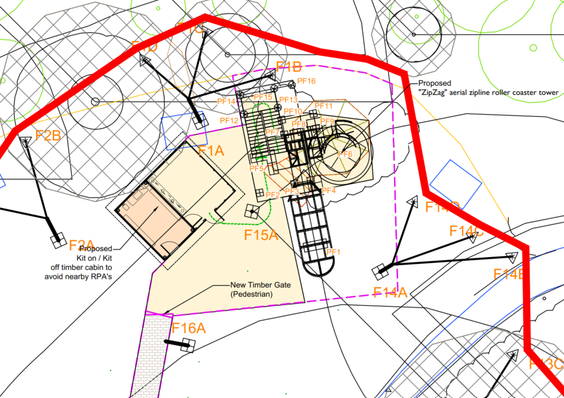

Detailed Extract of Site Plan showing Tower, Cabin and support posts

There would be 20 main support columns for the glider line with 14 concrete pad foundations (typically 0.9 x0.45m deep) which in turn are supported by ‘backstays’ which can best be described as large guide ropes (akin to tent stabilisation). As shown by an ISO view of the proposal, some of the support posts would actually be installed on a circa 15-degree angle. This is because the concrete pad would be installed close to the footpath edge, with the post angled to fall over the path itself – but without interfering with pedestrian access. The glider path or line itself would not pass over the pedestrian path itself.

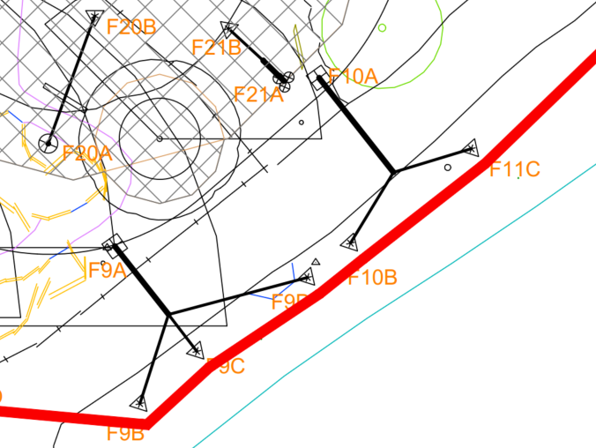

Extract from Site Plan showing concrete pads (squares) and cable supports over the path

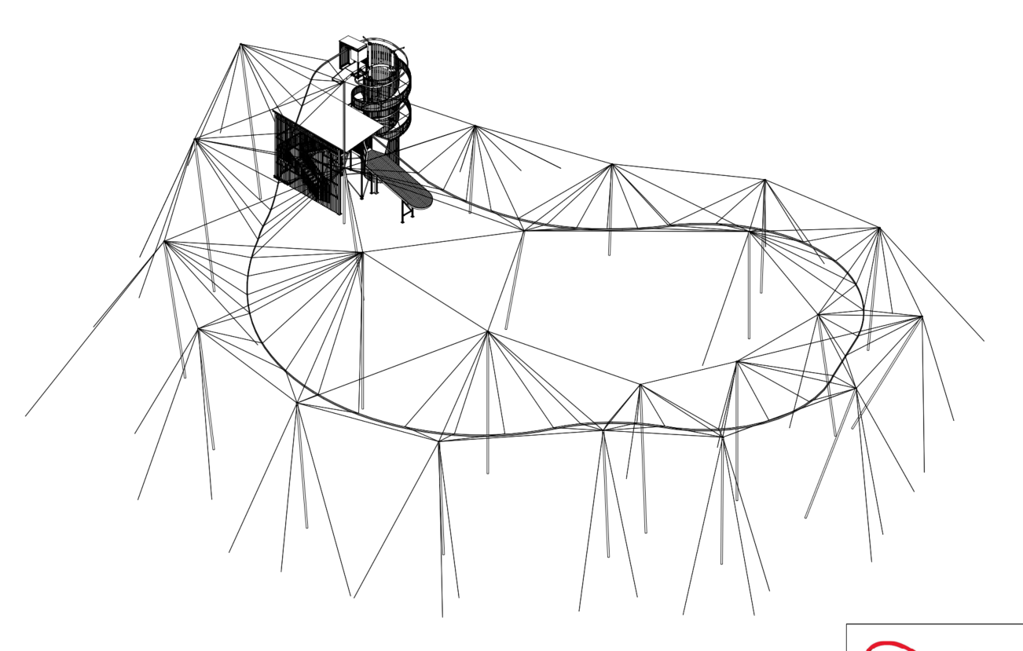

ISO view of the proposal

PLANNING HISTORY

There is an extensive planning history across the site but the most relevant and recent relates to the following application:

PL/2023/11150 - Erection of new log cabin kiosk with adventure golf courses – Approved with condition

RELEVANT LEGISLATION, POLICIES AND GUIDANCE

Statutory Legislation:

National Planning Policy:
- National Planning Policy Framework (NPPF)
- Planning Practice Guidance (PPG)
- National Design Guide
Development Plan:
The development plan for Wiltshire comprises the Wiltshire Core Strategy (WCS) (adopted January 2015) and any made neighbourhood plans, which remains the principal statutory planning document guiding development across the county. In line with Section 38(6) of the Planning and Compulsory Purchase Act 2004, planning decisions must be made in accordance with the development plan unless material considerations indicate otherwise.

Though the development plan is considered as a whole, those parts deemed to be particularly relevant to this application are listed below:

The adopted Wiltshire Core Strategy (WCS), with particular regard to:

- Core Policy 1 Settlement Strategy;
- Core Policy 2 Delivery Strategy;
- Core Policy 31 Spatial Strategy for the Warminster Community Area
- Core Policy 39 Tourist Development
- Core Policy 50 Biodiversity and Geodiversity;
- Core Policy 51 Landscape
- Core Policy 57 Ensuring High Quality Design and Place Shaping;

Neighbourhood Plan: Longbridge Deverill Does not have a Neighbourhood Plan or Area Designation

Other Documents:

Cranborne Chase National Landscape (formerly AONB) Management Plan 2019 – 2024
Cranborne Chase National Landscape Partnership Plan 2025 – 2030
Cranborne Chase International Dark Sky Reserve Status (2019)
Position Statement on Light Pollution, Good Practice Guides on Good Lighting, and IDSR criteria

ISSUES

The main issues that need to be addressed in this case include:

- Whether the proposal constitutes EIA development
- Whether the principle of development is supported
- Whether the scheme constitutes high quality design (CP 57)
- Whether the scheme would have an acceptable impact upon the reasonable living conditions of the adjoining occupants or uses (CP 57)
- Whether the scheme would have an acceptable landscape impact (CP 51)
- Whether there would be any harmful impacts upon protected species or priority habitats (CP 50)

CONSULTATION RESPONSES

The views of consultees are material considerations in the determination of the application. However, the decision-maker must exercise their own planning judgement. Where consultees raise concerns or recommend conditions, these have been considered and are addressed within the assessment section of this report.

Longbridge Deverell Parish Council: No comments to make

Cranborne Chase and West Wiltshire Downs National Landscape Officer: No objection subject to condition

Wiltshire Council Tree Officer: No objection subject to condition

Wiltshire Council Ecology Officer: No objection subject to condition and legal agreement

REPRESENTATIONS
In accordance with the requirements of the Town and Country Planning (Development Management Procedure) (England) Order 2015 (as amended), the application was publicised by way of:

- A site notice displayed near the site;

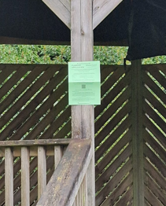

This method was used to inform interested parties and provide a period of 21 days for comments to be submitted.

No comments were received

ASSESSMENT
Section 38(6) of the Planning and Compulsory Purchase Act 2004 states:

"If regard is to be had to the development plan for the purposes of any determination to be made under the planning Acts, the determination must be made in accordance with the plan unless material considerations indicate otherwise."

In accordance with this statutory requirement, this application has been assessed against the relevant policies of the Development Plan, including the Wiltshire Core Strategy (2015) and, where applicable, any made Neighbourhood Plans. Consideration has also been given to the policies of the National Planning Policy Framework (NPPF) as a material consideration in the assessment.

The assessment below considers each of the main issues identified above. Each topic is assessed in turn with reference to the relevant policy context, the evidence submitted, consultee responses, and all other material considerations, before a conclusion is reached.

Environmental Impact Assessment (EIA) Screening
In accordance with the Town and Country Planning (Environmental Impact Assessment) Regulations 2017 (as amended), the local planning authority has considered whether the proposed development constitutes EIA development.

No Screening Opinion Issued
No formal screening opinion was requested or issued. However, the local planning authority has considered the scale and nature of the development as part of the application process and is satisfied that it does not constitute EIA development under the 2017 Regulations.

In reaching this view, regard has been had to the criteria set out in Schedule 2 of the EIA Regulations, including the scale, location and characteristics of the development. The proposal does not meet the relevant thresholds, nor is it considered likely to give rise to significant environmental effects by reason of factors such as its size or location.

Having assessed the proposal against the relevant screening criteria, officers are satisfied that the development would not be likely to give rise to significant environmental effects and therefore does not constitute EIA development.

Habitats Regulations Assessment (HRA)
Regulation 63 of the Conservation of Habitats and Species Regulations 2017 (as amended) requires the Local Planning Authority, as the competent authority, to consider whether a plan or project is likely to have a significant effect on a European site, either alone or in combination with other plans or projects. Where likely significant effects cannot be ruled out, an Appropriate Assessment must be undertaken.

Screening for Likely Significant Effects
The proposed development has been assessed, having regard to its location, scale and nature, and its potential to affect designated European sites, including Special Areas of Conservation (SACs) and Special Protection Areas (SPAs).

The application site falls within the catchment of the River Avon Special Area of Conservation (SAC). The Council, as competent authority, has undertaken a test of likely significance in accordance with Regulation 63 of the Conservation of Habitats and Species Regulations 2017 (as amended). The proposal comprises the installation of a Treetop Glider attraction and associated infrastructure and does not include the provision of any additional overnight accommodation.

The Council's Ecologist advises that whilst development within the River Avon SAC catchment has the potential to result in adverse effects through increased phosphorus loading arising from wastewater discharges, there is no mechanism for such effects to arise in this instance because the proposal would not generate any additional overnight stays or increase visitor accommodation.

As the proposal would not result in any additional visitor accommodation, increased overnight occupancy or additional wastewater-generating accommodation, officers are satisfied that no credible pathway exists whereby the development could adversely affect the River Avon SAC through nutrient loading. The proposal is therefore not likely to have a significant effect on the SAC, either alone or in combination with other plans or projects and can be screened out from Appropriate Assessment.

Principle of Development
Policy Context
Core Policy 39 (Tourist Development) supports the expansion and enhancement of existing tourism facilities where proposals are appropriately scaled, compatible with their landscape setting and help secure the long-term viability of established tourism businesses. The policy specifically recognises that extensions to existing facilities may be appropriate where they support the continued operation and future viability of established tourist attractions.

The NPPF also contains policies relating to the location of development. Policies S3-S5 distinguish between development within settlements and development in the countryside, support sustainable patterns of growth and recognise that certain forms of development, including tourism and leisure development, may be appropriately located outside settlement boundaries where supported by specific development plan policies and site-specific circumstances.

Assessment
The principle of development is accepted, subject to consideration of all material planning issues and site-specific constraints. Officers acknowledge and recognise the well-established tourism and leisure function of Center Parcs Longleat Forest, which has operated as a major holiday destination since 1994 and forms an important part of Wiltshire's visitor economy. Whilst the site is located within the open countryside, Core Policy 39 specifically supports the enhancement and expansion of existing tourism facilities where proposals are of an appropriate scale and assist in maintaining the long-term viability of established tourism businesses. This part of the resort forms one of the principal activity hubs and contains a number of recreational attractions and organised activities associated with the established operation of the holiday village.

The proposal comprises the provision of an additional leisure attraction within the confines of an existing and established holiday resort. It would be located within an area already utilised for recreational activities and would not result in the expansion of the resort beyond its existing operational boundaries. The development is therefore considered to represent an ancillary tourism and leisure facility that supports and enhances the existing offer at Center Parcs rather than establishing a new tourism use in the countryside.

The proposal represents the enhancement of an existing tourism destination rather than the establishment of a new tourism use within the countryside. It would remain wholly contained within the established operational area of Center Parcs and would contribute towards the ongoing attractiveness, competitiveness and long-term viability of the resort. As such, the proposal falls within the type of development expressly envisaged by Core Policy 39. Whilst located in the open countryside, the proposal is directly related to the continued operation and enhancement of an established tourism enterprise and does not result in the encroachment of development beyond the existing resort boundary. The proposal is therefore considered compatible with the spatial strategy of the development plan and the objectives of Policies S3-S5 in respect of the sustainable location of development. Subject to compliance with all other relevant development plan policies, the principle of development is therefore considered acceptable.

Design and Impact on the Character and Appearance of the Area
Policy Context
Core Policy 57 of the Wiltshire Core Strategy requires development to achieve a high standard of design that responds positively to local character, context and distinctiveness.

Policies DP1-DP4 of the NPPF seek to ensure that development is well-designed, visually attractive, sustainable and responsive to its surroundings. Development should contribute positively to local character, create high quality places and support healthy and inclusive communities.

The Wiltshire Design Guide provides further guidance on achieving high quality, context-led design and should be taken into account where relevant.

Assessment
The principal structure would comprise the Treetop Glider tower, which would have an overall height of approximately 12.9 metres. Whilst the tower is undoubtedly tall in absolute terms, height alone is not determinative of visual impact. In this case a number of factors substantially reduce its prominence. Firstly, the tower would be located on land that sits at a lower level than the woodland immediately to the north. Secondly, the land rises away from the site and is occupied by mature woodland containing trees that are themselves in excess of approximately 12 metres in height. Consequently, the tower would be viewed against an elevated and heavily wooded backdrop, which would significantly reduce its visual prominence and assist in assimilating the structure into the wider forest setting.

Additionally, the tower itself has a relatively modest footprint of approximately 17.5 square metres. Its circular form gives it a lightweight and vertical appearance when compared with more conventional buildings. In visual terms it resembles a leisure structure, akin to a helter-skelter or observation tower, and its function as a recreational attraction is immediately apparent. Given its slender proportions and limited footprint, officers do not consider the tower to appear imposing, dominant or visually harmful within the context of an established holiday resort characterised by a wide range of recreational facilities.

Greater consideration has been given to the enclosed staircase and platform structure positioned adjacent to the tower. Although lower in height at approximately 8.5 metres, this element would measure approximately 4.3 metres in width and 7 metres in length and consequently possesses a greater sense of bulk and massing. Its enclosed form and shallow lean-to roof, which appears almost flat in profile, result in a more utilitarian and functional appearance than the tower itself. As such, this element has the greatest potential to influence the character and appearance of the immediate area.

Notwithstanding this, the enclosure would remain of a relatively modest scale within the broader context of the resort and would be viewed against a backdrop of mature woodland. The submitted plans indicate that both the tower and enclosure would comprise a steel structural frame clad predominantly in timber pine cladding. The use of natural timber materials is considered appropriate within a woodland setting and reflects the wider architectural approach adopted throughout Center Parcs. Over time, weathering of the timber cladding would further assist in integrating the structures into their surroundings and reducing visual contrast with adjacent trees and woodland vegetation.

The Treetop Glider has been intentionally designed as a leisure attraction and, whilst visible within the resort, this is not considered inappropriate given its recreational purpose. The proposal is read as part of the established activity offer of Center Parcs and would not introduce an incongruous form of development into an otherwise undeveloped landscape.

The Design and Access Statement confirms that, due to its woodland setting and surrounding vegetation, the structure is not expected to be readily visible from viewpoints outside the holiday village. Officers have undertaken a site inspection and are satisfied that the combination of mature woodland cover, landform and the contained nature of this established activity hub substantially limits the wider visibility of the proposed development. Whilst the structures would be visible from within the immediate vicinity of the attraction, they would be experienced as part of the established leisure function of the resort rather than as isolated structures within an undeveloped landscape.

In addition, the proposal includes a small ancillary cabin positioned adjacent to the tower structure. This building would measure approximately 7.2 metres in length, 5 metres in width and 2.8 metres in height and would be finished in timber cladding to match the wider development. By comparison with the tower and staircase enclosure, the cabin is modest in scale and has the appearance of a simple woodland lodge or service building. Given its limited height, modest footprint and use of natural materials, it would sit comfortably within the established woodland setting and wider resort environment. The structure would not appear visually prominent, overbearing or incongruous and would have no material adverse impact upon the character or appearance of the site or its surroundings.

Overall, whilst the proposal introduces a noticeable new recreational structure into the resort, officers are satisfied that its design, form, scale and material palette are appropriate to its function and location. The surrounding woodland, varied topography and extensive tree cover would substantially reduce wider visual impacts, whilst the use of timber cladding would assist in integrating the development into its forest setting.

Conclusion
Having regard to the scale, design, siting and appearance of the proposed development, it is considered that the Treetop Glider, tower platform and associated structures would not result in unacceptable harm to the character or appearance of the area. The proposal represents an appropriately designed leisure attraction within an established holiday resort and would successfully integrate with its woodland surroundings through its form, materials and relationship with the existing topography and tree cover. The development is therefore considered to accord with Core Policy 57 of the Wiltshire Core Strategy and the design objectives of the NPPF.

Amenity
Policy Context
Core Policy 57 (Point vii) of the Wiltshire Core Strategy requires development to respect the amenity of existing occupants and ensure appropriate amenity levels for future residents.

Policy P3 of the NPPF requires development to be appropriate for its location, taking account of its likely effects on health, living conditions and the environment. In particular, Policy P3(2)(b) requires development to avoid giving rise to unacceptable impacts on the living conditions of neighbouring residents and occupiers. In assessing amenity impacts, regard should be had to matters including daylight and sunlight, outlook, privacy, overbearing impacts and other effects on residential amenity.

These policies guide the assessment of amenity impacts. Each of the below matters has been assessed having regard to the specific site context and layout of the proposal.

Assessment
The application site is located within the established leisure and recreation area of Center Parcs Longleat Forest, positioned between the Sports Plaza, Mini Golf area and the lake. This part of the resort accommodates a range of recreational activities and visitor attractions and is characterised by a high level of visitor movement and activity throughout the day. The proposal would therefore be experienced within an active leisure environment rather than a residential setting.

The nearest sensitive receptors comprise holiday lodges located elsewhere within the resort. Given the separation distances involved, the intervening woodland and the siting of the proposal within an existing recreational hub, the development would not result in any unacceptable impacts on the occupiers of those lodges.

In terms of privacy, the proposal would not introduce any direct overlooking opportunities. Whilst the tower platform would be elevated, it forms part of a leisure attraction rather than a viewing platform and users would not be directed towards or obtain meaningful views into nearby accommodation. The surrounding woodland would also provide substantial screening and visual containment. Accordingly, no harmful loss of privacy would arise.

With regard to outlook and overbearing impact, the proposed structures are located within an open recreational area and would not be positioned in close proximity to any residential accommodation. Whilst the tower would have a maximum height of approximately 12.9 metres, its circular form, limited footprint and relationship with the surrounding mature woodland significantly reduce its visual mass. The ancillary structures and cabin are similarly modest in scale. Given the distances involved and the leisure context of the site, officers do not consider the proposal would appear oppressive, dominant or overbearing from any neighbouring property.

The proposal would likewise give rise to no unacceptable overshadowing impacts. The structures are located within an open area surrounded by mature trees which are already substantially taller than the proposed buildings and attract a degree of natural shading. Furthermore, there are no nearby residential properties that would experience any material loss of sunlight or daylight as a result of the development.

Whilst the attraction is likely to generate some additional activity-related noise, this would occur within a part of the resort already characterised by organised recreation, visitor activity and existing leisure attractions. The proposal would not introduce a materially different form of activity to that already experienced within this locality and, having regard to existing background activity levels, the established recreational character of the area and separation from holiday accommodation, officers do not consider any resulting disturbance would be unacceptable.

Conclusion
Having regard to the nature of the proposal, its location within an established leisure and recreation area of Center Parcs, and the separation distances to surrounding accommodation, the development would not give rise to any unacceptable overlooking, loss of privacy, overshadowing, overbearing effects or other material harm to amenity. The proposal is therefore considered to accord with Core Policy 57 of the Wiltshire Core Strategy and the relevant provisions of the NPPF.

Ecology and Biodiversity
Policy Context
Core Policy 50 of the Wiltshire Core Strategy requires development to protect and, where appropriate, enhance biodiversity and geodiversity interests.

Policy N2 of the NPPF seeks to conserve and enhance biodiversity, support nature recovery, protect habitats and species, and strengthen ecological networks.

Where relevant, proposals should assess impacts upon protected species, habitats, ecological networks and green and blue infrastructure and demonstrate that any adverse impacts can be appropriately avoided, mitigated or compensated for.

Biodiversity Net Gain (BNG) is mandatory for most development and proposals should demonstrate compliance with the statutory requirements unless an exemption applies.

Development that would result in significant biodiversity harm which cannot be avoided, adequately mitigated or compensated for should be refused.

Assessment
In assessing this aspect of the proposal, regard has been had to the site context, the details of the proposed development, the relevant development plan policies, and all other material considerations. The key considerations are set out below.

The application has been supported by a Preliminary Ecological Appraisal and Biodiversity Net Gain Assessment. The site itself is not subject to any statutory ecological designation, although it lies within the River Avon SAC catchment and the wider estate is known to support protected species including bats, great crested newts, nesting birds, badgers and otters.

The Council's Ecologist raises no objection to the principle of the development. The existing pavilion was assessed as having negligible bat roost potential and no further bat surveys were considered necessary. Appropriate mitigation and enhancement measures are recommended in respect of bats, nesting birds, amphibians and other protected species and can be secured by planning condition.

The proposal is required to deliver a minimum 10% Biodiversity Net Gain. Biodiversity Net Gain is also subject to the separate statutory requirements of Schedule 7A of the Town and Country Planning Act 1990, including the approval of a Biodiversity Gain Plan where required. The approved Habitat Management and Monitoring Plan (HMMP) forms part of the planning permission and provides the framework for the long-term management and monitoring of the proposed habitat enhancements. Compliance with the HMMP is secured through planning condition, whilst the completed Section 111 Agreement secures the Council's Biodiversity Net Gain monitoring arrangements and associated monitoring contribution.

During the course of the application, the Council's Ecologist requested further information in relation to the extent of the Biodiversity Net Gain area, the proposed habitat management arrangements and the mechanism for securing long-term monitoring. In response, the applicant submitted revised ecological information, including clarification of the Biodiversity Net Gain area and updated management and monitoring proposals. Following review of the additional information, the Council's Ecologist confirmed that the outstanding ecological concerns had been satisfactorily addressed.

Following the submission of revised information, including clarification of the Biodiversity Net Gain area, the Ecologist confirmed that the outstanding ecological concerns had been satisfactorily addressed. Biodiversity enhancements and lighting controls are secured through planning conditions, whilst long-term Biodiversity Net Gain monitoring arrangements are secured through the completed Section 111 Agreement. Compliance with the approved Habitat Management and Monitoring Plan (HMMP) is secured through a planning condition. Subject to these measures, no ecological objection is maintained.

Conclusion
Having regard to the submitted ecological information, consultation responses and the proposed mitigation measures, it is considered that the development would not result in unacceptable harm to biodiversity, protected species or ecological networks. The Council's Ecologist has confirmed that there is no objection in principle to the proposal and is satisfied that the matters initially raised in relation to Biodiversity Net Gain have been adequately addressed through the submission of revised information.

The site is not subject to any statutory ecological designation and the existing pavilion has been assessed as having negligible bat roost potential. Appropriate mitigation and enhancement measures have been identified in respect of bats, great crested newts, nesting birds, badgers and otters, and these can be secured through suitably worded planning conditions. Furthermore, the proposal has been screened through the Habitats Regulations process and is not considered likely to result in a significant effect on the River Avon Special Area of Conservation.

The development is required to achieve a minimum 10% Biodiversity Net Gain and the Council's Ecologist is satisfied that this is secured through the approved Biodiversity Net Gain Strategy, together with the approved Habitat Management and Monitoring Plan, biodiversity enhancement measures, lighting controls and long-term monitoring arrangements, the latter being secured through the completed Section 111 Agreement.

Officers are therefore satisfied that the proposal would conserve and enhance biodiversity interests and would accord with Core Policy 50 of the Wiltshire Core Strategy, the objectives of the Green and Blue Infrastructure Strategy, Policy N2 of the NPPF and the biodiversity gain requirements of the Environment Act 2021.

Landscape and Visual Impact
Policy Context
Core Policy 51 of the Wiltshire Core Strategy seeks to protect, conserve and enhance landscape character and quality and requires development to respond appropriately to its landscape setting.

Policy N2 of the NPPF seeks to conserve and enhance the natural environment and requires development to take account of landscape character, local distinctiveness and the natural beauty of the countryside.

The Wiltshire Design Guide promotes a context-led approach that integrates development with landscape features and local character.

Policy N4 of the NPPF affords significant protection to National Landscapes and requires development proposals to conserve and enhance their natural beauty and special qualities.

Under Section 245 of the Levelling-up and Regeneration Act 2023, the Council must seek to further the purposes of National Landscapes when exercising its planning functions.

The site is also located within the Cranborne Chase International Dark Sky Reserve, designated in 2019 in recognition of the area's nationally and internationally important dark skies. Development within the National Landscape should therefore seek to minimise light pollution and avoid adverse impacts on the tranquillity, dark sky qualities and nocturnal environment of the area.

Assessment
The application site is located within Center Parcs Longleat Forest and falls within the Cranborne Chase National Landscape (formerly Cranborne Chase and West Wiltshire Downs AONB).

Having regard to the site's location within an established leisure and recreation area of Center Parcs Longleat Forest, the surrounding mature woodland, rising topography and the limited extent of built development proposed, it is considered that the proposal would not result in unacceptable harm to the character, appearance or scenic qualities of the Cranborne Chase National Landscape. Whilst the development would introduce new structures into the woodland setting, these would be viewed in the context of an existing holiday resort and would be appropriately assimilated into the landscape.

A key consideration in this case relates to lighting and the special qualities of the Cranborne Chase National Landscape, including its designation as an International Dark Sky Reserve in 2019. Whilst the submitted Design and Access Statement references the need to minimise light pollution through Core Policy 51, it does not specifically assess the effects of the proposal on the Dark Sky Reserve.

The proposal incorporates a limited amount of new lighting associated solely with the tower structure, comprising three LED luminaires. Following consultation with the National Landscape Officer, the applicant has agreed to reduce the colour temperature of the proposed lighting from 4000K to 2700K in order to minimise blue light content and reduce impacts on the dark night environment. Importantly, no additional lighting is proposed along the glider route itself. Whilst the attraction may operate until 20:00 and therefore for limited periods after dusk during the winter months, the proposed lighting is restricted to a small number of low-colour-temperature luminaires and is subject to detailed controls through planning conditions.

Given the sensitive location within the National Landscape and International Dark Sky Reserve, officers consider it appropriate to impose conditions requiring the submission and approval of a detailed lighting scheme, securing the amended 2700K specification, controlling illumination levels in accordance with Environmental Zone E0 standards and restricting the installation of additional lighting. Subject to these controls, together with the considerable woodland screening surrounding the site, it is considered that the proposal would not result in unacceptable harm to the dark sky qualities, tranquillity or special characteristics of the Cranborne Chase National Landscape.

Overall, whilst the proposal would introduce new built form within a woodland setting, it would be located within an established and developed part of the holiday village characterised by existing leisure attractions, recreational activities and associated infrastructure. Owing to the surrounding mature woodland, the site's topography and the contained nature of this part of the resort, the development would be largely confined to its immediate surroundings and would not be readily visible from elsewhere within the holiday village or from viewpoints outside the Center Parcs complex. The scale of development, together with the extensive woodland screening, limited lighting proposals and use of timber cladding, would ensure that the proposal is successfully assimilated into its surroundings and would not give rise to significant landscape or visual harm.

Conclusion
Having regard to the siting, scale, design and appearance of the proposed development, officers are satisfied that the proposal would not result in unacceptable harm to the character, appearance or scenic qualities of the Cranborne Chase National Landscape. The structures would be appropriately assimilated into the woodland environment through their location, materials and relationship with the surrounding topography and mature tree cover. Furthermore, subject to conditions controlling external lighting, limiting illumination levels, securing compliance with Environmental Zone E0 standards and preventing the installation of unauthorised additional lighting, the proposal would not materially harm the tranquillity, dark sky qualities or special characteristics of the National Landscape.

The proposal is therefore considered to accord with Core Policy 51 of the Wiltshire Core Strategy, the relevant provisions of the NPPF, and the objectives of the Cranborne Chase National Landscape, including the conservation and enhancement of its International Dark Sky Reserve status.

Trees and Arboricultural Impact
Policy Context
Core Policy 51 of the Wiltshire Core Strategy seeks to protect and enhance landscape character, including important trees and woodland features.

Policy N2 of the NPPF requires decision-makers to consider the environmental qualities of land proposed for development and to conserve and enhance existing natural features of visual, historic or nature conservation value, including established trees and hedgerows where possible. The policy also seeks to ensure that landscaping and natural features are used to help integrate development into its surroundings.

Assessment
The application site is located within an established woodland area of Center Parcs Longleat Forest and contains a mixture of mature broadleaf and conifer trees of varying age, quality and arboricultural value. An Arboricultural Impact Assessment (AIA) and Arboricultural Method Statement (AMS), prepared by Redeswood Tree Surveying and dated April 2026, have been submitted in support of the application. The report has been prepared in accordance with BS5837:2012 and assesses the relationship between the proposed development and surrounding trees.

Consideration has been given to:
- The impact of the development on existing trees;
- Whether any trees are subject to Tree Preservation Orders;
- The adequacy of any submitted arboricultural information;
- The retention, protection and replacement of trees.

The submitted tree survey identifies a number of Category A and Category B trees within and surrounding the application site. The Arboricultural Impact Assessment confirms that all existing trees are to be retained and that no tree removal is required as part of the development. Whilst limited pruning works are proposed to facilitate the ride envelope and associated structures, these works are minor in nature and are not considered likely to adversely affect the health, longevity or amenity value of the affected trees.

The proposal has been specifically designed to work within an existing woodland environment. The submitted information acknowledges that a number of foundations and anchor points fall within Root Protection Areas (RPAs). However, bespoke foundation solutions and construction methodologies have been employed to minimise impacts on root systems. The AMS confirms that all foundations within RPAs have been carefully positioned and designed to avoid significant root damage and that foundation locations can be adjusted should significant roots be encountered during installation. Furthermore, all foundations have been located at least 2 metres from tree stems to avoid principal rooting zones.

The Arboricultural Method Statement also details protective fencing, supervised excavations, restricted working methods, the use of existing access routes, temporary ground protection where necessary, and ongoing arboricultural supervision throughout construction. No fixings are proposed to be attached to retained trees, and no new hard surfacing is proposed.

The Council's Tree Officer has confirmed that, following a site visit and review of the submitted information, the Arboricultural Impact Assessment and Arboricultural Method Statement demonstrate that the proposal has sufficiently considered the trees on site and that the design has been arranged to ensure minimal impact on retained trees during both construction and operation of the Treetop Glider. The Tree Officer raises no objection to the proposal subject to the Arboricultural Impact Assessment and Arboricultural Method Statement being approved documents and compliance with their recommendations being secured by condition.

The assessment further confirms that there are no trees protected by Tree Preservation Orders and the site is not located within a Conservation Area.

Conclusion
Having regard to the submitted Arboricultural Impact Assessment and Arboricultural Method Statement, the findings of the site inspection undertaken with the Council's Tree Officer and the proposed protection and construction measures, officers are satisfied that the proposal would not result in unacceptable harm to retained trees or the wider woodland character of the site. Subject to a condition requiring development to be carried out in full accordance with the approved Arboricultural Impact Assessment and Arboricultural Method Statement, the proposal is considered to accord with Core Policy 51 of the Wiltshire Core Strategy.

PLANNING BALANCE AND CONCLUSION
In reaching a decision, all identified harms and benefits must be weighed in the overall planning balance, having regard to Section 38(6) of the Planning and Compulsory Purchase Act 2004 and the provisions of the National Planning Policy Framework.

The proposed development seeks to introduce a new Treetop Glider attraction and associated facilities within the established Center Parcs Longleat Forest holiday village. The proposal would provide an additional recreational facility which would support and enhance the existing tourism offer at the resort, thereby assisting the continued viability and attractiveness of one of Wiltshire's principal tourism destinations.

The proposal has been carefully designed to integrate within an existing leisure and recreation area of the resort and would not result in an unacceptable impact upon the character or appearance of the area. Despite the height of the principal tower structure, the development would be viewed against a backdrop of mature woodland and rising landform and would be appropriately assimilated into its surroundings. The proposal is not considered to cause unacceptable harm to the scenic qualities of the Cranborne Chase National Landscape and, subject to appropriate controls over lighting and hours of operation, would preserve the tranquillity and dark sky qualities of the area.

The development would not result in unacceptable impacts upon residential amenity. Furthermore, ecological and arboricultural matters have been fully considered through the submission of detailed supporting information. The Council's Ecologist and Tree Officer raise no objections subject to conditions and, in the case of ecology, the completed legal agreement. The proposal has also been screened through the Habitats Regulations process and is not considered likely to have a significant effect on the River Avon SAC.

No objections have been received from statutory consultees, the National Landscape Officer, the Tree Officer, the Ecologist, the Parish Council or members of the public.

For these reasons, officers conclude that the proposal represents an appropriate enhancement of an existing tourism destination and that any impacts can be satisfactorily mitigated through planning conditions and the completed Section 111 Agreement. The proposal is therefore considered to accord with Core Policies 39, 50, 51 and 57 of the Wiltshire Core Strategy, together with the relevant provisions of the National Planning Policy Framework.

The completed Section 111 Agreement secures the Council's Biodiversity Net Gain monitoring arrangements and associated monitoring contribution. Officers are satisfied that the agreement is directly related to the development and is necessary to ensure the effective long-term delivery and monitoring of the approved biodiversity enhancements.

Accordingly, planning permission is recommended for approval subject to planning conditions, including those relating to approved plans, arboricultural protection, ecological mitigation, biodiversity enhancement measures, habitat management, external lighting and compliance with the approved supporting documentation. The completed Section 111 Agreement secures the necessary Biodiversity Net Gain monitoring arrangements and associated monitoring contribution.

RECOMMENDATION:
That Planning Permission be GRANTED, subject to conditions and the completed s111 agreement

