APPLICATION FOR TECHNICAL DETAILS CONSENT
DELEGATED REPORT

APPLICATION REFERENCE: | PL/2026/01558
APPLICATION TYPE: | Technical Details Consent
SITE ADDRESS: | Rectory Barn, Whaddon, Hilperton, Trowbridge, BA14 6NR
DEVELOPMENT DESCRIPTION: | Erection of a single new dwelling and associated works. (Technical details consent following approval of permission in principle reference PL/2025/03764).
RECOMMENDATION: | That Planning Permission be GRANTED

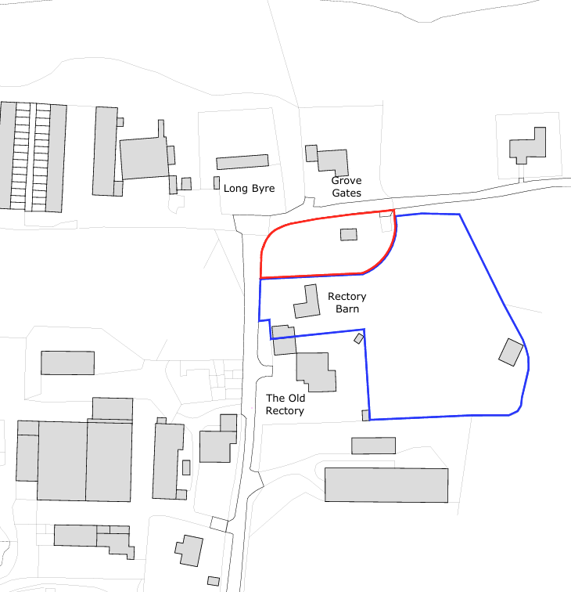

PROPOSAL

The application seeks Technical Details Consent following the grant of Permission in Principle (ref. PL/2025/03764) for the erection of a single self-build dwelling within the curtilage of Rectory Barn. The proposal comprises a 1.5-storey dwelling with associated access, parking, landscaping and infrastructure works, utilising the existing access onto Whaddon Lane.

SITE DESCRIPTION / CONTEXT

The site comprises a parcel of residential garden land associated with Rectory Barn, located within the small hamlet of Whaddon, outside of any defined settlement boundary and therefore within the open countryside. The immediate area is characterised by a loose-knit cluster of residential properties set within a predominantly rural landscape of agricultural fields, with development generally low-density and varied in design, including both traditional and more contemporary dwellings. The site is bounded by Whaddon Lane to the north and west, with open countryside beyond, and is enclosed in part by established hedgerows and landscaping. The wider context includes nearby heritage assets, notably the Grade II* Church of St Mary and associated listed structures to the northeast, along with public rights of way in close proximity.

PLANNING HISTORY

Reference No. | Proposal / Summary | Decision
W/97/00246/FUL | Double garage utility room and log store | Approved
W/93/01315/FUL | Conversion to dwelling including extension | Approved
W/87/01534/FUL | Conversion of existing farm building into a dwelling | Approved
W/88/01245/FUL | Conversion of barn to single dwelling | Approved
PL/2025/03764 | Permission in principle for a single new dwelling | Approved

RELEVANT LEGILSATION, POLICIES AND GUIDANCE

Wiltshire Core Strategy:

Core Policy 1 Settlement Strategy;
Core Policy 2 Delivery Strategy;
Core Policy 29 Spatial Strategy: Trowbridge Community Area;
Core Policy 50 Biodiversity and Geodiversity;
Core Policy 51 Landscape;
Core Policy 57 Ensuring High-Quality Design and Place Shaping;
Core Policy 58 Ensuring Conservation of the Historic Environment;
Core Policy 60 Sustainable Transport;
Core Policy 61 Transport and Development;
Core Policy 64 Demand Management;
Core Policy 67 Flood Risk;

Hilperton Neighbourhood Plan 2017-2026

Policy 3 Heritage and Design

The National Planning Policy Framework (NPPF) and The Planning Practice Guidance (PPG)

Wiltshire Design Guide

The Wiltshire Local Transport Plan 2011 – 2026: Car Parking Strategy (March 2015).

The Wiltshire Local Transport Plan 4 (LTP4) (March 2025)

New Wiltshire Local Plan

At Full Council on 19 May 2026, the elected members of Wiltshire Council agreed to withdraw the emerging Wiltshire Local Plan. The said Plan has no material weight for the purposes of the application.

In accordance with Regulation 19 of the Town and Country Planning (Local Planning) (England) Regulations 2026, on 30th June 2026 Wiltshire Council published a notice of intention to prepare a new local plan for Wiltshire. The next stage is a Scoping Consultation which commences on 2nd September 2026. This plan is at a very early stage and currently carries no weight for decision making.

CONSULTATION RESPONSES

Hilperton Parish Council – No Objection
Noted sensitivity of the nearby listed church and requested retention of hedgerows.

Local Highway Authority (Wiltshire Council) – No Objection (Subject to condition)

Conservation Officer (Wiltshire Council) – Objects
Expressed concern over impact of east elevation windows and outward light spill impact to the setting of the listed building.

Arboriculture Officer (Wiltshire Council) – No Objection
Highlighted outstanding conditions 4 and 6 of PL/2025/03764 concerning a tree protection plan and a soft landscaping plan.

Ecology Officer (Wiltshire Council) – No Objection (subject to conditions)

Natural England – No Objection (subject to conditions)

REPRESENTATIONS

One comment of support was received in relation to the application. The representation expressed general agreement with the proposal and supported the principle of the development.

ASSESSMENT

Section 38(6) of the Planning and Compulsory Purchase Act 2004 states:

"If regard is to be had to the development plan for the purposes of any determination to be made under the planning Acts, the determination must be made in accordance with the plan unless material considerations indicate otherwise."

In accordance with this statutory requirement, this application has been assessed against the relevant policies of the Development Plan, including the adopted Wiltshire Core Strategy (2015) and, where applicable, any made Neighbourhood Plans.

The principle of residential development on the site has been established through the grant of Permission in Principle under ref. PL/2025/03764, which confirmed the acceptability of a single dwelling in terms of location, land use and amount of development. As such, the current application for Technical Details Consent does not revisit the acceptability of the development in principle, and instead focusses on the detailed design, layout and technical matters, consistent with the two-stage process set out in national guidance.

Design and Impact upon the upon the character and context of the area

Core Policy 57 of the Wiltshire Core Strategy seeks to secure high-quality design which responds positively to local character and distinctiveness. At the national level, Policy DP3 of the National Planning Policy Framework requires development proposals to respond positively to their context and integrate with and enhance their surroundings. Development should also reflect, where relevant, the principles of liveability, climate resilience, nature, movement, built form, public space and local identity. Assessment of design quality therefore requires consideration of the scale, appearance, massing, materials, layout and relationship of the proposal with both the host site and the wider character of the surrounding area.

The Hilperton Neighbourhood Development Plan, through Policy 3 (Heritage and Design), adds locally specific guidance, emphasising the importance of reflecting local character and responding to the Village Design Statement. While primarily directed toward development within the Conservation Area, it is a material consideration in reinforcing design quality expectations more generally across the parish.

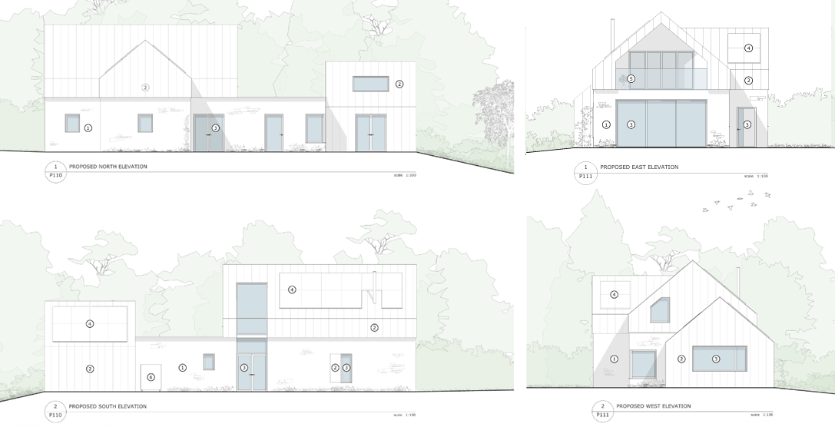
Proposed Elevations

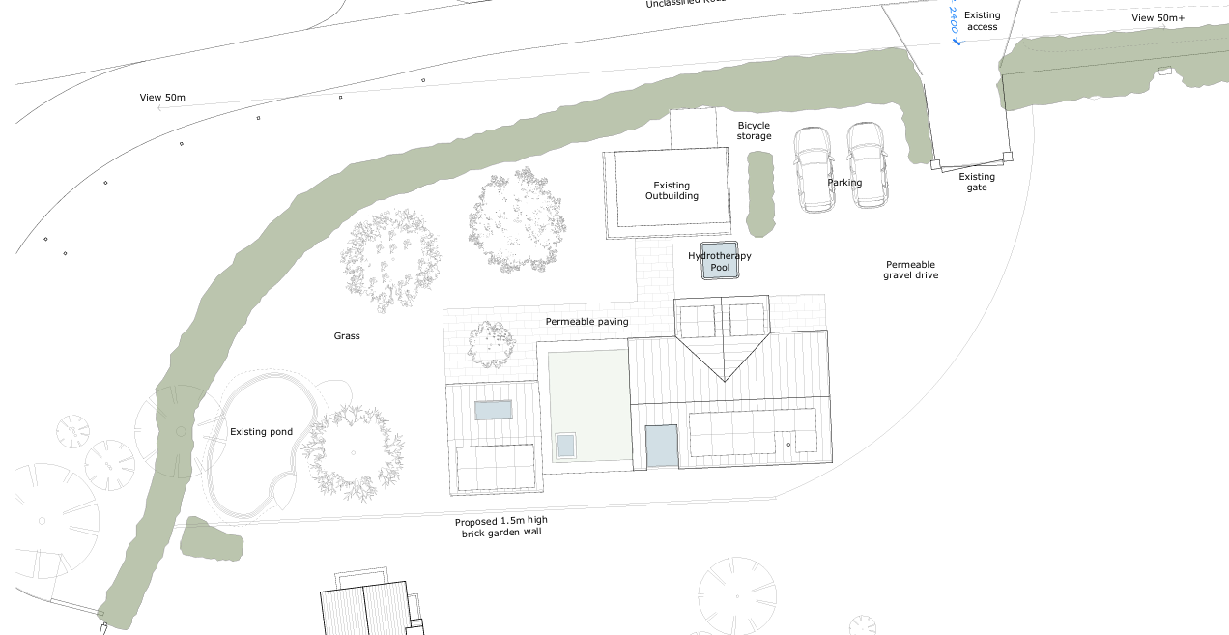
Proposed Site Plan

The proposed dwelling is of a scale and massing that reflects the established pattern of development within the locality, measuring approximately 7.1m to ridge with a footprint comparable to adjacent dwellings to the north. Its stepped form and retained separation distances ensure it reads as a subordinate addition within this loose grouping of low-density development, consistent with the informal and spacious character of the hamlet. The overall composition, including the articulated ‘T-shaped’ roof plan and ancillary elements, serves to break up the massing and avoids the appearance of a singular bulky structure.

In design terms, the proposal presents a blend of traditional and contemporary influences. The use of natural stone at lower levels reflects materials characteristic of the area, aligning with the Village Design Statement’s emphasis on development that complements local visual character. This is contrasted by a standing seam metal roof finish, which wraps slightly onto the upper elevations and gives the building a modern barn-like appearance. Whilst this introduces a more contemporary expression, it is considered to draw appropriately from agricultural forms present within the wider rural landscape. The fenestration is modern in detailing, including larger glazed openings, but these are balanced within a restrained palette and do not result in an overly urban or incongruous appearance.

The Village Design Statement encourages development that respects local character, including appropriate scale, materials and retention of rural features. While aspects such as the glazing and roof treatment depart from traditional forms, the proposal as a whole is considered to respond positively to its context, avoiding suburbanising features and maintaining a rural aesthetic. The inclusion of solar panels is also considered acceptable, being largely screened by existing hedgerows and visually recessive against the roof finish. Overall, the proposal is considered to achieve an appropriate balance between contemporary design and rural character, in accordance with Core Policy 57, the guidance of the Village Design Statement and the Wiltshire Design Guide.

Core Policy 51 seeks to protect, conserve and where possible enhance landscape character. The Council's Arboricultural Officer advised that a Tree Protection Plan and soft landscaping scheme should accompany the application. In respect of tree protection, the submitted Arboricultural Impact Assessment identifies that protective fencing will be required to safeguard retained trees and associated Root Protection Areas during construction. As no Tree Protection Plan was submitted with the application, it is considered reasonable and necessary to secure this detail by condition to ensure the long-term retention and protection of existing trees on the site.

With regard to landscaping, the submitted site layout indicates very limited alteration to the existing landscape structure of the site beyond patio and hard surfaces, as well as the proposed dwelling itself. The principal vegetative features comprise retained trees and established boundary hedgerows, the protection of which is secured through the recommended Tree Protection Plan condition and the Hedgerow Protection Plan required as part of the ecological mitigation strategy. In the absence of any significant new landscaping proposals, and given the retention of the site's existing landscape framework, it is not considered necessary or reasonable to require a separate hard and soft landscaping scheme in this instance.

Conservation and Heritage

Core Policy 58 requires heritage assets and their settings to be conserved in a manner appropriate to their significance. Policies HE4, HE5 and HE6 of the National Planning Policy Framework provide the principal national decision-making policies relevant to this proposal. Policy HE4 establishes that heritage assets are an irreplaceable resource and should be conserved in a manner appropriate to their significance. Policy HE5 requires decision-makers to identify and assess the significance of any heritage asset that may be affected by a proposal and to consider the impact of development upon that significance. Where development would result in harm to the significance of a designated heritage asset, Policy HE6 requires that harm to be given great weight and weighed against any public benefits arising from the proposal. In addition, Section 66(1) of the Planning (Listed Buildings and Conservation Areas) Act 1990 places a statutory duty on the Local Planning Authority to have special regard to the desirability of preserving listed buildings and their settings when determining planning applications.

Whilst the site does not lie within a Conservation Area, nor directly within the curtilage of a listed building, it is located in proximity to a Grade II* listed church. The setting of this asset is characterised by a predominantly open, rural landscape with limited and dispersed built form, and relatively little fenestration at an elevated level orientated toward the church. As such, the setting is particularly sensitive to intervention, especially where development may introduce visually prominent or illuminated features within outward views from or toward the heritage asset.

The Conservation Officer raised specific concerns in relation to the proposed east elevation, in particular the glazed gable and balcony arrangement at first floor level. It was considered that extensive glazing at this elevated position, when illuminated during hours of darkness, could result in light spill appearing as a visually intrusive and potentially distracting feature within the rural setting of the church to its detriment. In this context, the Conservation Officer had stated that the proposal as originally submitted was considered to give rise to a degree of less-than-substantial harm to the significance of the designated heritage asset through its setting, for which no clear public benefits had been identified to outweigh that harm.

The applicant has subsequently amended the proposal to reduce the extent of glazing to the east elevation, including the infilling of the upper triangular section above the balcony doors. This change significantly reduces the amount of glazing visible above the existing boundary hedgerow and correspondingly limits the potential for light spill. Whilst the Conservation Officer had also expressed a preference for the further removal of the flanking windows, it is considered that these elements, given their limited visibility above the hedgerow (notwithstanding some seasonal variation), can be satisfactorily controlled through the specification of glazing materials.

To this end, it is considered reasonable and necessary to impose a condition requiring the use of low light-transmission, non-reflective glazing to the remaining openings on this elevation. This approach will ensure that any outward light spill is minimised and that the development appears as a subdued and recessive feature within views toward the church, particularly during hours of darkness. When taken together with the reduction in glazing extent, this mitigation is considered sufficient to reduce the level of harm to the setting of the listed building to a negligible level, such that the statutory duty to preserve the asset and its setting is complied with.

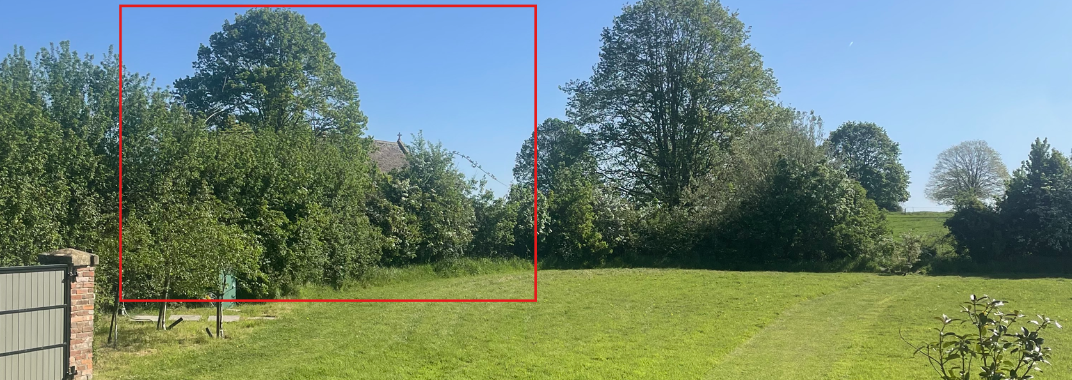
View of the Church from within the site

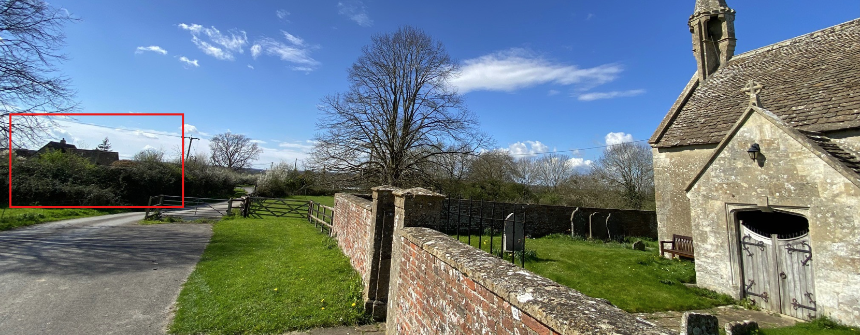
View of the host dwelling from the Church

Amenity

Core Policy 57 criterion vii seeks to ensure development does not have an unacceptable impact upon the amenities of neighbouring occupiers. Nationally, Policy P3 requires development proposals to provide healthy living conditions for occupiers and users and to avoid unacceptable impacts arising from loss of light, outlook, privacy, noise, disturbance or other forms of pollution. Policy DP3 additionally requires development to create liveable and attractive places for existing and future users. Accordingly, the assessment below considers the effect of the proposal upon neighbouring occupiers and whether acceptable living conditions would be maintained.

In respect of overlooking, the relationship with dwellings to the north is such that they are separated by the intervening highway and substantial boundary hedgerow, at a distance of approximately 30m, ensuring no material intervisibility. Openings within the northern elevation are confined to ground floor level, with the exception of a rooflight serving the studio element which is not associated with a habitable upper floor space and therefore does not give rise to overlooking concerns. To the west, while there are ground and limited upper-level openings, these are either angled or partially screened by the building’s form and intervening hedgerow, preventing direct lines of sight. To the south, the proposal includes limited ground floor openings and a larger vertically expressed window; however, these face obliquely toward the host dwelling and are partly screened by a proposed 1.5m boundary wall and existing level changes. Whilst the larger glazed element is more prominent, it serves a circulation space rather than a habitable room and would not result in sustained overlooking, with any views limited to transient glimpses. The eastern elevation contains more extensive glazing, including a recessed balcony, but as there are no neighbouring residential properties in this direction, no adverse impacts arise.

In terms of overbearing impact and outlook, the dwelling is modest in scale at approximately 7.1m to ridge and is set at an appropriate distance from surrounding properties, including circa 11m from the host dwelling and substantially greater distances to neighbouring dwellings beyond the road. The building’s 1.5-storey form and articulated massing ensure that it does not appear dominant or oppressive in the context of the site or its surroundings. With regard to overshadowing, the siting of the proposed dwelling to the north of the host property means that it would not interrupt the primary southern aspect or daylight received by neighbouring properties, and no unacceptable loss of light would occur. Some limited shading from the existing dwelling onto the proposed dwelling may occur during certain times of year; however, this would not materially affect the living conditions of future occupiers.

The proposal is appropriately sited, designed, and oriented to ensure that it would not result in unacceptable impact upon/to the amenities or living conditions of neighbouring residential occupiers, particularly in terms of outlook, privacy, or access to natural light. The proposal therefore accords with Core Policy 57 point vii in respect of safeguarding residential amenity and Appendix D of the Wiltshire Design Guide.

Transport and Highways

Core Policies 60, 61 and 64 of the Wiltshire Core Strategy seek to promote sustainable transport, secure safe access arrangements and ensure adequate parking provision. Nationally, Policies TR3 and TR4 of the National Planning Policy Framework require development to be located in sustainable locations where appropriate, provide safe access arrangements, prioritise walking, wheeling and cycling, and provide suitable parking provision having regard to the nature and location of the development. Policy TR6 confirms that development should be refused where it would result in a severe adverse impact on the transport network or an unacceptable impact on highway safety after consideration of any mitigation measures.

Core Policy 64, together with the Wiltshire Local Transport Plan and Car Parking Strategy, establishes minimum parking standards for new residential development based on dwelling size. In this instance, the proposal relates to a two-bedroom dwelling which would typically require a minimum of one parking space. The submitted site plan indicates provision for two off-street parking spaces together with adequate turning provision within the site, allowing vehicles to enter and exit in a forward gear.

Access to the site is to be taken from an existing vehicular access onto Whaddon Lane. The road is characterised as a quiet rural lane with low traffic speeds and good levels of visibility in both directions. The Local Highway Authority has been consulted and has raised no objection to the proposal, subject to the imposition of a condition to ensure that surface water from the development is not discharged onto the public highway.

Having regard to the above, it is considered that the proposal would not give rise to any unacceptable impacts on highway safety or the operation of the wider network. The development is therefore compliant with Core Policies 60, 61 and 64 of the Wiltshire Core Strategy and the provisions of the NPPF.

Ecology

Core Policy 50 of the Wiltshire Core Strategy seeks to protect and enhance biodiversity interests and ensure development avoids unacceptable harm to ecological assets. National policy is set out within Policies N2 and N6 of the National Planning Policy Framework. These policies require development proposals to minimise impacts upon biodiversity, protect important habitats and species, and secure opportunities for biodiversity enhancement where appropriate. Where significant harm to biodiversity cannot be avoided, adequately mitigated or compensated for, development should be refused. Biodiversity Net Gain (BNG) was established as a mandatory aspect of planning evaluation through Schedule 7A of the Town and Country Planning Act 1990 (as amended by the Environment Act 2021 Schedule 14).

The application site lies within the Yellow Risk Zone of the Trowbridge and Westbury Bat Mitigation Strategy and therefore falls within an area identified as supporting habitat of importance to qualifying bat species associated with the Bath and Bradford-on-Avon Bats Special Area of Conservation (SAC). The submitted Ecological Impact Assessment identified the site as comprising predominantly residential garden land of relatively limited ecological value, together with retained boundary hedgerows and an onsite pond which represent the principal ecological features of interest. Surveys recorded a diverse assemblage of bat species utilising the site, including occasional records of greater and lesser horseshoe bats associated with the SAC, whilst great crested newts were confirmed present within the pond. The assessment concluded that the most valuable ecological features, namely the northern and western hedgerows and the onsite pond, would be retained and protected as part of the development proposals.

Wiltshire Council's Ecology Officer initially requested further information in relation to the protection of boundary hedgerows and the mitigation strategy for great crested newts. Following the submission of a Hedgerow Protection Plan and confirmation that the development has been enrolled within the Great Crested Newt District Level Licensing Scheme, including submission of the relevant Impact Assessment and Conservation Payment Certificate, the Ecology Officer confirmed that these matters had been satisfactorily addressed and raised no objection subject to conditions. The proposed development has been specifically designed to minimise impacts upon bat commuting and foraging habitat through the retention and protection of boundary hedgerows, the positioning of the dwelling away from these features, limited fenestration on the northern and western elevations and the absence of proposed external lighting. Appropriate planning conditions are recommended requiring compliance with the submitted ecological mitigation measures and restricting the installation of external lighting unless first approved by the Local Planning Authority.

As the site lies within the zone of influence of the Bath and Bradford-on-Avon Bats SAC, the proposal has been subject to a Habitats Regulations Assessment. Wiltshire Council, acting as the competent authority, has undertaken an Appropriate Assessment which concludes that, subject to the proposed mitigation measures, the development would not result in an adverse effect on the integrity of the SAC either alone or in combination with other plans and projects. The assessment found that whilst a small area of bat foraging habitat would be lost, the retention and protection of hedgerow commuting corridors, restrictions on lighting and the provision of a financial contribution toward the strategic habitat mitigation measures contained within the Trowbridge and Westbury Bat Mitigation Strategy would satisfactorily mitigate identified impacts. Natural England has subsequently reviewed the Appropriate Assessment and confirmed that it agrees with the Council's conclusions and raises no objection to the development subject to the recommended mitigation and conditions being secured.

In respect of Biodiversity Net Gain, the proposal is put forward as a self-build dwelling and falls within the exemption provisions contained within Schedule 7A of the Town and Country Planning Act 1990 (as amended). A completed unilateral undertaking securing the self-build status of the development has been submitted and agreed by the Council. As such, the mandatory requirement to demonstrate a minimum 10% Biodiversity Net Gain does not apply in this instance.

Having regard to the submitted Ecological Impact Assessment, the conclusions of the Appropriate Assessment, the response from Natural England and the advice of the Council's Ecology Officer, it is considered that the proposal would not result in unacceptable harm to protected species, ecological networks, or the integrity of the Bath and Bradford-on-Avon Bats SAC. Subject to the recommended planning conditions, the proposal accords with Core Policy 50 of the Wiltshire Core Strategy and the biodiversity objectives of the National Planning Policy Framework.

Flooding and Drainage

Core Policy 67 of the Wiltshire Core Strategy seeks to ensure that development is directed away from areas at greatest risk of flooding and is designed to minimise vulnerability to flooding whilst avoiding any increase in flood risk elsewhere. National planning policy relating to flood risk and drainage is contained within Policies F4 to F8 of the National Planning Policy Framework. Collectively, these policies establish a risk-based approach to the location and assessment of development proposals. The Framework requires flood risk to be properly assessed where necessary, seeks to direct development towards areas at the lowest risk of flooding through the application of the sequential approach where applicable, and ensures that development remains safe for its lifetime without increasing flood risk elsewhere. The policies also support the incorporation of sustainable drainage measures where appropriate in order to manage surface water runoff and reduce the potential for flooding.

The principle of residential development on the site has been established through the grant of Permission in Principle (ref. PL/2025/03764). As such, the suitability of the site in flood risk terms, including the application of the sequential approach set out within the National Planning Policy Framework, has been accepted and does not form part of this Technical Details Consent assessment. The current assessment therefore relates only to the technical feasibility of drainage arrangements for the proposed dwelling.

The application site is located within Flood Zone 1 and is therefore at low risk of fluvial flooding. The Council’s Strategic Flood Risk Assessment and Environment Agency mapping identify a limited area of surface water flood risk (0.1% AEP) associated with a pond within the wider garden area; however, this is located away from the footprint of the proposed dwelling and is not considered to present a constraint to development. The site is currently laid to a mix of hard and soft surfacing, including patio and domestic garden, and therefore already exhibits a degree of impermeability.

Whilst detailed drainage proposals have not been submitted as part of this application, there is no evidence to suggest that an appropriate surface water drainage strategy could not be achieved on site. Given the scale and nature of the development, it is considered reasonable to secure full details of surface water and foul drainage by condition. This will ensure that runoff is appropriately managed, incorporating sustainable drainage principles where feasible, and that the development does not increase flood risk elsewhere.
Subject to the imposition of appropriate planning conditions, the proposal is therefore considered to accord with the provisions of Core Policy 67 of the Wiltshire Core Strategy and the National Planning Policy Framework.

CONCLUSION

The principle of a single dwelling on the site has been established by the extant Permission in Principle, with this application seeking approval of the detailed design and technical matters. Having carefully considered the proposal against the provisions of the Development Plan, the National Planning Policy Framework and all other material considerations, it is concluded that the dwelling represents an appropriately designed form of development which would integrate successfully within its rural surroundings, preserve the setting and significance of the nearby Grade II* listed Church of St Mary, safeguard neighbouring residential amenity, provide acceptable access and parking arrangements, and avoid unacceptable impacts upon biodiversity, including the Bath and Bradford-on-Avon Bats SAC. Subject to the recommended planning conditions, the proposal is considered to accord with Core Policies 50, 57, 58, 60, 61, 64 and 67 of the Wiltshire Core Strategy, Policy 3 of the Hilperton Neighbourhood Plan and the relevant provisions of the National Planning Policy Framework. Accordingly, the application is recommended for approval.

RECOMMENDATION: That Planning Permission be GRANTED subject to conditions

