APPLICATION FOR FULL-PLANNING PERMISSION
CASE OFFICER REPORT

APPLICATION REFERENCE: | PL/2026/03633
APPLICATION TYPE: | Listed Building Consent
SITE ADDRESS: | Yarnfield Manor, Maiden Bradley, Warminster, BA12 7HX
DEVELOPMENT DESCRIPTION: | Internal and external alterations to faciliate change of use to dwelling.
RECOMMENDATION: | Approve with conditions

SITE DESCRIPTION/CONTEXT

The application site relates to an existing converted building at the far north-eastern side of Grange Farm. The site is located in the open countryside where Grange Farmhouse which lied approximately 70m to the South West is Grade II Listed.

Grange Farmhouse is listed as follows:

MAIDEN BRADLEY DUKES LANE ST 73 NE (north side) 3/96 Grange Farmhouse II Farmhouse. Early C18, altered and extended Cl9. Rubble stone; front rendered, 2-span tiled roof, gable end stone stacks with moulded stone cappings. Two parallel ranges. Two-storey, 3-window front. Central 4-panelled door in beaded architrave within stone segmental-headed porch, two 2-light beaded mullioned sashes either side, string course at lintel level. First floor has three 2-light beaded mullioned sashes. Right return has single and 2-light casements. Rear has central planked door with C19 four-light casement either side, first floor with 4-light and 2-light casements. Attached to left return is single-storey rubble stone extension with 2-light casements and hipped dormer. Interior has mainly C19 fittings.

The site is located within the Cranborne and Chase West Wiltshire Downs National Landscape and within the River Avon Catchment (Hampshire River Avon Sub-Catchment).

The building itself is considered to be a heritage asset and is curtilage listed.

PROPOSAL

The building subject of this application has already been converted into residential following applications 15/04764/FUL and 2015/2106 for a holiday let and grooms accommodation. However the building was not built in accordance with the approved plans and has been left redundant by its previous owners.

It is not known by the current owners what application had been implemented and has no active use.

Changes to the building in question include (following amended plans) a ground floor window and replacement of render with lime on the south west elevation, two conservation rooflights and two ground floor windows on the north eastern elevation. Rainwater goods are to be replaced in cast iron, hip tiles are to be replaced and render is to be removed and replaced in lime. and

The proposal also sees the removal of the menage and a concrete block wall and the creation of a parking/turning area for 2 vehicles with a post and rail fence to the garden boundary.

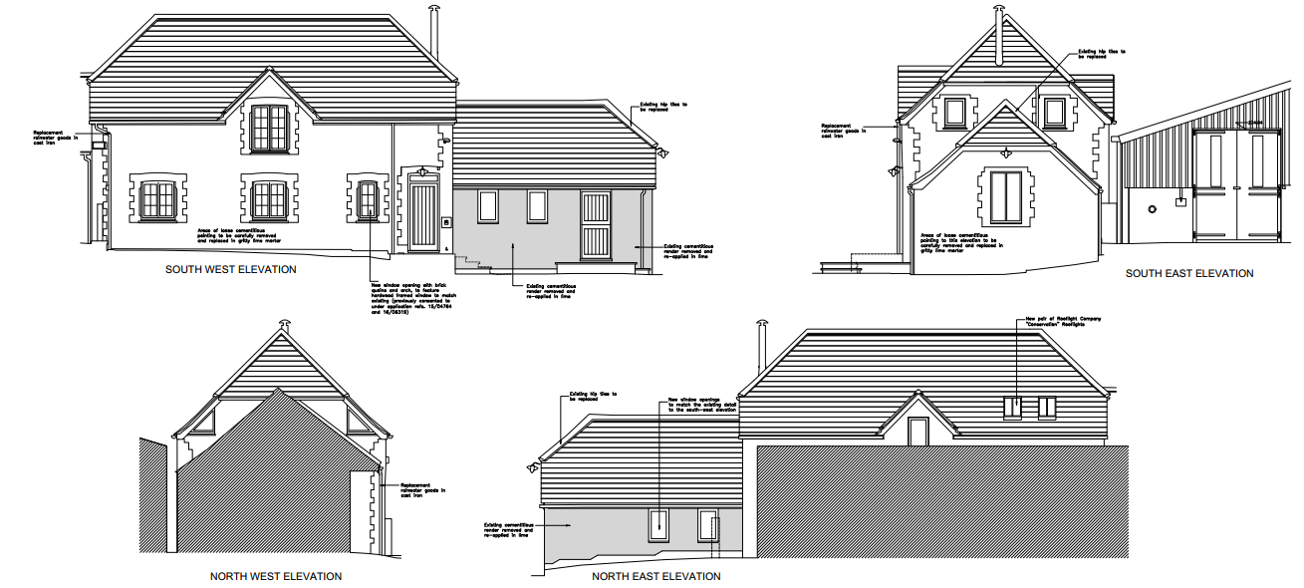

Also proposed are internal changes which include the following:

- Modern chimney piece to be replaced
- Upgrading of stud wall
- Formation of shower cubicle to the first floor bathroom through the changing of stud wall

PLANNING HISTORY

14/05328/FUL - Change of use of Dairy Cottage from agricultural to residential with associated alterations including new windows and doors to west and south elevation, new chimney to south elevation and 2 roof lights to east elevation – Withdrawn

15/04764/FUL - Change of use of Dairy Cottage from agricultural to residential with associated alterations – Approved

15/04937/LBC - Internal and external alterations to facilitate the change of use from agriculture to residential – Approved

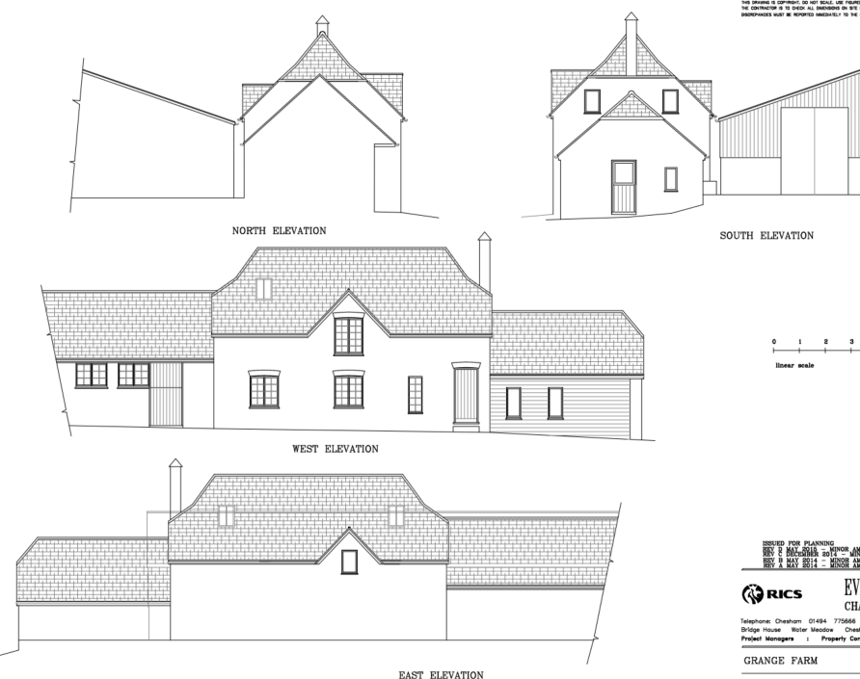

16/06319/FUL - Change of use from Agricultural to Residential for the purposes of Holiday Lettings. – Approved

16/06935/LBC - Internal and external alterations to facilitate the change of use to residential for the purpose of holiday lettings.- Approved

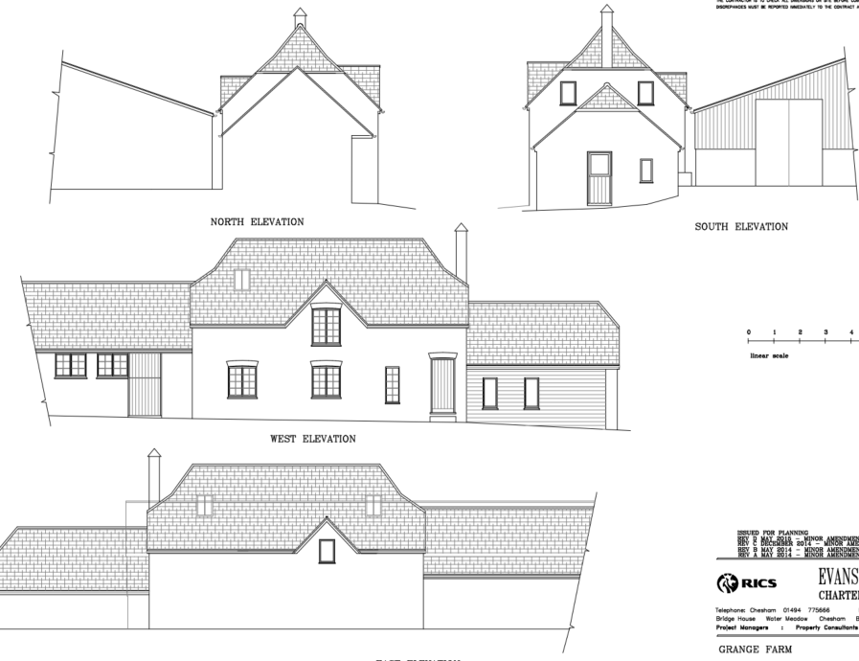

RELEVANT LEGISLATION, POLICIES AND GUIDANCE
Statutory Legislation:

National Planning Policy:
- National Planning Policy Framework (NPPF)
- Planning Practice Guidance (PPG)
- National Design Guide
Development Plan:
The development plan for Wiltshire comprises the Wiltshire Core Strategy (WCS) (adopted January 2015) and any made neighbourhood plans, which remains the principal statutory planning document guiding development across the county. In line with Section 38(6) of the Planning and Compulsory Purchase Act 2004, planning decisions must be made in accordance with the development plan unless material considerations indicate otherwise.

Though the development plan is considered as a whole, those parts deemed to be particularly relevant to this application are listed below:

The adopted Wiltshire Core Strategy (WCS), with particular regard to:

- Core Policy 58 Ensuring the Conservation of the Historic Environment;

Draft Wiltshire Local Plan
At Full Council on 19 May 2026, the elected members of Wiltshire Council agreed to withdraw the emerging Wiltshire Local Plan. The said Plan has no material weight for the purposes of the application.

In accordance with Regulation 19 of the Town and Country Planning (Local Planning) (England) Regulations 2026, on 30th June 2026 Wiltshire Council published a notice of intention to prepare a new local plan for Wiltshire. The next stage is a Scoping Consultation which commences on 2nd September 2026. This plan is at a very early stage and currently carries no weight for decision making.

Neighbourhood Plan: No NP

ISSUES
The main issues that need to be addressed in this case include:

- Whether the scheme would preserve or enhance the historic environment (CP 58)

CONSULTATION RESPONSES
WC Highways: No objection subject to conditions

WC Conservation: No objection subject to conditions

WC Ecology: No objection

Maiden Bradley Parish Council: Nothing received at time of writing

REPRESENTATIONS
In accordance with the requirements of the Town and Country Planning (Development Management Procedure) (England) Order 2015 (as amended), the application was publicised by way of:

- Neighbour notification letters sent to adjoining and nearby properties;
- A site notice displayed near the site;
- An advertisement placed in the local press

These methods were used to inform interested parties and provide a period of 21 days for comments to be submitted.

Below is a summary of the representations received during the consultation period. Only material planning considerations have been taken into account in the assessment of this application. Non-material issues, such as property values or private legal disputes, cannot be considered in the determination process.

No letters have been received from third parties by the Local Planning Authority

ASSESSMENT
Section 38(6) of the Planning and Compulsory Purchase Act 2004 states:

"If regard is to be had to the development plan for the purposes of any determination to be made under the planning Acts, the determination must be made in accordance with the plan unless material considerations indicate otherwise."

In accordance with this statutory requirement, this application has been assessed against the relevant policies of the Development Plan, including the Wiltshire Core Strategy (2015) and, where applicable, any made Neighbourhood Plans. Consideration has also been given to the policies of the National Planning Policy Framework (NPPF) as a material consideration in the assessment.

Impact on Heritage Assets
Policy Context
From the point of view of the historic environment, the main statutory duties are set out within the Planning (Listed Buildings and Conservation Areas) Act 1990.

Section 66(1) requires special regard to be given to the desirability of preserving listed buildings, their settings and any features of special architectural or historic interest which they possess.

Core Policy 58 of the Wiltshire Core Strategy seeks to conserve and, where appropriate, enhance the significance of designated and non-designated heritage assets and their settings. Core Policy 57 requires development to respond positively to local character and historic context through high quality design.

Policies HE4-HE10 of the NPPF recognise heritage assets as an irreplaceable resource and require proposals affecting heritage assets to be assessed having regard to their significance and the contribution made by their setting.

Assessment
In assessing this aspect of the proposal, regard has been had to the site context, the details of the proposed development, the relevant development plan policies, and all other material considerations. The key considerations are set out below.

The significance of the building in question lies largely with its historic fabric and vernacular design, using local materials, and its group setting as a farmstead with the main house which have significant aesthetic and historic interest, and which contribute to the setting of the listed buildings.

The original building was formed of a single room to the ground and first floor, with two open bays to the right-hand side. The original consent for conversion incorporated part of the adjoining building (to the lefthand side) to allow for the creation of a large en-suite to the proposed ground floor bedroom. The ground floor of the main building was sub-divided to create a bedroom and living space, and a new staircase was inserted. The first floor was sub-divided to create two further bedrooms and a bathroom. The former open bays were enclosed and converted to form a kitchen. To the rear, a small Utility / Cloak Room was approved.

The ‘existing’ floor plans in this submission do not correspond with the previously approved floor plan. The ground floor ensuite was not undertaken but incorporated into the bedroom. The staircase is now a straight flight of stairs rather than dog legged. The rear Utility/ Cloak Room was not formed and this opening closed. The kitchen was formed, but the external door has been relocated from the gable end to the front elevation, and the gable elevation has a larger, central window installed. There are two additional windows (bedroom and bathroom) to the first floor (left-hand side elevation). The exterior has a more domestic appearance due to the enlarged window openings and the position of the doors.

The proposed scheme looks to undertake the following works:
Ground floor
• New Window to living Room
This was approved as part of the previous consented schemes, and as the works have commenced, this still has permission to be installed, and therefore no objection is raised.

• Modern Chimney piece to be replaced
This is clearly a modern, off the shelf surround, and therefore the proposed replacement is considered to cause no harm to the significance of the listed building.

• Upgrade of stud wall
This is a modern stud wall, and therefore the up grading is considered not to cause harm to the significance of the listed building.

• Replacement of windows to front and side elevations
The principle of replacing the modern windows is acceptable

• Formation of two new windows to the rear elevation of the kitchen
The proposed scheme looks to create two windows to the rear elevation which respond to the two windows on the front elevation. This wall was originally blind and would have been blind for security and practical reasons. The inward-looking nature of farm buildings forms part of their significance. It has not been clearly demonstrated that the additional windows are required to provide natural light or ventilation into the kitchen space. As previously noted, the existing windows are not as approved.

• Replacement of hips tiles to single storey element
The proposed replacement of these is acceptable.

• Formation of new shower cubicle to the first-floor bathroom through the changing of stud
wall
The first floor was originally open and has been sub-divided to create a bathroom and two bedrooms. The insertion of the shower will impact the modern fabric stud walls. There is no understanding if the shower tray will be flush or insert into the floor which could have some impact to the historic floor joists. This harm would be minimal, and it has not been demonstrated that the creation of the shower will not cause harm to the historic fabric.

• Pair of new rooflights to rear elevation over bathroom
The approved drawing had two rooflights to this elevation, and therefore the change of location for these rooflights is considered to be acceptable. These rooflights should be conservation/ flush.

• Replacement of UPVc rainwater goods with cast iron
This is supported as the materials are more traditional.

• Removal of menage and block wall
This is supported but offer limited heritage benefit to the setting of the listed building as the menage and block wall are considered to cause no harm to the setting of the listed buildings.

Conclusion
Following the amendments to the submitted proposed elevations, the porch, half-glazed door and change of style of the windows has been omitted from the original submitted scheme, and these changes are supported by the Conservation Officer. The rear two windows of the kitchen have been retained, but the removal of the other elements which were considered to cause more harm, the creation of the two windows to the rear elevation is considered acceptable, with the longer-term benefits and works to the estate considered to outweigh the harm. It is therefore considered that the proposal would cause less than substantial harm which would be outweighed by public benefits which include the heritage benefit and although minimal, an additional dwelling at a time when the LPA are not able to demonstrate a five year housing land supply and as such would comply with the associated policies.

PLANNING BALANCE AND CONCLUSION
In reaching a decision, all identified harms and benefits must be weighed in the overall planning balance, having regard to Section 38(6) of the Planning and Compulsory Purchase Act 2004, the provisions of the Development Plan and the NPPF.

The NPPF contains a presumption in favour of sustainable development. Applications should be determined in accordance with the development plan unless material considerations indicate otherwise.

The weight to be afforded to any identified benefits must be considered alongside all other material considerations, including whether the proposal accords with the Development Plan and whether any other policies of the NPPF indicate that development should be refused or that substantial weight should be attributed to identified harms.

The proposal conflicts with the Development Plan when read as a whole. Accordingly, the statutory duty under Section 38(6) of the Planning and Compulsory Purchase Act 2004 requires that planning permission be refused unless material considerations indicate otherwise.

The application site would comply with CP58 of the WCS and policies contained in the NPPF.

RECOMMENDATION:
That Listed Building Consent be GRANTED, subject to conditions

