APPLICATION FOR FULL-PLANNING PERMISSION
CASE OFFICER REPORT

APPLICATION REFERENCE: | PL/2026/03633
APPLICATION TYPE: | Full planning permission
SITE ADDRESS: | Yarnfield Manor, Maiden Bradley, Warminster, BA12 7HX
DEVELOPMENT DESCRIPTION: | Change of use of Dairy Cottage to separate residential use and associated alterations and landscape enhancements
RECOMMENDATION: | Approve with conditions

SITE DESCRIPTION/CONTEXT

The application site relates to an existing converted building at the far north-eastern side of Grange Farm. The site is located in the open countryside where Grange Farmhouse which lied approximately 70m to the South West is Grade II Listed.

Grange Farmhouse is listed as follows:

MAIDEN BRADLEY DUKES LANE ST 73 NE (north side) 3/96 Grange Farmhouse II Farmhouse. Early C18, altered and extended Cl9. Rubble stone; front rendered, 2-span tiled roof, gable end stone stacks with moulded stone cappings. Two parallel ranges. Two-storey, 3-window front. Central 4-panelled door in beaded architrave within stone segmental-headed porch, two 2-light beaded mullioned sashes either side, string course at lintel level. First floor has three 2-light beaded mullioned sashes. Right return has single and 2-light casements. Rear has central planked door with C19 four-light casement either side, first floor with 4-light and 2-light casements. Attached to left return is single-storey rubble stone extension with 2-light casements and hipped dormer. Interior has mainly C19 fittings.

The site is located within the Cranborne and Chase West Wiltshire Downs National Landscape and within the River Avon Catchment (Hampshire River Avon Sub-Catchment).

The building itself is considered to be a heritage asset and is curtilage listed.

PROPOSAL

The building subject of this application has already been converted into residential following applications 15/04764/FUL and 2015/2106 for a holiday let and grooms accommodation. However the building was not built in accordance with the approved plans and has been left redundant by its previous owners.

It is not known by the current owners what application had been implemented and has no active use.

Changes to the building in question include (following amended plans) a ground floor window and replacement of render with lime on the south west elevation, two conservation rooflights and two ground floor windows on the north eastern elevation. Rainwater goods are to be replaced in cast iron, hip tiles are to be replaced and render is to be removed and replaced in lime.

The proposal also sees the removal of the menage and a concrete block wall and the creation of a parking/turning area for 2 vehicles with a post and rail fence to the garden boundary.

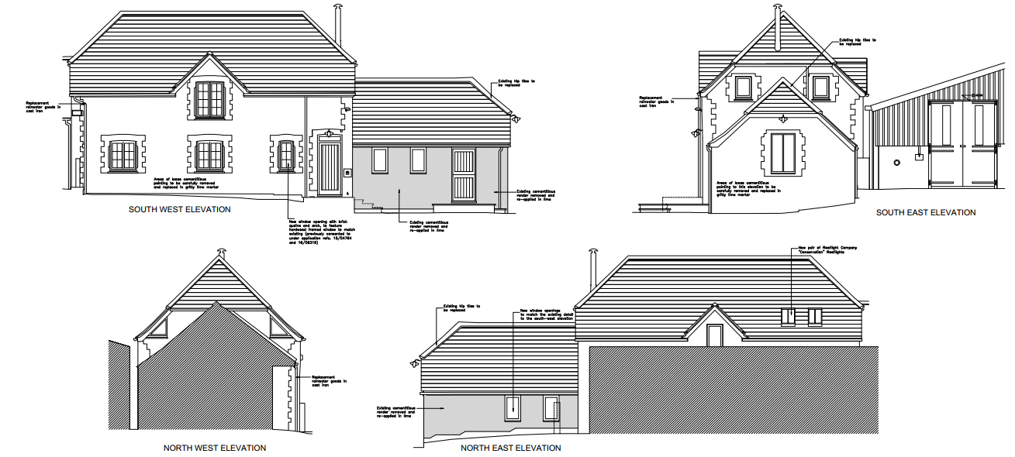

Also proposed are internal changes which include the following:

- Modern chimney piece to be replaced
- Upgrading of stud wall
- Formation of shower cubicle to the first floor bathroom through the changing of stud wall

PLANNING HISTORY

14/05328/FUL - Change of use of Dairy Cottage from agricultural to residential with associated alterations including new windows and doors to west and south elevation, new chimney to south elevation and 2 roof lights to east elevation – Withdrawn

15/04764/FUL - Change of use of Dairy Cottage from agricultural to residential with associated alterations – Approved

15/04937/LBC - Internal and external alterations to facilitate the change of use from agriculture to residential – Approved

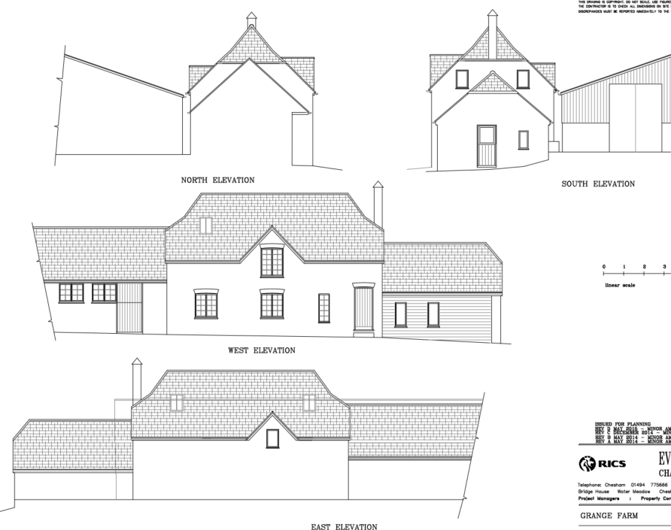

16/06319/FUL - Change of use from Agricultural to Residential for the purposes of Holiday Lettings. – Approved

16/06935/LBC - Internal and external alterations to facilitate the change of use to residential for the purpose of holiday lettings.- Approved

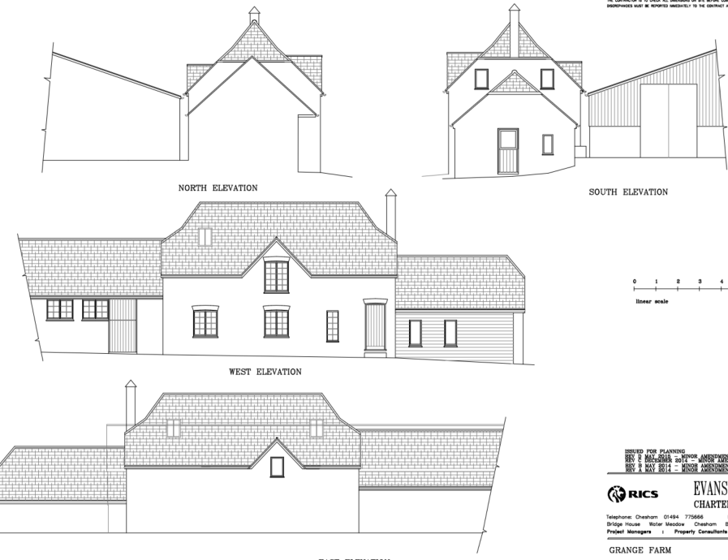

RELEVANT LEGISLATION, POLICIES AND GUIDANCE
Statutory Legislation:

National Planning Policy:
- National Planning Policy Framework (NPPF)
- Planning Practice Guidance (PPG)
- National Design Guide
Development Plan:
The development plan for Wiltshire comprises the Wiltshire Core Strategy (WCS) (adopted January 2015) and any made neighbourhood plans, which remains the principal statutory planning document guiding development across the county. In line with Section 38(6) of the Planning and Compulsory Purchase Act 2004, planning decisions must be made in accordance with the development plan unless material considerations indicate otherwise.

Though the development plan is considered as a whole, those parts deemed to be particularly relevant to this application are listed below:

The adopted Wiltshire Core Strategy (WCS), with particular regard to:

- Core Policy 1 Settlement Strategy;
- Core Policy 2 Delivery Strategy;
- Core Policy 31 Spatial Strategy Warminster
- Core Policy 45 Meeting Wiltshire’s Housing Needs;
- Core Policy 50 Biodiversity and Geodiversity;
- Core Policy 51 Landscape
- Core Policy 52 Green Infrastructure
- Core Policy 57 Ensuring High Quality Design and Place Shaping;
- Core Policy 58 Ensuring the Conservation of the Historic Environment;
- Core Policy 60 Sustainable Transport;
- Core Policy 61 Transport & Development;
- Core Policy 62 Development Impacts on the Transport Network;
- Core Policy 63 Transport Strategies
- Core Policy 64 Demand Management
- Core Policy 67 Flood Risk;
- Core Policy 68 Water Resources;
- Core Policy 69 Protection of the River Avon SAC

Draft Wiltshire Local Plan
At Full Council on 19 May 2026, the elected members of Wiltshire Council agreed to withdraw the emerging Wiltshire Local Plan. The said Plan has no material weight for the purposes of the application.

In accordance with Regulation 19 of the Town and Country Planning (Local Planning) (England) Regulations 2026, on 30th June 2026 Wiltshire Council published a notice of intention to prepare a new local plan for Wiltshire. The next stage is a Scoping Consultation which commences on 2nd September 2026. This plan is at a very early stage and currently carries no weight for decision making.

Neighbourhood Plan: No NP

Supplementary Planning Documents and other Guidance:
- Wiltshire Design Guide (adopted April 2024)
- Wiltshire Local Transport Plan 2011-2026, adopted 2015 - including the Car Parking Strategy and Cycling Strategy, adopted 2015
- A Green & Blue Infrastructure Strategy for Wiltshire: Wiltshire’s Natural Environment Plan 2022-2030

ISSUES
The main issues that need to be addressed in this case include:

- Whether the proposal constitutes EIA development
- Whether the development is acceptable in principle (CP 1 and 2)
- Whether the scheme constitutes high quality design (CP 57)
- Whether the scheme would have an acceptable impact upon the reasonable living conditions of the adjoining occupants (CP 57)
- Whether the scheme would preserve or enhance the historic environment (CP 58)
- Whether the scheme would have an acceptable landscape impact (CP 51)
- Whether the proposal would have a negative effect upon highway safety, including if there is sufficient parking for the proposed development (CP 61 and 64)
- Whether the site can be adequately drained without increasing flood risk elsewhere (CP 67)
- Whether there would be any harmful impacts upon protected species or priority habitats (CP 50)
- Are there any other planning issues raised by the development?

CONSULTATION RESPONSES
WC Highways: No objection subject to conditions

WC Conservation: No objection subject to conditions

WC Ecology: No objection

Maiden Bradley Parish Council: Nothing received at time of writing

REPRESENTATIONS
In accordance with the requirements of the Town and Country Planning (Development Management Procedure) (England) Order 2015 (as amended), the application was publicised by way of:

- Neighbour notification letters sent to adjoining and nearby properties;
- A site notice displayed near the site;
- An advertisement placed in the local press

These methods were used to inform interested parties and provide a period of 21 days for comments to be submitted.

Below is a summary of the representations received during the consultation period. Only material planning considerations have been taken into account in the assessment of this application. Non-material issues, such as property values or private legal disputes, cannot be considered in the determination process.

No letters have been received from third parties by the Local Planning Authority

ASSESSMENT
Section 38(6) of the Planning and Compulsory Purchase Act 2004 states:

"If regard is to be had to the development plan for the purposes of any determination to be made under the planning Acts, the determination must be made in accordance with the plan unless material considerations indicate otherwise."

In accordance with this statutory requirement, this application has been assessed against the relevant policies of the Development Plan, including the Wiltshire Core Strategy (2015) and, where applicable, any made Neighbourhood Plans. Consideration has also been given to the policies of the National Planning Policy Framework (NPPF) as a material consideration in the assessment.

Environmental Impact Assessment (EIA) Screening
In accordance with the Town and Country Planning (Environmental Impact Assessment) Regulations 2017 (as amended), the local planning authority has considered whether the proposed development constitutes EIA development.

No formal screening opinion was requested or issued. However, the local planning authority has considered the scale and nature of the development as part of the application process and is satisfied that it does not constitute EIA development under the 2017 Regulations.

Principle of Development
Policy Context
Core Policies 1 and 2 of the Wiltshire Core Strategy establish the overarching spatial strategy for Wiltshire and provide the primary Development Plan framework for determining whether development is appropriately located. Together, these policies seek to direct growth towards the most sustainable locations whilst protecting the intrinsic character and beauty of the countryside. The strategy prioritises development within Principal Settlements, Market Towns, Local Service Centres and larger villages, whilst development in the countryside will only be supported where it accords with specific development plan policies or where material considerations indicate otherwise.

Annex A of the NPPF states that development-plan policies, or parts of policies, which are materially inconsistent with national decision-making policies should be given very limited weight unless they were examined and adopted against the current Framework. Other policies should not be given reduced weight merely because of their age. The relationship between Core Policies 1, 2 and 31 and NPPF Policy S5 is considered below.

The NPPF also contains national policies relating to the location of development. Policies S3-S5 distinguish between development within settlements and development in the countryside, support sustainable patterns of growth, and require decisions to have regard to the role and function of settlements, accessibility to services and facilities, and other site-specific considerations.

The principle of development should be assessed having regard to the Development Plan as a whole, the NPPF and all other material considerations. The weight afforded to individual policies will depend upon the nature, scale and location of the development proposed.
Policy HO7 of the NPPF recognises the importance of delivering homes which contribute towards meeting the evidenced accommodation needs of the community and states that substantial weight should be given to the benefits of providing such homes.

Assessment
The site is located outside the limits of development and as such is considered to be in the open countryside. The history of the site demonstrates that consent has been granted for an agriculturally tied dwelling and also a holiday let which was considered under CP39 & CP48. The applicant is of the opinion that as the building has not been converted in accordance with the approved plans the use is therefore in-active.

However, the building has been built in broad accordance with the approved plans albeit there are some differences regarding windows, roof slant, doors and a porch. The floor layouts are also slightly different. It is considered that the changes are not so vast to result in one of the two previous consents not being implemented. With this in mind, the current use of the building would either be an agriculturally tied dwelling or a holiday let.

Core Policy 48 relates to the conversion and re-use of existing rural buildings. As the building has already been converted this policy would not be relevant. Marketing has not been put forward as part of the application to demonstrate that neither an agriculturally tied dwelling or holiday let are no longer required in the area.
The proposal would result in a separate residential dwelling outside a defined settlement and would therefore conflict with the locational strategy in Core Policies 1, 2 and 31. That conflict must, however, be considered alongside the express national support in Policy S5 for certain forms of development outside settlements.

When applying the tests of the NPPF, the first question is whether the proposal falls within one of the categories of development identified by Policy S5(1) as potentially acceptable outside settlements.

• S5(1)(c): The reuse, extension, alteration or replacement of an existing building, provided that the existing building is of permanent and substantial construction, is lawful in planning terms, and any extension or alteration will not result in a disproportionate increase in size compared to the existing building.

The proposal concerns the reuse and alteration of an existing building without an extension. The building is of permanent and substantial construction. Subject to the lawful planning status being established for the reasons set out above, the proposal falls within Policy S5(1)(c). Policy S5 states that development falling within this category should be approved unless its benefits would be substantially outweighed by adverse effects when assessed against the national decision-making policies in the Framework. That balance is undertaken in the Planning Balance and Conclusion section.

Conclusion
The proposal conflicts with the locational strategy in Core Policies 1, 2 and 31. However, it falls within the category of development supported by NPPF Policy S5(1)(c), subject to confirmation that the existing building is lawful in planning terms. The principle of development is therefore supported unless the benefits of approval are substantially outweighed by adverse effects assessed against the relevant national decision-making policies.

5 Year Housing Land Supply
The Council's latest Housing Land Supply Statement provides the most up-to-date position regarding the availability of deliverable housing land within Wiltshire and is a material consideration in the determination of planning applications.

The NPPF requires local planning authorities to identify and maintain a supply of specific deliverable housing sites. Housing need, housing requirements, and the supply of deliverable sites are addressed through Policies HO1 to HO6 (for plan-making) and HO7 to HO13 (for decision taking) and Annex D of the NPPF. Annex D sets out the methodology for calculating housing need, assessing land supply, the application of housing land supply buffers using the latest Housing Delivery Test results, and establishing a five-year supply of deliverable housing sites.

The Council's current housing land supply position demonstrates a supply of 2.8 years of deliverable housing land against the relevant housing requirement. This position is a material consideration when assessing proposals for residential development. Where a shortfall exists, this indicates that the Council is unable to demonstrate a full five-year supply of deliverable housing sites and this is capable of attracting significant weight in favour of proposals which would contribute towards meeting identified housing needs. Conversely, where a five-year supply can be demonstrated, this is also a material consideration to be afforded appropriate weight in the overall planning balance. Policy HO7 requires substantial weight to be given to the benefit of providing homes which contribute towards meeting evidenced accommodation needs. The proposal would make a limited numerical contribution of one dwelling, but substantial policy weight is attached to that housing benefit.

In determining this application, regard has been had to the Council's current housing land supply position, the relevant housing policies of the development plan, the housing objectives of the NPPF, and all other material considerations. The extent to which the Council's housing land supply position affects the weight to be afforded to housing delivery and other material considerations has been considered as part of the planning balance set out below.

The contribution that this proposal would make towards meeting housing needs, together with any other benefits and harms arising from the development, is assessed within the overall planning balance and conclusion sections of this report.

Design and Impact on the Character and Appearance of the Area
Policy Context
Core Policy 57 of the Wiltshire Core Strategy requires development to achieve a high standard of design that responds positively to local character, context and distinctiveness.

Policies DP1-DP4 of the NPPF seek to ensure that development is well-designed, visually attractive, sustainable and responsive to its surroundings. Development should contribute positively to local character, create high quality places and support healthy and inclusive communities.

The Wiltshire Design Guide provides further guidance on achieving high quality, context-led design and should be taken into account where relevant.

Assessment
In assessing this aspect of the proposal, regard has been had to the site context, the details of the proposed development, the relevant development plan policies, and all other material considerations. The key considerations are set out below.

The proposal results in minimal external changes to the building itself which by reason of their location, design and materials are considered appropriate to the existing building and their immediate setting.

The proposal includes the removal of a menage and concrete brick wall which will be replaced by grassland. There is no objection to their removal in design terms or to the proposed grassland.

Also proposed is a post and rail fence which is considered to be appropriate to its rural/agricultural area.

Conclusion
There is no objection to the change of use, removal of the menage and concrete wall or the erection of a post and rail fence. The proposal is therefore considered to comply with the relevant criteria of CP57.

Impact on Heritage Assets
Policy Context
From the point of view of the historic environment, the main statutory duties are set out within the Planning (Listed Buildings and Conservation Areas) Act 1990.

Section 66(1) requires special regard to be given to the desirability of preserving listed buildings, their settings and any features of special architectural or historic interest which they possess.

Core Policy 58 of the Wiltshire Core Strategy seeks to conserve and, where appropriate, enhance the significance of designated and non-designated heritage assets and their settings. Core Policy 57 requires development to respond positively to local character and historic context through high quality design.

Policies HE4-HE10 of the NPPF recognise heritage assets as an irreplaceable resource and require proposals affecting heritage assets to be assessed having regard to their significance and the contribution made by their setting.

Assessment
In assessing this aspect of the proposal, regard has been had to the site context, the details of the proposed development, the relevant development plan policies, and all other material considerations. The key considerations are set out below.

The significance of the building in question lies largely with its historic fabric and vernacular design, using local materials, and its group setting as a farmstead with the main house which have significant aesthetic and historic interest, and which contribute to the setting of the listed buildings.

The original building was formed of a single room to the ground and first floor, with two open bays to the right-hand side. The original consent for conversion incorporated part of the adjoining building (to the lefthand side) to allow for the creation of a large en-suite to the proposed ground floor bedroom. The ground floor of the main building was sub-divided to create a bedroom and living space, and a new staircase was inserted. The first floor was sub-divided to create two further bedrooms and a bathroom. The former open bays were enclosed and converted to form a kitchen. To the rear, a small Utility / Cloak Room was approved.

The ‘existing’ floor plans in this submission do not correspond with the previously approved floor plan. The ground floor ensuite was not undertaken but incorporated into the bedroom. The staircase is now a straight flight of stairs rather than dog legged. The rear Utility/ Cloak Room was not formed and this opening closed. The kitchen was formed, but the external door has been relocated from the gable end to the front elevation, and the gable elevation has a larger, central window installed. There are two additional windows (bedroom and bathroom) to the first floor (left-hand side elevation). The exterior has a more domestic appearance due to the enlarged window openings and the position of the doors.

The proposed scheme looks to undertake the following works:
Ground floor
• New Window to living Room
This was approved as part of the previous consented schemes, and as the works have commenced, this still has permission to be installed, and therefore no objection is raised.

• Modern Chimney piece to be replaced
This is clearly a modern, off the shelf surround, and therefore the proposed replacement is considered to cause no harm to the significance of the listed building.

• Upgrade of stud wall
This is a modern stud wall, and therefore the up grading is considered not to cause harm to the significance of the listed building.

• Replacement of windows to front and side elevations
The principle of replacing the modern windows is acceptable

• Formation of two new windows to the rear elevation of the kitchen
The proposed scheme looks to create two windows to the rear elevation which respond to the two windows on the front elevation. This wall was originally blind and would have been blind for security and practical reasons. The inward-looking nature of farm buildings forms part of their significance. It has not been clearly demonstrated that the additional windows are required to provide natural light or ventilation into the kitchen space. As previously noted, the existing windows are not as approved.

• Replacement of hips tiles to single storey element
The proposed replacement of these is acceptable.

• Formation of new shower cubicle to the first-floor bathroom through the changing of stud
wall
The first floor was originally open and has been sub-divided to create a bathroom and two bedrooms. The insertion of the shower will impact the modern fabric stud walls. There is no understanding if the shower tray will be flush or insert into the floor which could have some impact to the historic floor joists. This harm would be minimal, and it has not been demonstrated that the creation of the shower will not cause harm to the historic fabric.

• Pair of new rooflights to rear elevation over bathroom
The approved drawing had two rooflights to this elevation, and therefore the change of location for these rooflights is considered to be acceptable. These rooflights should be conservation/ flush.

• Replacement of UPVc rainwater goods with cast iron
This is supported as the materials are more traditional.

• Removal of menage and block wall
This is supported but offer limited heritage benefit to the setting of the listed building as the menage and block wall are considered to cause no harm to the setting of the listed buildings.

Conclusion
Following the amendments to the submitted proposed elevations, the porch, half-glazed door and change of style of the windows has been omitted from the original submitted scheme, and these changes are supported by the Conservation Officer. The rear two windows of the kitchen have been retained, but the removal of the other elements which were considered to cause more harm, the creation of the two windows to the rear elevation is considered acceptable, with the longer-term benefits and works to the estate considered to outweigh the harm. The retained rear kitchen windows would cause limited harm to the agricultural character and significance of the curtilage-listed building. In accordance with Policy HE6, substantial weight is given to the conservation of the designated heritage asset, and the identified harm is treated as a matter of considerable importance and weight. The harm must be weighed against the public benefits of the proposal. Public benefits include the heritage benefit and although minimal, an additional dwelling at a time when the LPA are not able to demonstrate a five year housing land supply and as such would comply with the associated policies.

Amenity
Policy Context
Core Policy 57 (Point vii) of the Wiltshire Core Strategy requires development to respect the amenity of existing occupants and ensure appropriate amenity levels for future residents.

Policy P3 of the NPPF requires development to be appropriate for its location, taking account of its likely effects on health, living conditions and the environment. In particular, Policy P3(2)(b) requires development to avoid giving rise to unacceptable impacts on the living conditions of neighbouring residents and occupiers. In assessing amenity impacts, regard should be had to matters including daylight and sunlight, outlook, privacy, overbearing impacts and other effects on residential amenity.

These policies guide the assessment of amenity impacts. Each of the below matters has been assessed having regard to the specific site context and layout of the proposal.

Assessment
The submitted location plan identifies the residential curtilage of the dwelling subject of this application which includes the parking and turning area. The remainder of the land would remain as part of the wider estate.

Concerns were raised by the LPA regarding the amenity of future occupiers given the immediate neighbouring uses (equestrian, agricultural, residential), however the Applicant has requested that the dwelling is tied to the Yarnfield Manor Estate rather than an independent open market dwelling which is considered to be appropriate. As such there are no adverse impacts with regards to amenity to either existing or future occupiers.

Conclusion
The proposal is therefore considered to comply with the relevant criteria of CP57.

Highways Impacts and Parking
Policy Context
Policies TR3-TR8 of the NPPF seek to ensure that development is supported by safe, suitable and sustainable transport arrangements. Development should provide appropriate access, promote sustainable travel choices where possible and avoid unacceptable impacts on highway safety and the operation of the transport network.

Core Policies 60-64 of the Wiltshire Core Strategy require development to provide safe access, promote sustainable transport, minimise transport impacts and provide appropriate parking arrangements.

Where relevant, regard should also be had to the Wiltshire Local Transport Plan, the Council's parking standards and any applicable Local Cycling and Walking Infrastructure Plans (LCWIPs).

Assessment
In assessing this aspect of the proposal, regard has been had to the site context, the details of the proposed development, the relevant development plan policies, and all other material considerations. The key considerations are set out below.

Access to the building is via Dukes Lane which is a Class 3 road that is narrow with raised verges and hedge boundaries to both sides of the carriageway and no passing bays. The access also serves Monks Cottage and an existing menage/agricultural building at Yarnfield Manor.

The Councils Highway Officer has assessed the submitted information and confirmed that the proposed use compared to the lawful fallback position of either a holiday let or agricultural workers dwelling would not be considered a severe increase in traffic generation and as such would not give rise to unacceptable impacts of highway safety. The constrained nature of Dukes Lane has been noted and the proposed use could result in some conflict between vehicles along this lane but this would not be considered severe.

The proposal would utilise the existing access and parking arrangements which are considered to be acceptable. Visibility splays would need to be submitted for approval which can be controlled via a condition.

Conclusion
The proposal would comply with CP60-CP64 subject to conditions regarding parking spaces, turning areas, and visibility splays.

Ecology and Biodiversity
Policy Context
Core Policy 50 of the Wiltshire Core Strategy requires development to protect and, where appropriate, enhance biodiversity and geodiversity interests.

Policy N2 of the NPPF seeks to conserve and enhance biodiversity, support nature recovery, protect habitats and species, and strengthen ecological networks.

Where relevant, proposals should assess impacts upon protected species, habitats, ecological networks and green and blue infrastructure and demonstrate that any adverse impacts can be appropriately avoided, mitigated or compensated for.

Biodiversity Net Gain (BNG) is mandatory for most development and proposals should demonstrate compliance with the statutory requirements unless an exemption applies.

Assessment
In assessing this aspect of the proposal, regard has been had to the site context, the details of the proposed development, the relevant development plan policies, and all other material considerations. The key considerations are set out below.

This development falls within the catchment of the River Avon SAC and has potential to cause adverse effects alone or in combination with other developments through discharge of phosphorus in wastewater. A test of likely significance has been carried out by the relevant Competent Authority (Wiltshire Council) as required by Regulation 63 of the Conservation of Habitats and Species Regulations 2017 (as amended). This concluded that since there is no proposal to create additional overnight accommodation, there would be no overall mechanism for adverse effect. The HRA has concluded that the application is not likely to have significant impacts on the SAC and subsequently the application is screened out of Appropriate Assessment.

The ecology report states that the building was found to be of negligible potential for use by roosting bats, with no potential roosting features noted. No trees are proposed for removal as part of this development. The habitats to be affected comprise short sward amenity lawn and developed land. As such, the risk posed to taxa such as reptiles and amphibians is considered to be minimal. The ecology report’s suggestion of a bat box and wildlife-friendly plantings is welcomed, in line with CP50 and the NPPF. Enhancements for biodiversity, relevant to local habitats and wildlife populations, should form part of the proposed development and as such the provision and implementation of an ecological enhancement plan should be secured via a condition.

A completed statutory metric calculation, map and habitat condition assessments (Biodiversity Net Gain Assessment, Pro Vision, May 2026; Statutory Biodiversity Metric, Alex Hannam, May 2026) confirming the baseline and predicted post-development biodiversity units of the site have been submitted. Confirmation of how the development will achieve BNG is a post-determination matter, though consideration should be given to how any proposed BNG will be secured. The proposed BNG is shown within the redline boundary and includes the creation (and retention) of hedgerow and grassland.

Conclusion
The proposal would comply with CP50.

Landscape and Visual Impact
Policy Context
Core Policy 51 of the Wiltshire Core Strategy seeks to protect, conserve and enhance landscape character and quality and requires development to respond appropriately to its landscape setting.

Policy N2 of the NPPF seeks to conserve and enhance the natural environment and requires development to take account of landscape character, local distinctiveness and the natural beauty of the countryside.

The Wiltshire Design Guide promotes a context-led approach that integrates development with landscape features and local character.

Policy N4 of the NPPF affords significant protection to National Landscapes and requires development proposals to conserve and enhance their natural beauty and special qualities.

Under section 85(A1) of the Countryside and Rights of Way Act 2000, as amended, the Council must seek to further the purpose of conserving and enhancing the natural beauty of the National Landscape when exercising its planning functions.

Assessment
In assessing this aspect of the proposal, regard has been had to the site context, the details of the proposed development, the relevant development plan policies, and all other material considerations. The key considerations are set out below.

Given the previous uses relate to an agriculturally tied dwelling and/or a holiday let where there are minimal external changes to the building in question, it is considered that there would be no landscape issues that would result in a reason to refuse the change of use of the existing building to a tied residential unit.

The replacement of the menage and concrete wall with a new species rich grassland and post and rail fence are considered to be of benefit to the wider National Landscape.

Conclusion
The proposal would comply with CP51.

Flood Risk and Drainage
Policy Context
Core Policy 67 of the Wiltshire Core Strategy seeks to ensure that development is appropriately located and designed to avoid increasing flood risk on-site or elsewhere. Sustainable drainage measures should be incorporated where appropriate.

Policies F4-F8 of the NPPF require flood risk to be taken into account in planning decisions and seek to ensure that development is safe for its lifetime, does not increase flood risk elsewhere and incorporates appropriate drainage measures.

Assessment
In assessing this aspect of the proposal, regard has been had to the site context, the details of the proposed development, the relevant development plan policies, and all other material considerations. The key considerations are set out below.

The site is located in Flood Zone 1 and is not at risk of surface or ground water flooding. The building in question is already in residential use with no level changes proposed and therefore there are no objections raised regarding flooding. The removal of the menage and its replacement with grassland is considered to be of benefit to the immediate and wider area due to it being a permeable surface.

Conclusion
The proposal would comply with CP67.

CIL
The proposed development would be liable for CIL as set out in the Wiltshire CIL Charging Schedule dated May 2015. This is a charge that local authorities can impose on new developments in their area. The money generated through the levy will contribute towards the funding of infrastructure to support growth and is payable upon commencement of development.

PLANNING BALANCE AND CONCLUSION
In reaching a decision, all identified harms and benefits must be weighed in the overall planning balance, having regard to Section 38(6) of the Planning and Compulsory Purchase Act 2004, the provisions of the Development Plan and the NPPF. Because the site lies outside a settlement and the proposal falls within Policy S5(1)(c), national policy states that it should be approved unless its benefits would be substantially outweighed by adverse effects assessed against the relevant national decision-making policies. This national-policy test must be applied alongside the statutory requirement in section 38(6).

The NPPF contains a presumption in favour of sustainable development. Applications should be determined in accordance with the development plan unless material considerations indicate otherwise.

The weight to be afforded to any identified benefits must be considered alongside all other material considerations, including whether the proposal accords with the Development Plan and whether any other policies of the NPPF indicate that development should be refused or that substantial weight should be attributed to identified harms.

The proposal conflicts with the Development Plan when read as a whole. Accordingly, the statutory duty under Section 38(6) of the Planning and Compulsory Purchase Act 2004 requires that planning permission be refused unless material considerations indicate otherwise.

The application site lies outside a defined settlement and Policy S5 of the NPPF is therefore relevant. However, as set out within the Principle of Development section of this report, the proposal is considered to comply with the requirements of Policy S5(1)(c) and is therefore capable of being supported in principle outside a settlement.

RECOMMENDATION:
That Planning Permission be GRANTED, subject to conditions

