APPLICATION FOR LISTED BUILDING CONSENT
OFFICER DELGATED REPORT

APPLICATION REFERENCE: | PL/2026/04925
APPLICATION TYPE: | Listed building consent (Alt/Ext)
SITE ADDRESS: | 17-18 High Street, Marlborough, SN8 1AA
DEVELOPMENT DESCRIPTION: | Replacement of CCTV camera with a new camera and bracket in the same location, on external wall of the building
RECOMMENDATION: | Approve with Conditions

Context and Relationship to Associated Applications

The current application forms part of a wider programme of CCTV upgrades submitted by Marlborough Town Council relating to three separate Grade II listed buildings within Marlborough High Street and the Marlborough Conservation Area, namely Marlborough Town Hall, High Street, 17-18 High Street and Marlborough Library, 91 High Street. Each property has been subject to both a planning application and a listed building consent application, all of which are being considered concurrently by the Local Planning Authority.

Whilst the applications have been submitted and assessed over the same period, each proposal relates to a separate site and must be determined on its own individual merits having regard to the relevant statutory duties, development plan policies and other material considerations. The associated planning and listed building consent applications for each site are therefore considered independently, notwithstanding their connection as part of a wider town centre CCTV improvement programme.

CCTV cameras were installed at five locations within Marlborough High Street in 2015, including cameras mounted on the Town Hall and Library. Marlborough Town Council now seeks to replace the existing cameras with updated equipment and, in the case of the Town Hall, provide one additional camera. The stated objectives of the programme are to improve visibility and reduce blind spots, better monitor and deter criminal activity, capture vehicular incidents associated with increased traffic levels, and support the continued economic vitality of Marlborough town centre by helping to maintain public safety.

Across all three sites, the cameras would be mounted on decorative black corner brackets projecting approximately 600-800mm from the building faces. Whilst the brackets and cameras would remain visible modern additions to the host buildings, the design seeks to reduce their utilitarian appearance and minimise visual impact whilst providing improved surveillance coverage.
In considering the wider heritage context, it is noted that there are no Grade I listed buildings within Marlborough High Street. However, nearby Grade II* listed buildings include Nos. 142-143 High Street and Nos. 132-133 High Street together with the outhouse to the rear of No. 133. The former lies immediately to the north of Marlborough Town Hall on the opposite side of the High Street, whilst the latter lies approximately 60 metres south-west of the Town Hall and approximately 70 metres north-east of 17-18 High Street. Marlborough Library is located further to the east along the High Street. Notwithstanding the collaborative nature of the wider proposal, the potential impacts upon the significance of the host Grade II listed building, nearby designated heritage assets and the character and appearance of the Marlborough Conservation Area are assessed within the relevant sections of this report.

SITE DESCRIPTION/CONTEXT

No’s 17-18 High Street is located within the historic core of Marlborough town centre on the southern side of the High Street, approximately midway along its length, within the Marlborough Conservation Area. The Conservation Area contains over 100 listed buildings of various grades, reflecting the exceptional historic and architectural significance of the town centre.

The property is occupied by Waitrose and Partners and is Grade II listed, although the principal heritage significance derives from the retained frontage of the former Corn Exchange building constructed in 1859. The building was subsequently converted for cinema use before being redeveloped as a supermarket, which opened in 1977. Only the former Corn Exchange frontage now survives from the original building, with later redevelopment having taken place to the rear.

The listed building description reads:

Shortly before 1859. Built as a Corn Exchange by the Marquess of Ailesbury. Rendered. 2 storeys. Band. Moulded eaves cornice. Parapet masking roof. 4 blind panels with cills on 1st floor. Arcade of 4 depressed arches with keystones and moulded imposts, that on left open to yard, remainder with C20 glazing and glazing bars.

The site forms part of a wider group of designated heritage assets within the High Street. The Grade II* listed Nos. 132-133 High Street and the attached outhouse to the rear of No. 133 are located approximately 70m to the north-east. Marlborough Town Hall, itself a Grade II listed building, lies approximately 125m to the north-east and occupies a prominent central position within the High Street. The application site is therefore experienced within a rich historic townscape containing numerous designated heritage assets and forms part of the wider setting in which these buildings are appreciated.

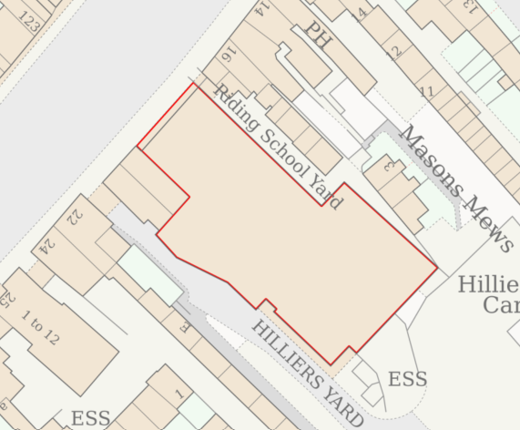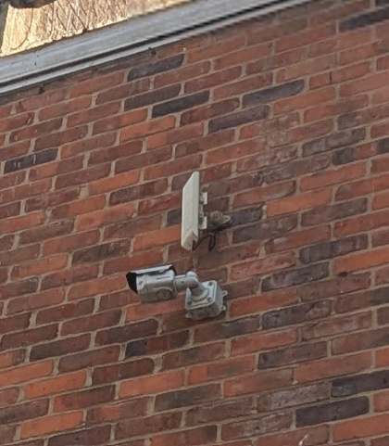

Site Location Plan and Photo of existing CCTV camera

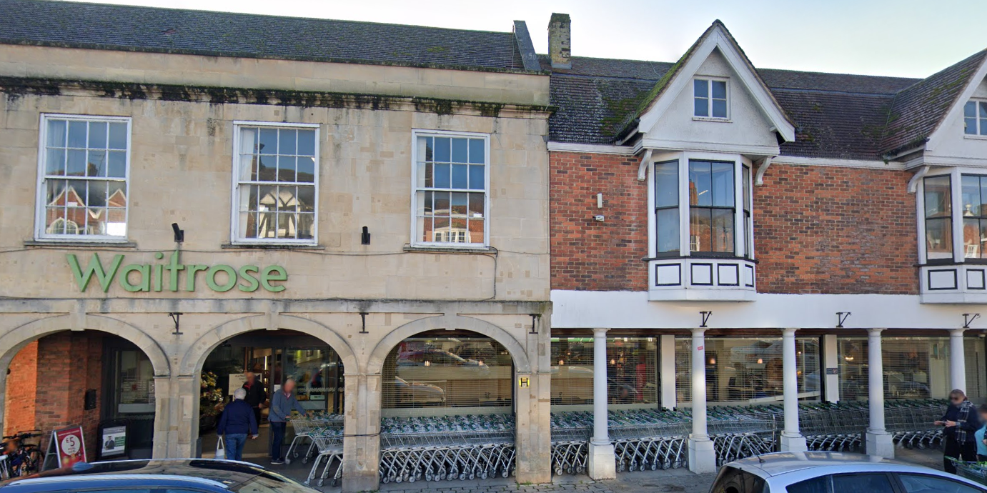

Google Street View Image September 2023

PROPOSAL

The supporting information explains that the new camera would be installed in broadly the same position as the existing camera, at high level on the western side of the building. To improve surveillance coverage and reduce blind spots, the replacement camera would be mounted on a black bracket projecting approximately 800mm from the building façade. The bracket would be fixed into mortar joints where practicable and would incorporate concealed cabling. The proposed camera forms part of the wider CCTV upgrade programme intended to improve visibility, assist in the monitoring and deterrence of criminal activity, capture vehicular incidents and support public safety within Marlborough town centre.

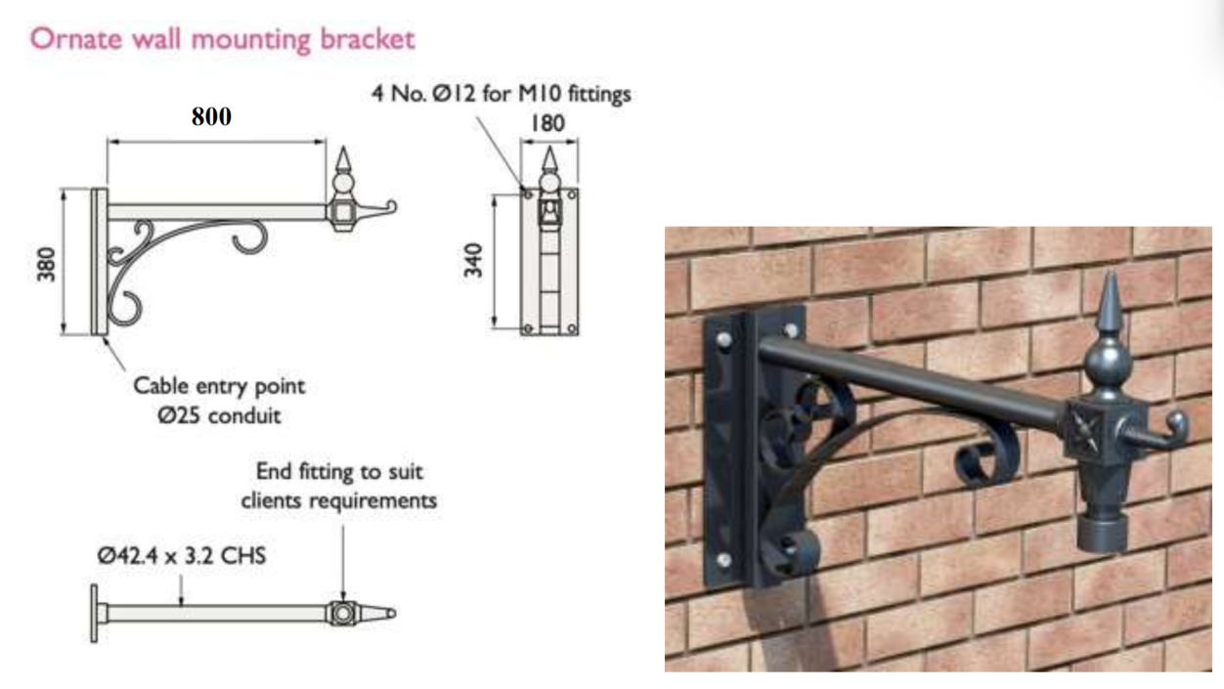

Details of Proposed Hanging Bracket

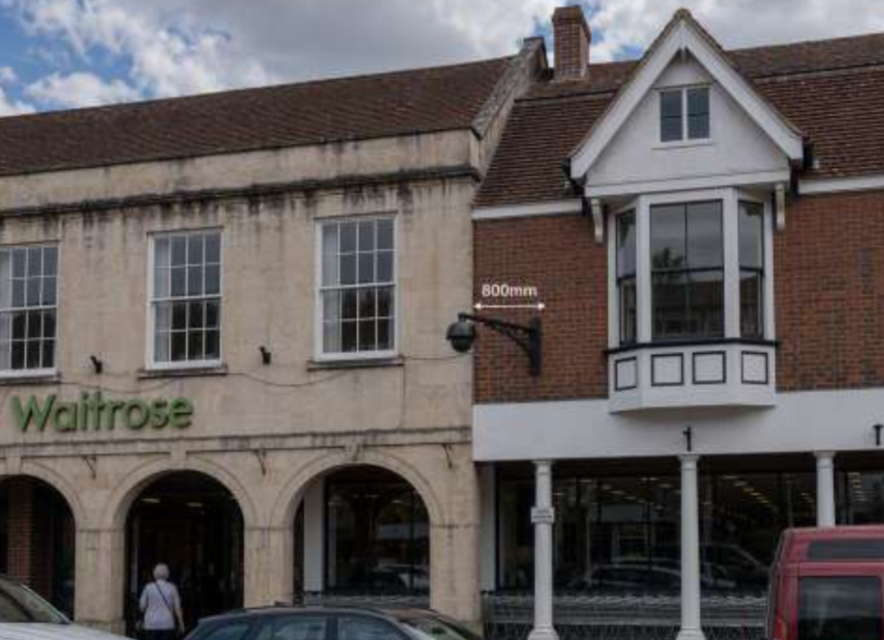

Elevation image of proposed hanging bracket and camera

RELEVANT PLANNING HISTORY

There are 32 planning records on No 17-18 High Street with the most relevant being 15/01482/FUL & 15/01742/LBC - A digital CCTV camera to be placed on external walls of building – Approved with conditions.

RELEVANT LEGISLATION, POLICIES AND GUIDANCE
Legislation
From the point of view of the historic environment the main statutory tests are set out within the Planning (Listed Building and Conservation Areas) Act 1990. Section 16 requires that special regard be given to the desirability of preserving listed buildings, their settings or any features of special architectural or historic interest which they possess.

Section 72(1) of the Planning (Listed Building and Conservation Areas) Act 1990 also requires the Council to pay special attention to the desirability of preserving or enhancing the character or appearance of designated Conservation Areas.

National Policy and Guidance
The National Planning Policy Framework (NPPF) August 2026 sets out government policy, including in respect of the historic environment.

Chapter 20 - Conserving and enhancing the historic environment, recognises heritage assets as an irreplaceable resource. Heritage assets should be conserved in a manner appropriate to their significance, with harm avoided unless there is a clear and convincing justification. Decision-makers are required to apply a balanced approach, giving substantial weight to the conservation of heritage assets and weighing any harm to significance against the public benefits of the proposal.

National Planning Practice Guidance provides guidance on interpreting the NPPF.

Historic England’s Conservation Principles, Policies and Guidance (2008) provides policy and guidance for the “sustainable management of the historic environment”. Additional guidance on the application of policies set out in the NPPF is contained within their publications:
- Historic Environment Good Practice Planning Advice Note 2 – Managing Significance in Decision-Taking in the Historic Environment (2015)
- Historic Environment Good Practice Planning Advice Note 3 – The Setting of Heritage Assets 2nd edition (2017)
- Historic England Advice Note 2 – Making changes to Heritage Assets (2025)
- Historic England Advice Note 18 – Adapting Historic Buildings for Energy and Carbon Efficiency (2026)

Wiltshire Core Strategy:
Whilst not directly relevant to listed building consent applications, the below policies give an indication of the Council’s approach to development affecting heritage assets:

- Core Policy 57 ‘Ensuring high quality design and place shaping’: A high standard of design is required in all new developments, including extensions, alterations, and changes of use of existing buildings. Development is expected to create a strong sense of place through drawing on the local context and being complementary to the locality.

- Core Policy 58 ‘Ensuring the conservation of the historic environment’ requires that “designated heritage assets and their settings will be conserved, and where appropriate enhanced, in a manner appropriate to their significance.”

ISSUES

Impact upon the preservation of the listed building or its setting or any features of special architectural and/or historic interest.

CONSULTATION RESPONSES

Marlborough Town Council: Noted the application (but didn’t offer a recommendation)

Wiltshire Council Conservation Officer: No objection

REPRESENTATIONS

In accordance with the requirements of Section 5(1) of the Planning (Listed Buildings and Conservation Areas) Regulations 1990 (as amended) the application for listed building consent was publicised by way of:

- A site notice displayed near the site;
- An advertisement placed in the local press dated 13 August – expired 3 September 2026

These methods were used to inform interested parties and to allow a statutory consultation period of 21 days for representations to be submitted.

No comments received.

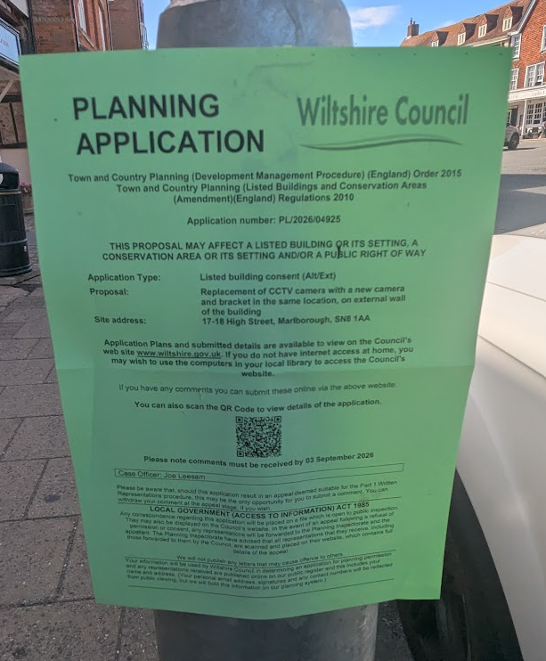

ASSESSMENT
In accordance with Section 16(2) of the Planning (Listed Buildings and Conservation Areas) Act 1990, special regard has been given to the significance of the listed building, including its architectural and historic interest, and the desirability of preserving both the building and its setting. Relevant policies within the National Planning Policy Framework (NPPF), particularly Section 20: Conserving and Enhancing the Historic Environment, have also been taken into account. These policies require that any harm to the significance of a designated heritage asset must be clearly justified and weighed against the public benefits of the proposal.

In order to be acceptable, the application needs to be assessed against the following criteria:

Information considered/submitted

Policy HE5 of the NPPF requires applicants to assess the significance of any heritage assets affected by a proposal, including the contribution made by their setting, and to identify the likely effects of the development on that significance. Sufficient information should be provided to enable a clear understanding of the significance of the heritage asset and its setting, and the impact of the proposal upon it.

Decision-makers must be satisfied that assessments accurately reflect the effects on heritage assets caused by development proposals. In this case the application is supported by a Heritage Statement and Design and Access Statement which describe the significance of the Grade II listed building, explain the background to the existing CCTV installation, identify the extent of the proposed works, and assess the likely impact of the replacement camera and bracket on the significance of the listed building. The submitted information confirms that the CCTV camera would be installed in broadly the same position as the existing apparatus, that fixing points would as far as possible utilise mortar joints rather than historic brickwork, and that no historic fabric would be removed as part of the works. The documents also explain the public safety objectives of the scheme and the measures taken to reduce visual impact through the use of a decorative bracket and revised mounting arrangement.

Having reviewed the submitted information, the Local Planning Authority is satisfied that sufficient information has been provided to understand the significance of the heritage asset and to assess the impact of the proposal upon that significance. The submitted heritage assessment is therefore considered proportionate to the scale and nature of the proposed works and accords with the requirements of Policy HE5 of the NPPF.

Assessment of significance:
According to the National Planning Policy Framework (NPPF), significance is defined as:

“The value of a heritage asset to this and future generations because of its heritage interest. The interest may be archaeological, architectural, artistic or historic. Significance derives not only from a heritage asset’s physical presence, but also from its setting.”

Historic England further categorises significance into four key values:

- Evidential – the potential of the asset to yield evidence about past human activity.
- Historic – the ways in which the asset illustrates aspects of history.
- Aesthetic – the sensory and design qualities of the asset.
- Communal – the meanings and associations attached to the asset by people.

In this case, the significance of No. 17-18 High Street lies primarily in its historic and aesthetic values. The building was originally constructed in 1859 as Marlborough Corn Exchange by the Marquess of Ailesbury and reflects the commercial and agricultural prosperity of Marlborough during the nineteenth century. Its historic significance also derives from its subsequent adaptation and continued evolution, including its use as a cinema and later as a supermarket, illustrating changing patterns of commercial and social activity within the town.

The building possesses aesthetic value through the survival of the former Corn Exchange frontage, including the distinctive arcaded ground floor and the use of ashlar limestone, which is unusual within Marlborough and contributes to the building's individual architectural character. Although much of the original structure has been replaced through later redevelopment, the surviving historic frontage remains the principal element of special architectural and historic interest which justified the building's designation.

The listed building also derives significance from its contribution to the wider historic townscape of Marlborough High Street. As part of a group of designated heritage assets within the Marlborough Conservation Area, it contributes positively to the character and appearance of one of the most historically significant parts of the town.

Communal value is present through the building's long-standing commercial and public role within Marlborough town centre. Evidential value remains within the surviving historic fabric of the retained façade, although the proposals do not directly affect those aspects of significance.

Impact of proposals on the significance and setting of the building/structure:

Understanding the impact of proposed works on a listed building requires a careful and proportionate assessment of how those changes affect the asset's heritage significance and its setting. This includes both the physical alterations to the building itself and any changes to its spatial or visual relationship with surrounding structures or spaces.

The significance of a heritage asset is derived from its architectural, historic and communal values, and from the contribution those values make to the wider historic environment. Any proposal affecting a heritage asset must therefore be assessed having regard to its identified significance, with consideration given to the extent to which the proposals would preserve or harm those special qualities.

This assessment is informed by the statutory duty under Section 16 of the Planning (Listed Buildings and Conservation Areas) Act 1990, which requires special regard to be given to the desirability of preserving a listed building and its features of special architectural or historic interest. It also takes account of the heritage policies contained within the NPPF and relevant local planning policy.

No. 17-18 High Street is a Grade II listed building dating from the 1850s, originally constructed as a Corn Exchange and subsequently altered and adapted over time. Its significance derives principally from its historic role within the development of Marlborough, its distinctive ashlar limestone frontage and the surviving arcaded ground floor which makes an important contribution to the character and appearance of the Marlborough Conservation Area.

The proposal relates to the replacement of an existing CCTV camera with a new camera mounted on a decorative bracket projecting approximately 800mm from the building. CCTV equipment has been present on the site since 2015 and therefore already forms part of the established appearance of the building and wider streetscape.

The proposed camera and bracket would be attached to the adjoining brick-built frontage of No. 18, which forms part of the listed building. Whilst this part of the building contributes to its overall significance, it is of lesser architectural interest than the principal ashlar limestone Corn Exchange façade and arcaded frontage which represent the most significant elements of the designated heritage asset.

The proposal would increase the overall size and projection of the installation when compared with the existing arrangement. Whilst CCTV equipment is inherently modern in appearance and the proposed camera and bracket are not particularly sympathetic additions to a historic building, efforts have been made to reduce their visual impact through the use of a decorative bracket and a more considered mounting arrangement. The equipment would nevertheless remain a visible modern feature attached to the listed building.

The works would not result in the loss of historic fabric, removal of architectural detailing, alteration to the building's historic plan form or any meaningful change to its relationship with surrounding heritage assets. Any fixing points would be limited in extent and capable of reversal. Whilst the installation would be more visually prominent than the existing arrangement, it would remain modest in scale and would have only a very limited effect on the appearance of the listed building. Consequently, the proposal would not diminish the significance of the heritage asset or harm its contribution to the character and appearance of the Marlborough Conservation Area.

The Council's Conservation Officer has reviewed the proposal and raises no objection. Whilst noting that the preferred heritage solution would avoid mounting surveillance equipment directly onto the listed building, the Conservation Officer accepts the operational need for the CCTV camera and acknowledges that reasonable efforts have been made to reduce visual impact through the use of a decorative bracket. Significant weight is therefore afforded to this specialist heritage advice.

Accordingly, it is considered that the proposal would preserve the special architectural and historic interest of the Grade II listed building and preserve the character and appearance of the Marlborough Conservation Area. The proposal would result in no harm to the significance of the designated heritage asset or its setting.

Impact on Ecology
While Sections 16 and 72 of the Planning (Listed Buildings and Conservation Areas) Act 1990 do not explicitly reference protected species, Local Planning Authorities have a statutory duty to consider potential impacts on protected species when determining applications. This responsibility arises from broader environmental legislation and national planning policy, and must be taken into account where relevant.

Does the site or proposed development possess/impact on any of the features where
protected species are likely to be present (assessed against Natural England’s standing
advice) and where species are likely to be found?
 |  | Y / N / NA
(a) | Does the site or proposed development possess/impact on any of the features where protected species are likely to be present (assessed against Natural England’s standing advice) and where species are likely to be found? | No
(b) | If yes, has a protected species survey been submitted? | N/A
(c) | If yes, does the survey show a detailed consideration of ecological impacts, wildlife mitigation and the creation, restoration and enhancement of wildlife corridors to preserve and enhance biodiversity in accordance with the standing advice? | N/A

CONCLUSION

The NPPF confirms that great weight should be given to the conservation of designated heritage assets and that any harm to their significance should require clear and convincing justification.

In this case, the proposal comprises the replacement of an existing CCTV camera with a new camera and bracket mounted on the listed building. Whilst CCTV equipment is inherently modern in appearance and the proposed camera and bracket are not particularly sympathetic additions to a historic building, the works have been designed to reduce visual impact through the use of a decorative bracket and a more considered mounting arrangement. The proposal would not result in the loss of historic fabric, removal of architectural detailing, alteration to the building's historic plan form, or any meaningful change to those elements which contribute most strongly to the significance of the Grade II listed building.

The proposed installation would be attached to the later brick-built frontage of No. 18 rather than the principal ashlar limestone Corn Exchange façade. Whilst the replacement installation would be more visually prominent than the existing arrangement due to its increased size and projection, it would remain modest in scale and would have only a very limited effect on the appearance of the building. The proposal would not diminish the significance of the listed building, its setting or its contribution to the character and appearance of the Marlborough Conservation Area. Nor would it materially affect the significance or setting of nearby designated heritage assets, including the Grade II* listed building at Nos. 132-133 High Street and the associated outhouse.

Having regard to the above, it is considered that the proposal would preserve the special architectural and historic interest of the Grade II listed building and preserve the character and appearance of the Marlborough Conservation Area. No harm to the significance of designated heritage assets has been identified.

As no harm to significance has been identified, no heritage balancing exercise is required under the NPPF. The proposal would, however, support the continued operation of the established town centre CCTV network and contribute towards public safety objectives within Marlborough town centre.

Accordingly, the proposal is considered to satisfy the requirements of Sections 16, 66 and 72 of the Planning (Listed Buildings and Conservation Areas) Act 1990, the relevant provisions of the NPPF, Core Policies 57 and 58 of the Wiltshire Core Strategy, and Policy MARL9 of the Marlborough Area Neighbourhood Plan.

RECOMMENDATION:
That Listed Building Consent be GRANTED, subject to the following conditions:

