APPLICATION FOR FULL PLANNING PERMISSION
DELEGATED REPORT

APPLICATION REFERENCE: | PL/2026/03524
APPLICATION TYPE: | Full Planning Permission
SITE ADDRESS: | Land Adjacent to Kajha, Millditch, Bratton, Wiltshire, BA13 4SX
DEVELOPMENT DESCRIPTION: | Change of use of building for personal storage and private office/study purposes by the named applicants only, together with external alterations and associated site tidying works.
RECOMMENDATION: | That Planning Permission be GRANTED

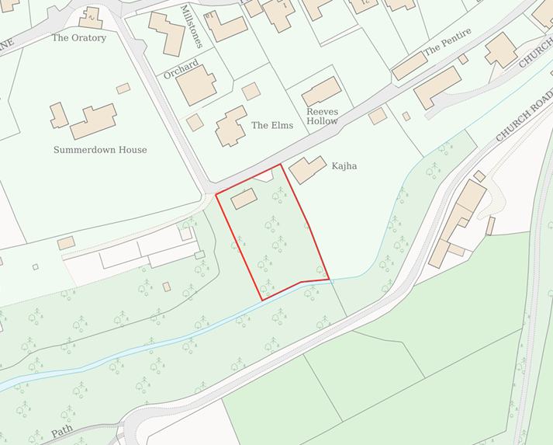
PROPOSAL

The application seeks planning permission for the change of use of an existing detached outbuilding for personal storage and private office/study purposes by the named applicants only. The proposal includes minor external alterations to the building comprising the installation of larch timber cladding, replacement windows and doors, together with internal alterations including the provision of WC facilities. The proposal is expressly proposed as a non-residential and personal use of the existing building and does not seek the creation of a dwelling, residential curtilage, overnight accommodation or any wider domestic use of the surrounding land. The development also includes associated site tidying works in the vicinity of the building.

SITE DESCRIPTION / CONTEXT

The site comprises an existing single-storey outbuilding and associated land situated to the south of The Elms and adjacent to Kajha, Millditch, Bratton. Access is obtained via Public Right of Way BRAT38 which traverses this part of Church Coombe. The site occupies a rural and comparatively secluded edge-of-settlement location characterised by detached dwellings set within spacious plots, significant tree cover, hedgerows and an overall low-density pattern of development.

The site lies within Bratton Conservation Area and immediately outside the defined settlement boundary, although it adjoins residential development forming part of the village to the north and east. The subject site is also considered to be located within the setting of the Grade II* listed Church of St James, to the south-west. The land also lies within an area of Priority Habitat, within the zone of influence of Salisbury Plain SPA and is identified within the Council's Strategic Flood Risk Assessment as being susceptible to groundwater flooding. The wider valley landscape contributes significantly to the rural character of Church Coombe and provides an important transition between the built form of the village and surrounding countryside.

PLANNING HISTORY

Reference No. | Proposal / Summary | Decision
W/78/00936/HIS | Outline detached house and garage | Refuse
W/80/01371/HIS | Paddock and Stabling for 2 horses | Approved
W/81/01120/HIS | Dwellinghouse and garage | Refuse
W/83/00198/FUL | Dwelling and garage | Refuse
W/84/00206/FUL | Erection of stable block | Refuse
W/84/00820/FUL | Stable block | Refuse
W/86/00057/FUL | Change of use and conversion of stable block to bungalow | Refuse
W/87/01427/FUL | Change of use to storage and restoration of antique furniture | Refuse
W/91/00768/FUL | To convert the existing stables into a dwellinghouse | Refuse
W/91/01232/FUL | Change of use from stables to store and hobby room | Refuse
W/92/00249/FUL | Convert existing stables into holiday accommodation | Refuse
W/92/00726/FUL | To convert existing stables into holiday accommodation | Refuse
W/03/02114/FUL | Conversion change of use to residential | Refuse
W/06/02961/FUL | Change of use to storage of domestic furniture | Approved
18/07443/OUT | Conversion of existing building on site that is used for storage into a 2 bedroomed bungalow. | Refuse

A material consideration in the assessment of the current proposal is planning permission W/06/02961/FUL, granted in November 2006, which authorised the use of the existing building for the storage of domestic furniture. Importantly, that permission was subject to a personal condition restricting the benefit of the consent to Mr Alan Dale only, together with conditions limiting the use to personal storage and preventing any commercial storage activities or alternative Class B8 uses. As a consequence, whilst the Council previously accepted a low-key personal storage use of the building, that permission did not run with the land and cannot be relied upon by subsequent owners. Nevertheless, it establishes a planning history whereby the Council accepted that a limited personal use of the existing building could occur without resulting in unacceptable harm to the character of the Conservation Area, setting of the nearby listed building, surrounding landscape or highway network, subject to the specific restrictions imposed by condition.

RELEVANT LEGISLATION, POLICIES AND GUIDANCE

Wiltshire Core Strategy:

Core Policy 1 Settlement Strategy;
Core Policy 2 Delivery Strategy;
Core Policy 32 Spatial Strategy: Westbury Community Area;
Core Policy 50 Biodiversity and Geodiversity;
Core Policy 51 Landscape;
Core Policy 57 Ensuring High-Quality Design and Place Shaping;
Core Policy 58 Ensuring Conservation of the Historic Environment;
Core Policy 60 Sustainable Transport;
Core Policy 61 Transport and Development;
Core Policy 64 Demand Management;
Core Policy 67 Flood Risk

Bratton Neighbourhood Development Plan 2025-2038

The National Planning Policy Framework (NPPF) and The Planning Practice Guidance (PPG)

Wiltshire Design Guide

The Wiltshire Local Transport Plan 2011 – 2026: Car Parking Strategy (March 2015).

The Wiltshire Local Transport Plan 4 (LTP4) (March 2025)

New Wiltshire Local Plan: At Full Council on 19 May 2026, the elected members of Wiltshire Council agreed to withdraw the emerging Wiltshire Local Plan. The said Plan has no material weight for the purposes of the application.

In accordance with Regulation 19 of the Town and Country Planning (Local Planning) (England) Regulations 2026, on 30th June 2026 Wiltshire Council published a notice of intention to prepare a new local plan for Wiltshire. The next stage is a Scoping Consultation which commences on 2nd September 2026. This plan is at a very early stage and currently carries no weight for decision-making.

CONSULTATION RESPONSES

Bratton Parish Council – Supports

Conservation (Wiltshire Council) – Objects – The Conservation Officer considers that the proposal would harm the character and appearance of Bratton Conservation Area through the increased domestication and activity associated with the site, resulting in less than substantial heritage harm which is not outweighed by any identified public benefits.

REPRESENTATIONS

Four comments of support have been received. The representations indicate that the site has become neglected in recent years and that the proposal would facilitate the improvement and ongoing management of both the building and wider land. Supporters consider that the development represents a sensitive and low-impact proposal which would enhance the visual appearance of the site whilst respecting the character of the surrounding valley landscape.

ASSESSMENT

Section 38(6) of the Planning and Compulsory Purchase Act 2004 states:

"If regard is to be had to the development plan for the purposes of any determination to be made under the planning Acts, the determination must be made in accordance with the plan unless material considerations indicate otherwise."

In accordance with this statutory requirement, this application has been assessed against the relevant policies of the Development Plan, including the adopted Wiltshire Core Strategy (2015) and, where applicable, any made Neighbourhood Plans.

Principle of the Development

The application site lies outside the Limits of Development for Bratton and therefore falls within the countryside for the purposes of Core Policies 1 and 2 of the Wiltshire Core Strategy. The proposal seeks the change of use of an existing building for personal storage and private office/study purposes, together with minor external alterations. Importantly, the description of development relates specifically to the existing building and does not seek the creation of a dwelling, the extension of residential curtilage, or the introduction of new built development within the wider site.

Whilst the site lies outside the settlement boundary, no additional built form is proposed, and the development would utilise an existing building which has previously been accepted by the Council as accommodating a limited personal storage use under planning permission W/06/02961/FUL. Although that permission was personal in nature and cannot be relied upon by the current applicants, it remains a material consideration in demonstrating that a low-key personal use of the building has previously been found acceptable in principle at this location.

In assessing the proposal against Core Policies 1 and 2, it is noted that the development would not physically extend the settlement, result in ribbon development, consolidate sporadic development, or introduce additional residential accommodation into the countryside. The proposal is confined to the reuse of an existing building and associated parking area and therefore does not materially alter the established form or extent of development within this part of Bratton.

The principal consideration is therefore whether the proposed use would result in unacceptable harm to the character of the countryside or the Bratton Conservation Area. Subject to conditions restricting the use to the named applicants, confining the use to the existing building and associated parking area, and preventing residential occupation or overnight accommodation, it is considered that the proposal represents a limited and appropriately controlled reuse of an existing building. As such, the proposal is not considered to conflict with the spatial objectives of Core Policies 1 and 2, subject to its acceptability in terms of heritage, character and amenity considerations.

Conservation and Heritage

Section 66(1) of the Planning (Listed Buildings and Conservation Areas) Act 1990 requires local planning authorities to have "special regard to the desirability of preserving" any listed building, its setting, or its special architectural or historic features when deciding on planning applications.

Section 72(1) of the Planning (Listed Buildings and Conservation Areas) Act 1990 requires special attention to be paid to the desirability of preserving or enhancing the character or appearance of Conservation Areas.

Core Policy 58 of the Wiltshire Core Strategy similarly seeks the conservation and enhancement of designated heritage assets and their settings, whilst Policy BNP3 of the Bratton Neighbourhood Development Plan requires development proposals to preserve and, where appropriate, enhance the character, appearance and special interest of the Conservation Area and its setting.

The significance of this part of the Bratton Conservation Area derives principally from its verdant and semi-rural character at the edge of the village, established vegetation, and the transitional relationship between the historic settlement and the surrounding countryside. The application site contains an existing outbuilding that has been present within the landscape for many years. The contribution made by the site to the significance of the Conservation Area therefore arises primarily from its rural appearance, limited level of activity, vegetation and absence of intrusive built development.

The Conservation Officer objects to the proposal on the basis that the introduction of additional activity, services and associated infrastructure could result in the gradual domestication of the site and lead to less than substantial harm to the character and appearance of the Conservation Area. The Conservation Officer has also mentioned the proposed changes to increase “the permanence of the structure and the longer-term occupation of the building”.

These concerns have been carefully considered. However, the proposal does not involve any significant operational development beyond modest alterations to the existing building which are considered to improve its appearance through the installation of timber cladding and replacement doors and windows, without increasing its footprint, height or massing.

In assessing the proposed use, significant weight is attributed to planning permission W/06/02961/FUL, which authorised the personal storage of domestic furniture within the existing building. Whilst that permission was personal in nature and cannot be relied upon by the current applicants, it nevertheless establishes that the Council has previously accepted a low-key personal use of the building without harm to the character or appearance of the Conservation Area. Furthermore, whilst the current proposal introduces an ancillary office/study use and WC facilities, the scale and extent of activity is considered to remain limited and would be restricted by condition to the personal benefit of two named individuals. The description of development relates specifically to the use of the building and associated parking area, rather than the wider site, and conditions are proposed to prevent residential occupation, overnight accommodation and any wider use of the land.

Whilst the Conservation Officer's concerns regarding potential domestication are acknowledged, the application does not seek residential occupation, overnight accommodation, external domestic paraphernalia, residential curtilage formation, or additional built development. Subject to the proposed conditions, the use would remain confined to the existing building and parking area. Having regard to the contribution that the site presently makes to the character and appearance of the Conservation Area, it is considered that the proposal would not alter those characteristics to a degree that would result in harm to the significance of the designated heritage asset.

The applicant has also provided additional information confirming that foul drainage would connect to an existing sewer connection rather than requiring a septic tank arrangement, thereby addressing concerns regarding regular servicing activity and associated infrastructure. Having regard to the existing characteristics of the site, including the established building, parking area, access arrangements and boundary treatments, it is not considered that the proposal would generate a level of activity, vehicle movements or associated infrastructure materially greater than that previously accepted under the 2006 permission, nor one which would erode the verdant and rural qualities that contribute to the significance of this part of the Conservation Area.

Section 66(1) of the Planning (Listed Buildings and Conservation Areas) Act 1990 requires the decision-maker to give special regard to the desirability of preserving the setting of listed buildings. The site is located within the wider setting of the Grade II* Church of St James. The significance of the church derives principally from its architectural and historic interest and its presence within the landscape. The proposal does not involve new built form, does not alter important views towards or from the church, and would retain the existing pattern of development and landscaping within this part of Church Coombe. The proposed alterations would be limited to improvements to the appearance of an existing building and would not diminish the ability to appreciate the church within its historic landscape setting. The proposed use would also remain low-key in nature and would not introduce activity at a level likely to affect the character of the church's surroundings. The proposal therefore preserves the setting of the Grade II* listed building and substantial weight has been given to that conclusion in accordance with the statutory duty under Section 66(1).

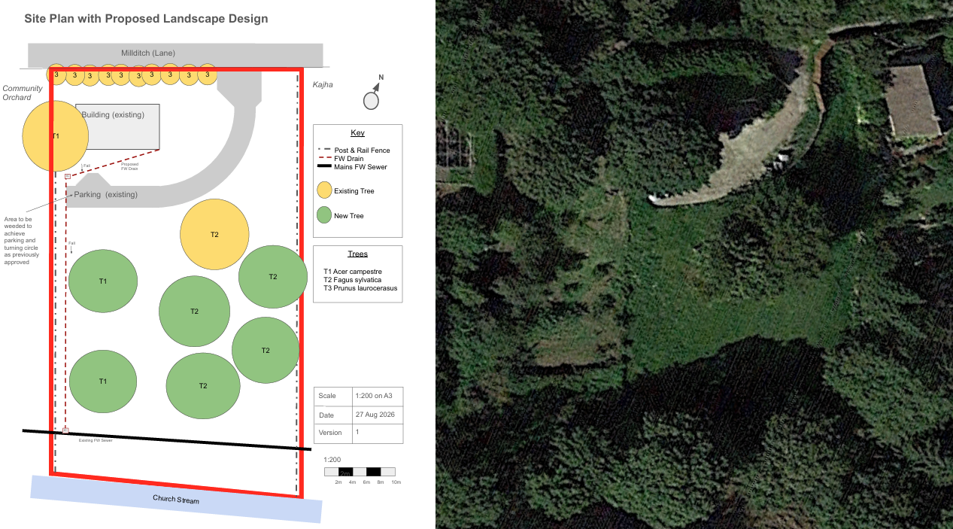
Proposed Site Plan and Site Aerial Image

Accordingly, whilst the concerns of the Conservation Officer are duly acknowledged, it is not considered that the proposal would harm the character or appearance of the Bratton Conservation Area. Subject to appropriate conditions restricting the nature and extent of the use, the proposal is considered to preserve the character and appearance of the Conservation Area and therefore accords with Section 72(1) of the Act, Core Policy 58 of the Wiltshire Core Strategy and Policy BNP3 of the Bratton Neighbourhood Development Plan.

Design and Impact the upon the character and context of the area

Core Policy 57 of the Wiltshire Core Strategy seeks to secure high-quality design which responds positively to local character and distinctiveness. At the national level, Policy DP3 of the National Planning Policy Framework requires development proposals to respond positively to their context and integrate with and enhance their surroundings. Development should also reflect, where relevant, the principles of liveability, climate resilience, nature, movement, built form, public space and local identity. Assessment of design quality therefore requires consideration of the scale, appearance, massing, materials, layout and relationship of the proposal with both the host site and the wider character of the surrounding area.

The proposed physical alterations are limited in scale and comprise predominantly cosmetic improvements to an existing building. The application proposes larch timber cladding together with replacement windows and doors within largely existing openings. The building would remain single-storey with no increase in footprint, height or massing. Given the utilitarian and unfinished appearance of the existing structure, the proposed external treatment would result in a more cohesive and visually attractive form of development.

Given the setting of the existing building and the existing and proposed tree planting, the proposed use of timber cladding would be appropriate in this instance. The alterations are overall considered acceptable from a design perspective and would represent an improvement to the appearance of the building itself.

Having regard to the above, the proposal complies with the design principles set out in the NPPF Policy DP3, Core Policy 57 of the Wiltshire Core Strategy, and Appendix D of the Wiltshire Design Guide.

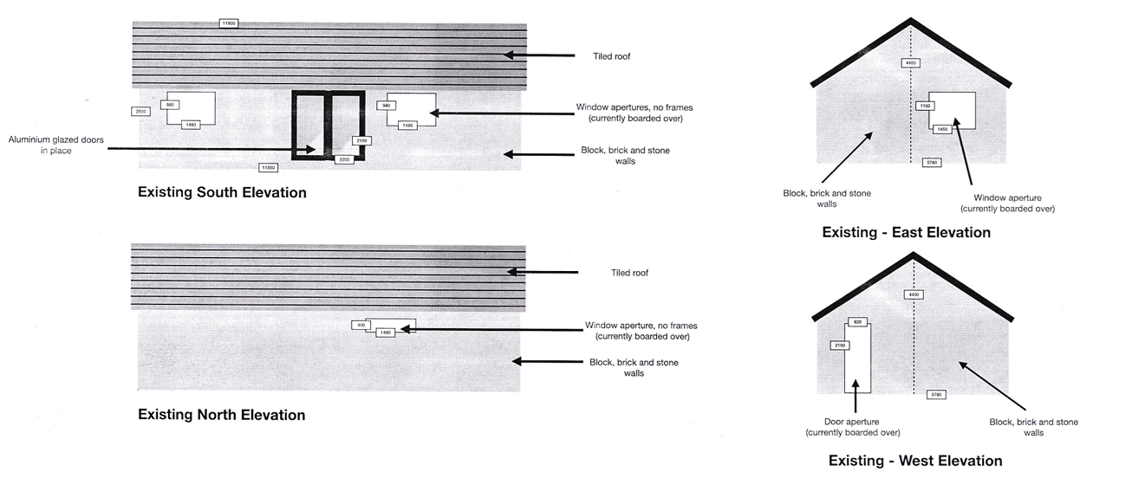
Existing Elevations

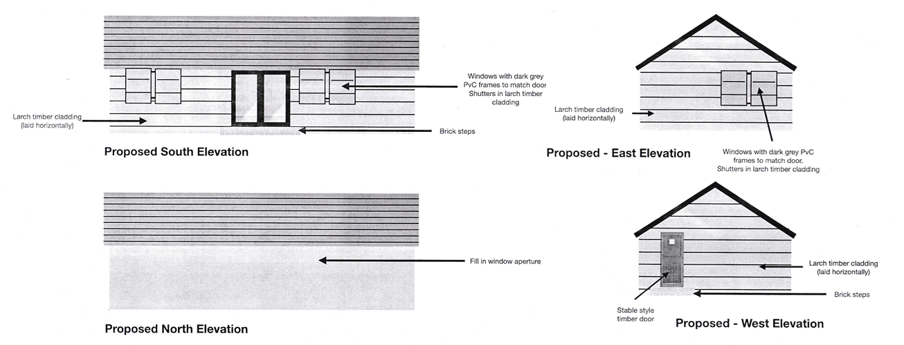
Proposed Elevations

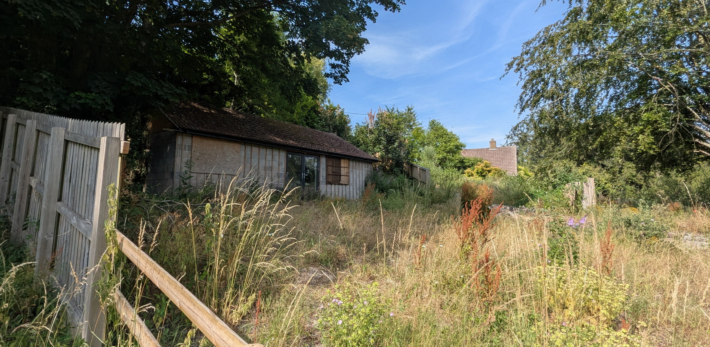
Site Visit Image

Amenity

Core Policy 57 criterion vii seeks to ensure development does not have an unacceptable impact upon the amenities of neighbouring occupiers. Nationally, Policy P3 requires development proposals to provide healthy living conditions for occupiers and users and to avoid unacceptable impacts arising from loss of light, outlook, privacy, noise, disturbance or other forms of pollution. Policy DP3 additionally requires development to create liveable and attractive places for existing and future users. Accordingly, the assessment below considers the effect of the proposal upon neighbouring occupiers and whether acceptable living conditions would be maintained.

The proposal is not considered to give rise to any unacceptable impacts upon neighbouring residential amenity. The building already exists, and no increase in height, footprint or massing is proposed. Given the existing separation distances, established vegetation and relationship with neighbouring properties, the development would not result in overlooking, loss of privacy, overshadowing or overbearing impacts. The proposed use is also of a relatively low intensity and is not expected to generate significant noise or disturbance.

The proposal therefore accords with Core Policy 57 point vii in respect of safeguarding residential amenity and Appendix D of the Wiltshire Design Guide.

Transport and Highways

Core Policies 60, 61 and 64 of the Wiltshire Core Strategy seek to promote sustainable transport, secure safe access arrangements and ensure adequate parking provision. Nationally, Policies TR3 and TR4 of the National Planning Policy Framework require development to be located in sustainable locations where appropriate, provide safe access arrangements, prioritise walking, wheeling and cycling, and provide suitable parking provision having regard to the nature and location of the development. Policy TR6 confirms that development should be refused where it would result in a severe adverse impact on the transport network or an unacceptable impact on highway safety after consideration of any mitigation measures.

The proposal would utilise an existing access arrangement and would not create an independent residential unit, intensify occupation levels or generate significant additional vehicle movements. No alterations are proposed to the site access, and the use would remain ancillary in nature. Given the modest scale of the development and absence of any substantive change to traffic generation, the proposal would not result in any adverse highway safety or capacity impacts and is considered acceptable in relation to Core Policy 60.

Ecology

Core Policy 50 of the Wiltshire Core Strategy seeks to protect and enhance biodiversity interests and ensure development avoids unacceptable harm to ecological assets. National policy is set out within Policies N2 and N6 of the National Planning Policy Framework. These policies require development proposals to minimise impacts upon biodiversity, protect important habitats and species, and secure opportunities for biodiversity enhancement where appropriate. Where significant harm to biodiversity cannot be avoided, adequately mitigated or compensated for, development should be refused. Biodiversity Net Gain (BNG) was established as a mandatory aspect of planning evaluation through Schedule 7A of the Town and Country Planning Act 1990 (as amended by the Environment Act 2021 Schedule 14).

The site lies within an area containing Priority Habitat and therefore occupies an ecologically sensitive location. However, the proposal does not involve any additional built development, the loss of habitat, engineering operations or significant alterations to the wider site. The physical works are limited to alterations to an existing building and associated changes in use. As such, the proposal would not directly result in the loss or degradation of ecological features.

The primary ecological consideration therefore relates to the potential implications of the proposed use. In this regard, the development can be appropriately controlled through conditions restricting the approved use to the existing building and associated parking area. Consequently, the proposal would not facilitate the wider recreational or residential use of the remainder of the site and would not result in a level of activity likely to adversely affect the ecological value of the surrounding habitat. Subject to these controls, the proposal is not considered likely to result in significant ecological harm and therefore accords with the objectives of Core Policy 50 and the National Planning Policy Framework.

Flooding and Drainage

Core Policy 67 of the Wiltshire Core Strategy seeks to ensure that development is directed away from areas at greatest risk of flooding and is designed to minimise vulnerability to flooding whilst avoiding any increase in flood risk elsewhere. National planning policy relating to flood risk and drainage is contained within Policies F4 to F8 of the National Planning Policy Framework. Collectively, these policies establish a risk-based approach to the location and assessment of development proposals. The Framework requires flood risk to be properly assessed where necessary, seeks to direct development towards areas at the lowest risk of flooding through the application of the sequential approach where applicable, and ensures that development remains safe for its lifetime without increasing flood risk elsewhere. The policies also support the incorporation of sustainable drainage measures where appropriate in order to manage surface water runoff and reduce the potential for flooding.

The proposal does not involve any increase in built footprint or impermeable surfacing and is therefore not expected to materially alter the site's existing drainage characteristics. Whilst the Council's Strategic Flood Risk Assessment identifies groundwater flood susceptibility affecting the wider area, the development is limited to the reuse of an existing building and does not introduce additional vulnerable development. Furthermore, the submitted site plan confirms that foul drainage associated with the proposed WC facilities would connect to the existing sewer network. Having regard to the scale and nature of the proposal, no drainage objections are raised.

CONCLUSION

The application seeks a tightly controlled change of use of an existing building for personal storage and private office/study purposes by two named individuals, together with minor external alterations that would improve the appearance of the building. The proposal does not introduce additional built form, create a dwelling, extend the settlement boundary or materially alter the established pattern of development within this part of Bratton. Whilst the concerns raised by the Conservation Officer regarding the potential domestication of the site have been carefully considered, the proposal has been clarified through additional submissions and can be further controlled through planning conditions restricting the use to the existing building and associated parking area, limiting the use to the named applicants, and preventing any residential occupation or overnight accommodation.

Weight has been afforded to the reuse and enhancement of an existing building, the absence of additional development in the countryside, and the limited nature of the proposed use. Careful consideration has also been given to the concerns raised regarding potential domestication of the site. For the reasons set out above, and subject to appropriately restrictive conditions, the proposal is not considered to result in heritage harm or any material conflict with the development plan.

Significant weight is also afforded to the previous approval of a personal storage use under planning permission W/06/02961/FUL, which demonstrates that a similarly limited personal use of the building has previously been accepted without harm to the character and appearance of the Conservation Area. The proposed drainage arrangements via an existing sewer connection further reduce the potential for ancillary infrastructure or servicing activity to erode the rural qualities of the site.

Taking all matters into account, it is considered that the proposal would preserve the character and appearance of the Bratton Conservation Area, would not result in unacceptable ecological, amenity, drainage or highway impacts, and accords with the relevant provisions of the Wiltshire Core Strategy, Bratton Neighbourhood Development Plan and National Planning Policy Framework. Accordingly, planning permission is recommended for approval.

RECOMMENDATION: That Planning Permission be GRANTED subject to conditions

