APPLICATION FOR FULL-PLANNING PERMISSION CASE OFFICER REPORT

APPLICATION REFERENCE: | PL/2026/05005
APPLICATION TYPE: | Full planning permission
SITE ADDRESS: | Middledean, Swallowcliffe, Salisbury, SP3 5NY
DEVELOPMENT DESCRIPTION: | Change of use from part field to garden with localised regrading
RECOMMENDATION: | Approve with Conditions

SITE DESCRIPTION/CONTEXT

The application site relates to a large detached Grade 2 listed dwelling located within the Swallowcliffe Conservation Area and within the Cranborne Chase & West Wiltshire Downs National Landscape. The property is located within a generous residential curtilage and surrounded by fields and woodland.

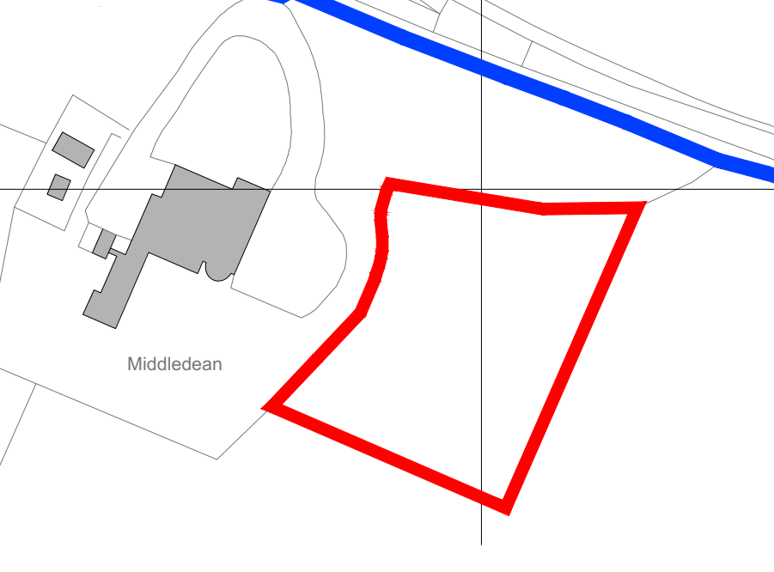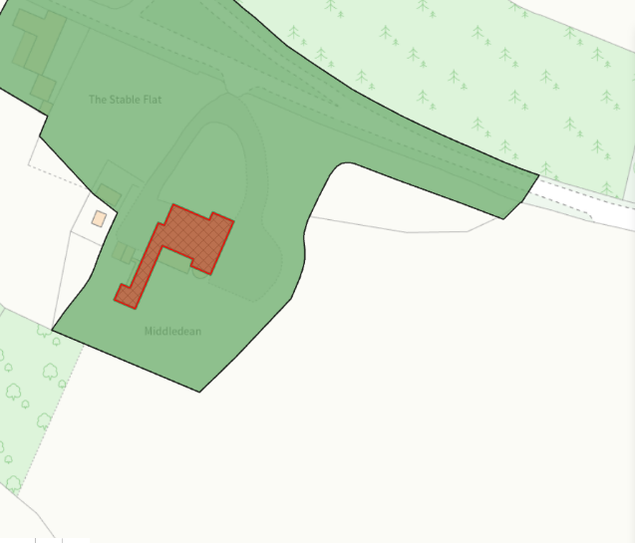
The site is located within the Chilmark Quarries Bat SAC, and within the Hampshire River Avon Catchment; Public Right of Way footpath SWAL 13 runs to the west of the site.

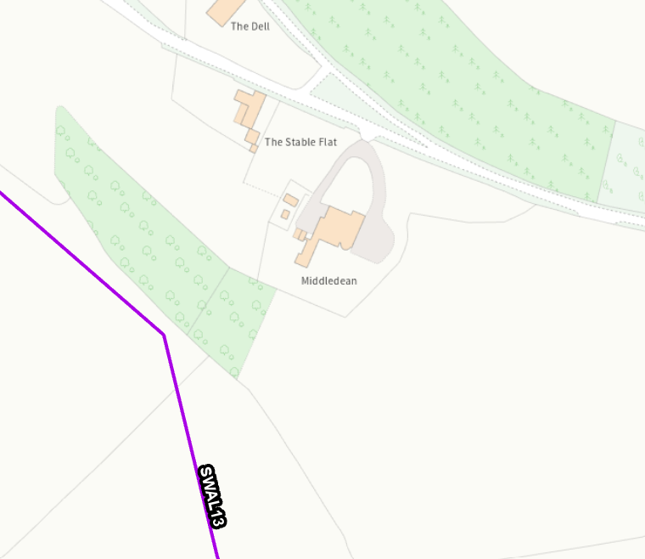

PROPOSAL

The application is seeking planning permission for the change of use of part of a field to residential curtilage with associated works comprising regrading of the land. The proposed layout is shown below, with estate-style fencing proposed as the boundary treatment.

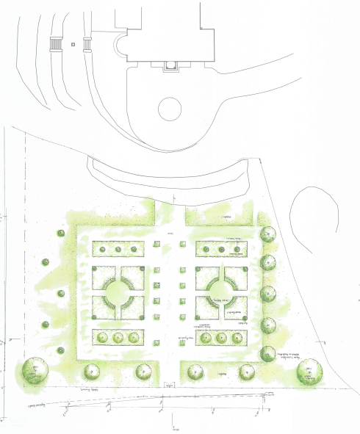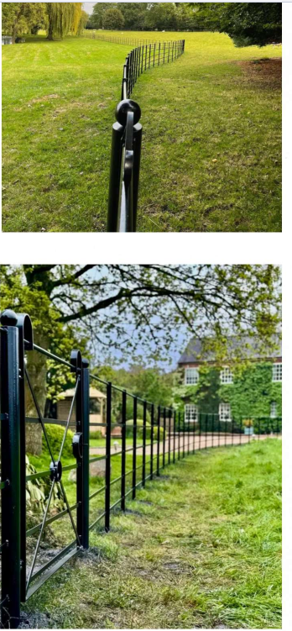

PLANNING HISTORY

There are several previous planning applications for works to the main dwelling, these are however not considered to be relevant to the current proposed application and therefore have not been included below.

Proposal / Summary
PL/2026/00262 - Middledean, Swallowcliffe, Salisbury, SP3 5NY - Full planning permission Decision - Withdrawn by Applicant Date: 30/4/2026 – Change of use from part field to garden with localised regrading

RELEVANT LEGISLATION, POLICIES AND GUIDANCE

Statutory Legislation:

Planning (Listed Building and Conservation Areas) Act 1990 - Section 72 and 66

National Planning Policy:
National Planning Policy Framework (NPPF)
Planning Practice Guidance (PPG)

Development Plan:

The development plan for Wiltshire comprises the Wiltshire Core Strategy (WCS) (adopted January 2015) and any made neighbourhood plans, which remains the principal statutory planning document guiding development across the county. In line with Section 38(6) of the Planning and Compulsory Purchase Act 2004, planning decisions must be made in accordance with the development plan unless material considerations indicate otherwise.

Though the development plan is considered as a whole, those parts deemed to be particularly relevant to this application are listed below:

The adopted Wiltshire Core Strategy (WCS), with particular regard to:

Core Policy 1 Settlement Strategy
Core Policy 2 Delivery Strategy
Core Policy 17 Spatial Strategy Tisbury Community Area
Core Policy 50 Biodiversity and Geodiversity
Core Policy 51 Landscape
Core Policy 57 Ensuring High Quality Design and Place Shaping
Core Policy 58 Ensuring the Conservation of the Historic Environment
Core Policy 69 River Avon SAC

Draft Wiltshire Local Plan
At Full Council on 19 May 2026, the elected members of Wiltshire Council agreed to withdraw the emerging Wiltshire Local Plan. The said Plan has no material weight for the purposes of the application.

In accordance with Regulation 19 of the Town and Country Planning (Local Planning) (England) Regulations 2026, on 30th June 2026 Wiltshire Council published a notice of intention to prepare a new local plan for Wiltshire. The next stage is a Scoping Consultation which commences on 2nd September 2026. This plan is at a very early stage and currently carries no weight for decision making.

Supplementary Planning Documents and other Guidance:

Wiltshire Design Guide (adopted April 2024)
National Design Guide
Creating Places Design Guide
National Landscape Management Plan

CONSULTATION RESPONSES

Parish Council – none received

Ecology – None received

Conservation - No objection

REPRESENTATIONS

None received

ASSESSMENT

Section 38(6) of the Planning and Compulsory Purchase Act 2004 states:

"If regard is to be had to the development plan for the purposes of any determination to be made under the planning Acts, the determination must be made in accordance with the plan unless material considerations indicate otherwise."

In accordance with this statutory requirement, this application has been assessed against the relevant policies of the Development Plan, including the Wiltshire Core Strategy (2015) and, where applicable, any made Neighbourhood Plans. Consideration has also been given to the policies of the NPPF (NPPF) as a material consideration in the assessment.

The assessment below considers each of the main issues in turn with reference to the relevant policy context, the evidence submitted, consultee responses, and all other material considerations, before a conclusion is reached.

Principle, Character, Landscape Impacts and Heritage Impacts

From the point of view of the historic environment, the main statutory duties are set out within the Planning (Listed Buildings and Conservation Areas) Act 1990.

Section 66(1) requires special regard to be given to the desirability of preserving listed buildings, their settings and any features of special architectural or historic interest which they possess.

Section 72(1) requires special attention to be paid to the desirability of preserving or enhancing the character or appearance of Conservation Areas.

Core Policy 58 of the Wiltshire Core Strategy seeks to conserve and, where appropriate, enhance the significance of designated and non-designated heritage assets and their settings.

Core Policy 57 requires development to respond positively to local character and historic context through high quality design.

Core Policy 51 of the Wiltshire Core Strategy seeks to protect, conserve and enhance landscape character and quality and requires development to respond appropriately to its landscape setting.

Policy N2 of the NPPF seeks to conserve and enhance the natural environment and requires development to take account of landscape character, local distinctiveness and the natural beauty of the countryside.

Policy N4 of the NPPF affords significant protection to National Landscapes and requires development proposals to conserve and enhance their natural beauty and special qualities.

Under Section 245 of the Levelling-up and Regeneration Act 2023, the Council must seek to further the purposes of National Landscapes when exercising its planning functions.

Policies HE4-HE10 of the NPPF recognise heritage assets as an irreplaceable resource and require proposals affecting heritage assets to be assessed having regard to their significance and the contribution made by their setting.

Policies DP1-DP4 of the NPPF seek to ensure that development is well-designed, visually attractive, sustainable and responsive to its surroundings. Development should contribute positively to local character, create high quality places and support healthy and inclusive communities.

The Wiltshire Design Guide provides further guidance on achieving high quality, context-led design and should be taken into account where relevant and also promotes development that integrates with landscape features and local character.

The application seeks planning permission for the change of use of part of an agricultural field to residential curtilage associated with Middledean. The proposed garden extension is located immediately to the front (east) of the existing dwelling and would incorporate an area of the adjoining field used for grazing sheep into the domestic curtilage. The proposal would extend the existing garden area and create a more regular boundary to the residential curtilage. Associated works comprise localised regrading of the land to provide a more even land profile and the erection of a low estate-style stock-proof fence to define the revised curtilage boundary. The proposed regrading is limited in extent and, given the relatively level nature of the site, would not materially alter the landform or create any landscape harm. No new buildings, extensions, hardstanding areas or other operational development are proposed as part of the application. The extended garden area would remain primarily landscaped and grassed in appearance. The submitted plans indicate that the proposal would effectively square off the existing garden area, which currently extends into the field in an irregular form, and would provide a larger landscaped foreground to the Grade II listed dwelling.

Whilst the proposal would result in a modest extension of the residential curtilage into the adjoining field, it would remain closely related to the existing dwelling and would not represent encroachment of a scale that would materially alter the character of the wider area. The proposed area is immediately adjacent to the established garden of Middledean and would form a logical extension to the existing residential curtilage. Given the absence of built development and the retention of a predominantly open and landscaped appearance, the proposal is not considered to result in an unacceptable urbanising effect within the countryside.

The site lies within the Cranborne Chase and West Wiltshire Downs National Landscape where Core Policy 51 seeks to conserve landscape character and scenic quality. Having regard to the limited scale of the proposal, the absence of built form, and the visual containment provided by the surrounding topography, vegetation and existing residential curtilage, Officers do not consider that the proposal would result in significant harm to the character, appearance or special qualities of the National Landscape. The proposed regrading is limited in extent and would not significantly alter the wider landscape character or views within the valley.

The application site forms part of the setting of Middledean, a Grade II listed building, and is also located within the Swallowcliffe Conservation Area. In accordance with Sections 66 and 72 of the Planning (Listed Buildings and Conservation Areas) Act 1990, special regard has been given to preserving the setting of the listed building and special attention has been paid to preserving the character and appearance of the Conservation Area. The proposal does not affect the historic fabric of the listed building and would not detract from the appreciation of the asset within its landscape setting. The Council's Conservation Officer raises no objection and advises that the proposal would not harm the setting of the listed building. Furthermore, given the limited nature of the works and the retention of the site's open and landscaped character, the proposal would preserve the character and appearance of the Conservation Area.

The proposed estate-style stock-proof fencing is modest in scale and appearance and is considered appropriate within this rural setting. Given its open form and limited height, it would not appear unduly domestic or result in harm to the character of the countryside, the National Landscape, the setting of the listed building, or the character and appearance of the Conservation Area. Whilst the proposal itself is considered acceptable, the extension of the residential curtilage into the adjoining field could increase the likelihood of future domestic paraphernalia, outbuildings, structures, fences, walls, gates or other means of enclosure being introduced which may erode the open character of the site, harm the rural landscape, and adversely affect the setting of the Grade II listed building and wider Conservation Area. It is therefore considered reasonable and necessary to remove relevant permitted development rights within the extended curtilage to retain control over the erection of buildings, structures and means of enclosure. This will ensure that the character of the area, the special qualities of the National Landscape, and the significance and setting of the heritage assets continue to be preserved.

Accordingly, the proposal is considered to accord with Core Policies 51, 57 and 58 of the Wiltshire Core Strategy, the relevant provisions of the NPPF, and the statutory duties contained within Sections 66 and 72 of the Planning (Listed Buildings and Conservation Areas) Act 1990.

Amenity

Core Policy 57 (Point vii) of the Wiltshire Core Strategy requires development to respect the amenity of existing occupants and ensure appropriate amenity levels for future residents.

Policy P3 of the NPPF requires development to be appropriate for its location, taking account of its likely effects on health, living conditions and the environment. In particular, Policy P3(2)(b) requires development to avoid giving rise to unacceptable impacts on the living conditions of neighbouring residents and occupiers. In assessing amenity impacts, regard should be had to matters including daylight and sunlight, outlook, privacy, overbearing impacts and other effects on residential amenity.

These policies guide the assessment of amenity impacts. Each of the below matters has been assessed having regard to the specific site context and layout of the proposal.

There are no immediate neighbouring properties that would be adversely affected by the proposed development. The proposal comprises a change of use of land and localised regrading only, with no new residential accommodation or built development proposed. As such, no material impacts are identified in terms of privacy, outlook, light, overbearing impact or noise and disturbance.

Ecology and Biodiversity

Core Policy 50 of the Wiltshire Core Strategy requires development to protect and, where appropriate, enhance biodiversity and geodiversity interests.

Policy N2 of the NPPF seeks to conserve and enhance biodiversity, support nature recovery, protect habitats and species, and strengthen ecological networks.

An Ecological Assessment has been submitted in support of the application. The report identifies the application site as comprising modified grassland adjoining the existing residential curtilage, together with an adjacent pond which would be retained and unaffected by the proposals. The ecological appraisal concludes that the proposal would have a negligible impact on biodiversity and protected species due to the small scale of the development and the retention of the majority of the wider grazing field.

The submitted report identifies no evidence of protected or notable species that would be adversely affected by the proposal. The site was assessed for bats, birds, reptiles, amphibians and great crested newts. No significant ecological constraints were identified, and the proposal would not result in the loss of important habitats, trees, hedgerows or waterbodies. The existing pond and ha-ha feature would be retained, with the latter continuing to provide a wildlife corridor for amphibians and other species.

The site lies within the consultation area of the Chilmark Quarries Bat SAC. However, no buildings or trees are affected, no new lighting is proposed, and the ecological assessment concludes that the proposal is unlikely to impact bat commuting, foraging or roosting opportunities. Furthermore, the nature and scale of the development is such that no likely significant effects upon designated ecological sites are anticipated.

No comments have been received from the Council’s ecologist for this current application however, in respect of the previous withdrawn application, the Council's Ecologist raised no concerns regarding protected species or habitat impacts, with further information only being requested in relation to Biodiversity Net Gain requirements.

The application site extends to approximately 0.08 hectares and therefore falls below the threshold at which mandatory Biodiversity Net Gain applies. Consequently, a statutory Biodiversity Gain Plan is not required in this instance. Notwithstanding this, the proposal incorporates ecological enhancements including the provision of a swift box and the planting of ten native or fruit-bearing trees within the grounds of the property. These measures are considered to provide a modest biodiversity benefit and can be secured by condition.

Accordingly, subject to the implementation of the proposed ecological enhancements, the development is not considered likely to result in unacceptable harm to biodiversity interests and is considered to accord with Core Policy 50 of the Wiltshire Core Strategy and the relevant provisions of the NPPF.

PLANNING BALANCE AND CONCLUSION

In reaching a decision, all identified harms and benefits must be weighed in the overall planning balance, having regard to Section 38(6) of the Planning and Compulsory Purchase Act 2004, the provisions of the Development Plan and the NPPF.

The NPPF contains a presumption in favour of sustainable development. Applications should be determined in accordance with the development plan unless material considerations indicate otherwise.

The proposal would result in the change of use of a modest area of agricultural land to residential curtilage associated with the existing dwelling. Whilst the proposal would extend the domestic curtilage into the adjoining field, the land would remain open and predominantly grassed in appearance, with no buildings or significant operational development proposed. Subject to appropriate controls over future development within the extended curtilage, the proposal would not result in harm to the character and appearance of the countryside, the Cranborne Chase and West Wiltshire Downs National Landscape, the setting of the Grade II listed building, or the character and appearance of the Swallowcliffe Conservation Area.

The proposal would not result in unacceptable impacts upon neighbouring amenity or ecology and includes modest biodiversity enhancements through the provision of a swift box and additional tree planting.

Having regard to the above, the proposal is considered to accord with Core Policies 50, 51, 57 and 58 of the Wiltshire Core Strategy and the relevant provisions of the NPPF.

RECOMMENDATION: That Planning Permission be GRANTED, subject to conditions

1. The development hereby permitted shall be begun before the expiration of three years from the date of this permission.

REASON: To comply with the provisions of Section 91 of the Town and Country Planning Act 1990 as amended by the Planning and Compulsory Purchase Act 2004

2. The development hereby permitted shall be carried out in accordance with the following approved plans:

Application form received 10/08/2026
Block Plan Drg no S02 received 10/08/2026
Location Plan Drg no LP01 received 10/08/2026
Field Plan B Drg no 10121/01b/2021 received 10/08/2026
Ecology Assessment by Peach Ecology received 10/08/2026

REASON: For the avoidance of doubt and in the interests of proper planning and for the protection, mitigation and enhancement of biodiversity.

3. Notwithstanding the provisions of the Town and Country Planning (General Permitted Development) (England) Order 2015 (as amended by the Town and Country Planning (General Permitted Development) (Amendment) (No.3) (England) Order 2020 (or any Order revoking or re-enacting or amending those Orders with or without modification), no development other than that shown on the approved plans within Part 1, Classes E; or Part 2 Class A shall take place within the residential curtilage hereby permitted.

REASON: In the interests of the character and appearance of the area, the National Landscape, the setting of the Grade II listed building and the character and appearance of the Conservation Area and to enable the Local Planning Authority to consider whether planning permission should be granted for any future structures, hardstanding or means of enclosure.

4. Notwithstanding the approved plans, prior to the first use of the extended residential curtilage, the biodiversity enhancement measures identified within Appendix E of the Ecology Assessment by Peach Ecology, including the provision of a swift box and the planting of ten native or fruit-bearing trees, shall be implemented and retained for the lifetime of the development.

REASON: To provide mitigation /enhancement for biodiversity

INFORMATIVES

1. BNG not required

The effect of paragraph 13 of Schedule 7A to the Town and Country Planning Act 1990 is that planning permission granted for development of land in England is deemed to have been granted subject to the condition (biodiversity gain condition) that development may not begin unless:

(a) a Biodiversity Gain Plan has been submitted to the planning authority, and
(b) the planning authority has approved the plan.

The planning authority, for the purposes of determining whether to approve a Biodiversity Gain Plan, if one is required in respect of this permission would be Wiltshire Council.

There are statutory exemptions and transitional arrangements which mean that the biodiversity gain condition does not always apply. For further information on exempt developments please refer to:
https://www.gov.uk/guidance/biodiversity-net-gain-exempt-developments
Based on the information available this permission is considered to be one which will not require the approval of a biodiversity gain plan before development is begun because one or more of the statutory exemptions or transitional arrangements is considered to apply

