APPLICATION FOR HOUSEHOLDER PLANNING PERMISSION
DELEGATED REPORT

APPLICATION REFERENCE: | PL/2026/03626
APPLICATION TYPE: | Householder planning permission
SITE ADDRESS: | 30 Willoughby Close, Westbury, BA13 3GA
DEVELOPMENT DESCRIPTION: | Side and rear extension
RECOMMENDATION: | That Planning Permission be GRANTED

SITE DESCRIPTION/CONTEXT
The subject property is a link-attached, two-storey dwelling, in a C21 development southwest of Westbury town centre, on the corner of Leigh Park Way and Willoughby Close, in an area of shared modern design and materiality.

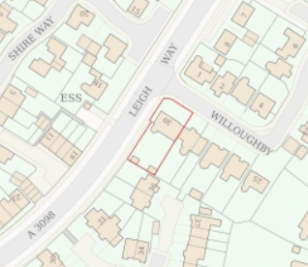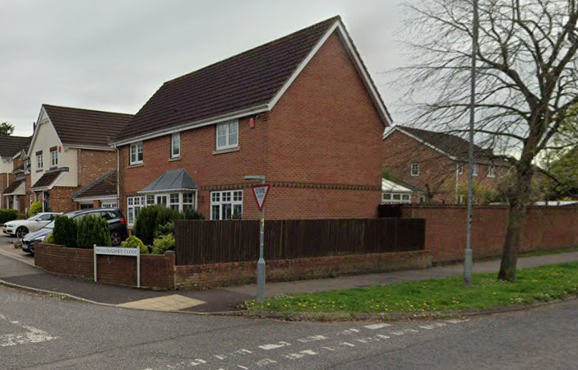

Location Plan and Google Earth Site Photo

The application site is in an area prone to increased ground water flooding .25%>50%.

PROPOSAL

The proposal seeks planning permission for:
- Demolition of existing conservatory, with rear projection 3.7m, and the single storey rear section of the kitchen.
- Rear extension, rear projection 3.6m, to create an open plan kitchen/dining/living space across the rear of the property with bifold doors and 4 rooflights.
- Rebuilt Utility room, including door to rear, to garage, and to the kitchen.

Proposed materials include red brick, interlocking concrete tiles and uPVC windows/doors to match existing.

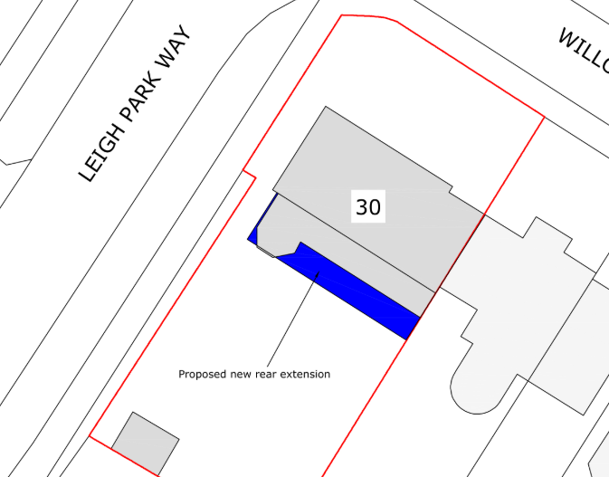

Proposed Block Plan

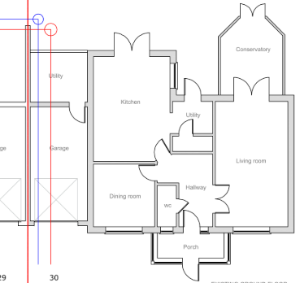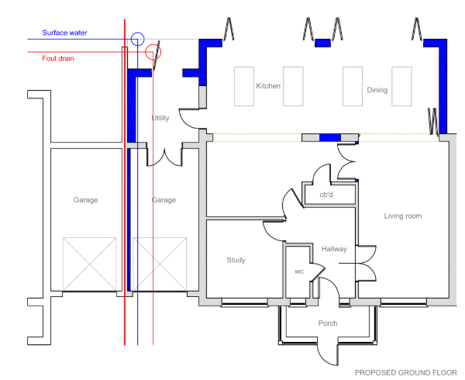

Existing and Proposed Ground Floor Plan

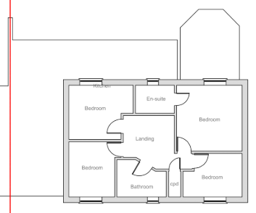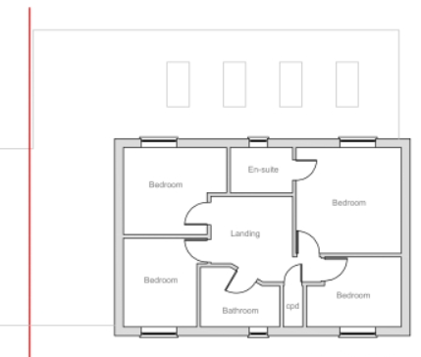

Existing and Proposed First Floor Plan

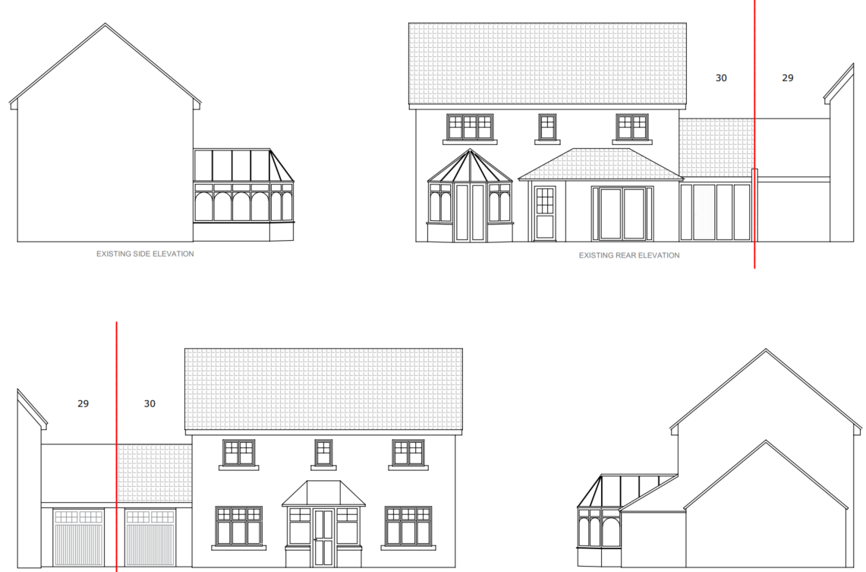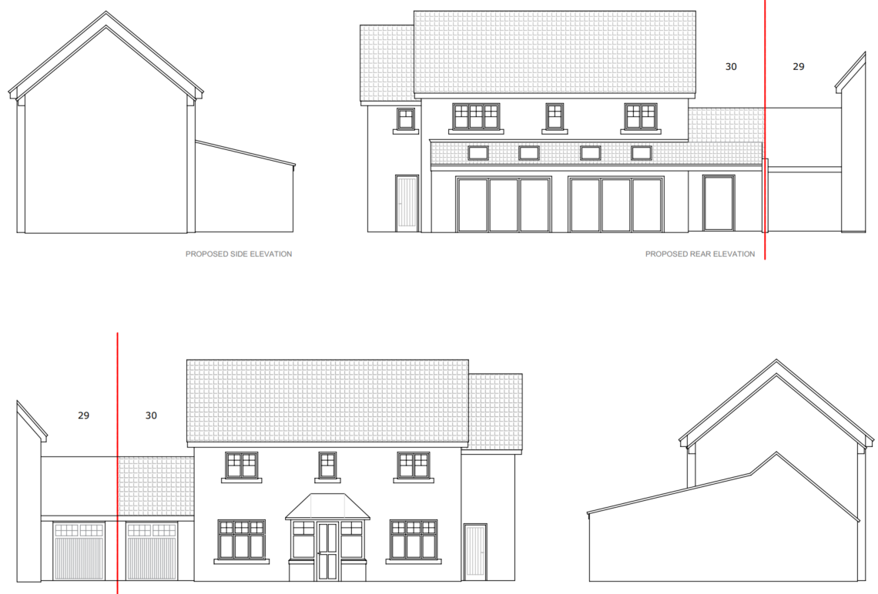

Existing and Proposed Side Elevation – from streetscape

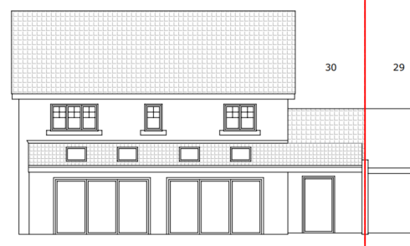

Existing and Proposed Rear Elevation

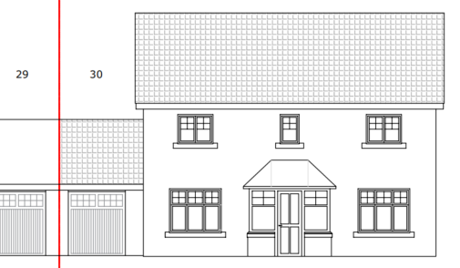

Existing and Proposed Front Elevation

Existing and Proposed Side Elevation

PLANNING HISTORY
W/99/01547/FUL - Conservatory - Approve with Conditions – Plot 1
W/99/00135/FUL – erection of Conservatory – Approve – Plot 1
W/08/03091/FUL – loft extension above garage – refuse – no.29-30
PL/2026/01234 - Householder planning permission Decision - Approve with Conditions Date: 29/4/2026 – To replace two sheds with a workshop in the rear garden
W/98/01795/REM - Reserved Matters Decision - Approve with Conditions Date: 18/2/1999 – Reserved matters 55 dwellings with associated garages parking spaces highway and drainage

RELEVANT POLICIES AND GUIDANCE
The National Planning Policy Framework (NPPF), August 2026
The Planning Practice Guidance
National Design Guide
Wiltshire Design Guide: Appendix D – Design Guidance for Householder extensions

Wiltshire Core Strategy:
- Core Policy 57 Ensuring High-Quality Design and Place Shaping
- Core Policy 67: Flood Risk

Westbury Neighbourhood Plan, made 2017

CONSULTATION RESPONSES
Westbury Town Council: No objection, noting that revisions have overcome previous objections.

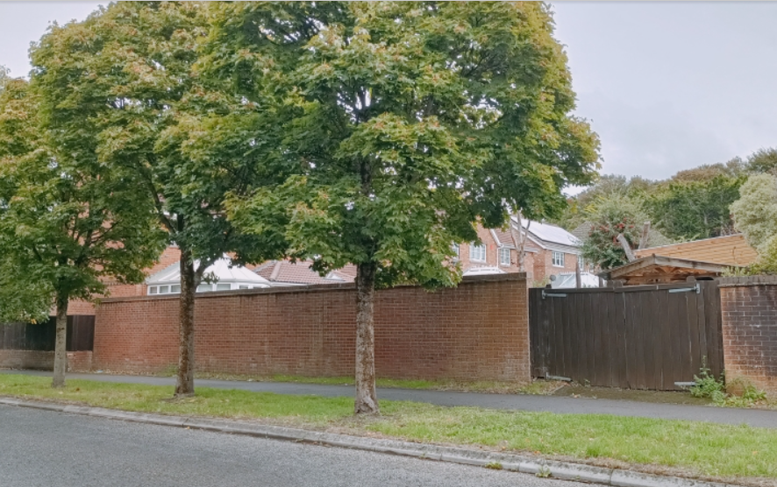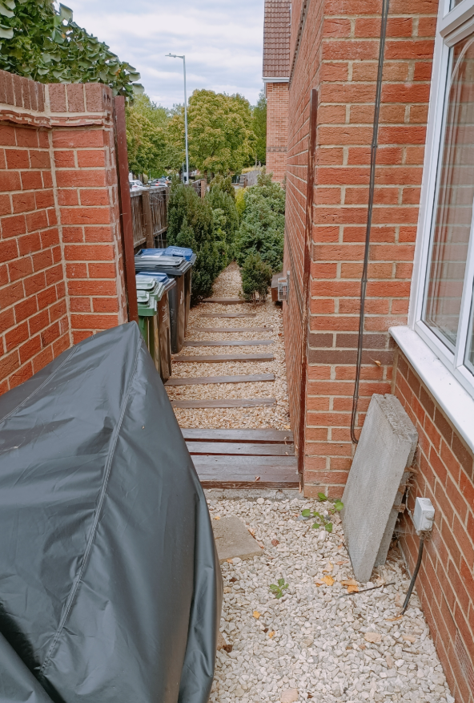

REPRESENTATIONS
One comment received from the owner, responding to Westbury Town Council’s previous objection, including retention of side and front access, as per site photos above.

ASSESSMENT
Section 38(6) of the Planning and Compulsory Purchase Act 2004 states:

"If regard is to be had to the development plan for the purposes of any determination to be made under the planning Acts, the determination must be made in accordance with the plan unless material considerations indicate otherwise."

In accordance with this statutory requirement, this application has been assessed against the relevant policies of the Development Plan, including the adopted Wiltshire Core Strategy (2015) and, where applicable, any made Neighbourhood Plans.

Design and Impact upon the upon the character and context of the area
Core Policy 57 - Ensuring High-Quality Design and Place Shaping of the Wiltshire Core Strategy seeks to ensure that all new development is of high design quality, reflecting local context, character, and distinctiveness.

The revised plans for the replacement of two single storey extensions for a single extension, also at single storey, and approximately the same width and rear projection, is considered appropriately scaled.

The proposed mono-pitch roof would be in keeping with the host dwelling and wider area, echoing the previous extensions, whilst refining the rear and side elevations.

The roof ridge would finish below first floor windows and so would just be visible over the boundary treatments, on what is a prominent corner, but would have a reduced visible impact than the muddle of existing conservatory and extensions.

Having regard to the above, the proposal complies with the design principles set out in Core Policy 57 of the Wiltshire Core Strategy and Appendix D of the Wiltshire Design Guide.

Amenity
Point vii of Core Policy 57 - Ensuring High-Quality Design and Place Shaping of the Wiltshire Core Strategy seeks to ensure that developments do not adversely affect neighbouring properties.

Policy P3 of the NPPF requires development proposals to provide healthy living conditions for occupiers and explicitly mandates avoiding unacceptable adverse impacts on neighbouring residents and occupiers. This includes protecting against adverse effects regarding daylight, sunlight, privacy, noise, and other sources of disturbance.

As single storey extensions, the proposed development would not raise concerns regarding overshadowing or overbearing.

The proposed bifold doors would face rear down the rear garden. The rooflights are at a height to raise no concerns with overlooking.

The proposal therefore accords with Core Policy 57 point vii in respect of safeguarding residential amenity and Appendix D of the Wiltshire Design Guide.

Drainage and Flood Risk
Core Policy 67 of the Wiltshire Core Strategy requires that all new development avoids increasing flood risk on-site or elsewhere and, where appropriate, incorporates sustainable drainage measures. Development must also comply with national policy on flood risk management and drainage design.

Section F7(1) of the NPPF states that ‘Development proposals should not present a risk from flooding to potential occupiers, users, or visitors, and should not increase flood risk elsewhere.’

Householder development is considered Minor Development, under the Flood Risk planning guidance, if “physical extensions to the existing dwelling itself,” and, barring a few exceptions not relevant here, “are unlikely to raise significant flood risk.”

The proposal to remodel an existing property, is therefore deemed to not result in any loss of land prone to flood risk. As such, the proposal is deemed to be safe for its users for the intended lifetime of the development with respect to the level and nature of the flood risk.

The proposal therefore complies with Core Policy 67 of the Wiltshire Core Strategy and the NPPF, ensuring that flood risk is not increased and that surface water drainage is appropriately managed.

Biodiversity Net Gain
Householder planning applications are exempt from the requirement to deliver Biodiversity Net Gain under Schedule 7A, Section 4(2)(a) of the Town and Country Planning Act 1990, as inserted by the Environment Act 2021.

CONCLUSION
The proposed development is considered to be acceptable in terms of its design, scale, and relationship with the surrounding area. It would not result in any unacceptable harm to the character of the locality, the amenities of neighbouring occupiers, or the interests of drainage.

The proposal is therefore considered to comply with the relevant policies of the Wiltshire Core Strategy, the Wiltshire Local Plan, and the National Planning Policy Framework. As such, the application is recommended for approval, subject to the conditions set out below.

RECOMMENDATION: That Planning Permission be GRANTED subject to conditions.

