APPLICATION FOR HOUSEHOLDER PLANNING PERMISSION
DELEGATED REPORT

APPLICATION REFERENCE: | PL/2026/04571
APPLICATION TYPE: | Householder Planning Permission
SITE ADDRESS: | 13 Elm Hill, Warminster, BA12 0AU
DEVELOPMENT DESCRIPTION: | Replacement of an existing septic tank with a new sewage treatment plant, including the installation of associated pipes and cables.
RECOMMENDATION: | That Planning Permission be GRANTED

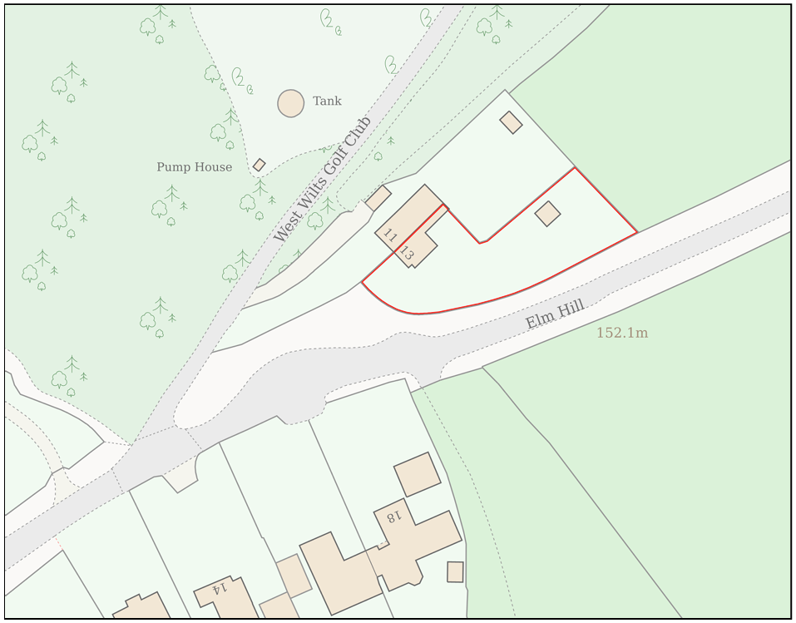
PROPOSAL

The application seeks planning permission for the replacement of an existing septic tank serving the host dwelling with a modern package sewage treatment plant. The proposed works comprise the installation of a 5-person Graf One2Clean sewage treatment plant, associated pipework, manholes, inspection chambers, gullies, and a new drainage field measuring approximately 16 square metres. The existing septic tank would be emptied and decommissioned as part of the works. The proposal is ancillary to the continued residential use of the property and is intended to modernise and improve the existing foul drainage arrangements serving the dwelling.

SITE DESCRIPTION / CONTEXT

The application site comprises one of a pair of two-storey semi-detached dwellings of traditional red brick construction situated on the edge of the Warminster settlement boundary. Whilst the subject dwelling is attached to an existing dwelling and is located within the defined settlement boundary for Warminster, the surrounding character becomes increasingly rural beyond the built form of the settlement, with extensive areas of open countryside located to the north and west.

The site lies within Flood Zone 1 and is identified by the Council's Strategic Flood Risk Assessment as being at low risk of groundwater flooding. Environmental constraints include its location within the Hampshire River Avon Catchment, within the 6.4km buffer of the Salisbury Plain Special Protection Area (SPA), and within Source Protection Zone 3. The site also falls within the locally designated Special Landscape Area (C3) which covers land adjacent to but not within the Cranborne Chase National Landscape.

A Public Right of Way (WARM29) runs immediately to the north of the application site, whilst an area of Priority Habitat Woodland is located approximately 22 metres to the north-west. Notwithstanding these constraints, the proposal relates to the replacement of existing drainage infrastructure within an established residential curtilage, and the implications of these designations are assessed further within this report.

PLANNING HISTORY

No relevant planning history has been identified for the site subject of this application.

RELEVANT LEGISLATION, POLICIES AND GUIDANCE

Wiltshire Core Strategy:

Core Policy 1 Settlement Strategy;
Core Policy 2 Delivery Strategy;
Core Policy 31 Spatial Strategy: Warminster Community Area;
Core Policy 50 Biodiversity and Geodiversity;
Core Policy 51 Landscape;
Core Policy 57 Ensuring High-Quality Design and Place Shaping;
Core Policy 60 Sustainable Transport;
Core Policy 61 Transport and Development;
Core Policy 64 Demand Management;
Core Policy 67 Flood Risk;
Core Policy 68 Water Resources

C3 ‘saved’ policies of the West Wiltshire District Local Plan 2004

Warminster Neighbourhood Plan 2015-2026

The National Planning Policy Framework (NPPF) and the Planning Practice Guidance (PPG)

Wiltshire Design Guide - Appendix D – Design Guidance for Householder extensions

The Wiltshire Local Transport Plan 2011 – 2026: Car Parking Strategy (March 2015).

The Wiltshire Local Transport Plan 4 (LTP4) (March 2025)

New Wiltshire Local Plan: At Full Council on 19 May 2026, the elected members of Wiltshire Council agreed to withdraw the emerging Wiltshire Local Plan. The said Plan has no material weight for the purposes of the application.

In accordance with Regulation 19 of the Town and Country Planning (Local Planning) (England) Regulations 2026, on 30th June 2026 Wiltshire Council published a notice of intention to prepare a new local plan for Wiltshire. The next stage is a Scoping Consultation which commences on 2nd September 2026. This plan is at a very early stage and currently carries no weight for decision making.

CONSULTATION RESPONSES

Warminster Town Council – No Objection

Arboricultural Officer (Wiltshire Council) – No Objection

Environment Agency – No comment

REPRESENTATIONS

No comments received.

ASSESSMENT

Section 38(6) of the Planning and Compulsory Purchase Act 2004 states:

"If regard is to be had to the development plan for the purposes of any determination to be made under the planning Acts, the determination must be made in accordance with the plan unless material considerations indicate otherwise."

In accordance with this statutory requirement, this application has been assessed against the relevant policies of the Development Plan, including the adopted Wiltshire Core Strategy (2015) and, where applicable, any made Neighbourhood Plans.

The proposed development comprises the replacement of an existing septic tank serving a dwellinghouse with a modern package sewage treatment plant and associated drainage infrastructure within the residential curtilage of the host property. The site lies within the defined settlement boundary of Warminster, where residential development is supported in principle. The proposal represents a domestic improvement ancillary to the continued residential use of the property and does not result in any intensification of use, additional residential accommodation, or alteration to the established character of the site. As such, the principle of development is considered acceptable and accords with the spatial strategy of the development plan.

Flooding, Drainage and Water Resources

Core Policy 67 of the Wiltshire Core Strategy seeks to ensure that development is directed away from areas at greatest risk of flooding and is designed to minimise vulnerability to flooding whilst avoiding any increase in flood risk elsewhere. National planning policy relating to flood risk and drainage is contained within Policies F4 to F8 of the National Planning Policy Framework. Collectively, these policies establish a risk-based approach to the location and assessment of development proposals. The Framework requires flood risk to be properly assessed where necessary, seeks to direct development towards areas at the lowest risk of flooding through the application of the sequential approach where applicable, and ensures that development remains safe for its lifetime without increasing flood risk elsewhere. The policies also support the incorporation of sustainable drainage measures where appropriate in order to manage surface water runoff and reduce the potential for flooding.

The application proposes the replacement of an existing septic tank with a package sewage treatment plant incorporating a new drainage field within the residential curtilage. The supporting information confirms that the existing septic tank would be decommissioned and replaced by a modern treatment system designed to provide improved treatment and filtration of foul wastewater prior to discharge. The development therefore constitutes an upgrade to existing drainage infrastructure rather than the creation of a new source of wastewater generation.
Whilst he site lies within Source Protection Zone 3, the proposal replaces an existing septic tank with a modern package treatment system and does not introduce any additional foul drainage load. On the basis of the submitted details, the development is considered unlikely to adversely affect groundwater quality and is therefore compatible with the objectives of Core Policy 68.
The site is located within Flood Zone 1, where national policy identifies the lowest probability of fluvial flooding. The Council's Strategic Flood Risk Assessment indicates no identified surface water flood risk and only a low level risk of groundwater flooding. Given the limited scale of the proposal, its largely underground nature, and the fact that it replaces existing drainage infrastructure serving the dwelling, it is not considered that the development would increase flood risk on or off site. Furthermore, the site lies within Source Protection Zone 3. Whilst groundwater protection is an important consideration, the replacement of an existing septic tank with a modern treatment plant is considered likely to improve the quality of treated effluent entering the ground. Subject to a condition preventing the use of chemical dosing products or other contaminants that could adversely affect groundwater quality, the proposal is considered to accord with the objectives of Core Policy 68 and would not result in harm to water resources.

Ecology

Core Policy 50 of the Wiltshire Core Strategy seeks to protect and enhance biodiversity interests and ensure development avoids unacceptable harm to ecological assets. National policy is set out within Policies N2 and N6 of the National Planning Policy Framework. These policies require development proposals to minimise impacts upon biodiversity, protect important habitats and species, and secure opportunities for biodiversity enhancement where appropriate. Where significant harm to biodiversity cannot be avoided, adequately mitigated or compensated for, development should be refused. Biodiversity Net Gain (BNG) was established as a mandatory aspect of planning evaluation through Schedule 7A of the Town and Country Planning Act 1990 (as amended by the Environment Act 2021 Schedule 14). Householder development is exempt from the statutory Biodiversity Net Gain requirements introduced through Schedule 7A of the Town and Country Planning Act 1990 (as amended). Nevertheless, proposals should seek to avoid ecological harm and incorporate biodiversity enhancements where appropriate.

The proposed development forms the replacement of the existing residential drainage infrastructure within an established area of domestic curtilage. The works would take place within land that is already associated with the residential use of the property and is subject to existing disturbance. As such, it is considered highly unlikely that the development would adversely affect protected species, priority habitats, or other ecological receptors. Whilst the site lies within the Hampshire River Avon Catchment and within the wider Salisbury Plain SPA buffer area, the proposal replaces an existing septic tank with a modern treatment plant and new drainage field, thereby improving the treatment of wastewater prior to discharge to ground.

Furthermore, the proposal would not increase the number of residential units, occupancy levels or wastewater generation arising from the site. Rather, it would replace an existing septic tank with a modern treatment plant providing enhanced treatment of foul effluent prior to discharge. Consequently, the proposal
represents a neutral to positive environmental outcome and is not considered to conflict with the objectives of Core Policy 50.

Impact on the Special Landscape Area

Saved policy C3 requires the landscape character of these areas to be “conserved and enhanced and development will not be permitted which is considered to be detrimental to the high quality of these landscapes”. In this instance, given the nature and the extent of the proposed works, the proposal would not harm the overall character of this Special Landscape Area. The proposed works would be fully contained within the established residential curtilage of the semi-detached pair and would not encroach into the surrounding open countryside.

Design and Impact the upon the character and context of the area

Core Policy 57 of the Wiltshire Core Strategy seeks to secure high-quality design which responds positively to local character and distinctiveness. At the national level, Policy DP3 of the National Planning Policy Framework requires development proposals to respond positively to their context and integrate with and enhance their surroundings. Development should also reflect, where relevant, the principles of liveability, climate resilience, nature, movement, built form, public space and local identity. Assessment of design quality therefore requires consideration of the scale, appearance, massing, materials, layout and relationship of the proposal with both the host site and the wider character of the surrounding area.

The proposed works comprise the installation of a replacement sewage treatment system, associated pipework, inspection chambers, and a new drainage field, all of which would be located below ground level within the existing residential garden. The development would not introduce any substantial above-ground structures and would have no material impact upon the appearance, character, or visual amenities of the surrounding area. Given the domestic nature of the works and the fact that the proposal largely replaces existing drainage infrastructure serving the property, it is considered that the development would preserve the character and appearance of the site and surrounding locality.

Having regard to the above, the proposal complies with the design principles set out in the NPPF Policy DP3, Core Policy 57 of the Wiltshire Core Strategy, and Appendix D of the Wiltshire Design Guide.

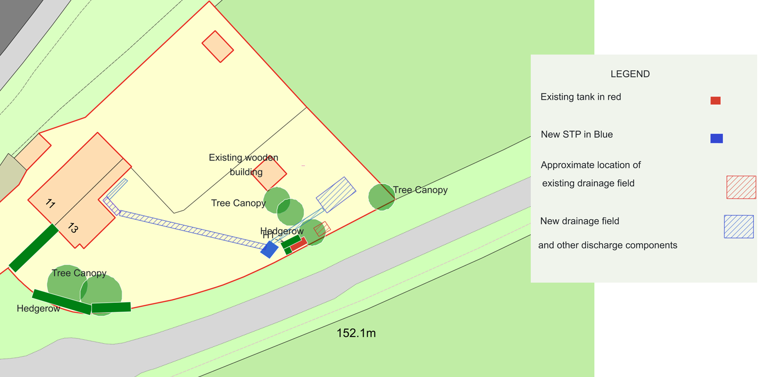
Proposed Block Plan

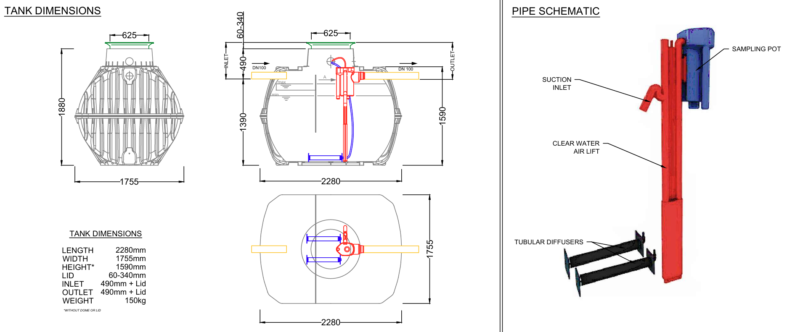
Proposed Tank Elevations

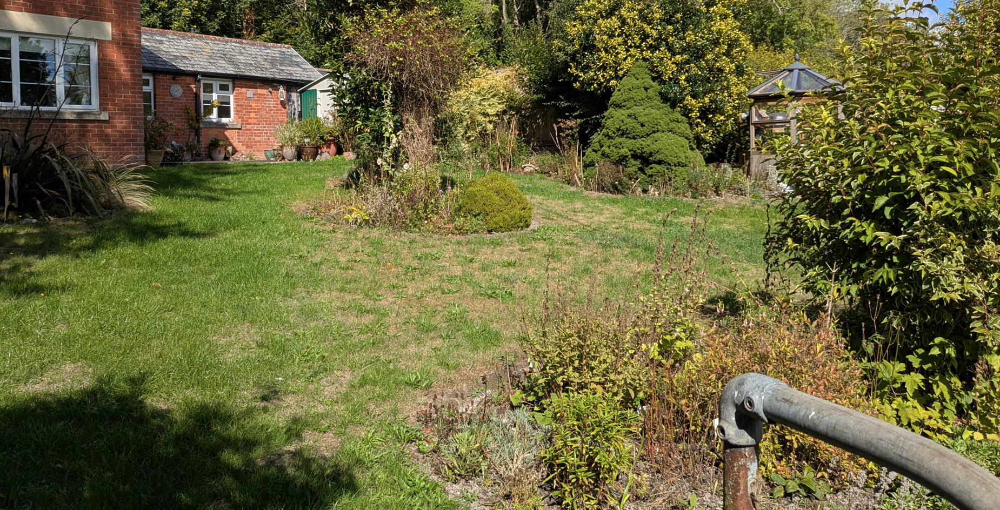
Site Visit (Front Garden)

Amenity

Core Policy 57 criterion vii seeks to ensure development does not have an unacceptable impact upon the amenities of neighbouring occupiers. Nationally, Policy P3 requires development proposals to provide healthy living conditions for occupiers and users and to avoid unacceptable impacts arising from loss of light, outlook, privacy, noise, disturbance or other forms of pollution. Policy DP3 additionally requires development to create liveable and attractive places for existing and future users. Accordingly, the assessment below considers the effect of the proposal upon neighbouring occupiers and whether acceptable living conditions would be maintained.

No amenity concerns are identified arising from the proposed development. The proposal represents an upgrade and replacement of existing foul drainage infrastructure and would be contained almost entirely below ground level within the residential curtilage. Consequently, the development would have no material visual presence and would not result in any overbearing impact, loss of privacy, overlooking, or reduction in access to natural light for neighbouring occupiers. The proposal is appropriately sited, designed, and orientated to ensure that the living conditions and amenities of surrounding residential properties are safeguarded.

The proposal therefore accords with Core Policy 57 point vii in respect of safeguarding residential amenity and Appendix D of the Wiltshire Design Guide.

Transport and Highways

Core Policies 60, 61 and 64 of the Wiltshire Core Strategy seek to promote sustainable transport, secure safe access arrangements and ensure adequate parking provision. Nationally, Policies TR3 and TR4 of the National Planning Policy Framework require development to be located in sustainable locations where appropriate, provide safe access arrangements, prioritise walking, wheeling and cycling, and provide suitable parking provision having regard to the nature and location of the development. Policy TR6 confirms that development should be refused where it would result in a severe adverse impact on the transport network or an unacceptable impact on highway safety after consideration of any mitigation measures.

The proposed development would not alter the existing means of access to the site, nor would it affect existing parking arrangements, highway visibility, or vehicle manoeuvring areas. Construction activities would be limited in scale and temporary in nature, whilst the completed development would generate no additional traffic movements when compared to the lawful existing situation. Accordingly, no highway safety or access concerns are identified and the proposal is considered acceptable in this regard.

CONCLUSION

The proposed replacement of the existing septic tank with a modern package sewage treatment plant and associated drainage field would represent a modest domestic improvement within the residential curtilage of the property. The development is acceptable in principle, would preserve the character and appearance of the area, would not adversely affect neighbouring residential amenity, highway safety, ecological interests, drainage infrastructure, or water resources, and is considered to result in a neutral to positive environmental outcome when compared to the existing arrangement. Accordingly, the proposal complies with the relevant policies of the development plan and is recommended for approval subject to appropriate conditions.

RECOMMENDATION: That Planning Permission be GRANTED subject to following conditions

