APPLICATION FOR FULL-PLANNING PERMISSION (MINOR DEVELOPMENT)
CASE OFFICER REPORT

APPLICATION REFERENCE: | PL/2026/04490
APPLICATION TYPE: | Full planning permission
SITE ADDRESS: | The Town Hall, High Street, Marlborough , SN8 1AA
DEVELOPMENT DESCRIPTION: | Replacement of 2 x CCTV cameras with 2 x new cameras and new corner brackets, and the installation of 1 x new camera and new corner bracket - all on the external walls of the Town Hall building
RECOMMENDATION: | Approve with Conditions

Context and Relationship to Associated Applications

The current application forms part of a wider programme of CCTV upgrades submitted by Marlborough Town Council relating to three separate Grade II listed buildings within Marlborough High Street and the Marlborough Conservation Area, namely Marlborough Town Hall, High Street, 17-18 High Street and Marlborough Library, 91 High Street. Each property has been subject to both a planning application and a listed building consent application, all of which are being considered concurrently by the Local Planning Authority.

Whilst the applications have been submitted and assessed over the same period, each proposal relates to a separate site and must be determined on its own individual merits having regard to the relevant statutory duties, development plan policies and other material considerations. The associated planning and listed building consent applications for each site are therefore considered independently, notwithstanding their connection as part of a wider town centre CCTV improvement programme.

CCTV cameras were installed at five locations within Marlborough High Street in 2015, including cameras mounted on the Town Hall and Library. Marlborough Town Council now seeks to replace the existing cameras with updated equipment and, in the case of the Town Hall, provide one additional camera. The stated objectives of the programme are to improve visibility and reduce blind spots, better monitor and deter criminal activity, capture vehicular incidents associated with increased traffic levels, and support the continued economic vitality of Marlborough town centre by helping to maintain public safety.

Across all three sites, the cameras would be mounted on decorative black corner brackets projecting approximately 600-800mm from the building faces. Whilst the brackets and cameras would remain visible modern additions to the host buildings, the design seeks to reduce their utilitarian appearance and minimise visual impact whilst providing improved surveillance coverage.

In considering the wider heritage context, it is noted that there are no Grade I listed buildings within Marlborough High Street. However, nearby Grade II* listed buildings include Nos. 142-143 High Street and Nos. 132-133 High Street together with the outhouse to the rear of No. 133. The former lies immediately to the north of Marlborough Town Hall on the opposite side of the High Street, whilst the latter lies approximately 60 metres south-west of the Town Hall and approximately 70 metres north-east of 17-18 High Street. Marlborough Library is located further to the east along the High Street. Notwithstanding the collaborative nature of the wider proposal, the potential impacts upon the significance of the host Grade II listed building, nearby designated heritage assets and the character and appearance of the Marlborough Conservation Area are assessed within the relevant sections of this report.

SITE DESCRIPTION/CONTEXT

The application relates to Marlborough Town Hall, a Grade II listed building prominently positioned on the centre island at the eastern end of Marlborough High Street, where it forms a focal point terminating views along the principal shopping street. Constructed in 1902 to the designs of architect C.E. Ponting, the building is executed in a combination of Flemish and Arts and Crafts influences and is recognised as a landmark civic building of considerable architectural and historic significance. The Town Hall accommodates a range of civic, community and public functions and occupies a highly visible location within the Marlborough Conservation Area.

The two-storey building is characterised by its brick and roughcast elevations, steeply pitched tiled roof, projecting cornices, ornate stone detailing and prominent entrance frontage. The building forms an important component of a wider group of listed buildings within the historic town centre.

Of the three application sites, the Town Hall appears to have undergone the greatest degree of alteration and contains a range of modern additions and fixtures associated with its ongoing use. These include existing CCTV equipment, security lighting, satellite dishes and associated brackets, external pipework, notice boards, ventilation equipment and electrical cabinets. Despite these interventions, the building remains readily appreciable as a historic civic structure and continues to make a strong positive contribution to the significance and character of both the listed building and the conservation area.

The listed building description reads:

HIGH STREET 1. 5407 (East End) CENTRE ISLAND The Town Hall SU 1869 1/1 II GV 2. . 1902 C E Ponting Architect. Freehandling of William and Mary and Renaissance styles. 2 storeys, brick plinth with brick ground floor and roughcast lst floor with brick quoins and dressings. String courses of brick. Steep pitch tiled roof with projecting bracketed moulded cornice. Domed arcaded lantern on ridge. Pedimented dormers. Main front is side elevation facing down High Street. Elaborate stone centrepiece with paired squat Doric columns on pedestals with vertical entablatures as imposts to entrance arch with keystones. Heavy scrolled brackets above to large renaissance bay windows with mullioned transomed lights, balcony and parapet balustrade. Elaborate stone armorial feature above. Either side of entrance on ground floor are large round headed windows with stone imposts architrave and keystone, inset panelled balustrade below sills. Dominating position closing High Street vista. The Town Hall form a group with Nos 1 to 12 (consec) and Nos 131 to 144 (consec) and Midland Bank.

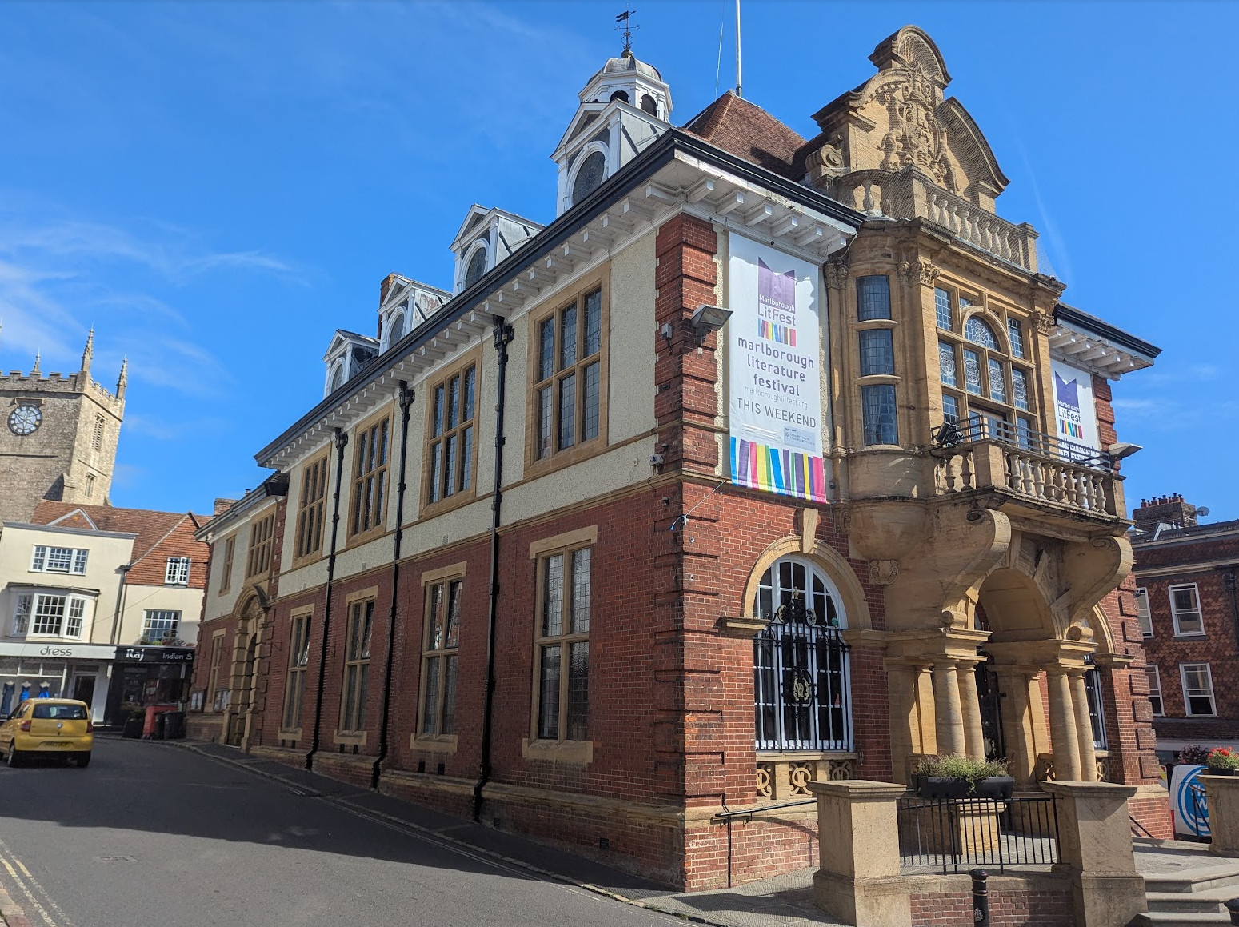

Front Elevation

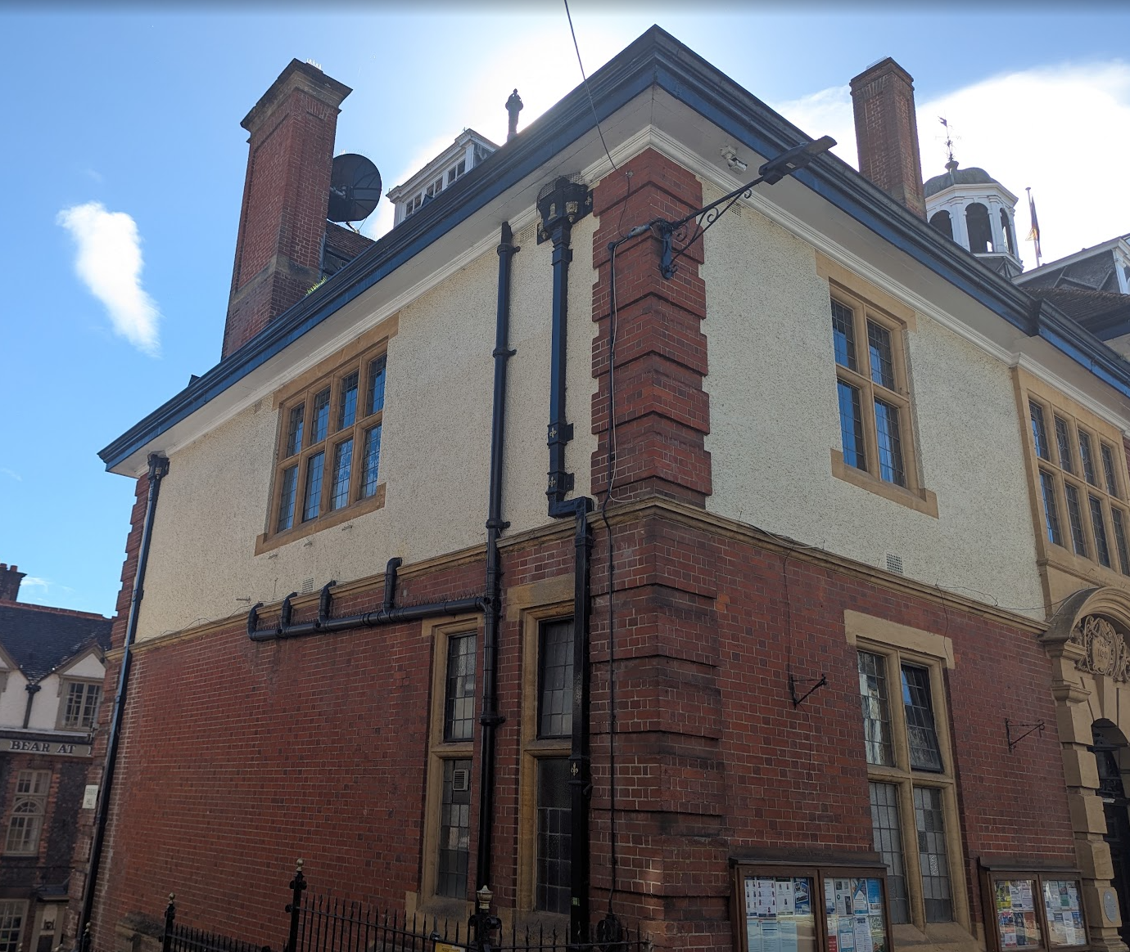

Rear Elevation

PROPOSAL

The application seeks full planning permission for the installation of three CCTV cameras. The proposals comprise the replacement of two existing cameras and the installation of one additional camera to improve surveillance coverage, reduce blind spots, assist in the monitoring of criminal and anti-social activity, and capture vehicular incidents within the town centre.

The proposed works consist of:

- The replacement of an existing CCTV camera on the southern corner of the building at first-floor level.
- The replacement of an existing CCTV camera on the northern corner facing Kingsbury Street, repositioned from beneath the roof overhang to a location beneath the projecting brick string course at first-floor level.
- The installation of a new CCTV camera on the western corner of the building at first-floor level.

The cameras would be mounted on black metal corner brackets projecting approximately 600mm from the building's elevations. The brackets have been designed to reflect the appearance of existing brackets present on the building and would conceal associated cabling. The submitted information advises that fixings would be inserted into mortar joints wherever practicable in order to minimise impacts upon the historic fabric.

The cameras would be positioned at a high level on the building's elevations and no historic fabric is proposed to be removed as part of the works.

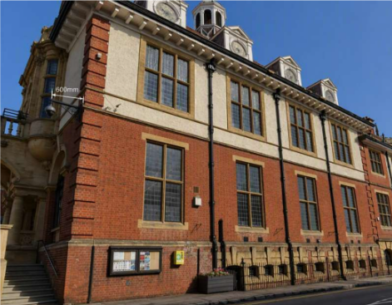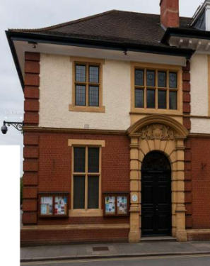

Proposed South Elevation Proposed North Elevation

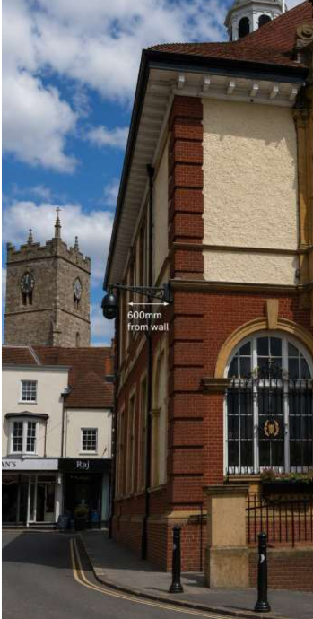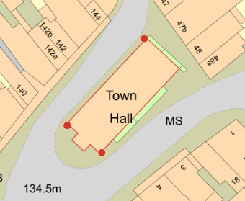

Proposed West Elevation and Extract from Proposed Site Plan (red dots show location of proposed CCTV cameras)

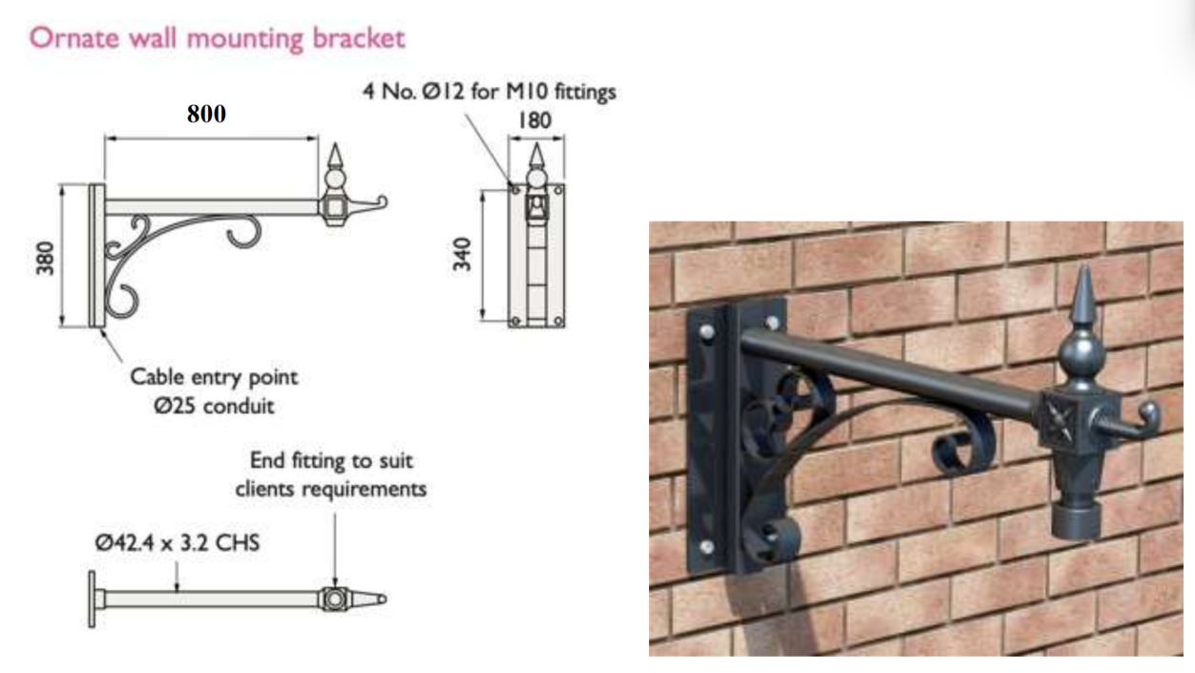
Details of Proposed Hanging Bracket

PLANNING HISTORY

There are 28 planning records on the Town Hall with the most relevant being 15/00674/FUL & 15/00788/LBC - Two CCTV cameras on external walls – Approved with conditions

It is also worth noting applications E/2013/0087/FUL & E/2013/0089/LBC - Installation of satellite dish on chimney at rear of building – Approved with conditions – as examples of alterations at the Town Hall.

RELEVANT LEGISLATION, POLICIES AND GUIDANCE

Statutory Legislation:

Town and Country Planning Act 1990

National Planning Policy:
- National Planning Policy Framework (NPPF)
- Planning Practice Guidance (PPG)

Development Plan:

The development plan for Wiltshire comprises the Wiltshire Core Strategy (WCS) (adopted January 2015) and any made neighbourhood plans, which remains the principal statutory planning document guiding development across the county. In line with Section 38(6) of the Planning and Compulsory Purchase Act 2004, planning decisions must be made in accordance with the development plan unless material considerations indicate otherwise.

Though the development plan is considered as a whole, those parts deemed to be particularly relevant to this application are listed below:

The adopted Wiltshire Core Strategy (WCS), with particular regard to:

• Core Policy 49 Protection of Rural Services and Community Facilities
• Core Policy 51 Landscape
• Core Policy 57 Ensuring High Quality Design and Place Shaping;
• Core Policy 58 Ensuring the Conservation of the Historic Environment

Neighbourhood Plan:

Marlborough Neighbourhood Plan (2021-2036) adopted 2023 – Policies MARL4, MARL7 and MARL9.

Supplementary Planning Documents and other Guidance:
- Wiltshire Design Guide (adopted April 2024)
- National Design Guide
- Marlborough Conservation Area Statement 2003

ISSUES

The main issues that need to be addressed in this case include:

- Whether the development is acceptable in principle (CP 1 and 2)
- Whether the scheme constitutes high quality design (CP 57)
- Whether the scheme would have an acceptable impact upon the reasonable living conditions of the adjoining occupants (CP 57)
- Whether the scheme would preserve or enhance the historic environment (CP 58)
- Whether the scheme would have an acceptable landscape impact (CP 51)

CONSULTATION RESPONSES

The views of consultees are material considerations in the determination of the application. However, the decision-maker must exercise their own planning judgement. Where consultees raise concerns or recommend conditions, these have been considered and are addressed within the assessment section of this report.

Marlborough Town Council: Noted the application (but didn’t offer a recommendation)

Wiltshire Council Conservation Officer: No objection

Wiltshire Council Public Protection Officer: No comment to make

Wiltshire Council Highways Officer: No objection

The consultee responses have been carefully considered. Whilst significant weight is afforded to specialist technical advice, the decision remains a matter for the Local Planning Authority and the officer assessment below reaches an independent planning judgement on the issues raised.

REPRESENTATIONS

In accordance with the requirements of the Town and Country Planning (Development Management Procedure) (England) Order 2015 (as amended), the application was publicised by way of:

- (53x) Neighbour notification letters sent to adjoining and nearby properties;
- A site notice displayed near the site;
- An advertisement placed in the local press 13 August 2026 (expiry date 3 September 2026)

These methods were used to inform interested parties and provide a period of 21 days for comments to be submitted.

No comments were received.

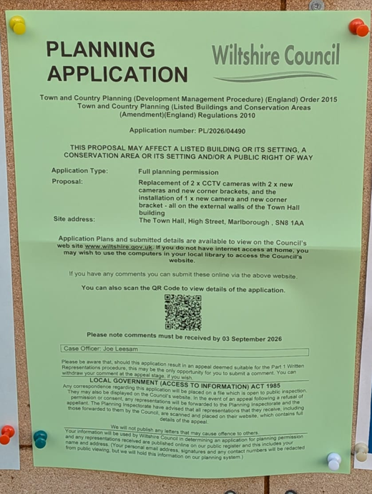

Photo of Site Notice erected in notice board cabinet

ASSESSMENT Section 38(6) of the Planning and Compulsory Purchase Act 2004 states:

"If regard is to be had to the development plan for the purposes of any determination to be made under the planning Acts, the determination must be made in accordance with the plan unless material considerations indicate otherwise."

In accordance with this statutory requirement, this application has been assessed against the relevant policies of the Development Plan, including the Wiltshire Core Strategy (2015) and, where applicable, any made Neighbourhood Plans. Consideration has also been given to the policies of the NPPF (NPPF) as a material consideration in the assessment.

The assessment below considers each of the main issues identified above. Each topic is assessed in turn with reference to the relevant policy context, the evidence submitted, consultee responses, and all other material considerations, before a conclusion is reached.

Principle of Development

    - Policy Context
The application seeks permission for the replacement of an existing CCTV camera and associated mounting bracket with updated surveillance equipment as well as the installation to two additional cameras. The proposal forms part of a wider programme of CCTV improvements being undertaken by Marlborough Town Council within Marlborough High Street. The stated objectives of the project are to improve surveillance coverage, reduce blind spots, assist in the deterrence and investigation of crime and anti-social behaviour, improve monitoring of vehicular incidents and contribute towards maintaining a safe and attractive town centre environment.

The application site is located within the built-up area of Marlborough town centre. Policy MARL4 of the Marlborough Area Neighbourhood Plan seeks to support a thriving town centre and recognises the importance of maintaining and enhancing facilities and services that contribute to its vitality and viability. In addition, Policy MARL7 identifies Marlborough Town Hall as a protected community facility and supports proposals that sustain or improve its continued operation and use.

At a strategic level, the Wiltshire Core Strategy seeks to support resilient communities through the protection and enhancement of services and facilities. Core Policy 49 supports the retention and improvement of community facilities, whilst Strategic Objective 4 seeks to promote community wellbeing, safety and social inclusion. Furthermore, Core Policy 57 requires development to achieve high-quality design and place shaping. Criterion ix) specifically seeks to ensure that the public realm and public spaces contribute towards places that are safe, legible and accessible. The upgrading of existing CCTV infrastructure is considered consistent with these objectives by contributing to public safety and assisting in the management of the public realm.

    - Planning History
The planning history of the site has been reviewed. Existing CCTV equipment has been present at the property for a number of years and forms an established feature of the building. The current proposal does not seek to introduce surveillance equipment for the first time but instead seeks to replace and modernise existing apparatus and increase the number of CCTV units as part of a wider town centre CCTV improvement programme. The proposal also offers the opportunity to rationalise and improve the appearance of the existing equipment through the installation of a consistent and more contemporary design.

    - Assessment
The site occupies a sustainable location within the defined settlement boundary of Marlborough town centre and comprises an existing community facility. The proposal would support the continued operation and management of the facility through the provision of updated CCTV infrastructure intended to improve surveillance coverage and public safety.

The development is considered to accord with the objectives of Policies MARL4 and MARL7 of the Marlborough Area Neighbourhood Plan, together with the broader aims of Core Policies 49 and 57 of the Wiltshire Core Strategy, which support the enhancement of community facilities and the creation of safe and accessible public environments.

    - Conclusion
The proposal accords with the Development Plan and the principle of development is supported in this location.

The proposal must nevertheless be assessed against all other relevant Development Plan policies, national policy and material considerations. Subject to that assessment, the principle of development is considered acceptable.

Design and Impact on the Character and Appearance of the Area

Policy Context
Core Policy 57 of the Wiltshire Core Strategy requires development to achieve a high standard of design that responds positively to local character, context and distinctiveness.

Policies DP1-DP4 of the NPPF seek to ensure that development is well-designed, visually attractive, sustainable and responsive to its surroundings. Development should contribute positively to local character, create high quality places and support healthy and inclusive communities.

Policy MARL9 of the Marlborough Area Neighbourhood Plan requires development proposals to sustain and enhance the special architectural and historic significance of the Marlborough Conservation Area and have full regard to the Marlborough Conservation Area Statement and Marlborough Town Character Study.

Assessment
The proposal comprises the replacement of two existing CCTV cameras together with their associated brackets and the installation of one additional CCTV camera, all mounted on black corner brackets projecting approximately 600mm from the building. By virtue of their functional design, positioning and relationship with the host building, the proposed cameras and brackets would not appear visually dominant or incongruous. The use of black-finished brackets and equipment would assist in reducing visual prominence against the host building and surrounding townscape.

Whilst the proposal would result in an increase in the overall amount of CCTV equipment attached to the building, including the introduction of one additional camera, the CCTV units themselves remain relatively compact. The cameras and brackets are not particularly sympathetic additions to a historic building and would remain visible modern features attached to the Town Hall. However, efforts have been made to reduce visual impact through the use of decorative brackets and concealed cabling. Having regard to their modest scale, high-level position and operational purpose, it is not considered that the additional equipment would result in material harm to the character or appearance of the building or wider street scene.

The Town Hall occupies a prominent position within Marlborough High Street and forms an important feature within the townscape. However, the proposed cameras would be viewed in the context of an active town centre environment containing a variety of modern fixtures and equipment associated with the day-to-day operation of the public realm. In this context, the proposal would sit comfortably within its surroundings and would not detract from the visual qualities of the building or wider street scene.

Whilst the proposal would be more visually prominent than the existing arrangement due to the additional camera and replacement bracket system, it is considered that the development would preserve the established appearance of the building and would not result in any material harm to the character or appearance of the surrounding area. The proposal is therefore considered to accord with the design objectives of Core Policy 57 of the Wiltshire Core Strategy, Policies DP1-DP4 of the NPPF and Policies MARL7 and MARL9 of the Marlborough Area Neighbourhood Plan.

Conclusion
Having regard to the above, it is considered that the proposal represents an acceptable alteration to the existing building. Whilst the cameras and brackets are not particularly sympathetic additions to a historic building, they have been designed with the intention of reducing visual impact and would not result in material harm to the character or appearance of the Town Hall, the surrounding townscape or the wider Marlborough Conservation Area. Accordingly, the proposal is acceptable in design terms.

Impact on Heritage Assets

Policy Context
From the point of view of the historic environment, the main statutory duties are set out within the Planning (Listed Buildings and Conservation Areas) Act 1990.

Section 66(1) requires special regard to be given to the desirability of preserving listed buildings, their settings and any features of special architectural or historic interest which they possess.

Section 72(1) requires special attention to be paid to the desirability of preserving or enhancing the character or appearance of Conservation Areas.

Core Policy 58 of the Wiltshire Core Strategy seeks to conserve and, where appropriate, enhance the significance of designated and non-designated heritage assets and their settings. Core Policy 57 requires development to respond positively to local character and historic context through high quality design.

Policies HE4-HE10 of the NPPF recognise heritage assets as an irreplaceable resource and require proposals affecting heritage assets to be assessed having regard to their significance and the contribution made by their setting.

Policy MARL9 of the Marlborough Area Neighbourhood Plan further requires development proposals to sustain and enhance the special architectural and historic significance of the Marlborough Conservation Area having regard to the Marlborough Conservation Area Statement and Marlborough Town Character Study.

Assessment
Marlborough Town Hall is a Grade II listed building occupying a prominent and highly visible position at the eastern end of Marlborough High Street. Constructed in 1901-02 to the designs of Charles Edwin Ponting, the building is an imposing example of Carolean Edwardian architecture characterised by ornate stone and brick detailing, columns, cornices, quoins and dressings beneath a steeply pitched tiled roof. Located at the junction of the High Street and Kingsbury Street, the Town Hall forms a focal point within the streetscape and contributes positively to an important group of listed buildings at this end of the town as well as to the significance and character of the Marlborough Conservation Area.

All three cameras would be mounted on decorative black brackets projecting approximately 600mm from the building elevations. Whilst surveillance equipment is a modern intervention and not a feature traditionally associated with the architectural character of the building, efforts have been made to reduce visual impact through the use of decorative brackets and a more considered mounting arrangement. The brackets adopt a form comparable to those traditionally used for hanging signs from historic commercial and public buildings, although the cameras and brackets would nevertheless remain visible modern additions to the listed building.

CCTV equipment has been present on the building for a number of years and forms part of the established town centre surveillance network. The proposal would result in an increase in the overall amount of equipment attached to the building through the addition of one new camera and replacement bracket system. Whilst the cameras and brackets are not particularly sympathetic additions to a historic building, efforts have been made to reduce their utilitarian appearance through the use of decorative brackets and a more considered mounting arrangement. The proposal would not result in the loss of historic fabric, obscure architectural detailing or otherwise diminish the significance of the listed building. Whilst the overall installation would be more prominent than the existing arrangement due to the additional camera and replacement bracket system, the works would remain modest in scale and would have only a very limited visual effect on the appearance of the building, without causing harm to its heritage significance.

The proposal would also improve CCTV coverage and support wider public safety objectives within the town centre.

The Council's Conservation Officer has reviewed the proposal and raises no objection. The Conservation Officer acknowledges that the preferred heritage solution would avoid mounting surveillance equipment directly on the listed building and notes that alternative positions such as existing lamp columns would generally be preferable. However, it is accepted that the operational requirement for CCTV coverage remains and that reasonable efforts have been made to reduce visual impact through the use of decorative brackets and concealed cabling. Significant weight is therefore afforded to this specialist advice.

Accordingly, the proposal is considered to preserve the special architectural and historic interest of the Grade II listed building, whilst also preserving the character and appearance of the Marlborough Conservation Area, and would not materially affect the significance or setting of nearby designated heritage assets, including the Grade II* listed buildings at Nos. 142-143 High Street and Nos. 132-133 High Street together with the outhouse to the rear of No. 133.

In accordance with the heritage policies of the NPPF, any harm to the significance of a heritage asset must be clearly identified and assessed. In this instance, it is considered that the proposal would result in no harm to the significance of the listed building, nearby heritage assets or the Marlborough Conservation Area.

Conclusion
Having regard to the above, it is considered that the proposal would preserve the special architectural and historic interest of Marlborough Town Hall as a Grade II listed building and preserve the character and appearance of the Marlborough Conservation Area. The proposal would not result in harm to the significance of designated heritage assets and therefore satisfies the statutory duties of Sections 66(1) and 72(1) of the Planning (Listed Buildings and Conservation Areas) Act 1990, Core Policies 57 and 58 of the Wiltshire Core Strategy, Policy MARL9 of the Marlborough Area Neighbourhood Plan, and Policies HE4-HE10 of the NPPF.

Amenity

Policy Context
Core Policy 57 (Point vii) of the Wiltshire Core Strategy requires development to respect the amenity of existing occupants and ensure appropriate amenity levels for future residents.

Policy P3 of the NPPF requires development to be appropriate for its location, taking account of its likely effects on health, living conditions and the environment. In particular, Policy P3(2)(b) requires development to avoid giving rise to unacceptable impacts on the living conditions of neighbouring residents and occupiers. In assessing amenity impacts, regard should be had to matters including daylight and sunlight, outlook, privacy, overbearing impacts and other effects on residential amenity.

These policies guide the assessment of amenity impacts. Each of the below matters has been assessed having regard to the specific site context and layout of the proposal.

Overlooking / loss of privacy
The proposal relates to the replacement of two existing CCTV cameras, together with the installation of one additional camera. CCTV equipment has been present on the building for a number of years and forms part of the established town centre surveillance network. Whilst the proposal would result in an increase in the amount of CCTV equipment attached to the building, the cameras would be mounted at high level and would be operated for the purposes of public surveillance rather than serving private accommodation.

It is recognised that, unlike conventional development proposals, CCTV equipment has the potential to give rise to concerns regarding privacy if not appropriately installed and programmed. In this regard, planning permission granted for the Town Hall CCTV system in 2015 was subject to conditions requiring the cameras to be installed and operated in a manner that protects the privacy of neighbouring occupiers. Given the presence of nearby residential accommodation, the repositioning of one existing camera and the installation of an additional camera, it is considered necessary and reasonable to impose a comparable condition requiring details of the cameras' installation, field of view and programming to be submitted for approval prior to their first use. Such a condition will ensure that neighbouring amenity continues to be safeguarded.

Subject to the imposition of this condition, the proposal would not result in any unacceptable impact upon the living conditions of neighbouring occupiers. The development would not affect daylight, sunlight, outlook or create any overbearing impacts. Accordingly, the proposal is considered to accord with Core Policy 57 of the Wiltshire Core Strategy and Policy P3 of the NPPF.

Landscape and Visual Impact

Policy Context
Core Policy 51 of the Wiltshire Core Strategy seeks to protect, conserve and enhance landscape character and quality and requires development to respond appropriately to its landscape setting.

Policy N2 of the NPPF seeks to conserve and enhance the natural environment and requires development to take account of landscape character, local distinctiveness and the natural beauty of the countryside.

The Wiltshire Design Guide promotes a context-led approach that integrates development with landscape features and local character.

Policy N4 of the NPPF affords significant protection to National Landscapes and requires development proposals to conserve and enhance their natural beauty and special qualities.

Under Section 245 of the Levelling-up and Regeneration Act 2023, the Council must seek to further the purposes of National Landscapes when exercising its planning functions.

Assessment
The application site lies within the North Wessex Downs National Landscape. However, it is also located within the established urban area of Marlborough town centre, where the surrounding environment is characterised by historic buildings, commercial premises, public realm infrastructure and associated town centre activity.

The proposal comprises three CCTV cameras and associated decorative mounting brackets attached to the existing building. Given the very small scale and localised nature of the works, the proposal would not result in any loss of landscape features, trees, open space, important views or elements which contribute to the wider landscape character of the National Landscape.

Furthermore, the development would be viewed solely within the context of the existing urban streetscape and would not be readily perceptible within the wider landscape setting of the National Landscape. The proposal would therefore have no impact upon the scenic beauty, special qualities or character of the North Wessex Downs National Landscape.

Conclusion
Having regard to the above, it is considered that the proposal would not give rise to any adverse landscape or visual impacts. The proposed development would conserve the character, appearance and special qualities of the North Wessex Downs National Landscape and accords with Core Policy 51 of the Wiltshire Core Strategy and Policies N2 and N4 of the NPPF.

Public Sector Equality Duty (PSED)
In reaching this decision, due regard has been had to the Public Sector Equality Duty under Section 149 of the Equality Act 2010. This requires the Local Planning Authority to have regard to the need to eliminate discrimination, advance equality of opportunity and foster good relations between persons who share a protected characteristic and those who do not.

The Local Planning Authority is satisfied that the proposal would not result in any unlawful discrimination and that any impacts on protected groups have been appropriately considered as part of this assessment.

PLANNING BALANCE AND CONCLUSION

Policy Context
In reaching a decision, all identified harms and benefits must be weighed in the overall planning balance, having regard to Section 38(6) of the Planning and Compulsory Purchase Act 2004, the provisions of the Development Plan and the NPPF.

The NPPF contains a presumption in favour of sustainable development. Applications should be determined in accordance with the development plan unless material considerations indicate otherwise.

The weight to be afforded to any identified benefits must be considered alongside all other material considerations, including whether the proposal accords with the Development Plan and whether any other policies of the NPPF indicate that development should be refused or that substantial weight should be attributed to identified harms.

Having regard to Section 38(6) of the Planning and Compulsory Purchase Act 2004, the proposal is considered to accord with the Development Plan when read as a whole.

The proposal is also considered to accord with the relevant policies of the NPPF.

The principle of development is therefore considered acceptable.

Conclusion
The proposed development is considered acceptable in planning terms. Having regard to the Development Plan, the NPPF and all other material considerations, the proposal is considered to accord with the Development Plan.

Accordingly, planning permission should be granted.

RECOMMENDATION:
That Planning Permission be GRANTED, subject to conditions

All conditions imposed have been assessed against the tests set out in Policy DM6 of the NPPF and are considered to be necessary, relevant to planning, relevant to the development to be permitted, enforceable, precise and reasonable in all other respects.

