APPLICATION FOR LISTED BUILDING CONSENT
OFFICER DELGATED REPORT

APPLICATION REFERENCE: | PL/2026/04904
APPLICATION TYPE: | Listed building consent (Alt/Ext)
SITE ADDRESS: | Marlborough Library, 91 High Street, Marlborough, SN8 1HD
DEVELOPMENT DESCRIPTION: | Replacement of CCTV camera with a new camera and bracket in the same location, on external wall of the building
RECOMMENDATION: | Approve with Conditions

Context and Relationship to Associated Applications

The current application forms part of a wider programme of CCTV upgrades submitted by Marlborough Town Council relating to three separate Grade II listed buildings within Marlborough High Street and the Marlborough Conservation Area, namely Marlborough Town Hall, High Street, 17-18 High Street and Marlborough Library, 91 High Street. Each property has been subject to both a planning application and a listed building consent application, all of which are being considered concurrently by the Local Planning Authority.

Whilst the applications have been submitted and assessed over the same period, each proposal relates to a separate site and must be determined on its own individual merits having regard to the relevant statutory duties, development plan policies and other material considerations. The associated planning and listed building consent applications for each site are therefore considered independently, notwithstanding their connection as part of a wider town centre CCTV improvement programme.

CCTV cameras were installed at five locations within Marlborough High Street in 2015, including cameras mounted on the Town Hall and Library. Marlborough Town Council now seeks to replace the existing cameras with updated equipment and, in the case of the Town Hall, provide one additional camera. The stated objectives of the programme are to improve visibility and reduce blind spots, better monitor and deter criminal activity, capture vehicular incidents associated with increased traffic levels, and support the continued economic vitality of Marlborough town centre by helping to maintain public safety.

Collectively, the proposals comprise the replacement and upgrading of existing CCTV infrastructure. At Marlborough Library and 17-18 High Street, the works involve replacement CCTV cameras positioned in substantially the same locations as the existing equipment. At Marlborough Town Hall, the proposal comprises the replacement of two existing CCTV cameras and brackets together with the installation of one additional camera. Across all three sites, the cameras would be mounted on decorative black corner brackets projecting approximately 600-800mm from the building faces, intended to provide improved surveillance coverage whilst seeking to reduce visual impact.

In considering the wider heritage context, it is noted that there are no Grade I listed buildings within Marlborough High Street. However, nearby Grade II* listed buildings include Nos. 142-143 High Street and Nos. 132-133 High Street together with the outhouse to the rear of No. 133. The former lies immediately to the north of Marlborough Town Hall on the opposite side of the High Street, whilst the latter lies approximately 60 metres south-west of the Town Hall and approximately 70 metres north-east of 17-18 High Street. Marlborough Library is located further to the east along the High Street. Notwithstanding the collaborative nature of the wider proposal, the potential impacts upon the significance of the host Grade II listed building, nearby designated heritage assets and the character and appearance of the Marlborough Conservation Area are assessed within the relevant sections of this report.

SITE DESCRIPTION/CONTEXT

Marlborough Library is located at the south western end of the high street and is on the Junction with Hyde Lane. It is a two storey Grade II listed building within the Marlborough Conservation Area.

The supporting heritage statement sets out that:

Marlborough Library was built in 1854 originally as St Peter’s School. It was adapted and opened as a library in 1965. It is a distinctive example of Victorian institutional architecture. The twin gabled building is constructed in buff coloured brick with stone quoins and gothic revival pointed arched windows.

The listed building description reads:

Mid Cl9. Stock brick. Pitched concrete tile roofs. 1 storey and attics. 2-gabled front, with smaller gable between, and set slightly back. 2 principal gables coped, with ornamental finials, and taken on kneelers. 1 mullioned window each, with square heads and hood moulds. Attics have 1 coulus each, whose outlines are formed by the intersection of a trilobe with a triangle, themselves set within "spherical triangles" under hoodmoulds with label stops carved as
medieval heads. Central bay has doorway with 4-centred arch and modern door, 2 stringcourses, single light with hoodmould, blind oculus consisting of quadrilobed set within square, and shaped gable above.

Nos 65 to 85 (consec), The Sun Public House and Nos 88 to 90 (consec) form a group, together with the Church of St Peter and St Paul, and with Nos 42 to 64 (consec) on the South Side.

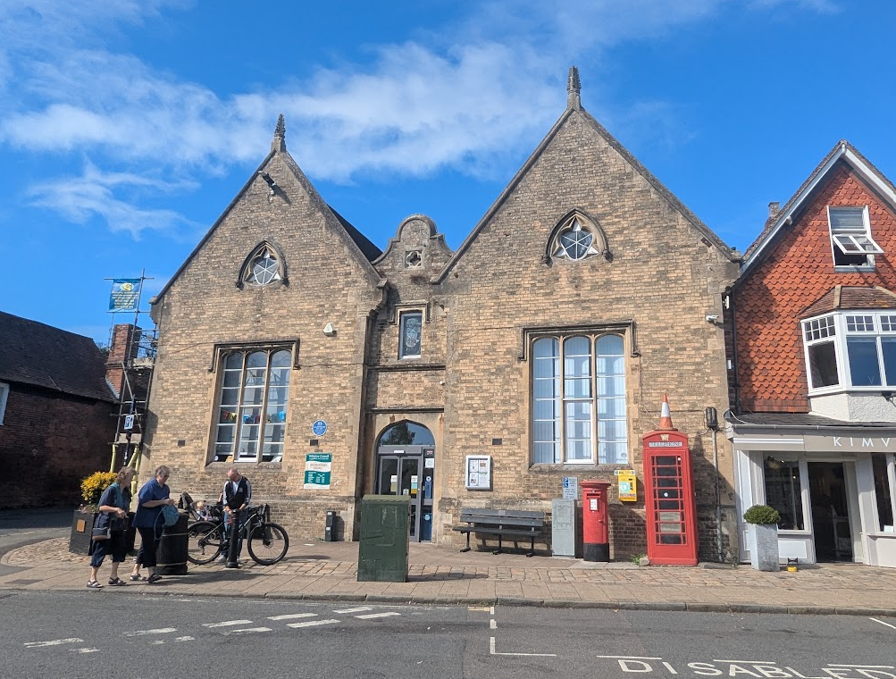

Site Visit Photo of front Elevation (existing camera on right hand side)

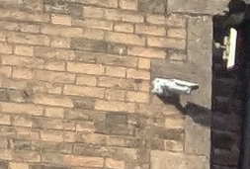

Zoomed image of existing camera

PROPOSAL

The supporting statements set out that:

The new camera would be fitted in the same positions as the existing cameras i.e. at the east end of the High Street façade at high level. To provide optimum coverage and reduce blind spots this new camera would be mounted on a sympathetically designed black bracket projecting approx. 800mm from the building faces. The design of these brackets is shown in the accompanying Design and Access Statement. The bracket would be fixed into mortar joints in the brickwork where possible and the brackets will hide all cabling.

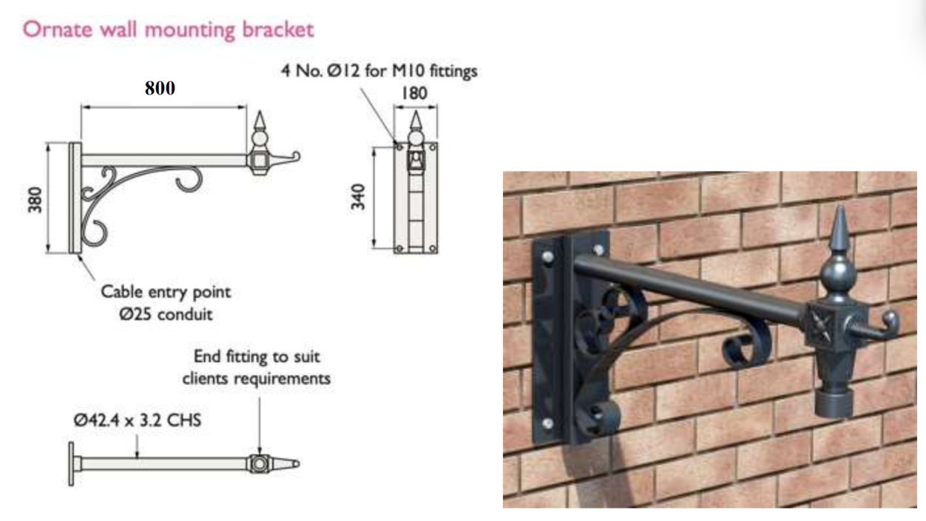

Details of Proposed Hanging Bracket

Elevation image of proposed hanging bracket

RELEVANT PLANNING HISTORY

There are 12 planning records on the library with the most relevant being 15/05681/LBC & 15/05548/FUL - 1 x CCTV camera to be placed on external wall of building – Approved with conditions.

RELEVANT LEGISLATION, POLICIES AND GUIDANCE
Legislation
From the point of view of the historic environment the main statutory tests are set out within the Planning (Listed Building and Conservation Areas) Act 1990. Section 16 requires that special regard be given to the desirability of preserving listed buildings, their settings or any features of special architectural or historic interest which they possess.

Section 72(1) of the Planning (Listed Building and Conservation Areas) Act 1990 also requires the Council to pay special attention to the desirability of preserving or enhancing the character or appearance of designated Conservation Areas.

National Policy and Guidance
The National Planning Policy Framework (NPPF) August 2026 sets out government policy, including in respect of the historic environment.

Chapter 20 - Conserving and enhancing the historic environment, recognises heritage assets as an irreplaceable resource. Heritage assets should be conserved in a manner appropriate to their significance, with harm avoided unless there is a clear and convincing justification. Decision-makers are required to apply a balanced approach, giving substantial weight to the conservation of heritage assets and weighing any harm to significance against the public benefits of the proposal.

National Planning Practice Guidance provides guidance on interpreting the NPPF.

Historic England’s Conservation Principles, Policies and Guidance (2008) provides policy and guidance for the “sustainable management of the historic environment”. Additional guidance on the application of policies set out in the NPPF is contained within their publications:
- Historic Environment Good Practice Planning Advice Note 2 – Managing Significance in Decision-Taking in the Historic Environment (2015)
- Historic Environment Good Practice Planning Advice Note 3 – The Setting of Heritage Assets 2nd edition (2017)
- Historic England Advice Note 2 – Making changes to Heritage Assets (2025)
- Historic England Advice Note 18 – Adapting Historic Buildings for Energy and Carbon Efficiency (2026)

Wiltshire Core Strategy:
Whilst not directly relevant to listed building consent applications, the below policies give an indication of the Council’s approach to development affecting heritage assets:

- Core Policy 57 ‘Ensuring high quality design and place shaping’: A high standard of design is required in all new developments, including extensions, alterations, and changes of use of existing buildings. Development is expected to create a strong sense of place through drawing on the local context and being complementary to the locality.

- Core Policy 58 ‘Ensuring the conservation of the historic environment’ requires that “designated heritage assets and their settings will be conserved, and where appropriate enhanced, in a manner appropriate to their significance.”

ISSUES

Impact upon the preservation of the listed building or its setting or any features of special architectural and/or historic interest.

CONSULTATION RESPONSES

Marlborough Town Council: Noted the application (but didn’t offer a recommendation)

Wiltshire Council Conservation Officer: No objection

REPRESENTATIONS

In accordance with the requirements of Section 5(1) of the Planning (Listed Buildings and Conservation Areas) Regulations 1990 (as amended) the application for listed building consent was publicised by way of:

- A site notice displayed near the site;
- An advertisement placed in the local press.

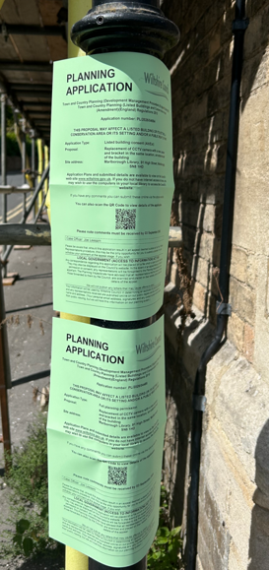

These methods were used to inform interested parties and to allow a statutory consultation period of 21 days for representations to be submitted.

No comments received

ASSESSMENT
In accordance with Section 16(2) of the Planning (Listed Buildings and Conservation Areas) Act 1990, special regard has been given to the significance of the listed building, including its architectural and historic interest, and the desirability of preserving both the building and its setting. Relevant policies within the National Planning Policy Framework (NPPF), particularly Section 20: Conserving and Enhancing the Historic Environment, have also been taken into account. These policies require that any harm to the significance of a designated heritage asset must be clearly justified and weighed against the public benefits of the proposal.

In order to be acceptable, the application needs to be assessed against the following criteria:

Information considered/submitted
Policy HE5 of the NPPF requires applicants to assess the significance of any heritage assets affected by a proposal, including the contribution made by their setting, and to identify the likely effects of the development on that significance. Sufficient information should be provided to enable a clear understanding of the significance of the heritage asset and its setting, and the impact of the proposal upon it.

Decision-makers must be satisfied that assessments accurately reflect the effects on heritage assets caused by development proposals. In this case the application is supported by a Heritage Statement and Design and Access Statement which describe the significance of the Grade II listed building, explain the background to the existing CCTV installation, identify the extent of the proposed works, and assess the likely impact of the replacement camera and bracket on the significance of the listed building. The submitted information confirms that the CCTV camera would be installed in broadly the same position as the existing apparatus, that fixing points would as far as possible utilise mortar joints rather than historic brickwork, and that no historic fabric would be removed as part of the works. The documents also explain the public safety objectives of the scheme and the measures taken to reduce visual impact through the use of a decorative bracket and revised camera mounting arrangement.

Having reviewed the submitted information, the Local Planning Authority is satisfied that sufficient information has been provided to understand the significance of the heritage asset and to assess the impact of the proposal upon that significance. The submitted heritage assessment is therefore considered proportionate to the scale and nature of the proposed works and accords with the requirements of Policy HE5 of the NPPF.

Assessment of significance:
According to the National Planning Policy Framework (NPPF), significance is defined as:

“The value of a heritage asset to this and future generations because of its heritage interest. The interest may be archaeological, architectural, artistic or historic. Significance derives not only from a heritage asset’s physical presence, but also from its setting.”

Historic England further categorises significance into four key values:

- Evidential – the potential of the asset to yield evidence about past human activity.
- Historic – the ways in which the asset illustrates aspects of history.
- Aesthetic – the sensory and design qualities of the asset.
- Communal – the meanings and associations attached to the asset by people.

In this case, the significance of Marlborough Library lies predominantly in its historic, aesthetic and communal values. The building dates from the mid-nineteenth century and was originally constructed as St Peter's School, illustrating the educational and civic development of Marlborough during the Victorian period. Its historic value is derived from its survival as a former school building and from its continued public use as the town library.

The building possesses considerable aesthetic value through its distinctive Victorian Gothic architectural style, buff brick construction, stone detailing, and prominent corner location within the High Street. It is unusual within Marlborough, differing from the prevailing local vernacular and reinforcing its formal civic character. The building also forms part of an important group of listed buildings which positively contribute to the significance and appearance of the Marlborough Conservation Area.

The communal value of the building arises from its long-standing public function, first as a school and subsequently as a public library, giving it a strong association with the social and cultural life of the town. Evidential value is present within the surviving historic fabric of the building, although the proposals do not directly affect those aspects of significance.

Impact of proposals on the significance and setting of the building/structure:
Understanding the impact of proposed works on a listed building requires a careful and proportionate assessment of how those changes affect the asset’s heritage significance and its setting. This includes both the physical alterations to the building itself and any changes to its spatial or visual relationship with surrounding structures or spaces.

The significance of a heritage asset is not static; it is shaped by its architectural, historic, and communal values, and by how these are experienced in context. Therefore, any intervention must be considered in light of the asset’s identified significance, with attention given to both potential harm and benefits. Benefits may include repairs that support the long-term conservation of the building, improved energy performance, or enhanced public access and understanding.

This assessment is grounded in the statutory duty under Section 16 of the Planning (Listed Buildings and Conservation Areas) Act 1990, which requires special regard to be given to the desirability of preserving the building and its features of special interest. It is also informed by national policy, particularly policies HE4-9 of the National Planning Policy Framework (NPPF), and relevant local heritage policies and guidance.

The proposal seeks to replace the existing CCTV camera with a new camera mounted upon a decorative bracket projecting approximately 800mm from the building's principal elevation. Although CCTV equipment is a modern addition that does not relate directly to the building's historic function or architectural design, surveillance equipment has been present on the building since 2015 and therefore already forms part of its established appearance.

The proposal would increase the overall size and projection of the installation. However, the submitted design demonstrates a clear attempt to reduce visual impact through the use of a decorative bracket similar in appearance to those traditionally used for hanging signs from historic commercial and public buildings. Whilst the apparatus is not a particularly sympathetic feature when viewed against the architectural character of the listed building, efforts have been made to improve its appearance and reduce its utilitarian character when compared with conventional CCTV equipment.

The works would not result in the removal of historic fabric, loss of architectural detailing, alteration of the building's historic plan form, or any change to the building's relationship with surrounding heritage assets. Any fixing points would be limited and reversible in nature. The proposal would therefore have only a very limited visual effect on the significance of the listed building and its contribution to the character and appearance of the Marlborough Conservation Area.

The Council's Conservation Officer has reviewed the proposal and raises no objection. Whilst noting that the preferred solution would avoid mounting surveillance equipment directly on the listed building, the Conservation Officer recognises the operational need for the CCTV system and considers that reasonable efforts have been made to reduce visual impact through the use of a decorative bracket. Significant weight is afforded to this specialist heritage advice.

Overall, the proposal would preserve the special architectural and historic interest of the Grade II listed building and preserve the character and appearance of the Marlborough Conservation Area. The proposal would not give rise to harm to the significance or setting of the listed building or nearby designated heritage assets and would therefore satisfy the statutory duty under Section 16 of the Planning (Listed Buildings and Conservation Areas) Act 1990, together with the relevant heritage policies of the NPPF and Development Plan.

Impact on Ecology
While Sections 16 and 72 of the Planning (Listed Buildings and Conservation Areas) Act 1990 do not explicitly reference protected species, Local Planning Authorities have a statutory duty to consider potential impacts on protected species when determining applications. This responsibility arises from broader environmental legislation and national planning policy, and must be taken into account where relevant.

Does the site or proposed development possess/impact on any of the features where
protected species are likely to be present (assessed against Natural England’s standing
advice) and where species are likely to be found?
 |  | Y / N / NA
(a) | Does the site or proposed development possess/impact on any of the features where protected species are likely to be present (assessed against Natural England’s standing advice) and where species are likely to be found? | No
(b) | If yes, has a protected species survey been submitted?
(c) | If yes, does the survey show a detailed consideration of ecological impacts, wildlife mitigation and the creation, restoration and enhancement of wildlife corridors to preserve and enhance biodiversity in accordance with the standing advice?

CONCLUSION

The NPPF confirms that when considering the potential impact of a development proposal on the significance of a designated heritage asset, substantial weight should be given to the asset’s conservation, and any identified harm must be afforded considerable importance and weight.

In this case, the proposal comprises the replacement of an existing CCTV camera with a new camera and decorative bracket. The works would not result in the loss of historic fabric, alteration of the building's historic plan form, or any material change to those elements which contribute to the significance of the Grade II listed building. Whilst the new installation would be larger than the existing arrangement, efforts have been made to reduce its visual impact through the use of a decorative bracket and a more considered mounting arrangement. The apparatus would nevertheless remain a visible modern addition to the building.

Having regard to the significance of the listed building, its setting and its contribution to the Marlborough Conservation Area, it is considered that the proposal would preserve the special architectural and historic interest of the listed building and preserve the character and appearance of the Conservation Area. The proposal would not harm the significance of designated heritage assets, including nearby listed buildings.

As no harm to significance has been identified, no heritage balancing exercise is required under the NPPF. Nevertheless, the proposal would support the continued operation of an established town centre CCTV network and assist in maintaining the ongoing public use and management of the building as a community facility.

Accordingly, the proposal is considered to satisfy the requirements of Sections 16, 66 and 72 of the Planning (Listed Buildings and Conservation Areas) Act 1990, the relevant provisions of the NPPF, Core Policies 57 and 58 of the Wiltshire Core Strategy, and Policy MARL9 of the Marlborough Area Neighbourhood Plan.

RECOMMENDATION:
That Listed Building Consent be GRANTED, subject to the following conditions:

