APPLICATION FOR FULL-PLANNING PERMISSION (MINOR DEVELOPMENT)
CASE OFFICER REPORT

APPLICATION REFERENCE: | PL/2026/04488
APPLICATION TYPE: | Full planning permission
SITE ADDRESS: | Marlborough Library, 91 High Street, Marlborough, SN8 1HD
DEVELOPMENT DESCRIPTION: | Replacement of CCTV camera with a new camera and bracket in the same location, on external wall of the building
RECOMMENDATION: | Approve with Conditions

Context and Relationship to Associated Applications

The current application forms part of a wider programme of CCTV upgrades submitted by Marlborough Town Council relating to three separate Grade II listed buildings within Marlborough High Street and the Marlborough Conservation Area, namely Marlborough Town Hall, High Street, 17-18 High Street and Marlborough Library, 91 High Street. Each property has been subject to both a planning application and a listed building consent application, all of which are being considered concurrently by the Local Planning Authority.

Whilst the applications have been submitted and assessed over the same period, each proposal relates to a separate site and must be determined on its own individual merits having regard to the relevant statutory duties, development plan policies and other material considerations. The associated planning and listed building consent applications for each site are therefore considered independently, notwithstanding their connection as part of a wider town centre CCTV improvement programme.

CCTV cameras were installed at five locations within Marlborough High Street in 2015, including cameras mounted on the Town Hall and Library. Marlborough Town Council now seeks to replace the existing cameras with updated equipment and, in the case of the Town Hall, provide one additional camera. The stated objectives of the programme are to improve visibility and reduce blind spots, better monitor and deter criminal activity, capture vehicular incidents associated with increased traffic levels, and support the continued economic vitality of Marlborough town centre by helping to maintain public safety.

Collectively, the proposals comprise the replacement and upgrading of existing CCTV infrastructure. At Marlborough Library and 17-18 High Street, the works involve replacement CCTV cameras positioned in substantially the same locations as the existing equipment. At Marlborough Town Hall, the proposal comprises the replacement of two existing CCTV cameras and brackets together with the installation of one additional camera. Across all three sites, the cameras would be mounted on sympathetically designed black corner brackets projecting approximately 600-800mm from the building faces, intended to provide improved surveillance coverage whilst remaining visually compatible with the host buildings.

In considering the wider heritage context, it is noted that there are no Grade I listed buildings within Marlborough High Street. However, nearby Grade II* listed buildings include Nos. 142-143 High Street and Nos. 132-133 High Street together with the outhouse to the rear of No. 133. The former lies immediately to the north of Marlborough Town Hall on the opposite side of the High Street, whilst the latter lies approximately 60 metres south-west of the Town Hall and approximately 70 metres north-east of 17-18 High Street. Marlborough Library is located further to the east along the High Street. Notwithstanding the collaborative nature of the wider proposal, the potential impacts upon the significance of the host Grade II listed building, nearby designated heritage assets and the character and appearance of the Marlborough Conservation Area are assessed within the relevant sections of this report.

SITE DESCRIPTION/CONTEXT

Marlborough Library is located at the south western end of the high street and is on the Junction with Hyde Lane. It is a two storey Grade II listed building within the Marlborough Conservation Area.

The supporting heritage statement sets out that:

Marlborough Library was built in 1854 originally as St Peter’s School. It was adapted and opened as a library in 1965. It is a distinctive example of Victorian institutional architecture. The twin gabled building is constructed in buff coloured brick with stone quoins and gothic revival pointed arched windows.

The listed building description reads:

Mid Cl9. Stock brick. Pitched concrete tile roofs. 1 storey and attics. 2-gabled front, with smaller gable between, and set slightly back. 2 principal gables coped, with ornamental finials, and taken on kneelers. 1 mullioned window each, with square heads and hood moulds. Attics have 1 coulus each, whose outlines are formed by the intersection of a trilobe with a triangle, themselves set within "spherical triangles" under hoodmoulds with label stops carved as
medieval heads. Central bay has doorway with 4-centred arch and modern door, 2 stringcourses, single light with hoodmould, blind oculus consisting of quadrilobed set within square, and shaped gable above.

Nos 65 to 85 (consec), The Sun Public House and Nos 88 to 90 (consec) form a group, together with the Church of St Peter and St Paul, and with Nos 42 to 64 (consec) on the South Side.

The site is subject to the following key constraints and designations:

- North Wessex Downs National Landscape

There are no other (relevant) policy designations relating to ecology.

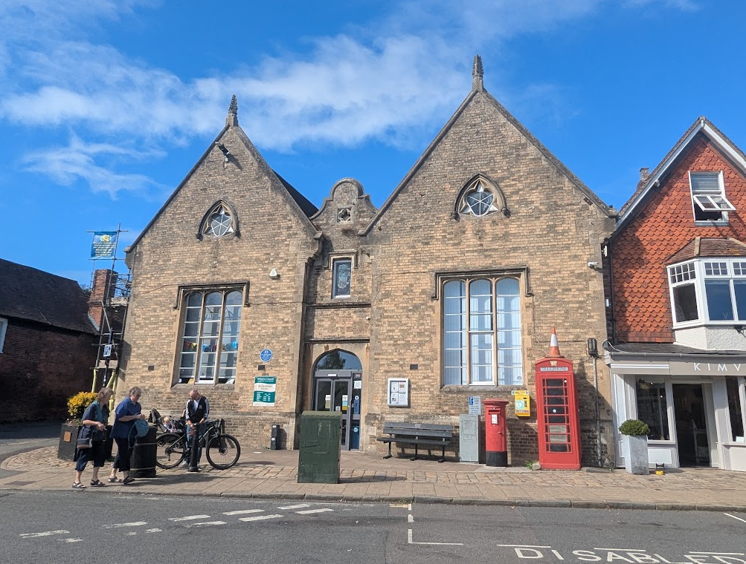

Site Visit Photo of front Elevation (existing camera on right hand side)

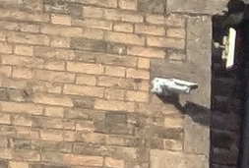

Zoomed image of existing camera

PROPOSAL

The supporting statements set out that:

The new camera would be fitted in the same positions as the existing cameras i.e. at the east end of the High Street façade at high level. To provide optimum coverage and reduce blind spots this new camera would be mounted on a sympathetically designed black bracket projecting approx. 800mm from the building faces. The design of these brackets is shown in the accompanying Design and Access Statement. The bracket would be fixed into mortar joints in the brickwork where possible and the brackets will hide all cabling.

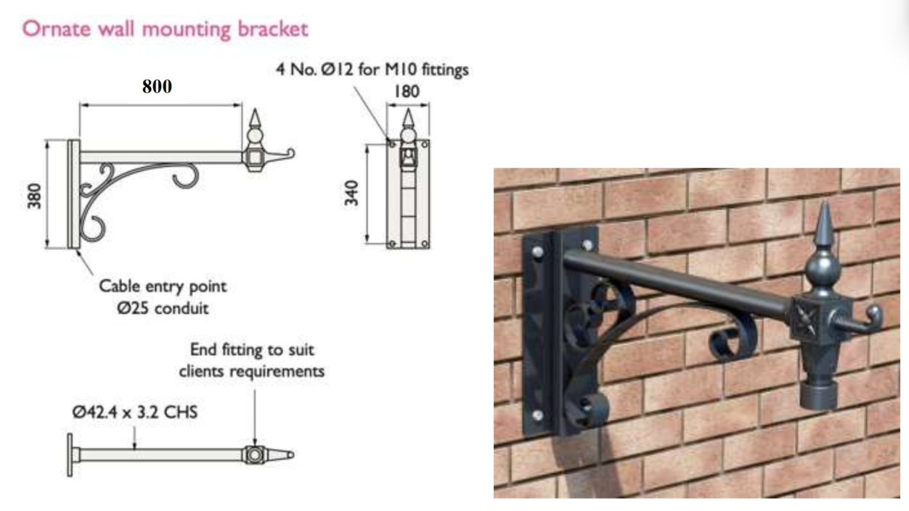

Details of Proposed Hanging Bracket

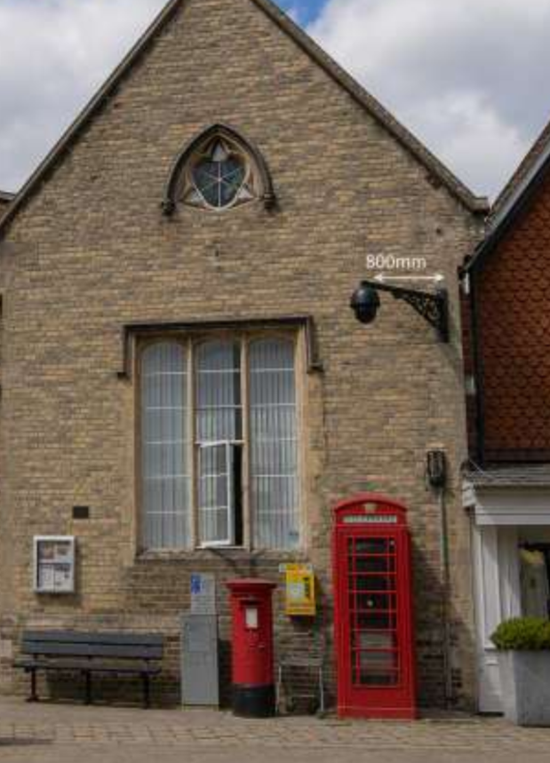

Elevation image of proposed hanging bracket

PLANNING HISTORY

There are 12 planning records on the library with the most relevant being 15/05681/LBC & 15/05548/FUL - 1 x CCTV camera to be placed on external wall of building – Approved with conditions.

RELEVANT LEGISLATION, POLICIES AND GUIDANCE

Statutory Legislation:

Town and Country Planning Act 1990

National Planning Policy:
- National Planning Policy Framework (NPPF)
- Planning Practice Guidance (PPG)

Development Plan:

The development plan for Wiltshire comprises the Wiltshire Core Strategy (WCS) (adopted January 2015) and any made neighbourhood plans, which remains the principal statutory planning document guiding development across the county. In line with Section 38(6) of the Planning and Compulsory Purchase Act 2004, planning decisions must be made in accordance with the development plan unless material considerations indicate otherwise.

Though the development plan is considered as a whole, those parts deemed to be particularly relevant to this application are listed below:

The adopted Wiltshire Core Strategy (WCS), with particular regard to:

- Core Policy 49 Protection of Rural Services and Community Facilities
- Core Policy 51 Landscape
- Core Policy 57 Ensuring High Quality Design and Place Shaping;
- Core Policy 58 Ensuring the Conservation of the Historic Environment;

Neighbourhood Plan:

Marlborough Neighbourhood Plan (2021-2036) adopted 2023 – Policies MARL4, MARL7 and MARL9.

Supplementary Planning Documents and other Guidance:
- Wiltshire Design Guide (adopted April 2024)
- National Design Guide
- Marlborough Conservation Area Statement 2003

ISSUES

The main issues that need to be addressed in this case include:

- Whether the scheme constitutes high quality design (CP 57)
- Whether the scheme would have an acceptable impact upon the reasonable living conditions of the adjoining occupants (CP 57)
- Whether the scheme would preserve or enhance the historic environment (CP 58)

CONSULTATION RESPONSES

The views of consultees are material considerations in the determination of the application. However, the decision-maker must exercise their own planning judgement. Where consultees raise concerns or recommend conditions, these have been considered and are addressed within the assessment section of this report.

Marlborough Town Council: Noted the application (but didn’t offer a recommendation)

Wiltshire Council Conservation Officer: No objection

Wiltshire Council Public Protection Officer: No comment to make

Wiltshire Council Highways Officer: No objection

The consultee responses have been carefully considered. Whilst significant weight is afforded to specialist technical advice, the decision remains a matter for the Local Planning Authority and the officer assessment below reaches an independent planning judgement on the issues raised.

REPRESENTATIONS

In accordance with the requirements of the Town and Country Planning (Development Management Procedure) (England) Order 2015 (as amended), the application was publicised by way of:

- 11x Neighbour notification letters sent to adjoining and nearby properties;
- A site notice displayed near the site;
- An advertisement placed in the local press 13 August 2026 (expiry date 3 September 2026)

These methods were used to inform interested parties and provide a period of 21 days for comments to be submitted.

No comments were received
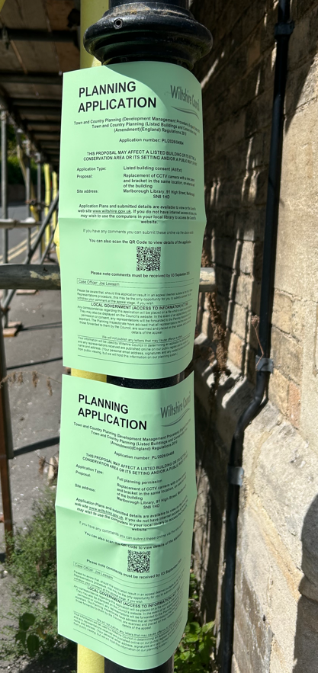

Photo of site notice

ASSESSMENT
Section 38(6) of the Planning and Compulsory Purchase Act 2004 states:

"If regard is to be had to the development plan for the purposes of any determination to be made under the planning Acts, the determination must be made in accordance with the plan unless material considerations indicate otherwise."

In accordance with this statutory requirement, this application has been assessed against the relevant policies of the Development Plan, including the Wiltshire Core Strategy (2015) and, where applicable, any made Neighbourhood Plans. Consideration has also been given to the policies of the NPPF (NPPF) as a material consideration in the assessment.

The assessment below considers each of the main issues identified above. Each topic is assessed in turn with reference to the relevant policy context, the evidence submitted, consultee responses, and all other material considerations, before a conclusion is reached.

Principle of Development

Policy Context
The application seeks permission for the replacement of an existing CCTV camera and associated mounting bracket with updated surveillance equipment. The proposal forms part of a wider programme of CCTV improvements being undertaken by Marlborough Town Council within Marlborough High Street. The stated objectives of the project are to improve surveillance coverage, reduce blind spots, assist in the deterrence and investigation of crime and anti-social behaviour, improve monitoring of vehicular incidents and contribute towards maintaining a safe and attractive town centre environment.

The application site is located within the built-up area of Marlborough town centre. Policy MARL4 of the Marlborough Area Neighbourhood Plan seeks to support a thriving town centre and recognises the importance of maintaining and enhancing facilities and services that contribute to its vitality and viability. In addition, Policy MARL7 identifies Marlborough Library as a protected community facility and supports proposals that sustain or improve its continued operation and use.

At a strategic level, the Wiltshire Core Strategy seeks to support resilient communities through the protection and enhancement of services and facilities. Core Policy 49 supports the retention and improvement of community facilities, whilst Strategic Objective 4 seeks to promote community wellbeing, safety and social inclusion. Furthermore, Core Policy 57 requires development to achieve high quality design and place shaping. Criterion ix) specifically seeks to ensure that the public realm and public spaces contribute towards places that are safe, legible and accessible. The upgrading of existing CCTV infrastructure is considered consistent with these objectives by contributing to public safety and assisting in the management of the public realm.

Planning History
The planning history of the site has been reviewed. Existing CCTV equipment has been present at the property for a number of years and forms an established feature of the building. The current proposal does not seek to introduce surveillance equipment for the first time but instead seeks to replace and modernise existing apparatus as part of a wider town centre CCTV improvement programme. The proposal also offers the opportunity to rationalise and improve the appearance of the existing equipment through the installation of a consistent and more contemporary design.

Assessment
The site occupies a sustainable location within the defined settlement boundary of Marlborough town centre and comprises an existing community facility. The proposal would support the continued operation and management of the facility through the provision of updated CCTV infrastructure intended to improve surveillance coverage and public safety.

The development is considered to accord with the objectives of Policies MARL4 and MARL7 of the Marlborough Area Neighbourhood Plan, together with the broader aims of Core Policies 49 and 57 of the Wiltshire Core Strategy, which support the enhancement of community facilities and the creation of safe and accessible public environments.

Conclusion
The proposal accords with the Development Plan and the principle of development is supported in this location.

The proposal must nevertheless be assessed against all other relevant Development Plan policies, national policy and material considerations. Subject to that assessment, the principle of development is considered acceptable.

Design and Impact on the Character and Appearance of the Area

Policy Context
Core Policy 57 of the Wiltshire Core Strategy requires development to achieve a high standard of design that responds positively to local character, context and distinctiveness.

Policies DP1-DP4 of the NPPF seek to ensure that development is well-designed, visually attractive, sustainable and responsive to its surroundings. Development should contribute positively to local character, create high quality places and support healthy and inclusive communities.

Policy MARL9 of the Marlborough Area Neighbourhood Plan requires development proposals to sustain and enhance the special architectural and historic significance of the Marlborough Conservation Area and have full regard to the Marlborough Conservation Area Statement and Marlborough Town Character Study.

Assessment
The proposal comprises the replacement of an existing CCTV camera with a modern unit mounted on a black corner bracket projecting approximately 800mm from the building. Whilst the camera and bracket are modern additions that are not traditional features of the building, efforts have been made to reduce their visual impact through the use of a decorative mounting bracket and concealed cabling. The proposed installation would be larger and project further from the building than the existing arrangement and would remain visible within the streetscene. However, having regard to its modest scale, high-level position and functional purpose, it is not considered that the proposal would appear unduly intrusive or incongruous within the town centre environment.

Whilst more visually prominent than the existing installation, it is considered that the development would preserve the established appearance of the building and would not result in material harm to the character or appearance of the surrounding area. The proposal is therefore considered to accord with the design objectives of Core Policy 57 of the Wiltshire Core Strategy, Policies DP1-DP4 of the NPPF and Policy MARL9 of the Marlborough Area Neighbourhood Plan.

Conclusion
Having regard to the above, it is considered that the proposal represents a minor alteration to the existing building. Whilst the CCTV equipment and bracket would remain visible modern additions, the scale and design of the proposal are such that it would preserve the character and appearance of the site and surrounding area. The replacement CCTV equipment would not result in any unacceptable visual impacts and would preserve the character and appearance of the site, the surrounding townscape and the wider Marlborough Conservation Area. Accordingly, the proposal is acceptable in design terms.

Impact on Heritage Assets

Policy Context
From the point of view of the historic environment, the main statutory duties are set out within the Planning (Listed Buildings and Conservation Areas) Act 1990.

Section 66(1) requires special regard to be given to the desirability of preserving listed buildings, their settings and any features of special architectural or historic interest which they possess.

Section 72(1) requires special attention to be paid to the desirability of preserving or enhancing the character or appearance of Conservation Areas.

Core Policy 58 of the Wiltshire Core Strategy seeks to conserve and, where appropriate, enhance the significance of designated and non-designated heritage assets and their settings. Core Policy 57 requires development to respond positively to local character and historic context through high quality design.

Policies HE4-HE10 of the NPPF recognise heritage assets as an irreplaceable resource and require proposals affecting heritage assets to be assessed having regard to their significance and the contribution made by their setting.

Policy MARL9 of the Marlborough Area Neighbourhood Plan further requires development proposals to sustain and enhance the special architectural and historic significance of the Marlborough Conservation Area having regard to the Marlborough Conservation Area Statement and Marlborough Town Character Study.

Assessment
Marlborough Library is a Grade II listed building dating from the mid-nineteenth century and occupies a prominent corner position within Marlborough High Street. Originally constructed as a school, it is an unusual building within Marlborough due to its distinctly Victorian Gothic architectural style and use of buff brick, which differs from the prevailing local vernacular and reinforces its civic and institutional character. The building forms part of an attractive group of listed buildings which make a positive contribution to the significance of the Marlborough Conservation Area.

The proposal relates to the replacement of existing CCTV equipment with a new camera mounted upon a decorative bracket. Whilst the camera and bracket are not particularly sympathetic features when viewed against the architectural character of the listed building, the submitted design demonstrates an effort to reduce visual impact through the use of a decorative bracket and a more considered mounting arrangement. The proposal would introduce a larger bracket and increased projection from the building when compared with the existing installation; however, the works would remain limited in scale and would not obscure or detract from important architectural features.

CCTV equipment has been present on the building for a number of years and forms part of the established town centre surveillance network. The current proposal would increase the overall size and projection of the installation through the introduction of the new bracket. Whilst, in principle, a solution avoiding attachment to the listed building would be preferable, it is recognised that the building has historically accommodated CCTV equipment and serves an important role within the wider surveillance network. The proposal would not result in the loss of historic fabric, obscure architectural detailing, or otherwise diminish the significance of the heritage asset. Having regard to the modest scale of the works and the measures incorporated to reduce visual impact, it is considered that the proposal would preserve the significance of the listed building and its contribution to the Marlborough Conservation Area.

The Council's Conservation Officer has reviewed the proposal and raises no objection. In reaching this view, the Conservation Officer acknowledged that the camera and bracket are not particularly sympathetic or visually attractive fixtures but accepted that efforts had been made to reduce visual impact through the use of a decorative bracket. The Conservation Officer also noted that a solution avoiding attachment to the listed building would have been preferable. Significant weight is afforded to this specialist advice.

Accordingly, the proposal is considered to preserve the special architectural and historic interest of the Grade II listed building, preserve the character and appearance of the Marlborough Conservation Area, and would not materially affect the significance or setting of the listed building itself or nearby designated heritage assets, including the Grade II* listed buildings within the High Street.

In accordance with the heritage policies of the NPPF, any harm to the significance of a heritage asset must be clearly identified and assessed. In this instance, it is considered that the proposal would result in no harm to the significance of the listed building, nearby heritage assets or the Marlborough Conservation Area.

Conclusion
Having regard to the above, it is considered that the proposal would preserve the special architectural and historic interest of Marlborough Library as a Grade II listed building and preserve the character and appearance of the Marlborough Conservation Area. The proposal would not result in harm to the significance of designated heritage assets and therefore satisfies the statutory duties of Sections 66(1) and 72(1) of the Planning (Listed Buildings and Conservation Areas) Act 1990, Core Policies 57 and 58 of the Wiltshire Core Strategy, Policy MARL9 of the Marlborough Area Neighbourhood Plan, and Policies HE4-HE10 of the NPPF.

Amenity

Policy Context
Core Policy 57 (Point vii) of the Wiltshire Core Strategy requires development to respect the amenity of existing occupants and ensure appropriate amenity levels for future residents.

Policy P3 of the NPPF requires development to be appropriate for its location, taking account of its likely effects on health, living conditions and the environment. In particular, Policy P3(2)(b) requires development to avoid giving rise to unacceptable impacts on the living conditions of neighbouring residents and occupiers. In assessing amenity impacts, regard should be had to matters including daylight and sunlight, outlook, privacy, overbearing impacts and other effects on residential amenity.

These policies guide the assessment of amenity impacts. Each of the below matters has been assessed having regard to the specific site context and layout of the proposal.

Assessment
The proposal relates solely to the replacement of existing CCTV equipment and does not involve the creation of any new windows, openings or other features capable of giving rise to overlooking. CCTV equipment has been present on the building for a number of years and the proposal would replace an established installation rather than introduce a new form of surveillance. Whilst the overall installation would be larger than the existing arrangement due to the proposed bracket, measures have been incorporated to reduce visual impact, including the use of a decorative mounting bracket and concealed cabling. Notwithstanding these measures, the apparatus would remain a visible modern feature attached to the building.

The proposal would not materially affect the amenities of neighbouring occupiers and would not result in any loss of daylight, sunlight or outlook to neighbouring properties. Similarly, the scale of the proposed apparatus is such that it would not appear overbearing, create any sense of enclosure or otherwise detract from the living conditions of adjacent occupiers.

Overall, the proposal would have no detrimental impact on the amenities of neighbouring land uses and is considered to accord with Core Policy 57 of the Wiltshire Core Strategy and Policy P3 of the NPPF.

Landscape and Visual Impact

Policy Context
Core Policy 51 of the Wiltshire Core Strategy seeks to protect, conserve and enhance landscape character and quality and requires development to respond appropriately to its landscape setting.

Policy N2 of the NPPF seeks to conserve and enhance the natural environment and requires development to take account of landscape character, local distinctiveness and the natural beauty of the countryside.

The Wiltshire Design Guide promotes a context-led approach that integrates development with landscape features and local character.

Policy N4 of the NPPF affords significant protection to National Landscapes and requires development proposals to conserve and enhance their natural beauty and special qualities.

Under Section 245 of the Levelling-up and Regeneration Act 2023, the Council must seek to further the purposes of National Landscapes when exercising its planning functions.

Assessment
The application site lies within the North Wessex Downs National Landscape. However, it is also located within the established urban area of Marlborough town centre, where the surrounding environment is characterised by historic buildings, commercial premises, public realm infrastructure and associated town centre activity.

The proposal comprises the replacement of CCTV camera and decorative mounting bracket attached to the existing building. Given the very small scale and localised nature of the works, the proposal would not result in any loss of landscape features, trees, open space, important views or elements which contribute to the wider landscape character of the National Landscape.

Furthermore, the development would be viewed solely within the context of the existing urban streetscape and would not be readily perceptible within the wider landscape setting of the National Landscape. The proposal would therefore have no impact upon the scenic beauty, special qualities or character of the North Wessex Downs National Landscape.

Conclusion
Having regard to the above, it is considered that the proposal would not give rise to any adverse landscape or visual impacts. The proposed development would conserve the character, appearance and special qualities of the North Wessex Downs National Landscape and accords with Core Policy 51 of the Wiltshire Core Strategy and Policies N2 and N4 of the NPPF.

Public Sector Equality Duty (PSED)
In reaching this decision, due regard has been had to the Public Sector Equality Duty under Section 149 of the Equality Act 2010. This requires the Local Planning Authority to have regard to the need to eliminate discrimination, advance equality of opportunity and foster good relations between persons who share a protected characteristic and those who do not.

The Local Planning Authority is satisfied that the proposal would not result in any unlawful discrimination and that any impacts on protected groups have been appropriately considered as part of this assessment.

PLANNING BALANCE AND CONCLUSION

Policy Context
In reaching a decision, all identified harms and benefits must be weighed in the overall planning balance, having regard to Section 38(6) of the Planning and Compulsory Purchase Act 2004, the provisions of the Development Plan and the NPPF.

The NPPF contains a presumption in favour of sustainable development. Applications should be determined in accordance with the development plan unless material considerations indicate otherwise.

The weight to be afforded to any identified benefits must be considered alongside all other material considerations, including whether the proposal accords with the Development Plan and whether any other policies of the NPPF indicate that development should be refused or that substantial weight should be attributed to identified harms.

Having regard to Section 38(6) of the Planning and Compulsory Purchase Act 2004, the proposal is considered to accord with the Development Plan when read as a whole.

The proposal is also considered to accord with the relevant policies of the NPPF.

The principle of development is therefore considered acceptable.

Conclusion
The proposed development is considered acceptable in planning terms. Having regard to the Development Plan, the NPPF and all other material considerations, the proposal is considered to accord with the Development Plan.

Accordingly, planning permission should be granted.

RECOMMENDATION:
That Planning Permission be GRANTED, subject to conditions

All conditions imposed have been assessed against the tests set out in Policy DM6 of the NPPF and are considered to be necessary, relevant to planning, relevant to the development to be permitted, enforceable, precise and reasonable in all other respects.

