APPLICATION FOR LISTED BUILDING CONSENT
OFFICER DELGATED REPORT

APPLICATION REFERENCE: | PL/2026/04881
APPLICATION TYPE: | Listed building consent (Alt/Ext)
SITE ADDRESS: | The Town Hall, High Street, Marlborough , SN8 1AA
DEVELOPMENT DESCRIPTION: | Replacement of 2 x CCTV cameras with 2 x new cameras and new corner brackets, and the installation of 1 x new camera and new corner bracket - all on the external walls of the Town Hall building
RECOMMENDATION: | Approve with Conditions

Context and Relationship to Associated Applications

The current application forms part of a wider programme of CCTV upgrades submitted by Marlborough Town Council relating to three separate Grade II listed buildings within Marlborough High Street and the Marlborough Conservation Area, namely Marlborough Town Hall, High Street, 17-18 High Street and Marlborough Library, 91 High Street. Each property has been subject to both a planning application and a listed building consent application, all of which are being considered concurrently by the Local Planning Authority.

Whilst the applications have been submitted and assessed over the same period, each proposal relates to a separate site and must be determined on its own individual merits having regard to the relevant statutory duties, development plan policies and other material considerations. The associated planning and listed building consent applications for each site are therefore considered independently, notwithstanding their connection as part of a wider town centre CCTV improvement programme.

CCTV cameras were installed at five locations within Marlborough High Street in 2015, including cameras mounted on the Town Hall and Library. Marlborough Town Council now seeks to replace the existing cameras with updated equipment and, in the case of the Town Hall, provide one additional camera. The stated objectives of the programme are to improve visibility and reduce blind spots, better monitor and deter criminal activity, capture vehicular incidents associated with increased traffic levels, and support the continued economic vitality of Marlborough town centre by helping to maintain public safety.

Across all three sites, the cameras would be mounted on decorative black corner brackets projecting approximately 600-800mm from the building faces. Whilst the brackets and cameras would remain visible modern additions to the host buildings, the design seeks to reduce their utilitarian appearance and minimise visual impact whilst providing improved surveillance coverage.

In considering the wider heritage context, it is noted that there are no Grade I listed buildings within Marlborough High Street. However, nearby Grade II* listed buildings include Nos. 142-143 High Street and Nos. 132-133 High Street together with the outhouse to the rear of No. 133. The former lies immediately to the north of Marlborough Town Hall on the opposite side of the High Street, whilst the latter lies approximately 60 metres south-west of the Town Hall and approximately 70 metres north-east of 17-18 High Street. Marlborough Library is located further to the east along the High Street. Notwithstanding the collaborative nature of the wider proposal, the potential impacts upon the significance of the host Grade II listed building, nearby designated heritage assets and the character and appearance of the Marlborough Conservation Area are assessed within the relevant sections of this report.

SITE DESCRIPTION/CONTEXT

The application relates to Marlborough Town Hall, a Grade II listed building prominently positioned on the centre island at the eastern end of Marlborough High Street, where it forms a focal point terminating views along the principal shopping street. Constructed in 1902 to the designs of architect C.E. Ponting, the building is executed in a combination of Flemish and Arts and Crafts influences and is recognised as a landmark civic building of considerable architectural and historic significance. The Town Hall accommodates a range of civic, community and public functions and occupies a highly visible location within the Marlborough Conservation Area.

The two-storey building is characterised by its brick and roughcast elevations, steeply pitched tiled roof, projecting cornices, ornate stone detailing and prominent entrance frontage. The building forms an important component of a wider group of listed buildings within the historic town centre.

Of the three application sites, the Town Hall appears to have undergone the greatest degree of alteration and contains a range of modern additions and fixtures associated with its ongoing use. These include existing CCTV equipment, security lighting, satellite dishes and associated brackets, external pipework, notice boards, ventilation equipment and electrical cabinets. Despite these interventions, the building remains readily appreciable as a historic civic structure and continues to make a strong positive contribution to the significance and character of both the listed building and the conservation area.

The listed building description reads:

HIGH STREET 1. 5407 (East End) CENTRE ISLAND The Town Hall SU 1869 1/1 II GV 2. . 1902 C E Ponting Architect. Freehandling of William and Mary and Renaissance styles. 2 storeys, brick plinth with brick ground floor and roughcast lst floor with brick quoins and dressings. String courses of brick. Steep pitch tiled roof with projecting bracketed moulded cornice. Domed arcaded lantern on ridge. Pedimented dormers. Main front is side elevation facing down High Street. Elaborate stone centrepiece with paired squat Doric columns on pedestals with vertical entablatures as imposts to entrance arch with keystones. Heavy scrolled brackets above to large renaissance bay windows with mullioned transomed lights, balcony and parapet balustrade. Elaborate stone armorial feature above. Either side of entrance on ground floor are large round headed windows with stone imposts architrave and keystone, inset panelled balustrade below sills. Dominating position closing High Street vista. The Town Hall form a group with Nos 1 to 12 (consec) and Nos 131 to 144 (consec) and Midland Bank.
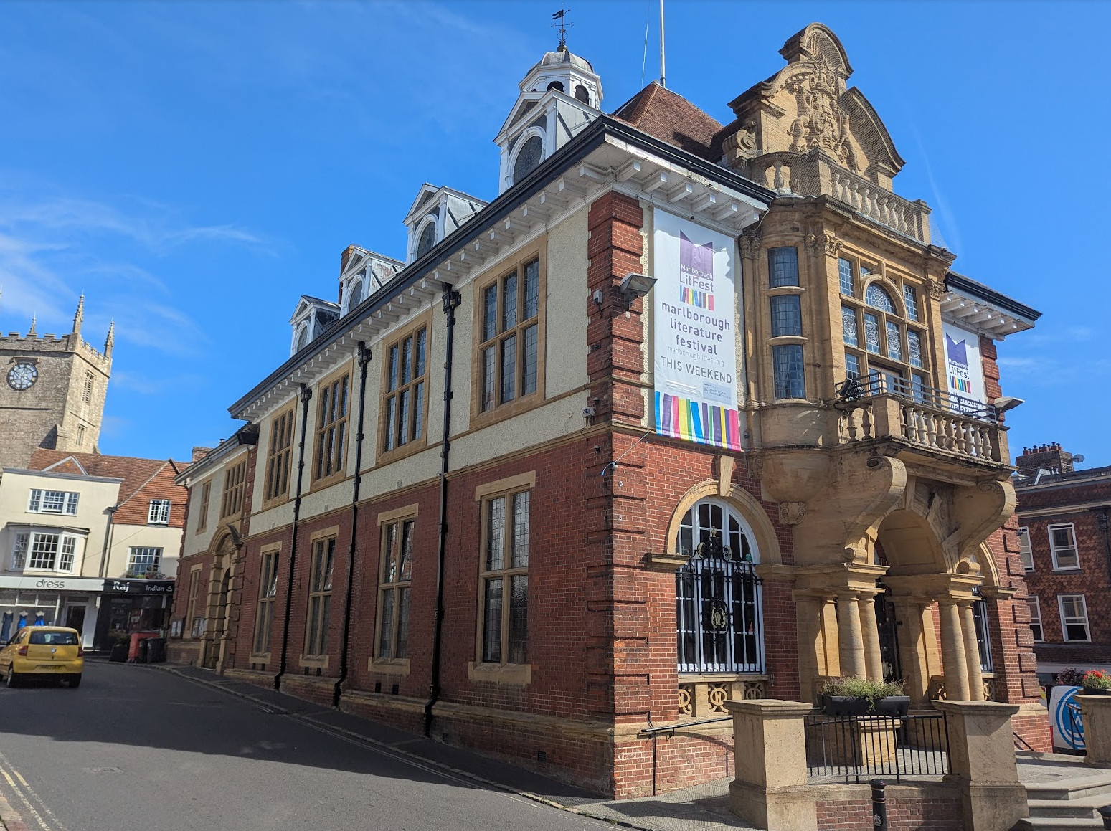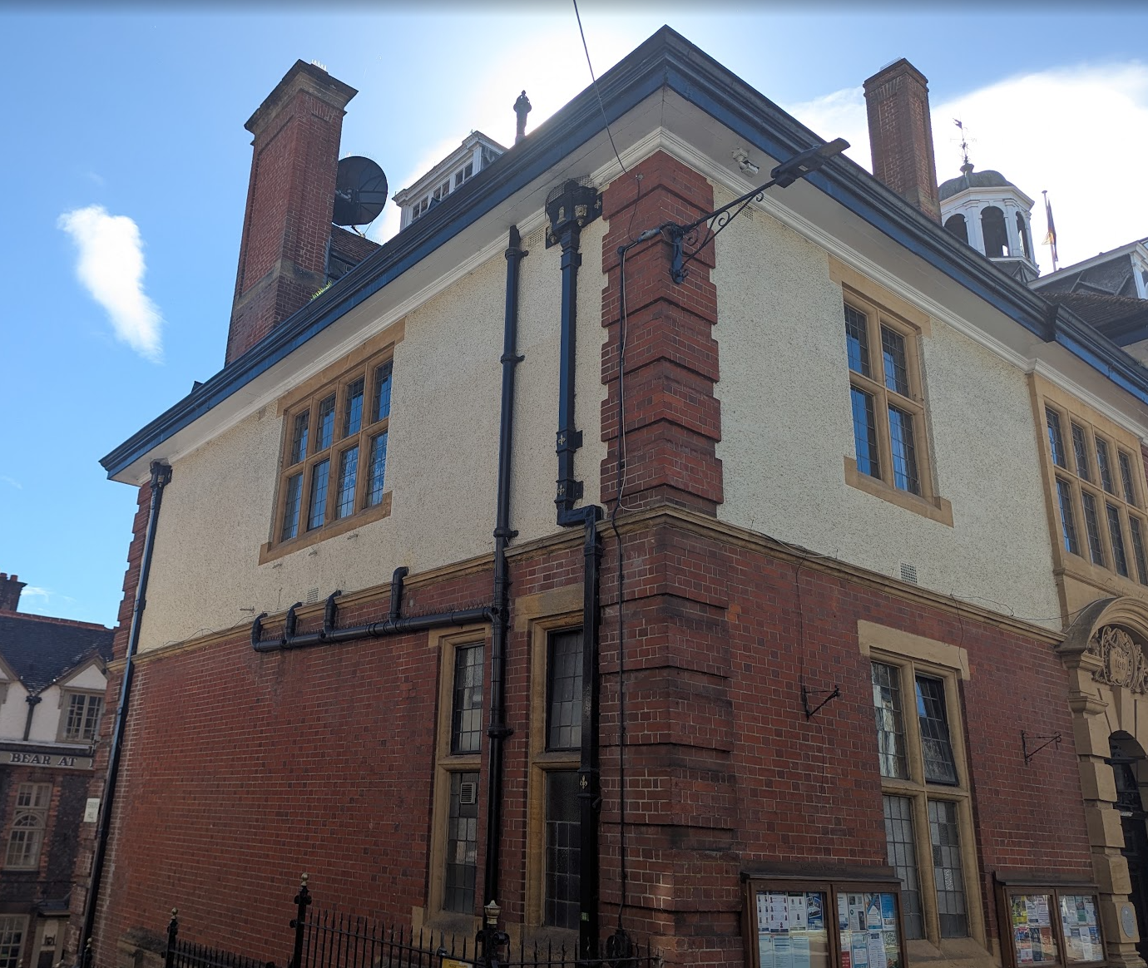

Front Elevation and Rear Elevation

PROPOSAL

The application seeks listed building consent for the installation of three CCTV cameras. The proposals comprise the replacement of two existing cameras and the installation of one additional camera to improve surveillance coverage, reduce blind spots, assist in the monitoring of criminal and anti-social activity, and capture vehicular incidents within the town centre.

The proposed works consist of:

- The replacement of an existing CCTV camera on the southern corner of the building at first-floor level.
- The replacement of an existing CCTV camera on the northern corner facing Kingsbury Street, repositioned from beneath the roof overhang to a location beneath the projecting brick string course at first-floor level.
- The installation of a new CCTV camera on the western corner of the building at first-floor level.

The cameras would be mounted on black metal corner brackets projecting approximately 600mm from the building's elevations. The brackets have been designed to reflect the appearance of existing brackets present on the building and would conceal associated cabling. The submitted information advises that fixings would be inserted into mortar joints wherever practicable in order to minimise impacts upon the historic fabric.

The cameras would be positioned at a high level on the building's elevations and no historic fabric is proposed to be removed as part of the works.

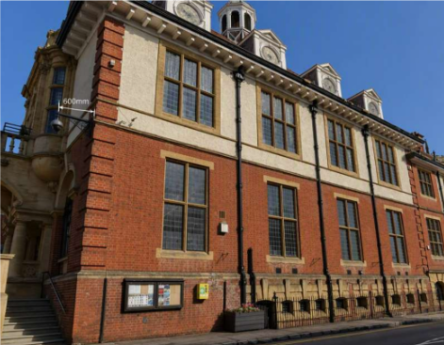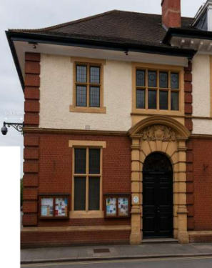

Proposed South Elevation Proposed North Elevation

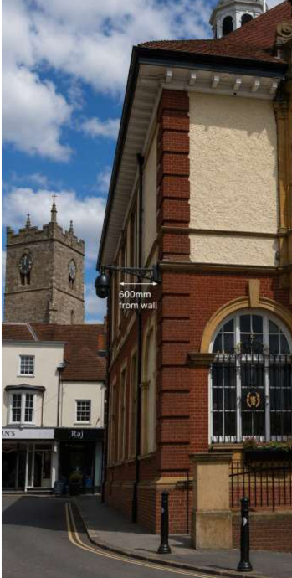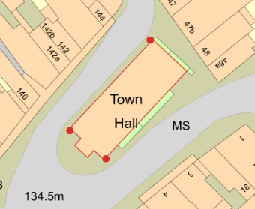

Proposed West Elevation and Extract from Proposed Site Plan (red dots show location of proposed CCTV cameras)

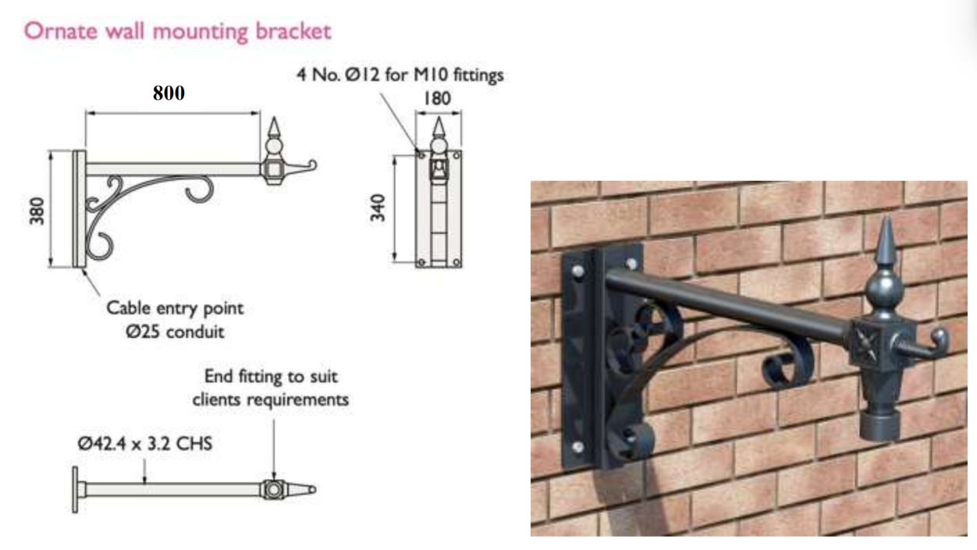
Details of Proposed Hanging Bracket

RELEVANT PLANNING HISTORY

There are 28 planning records on the Town Hall with the most relevant being 15/00674/FUL & 15/00788/LBC - Two CCTV cameras on external walls – Approved with conditions

It is also worth noting applications E/2013/0087/FUL & E/2013/0089/LBC - Installation of satellite dish on chimney at rear of building – Approved with conditions – as examples of alterations at the Town Hall.

RELEVANT LEGISLATION, POLICIES AND GUIDANCE
Legislation
From the point of view of the historic environment the main statutory tests are set out within the Planning (Listed Building and Conservation Areas) Act 1990. Section 16 requires that special regard be given to the desirability of preserving listed buildings, their settings or any features of special architectural or historic interest which they possess.

Section 72(1) of the Planning (Listed Building and Conservation Areas) Act 1990 also requires the Council to pay special attention to the desirability of preserving or enhancing the character or appearance of designated Conservation Areas.

National Policy and Guidance
The National Planning Policy Framework (NPPF) August 2026 sets out government policy, including in respect of the historic environment.

Chapter 20 - Conserving and enhancing the historic environment, recognises heritage assets as an irreplaceable resource. Heritage assets should be conserved in a manner appropriate to their significance, with harm avoided unless there is a clear and convincing justification. Decision-makers are required to apply a balanced approach, giving substantial weight to the conservation of heritage assets and weighing any harm to significance against the public benefits of the proposal.

Chapter 5 of the NPPF sets out policies for Meeting the challenge of climate change and gives substantial weight to the benefits of improving the energy efficiency of existing buildings and/or drawing energy from district heat networks, renewable and low carbon sources (including through the installation of heat pumps and solar panels where these do not already benefit from permitted development rights).
National Planning Practice Guidance provides guidance on interpreting the NPPF.

Historic England’s Conservation Principles, Policies and Guidance (2008) provides policy and guidance for the “sustainable management of the historic environment”. Additional guidance on the application of policies set out in the NPPF is contained within their publications:
- Historic Environment Good Practice Planning Advice Note 2 – Managing Significance in Decision-Taking in the Historic Environment (2015)
- Historic Environment Good Practice Planning Advice Note 3 – The Setting of Heritage Assets 2nd edition (2017)
- Historic England Advice Note 2 – Making changes to Heritage Assets (2025)
- Historic England Advice Note 18 – Adapting Historic Buildings for Energy and Carbon Efficiency (2026)

Wiltshire Core Strategy:
Whilst not directly relevant to listed building consent applications, the below policies give an indication of the Council’s approach to development affecting heritage assets:

- Core Policy 57 ‘Ensuring high quality design and place shaping’: A high standard of design is required in all new developments, including extensions, alterations, and changes of use of existing buildings. Development is expected to create a strong sense of place through drawing on the local context and being complementary to the locality.

- Core Policy 58 ‘Ensuring the conservation of the historic environment’ requires that “designated heritage assets and their settings will be conserved, and where appropriate enhanced, in a manner appropriate to their significance.”

ISSUES

Impact upon the preservation of the listed building or its setting or any features of special architectural and/or historic interest.

CONSULTATION RESPONSES

Marlborough Town Council: Noted the application (but didn’t offer a recommendation)

Wiltshire Council Conservation Officer: No objection

REPRESENTATIONS

In accordance with the requirements of Section 5(1) of the Planning (Listed Buildings and Conservation Areas) Regulations 1990 (as amended) the application for listed building consent was publicised by way of:

- A site notice displayed near the site;
- An advertisement placed in the local press dated 13 August – expired 3 September 2026

These methods were used to inform interested parties and to allow a statutory consultation period of 21 days for representations to be submitted.

No comments received.

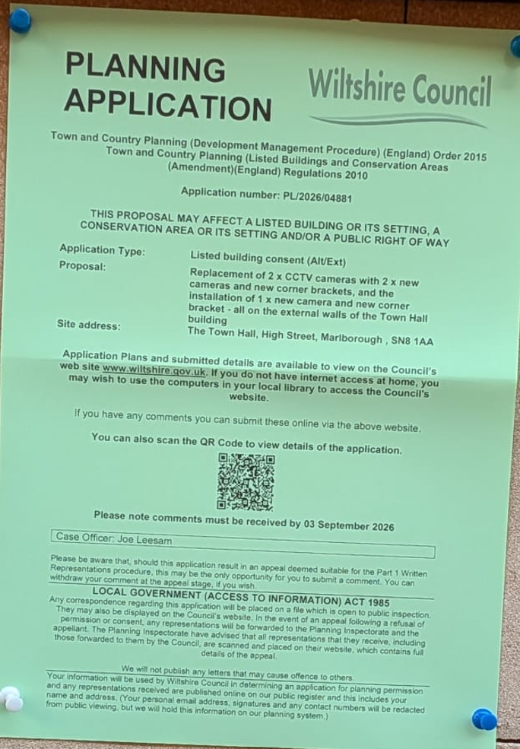

ASSESSMENT
In accordance with Section 16(2) of the Planning (Listed Buildings and Conservation Areas) Act 1990, special regard has been given to the significance of the listed building, including its architectural and historic interest, and the desirability of preserving both the building and its setting. Relevant policies within the National Planning Policy Framework (NPPF), particularly Section 20: Conserving and Enhancing the Historic Environment, have also been taken into account. These policies require that any harm to the significance of a designated heritage asset must be clearly justified and weighed against the public benefits of the proposal.

In order to be acceptable, the application needs to be assessed against the following criteria:

Information considered/submitted

Policy HE5 of the NPPF requires applicants to assess the significance of any heritage assets affected by a proposal, including the contribution made by their setting, and to identify the likely effects of the development on that significance. Sufficient information should be provided to enable a clear understanding of the significance of the heritage asset and its setting, and the impact of the proposal upon it.

Decision-makers must be satisfied that assessments accurately reflect the effects on heritage assets caused by development proposals. In this case the application is supported by a Heritage Statement and Design and Access Statement which describe the significance of the Grade II listed building, explain the background to the existing CCTV installation, identify the extent of the proposed works, and assess the likely impact of the replacement camera and bracket on the significance of the listed building. The submitted information confirms that the CCTV camera would be installed in broadly the same position as the existing apparatus, that fixing points would as far as possible utilise mortar joints rather than historic brickwork, and that no historic fabric would be removed as part of the works. The documents also explain the public safety objectives of the scheme and the measures taken to reduce visual impact through the use of a decorative bracket and revised camera mounting arrangement

Having reviewed the submitted information, the Local Planning Authority is satisfied that sufficient information has been provided to understand the significance of the heritage asset and to assess the impact of the proposal upon that significance. The submitted heritage assessment is therefore considered proportionate to the scale and nature of the proposed works and accords with the requirements of Policy HE5 of the NPPF.

Assessment of significance:

According to the National Planning Policy Framework (NPPF), significance is defined as:

“The value of a heritage asset to this and future generations because of its heritage interest. The interest may be archaeological, architectural, artistic or historic. Significance derives not only from a heritage asset’s physical presence, but also from its setting.”

Historic England further categorises significance into four key values:

- Evidential – the potential of the asset to yield evidence about past human activity.
- Historic – the ways in which the asset illustrates aspects of history.
- Aesthetic – the sensory and design qualities of the asset.
- Communal – the meanings and associations attached to the asset by people.

In this case, the significance of Marlborough Town Hall lies principally in its architectural, historic and communal values. Constructed in 1901-02 to the designs of Charles Edwin Ponting, the Grade II listed building occupies a prominent and visually dominant position at the eastern end of Marlborough High Street, where it forms an important landmark and terminates views along the High Street. The building is recognised for its distinctive architectural character, incorporating elements of Flemish and Arts and Crafts influences, together with a rich palette of decorative stone and brick detailing, including columns, cornices, quoins, dressings, elaborate window surrounds and a prominent roofscape.

The Town Hall also possesses considerable historic significance through its long-standing civic role within Marlborough. It was constructed to accommodate the Town Council, public events and the Magistrates' Court and continues to function as an important venue for civic, cultural and community activities. The building additionally derives significance from its contribution to an important group of designated heritage assets at the eastern end of the High Street and from its positive contribution to the character and appearance of the Marlborough Conservation Area. As noted within the submitted heritage statement, it is regarded as an iconic building within the town and is frequently featured in views, photographs and promotional material associated with Marlborough.

Whilst the Town Hall retains evidential value through its surviving historic fabric, its significance is derived primarily from its architectural qualities, historic civic function, landmark status and communal importance within the town.

Impact of proposals on the significance and setting of the building/structure:

The proposal seeks to install three CCTV cameras mounted on decorative black brackets projecting approximately 600mm from the building at high level. Two of the cameras would replace existing CCTV equipment installed in 2015, whilst the third would provide additional surveillance coverage and reduce existing blind spots within the town centre.

The proposed works would result in a limited degree of intervention to the listed building through the introduction of additional fixtures and associated fixings. However, the submitted information confirms that brackets would be fixed into mortar joints where possible and all associated cabling would be concealed. No significant historic fabric would be removed and the works would be readily reversible.

Whilst CCTV equipment is inherently modern in appearance and does not reflect the historic character of the listed building, the cameras would be relatively small in scale, finished in a dark colour and located at high level, thereby reducing their visual prominence. Whilst the cameras and brackets are not particularly sympathetic additions to a historic building, efforts have been made to reduce their visual impact through the use of decorative brackets, concealed cabling and a more considered mounting arrangement. The brackets adopt a decorative form similar to those traditionally used for hanging signs from historic commercial and public buildings and are intended to reflect existing bracketed features present on the Town Hall. As such, reasonable efforts have been made to minimise visual impacts on the significance of the listed building.

The proposal would not result in the loss of historic architectural detailing, alteration to the plan form of the building, or any meaningful change to its relationship with surrounding heritage assets. Although the additional camera would introduce a new feature to part of the building and increase the overall amount of equipment attached to the building, the works would remain modest in scale and would have only a very limited visual effect on the significance of the listed building and its contribution to the character and appearance of the Marlborough Conservation Area.

The Council's Conservation Officer raises no objection to the proposal. Whilst noting that the preferred heritage solution would avoid mounting surveillance equipment directly onto the listed building, the Conservation Officer acknowledges that the cameras and brackets are not particularly sympathetic or visually attractive fixtures and notes that alternative locations avoiding attachment to the listed building would be preferable. However, the operational requirement for CCTV coverage is recognised and reasonable efforts have been made to reduce visual impact through the use of decorative brackets and concealed cabling. Significant weight is therefore afforded to this specialist heritage advice.

Impact on Ecology

While Sections 16 and 72 of the Planning (Listed Buildings and Conservation Areas) Act 1990 do not explicitly reference protected species, Local Planning Authorities have a statutory duty to consider potential impacts on protected species when determining applications. This responsibility arises from broader environmental legislation and national planning policy, and must be taken into account where relevant.

Does the site or proposed development possess/impact on any of the features where
protected species are likely to be present (assessed against Natural England’s standing
advice) and where species are likely to be found?
 |  | Y / N / NA
(a) | Does the site or proposed development possess/impact on any of the features where protected species are likely to be present (assessed against Natural England’s standing advice) and where species are likely to be found? | No
(b) | If yes, has a protected species survey been submitted? | N/A
(c) | If yes, does the survey show a detailed consideration of ecological impacts, wildlife mitigation and the creation, restoration and enhancement of wildlife corridors to preserve and enhance biodiversity in accordance with the standing advice? | N/A

CONCLUSION

The proposed works have been assessed having regard to the statutory duty under Section 16 of the Planning (Listed Buildings and Conservation Areas) Act 1990, the heritage policies of the National Planning Policy Framework, the submitted Heritage Statement and Design and Access Statement, and the advice of the Council's Conservation Officer. The proposal would introduce three CCTV cameras and associated decorative brackets to the listed building, including the replacement of two existing cameras and the installation of one additional camera.

Whilst the CCTV equipment and brackets would remain visible modern additions to the listed building and are not particularly sympathetic features, the cameras would be positioned at high level, would be modest in scale and incorporate measures intended to reduce visual impact. The works would involve only limited and reversible physical intervention to the building, would not result in the loss of historic fabric or architectural detailing, and would preserve the special architectural and historic interest of the Grade II listed building. The proposal would also preserve the character and appearance of the Marlborough Conservation Area and would not adversely affect the significance or setting of nearby designated heritage assets.

The proposal is therefore considered to accord with the statutory duties of the Planning (Listed Buildings and Conservation Areas) Act 1990 and the relevant heritage policies of the National Planning Policy Framework. Accordingly, the application is recommended for approval subject to appropriate conditions.

RECOMMENDATION:
That Listed Building Consent be GRANTED, subject to the following conditions:

