APPLICATION FOR HOUSEHOLDER PLANNING PERMISSION
DELEGATED REPORT

APPLICATION REFERENCE: | PL/2026/04898
APPLICATION TYPE: | Householder planning permission
SITE ADDRESS: | Drakes Barn, 73 Devizes Road, Potterne, Devizes, SN10 5LW
DEVELOPMENT DESCRIPTION: | Proposed Householder Developments: Porch, External Alterations, Hardsurface & Landscaping
RECOMMENDATION: | That Planning Permission be GRANTED

PROPOSAL

This application is seeking planning permission for the following key elements:

- change a window to a door on the rear elevation serving a bedroom;
- construction of a porch on the rear elevation;
- construction of a small area of decking and a hard surface in the rear garden; and
- minor landscaping works to the rear to create a level area.

SITE DESCRIPTION/CONTEXT

The application site comprises a recently converted detached dwelling known as Drakes Barn (formerly a redundant rural building) located on the western side of the A360 Devizes Road as identified on the Location Plan below. The site lies within a row of residential properties located between Devizes and Pottterne.

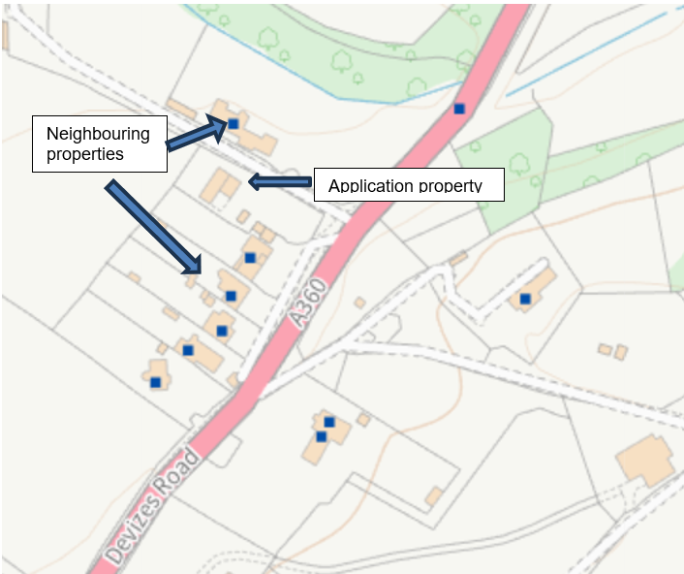

Map showing application property and neighbouring properties.

The application site lies outside of the settlement boundary. The application site is not subject to any notable planning constraints.

PLANNING HISTORY

Proposal / Summary
PL/2025/04855 - Building to the west of A360 Devizes Road, Potterne, Devizes, Wiltshire, SN10 5LW - Full planning permission Decision - Approve with Conditions Date: 4/8/2025 – Proposed change of use and conversion of a rural building to a single dwelling (partly retrospective)
PL/2025/07870 - Building to the west of A360 Devizes Road, Potterne, Devizes, Wiltshire, SN10 5LW - Approval of details reserved by a condition Decision - Approve Date: 4/11/2025 – Discharge of condition 3 of PL/2025/04855 (parking arrangements and EV charging details)

RELEVANT POLICIES AND GUIDANCE

Wiltshire Core Strategy:

- Core Policy 57 Ensuring High Quality Design and Place Shaping

Wiltshire Design Guide: Appendix D – Design Guidance for Householder extensions

The National Planning Policy Framework (NPPF)

The Planning Practice Guidance

Neighbourhood Plan:

- The Potterne Neighbourhood Plan, made January 2017

CONSULTATION RESPONSES

Parish/Town Council: No comment received at the time of writing

REPRESENTATIONS

No comments were received at the time of writing

ASSESSMENT

Section 38(6) of the Planning and Compulsory Purchase Act 2004 states:

"If regard is to be had to the development plan for the purposes of any determination to be made under the planning Acts, the determination must be made in accordance with the plan unless material considerations indicate otherwise."

In accordance with this statutory requirement, this application has been assessed against the relevant policies of the Development Plan, including the adopted Wiltshire Core Strategy (2015) and, where applicable, any made Neighbourhood Plans.

Design and Impact upon the character and context of the area

Core Policy 57 - Ensuring High Quality Design and Place Shaping of the Wiltshire Core Strategy seeks to ensure that all new development is of high design quality, reflecting local context, character, and distinctiveness.

Policies DP3 and DP4 of the National Planning Policy Framework require development to achieve a high standard of design that responds positively to local character and context. In assessing design quality, regard should be had to matters including scale, siting, form, appearance, materials and the relationship of development to its surroundings.

The application site lies outside a defined settlement. Policy S5(1)(c) of the NPPF recognises the reuse, extension, alteration or replacement of existing lawful buildings outside settlements as a form of development that may be acceptable in principle, provided that the existing building is lawful, of permanent and substantial construction and the proposal would not result in a disproportionate increase in size, or in the case of replacement buildings, would comply with the requirements of the policy.

The application site comprises the recently converted dwelling known as Drakes Barn, located along Devizes Road between Potterne and Devizes set within a small group of existing residential properties.

The application relates to the extension and alteration of an existing lawful building. The principle of the proposed development is therefore capable of being supported under Policy S5(1)(c), subject to ensuring compliance with the specific requirements of that policy and the detailed assessment set out below.

The proposed development comprises the following key elements:

- change a window to a door on the rear elevation;
- construction of a porch on the rear elevation;
- construction of a small area of decking and a hard surface in the rear garden; and
- minor landscaping works to the rear to create a level area.

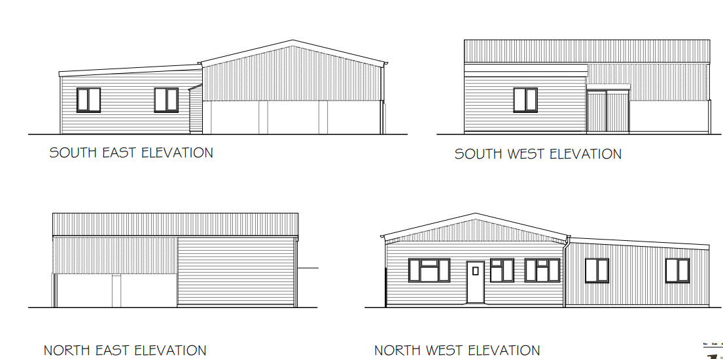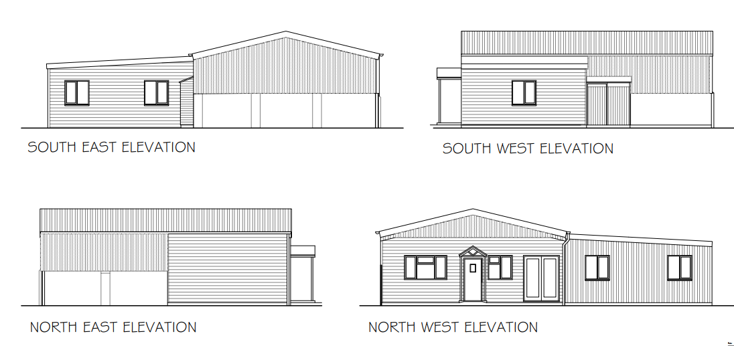
Existing elevations Proposed elevations

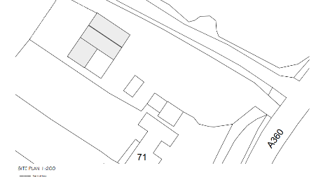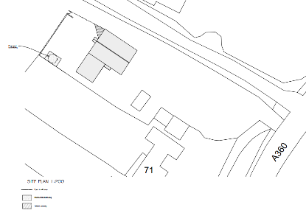

Existing site plan Proposed site plan

In design terms, the proposed works are limited in scale and are confined to the rear elevation and rear garden area. The porch would represent a modest and subservient addition to the dwelling and would not materially alter the overall form, scale or character of the converted barn. Similarly, the change from a window to a door and the introduction of decking and hard landscaping constitute minor domestic alterations that are proportionate to the scale of the host dwelling and consistent with its established residential use.

The development would be viewed within the context of the existing dwelling and residential curtilage and would not result in a significant increase in built form. As the proposed development would be positioned to the rear of the building, it would not be readily visibility public vantage points and would not adversely impact upon the character and appearance of the surrounding area. The proposed landscaping and creation of a level outdoor amenity space would appear as a typical domestic arrangement and would not introduce any incongruous features within the site.

The proposed development comprises a modest extension and alterations intended to improve the functionality and enjoyment of the dwelling whilst maintaining its overall appearance which would not undermine the character of the original barn conversion.

Having regard to the above, the proposal is considered to respect the character and appearance of the existing dwelling and its surroundings and would preserve the visual qualities of the site and wider area. Accordingly, the development complies with the design principles set out in Core Policy 57 of the Wiltshire Core Strategy, Appendix D of the Wiltshire Design Guide and the NPPF.

Amenity

Point vii of Core Policy 57 - Ensuring High Quality Design and Place Shaping of the Wiltshire Core Strategy seeks to ensure that developments do not adversely affect neighbouring properties.

Policy P3 of the National Planning Policy Framework requires development to be appropriate for its location, taking account of its likely effects on health, living conditions and the environment. In particular, Policy P3(2)(b) requires development to avoid giving rise to unacceptable impacts on the living conditions of neighbouring residents and occupiers. In assessing amenity impacts, regard should be had to matters including daylight and sunlight, outlook, privacy, overbearing impacts and other effects on residential amenity.
The proposed development has been assessed in terms of its potential impact on the residential amenity of neighbouring properties, with particular regard to loss of light, overshadowing, loss of privacy, and overbearing effects.

Loss of Light / Overshadowing

The proposed works are modest in scale and are located to the rear of the dwelling. The porch would represent only a small addition to the existing dwelling and would not introduce a significant increase in height, scale or massing. Given the limited size of the alterations and their relationship with neighbouring properties, the development would not result in any material loss of light to adjoining occupiers, nor would it create any significant overshadowing impacts. The associated decking, hard surfacing and landscaping works are low-level features and would similarly have no adverse effect on neighbouring access to light.

Loss of Privacy

The proposal does not include the introduction of any new upper-floor windows, balconies or elevated viewing areas that would give rise to overlooking. The replacement of an existing rear window with a door would serve the same habitable room (bedroom) and would not materially alter views towards neighbouring properties. The landscaping works and decking area are typical domestic features within a residential garden and considered not to result in a material increase in loss of privacy compared with the existing arrangement. Furthermore, from reviewing the submitted information, no new windows are proposed facing neighbouring properties.

Overbearing Impact

The proposed porch would be modest and subordinate in scale to the host dwelling and would not appear unduly dominant when viewed from adjoining land or neighbouring properties. The limited scale of the alterations, together with their location to the rear of the property, ensures that the development would not create any unacceptable sense of enclosure or result in an overbearing relationship with surrounding residential properties. The proposed landscaping associated with the creation of a level amenity area is considered to be minor in nature and would not materially impact neighbouring occupiers.

Having regard to the scale, design and siting of the proposed development, it is considered that the proposal would have an acceptable impact upon the reasonable living conditions of neighbouring occupiers. The development would not give rise to any significant loss of light, privacy or outlook, nor would it result in overbearing impacts or other material harm to residential amenity. Accordingly, the proposal therefore accords with Core Policy 57 point vii in respect of safeguarding residential amenity, Appendix D of the Wiltshire Design Guide and the NPPF.

Biodiversity Net Gain

Householder planning applications are exempt from the requirement to deliver Biodiversity Net Gain under Schedule 7A, Section 4(2)(a) of the Town and Country Planning Act 1990, as inserted by the Environment Act 2021.
Other matters

The proposed site plan identifies a possible outbuilding within the area of hardstanding to the rear of the dwelling. However, insufficient information has been submitted regarding the proposed structure, including its size, height, design and intended use, and no formal assessment of an outbuilding has therefore been undertaken as part of this application. Accordingly, the recommendation relates only to the proposed porch, external alterations, hard surfacing, decking and landscaping works as described within the application documents. Any outbuilding not falling within permitted development rights would require the submission of a separate planning application and would need to be assessed on its own merits.

Public Sector Equality Duty (PSED)

In reaching this decision, due regard has been had to the Public Sector Equality Duty under Section 149 of the Equality Act 2010. This requires the Local Planning Authority to have regard to the need to eliminate discrimination, advance equality of opportunity and foster good relations between persons who share a protected characteristic and those who do not.

The Local Planning Authority is satisfied that the proposal would not result in any unlawful discrimination and that any impacts on protected groups have been appropriately considered as part of this assessment.

CONCLUSION

The proposed development is considered to be acceptable in terms of its design, character and appearance, and would not result in any unacceptable harm to the amenities of neighbouring occupiers.

Furthermore, the proposal would not result in any unacceptable impacts in respect of any other material planning considerations.

The proposal is therefore considered to comply with the relevant policies of the Wiltshire Core Strategy, the National Planning Policy Framework and all other relevant material considerations. As such, the application is recommended for approval, subject to conditions.

For the avoidance of doubt, this permission does not grant consent for the erection or siting of any outbuilding within the application site.

RECOMMENDATION: That Planning Permission be GRANTED subject to conditions.

