Location Plan of Photos – Ground Floor
Location of maple tree
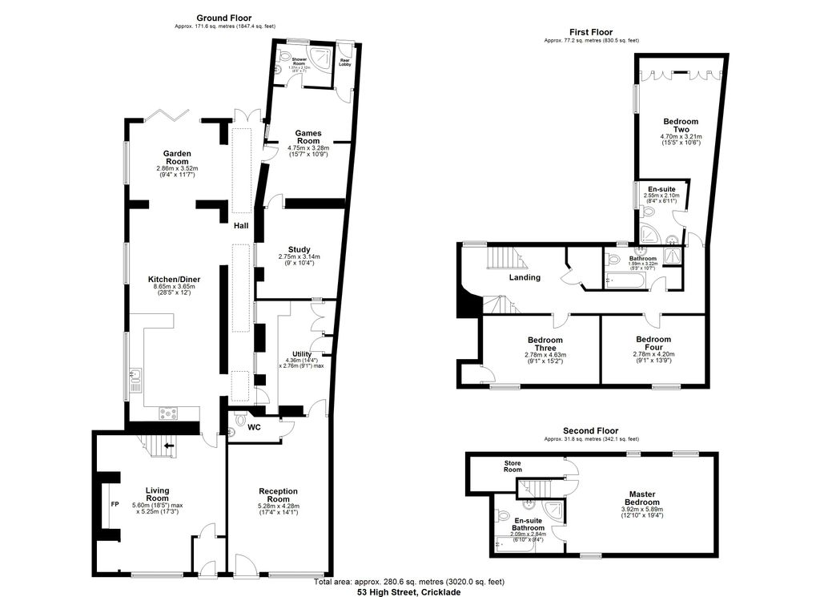
IMG_7167
IMG_7168 & IMG_7169
IMG_7163
IMG_7165 & IMG_7166
IMG_7164

Location of Photos – First Floor

IMG_7170

