APPLICATION FOR FULL-PLANNING PERMISSION (MINOR DEVELOPMENT)
CASE OFFICER REPORT

APPLICATION REFERENCE: | PL/2026/02354
APPLICATION TYPE: | Full planning permission
SITE ADDRESS: | Fairfields, Semington, Trowbridge, BA14 6JD
DEVELOPMENT DESCRIPTION: | Change of use of agricultural land to a sports and recreational facility, comprising two outdoor padel courts and associated ancillary development.
RECOMMENDATION: | Refuse

SITE DESCRIPTION/CONTEXT
The application site is located to the southwest of the village of Semington, adjacent to the A361, one of the main routes into the county town of Trowbridge which is located 1.5m to the southwest. The application site is in operation as a caravan storage facility. The application site consists of a number of agricultural buildings, Fairfields Farmhouse and Fairfields. The application site sits within the Bath and Bradford on Avon Special Area of Conservation (SAC) for bats and Trowbridge and Westbury Bat Mitigation Strategy (TWBMS) area. To the east of the application site lies a public right of way (SEM10).

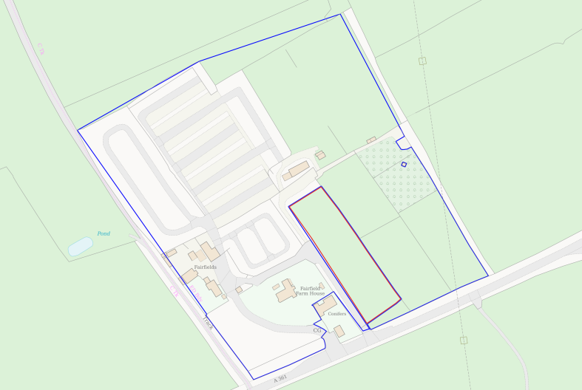
Location plan
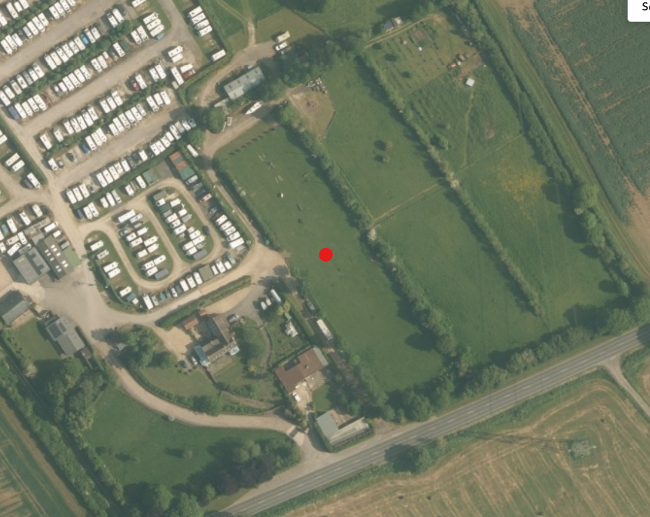
Aerial view of site (Council GIS mapping)

PROPOSAL
This full planning application seeks permission for change of use of an agricultural field to two padel courts. The proposal would comprise the construction of two padel courts, a deck / waiting area, a portacabin to be used as a storage facility, separate male and female toilets, and an off-road parking area. An existing driveway would be utilised to access the sports facility. As detailed in the plans below.

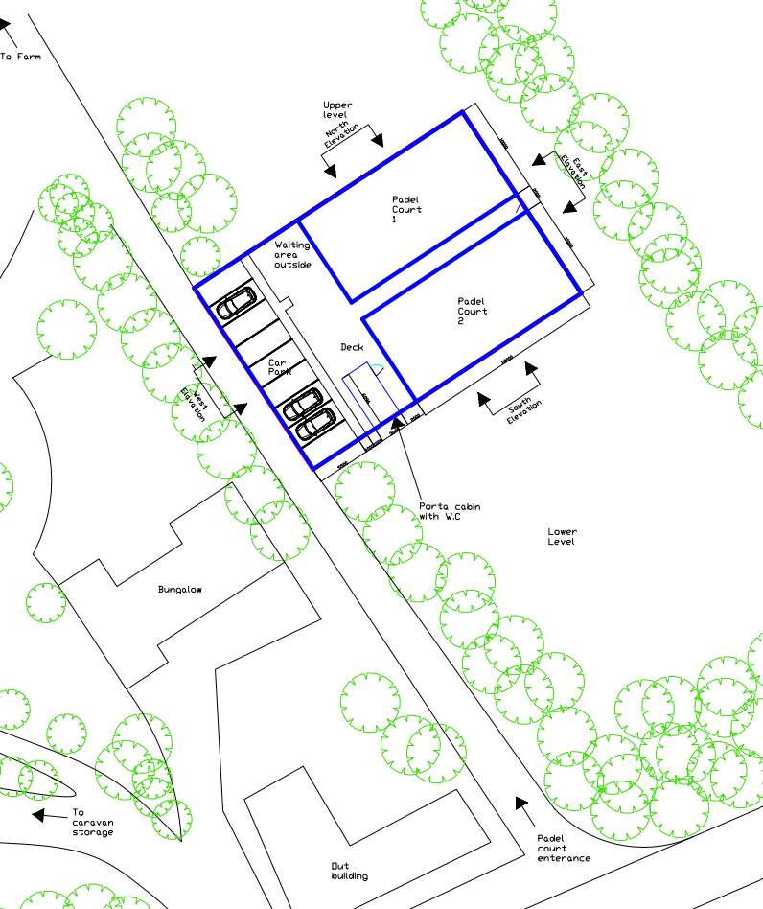
Proposed site plan
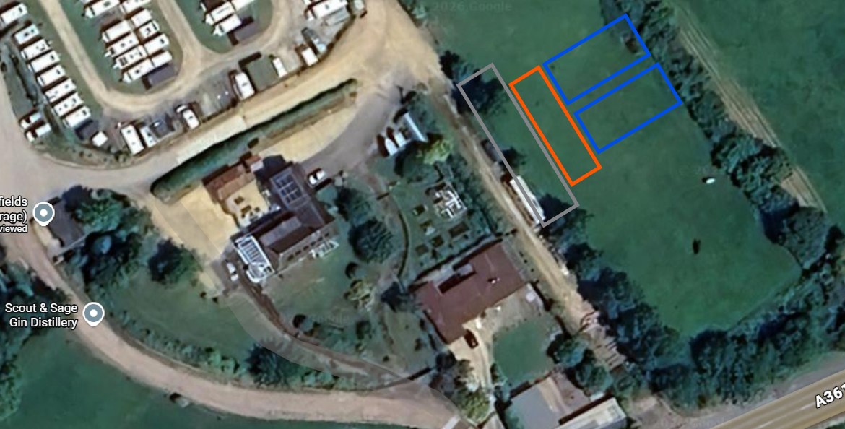
Aerial view demonstrating the position of the courts, decking and parking area

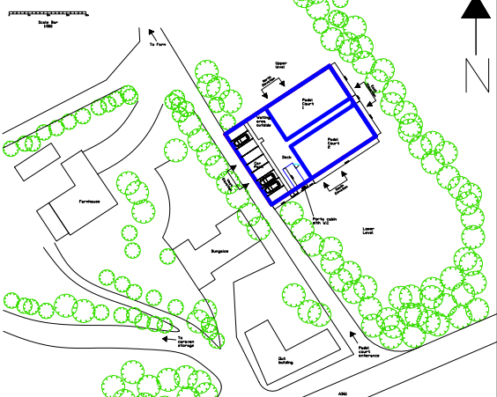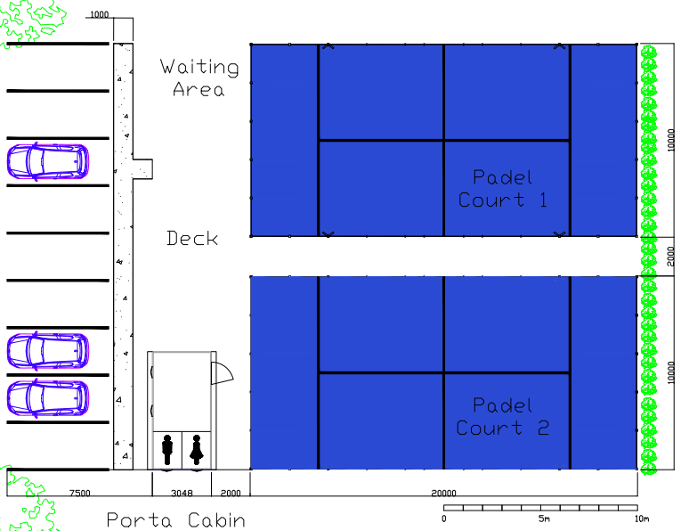

Site plans illustrating the proposal

The padel courts would be positioned adjacent to each separated by a walkway that is 2m in width each court would measure 20m by 10m with a 4m high perimeter chain link fence surrounding each court. The courts would be installed using an iframe modular system with a steel ring beam foundation system which negates the need for any hard landscaping works.

Each court would be served by 4 led lighting columns mounted at a height of 6m that would be downward facing to limit light spill beyond the courts.

To the southwest of the courts would be a decked area with a portacabin positioned in the southern corner. The cabin would serve as a storage area and would provide 2 toilets and sinks. To the southwest of the development would be the car parking area that would consist of a permeable surface which would provide parking for up to eight vehicles.

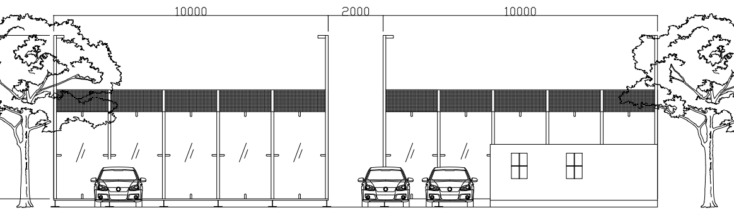
Proposed view across the site from the south

The application site is screened from view from the A361 by the existing mature trees that are positioned to the south of the proposal and all existing trees on site would be retained.

Planning history
Proposal / Summary
W/95/01229/FUL - Full planning permission Decision - Approve with Conditions Date: 20/11/1995 – Change of use of land from agricultural to storage of touring caravans (renewal)
W/06/03305/FUL - Full planning permission Decision - Refused Date: 21/12/2006 – Erection of permanent single storey dwelling for caravan storage/agricultural worker (to replace temporary caravan)
W/07/00778/FUL - Full planning permission Decision - Approve with Conditions Date: 21/1/2008 – Erection of permanent single storey dwelling for caravan storage/agricultural worker (to replace temporary caravan)
W/09/03492/PREAPP - Pre-Application enquiry Decision - West Historic PD/PREAPP response Date: 21/12/2009 – Caravan storage
W/95/01228/FUL - Full planning permission Decision - Approve with Conditions Date: 20/11/1995 – Stationing of caravan for security guard (renewal)
W/04/00823/FUL - Full planning permission Decision - Approve with Conditions Date: 9/2/2005 – Extend garage
W/97/01031/FUL - Full planning permission Decision - Approve with Conditions Date: 15/9/1997 – Extension to caravan parking area and improvement to lay-by
16/04513/FUL - Full planning permission Decision - Approve with Conditions Date: 1/7/2016 – Single storey side extension
17/06624/FUL - Full planning permission Decision - Approve with Conditions Date: 12/10/2017 – Conversion of part of old dairy parlour to a micro-distillery

Relevant policies and guidance

Wiltshire Core Strategy:
Core Policy 2 Delivery Strategy
Core Policy 29 Spatial Strategy for the Trowbridge Community Area
Core Policy 38 Retail and Leisure
Core Policy 50 Biodiversity and Geodiversity
Core Policy 57 Ensuring High-Quality Design and Place Shaping
Core Policy 60 Sustainable Transport
Core Policy 61 Transport and Development
Core Policy 64 Demand Management
Core Policy 67 Flood Risk

New Wiltshire Local Plan
At Full Council on 19 May 2026, the elected members of Wiltshire Council agreed to withdraw the emerging Wiltshire Local Plan. The said Plan has no material weight for the purposes of the application. In accordance with Regulation 19 of the Town and Country Planning (Local Planning) (England) Regulations 2026, on 30th June 2026 Wiltshire Council published a notice of intention to prepare a new local plan for Wiltshire. The next stage is a Scoping Consultation which commences on 2nd September 2026. This plan is at a very early stage and currently carries no weight for decision making.

Other
Wiltshire Design Guide SPD 2024
The National Planning Policy Framework (NPPF) August 2026
The Planning Practice Guidance
National Design Guide
Trowbridge and Westbury Bat Mitigation Strategy (TWBMS) 2025

Issues
The main issues that need to be addressed in this case include:
- Whether the development is acceptable in principle (CP 1 and 2)
- Whether the scheme constitutes high-quality design (CP 57)
- Whether the scheme would have an acceptable impact upon the reasonable living conditions of the adjoining occupants (CP 57)
- Whether the scheme would have an acceptable landscape impact (CP 51)
- Whether the proposal would have a negative effect upon highway safety, including if there is sufficient parking for the proposed development (CP 61 and 64)
- Whether the site can be adequately drained without increasing flood risk elsewhere (CP 67)
- Whether there would be any harmful impacts upon protected species or priority habitats (CP 50)

Consultation responses
The views of consultees are material considerations in the determination of the application. However, the decision-maker must exercise their own planning judgement. Where consultees raise concerns or recommend conditions, these have been considered and are addressed within the assessment section of this report.

Semington Parish Council: No objection - “At a meeting of the parish council on 20.05.2026, this matter was discussed and it was resolved to have no objection to this application, subject to the following considerations:-
• That the developers consider neighbours and biodiversity when choosing exterior lighting.
• To consider legal requirements of any bat survey recommendations.
• That if S137 funding is available, improvements of walking access on SEMI10 footpath and cycle access on SEMI39 be carried out.”

Wiltshire Council Drainage: No objection

Wiltshire Council Ecologist: No objection

Wiltshire Council Highways: No objection

Wiltshire Council Public Protection: Objection
“Environmental Protection has reviewed the submitted Noise Impact Statement and does not consider that it provides sufficient information to robustly assess the likely noise impact of the proposed development. The nearest residential receptors are stated to be approximately 25 metres from the proposed courts, a distance at which EP would normally expect a detailed acoustic assessment to be undertaken.

The submitted statement does not include the information necessary to undertake a BS4142-style assessment. In particular, it does not provide representative baseline noise measurements, receptor-specific noise predictions, assessment of the impulsive and distinctive characteristics of padel noise, or a comparison of predicted noise levels against measured background sound levels.
Environmental Protection also does not accept the assertion that noise from padel courts is directly comparable to traditional tennis. Padel generates frequent impulsive impacts associated with rackets, glass panels and mesh enclosures, together with player vocalisation, resulting in a distinct acoustic character which requires specific assessment. The scale of this proposal, comprising two courts located approximately 25 metres from residential receptors, and operation until 10pm warrants a robust acoustic assessment.
In the absence of a suitably detailed Noise Impact Assessment, Environmental Protection is unable to conclude that the proposal would not result in unacceptable harm to residential amenity from noise. A revised acoustic assessment should be submitted which follows Environmental Protection guidance and applies BS4142 principles as the framework for assessing padel noise impacts”

Representations
In accordance with the requirements of the Town and Country Planning (Development Management Procedure) (England) Order 2015 (as amended), the application was publicised by way of:
- Neighbour notification letters sent to adjoining and nearby properties;
- A site notice displayed near the site

These methods were used to inform interested parties and provide a period of 21 days for comments to be submitted.

Below is a summary of the representations received during the consultation period. Only material planning considerations have been taken into account in the assessment of this application. Non-material issues, such as property values or private legal disputes, cannot be considered in the determination process.

The application has attracted 9 representations in support.

Letters of Support
- The development would provide a welcome community sporting and recreational facility serving Semington and the surrounding area, with benefits for health, wellbeing and social interaction across a range of age groups.
- There is a perceived shortage of padel facilities locally and consider that the proposal would reduce the need for residents to travel further afield to participate in the sport.
- The accessibility of the site is also cited in support, particularly the availability of public transport from the nearby bus stop, providing opportunities for access by those without a car, including younger people.
- The existing access and availability of parking is considered to be adequate and supporters state that the proposal would avoid additional parking pressure within residential streets.
- The location is considered suitable in relation to neighbouring residential properties and the existing character and use of the site. Direct neighbours have indicated that they do not consider the proposal would adversely affect them.
- Other benefits identified include encouraging outdoor activity, providing additional recreational opportunities for families and young people, supporting local enterprise and contributing to the range of community sporting facilities available within the area.

Assessment
Section 38(6) of the Planning and Compulsory Purchase Act 2004 states:

"If regard is to be had to the development plan for the purposes of any determination to be made under the planning Acts, the determination must be made in accordance with the plan unless material considerations indicate otherwise."

In accordance with this statutory requirement, this application has been assessed against the relevant policies of the Development Plan, including the Wiltshire Core Strategy (2015) and, where applicable, any made Neighbourhood Plans. Consideration has also been given to the policies of the NPPF (NPPF) as a material consideration in the assessment.

The assessment below considers each of the main issues identified above. Each topic is assessed in turn with reference to the relevant policy context, the evidence submitted, consultee responses, and all other material considerations, before a conclusion is reached.

Principle of Development
The Settlement Strategy (Core Policy 1) identifies the settlements where sustainable development will take place to improve the lives of all those who live and work in Wiltshire. The proposal relates to the provision of padel courts in the place of land that is currently used as a caravan storage business. The court would be available to local people and more widely used as a tourism use.

CP34 generally supports development for diversification or for new and existing rural based businesses within or adjacent to Large and Small Villages.

CP39 supports tourist development and in particular, outside the Principal Settlements and Market Towns, tourist and visitor facilities should be located in or close to Local Service Centres or Large and Small Villages and, where practicable, be located in existing or replacement buildings. Any proposal needs to carefully consider the need to protect landscapes and environmentally sensitive sites with the objective of providing adequate facilities, enhancing enjoyment and improving the financial viability of the attraction.

The 2026 NPPF in Chapter 16 Promoting Healthy Communities Policy HC1(1) sets objectives to promote the creation of healthy and inclusive places and ‘set local standards for the provision of different types of recreational land and facilities. Including for play, sport and informal recreation.’

E4(1) of the 2026 NPPF sets out that ‘In applying policy E2, the sustainable growth of businesses in rural areas should be supported, including through:
b. The development and diversification of agricultural and other land-based businesses;
c.’ Facilities to support rural leisure and tourism’

Policy E4(2) of the NPPF recognises that ‘Development proposals to meet business needs in rural areas may need to be located outside settlements, and in locations that are not well served by public transport. In these circumstances’
a. Development proposals should take opportunities, where they exist, to use previously
developed land, and sites that are physically well-related to existing development’

The site is served by an existing bus stop to the south of the application site, which is located on the main distributor road, the A361.Given that the padel court would be sited on existing grassland that has permission for use as a caravan storage facility, would be sited close to a Large Village settlement (Semington) and close to existing sport grounds serving the market town of Trowbridge, the objectives of CP39 and E4 of the NPPF would seem to be met.

Design and Impact upon the upon the character and context of the area
Core Policy 57 - Ensuring High-Quality Design and Place Shaping of the Wiltshire Core Strategy seeks to ensure that all new development is of high design quality, reflecting local context, character, and distinctiveness.

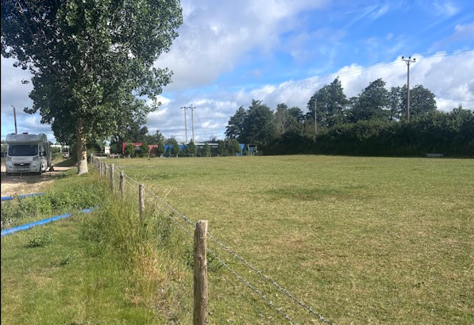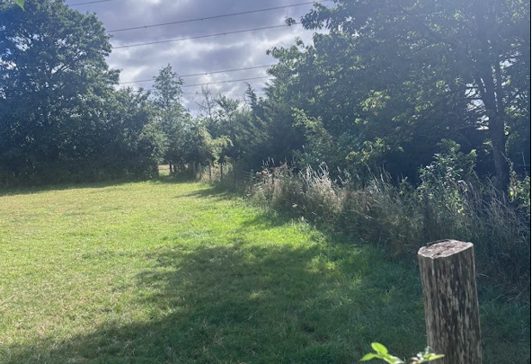
Views across the site to the north (left) and south(right)

The application site is screened from view from the A361 by the existing mature trees that are positioned to the south of the proposal and all existing trees on site would be retained.

The padel court would be sensitively located within an existing agricultural field that forms part of the wider site area in use as a caravan storage facility. The site is within the boundary of the existing rural complex and screened from direct views by the existing soft landscaping to the northeast and south and existing built development to the southwest. The siting, design and materials for the court are considered to have minimal impact on the character and appearance of the area with limited ground works proposed due to the steel ring beam foundation system setting.

It is considered that the proposal by virtue of its height, scale and design would constitute an acceptable addition to the application site with a benefit to the wider community. Having regard to the above, the proposal complies with the design principles set out in Core Policy 57 of the Wiltshire Core Strategy and Appendix D of the Wiltshire Design Guide.

Amenity
Point vii of Core Policy 57 - Ensuring High-Quality Design and Place Shaping of the Wiltshire Core Strategy seeks to ensure that developments do not adversely affect neighbouring properties.

Core Policy 57 of the Wiltshire Core Strategy seeks to ensure that development achieves a high standard of design and place shaping. Amongst other matters, the policy requires that appropriate levels of amenity are achievable for existing and future occupiers, having regard to potential adverse effects arising from noise, vibration and other forms of pollution.

The National Planning Policy Framework (NPPF), particularly Policy L2 (1)(d)(ii), stresses that substantial weight should be given to the benefits where a development proposal would maintain, amongst others, safe access and egress for occupiers and users, and acceptable living standards for residents and neighbours in terms of access to daylight, sunlight and privacy.

Policy P3(1) of the NPPF states development proposals should be appropriate for their location, taking into account the likely effects (including cumulative effects) of pollution on health and living conditions.

Policy P3(2)(b) of the NPPF states that development proposals should not give rise to, or contribute to, an unacceptable level of access to daylight and sunlight for neighbouring residents and occupiers, or unacceptable levels of air, noise, artificial light, water, soil or other forms of pollution on or beyond the site

Policy P3(2)(d) of the NPPF states that development proposals should ‘mitigate and reduce to a minimum, potential adverse impacts resulting from noise, not result in levels of noise exposure which would have a significant observed adverse effect’

Given the nature of the proposal and separation distances to neighbouring occupiers no overlooking, overbearing or overshadowing concerns are raised. However, due consideration has to be given to any potential adverse effects arising from noise pollution.

The Fairfield’s application site contains a number of small businesses and within the red line site area a couple of residential properties are present, however it is noted that within the Fairfields complex the property positioned to the southwest ‘Conifers’ is not included within the application site plan. The property is positioned some 25m from the proposed padel courts (as illustrated in the map insert below) and there would be an unobstructed line of sight between the courts and the dwelling and Conifer’s private residential curtilage. Therefore, officers are cognisant that some adverse noise effects could be experienced by residents of this property.

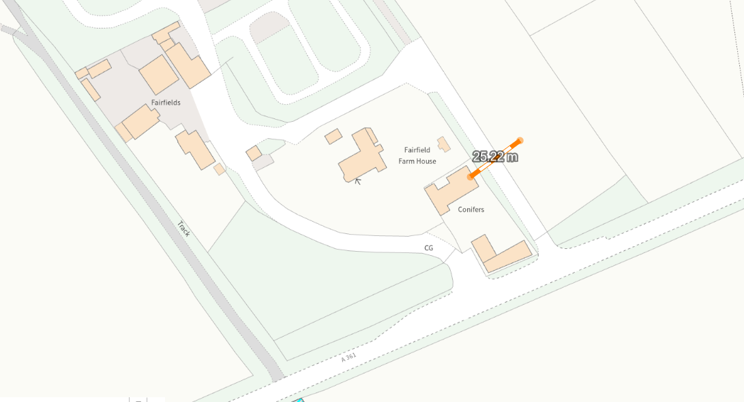

The outdoor padel courts are likely to introduce a sequence of readily distinguishable events rather than a continuous background sound, which would include the repeated impact noise from the ball being struck by rackets and the noise once the ball bounds against the mesh enclosure, with player conversations and shouting during play.

It is acknowledged that the application site is positioned to the north of the A361, a busy public highway which is one of the main routes into Trowbridge, where a steady stream of vehicle movements and noise is experienced. However, the proposal seeks to introduce continued noise within the application site with suggested opening hours from 8am until 10pm seven days a week, which would introduce an increased prominence of noise during evenings and quieter periods, when underlying ambient noise levels may fall. The proposal would also introduce additional activity on site with clients arriving and leaving, engine noise and vehicle noise with doors opening and closing, and conversation around the courts.

The submission includes a noise impact assessment that sets out that there would not be any Tannoy systems installed and the hours of operation would be limited to 8am -10pm. The Council’s Public Protection team were consulted and objected to the proposal citing concerns that the submitted noise assessment was not robust enough to support the scale of the proposal, citing there was lack of evidence within the report to substantiate the claim within the conclusion of the report that impacts on neighbouring residents would be low and not significant.

The Noise Impact Assessment concludes that the noise levels from the proposed padel courts will be modest and comparable to typical recreational activities, and that impacts at nearby residential properties will be low and not significant, and that the development is therefore considered acceptable in noise terms.
It is acknowledged that the owner of ‘Conifers’ has submitted a public representation in support of the proposal and does not have any opposition to the proposals, supporting the sporting facility and recognising the benefit for the wider community, suggesting that the development is ‘in keeping with the existing access and development’. However, the Council have a duty of care to protect any future owners from any adverse neighbouring amenity impacts and therefore a full appraisal of any neighbouring amenity impacts has to be undertaken.

Given the relatively short distance between the closest padel court and the side elevation of Conifers the dwelling would be regarded as a key noise sensitive receptor site and officers would expect any Noise Impact Assessment to have assessed any potential noise disturbance levels from this receptor. The Assessment should also have provided sufficient information to evidence that this key receptor site would not be adversely affected by the noise impacts that would be associated with this particular type of sporting facility.

Therefore, in the absence of a robust Noise Impact Assessment, supporting evidence, or details of mitigation measures, it has not been demonstrated that neighbouring occupiers would be protected from adverse noise impacts arising from the proposed development. As a result, Public Protection Officers object to the proposal. It is considered that insufficient evidence has been submitted to satisfy the Council that the occupiers of Conifers would not experience unacceptable noise pollution and consequent harm to residential amenity arising from frequent and distinctive impact noise over and above the existing acoustic environment.

The proposal therefore conflicts with Core Policy 57 point vii in respect of safeguarding residential amenity and the Policies of the NPPF.

Highways Impact
Core Policy 57 (xiv) of the Wiltshire Core Strategy seeks to ensure that development must meet the requirements of Core Policy 61. This policy requires proposals to be capable of being served by safe access to the highway network. Core Policy 64 seeks to ensure compliance with parking standards set out in the Local Transport Plan.

To the south of the padel courts an existing driveway (that has not recently been in use) would be used to access the site with an off-road parking area positioned within the field to the southwest of the padel courts. The car parking area that would consist of a permeable surface which would provide parking for up to eight vehicles.

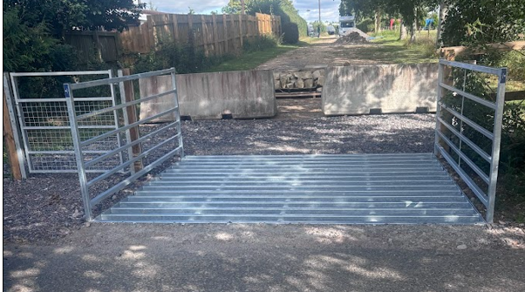
Existing access route and driveway to the padel courts

The Council’s Highway officer was consulted on the proposal and offered the following comments – I note the proposal for two paddle board courts, which will be available commercially. The proposals will utilise an existing access from the A361, which has not been in use for a number of years. Despite this, visibility splays and geometry of the junction are adequate and the access could thus be brought back into use without too much issue. Within the site, 8 car parking spaces are shown, which is considered sufficient.

Sufficient visibility splays have been identified, and sufficient turning space is provided within the site ensuring vehicles can access and egress the site in a forward gear.

Ecology Impact
Core Policy 50 of the Wiltshire Core Strategy seeks to protect and enhance biodiversity and geodiversity, including through ensuring that development avoids harm to protected species and habitats.

The National Planning Policy Framework (NPPF 2026) requires that development should minimise any adverse impacts on biodiversity and include features which support priority or threatened species such as swifts, bats and hedgehogs.

The application site is located within the ‘grey hatched’ recreational zone of the Trowbridge & Westbury Bat Mitigation Strategy (TWBMS).

The Parish Council have raised no objections to the scheme but have requested “that the developers consider neighbours and biodiversity when choosing exterior lighting and to consider legal requirements of any bat survey recommendations”. These queries have been suitably covered off within The Council’s Ecology team’s recommendations.

The Council’s Ecologist was consulted and offered the following comments

“Bath & Bradford on Avon Special Area of Conservation (SAC)
TWBMS Grey Zone
The application site is located within the boundary of the grey zone of the Trowbridge & Westbury Bat Mitigation Strategy (TWBMS), associated with the Bath & Bradford on Avon Bats Special Area of Conservation (SAC), and therefore has potential to result in significant adverse impact on the special features of the SAC. The application must be considered under the Habitats Regulations.

The grey medium risk zone represents an area where new residential development is likely to result in increased recreational use of important woodland bat sites. This application is not for residential development, and therefore, no increase in recreational impacts is anticipated.
A test of likely significance (screening assessment) has been carried out by Wiltshire Council as required under Regulation 63 of the Conservation of Habitats and Species Regulations 2017 (as amended) (also known as the Habitat Regulations).

The site is already subject to disturbance, it includes a minor loss of modified grassland (but this is expected to be mitigated for on-site via BNG), and will not impact any potential roost features. On the balance of evidence, the proposal is considered unlikely to adversely affect roosting bats, or foraging or commuting habitat, and the principles of the TWBMS are not considered further. The application is screened out of Appropriate Assessment with respect to the Bath and Bradford-on-Avon Bat SAC.

Artificial lighting
Artificial light at night can have a substantial adverse effect on biodiversity. Any new lighting should be for the purposes for safe access and security and be in accordance with the appropriate Environmental Zone standards set out by the Institute of Lighting Engineers in their publication GN01:2021, ‘Guidance for the Reduction of Obtrusive Light’ (ILP, 2021), and Guidance note GN08-18 “Bats and artificial lighting in the UK”, issued by the Bat Conservation Trust and Institution of Lighting Professionals.

The lighting impact statement clarifies that lighting will be operated between 08:00-22:00 only, and with directional aiming. However, a lux plan/lighting plan has not been provided. A condition securing these details, to be designed in a wildlife-sensitive manner, should be set.

Biodiversity Net Gain
From 12 February 2024 Biodiversity Net Gain (BNG) became mandatory under Schedule 7A of the Town and Country Planning Act 1990 (as inserted by Schedule 14 of the Environment Act 2021).

Thank you for providing a full BNG metric and BNG assessment, with condition assessments and maps. The pre-development baseline is accepted as accurate.
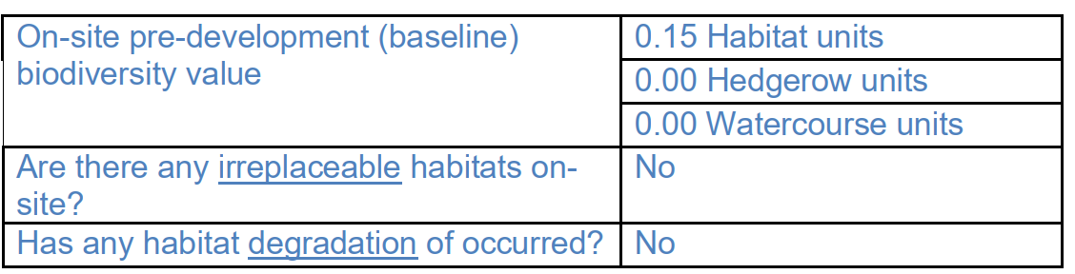

Confirmation of how the development will achieve BNG is a post-determination matter, however, consideration should be given to how any proposed BNG will be secured. The post-development habitats map and predicted BNG gains suggest that the majority of the site will remain as modified grassland.

However, it is noted that this does not align with the plans, and when the final BNG information is submitted at the discharge of condition stage, the padel courts, decking and porta cabin should not be counted as modified grassland”

The application was subject to consultation with the local authority ecology team who raised no objections in relation to the proposed development subject to the scheme being carried out in strict accordance with the supporting ecological documentation and conditions would be added to ensure this. Therefore, no concerns are raised in relation to any adverse ecological impacts.

Drainage and Flood Risk
Policy CP67 of the WCS requires that all new development will include measures to reduce the rate of rainwater runoff and improve rainwater infiltration to soil and ground (sustainable urban drainage.

Policy F7(2) of the 2026 NPPF requires that ‘development proposals should not present a risk from flooding to potential occupiers, users, or visitors, and should not increase flood risk elsewhere. Development must also comply with national policy on flood risk management and drainage design.

The area where the works are to be completed is located within flood zone 1 however it does lie within an area subject to surface water flooding. Therefore, officers need to appraise the development to ensure the development would not increase flooding from surface water. During the course of the consultation period the drainage team have requested clarification on a number of details and updated plans have been submitted, The Council’s Drainage team have offered the following comments;

“Assessment
The proposed surface water drainage strategy adopts an infiltration-led approach whereby rainfall from the padel courts, permeable gravel parking area, and ancillary development is allowed to infiltrate naturally into the ground, thereby maintaining the site's existing drainage regime and minimising runoff. The padel courts will be constructed using a permeable iFrame system that allows water to pass through the surface and sub-base layers, while runoff from the welfare cabin roof will be infiltrated through a stone-filled infiltration trench beneath the cabin.
Based on the Wiltshire Council Strategic Flood Risk Assessment, SFRA Data Explorer the site has a high risk of groundwater flooding affecting both surface and subsurface assets as shown in Figure 1.

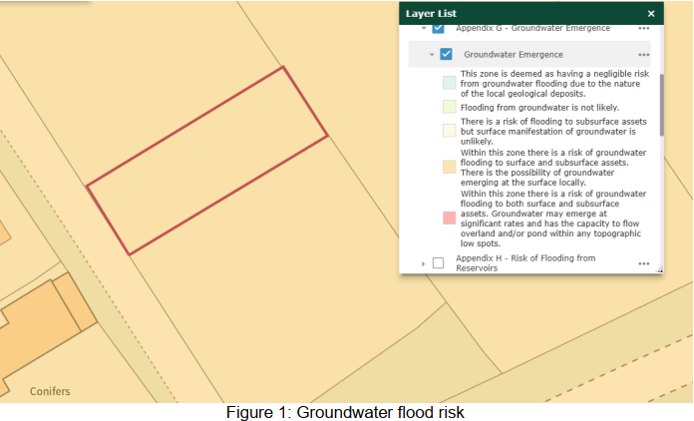

The applicant has demonstrated that the majority of the development remains permeable and broadly follows the existing drainage regime, and that there will be no change in levels across the site. The drainage strategy adopts SuDS principles and relies on infiltration to manage surface water runoff. However, the identified high risk of groundwater flooding presents a potential constraint.

Consequently, the suitability of the proposed approach should be supported by BRE365 infiltration testing and groundwater monitoring, to demonstrate that the proposed infiltration measures can operate effectively without increasing flood risk or adversely affecting surface and subsurface assets. If there has been previous infiltration testing & groundwater monitoring at the farm, the applicant could provide these documents to the LLFA for review. The highest recorded groundwater level must be identified to ensure that the base of the proposed soakaway is positioned at least 1 m above it.

The submitted information does not include a maintenance and management plan for the proposed drainage features. Long-term maintenance arrangements remain necessary to ensure the continued operation of the approved drainage system”

The drainage team raised no objections in relation to the proposed development subject to the scheme being carried out in strict accordance with the supporting documentation and conditions would be added to ensure this.

Given the scale and nature of the works, no drainage concerns arise, and the proposal is not considered to increase flood risk on or off-site. Officers are satisfied that the works to be undertaken would not exacerbate flood risk, and the development would not be at risk from flooding.

Public Right of Way
To the east of the application site lies a public right of way (SEM10) as shown on the map insert below, the footpath runs from the north to the south linking with additional footpaths within the vicinity of Semington.

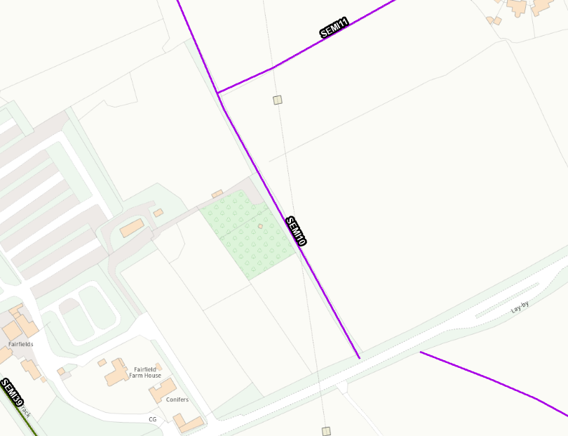

The footpath runs through agricultural fields that border the application site, however, there exists maturing hedging and trees surrounding the site, limiting views across to the site. Officers consider that there would not be any open views of surrounding countryside that would be obstructed by the proposal, given the topography and existing tree cover and vegetation screening the footpath. Therefore, the proposal would not have a detrimental effect to users of the public footpath as only glimpses from this particular footpath would be observed of the site.

The Parish Council have raised a query as to whether “if S137 funding is available, improvements of walking access on SEMI10 footpath and cycle access on SEMI39 be carried out.”. However, given the small scale of this proposal the funding is not available in this instance.

CONCLUSION
The proposed development is considered to be acceptable in terms of its design, scale, and relationship with the surrounding area. It would not result in any unacceptable harm to the character of the locality, or the interests of highway safety, the public right of way, ecology or flood risk.

However, it is considered that insufficient information has been submitted to adequately assess the noise impacts arising from the proposed development to ensure that the occupiers of the neighbouring property would not experience unacceptable adverse noise pollution from frequent and distinctive impact noises which would be clearly perceptible above the existing acoustic environment which would result in disturbance and loss of residential amenity.

The proposal therefore conflicts with Core Policy 57 point vii of the Wiltshire Core Strategy in respect of safeguarding residential amenity, and Policies P3(1) and P3(2) of the NPPF. As such, the application is recommended for refusal.

RECOMMENDATION: That Planning Permission be REFUSED.

