LOWER COWESFIELD FARM
LOWER COWESFIELD
WHITEPARISH
SALISBURY
WILTSHIRE
SP5 2QZ
ECOLOGICAL SURVEY REPORT (BATS)
(Preliminary Roost Assessment/DBW)
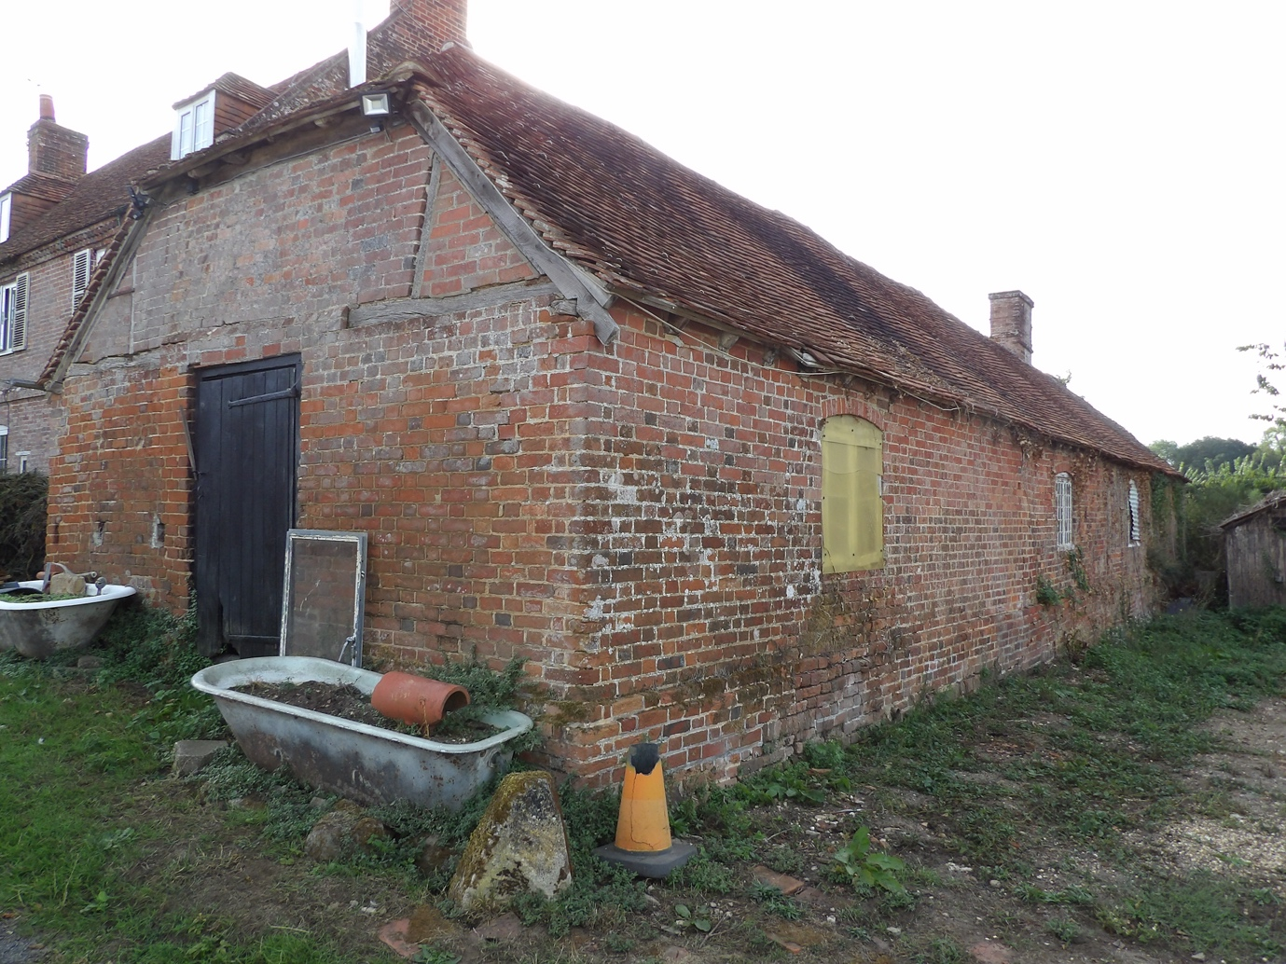

Prepared for:
Mr M. HEAD.
Date: 7/9/26.
Ref: NWP/ESR-7/9/26-version 1.

CONTENTS
Executive Summary
- Introduction
1.1 Instruction
1.2 Aims and Objectives
1.3 Proposed works
1.4 Surveyor Background and Experience
- Legislation and Planning Policy
2.1 Legislative Background
- Site Location and Description
3.1 Site Location 3.2 Site Description
- Survey Methodology
4.1 Pre-Survey Data Search
4.2 Daylight Survey
4.3 Constraints
- Survey Findings
5.1 External Inspection 5.2 Internal Inspection
- Evaluation
- Conclusions
7.1 Interpretation
  - Contingency plan

  - Mottisfont Bats SAC.

  - Recommendations.
8.References
9.Queries
Appendix 1

EXECUTIVE SUMMARY
BatCraft was commissioned Mr M. HEAD to conduct a preliminary ecological appraisal (daytime bat walkover [DBW]), of an outbuilding at Lower Cowesfield Farm, Lower cowesfield, Whiteparish, Salisbury, Wiltshire SP5 2QZ. This is to support a forthcoming planning application.
The site visit was carried out on the 7TH September 2026, during daylight hours. An internal and external inspection of the property took place to look for signs of bats. The preliminary ecological appraisal consists of a desk top study prior to the survey to review existing information about the site and its surroundings and to inform the design of subsequent bat surveys, if required. The desk top study was conducted based upon a 2km search radius and it revealed 3 designations over 2 sites, these are:
THE NEW FOREST-
SITE of SPECIAL SCIENTIFIC INTEREST (SSSI)
NATIONAL PARK
SPECIAL AREA of CONSERVATION (SAC)
WHITEPARISH COMMON-
SITE of SPECIAL SCIENTIFIC INTEREST (SSSI)
MOTTISFONT BATS -SPECIAL AREA of CONSERVATION (SAC) lies approximately 6.3KM northeast of the proposed development site.
There are 0 current European Protected Species Licences (EPSLs) for bats, there is 2 expired EPSL for bats within 2km of the proposed development site with the latest end date of 31/8/12.
The proposed development is in a rural setting and is part of a bigger property (Site description figure 3. there is a very small amount of outside space included as part of the proposed development site. The adjoining garden with trees/shrubs and hedges would allow excellent ecological connectivity to the wider landscape including the designated areas. These should provide good foraging and commuting habitats for bats providing rich and diverse habitats suitable for a wide range of bat species.
The DBW comprised a detailed search of the exterior and interior of the building for bats, signs of bats and features suitable for use by roosting bats. This includes droppings, scratch marks, rubbing and staining at exit holes, live or dead bats and other features such as missing tiles, this list is not exhaustive.
The buildings suitability to support roosting bats was assessed, no bats or evidence of bats was found. The external condition of the outbuilding would allow bats access, however a thorough inspection was possible and there was no evidence to suggest it has been used either recently or historically.
When the findings are combined the outbuilding building can be characterised as having negligible potential1 to support roosting bats, in line with best practice guidelines2; no further survey effort is required.

1-Table 4.1 Guidelines for assessing the potential suitability of proposed development sites for bats. Bat Surveys for Professional Ecologists Good Practice Guidelines 4th Edition. Page 44.
2- Collins, J. (ed) (2023) Bat Surveys for Professional Ecologists Good Practice Guidelines (4th Edition).

1.INTRODUCTION

  - Instruction
BatCraft was instructed by Mr M. HEAD to conduct a DBW of an outbuilding at Lower Cowesfield Farm, Lower Cowesfield, Whiteparish, Salisbury, Wiltshire SP5 2QZ to support a planning application.

1.2 Aims and Objectives
The DBW is designed to:
• Identify the presence/likely absence of bats within the building.
• Provide information on previous bat ecological surveys/reports.
• Provide information on the status of bats using the buildings currently or previously.
• To add confidence where no bats are found, or to categorise the nature of a roost where evidence of bats are found.
• To establish whether further surveys, mitigation or an EPSL is required.
The preliminary ecological appraisal (bats) and report writing were carried out in accordance with Bat Surveys for Professional Ecologists Good Practice Guidelines 4th edition.
  - Proposed Works
The survey was commissioned in connection with a forthcoming planning application, final plans were not available.
  - Surveyor Background and Experience
The preliminary ecological appraisal for bats was undertaken and the report written by Nicholas Powell. Nicholas holds a Class 2 Bat License (CLS-11742) and has received training in bat ecology and surveying, bat detector use, acoustic monitoring/sonogram analysis, architectural terms for bat workers, bats and development, H & S awareness for bat workers, legislation for bat workers, British bats their ecology and conservation, surveying trees for bats, Bat ID and handling, bat biology.

Lower Cowesfield Farm, Lower Cowesfield, Whiteparish, Salisbury, Wiltshire SP5 2QZ
2. Legislation and Planning Policy
2.1 Legislative Background
All species of British bat are protected under the Conservation of Habitats and Species Regulations 2017 and the Wildlife and Countryside Act 1981, as amended. Under this legislation it is an offence to kill or injure a bat or interfere with any roosting or resting site. A bat roost is interpreted as “any structure or place used for shelter or protection” whether bats are present at the time. A summary of the main legislation and planning considerations are included at Appendix 1.
Seven species of bat are also Species of Principal Importance for nature conservation in England under Section 41 of the Natural Environment and Rural Communities Act 2006. This places a duty on all government departments to have regard for the conservation of these species and on the Secretary of State to further, or promote others to further, the conservation of these species.
All rights in this report are reserved. No part of it may be reproduced, edited or transmitted, in any form or by any means, electronic, mechanical, photocopying, recording or otherwise, or stored in any retrieval system of any nature, without our written permission. Its content and format are for the exclusive use of MR M. HEAD and their agents in dealing with this site. It may not be sold, lent, hired out or divulged to any third party not directly involved in this site without the written consent of BatCraft It may be reproduced as part of a planning application.
This report is valid for 12 months from the site inspection. The lifespan of this report may be subject to change if the site conditions change due to unspecified works that affect the site.

Lower Cowesfield Farm, Lower cowesfield, Whiteparish, Salisbury, Wiltshire SP5 2QZ
3. Site Location and Description
3.1 Site Location
The building is located at Grid Reference SU 2651 2388, see Figure 1 below. An overview of the immediate area is shown on Figure 2, both images courtesy of Bing Maps.
Figure 1. 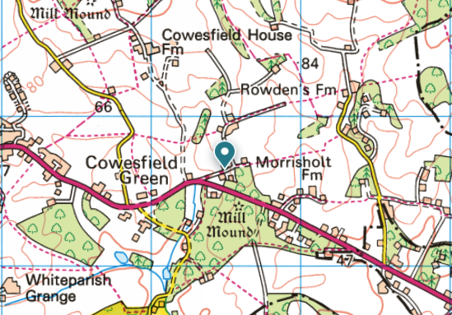Figure 2. 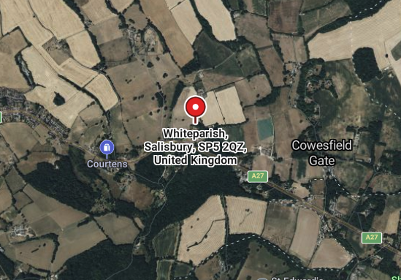

Lower Cowesfield Farm, Lower cowesfield, Whiteparish, Salisbury, Wiltshire SP5 2QZ
3.2 Site Description

The application site comprises of a detached brick-built outbuilding that is part of a bigger property, the external boundary is undefined, figure 3 shows the proposed development site highlighted in red.
On the eastern aspect there is a paved walkway which adjoins the main dwelling. On all other aspects is bare soil c1.5 metres from the external walls.
The site itself offers a negligible amount of foraging and commuting habitat for bats.
The immediate surroundings do offer excellent foraging and commuting, there is excellent connectivity to the wider landscape including the designated areas.
Figure 4/5/6 Show the outbuilding/proposed development site and its relation to its surroundings.
Figure 3.
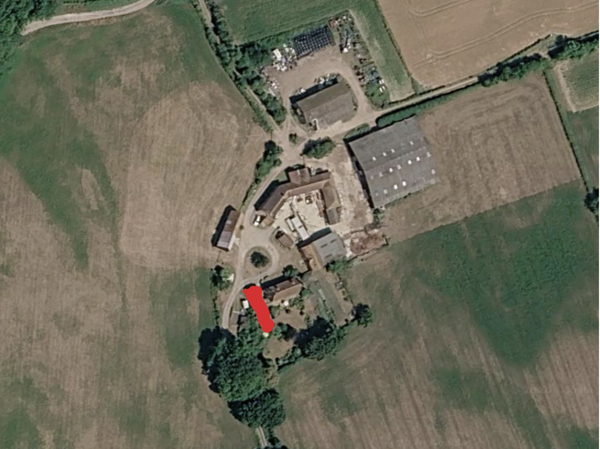
Figure 4/5/6.

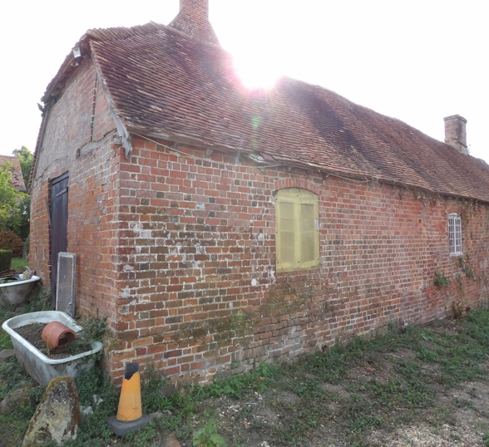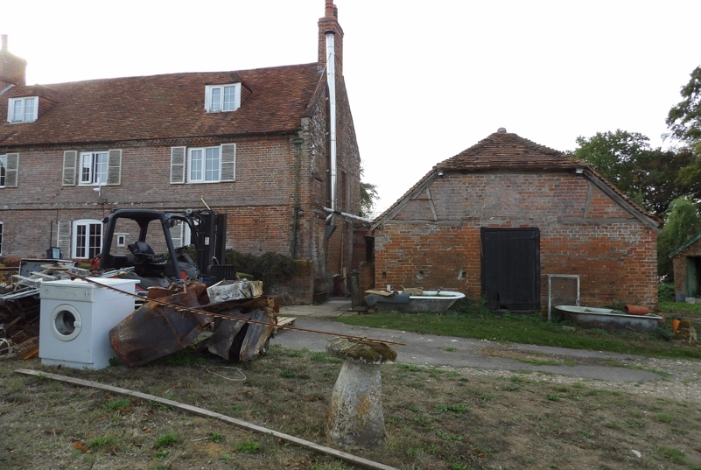
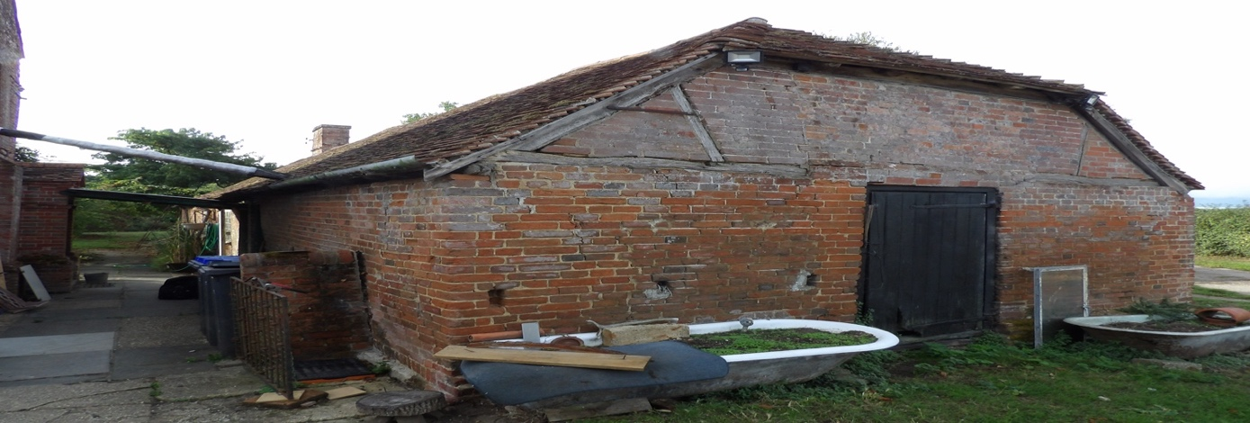
Lower Cowesfield Farm, Lower Cowesfield, Whiteparish, Salisbury, Wiltshire SP5 2QZ
4.Survey Methodology
4.1 Pre-Survey Data Search
The client has advised that to their knowledge, no previous bat surveys have been undertaken on the site. Google Earth and MAGIC maps (magic.defra.gov.uk) websites were used prior to the survey to determine the suitability of the surrounding habitat to support roosting bats and to identify any statutory designated sites or EPSLs within 2km of the site. No data was sought from the local records centre at this time.
The desk top study was conducted based upon a 2km search radius and it revealed 3 designations over 2 sites, these are:
THE NEW FOREST-
SITE of SPECIAL SCIENTIFIC INTEREST (SSSI)
NATIONAL PARK
SPECIAL AREA of CONSERVATION (SAC)
WHITEPARISH COMMON-
SITE of SPECIAL SCIENTIFIC INTEREST (SSSI)
MOTTISFONT BATS -SPECIAL AREA of CONSERVATION (SAC) lies approximately 6.3KM northeast of the proposed development site.
There are 0 current European Protected Species Licences (EPSLs) for bats, there is 2 expired EPSL for bats within 2km of the proposed development site with the latest end date of 31/8/12. Figure 1.
The site is situated along a no through track c450 metres north of the hamlet of Cowesfield Green, c1500 metres to the east of the village of Whiteparish and has the small village of Sherfield English c3000 metres to the southeast.
The immediate landscape is mixed farmland frequently broken up by blocks of woodland and connected by hedgerows.
The ecological connectivity to the designated site from the proposed development site is excellent due to the lack of any significant obstruction, the trees/hedges/gardens and open countryside adjoining the site should provide good commuting/foraging/roosting opportunities for a wide range of bat species.
Figure 2 shows the proposed development site and its relation to the designated sites courtesy of Magic maps, the legend is Figure 1 in appendix.

Figure 1. Expired Licences
CASE REFERENCE OF GRANTED LICENCE | SPECIES ON THE LICENCE | LICENSABLE PERIOD | LICENSABLE WORKS
EPSM2010-2148 | C-PIP; S-PIP; BLE | LICENCE_ST  01/09/2010  LICENCE_EN  31/08/2012 | DESTROY A RESTING/BREEDING SITE
EPSM2010-1821 | C-PIP; BLE | LICENCE_ST  31/03/2010  LICENCE_EN  30/03/2012 | DESTROY A RESTING SITE

Lower Cowesfield Farm, Lower Cowesfield, Whiteparish, Salisbury, Wiltshire SP5 2QZ
Figure 2.
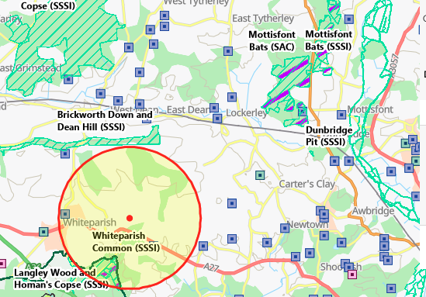

4.2 Daylight Survey
The DBW of an outbuilding at Lower Cowesfield Farm, Lower Cowesfield, Whiteparish, Salisbury, Wiltshire SP5 2QZ was carried out by Nicholas Powell on the 7th September 2026 at 9.00 am. The weather conditions for the survey were clear with no rain, occasional gusts of wind up to Beaufort 1 and a temperature of 24 degrees.
Equipment used included a high-powered torch, a digital camera, a digital camera on a telescopic pole, an endoscope and a ladder.
During the DBW an external inspection of the property was carried out to identify any signs of occupation by bats and features that could offer potential roosting sites following standard survey guidelines.
Features investigated included:
• Construction of the building– soffits, loft space, tiles/slates, lead flashings etc.
• Building condition – structure of roof and walls.
• Access points – potential entry and exit points for bats.
• Roosting points – cracks and crevices, between underlay and roofing tiles/slates.
Field signs that would indicate the presence of bats were searched for. These included:
• Bat droppings on the floor and walls of the building.
• Feeding remains (particularly butterfly and moth wings).
• Evidence of urine and/or oily staining around possible roost entrance
• Presence of areas cleared of cobwebs.
• Where a breathable roofing membrane has been fitted staining on the membrane may suggest use by bats.
• Odour can sometimes suggest the present of bats.
• Squeaking and chattering can reveal bats roosting between the tiles and roofing underlay.

4.3 Constraints
Full access to the site during the visit was made possible by the client.
There was nothing to be considered a significant constraint.

Lower Cowesfield Farm, Lower Cowesfield, Whiteparish, Salisbury, Wiltshire SP5 2QZ
5. Survey Findings
5.1 External inspection
The external features of the property were examined for signs described in section 4.2. Windowsills, exposed features around the windows, fascia and walls were inspected for any evidence of bat droppings or staining.

The property is a detached brick-built outbuilding in a deteriorated condition, it did not appear to have cavity walls.

Outbuilding.
The ridge tiles were in poor condition with significant mortar missing. Figure 1.
The hip tiles were in poor condition with significant mortar missing. Figure 2.
The tiles covering the roof were in poor condition, with visible slipped/missing/broken. Figure 1/3.
The eaves tiles were in poor condition with significant mortar missing. Figure 4.
The eaves were open, there was no soffits/fascia. Figure 2.
The mortar around the chimney was complete. Figure 5.
No bats or evidence of bats was recorded during the external inspection of the outbuilding, there were no visible roosting opportunities but there were ingress points into the outbuilding that bats could exploit.

Figure1.
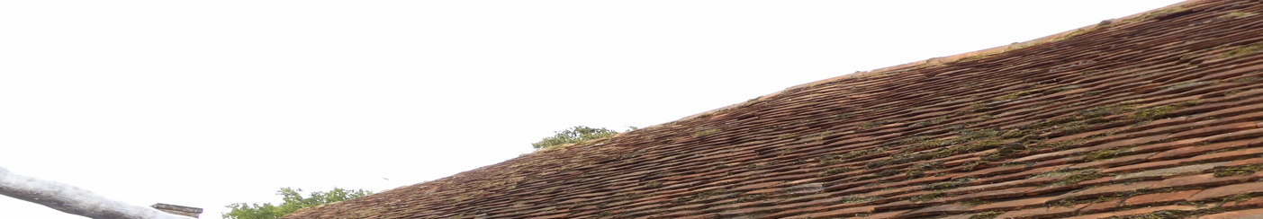
Figure 2. Figure 3.
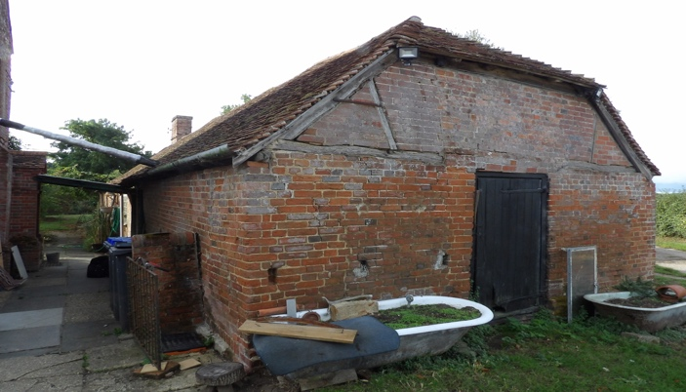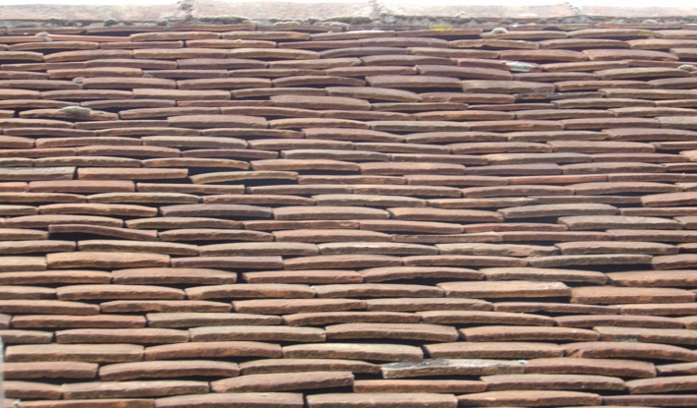
Figure 4. Eaves tiles. Figure 5. Example of mortar around the chimney.
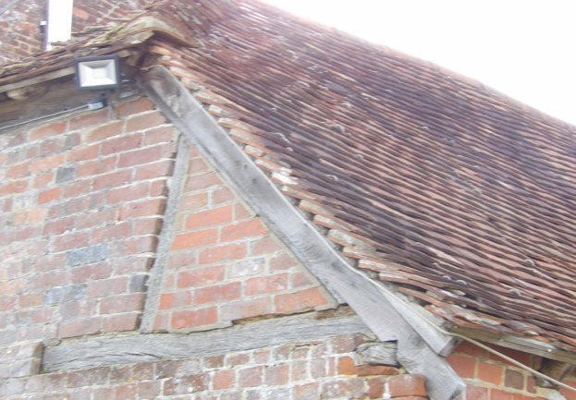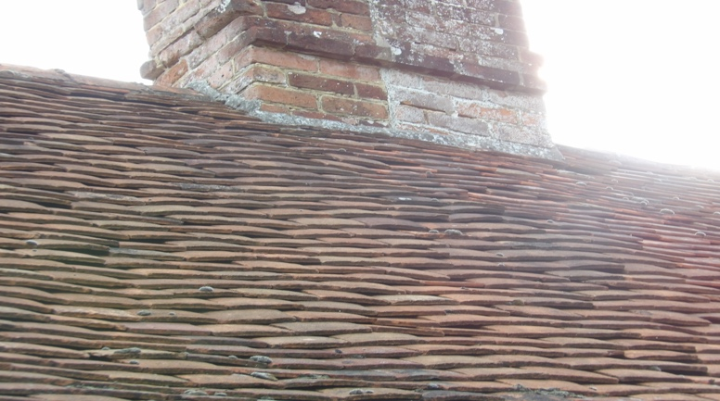

Lower Cowesfield Farm, Lower Cowesfield, Whiteparish, Salisbury, Wiltshire SP5 2QZ
5.2 Internal Inspection
An internal inspection of the property was undertaken and was examined for any signs of bats, (described in section 4.2)
Outbuilding.
There was no roof void.
The tiles were not lined allowing a thorough inspection.
There was light ingress due to the windows.
There was a lot of mould on the underside of tiles and on the timber joists, it would appear to suffer water ingress in wet weather.
Figure 1/2/3/4. Shows general internal structure and condition of the underside of the tiles.

No evidence of bats was recorded during the internal inspection of the outbuilding.

Figure 1/2/3/4.
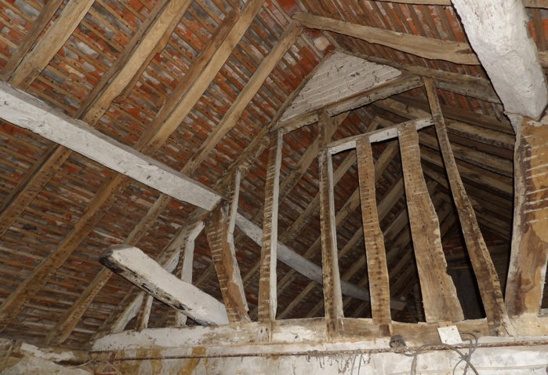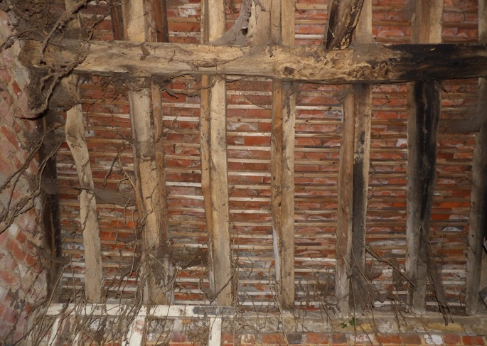
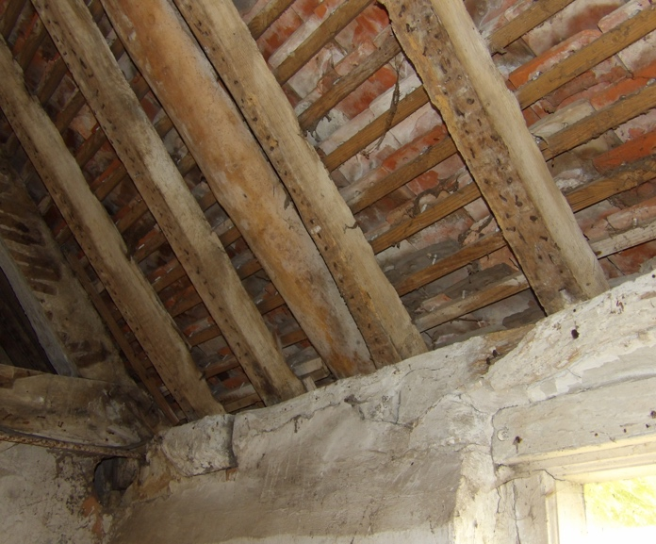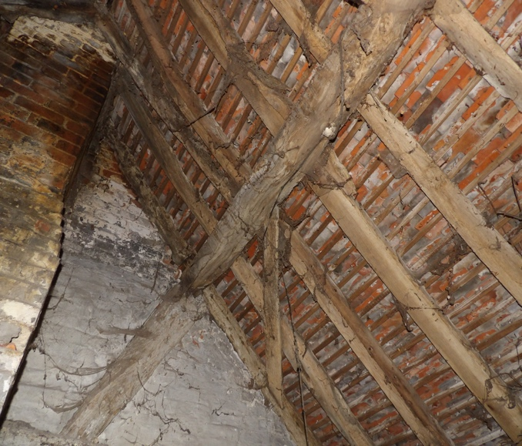

Lower Cowesfield Farm, Lower Cowesfield, Whiteparish, Salisbury, Wiltshire SP5 2QZ
6. Evaluation
The bat roost potential of the features within the site have been assessed with reference to the following criteria and include seasonal variation where increased or decreased probability may arise. Where features are present, they are highlighted in bold.

The likelihood of bat roosts being present will be higher where structures:
• are of a pre-20th Century construction;
• are in a lowland rural setting;
• have woodland, mature trees, species-rich grassland and/or water nearby.
•have large dimension roof timbers with cracks, joints and holes,
• have an uneven roof covering with gaps, though not too draughty.
have numerous crevices in stonework and structures;
• have hanging tiles or roof cladding, especially on south-facing walls;
• have a roof warmed by the sun;
• are disused or little used; largely undisturbed;
• provide appropriate hibernation conditions, such as abandoned mines, tunnels, kilns, or fortifications; or
• Recent and historical records of bat roosts in the general area.
The likelihood of bat roosts being present will be lower where structures:
• are in an urban setting with little green space;
• are subject to heavy disturbance (constant movement due to draughts and noise, also unstable microclimate);
• have a small, cluttered roof void (particularly for brown long-eared);
• are of a modern construction with few gaps or crevices that bats can fly or crawl through (though pipistrelle bats may still be present);
• are comprised of prefabricated steel or sheet materials; (some sections);
• are active industrial premises.

Please note that the above list provides generic screening criteria only and there are exceptions to consider.

7.Conclusion

7.1 Interpretation
Outbuilding- The combined evidence from the desktop study and the external/internal inspection of the property provides a high level of confidence in support of the opinions set out in this report, although there are points of access that could be used by opportunistic bats the condition of the building which appeared to allow water ingress in wet weather and the ability to thoroughly inspect the underside of the tiles due to them not being lined it is concluded that the outbuilding is not being or been used by bats, there is no evidence either recent or historic to suggest that is has. There is negligible potential for roosting bats within the building, based on recommendations in the Bat Workers Manual and the Bat Surveys Good Practice Guidelines, no further survey effort is required.

7.2 Contingency Plan.
In the unlikely event that bats are found during the works within the buildings, all work must stop, and advice sought from BatCraft or another licensed bat ecologist. If, for whatever reason, there is a time delay of greater than 12 months between this survey and the commencement of work, then the survey should be repeated as the condition of the buildings may change and bats may start roosting at the site.
Lower Cowesfield Farm, Lower Cowesfield, Whiteparish, Salisbury, Wiltshire SP5 2QZ
7.3 Mottisfont Bats (SAC)
Mottisfont Bats SAC- MITIGATION.

Lighting: The exact lighting proposals are not known at this stage but where new external lighting is provided best practice in the form of Bats and Artificial Lighting At Night Guidance Note GN08/23 (Bat Conservation Trust and Institution for Lighting Professionals) must be followed.
Research into artificial lighting at night (ALAN) has identified a reduction in insect diversity at night and the potential to disrupt a broad range of insect behaviour patterns and in turn foraging opportunities for bats, particularly where they are bright white. It is therefore essential that any new external lighting is carefully selected, for example, all external lighting must be Light Emitting Diode (LED) and directed downward or be located at a low level. By carefully directing light downwards and using a PIR with short illumination sensor the impact of external lighting on any foraging bats can be reduced.

Habitat loss
There is no habitat loss relating to this scheme and no requirement for habitat compensation.

Post construction work
There is no requirement for post-construction monitoring of this scheme.

7.4 Recommendation.
One general purpose woodcrete bat box, for example a Schwegler 1FF bat box (see www.NHBS.com) or similar design will be suitably sited and remain in situ.

8. References
Collins, J (ed.) (2023). Bat Surveys for Professional Ecologists: Good Practice Guidelines (4th Edition). The Bat Conservation Trust, London.
HM Government (2017) Conservation of Habitats and Species Regulations as (amended).
HM Government (1981) The Wildlife and Countryside Act (as amended). HM Government (2006) Natural Environment and Rural Communities Act.
Mitchell-Jones, A.J. & McLeish, A.P. (2004). Bat Workers' Manual (3rd Edition). Joint Nature Conservation Committee.
9.Queries
Any queries regarding this report should be addressed in the first instance to BatCraft.
Telephone; 07960 351558. Email: info@batcraft.co.uk
1 The Chestnuts, East Grimstead, Salisbury, Wiltshire SP5 3RU.

APPENDIX 1
In summary, the legislation combined makes it an offence to:
- • Intentionally or recklessly damage, destroy or obstruct access to a structure or place used for shelter by a bat.
- • Intentionally or recklessly disturb bats; in particular any disturbance which is likely to impair the ability of bats to survive, breed or reproduce or nurture their young; or in the case of hibernating or migrating bats, to hibernate or migrate.
- • Intentionally or deliberately kill, injure or take any bat.
Planning Considerations:
Government guidance to Local Planning Authorities stipulates the need to consider biodiversity and protected species during the consideration of planning applications. The NPPF makes clear that the planning system should help minimise the impacts that development can have on biodiversity and provide net gains in biodiversity where possible. In addition, the ODPM Circular 04/2005 states “It is essential that the presence or otherwise of protected species, and the extent that they may be affected by the proposed development, is established before the planning permission is granted, otherwise all relevant material considerations may not have been addressed in making the decision”.
Developments that compromise the protection afforded to bats or roosts under the provisions of the Conservation of Habitats and Species Regulations 2017 and the Wildlife and Countryside Act 1981 will require a European Protected Species (EPS) licence from Natural England (NE).
NE, the government’s statutory conservation advisory organisation, is responsible for issuing EPS licences that would permit activities that would otherwise lead to an infringement of the Habitat Regulations.
Three tests must be satisfied before this licence (to permit otherwise prohibited acts) can be issued:
- • Reg 44(2)(e) – the derogation is “in the interests of public health and public safety, or for other imperative reasons of overriding public interest, including those of a social or economic nature and beneficial consequences of primary importance for the environment”.
- • Reg 44(3)(a) – there is “no satisfactory alternative” to the derogation.
- • Reg 44(3)(b) –the derogation is “not detrimental to the maintenance of the populations of the species concerned at a favourable conservation status in their natural range”.
Tests (a) and (e) can be met with the issue of planning permission for the proposed works. Test (b) is determined by NE’s ecology department that requires the development of a suitable mitigation strategy that would ensure that any bats present on site, are retained at the same population level or better.

FIGURE 1.
Magic

Designations
Land-Based Designations
Statutory
Areas of Outstanding Natural Beauty (England)
Limestone Pavement Orders (England)
Local Nature Reserves (England)
Local Nature Reserves (England)
National Nature Reserves (England)
National Nature Reserves (England)
National Parks (England)
Ramsar Sites (England)
Ramsar Sites (England)
Sites of Special Scientific Interest (England)
Sites of Special Scientific Interest (England)
Special Areas of Conservation (England)
Special Areas of Conservation (England)
Special Protection Areas (England)
Special Protection Areas (England)
Biosphere Reserves (England)
Biosphere Reserves (England)

Habitats and Species
Species
European Protected Species Licensing
Granted European Protected Species Applications (England)
Amphibian
Bat
Cetacean
Invertebrate
Other Mammal
Plant
Reptile

