APPLICATION FOR FULL PLANNING PERMISSION (MINOR DEVELOPMENT) CASE OFFICER REPORT

APPLICATION REFERENCE: | PL/2026/04443
APPLICATION TYPE: | Full planning permission
SITE ADDRESS: | Coombe Down Farm, Blandford Road, Coombe Bissett, SP5 4LJ
DEVELOPMENT DESCRIPTION: | Addition of an external door at first-floor level, extension of the landing area to the existing balcony and associated external access works serving the approved ancillary residential accommodation.
RECOMMENDATION: | Approve with Conditions

SITE DESCRIPTION/CONTEXT

The application site relates to Coombe Down Farm, a primarily agricultural property with approx. 7.86 hectares of agricultural land and associated agricultural buildings; mixed with a B2 commercial use to provide engineering workshop facilities to serve a rural land-based industry with associated one bedroom flat above. The residential flat is tied by condition for occupation solely by a person(s) employed in the B2 use of the property. The site is located on the west side of the A354, accessed direct from the A354 via a sloping private driveway. The land rises steeply to the west, and the site is located in a prominent location within the Coombe Bissett valley.

The application site is located outside of the settlement boundary for Coombe Bissett which is defined as a large village through Core Polices 1, 2 and 23 of the Wiltshire Core Strategy and is therefore considered to be in the open countryside.

The application site is located within the Cranborne Chase & West Wiltshire Downs National Landscape formerly (AONB); the Hampshire River Avon Catchment, it is also within the 13.8 kilometres recreational zone of influence for the New Forest SAC, Special Protection Area (SPA) and Ramsar site.

PROPOSAL

The application is seeking consent for the installation of a new external door on the east elevation of the existing building and an extension to the existing external balcony to serve the new door.

Existing elevations
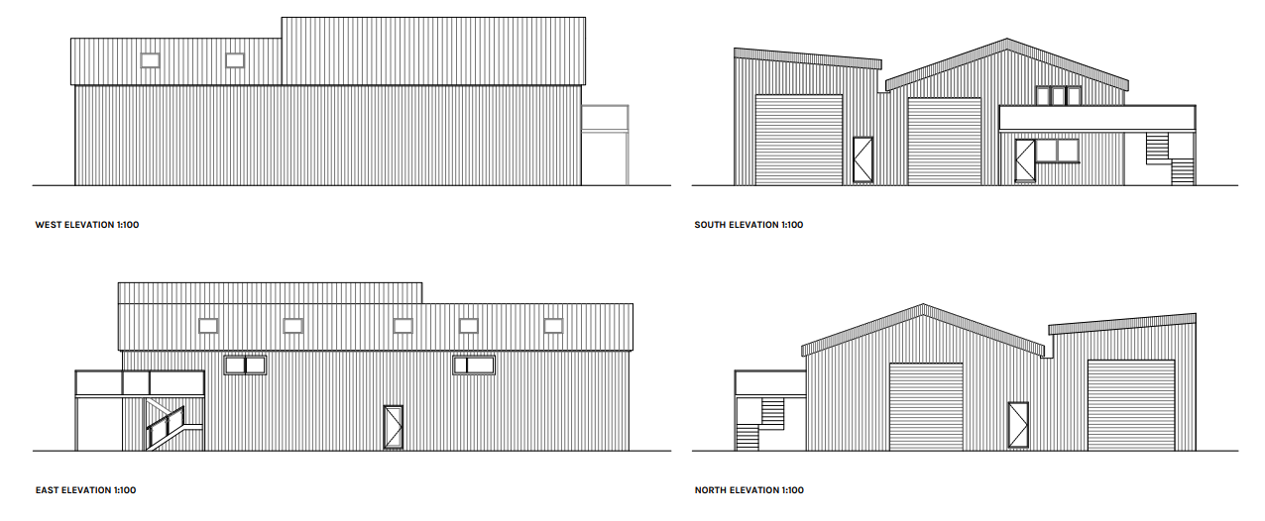
Proposed elevations

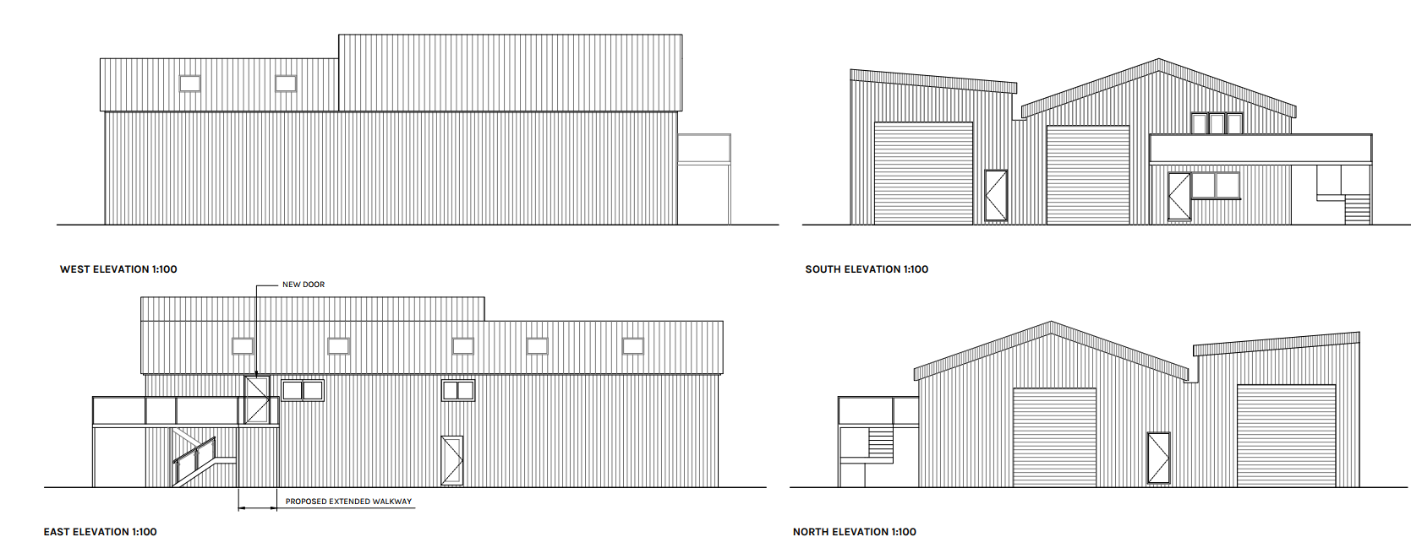
Existing floor plans

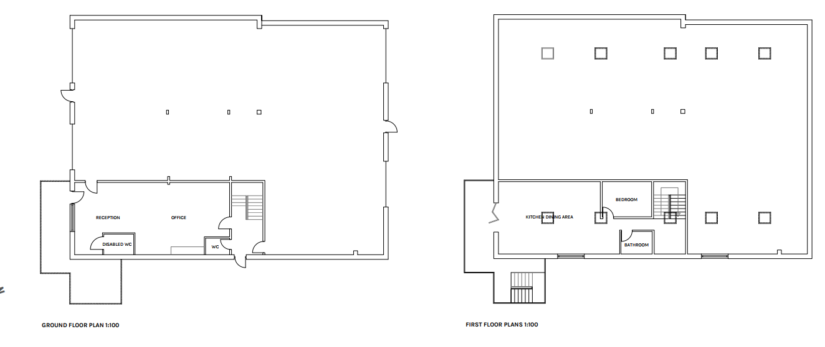
Proposed floor plans

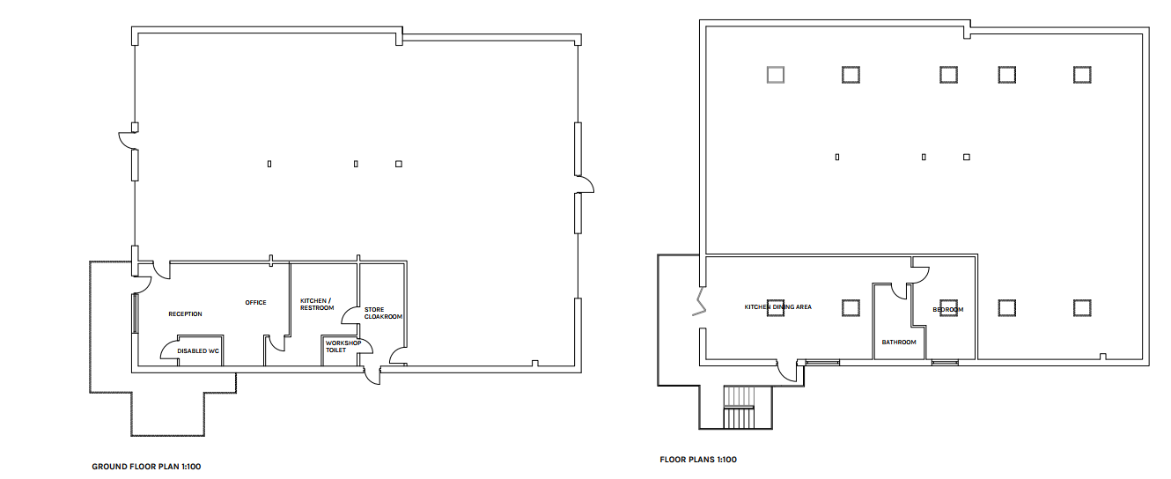

The proposals also include internal alterations to close of the internal staircase however; internal works do not require planning permission.

PLANNING HISTORY

Proposal / Summary
PL/2025/09224 - Full planning permission Decision - Withdrawn by Applicant Date: 20/4/2026 – Addition of external door on first floor and extension of landing area to existing balcony
PL/2026/04305 - Full planning permission – Refused 02/09/2026 - Change of use of land to ancillary garden land associated with the existing residential accommodation.
13/01037/ADV - Consent to display an advertisement Decision - Approve with Conditions Date: 13/6/2014 – Retrospective application for the erection of 6 non-illuminated signs (relating to the business) situated near vehicular access to site
PL/2022/02111 - Full planning permission Decision - Approve with Conditions Date: 2/8/2022 – Change of use of first floor store into small living accommodation.
PL/2023/03919 - Full planning permission Decision - Refuse Date: 9/8/2023 – Erection of bungalow
PL/2023/07449 - Full planning permission Decision - Approve with Conditions Date: 8/11/2023 – Formation of balcony with external stairs and two new windows.
PL/2025/09295 - Full planning permission Decision - Refuse Date: 21/4/2026 – Retrospective Application for Farm Office
PL/2025/09300 - Full planning permission Decision - Refuse Date: 21/4/2026 – Retrospective Application for Creation of a Vehicle Ramp
S/1997/1620 - Full planning permission Decision - Refused Date: 16/12/1997 – erection of a replacement agricultural worker's dwelling
S/2009/0853 - Full planning permission Decision - Withdrawn Date: 10/8/2009 – demolition of corrugated iron structure. change of use of redundant agricultural buildings to commercial (b1) use, alterations and extensions to building together with formation of replacement highway access and track and associated landscaping works

RELEVANT LEGISLATION, POLICIES AND GUIDANCE

Statutory Legislation:

National Planning Policy:

- National Planning Policy Framework (NPPF)
- Planning Practice Guidance (PPG)

The development plan for Wiltshire comprises the Wiltshire Core Strategy (WCS) (adopted January 2015) and any made neighbourhood plans, which remains the principal statutory planning document guiding development across the county. In line with Section 38(6) of the Planning and Compulsory Purchase Act 2004, planning decisions must be made in accordance with the development plan unless material considerations indicate otherwise.

Though the development plan is considered as a whole, those parts deemed to be particularly relevant to this application are listed below:

The adopted Wiltshire Core Strategy (WCS), with particular regard to:

- Core Policy 1 Settlement Strategy;
- Core Policy 2 Delivery Strategy;
- Core Policy 23 Southern Wiltshire Spatial Strategy Community Area;
- Core Policy 35 Existing Employment Land;
- Core Policy 48 Supporting Rural Life;
- Core Policy 50 Biodiversity and Geodiversity;
- Core Policy 51 Landscape;
- Core Policy 57 Ensuring High Quality Design and Place Shaping;
- Core Policy 69 River Avon SAC;

Draft Wiltshire Local Plan

At Full Council on 19 May 2026, the elected members of Wiltshire Council agreed to withdraw the emerging Wiltshire Local Plan. The said Plan has no material weight for the purposes of the application.

In accordance with Regulation 19 of the Town and Country Planning (Local Planning) (England) Regulations 2026, on 30th June 2026 Wiltshire Council published a notice of intention to prepare a new local plan for Wiltshire. The next stage is a Scoping Consultation which commences on 2nd September 2026. This plan is at a very early stage and currently carries no weight for decision making.

Neighbourhood Plan:

Coombe Bissett and Homington Neighbourhood Plan 2023-2038, Made January 2026

Supplementary Planning Documents and other Guidance:

Wiltshire Design Guide (adopted April 2024)
National Design Guide
Creating Places Design Guide
Cranborne Chase & West Wiltshire Downs National Landscape formerly (AONB) Management Plan

CONSULTATION RESPONSES

Parish Council – no objection

REPRESENTATIONS

None received

ASSESSMENT

Section 38(6) of the Planning and Compulsory Purchase Act 2004 states:

"If regard is to be had to the development plan for the purposes of any determination to be made under the planning Acts, the determination must be made in accordance with the plan unless material considerations indicate otherwise."

In accordance with this statutory requirement, this application has been assessed against the relevant policies of the Development Plan, including the Wiltshire Core Strategy (2015) and, where applicable, any made Neighbourhood Plans. Consideration has also been given to the policies of the NPPF (NPPF) as a material consideration in the assessment.

The assessment below considers each of the main issues. Each topic is assessed in turn with reference to the relevant policy context, the evidence submitted, consultee responses, and all other material considerations, before a conclusion is reached.

Principle, Character, Design and Landscape Impacts

Core Policy 51 of the Wiltshire Core Strategy seeks to protect, conserve and enhance landscape character and quality and requires development to respond appropriately to its landscape setting.

Core Policy 57 of the Wiltshire Core Strategy requires development to achieve a high standard of design that responds positively to local character, context and distinctiveness.

Policies DP1-DP4 of the NPPF seek to ensure that development is well-designed, visually attractive, sustainable and responsive to its surroundings. Development should contribute positively to local character, create high quality places and support healthy and inclusive communities.

Policy N2 of the NPPF seeks to conserve and enhance the natural environment and requires development to take account of landscape character, local distinctiveness and the natural beauty of the countryside.

Policy N4 of the NPPF affords significant protection to National Landscapes and requires development proposals to conserve and enhance their natural beauty and special qualities.

Under Section 245 of the Levelling-up and Regeneration Act 2023, the Council must seek to further the purposes of National Landscapes when exercising its planning functions.

The Wiltshire Design Guide promotes a context-led approach that integrates development with landscape features and local character and provides further guidance on achieving high quality, context-led design and should be taken into account where relevant.

The application relates to the insertion of an external door at first-floor level together with a modest extension to the landing area of an existing balcony serving the ancillary residential accommodation, both elements are located on the east elevation of the existing building.

The proposal comprises minor alterations to an existing building within an established mixed agricultural and commercial site. As it would not create additional residential accommodation, introduce a new use, establish a separate planning unit, or materially alter the use of the site, no objection is raised in principle, subject to consideration of the detailed impacts set out below.

It is acknowledged that a previous application for similar works under reference PL/2025/09224 was withdrawn prior to determination due to Officer concerns about the development due to lack of information. The current resubmission is supported by additional information which has addressed a number of matters that were not fully explained as part of the withdrawn application and has enabled the proposal to be fully assessed.

The principle of an external balcony and staircase serving the ancillary residential accommodation has previously been established through planning permission PL/2023/07449. The current application proposes changes to an existing arrangement comprising a limited extension to the balcony and the insertion of a new external doorway. These alterations would be accommodated within the existing building and would not appear out of keeping with its character or appearance

The application is accompanied by a Fire Safety Consultancy Report and subsequent addendum. Whilst the report includes reference to an external platform beneath a bedroom window, the submitted plans indicate that the proposed balcony extension would serve the proposed access door and would not extend beneath the bedroom window. The Addendum provided has confirmed that the proposed works are separate to the bedroom window as detailed within the original Fire Safety report. Given that compliance with Building Regulations is a separate matter from the planning process, advice was sought from Wiltshire Council Building Control. Building Control have confirmed that an external platform beneath a bedroom window is not a statutory requirement and have indicated that no concerns are raised regarding the proposed balcony extension and access arrangements but have advised that the applicant would need to seek Building Regulations approval for these works. Whilst the Fire Safety Consultancy Report explains the benefits of closing off the internal doorway, as previously mentioned these works do not require planning permission and the Fire Safety Consultancy Report does not materially alter the Council’s assessment of the development.

The site occupies a position within the Cranborne Chase National Landscape; however, the proposed works are confined to an existing building forming part of an established group of agricultural and commercial buildings. Given the limited scale of the balcony extension and the fact that the development would be viewed in the context of the existing building and wider site, the proposal would not materially increase the prominence of the building within the landscape. It is therefore considered that the works would not adversely affect the character, appearance or special qualities of the National Landscape in this instance.

Overall, the proposed development is considered to be an acceptable alteration to the existing building which would not have a significant impact on the character and appearance of the site and its surroundings. The proposal is not considered to create significant harm to the special qualities of the National Landscape and is therefore considered to accord with Core Policies 51 and 57 of the Wiltshire Core Strategy, the relevant provisions of the Coombe Bissett and Homington Neighbourhood Plan, and the National Planning Policy Framework.

The ancillary residential accommodation approved under planning permission PL/2022/02111 remains subject to an occupancy restriction which limits occupation to a person solely or mainly employed in connection with the associated MOT and vehicle repair business and further requires the accommodation to remain within the same planning unit as the commercial use. The current application does not seek to vary or remove those restrictions.

It is acknowledged that the previously approved internal staircase linking the ground floor commercial premises and first floor accommodation has been removed, resulting in the loss of the direct internal connection between the two elements of the building. Officers have carefully considered whether this affects the relationship between the residential accommodation and the commercial use. However, the removal of the staircase and associated internal alterations do not form part of the development currently under consideration and, in themselves, do not alter the requirements of the extant occupancy condition. The accommodation remains physically located above the commercial premises and there is no evidence before the Local Planning Authority that the residential accommodation has become a separate planning unit or is being occupied contrary to the restrictions imposed by planning permission PL/2022/02111.

Notwithstanding this, given the concerns raised regarding the loss of the internal connection and in the interests of ensuring the accommodation remains ancillary to the commercial use of the site, it is considered reasonable and necessary to impose a condition on any planning permission granted which replicates the existing occupancy restriction. This will ensure that the residential accommodation continues to be occupied only in association with the commercial business and remains within the same planning unit as the wider site.

Amenity

Core Policy 57 (Point vii) of the Wiltshire Core Strategy requires development to respect the amenity of existing occupants and ensure appropriate amenity levels for future residents.

Policy P3 of the NPPF requires development to be appropriate for its location, taking account of its likely effects on health, living conditions and the environment. In particular, Policy P3(2)(b) requires development to avoid giving rise to unacceptable impacts on the living conditions of neighbouring residents and occupiers. In assessing amenity impacts, regard should be had to matters including daylight and sunlight, outlook, privacy, overbearing impacts and other effects on residential amenity.

Given that the proposal comprises a modest extension to an existing approved balcony and the installation of an associated access door, it is not considered that the development would result in any unacceptable impact upon neighbouring amenity. There are no immediate neighbouring dwellings adjoining the site and the nearest residential property to the north is sufficiently separated such that no harmful overlooking, loss of privacy, overbearing impact or loss of outlook would occur.

Ecology and Biodiversity

Core Policy 50 of the Wiltshire Core Strategy and the National Planning Policy Framework requires that the planning authority ensures protection of important habitats and species in relation to development and seeks enhancement for the benefit of biodiversity through the planning system.

Policy N2 of the NPPF seeks to conserve and enhance biodiversity, support nature recovery, protect habitats and species, and strengthen ecological networks.

BNG - From 12 February 2024 Biodiversity Net Gain (BNG) became mandatory under Schedule 7A of the Town and Country Planning Act 1990 (as inserted by Schedule 14 of the Environment Act 2021). Based on the information available the biodiversity gain planning condition is not considered to apply to this application as the application is for retrospective consent and BNG does not apply to retrospective development.

River Avon SAC - This development falls within the catchment of the River Avon SAC and has potential to cause adverse effects alone or in combination with other developments through discharge of phosphorus in wastewater. A test of likely significance has been carried out by the relevant Competent Authority (Wiltshire Council) as required by Regulation 63 of the Conservation of Habitats and Species Regulations 2017 (as amended). Given that technically there will be no net increase in overnight accommodation (the proposed works are not to add a new dwelling, but to carry out works to an existing building, it can be considered that there would be no overall mechanism for adverse effect. The HRA has concluded that the application is not likely to have significant impacts on the SAC and subsequently the application is screened out of Appropriate Assessment.

New Forest SPA, New Forest SAC and New Forest Ramsar site -The site is located within the 13.8km zone of influence for the New Forest internationally protected sites, which comprises the New Forest SPA, New Forest SAC and New Forest Ramsar site. Any applications within this area are screened into appropriate assessment under the Conservation of Habitats and Species Regulations 2017 (as amended) on account of its potential to cause adverse effects on the New Forest protected sites through increased recreational pressure which may occur alone and in-combination with other plans and projects. Many of the special features of the New Forest protected sites afforded protection are vulnerable to adverse effects associated with an increase in recreation as demonstrated in Natural England’s supplementary advice issued for the SPA on 19 March 2019 and for the SAC on 18 March 2019. Following a Cabinet decision on 7 May 2024, Wiltshire Council’s “Interim recreation mitigation strategy for the New Forest internationally protected sites” (Version 1.1, 21 March 2023) is being revised. However, as the development relates to external alterations to an existing building and does not involve new overnight accommodation, nor will it be bringing additional people to the locality which will impact on the New Forest protected sites it can be screened out of Appropriate Assessment.

PLANNING BALANCE AND CONCLUSION

The application seeks planning permission for the addition of an external door at first-floor level together with a modest extension to the landing area of the existing balcony serving the ancillary residential accommodation at Coombe Down Farm.

The proposal does not create any additional residential accommodation, establish a new dwelling or alter the lawful mixed-use nature of the site. The works are limited in scale and comprise alterations to an existing building within an established agricultural and commercial complex.

Officers have taken account of the planning history of the site, including the occupancy restriction attached to planning permission PL/2022/02111. Whilst officers acknowledge concerns regarding the removal of the previously approved internal staircase linking the residential accommodation with the commercial premises below, the occupancy restriction remains in force and there is insufficient evidence before the Local Planning Authority to conclude that a separate planning unit has been created. For the avoidance of doubt and in order to maintain the established relationship between the accommodation and the commercial use, it is considered reasonable and necessary to reimpose the occupancy restriction as part of any planning permission granted.

The proposed balcony extension and external door would represent modest alterations to the host building and would not result in harm to the character or appearance of the site, the wider countryside or the special qualities of the Cranborne Chase National Landscape. Furthermore, given the separation distances to neighbouring properties and the existence of the approved balcony, the proposal would not give rise to any unacceptable impacts upon residential amenity.

Taking all matters into account, the proposal is considered to accord with Core Policies 51 and 57 of the Wiltshire Core Strategy, the relevant provisions of the Coombe Bissett and Homington Neighbourhood Plan and the National Planning Policy Framework. The application is therefore recommended for approval subject to conditions

RECOMMENDATION:
That Planning Permission be GRANTED, subject to conditions

1.The development hereby permitted shall be begun before the expiration of three years from the date of this permission.

Reason: To comply with the provisions of Section 91 of the Town and Country Planning Act 1990, as amended by the Planning and Compulsory Purchase Act 2004.

2. The development hereby permitted shall be carried out in accordance with the following approved plans and documents.

Application form received 15/07/2026
Survey Location Plan & Block Plan Drg no 26/56/D1 Rev A received 07/08/2026
Proposed Elevations and Floor Plans Drg no 26/56/1 Rev A received 06/08/2026

REASON: For the avoidance of doubt and in the interests of proper planning.

3. Materials to be used in the development hereby permitted shall be as stated on the application form and approved plans and to match the existing building.

REASON: In the interests of visual amenity and the character and appearance of the area.

4. The ancillary residential accommodation hereby permitted shall not be occupied at any time other than by members of staff (and any resident dependants) of the associated (B8) commercial MOT and vehicle serving and repair garage use, known as PDK Motoring, at Coombe Down Farm, Blandford Road, Coombe Bissett, SP5 4LJ, and it shall remain within the same planning unit as the main building. The extent of the residential accommodation area hereby approved shall be limited to the first floor only, in accordance with the details shown on the approved plan Drg no 26/56/1 Rev A.

REASON: The ancillary accommodation is sited in a position where the Local Planning Authority, having regard to the reasonable standards of residential amenity, access, and planning policies pertaining to the area, would not permit a wholly separate dwelling.

INFORMATIVES:

1. BNG not required

The effect of paragraph 13 of Schedule 7A to the Town and Country Planning Act 1990 is that planning permission granted for development of land in England is deemed to have been granted subject to the condition (biodiversity gain condition) that development may not begin unless:

(a) a Biodiversity Gain Plan has been submitted to the planning authority, and
(b) the planning authority has approved the plan.

The planning authority, for the purposes of determining whether to approve a Biodiversity Gain Plan, if one is required in respect of this permission would be Wiltshire Council.

There are statutory exemptions and transitional arrangements which mean that the biodiversity gain condition does not always apply. For further information on exempt developments please refer to:
https://www.gov.uk/guidance/biodiversity-net-gain-exempt-developments
Based on the information available this permission is considered to be one which will not require the approval of a biodiversity gain plan before development is begun because one or more of the statutory exemptions or transitional arrangements is considered to apply

2. Building Regulations

The development as permitted requires Building Regulations Approval. Any alterations to the approved plans, brought about by compliance with Building Regulations or any other reason must first be agreed in writing with the Local Planning Authority before commencement of work.

