APPLICATION FOR HOUSEHOLDER PLANNING PERMISSION
DELEGATED REPORT

APPLICATION REFERENCE: | PL/2026/01663 and PL/2026/02218
APPLICATION TYPE: | Householder planning permission and Listed building consent
SITE ADDRESS: | Little Court, 47-49, Upper South Wraxall, Bradford On Avon, BA15 2SE
DEVELOPMENT DESCRIPTION: | Internal and external alterations including extensions
RECOMMENDATION: | That Planning Permission and Listed building consent be GRANTED

This is a joint report for PL/2026/01663 (HPP) and PL/2026/02218 (LBC). Each considers different legislation, guidance and policy as set out below.

SITE DESCRIPTION/CONTEXT
The subject property is a GII designated, detached dwelling, known as Little Court.

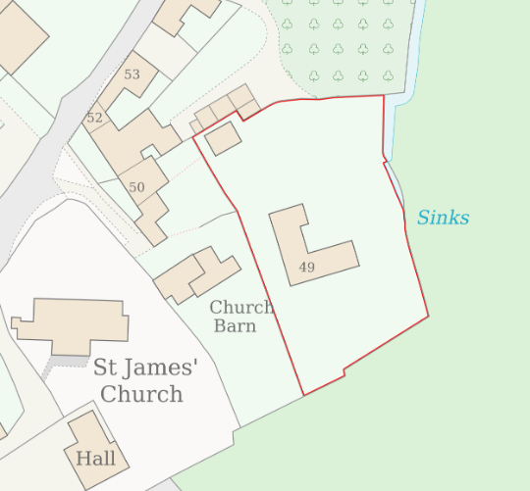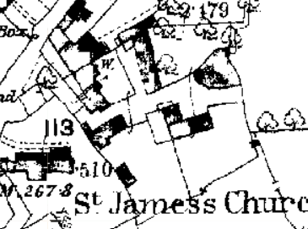

Location Plan and 1st epoch mapping – cluster of 4 structures, in stone and tin/wood.

The dwelling was once three late C17/C18 cottages, altered in the C20 to a single dwelling. The building is a single storey form with attics, L-plan, with a C20 garage to the northeast, converted to the existing kitchen in the C21, so effectively creating a U-Plan.

The site is surrounded by many listed buildings, and is within the core of the historic, post-medieval settlement of South Wraxall, still characterised and legible by form, dominated by farms with scattered dwellings, as recognised by its inclusion within the South/Lower South Wraxall Conservation Area.

GII Court Farm lies to the north and early C17, GII Lower Court Farmhouse is to the northeast.
Wraxall Mannor is to the north of the hamlet.

The site is within the West Wiltshire Green Belt, which covers the wider limestone lowland, within the Cotswolds Character Landscape.

An emerging drainage stream lies to the rear/east, and as such translates to an increased risk of groundwater and surface water flooding. The site is also within buffer zones of various bat roost and is within the Bradford on Avon Special Area of Conservation.

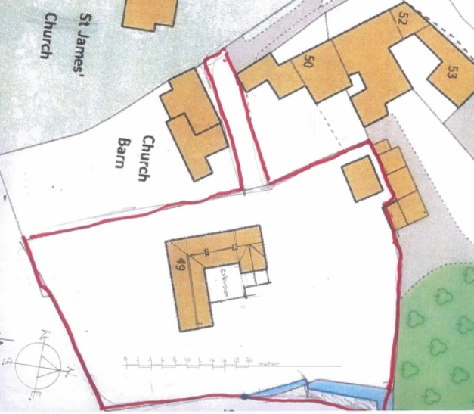

Proposed Block Plan

PROPOSAL

The proposal follows preapplication advice ENQ/2025/00229 and seeks planning permission for:
- 8.5m²oak-framed extension to C20 eastern wing to create a downstairs bedroom
- Reorganisation/partition of existing C20 east wing, turning the kitchen into a downstairs bathroom and a boot room
- Ground floor rear extension / courtyard infill measuring 45m² to create a new kitchen/dining space, with hipped roof, large lantern and glazed overhang
- Internal reconfiguration by

New doorway, reopen a doorway and new French doors to Living Room

New doorway (reopen), and extend a window into a door, from Dining Room into extension

New doorway into utility

Proposed materials include rubble stone and clay tiles to match existing with oak framing and large format glazing.

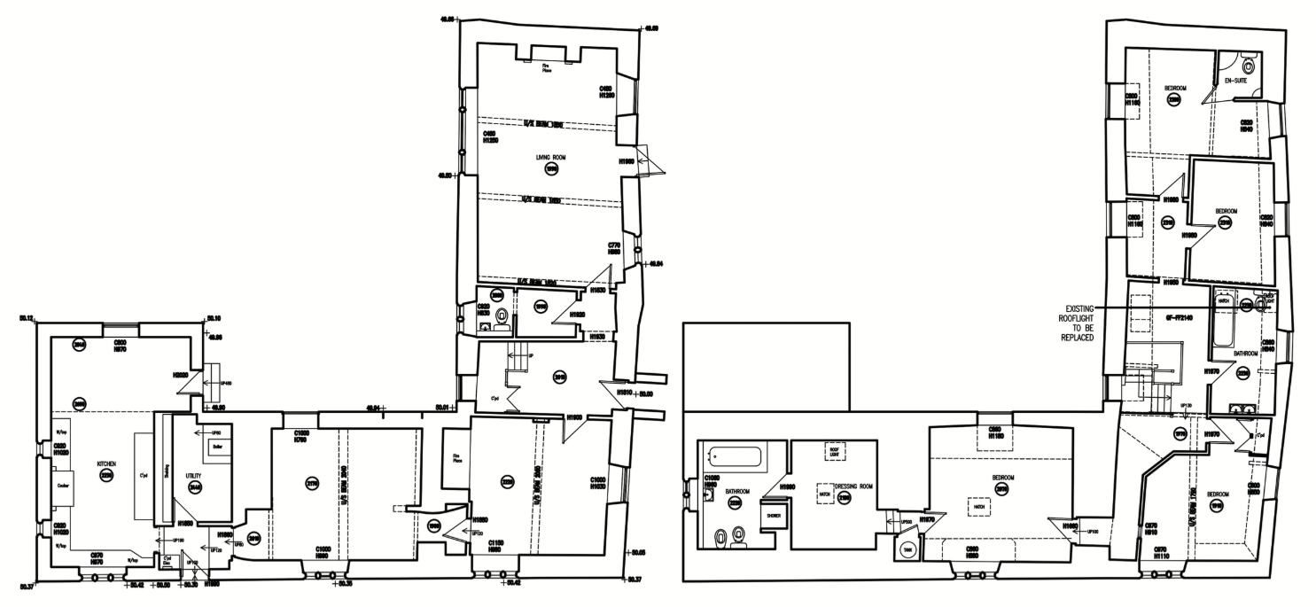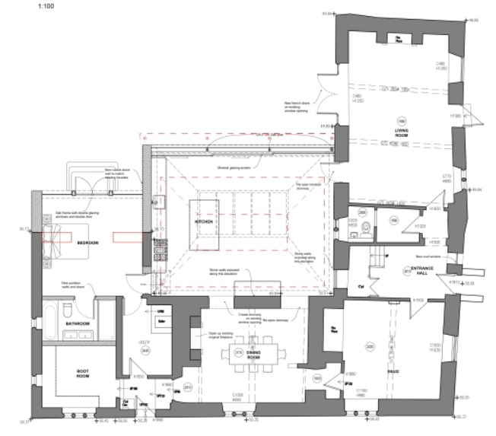

Existing and Proposed Ground Floor Plans

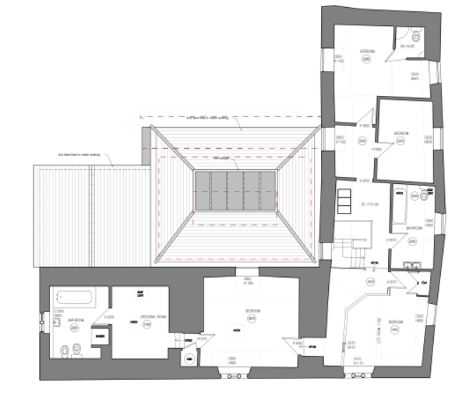

Existing and Proposed First Floor Plans – to demonstrate proposed roof plan

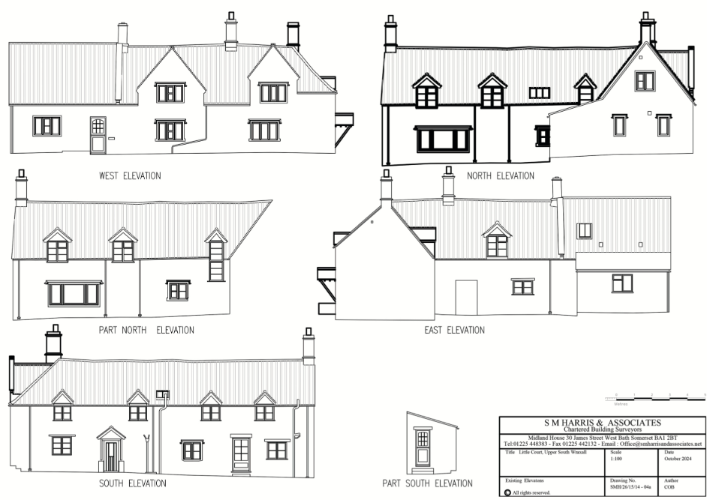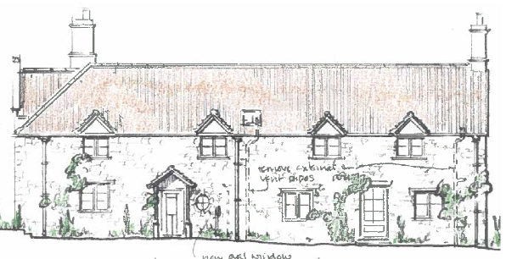

Existing and Proposed Front/South Elevations

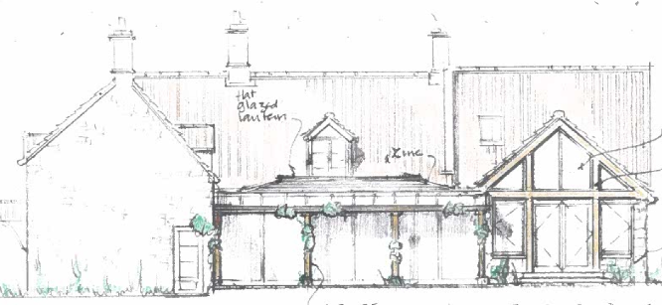

Existing and Proposed Rear Elevations

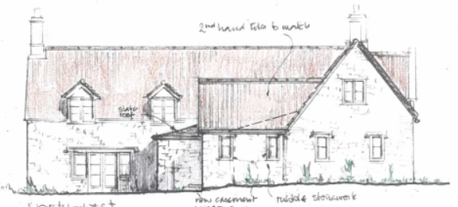

Existing and Proposed Side Elevations

PLANNING HISTORY
W/01/00041/LBC - Listed building consent Decision - Approve with Conditions Date: 28/2/2001 – Conversion of garage to kitchen and loft space into bedroom
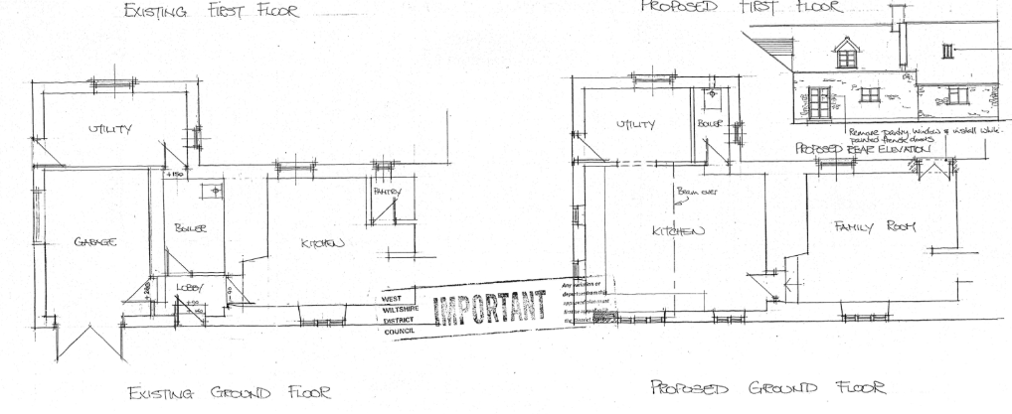
W/01/00185/FUL - Full planning permission Decision - Approve with Conditions Date: 9/4/2001 – Erection of detached double garage and store
W/01/00186/LBC - Listed building consent Decision - Approve with Conditions Date: 9/4/2001 – Erection of double garage/store
W/80/00947/HIS - Historic apps 1974 to 1983 Decision - Approve with Conditions Date: 16/9/1980 – Personal study and garage for private car
PL/2024/10585 - Householder planning permission Decision - Approve with Conditions Date: 4/3/2025 – Stripping and recovering of existing roof re-using salvaged tiles with the insertion of one new conservation roof light and the replacement of failed roof light.
PL/2024/10942 - Listed building consent (Alt/Ext) Decision - Approve with Conditions Date: 4/3/2025 – Stripping and recovering of roof existing roof re-using salvaged tiles with the insertion of one new conservation roof light and the replacement of failed roof light.

RELEVANT POLICIES AND GUIDANCE

National Planning Policy:
- National Planning Policy Framework (NPPF)
- Planning Practice Guidance (PPG)
- National Design Guide

Development Plan:
The development plan for Wiltshire comprises the Wiltshire Core Strategy (WCS) (adopted January 2015) and any made neighbourhood plans, which remains the principal statutory planning document guiding development across the county. In line with Section 38(6) of the Planning and Compulsory Purchase Act 2004, planning decisions must be made in accordance with the development plan unless material considerations indicate otherwise.

Though the development plan is considered as a whole, those parts deemed to be particularly relevant to this application are listed below:

The adopted Wiltshire Core Strategy (WCS), with particular regard to:

- Core Policy 50 Biodiversity and Geodiversity;
- Core Policy 57 Ensuring High Quality Design and Place Shaping;
- Core Policy 58 Ensuring the Conservation of the Historic Environment
- Core Policy 60 Sustainable Transport;
- Core Policy 61 Transport & Development;
- Core Policy 64 Demand Management
- Core Policy 67 Flood Risk;

Supplementary Planning Documents and other Guidance:
Historic England’s Conservation Principles, Policies and Guidance (2008) provides policy and guidance for the “sustainable management of the historic environment”.

Additional guidance on the application of policies set out in the NPPF is contained within their publications:
- Historic Environment Good Practice Planning Advice Note 2 – Managing Significance in Decision-Taking in the Historic Environment (2015)
- Historic Environment Good Practice Planning Advice Note 3 – The Setting of Heritage Assets 2nd edition (2017)
- Historic England Advice Note 2 – Making changes to Heritage Assets (2025)
- Historic England Advice Note 18 – Adapting Historic Buildings for Energy and Carbon Efficiency (2026)
- Traditional Windows: their care, repair and upgrading (2017)

South Wraxall does not have a designated Neighbourhood Plan Area
Lower and South Wraxall Conservation Area Assessment, 1981
The National Design Guide and Wiltshire’s Design Guide: Appendix D – Design Guidance for Householder extensions, provide further guidance.

CONSULTATION RESPONSES
South Wraxall Parish Council: No objections in principle to the application but feels that the plans for the proposed elevations are not comparable with the existing plans and there is not enough information for a Listed Building application.

Drainage: No objection. The applicant must ensure all development complies with Building Regs – Part H.

Highways Department: No objection.

Ecology: No objection, subject to informatives.

Conservation: No objection, the proposed works having a neutral impact on the significance of the dwelling. Conditions for further information required.

REPRESENTATIONS
No comments were received.

ASSESSMENT
Section 38(6) of the Planning and Compulsory Purchase Act 2004 states:

"If regard is to be had to the development plan for the purposes of any determination to be made under the planning Acts, the determination must be made in accordance with the plan unless material considerations indicate otherwise."

In accordance with this statutory requirement, this application has been assessed against the relevant policies of the Development Plan, including the Wiltshire Core Strategy (2015) and, where applicable, any made Neighbourhood Plans. Consideration has also been given to the policies of the National Planning Policy Framework (NPPF) as a material consideration in the assessment.

In addition, in accordance with Section 16(2) of the Planning (Listed Buildings and Conservation Areas) Act 1990, special regard has been given to the significance of the listed building, including its architectural and historic interest, and the desirability of preserving both the building and its setting.

Impact of proposals on the significance and setting of the building/structure, design and visual impact:

Section HE5 of the NPPF requires that ‘Development proposals affecting heritage assets should be accompanied by an assessment of the significance of the assets affected (including any contribution made by their setting) and of the potential effect of the proposal on their significance.’

The application is supported by a Design, Access and Heritage Statement which adequately identifies the significance of the listed building and impact by the proposed works.

Understanding the impact of proposed works on a listed building requires a careful and proportionate assessment of how those changes affect the asset’s heritage significance and its setting. This includes both the physical alterations to the building itself and any changes to its spatial or visual relationship with surrounding structures or spaces.

The significance of a heritage asset is not static; it is shaped by its architectural, historic, and communal values, and by how these are experienced in context. Therefore, any intervention must be considered in light of the asset’s identified significance, with attention given to both potential harm and benefits. Benefits may include repairs that support the long-term conservation of the building, improved energy performance, or enhanced public access and understanding.

This LBC assessment is grounded in the statutory duty under Section 16 of the Planning (Listed Buildings and Conservation Areas) Act 1990, which requires special regard to be given to the desirability of preserving the building and its features of special interest. It is also informed by national policy, particularly section 20 of the National Planning Policy Framework (NPPF), and relevant local heritage policies and guidance.

The extension and reconfiguration of the east wing, would not harm historic fabric but would by creation of an enclosed (and proposed infill) courtyard, would alter the setting of the dwelling.

An extended east wing would create a U-shaped layout. Historic maps show the building has undergone successive phases of development, the rear courtyard seeing the most change, such that further development is in line with historic precedent and evolution and would impact the elevations of lower significance.

The proposed extension would retain the existing rubble stone elevations and incorporate a timber-framed addition that would be clearly legible as a contemporary intervention. The extension would remain subservient to the host dwelling and would harmonise with its rural character through the use of complementary materials. Furthermore, the scale of the extension would be proportionate and commensurate with that of the host dwelling.

Subject to the detailing of how the extension is tied into the existing structure, the infill extension would not result in harm to the historic fabric. Through its modest scale, contemporary design, use of large-format glazing, and oak framing, the extension would remain lightweight in appearance and would allow the original L-shaped plan form and external elevations to remain readily appreciable.

The reinstatement and opening up of various historic openings would have a positive effect on the significance of the dwelling. Two new openings are also proposed: an opening between the lounge and the proposed kitchen, and the enlargement of an existing lounge window to form French doors. Whilst some historic fabric would inevitably be lost, the proposed openings have been carefully designed and positioned to minimise this impact. These alterations would improve the functionality, flow and accessibility of the dwelling, thereby supporting its continued viable use. When balanced against the heritage benefits arising from the reinstatement of historic openings, the overall impact on significance is considered to be neutral.

Proposed windows to the bedroom extension would match existing casements, but further details will be required to confirm this.

The proposed rear infill extension would not be readily visible from the public realm or in views from neighbouring listed buildings. Consequently, the proposals would preserve the character and appearance of the Conservation Area and would not result in harm to the setting or significance of adjacent heritage assets.

The proposed works would provide the additional accommodation necessary to meet the needs of the current occupants, thereby supporting the continued viable use of the property as a family home. The extensions have been carefully designed to affect only the rear elevation, which is considered to be of lower significance, and to respond positively to the character and appearance of the existing dwelling. The proposals would integrate successfully with the historic building through the use of appropriate design and materials. As such, the works would preserve the special interest of the listed building and are considered to have a neutral impact on its significance.

Impact on Green Belt:
Policy GB7(1)(b) of the NPPF, states that the following development is not inappropriate in the Green Belt: The reuse, extension, alteration or replacement of an existing building, provided that the existing building is of permanent and substantial construction, is lawful in planning terms, and any extension or alteration will not result in a disproportionate increase in size compared to the original building.

The submitted OS map below suggests the floor plan of the property in 1948, without the garage. Therefore the ‘original volume of the property as of 1948’ does not include this range.

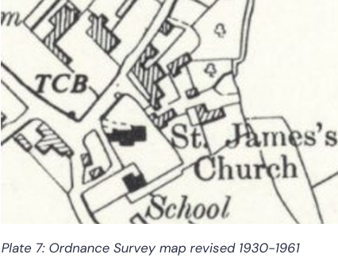

The existing garage and proposed extensions, are considered to be moderately scaled against the host dwelling, creating a courtyard and infilling, all at single storey. As such, the additions are considered to be proportionate to the dwelling and would not be inappropriate development within the green belt.

Amenity
Point vii of Core Policy 57 - Ensuring High-Quality Design and Place Shaping of the Wiltshire Core Strategy seeks to ensure that developments do not adversely affect neighbouring properties.

Policy P3(2) of the NPPF requires development proposals to provide healthy living conditions for occupiers and explicitly mandates avoiding unacceptable adverse impacts on neighbouring residents and occupiers. This includes protecting against adverse effects regarding daylight, sunlight, privacy, noise, and other sources of disturbance.

The proposed development has been assessed in terms of its potential impact on the residential amenity of neighbouring properties, with particular regard to loss of light, overshadowing, loss of privacy, and overbearing effects.

As single storey extensions, all to the rear of the property, without immediate neighbours, there are no concerns regarding neighbouring amenity.

The proposal therefore accords with Core Policy 57 point vii in respect of safeguarding residential amenity and Appendix D of the Wiltshire Design Guide.

Highways Impact
Core Policy 57 (xiv) of the Wiltshire Core Strategy seeks to ensure that development must meet the requirements of Core Policy 61. This policy requires proposals to be capable of being served by safe access to the highway network. Core Policy 64 seeks to ensure compliance with parking standards set out in the Local Transport Plan.

The proposed development would create an additional bedroom with increased associated parking demand.

The property benefits from a detached triple garage and off-street parking with the proposal making no alterations to these arrangements. The Highways Officer made no objection. As such sufficient parking provision is available.

The proposed development would not result in any adverse impact on highway safety. Adequate parking and turning provision is provided in accordance with Wiltshire’s adopted parking standards, and access arrangements are acceptable.

The proposal is therefore considered to comply with Core Policies 57 (xiv), 61 and 64 of the Wiltshire Core Strategy, the NPPF, and the Wiltshire Local Transport Plan.

Ecology Impact
Core Policy 50 of the Wiltshire Core Strategy seeks to protect and enhance biodiversity and geodiversity, including through ensuring that development avoids harm to protected species and habitats.

Policy N2 of the NPPF relates to improving the natural environment with (a) stating proposals should ‘consider the environmental qualities of land proposed for development, including habitats, landscape character and the natural beauty of the countryside, and identify opportunities for those qualities to be conserved or enhanced (including through requirements for biodiversity net gain where these apply.

The application is supported by a Bat and Bird Survey and Assessment (Alder Ecology UK Ltd, 23rd September 2024). The site is located within the Bath and Bradford on Avon Bat Special Area of Conservation (SAC).

A test of likely significance has been carried out by the relevant Competent Authority (Wiltshire Council) as required by Regulation 63 of the Conservation of Habitats and Species Regulations 2017 (as amended). This concluded that given the scale and nature of the development combined with the surveys strongly indicating bat species for which the SAC is designated will not be impacted, there is no mechanism for adverse effect. The HRA has concluded that the application is not likely to have significant impacts on the Bath and Bradford on Avon Bat SAC and subsequently the application is screened out of Appropriate Assessment.

As such, the development complies with Core Policy 50 of the Wiltshire Core Strategy and the relevant provisions of the NPPF.

Drainage and Flood Risk
Core Policy 67 of the Wiltshire Core Strategy and Section 18 of the NPPF requires that all new development avoids increasing flood risk on-site or elsewhere and, where appropriate, incorporates sustainable drainage measures. Development must also comply with national policy on flood risk management and drainage design.

The application is supported by a Flood Map and Flood Risk Assessment detailing mitigation measures for the proposed extension that could potentially be affected.

Wiltshire Council’s Drainage team have been consulted on this application and raised no objection, whilst highlighting that any development will need Building Regulations approval.

The proposal therefore complies with Core Policy 67 of the Wiltshire Core Strategy and the policy in the NPPF, ensuring that flood risk is not increased and that surface water drainage is appropriately managed.

Biodiversity Net Gain
Householder planning applications are exempt from the requirement to deliver Biodiversity Net Gain under Schedule 7A, Section 4(2)(a) of the Town and Country Planning Act 1990, as inserted by the Environment Act 2021.

CONCLUSION (Heritage impact)

The NPPF confirms that when considering the impact of a proposed development on the significance of a designated heritage asset, great weight should be given to the asset’s conservation (and the more important the asset, the greater the weight should be). It makes clear that any harm to a designated heritage asset requires clear and convincing justification.

The overall impact of the proposals on heritage assets will be neutral and it is considered the works will assist in securing the future use of a heritage asset in support of its long-term conservation. The requirements of current conservation legislation, policy or guidance are considered to be met.

RECOMMENDATION: That Listed Building Consent be GRANTED, subject to conditions.

CONCLUSION (Planning Balance)
The proposed development is considered to be acceptable in terms of its design, scale, and relationship with the surrounding area. It would not result in any unacceptable harm to the character of the locality, the amenities of neighbouring occupiers, or the interests of highway safety, heritage, or ecology.

The proposal is therefore considered to comply with the relevant policies of the Wiltshire Core Strategy, the Wiltshire Local Plan, and the National Planning Policy Framework. As such, the application is recommended for approval, subject to the conditions set out below.

RECOMMENDATION: That Planning Permission be GRANTED subject to conditions.

