APPLICATION FOR HOUSEHOLDER PLANNING PERMISSION
DELEGATED REPORT

APPLICATION REFERENCE: | PL/2026/04263
APPLICATION TYPE: | Householder planning permission
SITE ADDRESS: | The Old Church, Hill Deverill, Warminster, BA12 7EF
DEVELOPMENT DESCRIPTION: | Proposed installation of a 12 panels solar system to the roof pitches of the detached garage
RECOMMENDATION: | That Planning Permission be GRANTED

PROPOSAL

The proposal seeks planning permission for the installation of 12 solar photovoltaic panels on the roof slopes of the existing detached garage within the residential curtilage of The Old Church, Hill Deverill.

This application has been submitted following the refusal of planning permission and listed building consent under applications PL/2025/06003 and PL/2025/06183, which sought the installation of 12 solar panels on the prominent south-facing roof slope of The Old Church itself. Both applications were subsequently dismissed at appeal. The current proposal has been amended to address those concerns by relocating the solar panels from the listed former church to the detached garage building.

Historic mapping and the planning history indicate that the garage is a modern structure associated with the residential conversion of the former church. It is physically detached from the listed building and is not considered to form part of the listed building for planning purposes. Consequently, Listed Building Consent is not required for the proposed works.

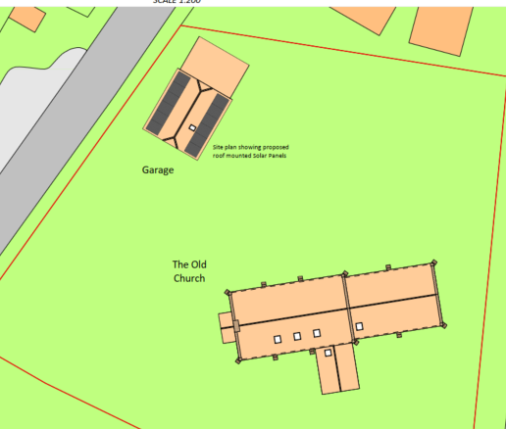

Extract from Proposed Site Plan

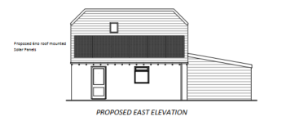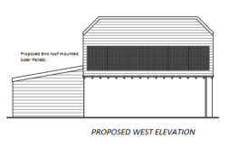

Proposed Elevations

SITE DESCRIPTION/CONTEXT

The application site comprises The Old Church, a Grade II listed former church which has been converted to a dwellinghouse. The site lies within the Cranborne Chase National Landscape and contains two Grade II listed chest tombs within the grounds. The detached garage subject to the application is located within the residential curtilage to the north west of the main dwelling and was constructed as part of the site's later residential use.

The application site is subject to the following planning policy constraints:

- Grade II Listed Building
- Setting of Grade II Listed Monuments
- Setting of a Scheduled Monument
- Cranborne Chase National Landscape
- Salisbury Plain Special Protection Area 6.4km Buffer Zone
- River Avon Catchment Zone

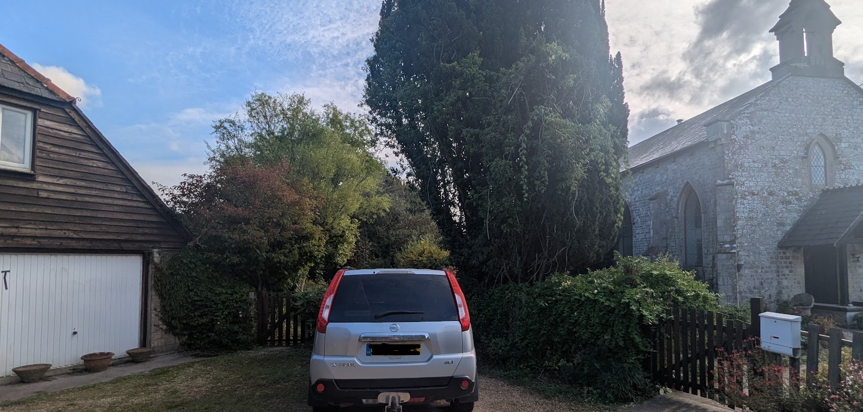

Photo of the garage in relation to the church

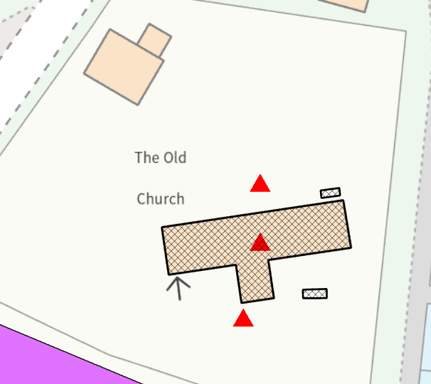

Council Mapping Image of the church and two listed monuments

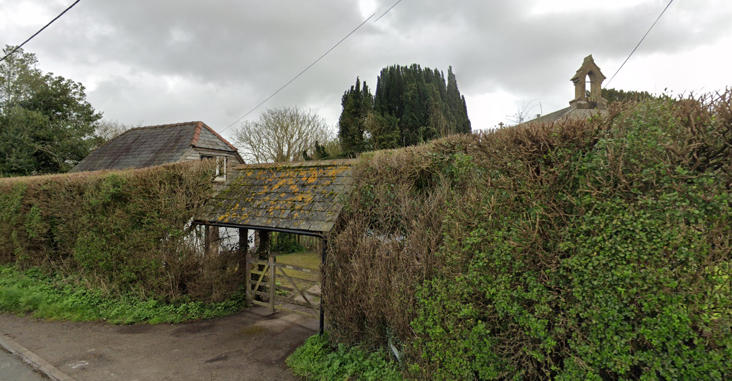

Google Street View Image (March 2024) of the garage (left) and church (right)

PLANNING HISTORY

There is extensive planning history on the site but the most relevant are as follows:

W/83/00182/OUT & W/84/00713/LBC - Change of use to residential – Approved with conditions

W/84/00605/FUL - Conversion of former church into dwelling house – Approved with conditions

W/84/00713/LBC - Conversion of church into dwelling - Approved

W/87/01459/LBC - Erection of lych gate, double garage and entrance porch – Approved

W/95/00140/LBC - Bedroom extension to church and lean-to extension to garage - Approve

W/05/02683/FUL & W/05/02684/LBC - Single storey extension to form utility room – Refused

W/06/00819/LBC - New external doorway and door in the north side elevation of the building – Approved with conditions

PL/2025/06003 and PL/2025/06183 - Installation of 12 panel Domestic solar pv array to the south facing roof slopes of the property – Refused. Dismissed on appeal 28 January 2026

The previous applications proposed the installation of solar panels directly on the principal south-facing roof slope of the Grade II listed former church. Both the Council and the Planning Inspector concluded that the proposal would result in less than substantial harm to the significance of the listed building through the introduction of visually prominent modern features that conflicted with the building's ecclesiastical character and attractive Welsh slate roof. While renewable energy generation and contribution towards the maintenance of the building were acknowledged as public benefits, these benefits were found insufficient to outweigh the identified heritage harm.

RELEVANT POLICIES AND GUIDANCE

Local Context:

Wiltshire Core Strategy:

- Core Policy 50: Biodiversity and Geodiversity
- Core Policy 51: Landscape
- Core Policy 57 Ensuring High Quality Design and Place Shaping
- Core Policy 58: Ensuring the Conservation of the Historic Environment

Wiltshire Design Guide: Appendix D – Design Guidance for Householder extensions

The National Planning Policy Framework (NPPF)

The Planning Practice Guidance

Longbridge Deveril does not have a Neighbourhood Plan or Area Designation

CONSULTATION RESPONSES

Longbridge Deverill Parish Council: No comments received.

Wiltshire Council Conservation Officer: General comments only

Wiltshire Council Public Protection Officer: No objection

REPRESENTATIONS

For the avoidance of doubt, (3x) notification letters were issued to adjoining occupiers. No site notice was erected as the proposal relates solely to a modern detached garage and does not comprise works to the listed building, notwithstanding that the impact on the setting of the listed building has been assessed as part of the application.

No comments were received.

ASSESSMENT

Section 38(6) of the Planning and Compulsory Purchase Act 2004 states:

"If regard is to be had to the development plan for the purposes of any determination to be made under the planning Acts, the determination must be made in accordance with the plan unless material considerations indicate otherwise."

In accordance with this statutory requirement, this application has been assessed against the relevant policies of the Development Plan, including the adopted Wiltshire Core Strategy (2015) and, where applicable, any made Neighbourhood Plans.

Design and Impact upon the character and context of the area

Core Policy 57 - Ensuring High Quality Design and Place Shaping of the Wiltshire Core Strategy seeks to ensure that all new development is of high design quality, reflecting local context, character, and distinctiveness.

Policies DP3 and DP4 of the National Planning Policy Framework require development to achieve a high standard of design that responds positively to local character and context. In assessing design quality, regard should be had to matters including scale, siting, form, appearance, materials and the relationship of development to its surroundings.

The application site lies outside a defined settlement. Policy S5(1)(c) of the NPPF recognises the reuse, extension, alteration or replacement of existing lawful buildings outside settlements as a form of development that may be acceptable in principle, provided that the existing building is lawful, of permanent and substantial construction and the proposal would not result in a disproportionate increase in size, or in the case of replacement buildings, would comply with the requirements of the policy.

The proposal relates to the alteration of an existing lawful building of permanent and substantial construction and therefore represents a form of development supported in principle by Policy S5(1)(c) of the NPPF, subject to compliance with other relevant policies.

The proposal does not involve any extension to the building and would not increase its footprint, height, bulk or massing. The solar panels would be mounted flush to the existing roof slopes and would follow the established form and angles of the building. In addition, the panels have been positioned relatively low on the roof slopes, reducing their prominence in wider views and further limiting their visual impact. Whilst visible from parts of the site, the panels would be positioned on a modern detached outbuilding rather than the historic church itself. The proposal therefore represents a relatively limited and proportionate alteration to an existing lawful building and would not materially alter its overall character or appearance.

Officers are satisfied that the proposed solar array has been appropriately designed and sited having regard to the character of the existing building and its surroundings. The low-profile nature of the installation, together with its location low on the roof slopes of a modern detached garage, ensures that visual impacts are limited.

Having regard to the above, the proposal complies with the design principles set out in Core Policy 57 of the Wiltshire Core Strategy, the National Planning Policy Framework and Appendix D of the Wiltshire Design Guide.

Amenity

Point vii of Core Policy 57 - Ensuring High-Quality Design and Place Shaping of the Wiltshire Core Strategy seeks to ensure that developments do not adversely affect neighbouring properties.

Policy P3 of the National Planning Policy Framework requires development to be appropriate for its location, taking account of its likely effects on health, living conditions and the environment. Policy P3(2)(b) requires development to avoid giving rise to unacceptable impacts on the living conditions of neighbouring residents and occupiers. In assessing amenity impacts, regard should be had to matters including daylight and sunlight, outlook, privacy, overbearing impacts and other effects on residential amenity.

The proposed development has been assessed in terms of its potential impact on the residential amenity of neighbouring properties, with regard to loss of light, overshadowing, loss of privacy, and overbearing effects.

The proposal comprises the installation of solar panels on an existing detached garage and would not result in any additional overlooking, overshadowing, overbearing impact, loss of privacy or loss of light. The development would therefore have no material impact upon the living conditions of neighbouring occupiers.

Consideration has also been given to the potential for glint and glare arising from the proposed solar panels. Modern photovoltaic panels are designed to absorb, rather than reflect, sunlight and are generally manufactured with anti-reflective coatings. In this case, the panels would be installed at a low level on the roof of an existing detached garage and would not form a prominent feature within the wider landscape.

Furthermore, the garage is enclosed by established boundary hedgerows, particularly along the adjacent highway frontage, which are of sufficient height to provide substantial screening of the panels from public vantage points. Given the low profile of the development, the orientation of the panels and the presence of the intervening vegetation, it is not considered that the proposal would give rise to any significant glint or glare impacts on neighbouring occupiers, users of the highway or the surrounding area.

The proposal therefore accords with Core Policy 57 point vii in respect of safeguarding residential amenity, Appendix D of the Wiltshire Design Guide and the NPPF.

Heritage Impact

Section 66(1) of the Planning (Listed Buildings and Conservation Areas) Act 1990 requires special regard to be given to the desirability of preserving listed buildings, their settings and any features of special architectural or historic interest which they possess.

Section 72(1) of the same Act requires special attention to be paid to the desirability of preserving or enhancing the character or appearance of Conservation Areas.

Core Policy 58 of the Wiltshire Core Strategy seeks to conserve and, where appropriate, enhance the significance of designated and non-designated heritage assets and their settings. Core Policy 57 requires development to respond positively to local character and historic context through high quality design.

Policies HE4-HE10 of the National Planning Policy Framework recognise heritage assets as an irreplaceable resource and require proposals affecting heritage assets to be assessed having regard to their significance and the contribution made by their setting.

This application follows the refusal and subsequent dismissal at appeal of applications PL/2025/06003 and PL/2025/06183 which proposed the installation of 12 solar panels on the south-facing roof slope of the listed church itself. In dismissing those appeals, the Inspector concluded that whilst the proposal would not harm historic fabric, it would result in less than substantial harm to the significance of the listed building through the introduction of a conspicuous and visually discordant modern feature on the prominent Welsh slate roof slopes of the former church. The Inspector considered the level of harm to be around the midpoint of the less than substantial harm spectrum.

The current proposal differs materially from the dismissed scheme. The solar panels would no longer be mounted on the listed building and would instead be located on the roof slopes of a modern detached garage. Consequently, the proposal would not affect the historic fabric, architectural detailing, ecclesiastical form or prominent Welsh slate roof slopes of the listed church which were the principal sources of harm identified by the Inspector.

The Council's Conservation Officer advises:

"The garage is a modern detached structure, presumably erected when the former church was converted to residential. The proposals are now to mount the panels on its roof (east/west facing slopes). I do think that there will be some slight harm to the setting of the church, however, I consider that harm to be at the lower end of 'less than substantial'."

Officers agree with this assessment. Whilst the garage forms part of the wider setting of the listed building and some limited visual impact would arise, the resulting harm would be confined to a low level of less than substantial harm to the significance of the Grade II listed building through its setting. This represents a significant reduction in heritage impact compared with the previous scheme.

Policy HE6 (4) of the NPPF requires any harm to a designated heritage asset to be weighed against the public benefits of the proposal. In dismissing the previous appeal, the Inspector accepted that renewable energy generation, contribution towards tackling climate change, improving energy security and assisting with the ongoing upkeep of the listed building all represented public benefits. However, the Inspector concluded that those public benefits did not outweigh the significantly greater degree of harm arising from the installation of panels on the listed church itself.

In the present case, those public benefits remain and attract substantial weight under both Policies CC2 and W3 of the NPPF. However, the heritage harm has been substantially reduced by relocating the panels onto a modern detached outbuilding. Officers therefore conclude that the identified public benefits now outweigh the low level of less than substantial harm to the setting of the listed building.

In reaching this conclusion, officers have given considerable importance and weight to the desirability of preserving the listed building and its setting in accordance with Section 66(1) of the Planning (Listed Buildings and Conservation Areas) Act 1990.

Accordingly, the proposal is considered to comply with Section 66(1) of the Planning (Listed Buildings and Conservation Areas) Act 1990, Core Policy 58 of the Wiltshire Core Strategy as well as the provisions of the NPPF.

National Landscape

Core Policy 51 of the Wiltshire Core Strategy requires all development to protect, conserve, and where possible enhance the character and quality of Wiltshire’s landscapes, giving particular weight to designated areas such as National Landscapes.

Policy N4 of the NPPF affords significant protection to Protected Landscapes, including National Landscapes. Development proposals within or affecting a National Landscape should conserve and enhance natural beauty and the special qualities of the designated area and avoid unacceptable harm to its landscape character and scenic quality.

Officers duly acknowledge that the Cranborne Chase National Landscape Officer has not been consulted on the application but consider that the solar panels, which would be located as low down on the roof slope as possible, would not cause adverse harm to the special qualities or scenic character of the National Landscape.

The development therefore complies with Core Policy 51 of the Wiltshire Core Strategy and Policy N4 of the NPPF in conserving and enhancing the National Landscape.

Ecology Issues:

Core Policy 50 of the Wiltshire Core Strategy seeks to protect and enhance biodiversity and geodiversity, including through ensuring that development avoids harm to protected species and habitats.

Policy N2 of the NPPF seeks to conserve and enhance biodiversity and support nature recovery. Development proposals should minimise impacts on habitats and species and, where relevant, demonstrate that appropriate mitigation measures are secured where harm cannot be avoided.

The Council’s Ecology Officer has not been consulted on this application. However, the application site lies within the 6.4km zone of influence of the Salisbury Plain SPA and, in light of the Habitats Regulations Assessment (HRA) prepared for the Wiltshire Core Strategy and Wiltshire Housing Site Allocations Plan, development within this zone is screened for potential recreational impacts upon stone curlew.

A strategic Appropriate Assessment (AA) has been prepared pertaining to development within the zone of influence that could result in a likely significant effect on the SPA through increased recreational pressure. The AA concluded that there would be no adverse effect on the integrity of the SPA or its qualifying features provided the Council’s mitigation strategy continues to be implemented. Annual stone curlew monitoring and associated protection measures continue to be secured by the Council.

In January 2026, Natural England confirmed its continued support for the Council’s strategic Appropriate Assessment for Salisbury Plain SPA.

The proposed development relates solely to the installation of solar photovoltaic panels on the roof of an existing detached garage. The works are confined to the existing roof structure and would not result in habitat loss, the removal of trees or hedgerows, alterations to supporting habitat, or the introduction of external lighting. No specific impact pathway affecting protected species, priority habitats, ancient woodland or other ecological receptors has been identified.

Whilst the site lies within the identified zone of influence for Salisbury Plain SPA, the proposal would not create a new dwelling, increase the number of residential units, increase overnight accommodation, or otherwise generate additional recreational pressure upon the SPA. As such, no likely significant effect has been identified, either alone or in combination with other plans or projects.

Furthermore, as the proposal would not result in any increase in overnight accommodation, there would be no increase in foul wastewater generation. The development would therefore not contribute to nutrient loading within the River Avon catchment and phosphate mitigation is not required in this instance.

Accordingly, the proposal is considered to comply with Core Policy 50 of the Wiltshire Core Strategy and Policy N2 of the National Planning Policy Framework.

Biodiversity Net Gain

Householder planning applications are exempt from the requirement to deliver Biodiversity Net Gain under Schedule 7A, Section 4(2)(a) of the Town and Country Planning Act 1990, as inserted by the Environment Act 2021.

Public Sector Equality Duty (PSED)

In reaching this decision, due regard has been had to the Public Sector Equality Duty under Section 149 of the Equality Act 2010. This requires the Local Planning Authority to have regard to the need to eliminate discrimination, advance equality of opportunity and foster good relations between persons who share a protected characteristic and those who do not.

The Local Planning Authority is satisfied that the proposal would not result in any unlawful discrimination and that any impacts on protected groups have been appropriately considered as part of this assessment.

CONCLUSION

Whilst the proposal would result in a low level of less than substantial harm to the setting of the Grade II listed building, officers conclude that the significant public benefits arising from renewable energy generation, climate change mitigation and improved energy resilience outweigh that harm. The proposal therefore complies with the statutory duty under Section 66(1) of the Planning (Listed Buildings and Conservation Areas) Act 1990, the Wiltshire Core Strategy and the National Planning Policy Framework.

Furthermore, the proposal would not result in any unacceptable impacts in respect of any other material planning considerations.

The proposal is therefore considered to comply with the relevant policies of the Wiltshire Core Strategy, the National Planning Policy Framework and all other relevant material considerations. As such, the application is recommended for approval, subject to conditions.

RECOMMENDATION: That Planning Permission be GRANTED subject to conditions.

